**Blox**

David Warshawsky

Neel Thacker

Zeus Lopez

**Blox** is about an customizability. We build power strips that are based on individual pieces that can be connected. and has a timer that connects via can online application that can connect to your smartphone.

**Mission Statement :**

We are a for-profit company that focuses on saving customers money and simplifying power cords and organization. We focus on efficiency, convenience, and simplicity.

**Motto: Simple –Flawless –Smooth**

**Target Audience**

We aim towards small business owners, stay at home workers, and those who live in suburban houses because, space is can very big issue because of messy cable management.

* **Gender: Male**
* **Marital status: tend to be married**
* **Age range: 30-50**
* **Median age: 40**
* **Location: urban or suburban.**
* **Occupation: They may be in college, or working.**
* **Income range: starting 68K+**
* **Education:early college, possibly recently finished college.**
* **Interests:** Their special interests are DIY projects or 3d printing. They spend their free time using technology, and they leave their machinery/devices running.
* **Note: They may or may not be interested in outdoor adventures.**
* **Elderly people that need a simple yet effective power strip so that they don't need to reach under the bed or behind the couches risking injury**

**Logos We Like**

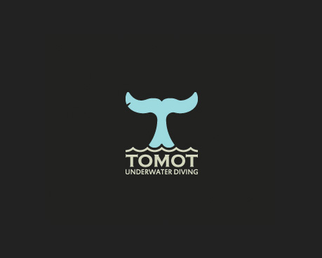

The Tomot logo is very straightforward and simple. It draws your eyes from top to bottom smoothly and gets the image of the company across. It uses a nice mix of dark and light colors to attract your eye to where it wants.



The painstore logo represents the company well and is visually enticing. The image makes you want it to look symmetrical and keeps your attention. The lack of symmetry also draws your eye.

**Logos We Do Not Like**

**We would like a logo with a simplistic color scheme with a slightly off putting and distinguishing shape. We would like to avoid dark color schemes and a logo with lots of words and more than 2 shapes. It should feel as if the image is connected**

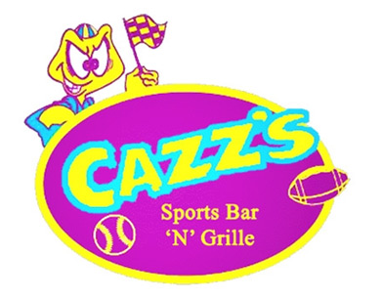

The Cazz’s logo is too bright. It makes you want to look away from it. It uses bright colors that are intimidating to the eye. It is kind of infuriating. The logo has too much going on. The logo looks like does not fit the mood of a sports bar. A sports bar should appeal more to adults. It seems to be a perfect child’s arcade logo.

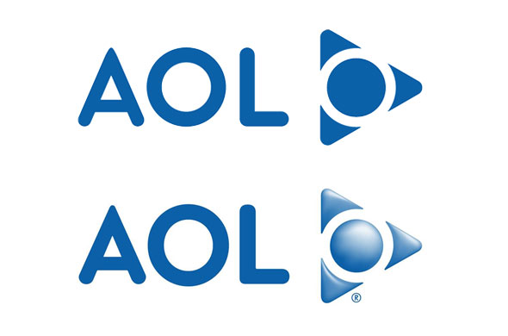

The AOL logo is not straightforward. It doesn’t explain what the company does. It is simple but it doesn’t catch your attention. The moncolor of the logo makes it boring. The circle inside of the triangle is off putting and makes you question which way is correct to look at it.

**Our Competition**

**Smart Plug: https://www.tp-link.com/us/home-networking/smart-home/smart-plugs**

Smart Plug is a item that has a timer on a power plug that connects to an app and can be told when to turn on. It is similar in the way that it is a smart IOT technology.

**Mott Manufacturing:**

**Overhead Service Carriers** builds custom power strips for companies in customized spaces. The service is similar to what our company does but does not have and stackable outlet or have an advantage for small businesses, because they tend to just need a extension cord not can overhead carrier.

**Logo Design – Colors**

https://color.adobe.com/create/color-wheel/?base=2&rule=Analogous&selected=4&name=My%20Color%20Theme&mode=rgb&rgbvalues=0.0009998187036120729,0.001,0.0009996,0,0.10212765957439841,0.24,0.26,0.259896,0.259896,0.7698039215686274,0.7698039215686274,0.7698039215686274,0.029627519999999997,0.03118591283314729,0.0312&swatchOrder=0,1,2,3,4

**Logo Design – Fonts**

**We think a good logo would be one that has the name BLOX incorporated into a power off/on icon with a cord attached. A combination logo like Burger King or Doritos would be optimal.**

**Nanum Gothic Coding** [**https://fonts.google.com/specimen/Nanum+Gothic+Coding**](https://fonts.google.com/specimen/Nanum+Gothic+Coding)

**This font would match with a simple picture.**

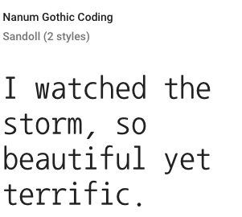

**Lego Thick** [**https://www.urbanfonts.com/fonts/Legothick.font**](https://www.urbanfonts.com/fonts/Legothick.font)

**This font would give a lego type association to represent how the power strip will be connectable like legos.**

