10/04/2018

David, Neel,Zeus

Organization Name: Blox

The organization is about customization and creates an adjustable style power block that can be built on individual pieces and has a timer that connects online to an app.

The goal of the organization is to save customers money and simplify power cords and organization. It should be perceived as being as efficient, convenient, and simple.

The typical user of this product would be a small business owner. This small business owner uses lots of electronics that need to be organized efficiently and to save costs.

The group is primarily male because they are more likely to be small business owners. They are married.

The age rage and median age is 30-50 with a median age of 40.

The target audience lives in big cities and suburban areas where it is important to save costs. Also it is more likely to have more small business owners.

Yes they work.

They do customer support, blockchain mining, web developers, printing companies, cybersecurity, tax workers. Their income is 100K+.

They are highly educated

Their special interests are how to optimize stuff. They spend their free time using technology, and they leave their machinery running.

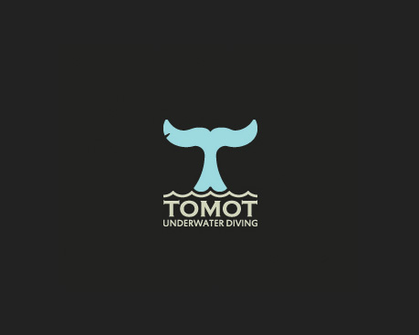



The first logo is very straightforward and simple. It draws your eyes from top to bottom smoothly and gets the image of the company across. It uses a nice mix of dark and light colors to attract your eye to where it wants.

The second logo represents the company well and is visually enticing. The image makes you want it to look symmetrical and keeps your attention. The lack of symmetry also draws your eye.

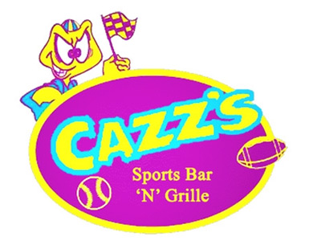

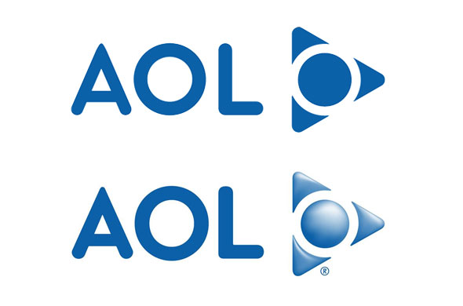

The first logo is too bright. It makes you want to look away from it. It uses bright colors that are intimidating to the eye. It is kind of infuriating. The logo has too much going on. The logo looks like does not fit the mood of a sports bar. A sports bar should appeal more to adults. It seems to be a perfect child’s arcade logo.

The second logo is not straightforward. It doesn’t explain what the company does. It is simple but it doesn’t catch your attention. The moncolor of the logo makes it boring. The circle inside of the triangle is off putting and makes you question which way is correct to look at it.

Smart Plug is a company that has a timer on a power plug that connects to an app and can be told when to turn on. It is similar in the way that it is a smart IOT technology. Overhead Service Carriers builds custom power strips for companies in customized spaces. The service is similar to what our company does but does not mass produce or have an advantage for small businesses.

# 

# Nanum Gothic Coding, Lego Thick

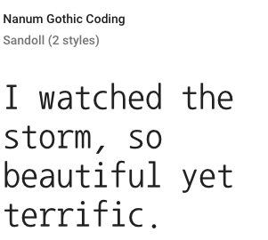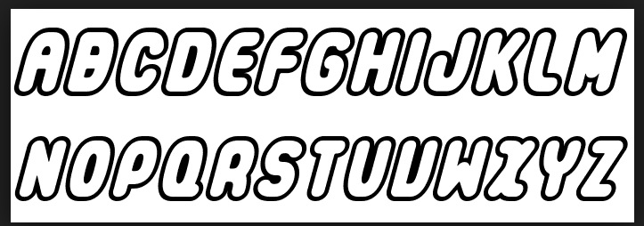

Black,gray,white, and navy blue