Name: David Warshawsky

**Wordmark**

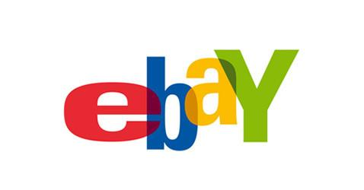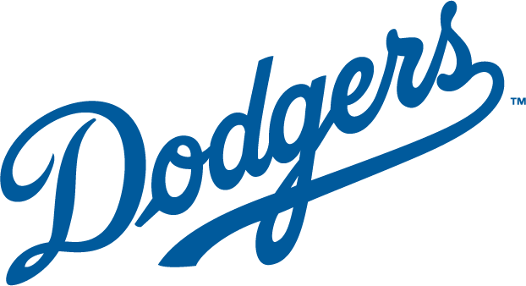

Ebay because it incorporates the full name of the company and I recognize the brand.

Dodgers because it incorporates the full name of the team and I like the font.

**Lettermark**



HBO because it is better than netflix and incorporates the abbreviation of the the company's name, Home Box Office.

HP because it incorporates the abbreviation of Hewlett Packard and I dislike their personal computers.

**Abstract**

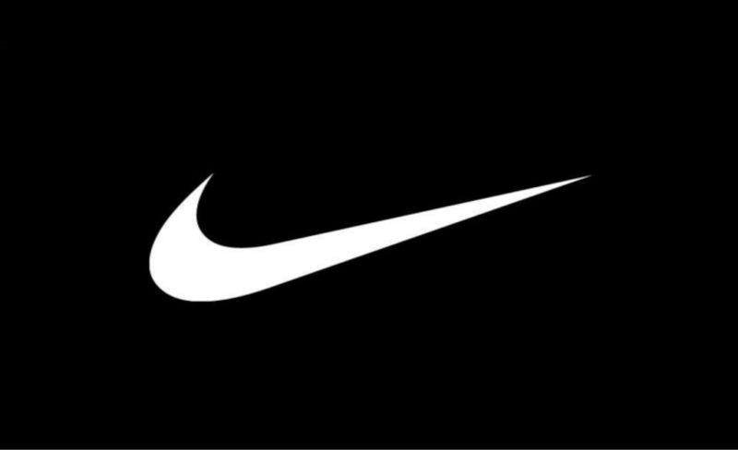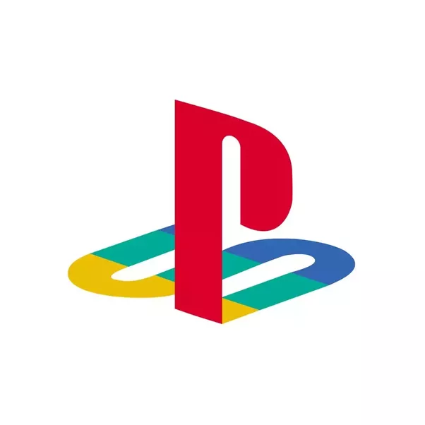

Nike because the logo can not be connected to the name of the company without it having brand recognition.

Playstation because the logo is incomprehensible other than the fact that it is associated with playstation.

**Pictorial**



Apple because the image is of an apple, therefore the image on the logo matches the company name.

Twitter because the logo is associated with the sound a bird makes, which is a tweet, therefore the image on the logo matches the company name.

**Combination**

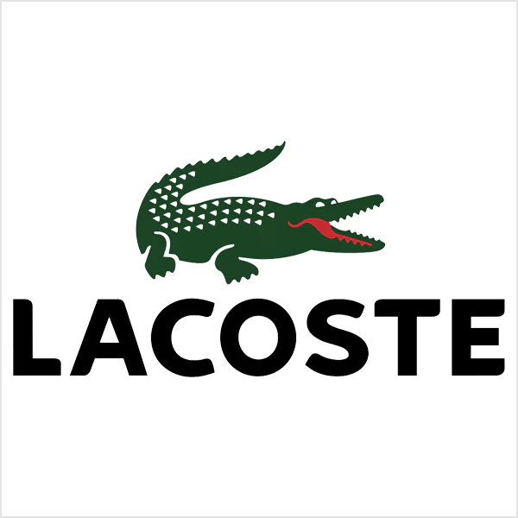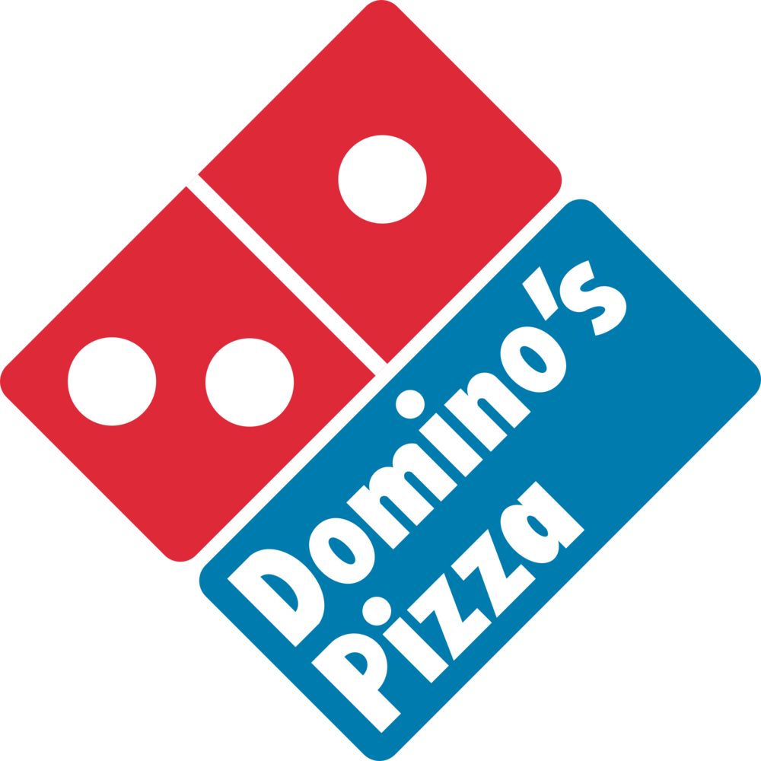

Lacoste because the image is a combination of the full company name and image associated to identify the brand.

Domino’s Pizza because the image is a combination of the full company name inside of the image used to identify the brand.