Barcode Scanner Configuration

1 Ensure the device has a sim card installed

2 Install the app and register the device

3 Exit the app

4 Start up the DataWedge app (see icon below)

5 From the menu dropdown select "New profile"

6 Name the new profile "aeg" (without the speech marks)

7 Tap on the profile "aeg"

8 "Profile enabled" should be ticked

9 "Barcode Input" "Enabled" should be ticked

10 "Barcode Input" "Hardware Trigger" should be ticked

11 "Intent output" "Enabled" should be ticked

12 "Intent action" is "com.aeg.ACTION" (without the speech marks)

13 "Intent delivery" is "Broadcast intent"

14 "Select Associated apps"

15 From the menu dropdown select "New app/activity"

16 From the list of apps select "com.aegglobal.ticketscanner"

17 "Select activity" select "com.aegglobal.ticketscanner.ui.main.MainActivity"

18 Configuration is now complete

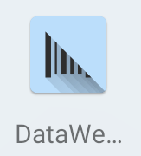

Datawedge app icon

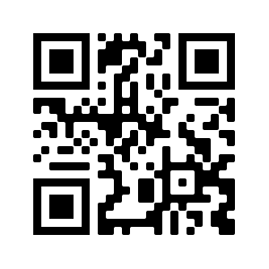

Sample qr code (Mercatura scan test)