General Physics I: Exam 1
October 8, 2004

1. In the following equation, x is in meters (m) and t is in seconds (s): x = 4.0 - 7.0 t + 9.1 t³. What are the units of 4.0, 7.0 and 9.1, in that order?
(a) m, m, m
(b) m, m/s, m
(c) m, m/s, m/s³
(d) m, m², m³
(e) m, m/s, m/s²

2. In the following equation, A has units of kg/m³, B has units of kg m/s² and C has units of kg/(m s²). What are the units of AB/C?
(a) kg/m
(b) m/s
(c) kg/s
(d) kg m²/s
(e) kg s

3. A car starts from rest, speeds up, moves for a while at constant speed, slows down and stops. Which of the following five coordinate versus time graphs best describes the position as a function of time? (D)
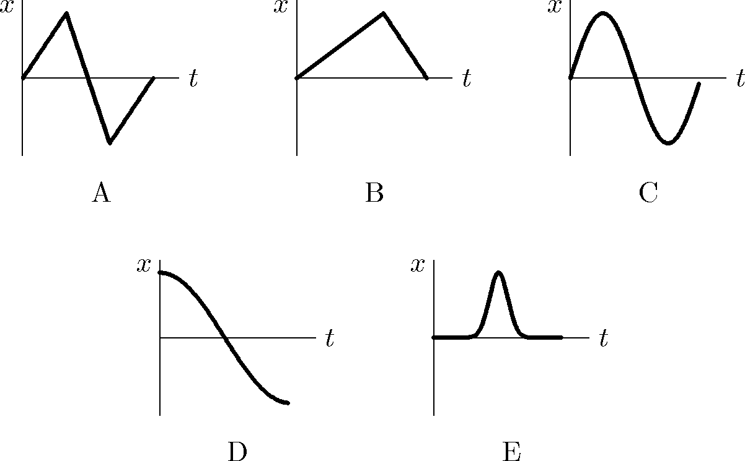

4. Let v represent velocity and a represent acceleration. Which of the following sets of signs of these two quantities describes an object that is slowing down?
(a) v > 0, a > 0
(b) v = 0, a > 0
(c) v > 0, a < 0
(d) v = 0, a < 0
(e) v < 0, a < 0

5. Consider the motion of an elevator that starts from rest on the ground floor, and ends up on the 10th floor, at rest. This motion of the elevator can be considered in three parts: (i) elevator starts from rest and speeds up until it reaches a speed at which it will continue upwards, (ii) it moves upwards at a constant speed, (iii) it starts to slow down and stops on the 10th floor. In which segment(s) will the force of the floor of the elevator on someone in the elevator be greatest?
(a) (i)
(b) (ii)
(c) (iii)
(d) (i) and (iii)
(e) (ii) and (iii)

6. This question refers to the situation described in the prior problem. In which segment(s) will the net acceleration of someone in the elevator point upwards?
(a) (i)
(b) (ii)
(c) (iii)
(d) (i) and (iii)
(e) (ii) and (iii)

7. Given the following position vector: 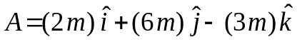. Which of the following is a unit vector in the same direction as ?
(a)
(b) 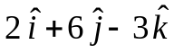
(c) 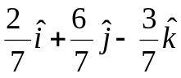
(d) 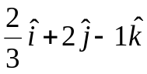
(e) 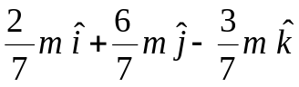

8. A ball is thrown at 15 m/s at an angle of 30º above the horizontal directly towards a wall. The wall is 15.0 meters high and 19.0 meters from the where the ball is launched. The ball is launched 1.5 meters above the ground. Neglect air resistance, taking into account gravity after the ball is launched. Does the ball hit the wall on the way up in its trajectory or on the way down or does it hit the wall horizontally, or does it land in front of the wall?
(a) It falls in front of the wall.
(b) It hits the wall horizontally, at the top of its trajectory.
(c) It hits the wall on the way down.
(d) It hits the wall on the way up.
(e) It goes over the wall.

9. This question refers to the situation described in the prior problem. The velocity of the ball when it gets to the wall is
(a)
(b) 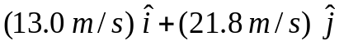
(c) 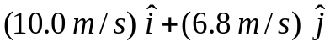
(d) 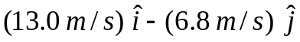
(e) 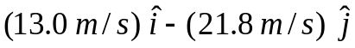

10. The object whose position vs time graph is shown below
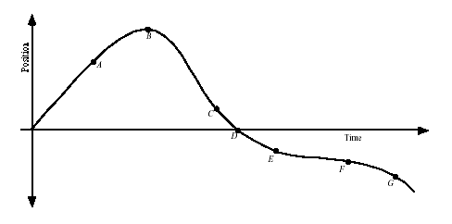
(a) moves at constant speed.
(b) moves at constant velocity.
(c) stops at D
(d) reverses direction at D
(e) reverses direction at B

11. An object starts from (x = -3 km, y = 0) goes north for 30 km, then east for 25 km and finally goes 15 km at an angle of 50 degrees, north of east. The total displacement vector of the object is given by.
(a) 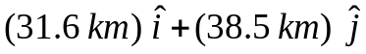
(b) 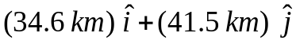
(c) 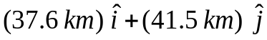
(d) 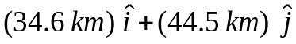
(e) 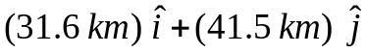

12. A wheel with a radius of 35.0 cm rolls without slipping along a horizontal floor.
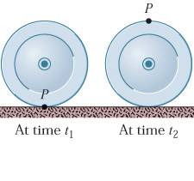
At time t₁ point P on the rim of the wheel is at the point of contact between the wheel and the floor. At a later time t₂ the wheel has rolled through one-half of a revolution. What is the magnitude of the displacement of P during this interval?
(a) 1.30 m
(b) 1.68 m
(c) 2.31 m
(d) 1.15 m
(e) 0.70 m

13. The Earth goes around the Sun in an almost circular path of radius 1.5 x 10⁸ km. It completes its orbit in approximately π x 10⁷ sec. The centripetal acceleration of the Earth is
(a) 9.8 m/sec²
(b) 32 feet/sec²
(c) 6 m/sec²
(d) 6 mm/sec²

14. The true wind velocity is 15 miles/hr from the South. A car is traveling northwest (45º north of west) with a velocity of 30 miles/hr. What is the speed of the wind with respect to the car?
(a) 15 miles/hr
(b) 45 miles/hr
(c) 22 miles/hr
(d) 2 miles/hr

15. A steel ball falls, starting at rest, from a height of ten meters onto the floor, where it penetrates a distance of 0.5 cm before coming to rest. What average acceleration did the ball suffer on stopping?
(a) 19,600 m/sec²
(b) 14 m/sec²
(c) 28 m/sec²
(d) 9.8 m/sec²

16. The energy released by the explosion of 20 thousand tons of TNT weighs about one gram, in the sense of E = m c². The energy released by the explosion of one gram of TNT equals:
(a) 10 Cal
(b) 1.1 Cal
(c) 45 kJ
(d) 12 GeV

17. Below are four equations, followed by the units of the quantities involved in the equations. M stands for a mass unit, L stands for a length unit, and T stands for a time unit. For example, the units of [g] are length/time². Which of the following equations are dimensionally incorrect?

I. Mgh = ½ M v² + ½ I ω²
II. Mgh = ½ M v² + ½ (M R²) ω²
III. Mgh = ½ M v² + ½ (M R²) (v²/R)²
IV. gh = ½ v² + ½ v⁴

[M] = kg
[g] = m/s²
[h] = m
[ω] = 1/s
[v] = m/s
[R] = m
[I] = kg m²

(a) I and II
(b) I and III
(c) I and IV
(d) III and IV

18. What is the circumference of the Earth? Hint: think of how long a drive is cross-country, and that the continental US spans three time zones.
(a) 400 km
(b) 4,000 km
(c) 40,000 km
(d) 400,000 km

19. Which of the following are units of energy?
(a) feet yards/seconds
(b) kg (feet)²/(seconds)²
(c) kg meters/yard
(d) kg yards/(seconds)²

20. What is the density of beer, approximately?
(a) 1 kg/m³
(b) 10 kg/m³
(c) 100 kg/m³
(d) 1,000 kg/m³

21. A bucket of water falls from a third-story window. How long does it take to fall to the ground, approximately?
(a) 0.01 sec
(b) 0.1 sec
(c) 1 sec
(d) 10 sec

22. What is the tension in the string marked T₂? Assume that all pulleys and strings are massless and frictionless. Use g = 10 m/s²
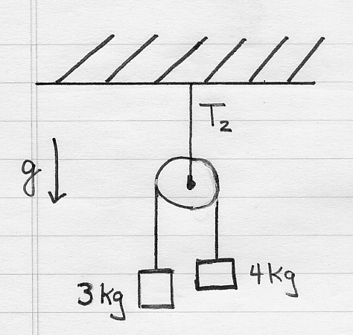
(a) a little less than 70 N
(b) 70 N
(c) a little more than 70 N
(d) 7 N

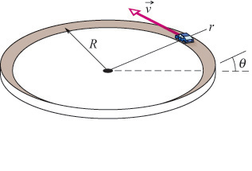
23. A car is rounding a horizontal, banked curve as shown, at constant speed.

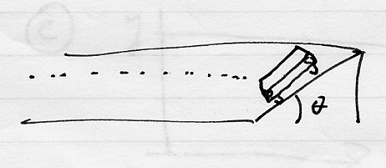

Which best describes the direction of the acceleration vector for the diagram above right?

(a) There is no acceleration. It equals zero.

(b) 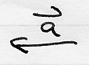

(c) 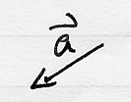

(d) 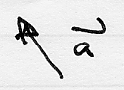

(e) 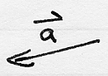

24. Which of the following is a possible graph of the vertical position of a dropped object as a function of time?

(a) 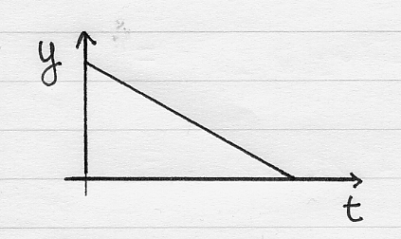

(b) 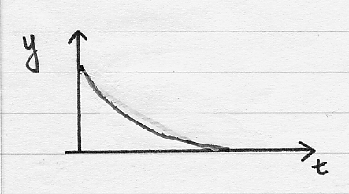

(c) 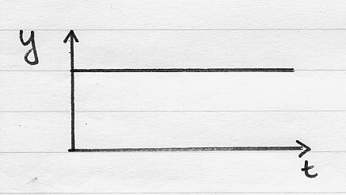

(d) 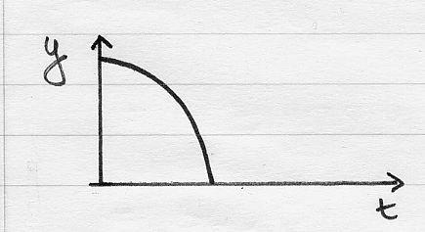

25. A block rests on a frictionless inclined plane. 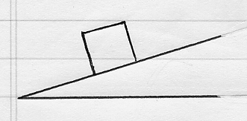
Which free-body diagram below is the correct one for this block?

(a) 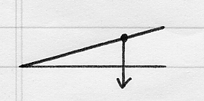

(b) 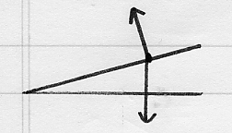

(c) 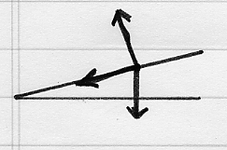

(d) 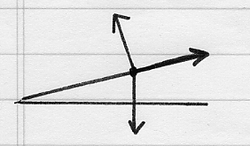

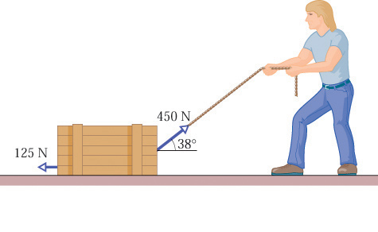
26. In the situation below the crate being pulled on by the man has a mass of 40 kg. Gravity acts on the crate, as does a frictional force of 125 N. What is the acceleration of the crate?
(a) 5.75 m/s
(b) 50 m/s
(c) 5.75 m/s²
(d) 50 m/s²

27. For the situation described in the previous problem, what is the value of the normal force the ground exerts on the crate, if the mass of the crate is 40 kg?
(a) 10 kg m/s²
(b) 115 kg m/s²
(c) 2.33 kg m/s
(d) 1200 kg m/s²

28. The time rate of change of the total momentum of a particle
(a) equals the mass times the velocity of the particle.
(b) is always zero.
(c) equals the total impulse on the particle.
(d) equals the total force on the particle.

29. The graph below shows the acceleration of a particle vs. time. What is the total change in the velocity during the interval 0 < t < 3 sec?
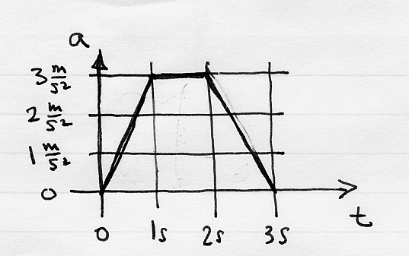

(a) 10 m/s
(b) 6 m/s
(c) 6 m/s²
(d) 2 m/s

30. A helicopter flies at constant velocity as shown. 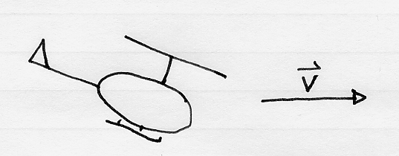
What is the possible free body diagram?

(a) 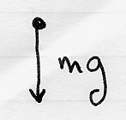

(b) 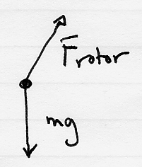

(c) 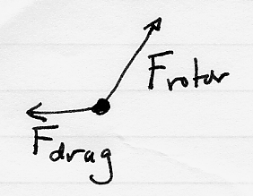

(d) None of the other choices is correct.

Formulas and Conversion Factors

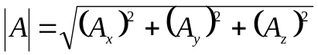

x₂ – x₁= v (t₂ – t₁)

x₂ – x₁= v₁ (t₂ – t₁) + ½ a (t₂ – t₁)²

v₂ – v₁= a (t₂ – t₁)

(v₂)² = (v₁)² + 2 a (y₂ – y₁)

1 eV = 1.6 x 10⁻¹⁹ joules

1 Cal = 1,000 calories

1 calorie = 4.186 joules

1,000 grams = 1 kilogram

1 ton ≈ 1,000 kilograms (1 ton is approximately 1,000 kilograms.)

c = 300,000,000 meters/second

F_{x} = m a_{x}

F_{y} = m a_{y}

E = m c²

a = v² / r

f_{k} = μ_{k} N

f_{s} ≤ μ_{s} N

circumference of a circle = 2 π r

1 m = 1,000 mm = 100 cm

1 foot = 0.3048 meters

g = 9.8 meters/second²

