General Physics I: Exam 2
November 5, 2004

- The figure shows four situations in which a force acts on a box while the box slides rightward a distance 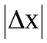 across a frictionless floor. The magnitudes of the forces are identical; their orientations are as shown. Rank the situations according to the work done on the box by the force during the displacement, from most positive to most negative.
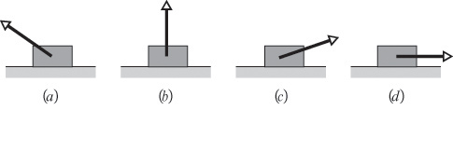
(a) d > a > c > b
(b) a = d > c > b
(c) b > c > a > d
(d) c = d > b > a
(e) d > c > b > a

- A frictionless roller coaster of mass m tops the first hill at speed v₁ pointing to the right. How much work does the gravitational force do on it from that point to point B? The gravitational force points downwards in the figure.
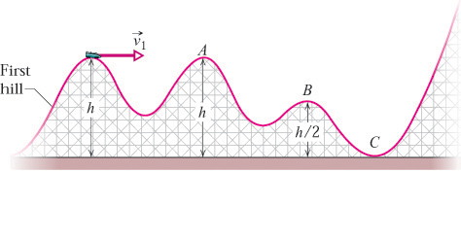

(a) -mgh
(b) mgh/2
(c) zero
(d) –mgh/2
(e) ½ mv₁²

- In the previous problem, what is the speed of the object at point C?

(a) 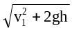
(b) mgv₁
(c) gh
(d) ½ mv₁²
(e) mgh

- Four objects having the same “radius” and mass are shown below. Rank the objects according to the rotational inertia about the axis shown, greatest first.

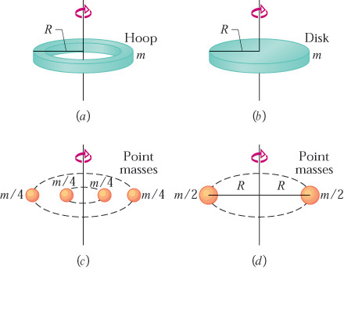

(a) d > a > c > b
(b) a = d > c > b
(c) b > c > a > d
(d) c = d > b > a
(e) a > b > d > c

- A 4-kg object can move along the x axis. It is subjected to a force  in the positive x direction; a graph of F_{x} as a function of time t is shown below. Over the time the force is applied the change in the velocity of the object is:
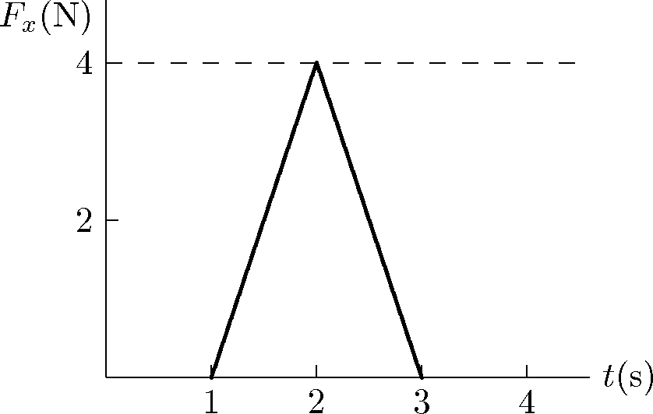

(a) 0.8 m/s
(b) 1.0 m/s
(c) 1.6 m/s
(d) 2.3 m/s
(e) 4.0 m/s

- A light rope passes over a light frictionless pulley attached to the ceiling. Neglect the mass of the pulley. An object with a large mass is tied to one end and an object with a smaller mass is tied to the other end. Which of the following statements is true for the system consisting of the two objects?

(a) The center of mass remains at rest.
(b) The net external force is zero.
(c) The velocity of the center of mass is a constant.
(d) The acceleration of the center of mass is g, downward.
(e) The acceleration of the center of mass is less than g, downward.

- The center of mass of a system of particles has a constant velocity if:

(a) the forces exerted by the particles on each other sum to zero
(b) the external forces acting on particles of the system sum to zero
(c) the velocity of the center of mass is initially zero
(d) the particles are distributed symmetrically around the center of mass
(e) the center of mass is at the geometric center of the system

- Cart A, with a mass of 0.20 kg, travels on a horizontal air track at 3.0 m/s and hits cart B, which has a mass of 0.40 kg and is initially traveling in the same direction as A at 2.0 m/s. After the collision the center of mass of the two cart system has a speed of:

(a) zero
(b) 0.33 m/s
(c) 2.3 m/s
(d) 7.5 m/s
(e) 5.0 m/s

- The figure shows two blocks each of mass m, suspended from the ends of a rigid massless rod of length L₁ + L₂ with L₁ = 30 cm and L₂ = 70 cm. What is the magnitude of the initial angular acceleration of the block on the left, closer to the fulcrum (the triangle on which the rod sits)?

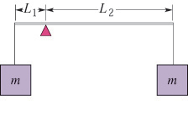
(a) 0.007 rad/sec²
(b) 50 rad/sec²
(c) 14 rad/sec²
(d) 0.7 rad/sec²
(e) 6.8 rad/sec²

- A cylinder having a mass of 4.0 kg can rotate about its central axis through point O. Forces applied as shown: F_{A} = 6.0 N, F_{B} = 4.0 N, F_{C} = 2.0 N, and F_{D} = 5.0 N. Also R₁ = 6.0 cm and R₂ = 12.0 cm.
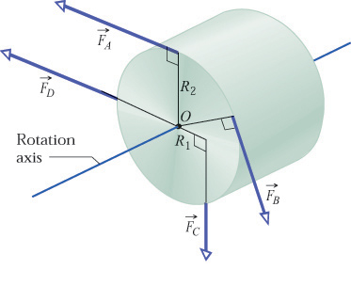
Find the magnitude of the torque on the cylinder.
(a) 0.72 N m
(b) 2.48 N m
(c) 0.48 N m
(d) 0.12 N m
(e) 0.03 N m

- The figure below shows two masses, m and M, suspended by a rope over a pulley of radius R, with moment of inertia I.
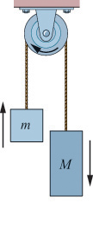
If the tension in the side of the string holding up mass m is denoted by T₁ and the tension in the side of the string holding up mass M is denoted by T₂ then which of the following is the proper expression for the angular acceleration of the pulley?

(a) (T₁ + T₂) R/I
(b) (T₁ + T₂) R
(c) (T₁ - T₂) R/I
(d) T₁ – T₂
(e) T₁

- What is the kinetic energy of a football player running at top speed, very approximately?
(a) 120 J
(b) 1,200 J
(c) 12,000 J
(d) 120,000 J

- How much mechanical work does it require for a typical NYU student to climb 10 typical flights of stairs, very approximately?
(a) 180 J
(b) 1,800 J
(c) 18,000 J
(d) 180,000 J

- A car is driving at constant speed v=60 mi/h on a horizontal road. If the drag force on the car is 1000 N, what is the power the car must be producing, very approximately?
(a) 0 W
(b) 26,000 W
(c) 60,000 W
(d) 700,000 W

- A solid spherical ball and a spherical shell, both with the same mass and radius, are rolling without slipping at the same speed v. Which has the greater total kinetic energy (translational plus rotational)?
(a) solid sphere
(b) spherical shell
(c) neither -- they are the same
(d) the answer depends on the speed v

- Same as the above question, but now the spherical shell has the same mass but a smaller radius.
(a) solid sphere
(b) spherical shell
(c) neither -- they are the same
(d) the answer depends on the speed v

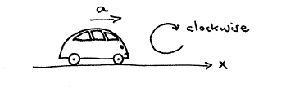
- A car accelerates in the x direction as shown. The acceleration is provided by an external force: the force of the road on the car. Does that force apply a torque to the car, taking the "axis" or "reference point" to be the center of mass of the car?

(a) yes -- in the clockwise direction
(b) yes -- in the counter-clockwise direction
(c) no -- no torque
(d) it depends on the magnitude of the acceleration
(e) it depends on the velocity of the car
- Escape velocity from the surface of the Earth is very approximately
(a) 110 m/s
(b) 11,000 m/s
(c) 1,100,000 m/s
(d) 110,000,000 m/s
- A tiny rubber ball, initially at rest, is hit by a bus moving at 60 mi/hr in the x direction. If the ball bounces off elastically also exactly in the x direction, what is the final speed of the ball?
(a) 0 mi/hr
(b) much less than 60 mi/hr but more than 0 mi/hr
(c) 60 mi/hr
(d) 120 mi/hr
(e) much more than 120 mi/hr

- Which object is possibly in static equilibrium? (A)
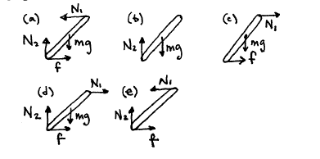

- The V-2 rocket had a take-off weight of 13 metric tons. It burned fuel at a rate of 125 kg/sec with an exhaust velocity of 1830 m/sec. What vertical acceleration with respect to the ground did the rocket have at lift-off?

(a) 17.6 m/ sec²
(b) 1.76 m/sec²
(c) 7.8 m/sec²
(d) 0.78 m/sec²
(e) 9.8 m/sec²

- How fast can a car weighing 2 metric tons be driven up a 5% grade (sin 0.05 radians = 0.05) by an engine delivering 40 hp (1 hp = 0.75 kW)? You may neglect friction and air resistance.

- 3 m/sec
- 30 m/sec
- 15 m/sec
- 1.5 m/sec
- 12 m/sec

- Two 500 g point masses are rotating on a radius of 10 cm from a vertical axis. The angular velocity is 20 rad/sec. What is the rotational momentum?

- 0.2 kgm²/sec
- 0.2 kgm/sec
- 2 kgm²/sec
- 2 kgm/sec²
- none of the above

- In the same set-up as above: if the masses were pulled in to a radius of 5 cm by a radial force, what would the rotational momentum be?

- 0.1 kgm²/sec
- 0.2 kgm²/sec
- 1 kgm²/sec
- 2 kgm/sec²
- none of the above

- In the set-up after the masses have been pulled in to a radius of 5 cm, what is the new rotational speed?

- 20 rad/sec
- 40 rad/sec
- 80 rad/sec
- 160 rad/sec
- none of the above

- In the same set-up: by how much did the energy of the two-mass system change when the masses were pulled in to the smaller radius?

- 0 J
- 2 J
- 4 J
- 6 J
- 8 J

- An escalator is used to move 20 people (60kg each) per minute from the first floor of a department store to the second floor, 5 m above. Neglecting friction, the power required is approximately:
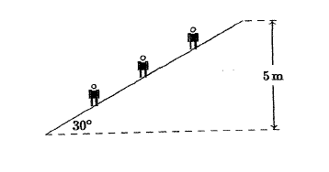

(a) 100 W
(b) 200 W
(c) 1000 W
- 2000 W
(e) 60,000 W

- Two disks are mounted on low-friction bearings on a common shaft. The first disc has rotational inertia I and is spinning with rotational velocity ω. The second disc has rotational inertia 2I and is spinning in the same direction as the first disc with rotational velocity 2ω as shown. The two disks are slowly forced toward each other along the shaft until they couple and have a final common rotational velocity of:
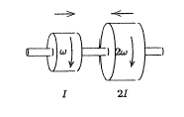

  - 5ω/3
  - ω√3
  - ω√7/3
  - ω
  - 3ω

- A and B are two solid cylinders made out of aluminum. Their dimensions are shown. The ratio of the rotational inertia of B to that of A about the common axis X-X' is:

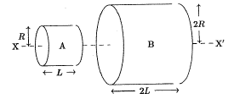

  - 2
  - 4
  - 8
  - 16
  - 32

- Two identical disks, with rotational inertia I (= ½ MR²), roll without sliding across a horizontal floor with the same speed and then up inclines. Disk A rolls up its incline without sliding. On the other hand, disk B rolls up a frictionless incline. Otherwise the inclines are identical. Disk A reaches a height of 12 cm above the floor before rolling down again. Disk B reaches a height above the floor of:

  - 24 cm
  - 18cm
  - 12 cm
  - 8 cm
  - 6 cm

