Note: This test consists of 35 questions, but any 30 correct answers will merit a score of 100%. Answer as many questions as you like; your best 30 answers will be counted.
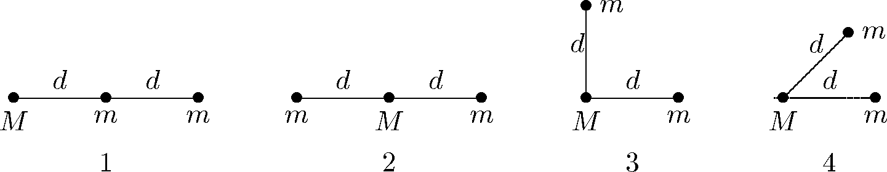
- Three particles, two with mass m and one with mass M, might be instantaneously arranged in any of the four configurations known below. Rank the configurations according to the magnitude of the gravitational force on M, greatest to least.
  - 1, 2, 3, 4
  - 2, 1, 3, 4
  - 2, 1, 4, 3
  - 4, 3, 1, 2
  - 1, 3, 2, 4
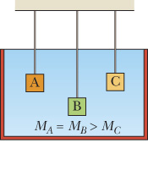
- Three objects of equal volume, submerged in water, are suspended from strings, as shown below. The figure indicates the relative masses of the three objects. Which of the following choices is the correct ranking of the buoyant forces acting on the masses from largest to smallest?
  - Buoyant forces are the same.
  - Buoyant force on A > buoyant force on B > buoyant force on C
  - Buoyant force on A = buoyant force on B > buoyant force on C
  - Buoyant force on C > buoyant force on A = buoyant force on B
  - Buoyant force on B > buoyant force on A > buoyant force on C
- The figure shows a pipe and gives the flow velocity (in cm/s) and the direction of flow for all but one section. What are the volume flow rate and the direction of flow for that section? All sections have the same cross-sectional area.
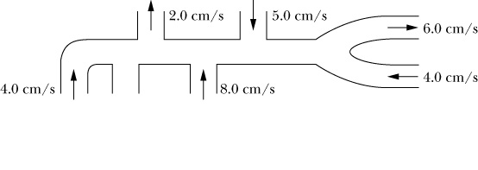
  - 13 cm/s, out
  - 10 cm/s, out
  - 2 cm/s, out
  - 10 cm/s, in
  - 13 cm/s, in
- A piston of cross sectional area a is used in a hydraulic press to exert a small force f on the enclosed liquid. A connecting pipe leads to a larger piston of cross-sectional area A. If the large piston has a cross-sectional area 10 times that of the small piston, what force magnitude on the small piston will balance a 20,000 N force on the large piston?
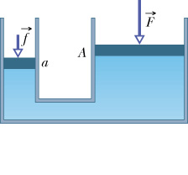
  - 200,000 N
  - 200 N
  - 20,000 N
  - 2,000 N
  - 2 N
- A body with a mass of 1/2 kg executes simple harmonic motion according to the equation
x = (6.0 m) cos ([4π rad/s] t – [π/4 rad])
What is the total (kinetic plus potential) energy of this body?
  - 7.1 x 10² joules
  - 1.4 x 10³ joules
  - 36.0 joules
  - 18.0 joules
  - 24.0 joules
- An object hangs from a spring balance. The object is connected to the spring balance by a string. The balance indicates 30 N in air and 20 N when the object is submerged in water. What is the buoyant force when the object is submerged in water?
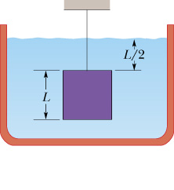
  - 5 N
  - 50 N
  - 10 N
  - 30 N
  - 0 N
- The figure below shows a fluid moving towards the right through a pipe of variable cross-sectional area, which also changes height with respect to the ground. The cross-sectional area at points 2 and 3 are the same. List the four locations along the pipe in order of increasing pressure.
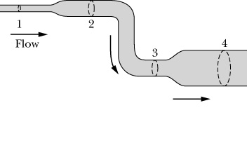
  - 1, 2, 3, 4
  - 4, 3, 2, 1
  - 1, 4, 3, 2
  - 3, 2, 1, 4
  - 2, 1, 4, 3
- A 0.25-kg block oscillates on the end of the spring with a spring constant of 200 N/m. If the oscillation is started by elongating the spring 0.15 m and giving the block a speed of 5.0 m/s, then the amplitude of the block’s motion is:
  - 0.03 m
  - 0.0023 m
  - 0.15 m
  - 15 m
  - 0.23 m
- Three pendula of masses m, 4m and 6m are suspended from strings of identical length. Rank the period of the pendula from smallest period to greatest period.
  - m, 4m, 6m
  - 4m, 6m, m
  - 4m, m, 6m
  - They all have the same period.
  - period of 4m and 6m are the same; period of m is the greatest.
- A wave traveling along a string is described by
y(x, t) = [0.00327 m] sin ([72.1 rad/m] x – [2.72 rad/s] t)
Which of the following statements is true?
  - The frequency of the wave is 72.1 rad/m
  - The speed of the wave is 2.72 rad/s
  - The direction of propagation of the wave is the +x direction.
  - The wavelength of the wave is 1/(72.1) m.
  - The period of the wave is 1/(2.72) s.
- What is the wavelength of the wave described by this equation?
y(x, t) = [0.00327 m] sin ([72.1 rad/m] x – [2.72 rad/s] t)
  - 0.00327 m
  - (0.00327/6.28) m
  - (72.1/6.28) m
  - (6.28/72.1) m
  - (1.00/72.1) m
- A police car with a siren emitting a whine at 1600 Hz overtakes and passes two cyclists pedaling a bike at 1.94 m/s and 2.90 m/s. Which of the two cyclists hears the lower frequency coming from the siren after the police car has passed them both?
  - They hear the same frequency
  - The cyclist moving faster hears the higher frequency
  - The cyclist moving slower hears the lower frequency.
  - The cyclist moving faster hears the lower frequency.
- Three 10.0 kg spheres are located in the xy plane as shown in the figure below. What is the net gravitational force on the sphere on the x-axis at x = 0.40 m due to the other two spheres?
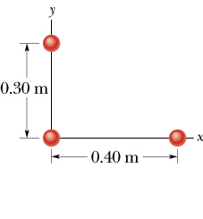
  - 4.2 x 10⁻⁸ N
  - 1.6 x 10⁻⁸ N
  - 2.1 x 10⁻⁸ N
  - 3.5 x 10⁻⁸ N
  - 6.5 x 10⁻⁸ N
- Which statement about simple harmonic motion is true?
  - The period of oscillation depends on the amplitude of the motion and the energy is proportional to the first power of the amplitude.
  - The frequency of oscillation depends on the amplitude of the motion and the energy is proportional to the first power of the maximum velocity.
  - The period of oscillation is independent of the amplitude of the motion and the energy is proportional to the second power of the amplitude.
  - The frequency of oscillation of a mass on a spring is independent of the mass attached to the spring.
  - The force on the mass undergoing simple harmonic motion is constant.
- When a 500 g mass is hung on a spring, the spring stretches 10 cm to a new equilibrium position. What is the force constant of the spring, roughly?
  - 49 kg/ sec²
  - 4.9 kg/sec²
  - 0.2 kg/sec²
  - 2 sec²/kg
  - none of these
- With data as in the previous problem, if the mass is then set into oscillation about the new equilibrium point, what is the period of the oscillation?
  - 1.58 sec
  - 0.63 sec
  - 9.9 sec
  - 0.1 sec
  - none of these
- A pendulum bob of mass m is pulled to the side until the pendulum’s string (of length L) is horizontal. After the bob is released the speed of the bob at the lowest point in its swing is
  - 6.28 (L/g)^{1/2}
  - (2gL)^{1/2}
  - (gL)^{1/2}
  - mgL
  - (2gL/3.14)
- If the length of a simple pendulum is doubled, by what percent does the period change?
  - 41 %
  - 71 %
  - 100 %
  - 200 %
  - 300 %
- The force needed to pull the plug in a fluid-filled sink (ignoring friction) is directly proportional to
  - the diameter of the plug
  - the viscosity of the fluid
  - the area of the sink
  - the depth of the fluid
  - none of these|
- A certain nuclear explosion released 150 Megawatt-years of energy. If the energy could have been spread out evenly over 30 years, how much power could have been produced?
  - 5 MW/year
  - 5 kW/year
  - 5 W/year
  - 5 MW
  - none of these
- A certain fluid has a specific heat of 3 J/(g deg C). If 500 g of it are heated by a perfectly efficient 1.2 kW heater, how much will its temperature change within 100 seconds?
  - 8 deg C
  - 80 deg C
  - 1.5 deg F
  - 8 Kelvin
  - none of these
- The speed of sound in air is given by the formula v = (1.4 RT/M)^{1/2}, where R is the universal molar gas constant, T the temperature in Kelvin, and M the mass of a mole of the gas. If the temperature increases by 21 %, by what percent does the speed of sound increase?
  - 21 %
  - 10 %
  - 5 %
  - 1.4 %
  - 0 %
- A tsunami is a very long wavelength water wave. The wavelength of a certain tsunami is 500 km and it travels at a speed of 180 m/sec in the open ocean. What is the time between incoming waves (the period)?
  - 90 sec
  - 3/4 hour
  - 180 minutes
  - 900 sec
  - 500 sec
- How long does it take for the Space Shuttle to make one orbit around the Earth? Recall that the Shuttle orbits just a few hundred km above the surface of the Earth, which is about 6000 km in radius. (Hint: You can get an answer just using R and g.)
  - 1.5 seconds
  - 1.5 minutes
  - 1.5 hours
  - 1.5 days
  - 1.5 years
- Which point has the greatest pressure? [needs diagram]
  - A
  - B
  - C
  - D
  - E
- How far under water do you have to dive in order to increase the pressure on yourself by one atmosphere?
  - 0.01 m
  - 0.1 m
  - 1 m
  - 10 m
  - 100 m
- How far up in altitude do you have to go to halve the air pressure, very very roughly?
  - 5 m
  - 50 m
  - 5,000 m
  - 50,000 m
  - 50,000,000 m
- Two masses are hung vertically from two identical springs. If one mass is twice the mass of the other mass, which statement is true?
  - The heavier mass has 1.4 times the period of oscillation of the lighter mass.
  - Both masses have the same period of oscillation.
  - The lighter mass has 1.4 times the period of oscillation of the heavier mass.
  - The lighter mass has twice the period of oscillation of the heavier mass.
  - The lighter mass has four times the period of oscillation of the heavier mass.
- Two masses are attached to two identical springs and allowed to oscillate horizontally on a frictionless surface. They are both oscillating with the same amplitude of oscillation. If one mass is twice the mass of the other mass, which statement is true? (Hint: Think of how much energy it takes to start the systems oscillating.)
  - The heavier mass has four times the total mechanical energy of the lighter mass.
  - The heavier mass has twice the total mechanical energy of the lighter mass.
  - Both masses have the same total mechanical energy.
  - The lighter mass has twice the total mechanical energy of the heavier mass.
  - The ligher mass has four times the total mechanical energy of the heavier mass.
- Two identical guitar strings are stretched to the same length but at different tensions. They have the same masses and lengths. Which statement is true?
  - The higher tension string has a faster wave speed and higher standing-wave frequencies.
  - The higher tension string has a faster wave speed and lower standing-wave frequencies.
  - The two strings have different wave speeds but identical standing-wave frequencies.
  - The two strings have the same wave speeds but different standing-wave frequencies.
- By what factor is the speed of light in vacuum greater than the speed of sound in air, roughly?
  - 2
  - 10
  - 1,000
  - 1,000,000
  - 1,000,000,000
- What is the approximate fractional pitch change (from the Doppler effect) you hear as a motorcycle drives past you at freeway speed, very very roughly? Assume you are at rest.
  - 0.000003
  - 0.0001
  - 0.003
  - 0.1
- What length should you make a pendulum that has a period of 2 s?
  - 0.03 m
  - 0.1 m
  - 0.3 m
  - 1 m
  - 3 m
- What is the natural oscillation frequency of your leg, if you let it swing freely like a pendulum, very roughly?
  - 0.05 s
  - 1 s
  - 20 s
  - 10 min
  - 1 h
- Determine the units of viscosity by analyzing the following formula. A viscous fluid of viscosity S flows through a thin tube of radius R and length L. Its flow-rate V (volume/time) depends on the pressure difference (p-p') between in-flow and out-flow points by “Hagen-Poiseuille's formula”
V = 3.14 (p - p') R⁴ / (8 L S)
What are the units of the viscosity S ?
  - N s m⁻²
  - kg s m⁻¹
  - J s m⁻²
  - m² s⁻¹
  - none of the above

Formula Sheet

F = G m₁ m₂/r²

G = 6.67 x 10⁻¹¹ N m²/kg²

P₁ = P_{atm} + ρgh

P + 1/2 ρ v² + ρ gh = constant

A v = constant

F = -k x

x = X cos (ω t + φ)

1/2 k X² = 1/2 m v² + 1/2 k x²

angular frequency = (k / m)^{1/2}

angular frequency = (g / L)^{1/2}

period = 1 / frequency

frequency = angular frequency / (2 π)

speed = wavelength times frequency

