***Aislinn Winslow***

***Occupational Therapist***

*BSc O. T. (Wits), Certified Workwell Practitioner (USA)*

*Registered with HPCSA*

*Physical address: 554 Louis Botha Ave, Postal address: 20 Elm Ave*

*Gresswold, Johannesburg, Modderfontein, 1609*

*Office: 011 440 0325*

*Fax: 0865101481 Practice number: 0253022*

*Cell: 0724411941*

*Email:* [*aislinn@ot-services.co.za*](mailto:aislinn@ot-services.co.za)

**CONFIDENTIAL OCCUPATIONAL THERAPY REPORT**

**1. Personal information**

**Name:** [[Client.FirstName]] [[Client.LastName]]

**Address:** [[Client.Address]]

**Contact number:** [[Client.CellNumber]]

[[Client.LandLine]]

**Date of Birth**: [[Client.DOB]]

**ID Number:** [[Client.IDNumber]]

**Home Language:** [[Client.HomeLanguage]] (Assessment conducted in [[Client.AssessmentLanguage]])

**2.** **Background information**

|  |  |
| --- | --- |
| Marital status | [[Background.MaritalStatus]] |
| Children | [[Background.Children]] |
| Siblings | [[Background.Siblings]] |
| Residence type | [[Background.ResidenceType]] |
| Has a car | [[Background.HasCar]] |
| IsDriving | [[Background.IsDriving]] |
| Alternative driver | [[Background.AlternativeDriver]] |

*Please see appendix 1 for school and vocational history.*

**3. Occupational information**

Occupation at time of illness[1]: [[Occupation.OccupationAtTimeOfIllness]]

Current occupation: [[Occupation.CurrentOccupation]]

Employer: [[Occupation.CurrentEmployer]]

* [[Occupation.JobDescription.ToString]]

Please refer to table on **page 8** – **Summary of client’s performance in comparison with job demands** – for details on physical, cognitive and psychosocial requirements of Ms. Piater’s occupation.

Classification of work[2]: Sedentary work

**4. Accident/Illness information**

Onset of illness: 2009 Ms. Piater was diagnosed with Rheumatoid Arthritis

**5. Medical information**

History of current disability (Provided by client and medical records available):

| ***Year*** | ***Medical history*** |
| --- | --- |
| *Unspecified* | * *Ms. Piater was diagnosed with hypertension* |
| *2007* | * *Ms. Piater reported that she began experiencing symptoms of rheumatoid arthritis such as stiffness in her joints* |
| *2009* | * *Ms. Piater was formally diagnosed with rheumatoid arthritis and began taking chronic medication* * *She was diagnosed and treated by Dr. A. L. de la Harpe* |
| *2011* | * *Ms. Piater reported that she suffered a ruptured oesophagus and had to undergo surgery* * *She further noted that her gall bladder was surgically removed* * *She reported that she was hospitalized for 53 days at the Glynwood Hospital* |
| *April 2013* | * *Ms. Piater began consulting with her current specialist, Dr. F. Khatib for the treatment of her rheumatoid arthritis* |
| *September 2013* | * *Current medication (As reported by the client and her treating doctor):*   + *Methotrexate*   + *Leflunomide*   + *Prednisone*   + *Meloxicam*   + *Ziak 5mg*   + *Tramahexal* |

|  |  |
| --- | --- |
| ***System*** | ***Result*** |
| *Weight:* | *82 kilograms* |
| *Height:* | *1,63 meters* |
| *Body Mass Index (BMI):* | *30, 86 (Overweight)* |
| *Blood pressure:* | *114/76 (Normal)* |
| *Heart rate (Resting):* | *64 beats per minute* |
| *Maximum heart rate according to age (220-age):* | *166 beats per minute* |

**6. Documentation received**

|  |  |  |
| --- | --- | --- |
| ***Document*** | ***Designation*** | ***Date*** |
| *Medical report* | *Dr. A. L. de la Harpe* | *August 8, 2009* |
| *Medical report* | *Dr. F. Khatib* | *June 24, 2013* |
| *Statement by treating doctor* | *Dr. F. Khatib* | *April 22, 2013* |
| *Employment Health and Wellness (EWH): Application for ill health retirement* | *Lt. Col. E. V. Swart* | *May 23, 2013* |

**7. Main complaints (as reported by client)**

* Joint pain in wrists, hands and fingers bilaterally (both sides)
* Decreased functional use of her hands

**8. Assessment information**

Date of Assessment: September 17, 2013

Place of assessment: 554 Louis Botha Ave, Gresswold Johannesburg

Age at time of assessment: 54 years old

Present at assessment: Mavreeyn Liebenberg (Occupational Therapist)

Wilma Piater (Client)

Date of report: September 19, 2013

**9. Referrer information**

Referring company: CMS/Alexander Forbes

Referring claims assessor: Maureen Broodryk

Our reference: AF/W. Piater/ML

Your reference (Persal number): 0474057-2

SAPS Authorization number: 3490793

**10. Purpose of this report**

* *Identify the client’s current impairments*
* *To gather information regarding the client’s pre-injury/illness, current and future abilities by means of an interview, collateral information, and assessment instruments*
* *To describe the effects of the injuries sustained by the client on their functional abilities and performance in personal management, at leisure and in the work place*
* *Determine ability to return to previous job or other job and transferable skills*
* *Determine psychological and cognitive abilities, and effect of these components on the client’s activities of daily living*

**11. Assessment methods used**

* *Background questionnaire and interview*
* *Clinical, Physical and Cognitive assessment*
* *Workwell FCE Protocol*
* *Self-report measures*

Table of Contents

Summary report………………………………………………………………………………..7

Physical assessment results…………………………………………………………….......12

Cognitive and psychosocial assessment results……………………..…………....…..16

Self-report measures………………………………………………………………….……..17

Workwell FCE assessment results and interpretation (work assessment)……….....17

Activities of daily living………………………………………………………………….......20

Appendices……………………………………………………………………………….…..21

**SUMMARY REPORT**

General Observations

* Ms. Piater was neat and presentable in appearance
* The client actively participated throughout the assessment and was cooperative with all presented tasks
* Ms. Piater effectively communicated in English and was friendly in her interaction
* She was able to give comprehensive personal and medical histories
* No cognitive deficits were observed during the interview or assessment

Cooperation and Effort

Ms. Piater participated in all tasks presented to her. She maintained consistent effort throughout the assessment. At no time did she give the impression of over-exaggerating the symptoms and difficulties she experiences.

Consistency of Performance

* Ms. Piater ’s reported perceived abilities, as measured on the Spinal Function Sort, were consistent with her functional abilities identified and observed during the assessment
* Ms. Piater ’s reports and displays of pain and discomfort during the assessment period were consistent with her diagnosis of Rheumatoid Arthritis

Pain report

Ms. Piater reported that the most significant and frequent pain she experiences is in her hands and wrists bilaterally. She noted that she experiences significant pain and stiffness in her elbows and knees on a daily basis. She further reported that this pain and discomfort is most significant when she is experiencing a “flare-up” of her rheumatoid arthritis. She is currently taking medication for the management of her pain.

Safety

The client displayed appropriate behavior in the assessment and she was socially appropriate. No tasks were deemed unsafe for her to execute during the assessment. When preforming lifting and carrying as part of the WorkWell testing, this was done within the client’s limits of pain.

Abilities/Strengths

* Ms. Piater is able to cope with all cognitive demands of her current occupation. She demonstrated competence in her work.
* The client is willing to participate in all intervention necessary to manage her condition
* Ms. Piater reports compliance to all medication and treatment prescribed
* The client is able to function within her home environment with assistance from her husband and domestic worker

Limitations

* Pain in her joints affects the client’s ability to perform functional postures and tasks at times
* The client suffers from fatigue as a result of her medical condition, which reportedly affects her productivity at times
* The client’s limited hand function, dexterity and coordination may make inherent job tasks, such as handwriting, difficult for the client to perform

Summary of client’s performance in comparison with job demands

|  | ***Critical demand of her job***  *(Based on job description)* | ***FCE abilities of Ms. Piater*** [3] | ***Job match*** |
| --- | --- | --- | --- |
| *Sitting* | *Frequently* | *Frequently* | *Yes* |
| *Walking* | *Occasionally* | *Occasionally* | *Yes* |
| *Stair climbing* | *Rarely* | *Occasionally* | *Yes* |
| *Standing* | *Rarely* | *Frequently* | *Yes* |
| *Bilateral hand function and dexterity* | *Frequently* | *Occasionally* | *No* |
| *Orientation* | *Frequently* | *Frequently* | *Yes* |
| *Concentration* | *Frequently* | *Frequently* | *Yes* |
| *Memory* | *Frequently* | *Frequently* | *Yes* |
| *Decision making and judgment* | *Frequently* | *Frequently* | *Yes* |
| *Stress management and coping skills* | *Frequently* | *Frequently* | *Yes* |
| *Time management skills* | *Frequently* | *Frequently* | *Yes* |

Ms. Piater does not meet all of the inherent **physical** demands of her current occupation; she demonstrated decreased bilateral (2 handed) hand function as well as decreased hand dexterity and coordination. She is able to meet the **cognitive and psychosocial** demands of her occupation and she demonstrated and reported competence in her work.

Current treatment

The client’s current treatment includes care under a specialist rheumatologist, Dr. F. Khatib. The client reported that she plans to continue receiving treatment under her treating doctor’s care.

Recommended treatment

**Physiotherapist**

It is recommended that the client receive regular treatment from a physiotherapist for a period of approximately 3 months in order to address her pain in her joints as well as to maintain her joint range of motion and her muscle strength.

Physiotherapists in her area:

**D. A. De Klerk / N. Naidu**

011 815 1194

(Practicing in the Springs area)

**Occupational therapist**

It is recommended that the client receive regular treatment from an occupational therapist for a period of approximately 6 months. Treatment can focus on addressing the client’s pain in her hands as well as maintaining her muscle strength and range of motion. Further treatment can address teaching the client joint protection techniques and adapted methods of preforming functional tasks in order to reduce the strain on her joints. Home adaptions can be made in order to enhance the client’s performance within her home environment.

Occupational therapists in the client’s area:

* **L. Gunter / A. R. Venter**

011 815 1085

(Practicing in the Springs area)

Prognosis

Ms. Piater was diagnosed with Rheumatoid Arthritis in 2009. Her medical prognosis is deferred to her treating specialist regarding her medical diagnosis.

At present Ms. Piater complains of pain in her joints. Based on her current level of functioning and taking the nature of her condition into account, her current prognosis is fair.

Conclusions regarding Functional Capacity

Ms. Piater began working for the SAPS in 1990 as an administration clerk. She maintained this position until 2004 when she was promoted to a police officer and performed the job of senior personnel practitioner under the rank of warrant officer. In March 2012 the client was placed on light duty after returning from 6 months sick leave following the rupture of her oespohagus and her hospitalization. She is currently performing the job of Vispol Support Officer where she provides assistance to the Vispol Station Commander.

Physical demands of Ms. Piater ’s occupation include frequent sitting tolerance as she works in an office. Walking is performed occasionally for short distances within the police station that she works in. Rarely is she expected to perform work in standing or perform stair climbing. Adequate bilateral hand function, coordination and dexterity are required for computer-based tasks, handwriting and other general administration tasks. Ms. Piater is able to perform all of the physical demands of her occupation with the exception of bilateral hand function, coordination and dexterity. She noted that her most significant limitation with her physical work demands is the handwriting demands. She is required to write minutes in meetings as well as perform writing for general administrative tasks. She noted that when she performs writing for extended periods of time she experiences pain and discomfort in her right hand and forearm. She reported an adequate ability to perform typing however she noted that her typing speed has decreased.

Ms. Piater did not display any limitations in her ability to adequately meet the cognitive requirements of her occupation. She did not report or display any cognitive or psychosocial limitations during the assessment period and she appeared competent in her work tasks when questioned during the assessment.

Due to the nature of Ms. Piater’s condition, her performance within her work environment is expected to fluctuate depending on her experience of pain as well as the phase of her rheumatoid arthritis (e.g. when she experiences a flare up of her joints). She furthermore noted that her ability to independently drive herself to work is dependent on her experience of pain and stiffness in her joints.

It is the writer’s opinion that at the present time, Ms. Piater would be able to perform her position as a Vispol Support Officer, as she has the basic physical and cognitive requirements with the exception of hand writing for extended periods of time. Her handwriting tasks would have to be reassigned to someone more capable. If the client’s job description cannot be adapted to exclude writing by hand then it is anticipated that she will not be able to meet her work demands and perform adequately in her work environment. Due to the nature of her condition she would only be able to cope with sedentary to occasional light duty work.

**Please note** that the opinion and recommendations in this report are based on the medical information made available to me at the time of this assessment and should any further relevant or updated information come to light, I reserve the right to alter this report accordingly.



**________________________**

**Mavreeyn Liebenberg**

***Occupational Therapist***

***BSc. OT (Wits)***



***Edited by A. Winslow, BSc OT (Wits)***

**PHYSICAL ASSESSMENT RESULTS**

**Musculoskeletal assessment**

| ***Physical ability*** | ***Comments on ability*** |
| --- | --- |
| *Posture* | *The client displayed adequate alignment in sitting. She displayed slightly decreased shoulder alignment in standing and walking.* |
| *Coordination* | *Ms. Piater displayed acceptable gross (large movements) motor coordination for general movements. She displayed decreased fine (small movements) motor control when using her hands for functional tasks.* |
| *Endurance* | *The client displayed decreased tolerance when performing lifting tasks; this was due to the client’s reported experience of pain and fatigue. Her general tolerance for static and dynamic postures was observed to be adequate throughout the assessment period.* |
| *Movement characteristics (Speed and posturing)* | *Ms. Piater ’s general movements were observed to be efficient and carried out at an acceptable rate.* |
| *Muscle strength* | *Ms. Piater was assessed to have functional muscle strength in her trunk, upper and lower limbs. Her muscle strength for these parts of her body ranged between grades 3+ to 4 the oxford scale*[4]*.* |
| *Range of joint motion* | *Ms. Piater was assessed to have range of joint motion within functional limits in all joints of her body with the exception of her fingers (Please see hand function assessment results).* |
| *Vision* | *Ms. Piater reported adequate vision with the use of spectacles for reading. No limitations in the client’s vision were observed or reported with the assistance of visual aids.* |

Hand function

The client is **right** hand dominant. She demonstrated an adequate ability to write in a clear and legible manner with her right hand however she reported pain in her hand and forearm as well as fatigue when writing for extended periods of time. The client was assessed to have decreased active joint range of motion in flexion in her Distal Interphalangeal Joints in both hands. She was further assessed to have decreased active movement of her right thumb and deformities consistent with rheumatoid arthritis were observed in the client’s hands. (Please see images below for structural changes in the appearance of the hands)

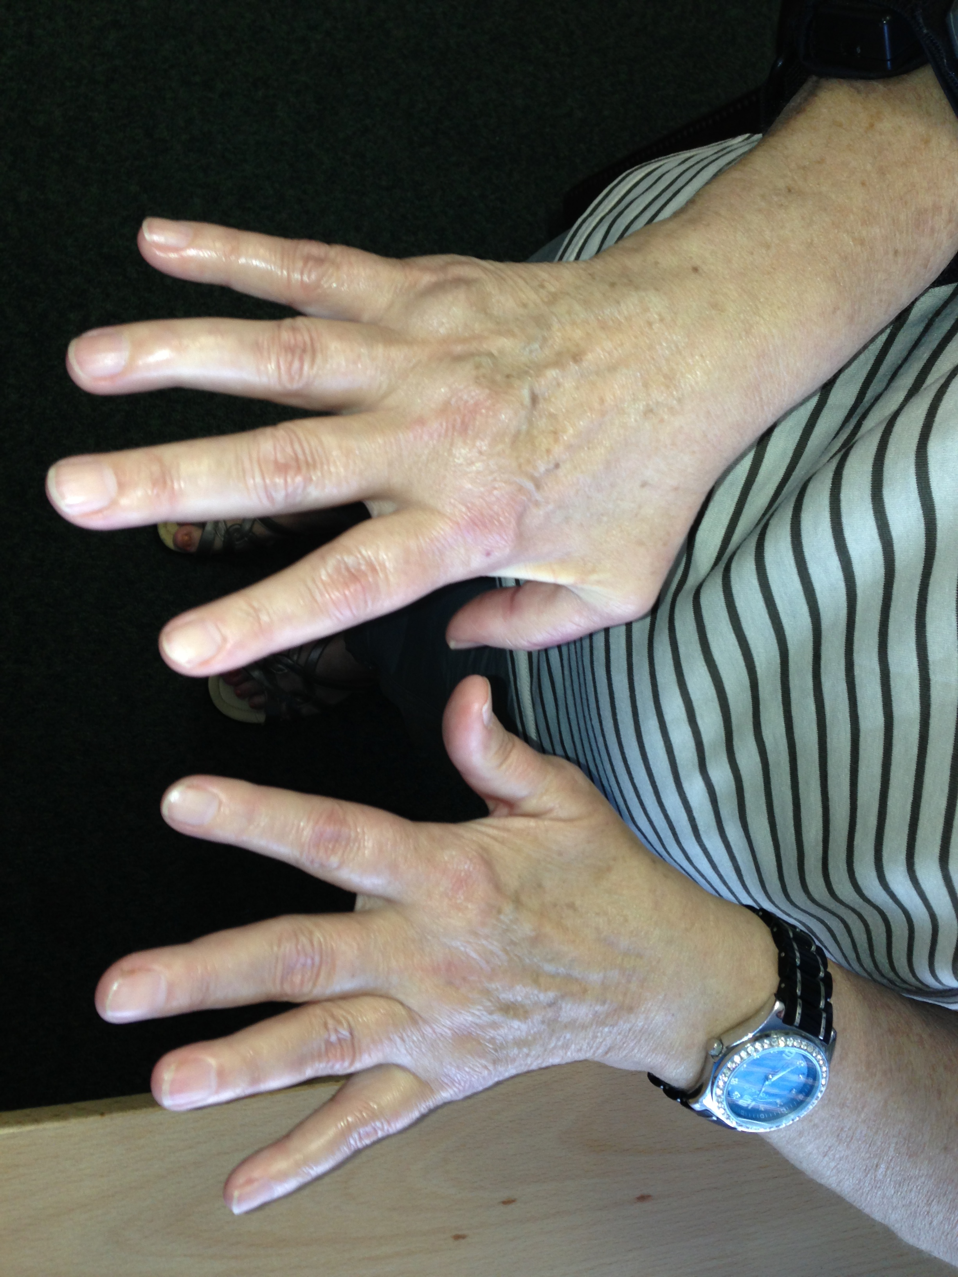(a) 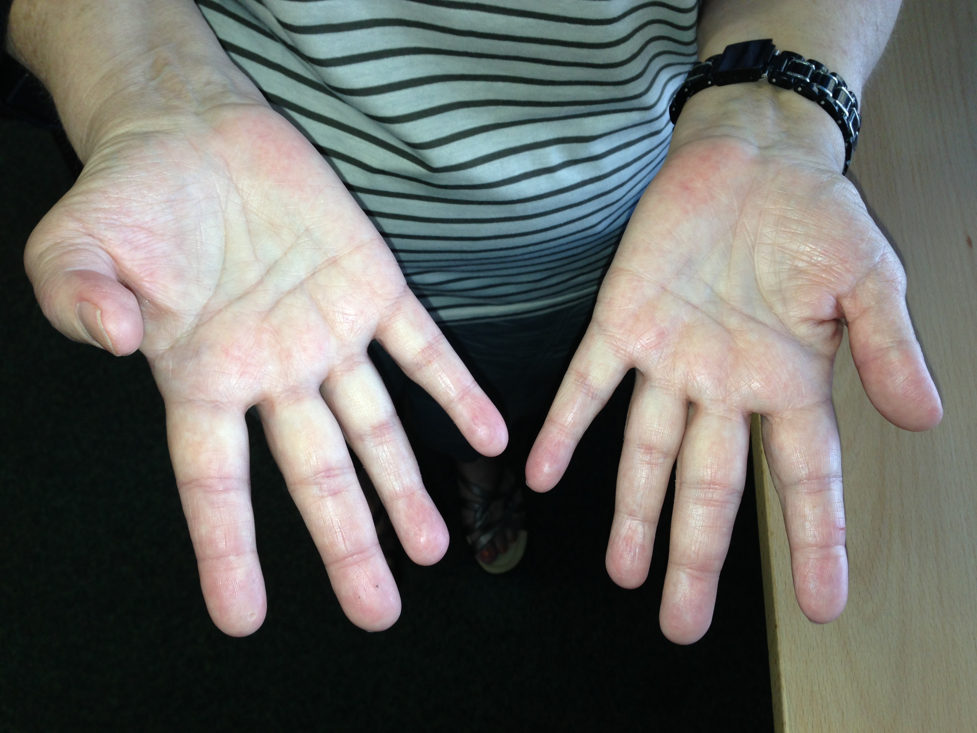(b)

Images 2 (a) and (b)

*Handgrip strength was formally assessed using a Jamar hand dynamometer* [5]

|  |  |  |  |  |  |  |  |  |  |  |  |
| --- | --- | --- | --- | --- | --- | --- | --- | --- | --- | --- | --- |
| ***Hand / finger strength*** | | ***Force (Pounds)*** | | ***Mean for age / gender*** | | ***Standard deviation*** | | ***Client standard deviation*** | | ***Result*** | |
| *Hand grip* | *Right* | | *15,1* | | *65,8* | | *11,6* | | *-4,4* | | *Below Average* |
| *Left* | | *17* | | *57,3* | | *10,7* | | *-3,8* | | *Below Average* |
| *Tip pinch* | *Right* | | *2,6* | | *12,5* | | *2,2* | | *-4,5* | | *Below Average* |
| *Left* | | *2,5* | | *11,4* | | *2,4* | | *-3,7* | | *Below Average* |
| *Lateral Pinch* | *Right* | | *5,5* | | *16,7* | | *2,5* | | *-4,5* | | *Below Average* |
| *Left* | | *5,7* | | *16,1* | | *2,7* | | *-3,9* | | *Below Average* |
| *Palmer Pinch* | *Right* | | *4* | | *17,3* | | *3,1* | | *-4,3* | | *Below Average* |
| *Left* | | *5,8* | | *16,4* | | *2,9* | | *-3,7* | | *Below Average* |

Ms. Piater was assessed to have below average strength in her grips and pinches in both hands. This indicates that she may have inadequate hand function for performance of functional tasks such as writing, typing and dressing.

Hand dexterity

*“The pegboard is placed in front of the client; they are required to place, pegs, washers and sleeves first unilaterally, then bilaterally*[6]*. This assesses the client’s fine motor coordination and dexterity. “*

Pegboard test

|  |  |  |  |
| --- | --- | --- | --- |
| ***Hand*** | ***Raw Score*** | ***Standard Score*** | ***Result*** |
| *Right* | *18,5* | *50* | *Below average* |
| *Left* | *21* | *65* | *Below average* |
| *Bilateral* | *31,5* | *55* | *Below average* |

PCE hand sort test

|  |  |  |  |
| --- | --- | --- | --- |
| ***Hand*** | ***Raw Score*** | ***Standard Score*** | ***Result*** |
| *Right* | *44,5* | *55* | *Below average* |
| *Left* | *49,5* | *60* | *Below average* |

During these tests the client complained of fatigue and joint pain in her fingers and wrist on her right upper limb. Ms. Piater obtained below average scores for fine motor dexterity in both hands. She further obtained below average scores for fine motor (small movements) coordination in both hands. These results indicate that he client has decreased fine motor and dexterous abilities in both hands and this may pose as a limitation in her ability to perform all inherent occupational and functional tasks.

Sensory functions

When testing with monofilaments [7] the client displayed intact sensation in both hands. The client has adequate two-point discrimination in both hands, as she was able to detect separate stimuli 5 mm from each other. This indicates that she has the sensory ability in her hands to be able to perform a task such as winding a watch.

**Balance**

Ms. Piater was able to maintain a stable posture in sitting and standing. She displayed an adequate ability to maintain her balance on an uneven surface with visual input however she was unable to maintain her posture without visual input. This indicates decreased proprioception, which is the ability of the body’s joints to identify their position in space. The client’s general balance for the performance of functional positions was assessed to be adequate.

| ***Screening for Gross Balance- CTSIB*** | ***Time (s) Trial 1*** | ***Result*** |
| --- | --- | --- |
| *Quiet Standing, Eyes open* | *30 seconds* | *Adequate* |
| *Quiet Standing, Eyes Closed* | *30 seconds* | *Adequate* |
| *Quiet Standing on Foam, Eyes open* | *30 seconds* | *Adequate* |
| *Quiet Standing on Foam, Eyes closed* | *14 seconds* | *Inadequate* |

Summary of Physical assessment

The client’s physical **abilities** were as follows:

* Adequate alignment in sitting
* Adequate gross motor (large movements) coordination
* Adequate quality of movement
* Functional muscle strength
* Functional range of joint motion (except in hands)
* Intact visual acuity
* Intact sensory functions
* Adequate balance

The client’s physical **limitations** were as follows:

* Decreased tolerance when performing lifting tasks
* Fatigue
* Pain in joints when performing tasks
* Decreased hand function, dexterity and coordination
* Slight decreased shoulder alignment in standing and walking

**COGNITIVE AND PSYCHOSOCIAL ASSESSMENT RESULTS**

| ***Aspect*** | ***Comment*** |
| --- | --- |
| *Orientation* | *The client was orientated to person, place and time.* |
| *Concentration* | *The client displayed an adequate ability to concentrate for the full length of the assessment.* |
| *Insight* | *Ms. Piater displayed adequate medical insight into her condition and its management.* |
| *Judgment and problem solving* | *The client displayed socially appropriate behavior and adequate judgment at all times throughout the assessment.* |
| *Motivation* | *Ms. Piater displayed adequate internal motivation during the assessment. She actively participated in tasks requested of her.* |
| *Communication* | *The client displayed adequate receptive and expressive communication in English and Afrikaans. She was able to follow verbal, written and diagrammatic instructions.* |
| *Decision making skills* | *Ms. Piater demonstrated an adequate ability to perform concrete and abstract decision-making.* |
| *Memory* | *The client displayed adequate long-term, working and short-term memory during the assessment. She was able to adequately recall events regarding her work and personal histories.* |

**Psychosocial comments**

|  |  |
| --- | --- |
| ***Aspect*** | ***Comments*** |
| *Emotional state* | *Ms. Piater demonstrated a euthymic (normal) mood throughout the assessment.* |
| *Self-concept* | *The client reported a low self-esteem when questioned. She reported that a change in her lifestyle as a result of her medical condition was attributed to her low self-esteem.* |
| *Anxiety/stress* | *Ms. Piater was observed to have adequate stress management skills and coping mechanisms.* |
| *Interpersonal relationship’s* | *The client reports close relationships with her immediate family.* |
| *Personal presentation of self* | *The client was able to adequately present herself at all times during the assessment.* |
| *Time management* | *Ms. Piater reported an adequate ability to manage her time and plan a daily routine. She arrived timeously for the assessment.* |

**SELF REPORT MEASURES**

EPIC Spinal function sort

*Perceived function* – In order to confirm the client’s reports of her functional tolerances and to better understand how her functional limitations impact her ability to work, the spinal function sort was administered to her.

Ms. Piater’s rating of perceived capacity (RPC) is **88**. This RPC score corresponds to the U. S. Department of labour’s **sedentary** level of physical demand characteristics. It’s the writer’s opinion that Ms. Piater has a realistic perception of her abilities as she noted that she does not perform lifting or carrying of heavy objects and she only performs light cleaning at home. She noted that heavier work causes pain in her joints.

**WORKWELL FCE ASSESSMENT RESULTS AND INTERPRETATION**

The interpretation of the WorkWell’s standardized functional testing is based on assumptions including normal breaks; basic ergonomic conditions and the tested functions are usually not required more than 2/3 of a normal working day. Explanation of each test has not been included for the purpose of this evaluation. A detailed description of the nature of testing is available on request.

| ***Frequency*** | ***Weighted activities***  ***Observed effort level*** | | ***Position/Ambulation***  ***Quantitative and qualitative results*** | | ***% Of workday*** |
| --- | --- | --- | --- | --- | --- |
| ***Never*** | *Contraindicated* | | *Not possible* | | *0%* |
| ***Rarely*** | *Maximum* | | *Significant limitation* | | *1-5%* |
| ***Occasionally*** | *Heavy* | | *Some limitation* | | *6-33%* |
| ***Frequently*** | *Low* | | *Slight/no limitation* | | *34-66%* |
| ***Self-limited*** | | *Client stopped test; sub maximum effort level* | | *Submax %* | |

**Lifting and carrying**

| ***Lifting strength (Kg)*** | ***Low*** | ***Heavy*** | ***Max*** | ***Limitations*** |
| --- | --- | --- | --- | --- |
| *Waist to floor lift* | *2 kg* | *6 kg* | *8 kg* | *Demonstrated good body ergonomics. The demonstrated signs of maximum effort when lifting a weight of 8 kg. She complained of pain in her wrists after the performance of this test.* |
| *Waist to crown lift (handles)* | *2 kg* | *4 kg* | *-* | *Demonstrated good ergonomics, maintained an upright posture in her back and neck. The client self limited the test due to reported pain in her hands and wrists; therefore a safe maximum weight could not be obtained.* |
| *Waist to crown lift (preferred)* | *2 kg* | *4 kg* | *-* | *Demonstrated good ergonomics, maintained an upright posture in her back and neck. The client self limited the test due to reported pain in her hands and wrists. Therefore a safe maximum weight could not be obtained.* |
| *Front carry* | *2 kg* | *6 kg* | *8 kg* | *Signs of maximum effort were observed when carrying a maximum weight of 8 kg.* |

The above table indicates that Ms. Piater would be able to lift a weight of 8 kilograms from waist to floor level on a rare basis or for up to 5% of her workday. She would be able to lift a weight of 6 kilograms from floor to waist level or 4 kilograms from waist to crown level on an occasional basis or for up to 33% of her workday. She would be able to carry a maximum weight of 8 kilograms on a rare basis or up to 5% of her workday. Ms. Piater reported that she is not expected to perform any lifting or carrying tasks as part of her occupation at present.

Static and Dynamic Posturing

| ***Posture, flexibility, Ambulation*** | ***Unable*** | ***Significant limitation*** | ***Some limitation*** | ***Slight or no limitation*** | ***Comments*** |
| --- | --- | --- | --- | --- | --- |
| *Sitting* |  |  |  | ** | *The client displayed no limitation in her sitting ability.* |
| *Standing* |  |  |  | ** | *Ms. Piater displayed no limitation in her ability to perform standing. She was observed to have slightly decreased alignment of her shoulders in standing however this was not observed to affect her functioning.* |
| *Walking*  *6 minute walk test* |  |  | ** |  | *The client was able to walk independently for the full duration of the test however he performed below age norms.* |
| *Elevated work* |  |  | ** |  | *Ms. Piater demonstrated some limitation in her ability to perform overhead work. She complained of fatigue and pain in her arms and self limited the test at 1 minute 18 seconds.* |
| *Forward bending in standing* |  |  |  | ** | *The client demonstrated slight limitation in her ability to perform forward bending in standing. She complained of pain in her lower back after the performance of this test.* |
| *Crouching* |  |  | ** |  | *The client demonstrated some limitation in her ability to perform crouching. She complained of pain in her knees and self limited the test at 21 seconds.* |
| *Kneel-half kneel* |  |  | ** |  | *Ms. Piater demonstrated some limitation in her ability to perform kneeling. She complained of pain in her lower back and self limited the test at 4 minutes 46 seconds.* |
| *Stair climbing* |  |  | ** |  | *The client was able to climb a flight of 20 stairs independently however she requires external support from the railings and she reported fatigue after performing this test.* |

Summary of work assessment

Ms. Piater demonstrated no limitations in her ability to perform sitting or standing. Based on her performance in the assessment, she would be able perform these body postures frequently or for up to 66% of her workday. She demonstrated some limitation in her ability to perform forward bending in standing however based on test results, she would be able to perform this position frequently or for up to 66% of her workday. She demonstrated some limitation in her ability to perform walking, stair climbing, crouching, kneeling and elevated work (working with hands at crown level). She would be able to perform these positions occasionally or for up to 33% of her workday.

**ACTIVITIES OF DAILY LIVING**

| ***Activity*** | ***Present functioning*** | |
| --- | --- | --- |
| *Eating* | *The client is able to eat with independence however she noted that she requires assistance from her husband to cut meat.* | |
| *Dressing* | *Ms. Piater reported that she has difficulty with fastenings such as buttons and zips on her clothing. She further reported difficulty putting clothes on and removing her clothing if she is experiencing a flare up in her hands.* | |
| *Toileting* | *The client has intact bowel control, and can independently use a toilet however she reported difficulty removing her pants at times when experiencing flare ups in her hands.* | |
| *Grooming* | | *Tooth care* |
| *Hair care* |
| *Nail care* |
| *Showering and bathing* | *The client reported independence in washing at present however she noted difficulty reaching her back and feet at times when washing. She further reported experiencing pain when getting out of the bath.* | |
| *Sleeping* | *Ms. Piater reported that her sleeping pattern is dependent on her experience of pain. She noted a poor sleeping pattern at present.* | |
| *Home maintenance and meal preparation* | *The client reported that she employs a domestic worker 5 days a week that performs all home maintenance tasks. The client performs light cleaning and she performs all meal preparation tasks with the assistance of her husband.* | |
| *Communication on telephone or written* | *The client has adequate expressive and receptive language in English and Afrikaans. She was able to communicate effectively with the assessor and her communication was appropriate. She was observed to be able to use a mobile phone with independence. She is able to write in a clear and legible manner using her right (dominant) hand however she noted that she experiences pain in her right hand and forearm when writing for extended periods of time.* | |
| *Managing money or using an ATM* | *The client reported that she is independent in her financial management.* | |
| *Shopping/ carrying shopping* | *Ms. Piater noted that she is able to shop independently using a trolley. She noted that she requires assistance when packing groceries into and out of her car.* | |
| *Driving* | *The client has a valid driver’s license and a private car. She noted independence in driving at present however she noted that she experiences pain in her hands at times when driving.* | |

**Please note** that the opinion and recommendations in this report are based on the medical information made available to me at the time of this assessment and should any further relevant or updated information come to light, I reserve the right to alter this report accordingly.

 

**________________________**

***Mavreeyn Liebenberg******Edited by A. Winslow, BSc OT (Wits)***

***Occupational Therapist***

***BSc. OT (Wits)***

**APPENDIX 1**

Education and training

|  |  |  |
| --- | --- | --- |
| ***Period*** | ***Institution*** | ***Accomplishment*** |
| *7 years* | *Redlands Primary School* | *Grade 7* |
| *4 years* | *High School Knysna* | *Grade 11* |
| *1 year* | *Success College* | *Grade 12* |
| *1 year* | *Business Training College of South Africa* | *Diploma in Human Resource Management* |
| *6 months* | *Bishop Lavis Police Training College* | *Basic Police Training* |

**Work Experience**

|  |  |  |
| --- | --- | --- |
| ***Period*** | ***Institution*** | ***Experience gained/Position held*** |
| *Unspecified* | *Various Furniture Stores* | *Administrator* |
| *3 years* | *F. H. Ordendal Hospital* | *Typist* |
| *23 years (Current occupation)* | *South African Police Services (SAPS)* | *Ms. Piater began working for the SAPS in 1990 as an administration clerk. She maintained this position until 2004 when she was promoted to a police officer and performed the job of senior personnel practitioner under the rank of warrant officer. In March 2012 the client was placed on light duty after returning from 6 months sick leave following the rupture of her oespohagus and her hospitalization. She is currently performing the job of Vispol Support Officer where she provides assistance to the Vispol Station Commander.* |

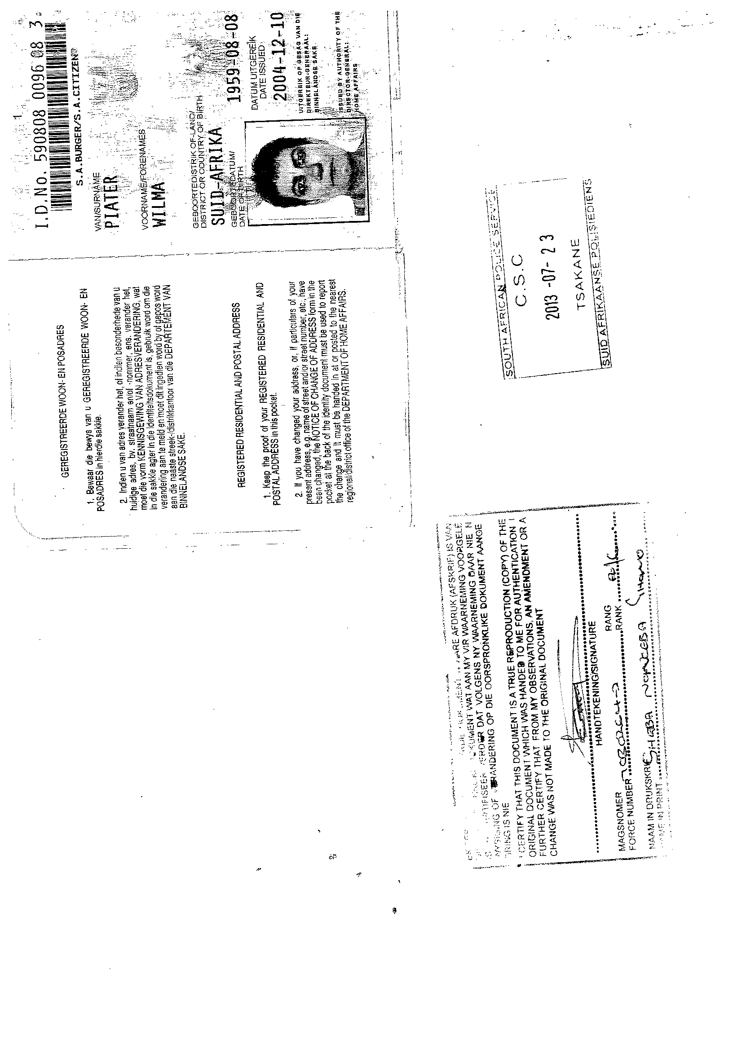

1. Please refer to appendix for vocational history
2. **Sedentary Work**

   Exerting up to 10 pounds (4.5 kg) of force occasionally (up to 1/3 of the time) or a negligible amount of force frequently (from 1/3 to 2/3 of the time) to lift, carry, push, pull or otherwise move objects, including the human body. Sedentary work involves sitting most of the time, but may involve walking or standing for brief periods of time.
3. Please refer to results of Workwell core FCE assessment for more detail on these items
4. *Grade 4 - The part moves through full range of motion against gravity and moderate resistance.*

   *Grade 3+ - The part moves through full range of motion against gravity and less-than moderate resistance.*
5. Norms for mean and standard deviation from Grip and Pinch strength: Normative data for adults, Mathiowetz, 1995.
6. Workwell manual 2006
7. Nylon filaments precisely calibrated and equal in length. Used to measure both diminishing and returning cutaneous sensation.