Project 1

David Shin

California State Polytechnic University, Pomona

CS 301 Numerical Methods

Abstract

Five root-finding methods were used to computationally find the roots of 2 given functions. The methods include: Bisection, Newton-Raphson, False Position, and 2 variants of the Secant Methods. The methodology consisted of finding all the roots of the given functions analytically, then verifying computational results with true root values. For the first function, 3 roots were found at x = 0.365098, x = 1.92174, and x = 3.56316. All methods were performed until the approximate relative error was less than 0.01 or until the max number of iterations was performed. Modified Secant and Newton Raphson methods were found to have consistently less number of iterations to find the root. For the second function, 1 root was found to exist at x = 126.632. The modified secant method had the least number of iterations compared to all the other methods for the second function. One thing that is interesting to point out is that when Bisection method is applied in the interval of [0,1] on the second function, my program would compute a root that is non-existent in the actual function.

Graph Plots

Function 1: $f\left(x\right)=2x^{3}-11.7x^{2}+17.7x-5$

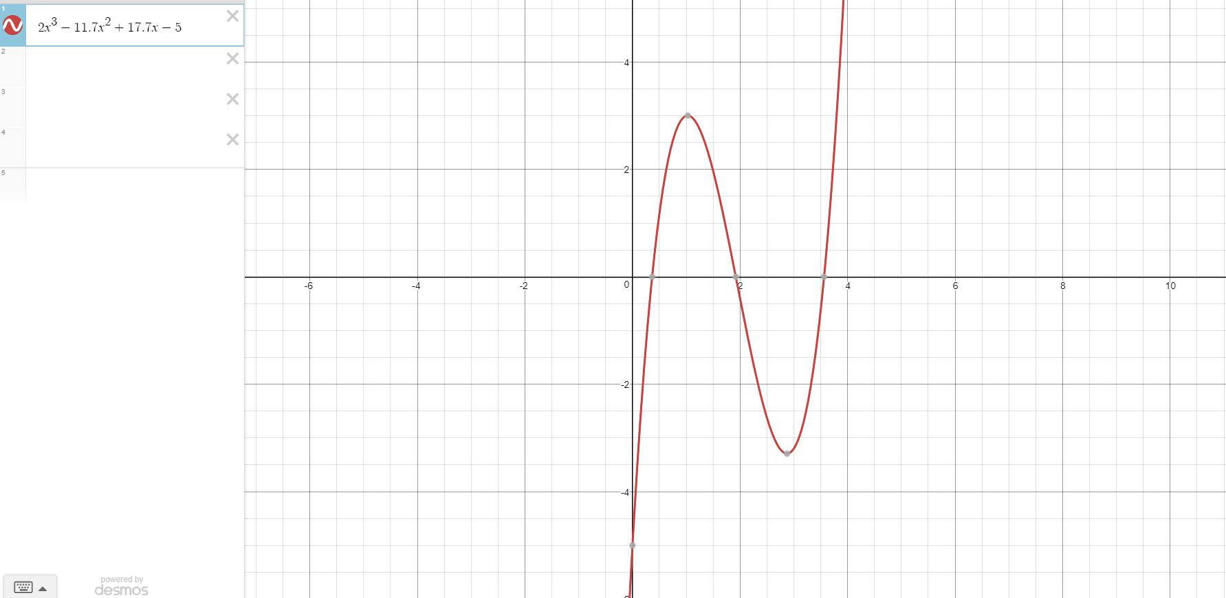

Function 2: $f\left(x\right)=x+10-cosh⁡(\frac{50}{x})$

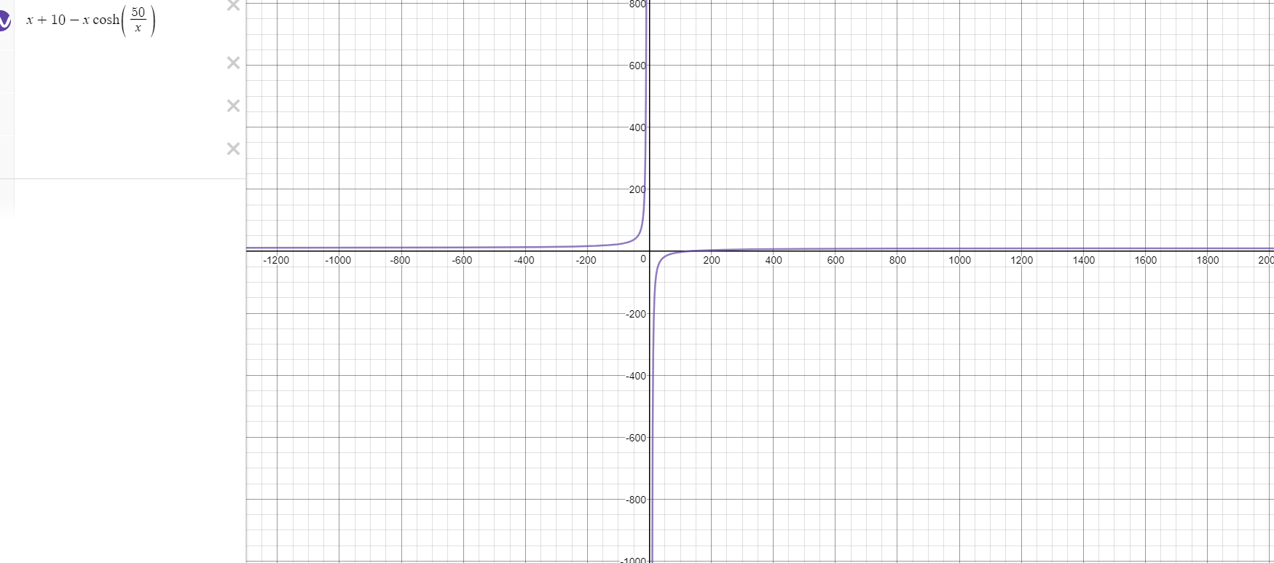

Data Entries