# ServiceWorker-Demo

ServiceWorker-Demo makes use of two browser APIs to offer client-side page persistence for Oracle APEX applications:

1. **ServiceWorker** allows Javascript files to run as "service workers" - background processes that can intercept network requests and offer an alternative to the browser cache. We use this to save static resources, like the page HTML, CSS, and JS.
2. **IndexedDB** is a transaction-based client-side database that can store arbitrary Javascript objects. We use IndexedDB here to store form and form field data from the page. By default, we update our IndexedDB on change events and at fixed intervals. On page load, form field data is reset to its default values; we offer the option either continue, discarding the saved IndexedDB data, or to restore form field from the IndexedDB.

**Note that regions and items that the client hasn't loaded yet will** ***not*** **work offline.** This includes items that open a popup window, pages that source data from SQL queries, and pages that the browser has not previously seen before going offline. Because of way that APEX stores session state data in the URL, it's difficult to determine which pages to be cached in advance. If possible, limit offline availability to a single page that doesn't pull data from the server after page load.

**Note also that we have no way of detecting which user is signed in when offline.** This is stored in the session number, which is entirely server-side.

# Installation and Setup

## TL;DR

* 1. Ask sysadmin to enable HTTPS. (generate *and sign* an SSL certificate for Tomcat).
  2. Ask sysadmin to copy S:\FINGROUP\Documents\DryDock FMM\ServiceWorker-Demo\sw.js to $CATALINA_HOME/webapps/ROOT/sw.js on the server.
  3. Ask sysadmin to restart Tomcat / reload the ROOT application.
  4. Upload everything in S:\FINGROUP\Documents\DryDock FMM\ServiceWorker-Demo\js as static application files. If you’re planning on changing them often, ask sysadmin to copy the contents of the js folder into the ROOT folder as well.
  5. Paste the following lines into Javascript > File URL on global page or page template in APEX.

#APP_IMAGES#/main.js  
#APP_IMAGES#/db.js  
#APP_IMAGES#/networkTest.js

#APP_IMAGES#/global_vars.js

#APP_IMAGES#/swHelper.js

#APP_IMAGES#/status.css  
../sw.js

If you’re serving the js files through the filesystem, paste these instead:

#APP_IMAGES#/status.css

../js/global_vars.js

../js/main.js

../js/db.js

../js/networkTest.js

../js/swHelper.js

../sw.js

5. Upload the CSS as a static application file.

## Tomcat configuration

***HTTPS / TLS / SSL*** must be enabled for ServiceWorker to work - the ServiceWorker standard requires that pages that serve a ServiceWorker must have a secure origin. See here([original](https://www.mulesoft.com/tcat/tomcat-ssl), [archive.is](http://archive.is/wRldn)) for a guide to enabling SSL in Tomcat.

### sw.js

***sw.js*** must be placed in the *ROOT webapp* if Oracle Rest Data Services is configured to run as a servlet under Apache Tomcat. This is a security restriction imposed by the ServiceWorker standard - the scope of the ServiceWorker must be higher or equal to the page location.

Effectively, this means that if the page is served at example.com/ords/f?p=123:345, then sw.js must be served at example.com/sw.js or example.com/ords/sw.js.

On the filesystem, this looks like **$CATALINA_HOME/webapps/ROOT/sw.js** if the file is to be served at example.com/sw.js.

## Other JS files

All other javascript files - those under the ***js*** directory - can be either served under the filesystem or uploaded as a shared component for the application.

Upload other files individually under **Application X > Shared Components > Static Application Files.**

## CSS Files

We use a CSS file to format a status indicator on the page. Upload the status.css file as a static application file.

## Referencing files

All Javascript files must be referenced on page or page templates where ServiceWorker and IndexedDB functionality is required.

The easiest way to do this is under the **File URLs** section while editing a page’s or template’s properties - one line per file.

Template:

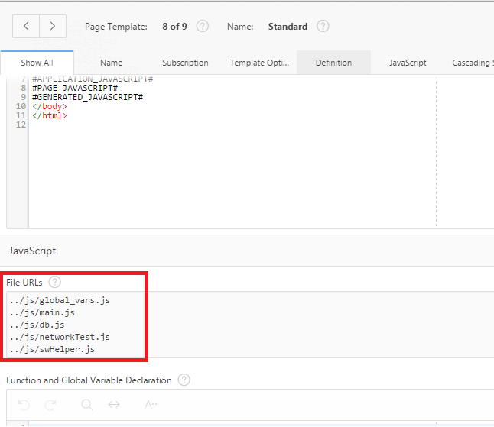

Page:

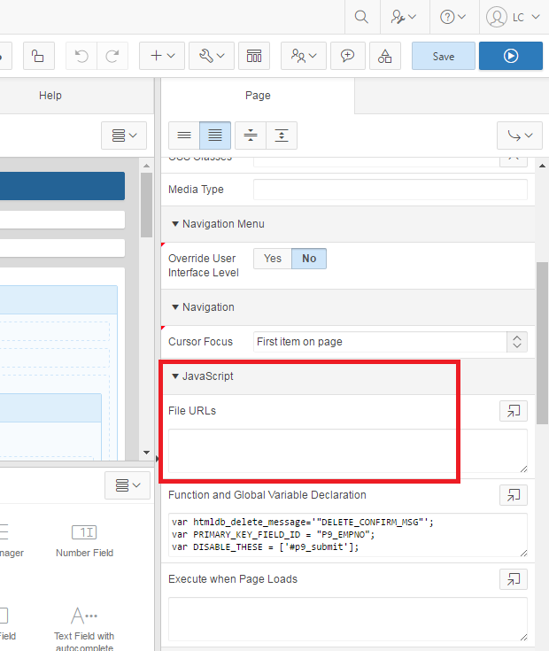

For files uploaded to the filesystem, use these:

../js/global_vars.js

../js/main.js

../js/db.js

../js/networkTest.js

../js/swHelper.js

../status.css

../sw.js

For files uploaded as shared components, use these:

* #APP_IMAGES#/main.js  
  #APP_IMAGES#/db.js  
  #APP_IMAGES#/networkTest.js
* #APP_IMAGES#/global_vars.js
* #APP_IMAGES#/swHelper.js
* #APP_IMAGES#/status.css  
  ../sw.js

# Using ServiceWorker-Demo

## TL;DR

1. Create modal dialog in Inline Dialog region with static ID. Paste static ID into MODAL_DIALOG_ID in global_vars.js so that our code can open it on pageload.
2. Call APEX_LOADALL() and APEX_DISCARDALL() Javascript functions when user makes a choice in the modal dialog.
3. Call APEX_SAVEALL()when you want to save the state of all fields on the page.
4. Call APEX_SAVETHIS(this) with a Change dynamic event that triggers on change for a jQuery selector for .t-Body-contentInner.
5. Paste this:

var PRIMARY_KEY_FIELD_ID = ‘$ITEM_NAME’;

into Function and Global Variable Declaration on an **individual page**.

$ITEM_NAME above needs to be replaced with the name of an item that is a primary key for the report or page.

1. There must be a static region on the page that indicates status. See below for source.
2. Items that should be disabled when the page is offline should have static IDs set and appropriate jQuery selectors placed into the DISABLE_THESE array in Function and Global Variable Declaration per page.
3. If the page breaks, Developer Tools[F12] > Application > Clear Storage. If things still keep breaking, go to chrome://serviceworker-internals/ and click all of the unregister buttons.

## Intro

ServiceWorker will automatically cache and serve pages without human intervention, but IndexedDB requires some work for integration with APEX.

The page will need

1. an **inline dialog region** that displays on page load, prompting the user to load or discard locally-saved changes.
2. A **save button** that forces all fields on a page to be saved.
3. A status indicator forces all fields on the page to be saved.
4. A **Change dynamic action** that saves an individual field on focus out.
5. A **primary key field** that holds the primary key for an object.

## Modal dialog

main.js will, on page load, attempt to determine if there's a discrepancy between the input fields on the page and the saved values in IndexedDB; if there is, a modal dialog prompts the user to either restore or discard the changes.

The dialog region should have a **static ID** set under the Advanced section of its region properties. The same static ID should be set in the MODAL_DIALOG_ID variable in the global_vars.js file. This static ID should be used across all pages that need a modal restore dialog.

The dialog should have two buttons: one to load values from IndexedDB, and another to discard values from IndexedDB. They should have dynamic actions attached that execute APEX_LOADALL() and APEX_DISCARDALL() as Javascript, respectively.

## Save Local Action

The Save Locally button should have a dynamic action that that executes APEX_SAVEALL() as Javascript upon click.

## Status indicator

The status indicator should be a static content region with source

<div>

Network: <span id="networkStatus" class="willHighlight status highlight"></span>

</br>

</br>

Time Last Saved: <span id="timeLastSaved" class="willHighlight"></span>

</div>

Make sure status.css is included in the page or the page’s template.

## Disable on Offline

We will periodically ping the host server in order to determine when we’ve lost connection to the server. The interval for offline checks can be controlled by changing the _NETWORK_CHECK_INTERVAL variable in global_vars.js. We can also disable parts of the page when the network is offline; appropriate jQuery selectors for these elements must be placed in an array global variable called DISABLE_THESE for each page.

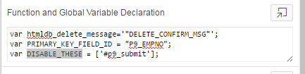

## Change dynamic action

The Change dynamic action should fire when any input field within the specified jQuery selected element changes(usually, when one clicks away from a field).

The event should fire upon a Change of a jQuery Selector, most likely the content body, .t-Body-contentInner. The associated action should affect only the event source; it should execute APEX_SAVEFIELD(this) as JavaScript.

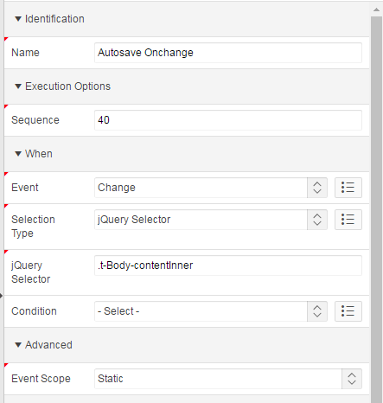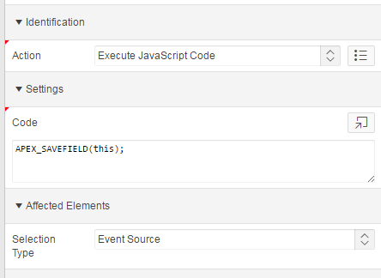

## Field-based Database Name

IndexedDB will attempt to create separate databases for different reports that are viewed on the same page by using the value of an item on the page, defined in the Javascript variable PRIMARY_KEY_FIELD_ID. Make sure the value assigned to this variable is unique for different items viewed on the same page. This should be placed in the Function and Global Variable Declaration section on a page.

# Force clear all page assets

Sometimes the ServiceWorker may keep caching an old version of a file or the IndexedDB may index the wrong values, particularly when the source for each of these are changed.

In production, increment the version numbers in sw.js and db.js to force the scripts to drop previous versions.

In development, unregister the current ServiceWorker and purge the cache and local storage through Developer Tools > Application > Clear Storage - check all of the boxes before selecting Clear Site Data.