Index

2.Fundamentals

* + Motor Structure
  + Coordination systems
  + Motor equations
  + SynRM machine parameters

2. Motor Fundamentals

In this chapter, a brief introduction to the Synchronize Reluctance Motor (SynRm) and its mathematical model is presented. Throughout this these, the content of this chapter will be constantly reference, since it serves as the backbone for the design of our motor control system. Important concepts such as the Park- and Clark-Transformation, as well as the dq-Coordinate system, which we base our entire mathematical equations for the motor on, is also introduced in this chapter. Lastly, the parameters of the SynRm we use is given in a Table.

2.1 Structure of SynRM

The Synchronize Reluctance Motor is an electromechanical energy conversion system that converts electrical energy to mechanical energy, which consist of a rotor and a stator as shown in Fig? The rotor, similar to other type of Motor such as PMSM or ASM, is a three-phase system, which consist of three sets of electric windings. The position of the three windings define the stator axis a,b and c. During operation, alternating current are induced on the three winding, which has a 120-degree phase shift to each other. This alternating current induced a rotating magnetic field, which interact with the rotor windings and drives the rotor.

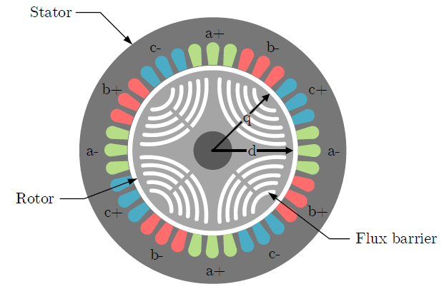

The rotor of the SynRM has the so-called “Flux barrier rotor design”. The rotor is composed of ferromagnetic material such as iron. Certain shape of gaps is carved out its core, which forms the so-called “Flux-barrier” when filled with air. Depends on the position of the air gaps on the rotor, d- and q-axis can be defined. The reluctance of the q axis is greater than that of the d-axis due to the low permeability of the air. This also means that the flux linkage on the d-axis is much greater of that on the q-axis.

When rotating magnetic field are applied, reluctant force

2.2 Coordinate Systems and Coordinate Transformation

In a symmetric three-phase system such as the stator of a SynRm, the electrical variables can be described within the coordination system composed by a,b and c axes. The three axes are fixed to the stator and have a phase shift of 120 degree to each other. For a three-phase system with frequency , the stator current can be described in eq ?

We assume that the system is perfectly symmetric and

For the sake of simplified calculation and better description of the electric variables of the system, the current space vector is typically described in the rotor-fixed coordination system characterized with the d,q axis. This conversion is carried out in two steps with the use of two Transformation.

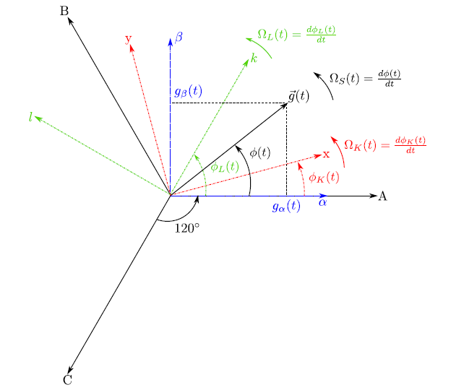

We first transform the current value and into the stator-fixed coordinate system with the use of Clarke Transformation. As figure ? shows, the axis correspond to the a axis. The Clarke Transformation of the stator current is described in equation?

, where

The superscript “S” indicates that the coordination of the current is fixed to the stator. The transformation reduces the three-phase variable into two variables that are defined in coordinate system.

The Matrix form of the Clarke-Transformation and reverse Transformation is showen in eq ?

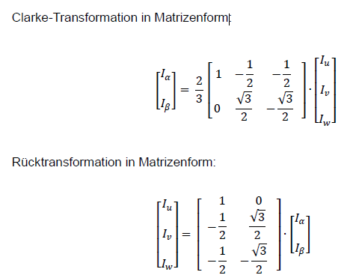

In order to transform the coordination of the current variable form stator-fixed to rotor-fixed, the electrical angle of the rotor needs to be considered. Park Transformation, as described in equation ?, transform the current coordinate system to the coordinate system.

= .

Again, the superscript “R” indicates that the coordination of the current is fixed to the rotor. The current space vector in rotor-fixed coordination system is compsed of d and q commpnent, as described in equation?

The Matrix form of the Park -Transformation and reverse Transformation is showed in eq ?

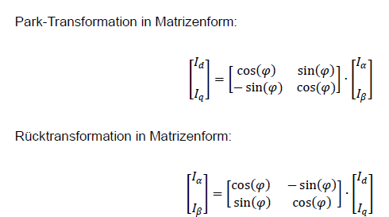

2.3 Motor Equations

In convention, the equations of the SynRM are described in the dq coordinate system with an obvious advantage. After the conversion of coordinate system via Clarke-Transformation and Park-transformation, the electric variables become direct signals on the d-q axis rather than alternating signals. This greatly simplifies the calculation and thus are used in the design of controller systems.

2.3.1 Electrical angle and Frequency

The electrical angle of the rotor can be obtained through the mechanical angle and the pole pair count , as described in equation ?

The same applied to the angular electrical frequency and

The relation of and are described in equation?

2.3.2 Voltage and Current

In order to obtain the voltage equation in the d-q coordination system, we start with equation ? ,which described the relation of voltage, current and flux in the stator-fixed coordinate system.

=

We obtain the same equation in the rotor-fixed coordinate system by applying the park transformation to equation? . Note that the last term of equation? is derived through the derivation of with time during the transformation.

=

The voltage space vector can be decomposed into voltage components in the d- and q-component. Considering equation? of the magnetic flux space vector, we are able to derive equation ?.

=

=

We know that the magnetic flux is the product of current of inductance respectively on the d- and q-axis. However, in reality, the relation between flux and current is not linear due to saturation effects. ***Literature*** has a detailed explanation on this phenomenon. For this thesis, we only consider the linear case for the inductance.

Considering the equation for magnetic flux and omitting the differential of inductance to time, we are able to rewrite equation? Into equation?

=

=

The reason of presenting two voltage equations in this chapter is that, both equations are used in this thesis. The voltage equation based on the inductance are used in the control design for the motor system, as we defined fixed value for the inductance on the d-q axis. However, in the modelling of the motor system, we modelled the magnetic flux as parameter of the current on the d- and q-axis as a 2-Dimensional Table.

The Table data are based on motor measurement. Such implementation aims for a better simulation of the dynamics of the motor systems, since the all terms of the deviation of magnetic flux to time are considered.

2.3.3 Power

Equation ? gives the definition the real power (DE: Wirkleistung) consumed in a three phase system, which in this case is the electrical power consumed by the stater of the Motor. With equation ?, we are able to derive equation? with the electrical variable in the d-q coordination system.

By substituting equation? into equation? and characterizing the terms of equation into three components, we can derive the equation for copper loss, magnetization power and mechanical power. The copper loss is caused by the resistance Rs in the state winding. The magnetization power is consumed during the change of magnetic field of the stator. The remaining term described the mechanical power that the motor is able to output to the motor shaft.

==

==

=

2.3.4 Torque

With the equation? for mechanical power and equation? for electrical frequency, we are able to derive the equation for Torque in equation?

=

2.4 Motor Parameters

The motor used in this thesis is a Synchronous Reluctance Motor produced by …

Literature

Geberfreie Drehzahlregelung einer fremderregten Synchronmaschine - Vasken Ketchedjian