Index

3.Motor Control

* Overview of Motor control system
  + field-oriented control
  + control block diagram
  + parameter normalization
* SynRm
  + Model equations in s-domain
  + discrete time representation
* Current controller
  + Time-continuous control
  + Time -discrete control
  + Anti-wind-up
* Torque controller

3. Motor Control

In the third chapter, the overall control method of the Reluctance synchronous motor are presented. The overall structure and block diagram of the motor system are first introduced. The mathematical model of the controlled system (SynRm) in time-continuous and time-discrete form are than presented. Lastly, the current and torque controller are presented in detail.

3. 1 Overview of Motor control system

We introduce importance concept for the motor control system as well as commonly used technique for the facilitation of the design of our controller.

3.1.1 Field-oriented control

Field-oriented control (DE: Feldorientierte Regelung), or vector control is a control method that is widley adopted for the control of three-phase motors. The control of the motor is performed by controlling the stator current vector on the rotational dq Coordinate system, which is defined according to the magnetic field of the rotor. During steady-state condition of the motor, these two orthogonal current components, i.e i_d and i_q, are direct current signals, rather that alternating signals. This characteristic of the control value being constant in steady -state condition gives us great advantage in control of the systems. However, real-time computation for the inverse dq transformation and the dq transformation for the control value are required, since the SynRm is drived with three-phased AC-current. The inverse dq transformation is performed while giving the control command to the motor, as the dq transformation is performed during the sampling of the output of the motor.

3.1.2 Control Block diagram

Fig? shows the block diagram of the overall control of the motor system. The control of the motor is performed through a set of cascade controllers, where the Torque controller serve as the superposed controller and the current controller serve as the Subordinate controller. The current controller is a feedback controller as the Torque controller is an open loop controller that generate current setpoints with the use of preprogrammed data (Look-up-Tables). Details of the controller are presented in the following chapter.

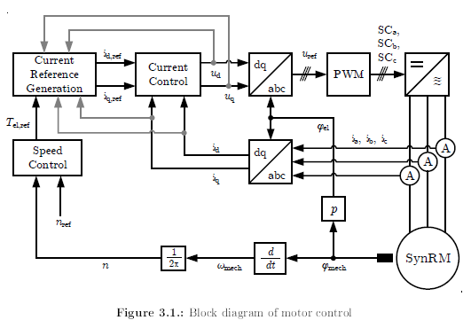

The controlled system is composed of the SynRm and the three-phase inverter. As mentioned in the previous chapter, inverse dq-Transformation is performed on the output of the controller. Through PWM( pulse width modulation) methods, the resulting voltage signals on the a,b and c axis are interpreted into switching commands and are fed to the DC-linked inverter, which drives the SynRm with tree-phase AC-current. These current components on the a,b and c axis are then sampled and transformed back to d-q coordinate system as he feed-back signals of the current controller.

For the sake of generating correct current reference, the torque controller requires the information of the motor speed. This required signal is measured through time derivation of the motor rotation angle measured be the encoder, which is mounted on the shaft of the motor. The equation for electrical angle and rotation speed is presented in …

3.1.3 Parameter normalization

For the design of our controller systems and control parameters, the mathematical model introduced in chapter 2 should be consider. In this chapter, we define the normalized value for each electric and mechanical variable in Table ?

|  |  |  |
| --- | --- | --- |
| Synbol | Name | Value |
| I_N | Normalized Current |  |
| U_N | Normalized Voltage |  |
| M_N | Normalized Torque |  |
| w_N | Normalized Angular Frequency |  |

In this thesis, the maximum value for each parameter are chose as the moralization quantity.

The normalization of the values are shown in equation? to equation ?

3.2 Synchronous reluctant motor

In this chapter, we define the Laplace representation in s-Domain and the block diagram of our controlled system based on normalization we defined in the previous chapter. Furthermore, a discrete representation of the motor equation should also be derived, since the controller of the motor should be a discrete time controller in order to be implemented on the test bench.

3.2.1 Model equations in s-domain

We start from the voltage equations in [equation number]. After normalization, we can derive the normalized voltage equation and its parameters in equation?

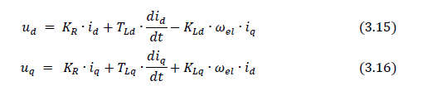

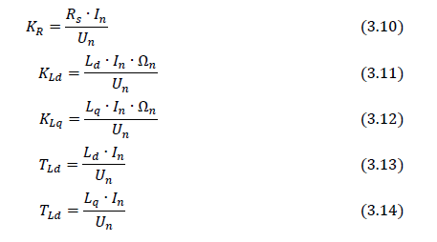

According to equation?, we are able to derive the block diagram representation of the motor in S-Domain, as shown in fig?

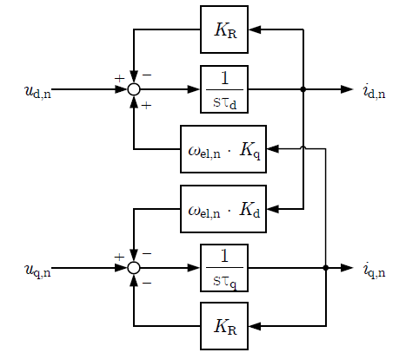

From the block diagram presented above, we can observe that the current of the d- and q-axis is cross-coupled***[literature num]***. Under high-velocity and high-dynamics operation, this characteristic can leads to deterioration in current control, since the cross-couple effect become more prominent with higher value of electric angular frequency. In some literature, a decoupling technique is adopted ***[literature num]***, where a decouple term is add into the output voltage value of the current controller to compensate the cross-coupling term of the motor.

For the design of our controllers, we can consider this cross-coupled term as disturbance and omit the signal for the sake of simplification. Also, the influence of resistance can be neglected. Thus, the simplified motor model can be view as an integrator with time constant T_d and T_q, as shown in equation?

The block diagram from fig? is reduced to the one in Fig?

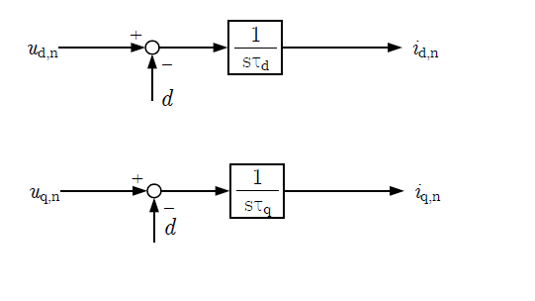

3.2.2 Model equations in z-domain

[reason for discrete time control: Reglungtechnik II Prof. Roth-Stielow]

[introducaiton to smapling time T_A (Abtastzeit)]

In equation? , we modelled the motor as an integrator. Thus, equation? can be adopted, where z represent a delay for one time step.

The block diagram for the d-axis current is shown in fig ?

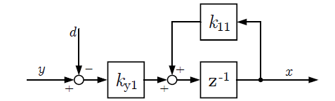

For the transfer function for the d-axis, the parameter k_y1 and k11 can be derived using the following procedure shown in equation?

The same applies to the transfer function for the q-axis. Hence, we derived the transfer function for the motor in z-Domain as shown in eeqution?

3.3 Current Controller

This chapter present the current controller both in time-continuous form and time-discrete form.

3.3.1 Time-continuous current controller

3.3.2 Time-discrete current controller

3.3.3 Anti-windup

3.4 Torque controller

In the cascade structure of the motor controller, the Torque controller serve as the superposed controller and generate reference points for the current vector on d-q coordinate System. Unlike the feedback control method used in current controller, the current reference point is generated with a per-determined data set, which is implemented as “Look-up Tables (LUT)”, as shown in fig?. In convention, torque control of the motor is performed through this offline technique, where the optimized operating points for every torque value in the whole speed range are stored in the controller beforehand, so that online calculation for is not needed. The calculation of these optimized data sets is gathered and calculated with the 2D inductance table of Ld and Lq with respect to current id and iq, which is measured on a test bench.***[find source]***

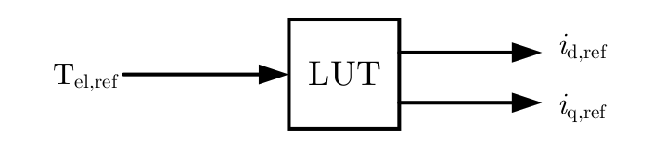

According to equation? Due to the induced voltage (back EMF) that proportional to the rotational speed, the utilized voltage of the motor reaches the voltage limit at a certain speed. We call this corner speed (DE:Eckdrehzahl). Hence, we divide the operation range of the motor to basic speed region and Field-weakening region

For the two different speed region, several operating methods are proposed for the optimized operating point of the current vector. The following paragraphs present this operating methods in detail.

3.4.1 Torque curve, Current limit circle, Voltage limit hyperbole

We introduce in this paragraph important visualization technique on the 2D plain of id and iq. This graph will be constantly reference in the following chapters, since it plays a integral part in the design of our control strategy.

Equaiton? Shows the condition for maximum operable current on the d- ,and q-axis.

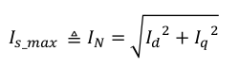

As we can infer in this equation, Is_max(Id,Iq) has the shape of a circle on the id,iq plain as shown in fig?. The current vector should always be inside this circle, so that the maximun current is not exceeded.

Equation? Shows the equation of the Torque as a function of Id and Iq.

M_soll =K_m.(Ld-Lq)IdIq

When Ld and Lq is fixed across the id iq plain, the M_soll (Id,Iq) should be a linear line across the id iq plain. However, if we consider saturation effect of the inductance across id iq plain, equation? Should be rewrite to equaiton?. M_soll (Id,Iq) thus has th shape of a curve, as shown in fig?.



[why is voltage limit a hyperbole]

With higher rotational speed, the voltage limit hyperbole becomes smaller, thus limiting the operation range and the current vector.

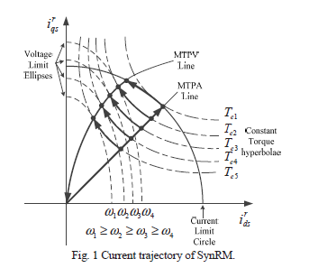

3.4.2 Basic speed region

In the basic speed region, the optimized operating point in id-iq plain is characterized by the “maximum Torque per Ampere” curve (MTPA). The MTPA curve represents the operating points that generate the maximum torque value with the same total current Is used. The Torque value along the MTPA curve varies form 0 to the maximum Torque, which is the point where MTPA curve and the current limit connects. As shown in Fig? , the MTPA curve is characterized as the tangent points of the Torque curve and the current circle.

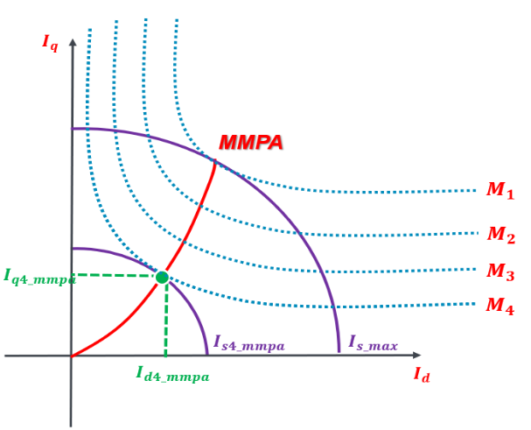

3.4.3 Field weakening region

With increasing speed, the voltage limit hyperbole shrinks. As corner speed of the motor is reached, the voltage limit hyperbole intersect the current limit on the highest point on MTPA curve. For motor speed higher than the corner speed, the motor can no longer maintain maximum Torque,and the operating point have to decrease it id value and increase the iq value, while maintain operation with maximum current, I_max. This trajectory of operation points is called “Maximum Ampere” (MA), which correspond to the current limit curve. As shown in fig?, the generated torque decrease while maintaining maximum current.

With even higher rotational speed, the induced voltage is so strong that operation with maximum current is no longer possible. Both the current on the d- and q- axis have to decrease in order to maintain operation with the maximum voltage. The trajectory followed in this region is called “Maximun Torque per Voltage”(MTPV). The MTPV is characterized as the tangent points of the Torque curve and the voltage hyperbole, as shwon on fig?. The output torque value continuous to drop, until the maximum operable speed is reached.

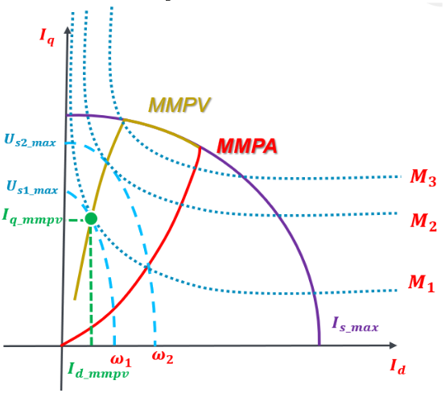

[show hyperbole \omega _eck, MA and MTPV]

With the torque command equals to the maximum Torque, and a motor speed form 0 to N_max, we are able to acquire the M-N relatiom ,as shown in Fig? The operation of the motor follows the operation trigectory MTPA,MA and MTPV presented in this chapter.

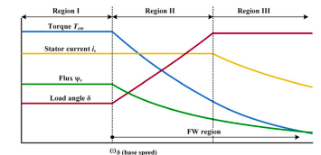

[show three region]

3.4.4 Overall control structure

The generation of the current reference in the torque controller is an off-line technique, where per-determined data set for optimized current vector according to Torque and speed is stored as an Look-up-Table and used during motor operation. Fig ? Show the block diagram of the Torque controller.

Three LUTs are used in torque controller. The Torque command is first limited by the M-n Table according to the current motor speed to prevent operation outside the operable region. The current reference point are than generated based on the Torque command using either the LUT for MTPA or MTPV and MA, determining on whether the motor is in basic speed or field-weakening region.

Literature

Decoupled dq-axis Current Control for PMLSM based on Variable-Gain Adaptive Internal Model