**Coactivation Patterns Pipeline**

Brain Connectivity Lab

University of Electronic Science and Technology of China

Chengdu 611731, China

david_young1994@foxmail.cpm

If you used our CAP pipeline scripts, please cite our paper

‘Yang, H., Zhang, H., Di, X., Wang, S., Meng, C., Tian, L., & Biswal, B. (2021). Reproducible coactivation patterns of functional brain networks reveal the aberrant dynamic state transition in schizophrenia. NeuroImage, 118193.’

1. Prerequisites

This CAP pipeline is based on MATLAB, please add the folder **‘CAP_functions’** using **‘add with subfolders’**. There are three folders within the **‘CAP_functions’**.

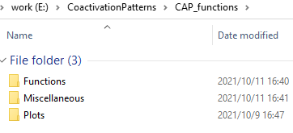

* **‘Functions’** is the main folder of the pipeline. It includes the k-means of CAPs, generates the NIFTI files for the group-averaged CAPs, and calculates temporal dynamic measures including fraction of time, persistence, counts, transition probability, and so on.
* **‘Plots’** includes scripts to plot the results.
* **‘Miscellaneous’** includes some supplementary scripts and files used in the pipeline.

In addition, **SPM12** (https://www.fil.ion.ucl.ac.uk/spm/software/spm12/) and **DPARSF** (http://www.rfmri.org/DPARSF) are required to import NIFTI files. **BrainNet Viewer** (https://www.nitrc.org/projects/bnv) is used to generate the CAP spatial maps. Please downloaded and add these toolboxes to your MATLAB before using our pipeline.

1. Data structure

The data of HC and Patient should be saved in separate folders, named **HC** and **PAT**. Within the group folder, each subject also has one folder to save the preprocessed images (either 4D or 3D NIFTI files are ok).

For example, ‘E:\Data\CAP_project\HC\HC001\4D_HC001.nii’

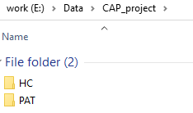

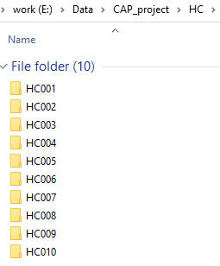

1. The CAP pipeline

a) Main function

The main function is **‘CAP_Framework’**, and it will call the **‘CAP_Framework_HC’** and **‘CAP_Framework_PAT’**. To run the CAP pipeline, you only need to set some parameters within the **‘CAP_Framework’**, and run the **‘CAP_Framework’**.

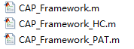

If you only have one HC group, then annotate the **CAP – PAT** part. As for the patient group, we don’t perform the k-means clustering, and instead, we directly match volumes from patients’ data with the group-averaged CAPs obtained from the HC group. Therefore, if you only have one patient group and without the control group, you can still annotate the **CAP – PAT** part, and use **‘CAP_Framework_HC’** to generate the CAPs of patients and calculate the temporal dynamic measures.

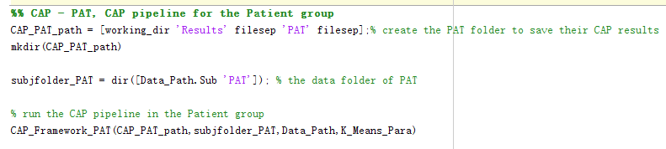

b) the settings for the CAP analysis

To run the CAP pipeline, you only need to set the filepath, working directory and k-means parameters. Then run the **‘CAP_Framework’**, and it will finish generating the CAPs and calculating their temporal dynamic measures.

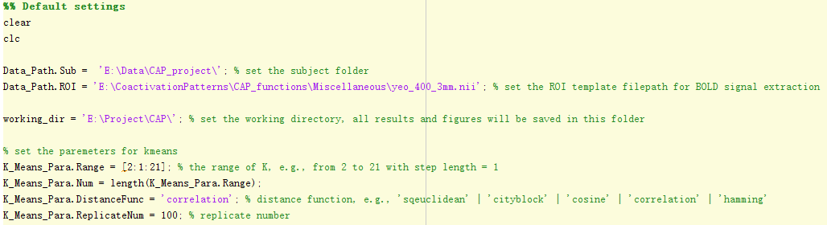

c) the settings for plots

There are several setting files for plots.

**'\CAP_functions\Miscellaneous\CAP_colormap.mat'** is the colormap to plot the matrix, e.g., the between-CAP similarity matrix.

**'\CAP_functions\Plots\CAP_BrainNet.mat'** is the setting option of BrainNet Viewer to plot the CAP spatial map. You can change it based on your requirement.

You also need to change the **‘brain_path’** to the filepath of your BrainNet Viewer. You can find and use other underlay in SurfTemplate.

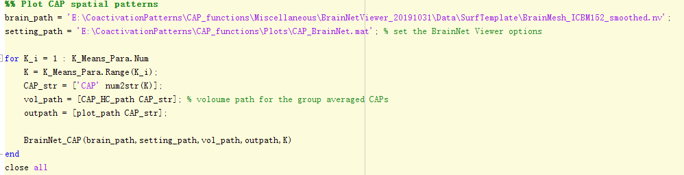

1. Results and figures

For example, the CAP results of K = 4 in the HC group, their CAP spatial maps would be saved in the folder, **‘\working directory\Results\HC\CAP4\’**

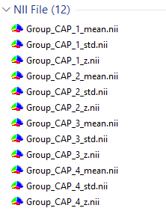

And their temporal dynamic measures would be saved in the **‘CAP_matrices.mat’**.



The Figures of the CAP maps would be saved in the folder,

**‘\working directory\Plots\HC\CAP4\’**

