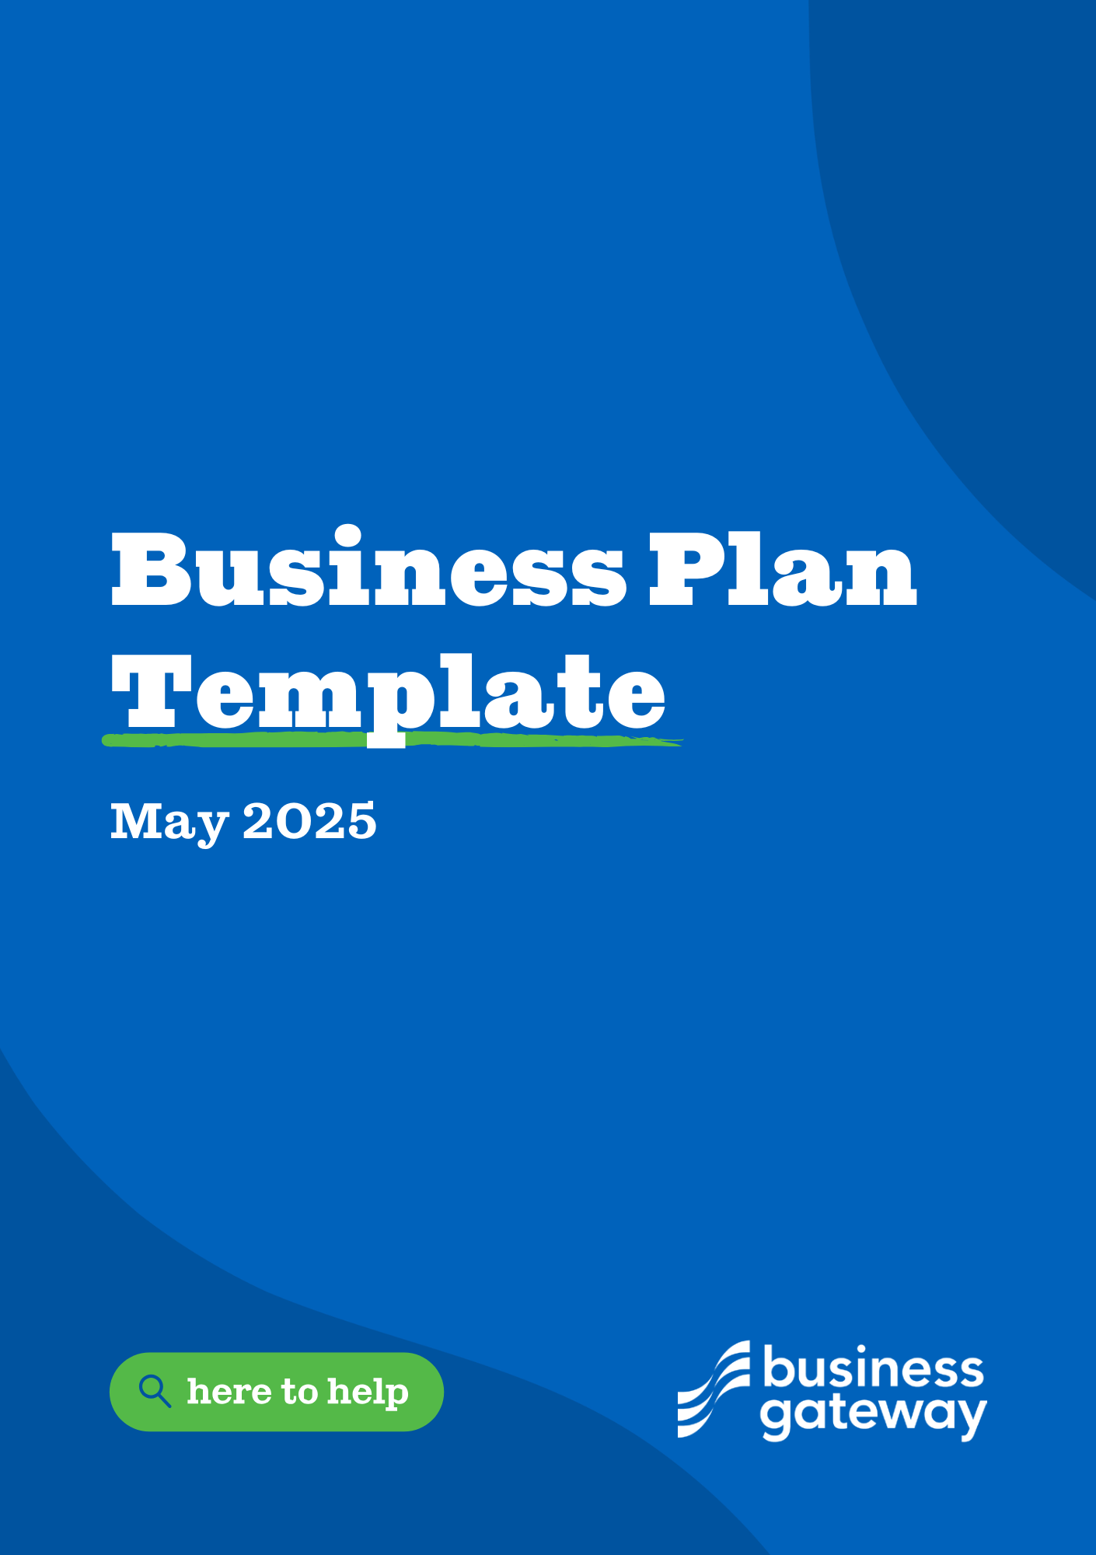
Business Plan Template
Whether you’re starting out, or looking to grow, Business Gateway can offer free advice, resources, and local support, all for free.

- Use this template to ensure the viability of your business proposition and give potential investors the information they need to determine whether your vision is one they can invest in.
- This Business Plan template will guide you through everything you need to include. Please use this template in conjunction with our guide for plenty of advice on how to approach each section.
- Artificial Intelligence (AI) tools, like ChatGPT, can support with some sections of your business plan, such as providing industry trends, secondary market research, or by reviewing the content you have written. However, there are limitations to AI and it should not be used for writing an entire business plan or as a replacement for undertaking primary market research. As with all information generated via AI, you must check the sources used as these may be incorrect, outdated or unreliable.

Get started today!

Introduction
Name:
Business Plan for:
Document Version:
Date:
Completed by:

Contents
Introduction 1
1. Executive Summary 1
2. Business Details 2
3. Business overview 3
4. Business Goals 4
5. Market Research 5
6. Market Overview 5
7. Competitor analysis 5
8. Sales 6
9. Marketing 6
10. Pricing 6
11. Staff 6
12. Premises 7
13. Suppliers 7
14. Equipment 7
15. Managing operational risks 7
16. Fair Work 8
17. Sustainability 8
18. Finance 8

1. Executive Summary
Executive Summary: | (We suggest you complete this section after you have completed the other sections of the Business Plan.)

2. Business Details
Business name:
Address:
Telephone number:
Legal status:
Date established:
Business Registration Number:
Advisers:
Are you / will you be VAT registered:
Do you have an online presence:
The business will: | (Provide a brief description of what your business will do.)

Key Personnel:
Details of owner(s)
Name:
Position/main responsibilities:
Experience and knowledge of our industry:
Previous employment:
Key skills brought to the business:
Business experience and any training undertaken:
Academic/professional qualifications:
Most recent salary:

Other key personnel (including shareholders):
Name:
Position/main responsibilities:
Experience and knowledge of our industry:
Previous employment:
Key skills brought to the business:
Business experience and any training undertaken:
Academic/professional qualifications:
Most recent salary:

3. Business overview
Business overview: | (Sum up your business idea)

4. Business Goals
Business goals: | (For example, what do you want to achieve in your first year of business? Where do you see your business in 3-5 years time?)
What the business does: | Product/service Features Benefits
What makes the business different | (Why is your product/service unique or different compared with the competition?)
SWOT analysis | (What are your business’s Strengths, Weaknesses, Opportunities and Threats?)

Legal requirements
(including regulations and licences particular to your business)
The legal and insurance requirements that apply in your business are:
You will meet your legal and insurance requirements by:

5. Market Research

Market research
Trends in your chosen market are:
How you know this:

6. Market Overview
The customer groups you will be selling to are:
What is the market size:
Your customer research has shown what your customers want is:
How you know this:
How many customers/clients do you require and what will you sell them:

7. Competitor Analysis
Competitor Name | Strengths | Weaknesses
(Add more rows to the table as needed)

What information have you gathered on your competitors?
How can you improve on their offer and/or price(s)?
What is your competitive advantage?

8. Sales
How will you sell your product/service?

9. Marketing
How and where will you promote your product/service?

10. Pricing
How you can calculate your prices?

How do your prices compare with the competition?
Product/Service | Your price(s) | Range of competitor prices (per unit)

Reasons for the difference between your price(s) and your competitors’ price(s):

11. Staff
Role | Total cost | Necessary experience | Specialist skills and qualifications

12. Premises
Premises required at start-up (£):
Premises required in the future (if different) (£):
13. Suppliers
Supplier | What you’ll buy from them | Number of days’ credit

14. Equipment
Resource | When | How funded | Cost £ per unit
(Add more rows to the table as needed)

15. Managing operational risks
 | Risk | Solution
Staff
Suppliers
Financial
Marketing
(Add more rows to the table as needed)

16. Fair Work
(Fair Work is good for workers, good for business, and good for the economy. As a business you should be fully aware of your corporate responsibility and strive to meet the needs of a modern flexible and diverse workforce.)
How will your business adopt fair work practices?

17. Sustainability
What sustainable practices are you adopting in your business?

18. Finance
(The financial section of the template is intended for business planning purposes only. If financial tables are to be used for any other purpose other than cash flow management, then we strongly recommend you consult an accountant or tax advisor)
Please note these tables will not automatically calculate totals. Click the links below the tables to access Microsoft Excel versions which will automatically update your totals. If you do not have access to Microsoft Excel, you can use Open Source Software such as Google Docs or OpenOffice to access the information by uploading the file into this software. Please note that these are examples but all tables can be customised, and additional rows and categories can be added depending on your own business needs.

Finance
Calculate how much money you need before you start trading
 | £
IT and computers | 0.00
Telephones and broadband | 0.00
Equipment | 0.00
Stock | 0.00
Tools | 0.00
Vehicles | 0.00
Professional fees | 0.00
Insurance | 0.00
Rent/rent deposit | 0.00
Stationery | 0.00
Marketing | 0.00
Consumables | 0.00
Licenses | 0.00
Training | 0.00
Association fees | 0.00
Wages/recruitment | 0.00
Security/health and safety equipment | 0.00
Market research costs | 0.00
Other (please specify) | 0.00
 | 0.00
 | 0.00
 | 0.00
TOTAL £ | 0.00*

*Total from here should be used in the Sourcing finance table below
You can also download the start up costs table shown above in Microsoft Excel format.

Personal survival budget
This helps you work out the minimum amount you need to earn from your business in the first year and how much money you might need to borrow to start the business.
Estimated expenditure | £
Mortgage and/or rent | 0.00
Council tax | 0.00
Utilities (gas, electricity, water etc) | 0.00
Personal and property insurance | 0.00
General housekeeping expenses (food etc) | 0.00
Phone and internet | 0.00
Car tax and insurance | 0.00
Car running expenses | 0.00
HP repayments | 0.00
Hire charges | 0.00
Subscriptions to journals, professional bodies, etc | 0.00
Savings plans & pension contributions | 0.00
Contingencies | 0.00
Tax | 0.00
National Insurance | 0.00
Other: please specify | 0.00
 | 0.00
Total personal expenditure | 0.00
Estimated personal income (after tax) | 0.00
Income from family, partner (total) | 0.00
Other income (specify the source) | 0.00
Total personal income | 0.00
Total survival income required from the business (after tax) | 0.00
Current income | 0.00

You can also download the personal survival budget table shown above in Microsoft Excel format

Profit and loss forecast
 | Year 1  (£) | Year 2  (£) | Year 3  (£)
Total expected sales | 0 | 0 | 0
Less variable costs | 0 | 0 | 0
Gross profit (sales less variable costs) = | 0 | 0 | 0
Calculate your gross profit margin % (gross profit divided by total sales x 100) (A) | 0 | 0 | 0
Salaries/wages (survival income + any staff) | 0 | 0 | 0
Premises (including rent, rates, utilities) | 0 | 0 | 0
Telephone and broadband | 0 | 0 | 0
Printing, post and stationery | 0 | 0 | 0
Advertising and promotion | 0 | 0 | 0
Bank charges | 0 | 0 | 0
Professional fees | 0 | 0 | 0
Insurances | 0 | 0 | 0
Bank/HP/Interest (payable to your bank) | 0 | 0 | 0
Stock | 0 | 0 | 0
Consumables | 0 | 0 | 0
Equipment and vehicle leasing | 0 | 0 | 0
Depreciation | 0 | 0 | 0
Other (please specify) | 0 | 0 | 0
Other | 0 | 0 | 0
Other | 0 | 0 | 0
Total fixed costs | 0 | 0 | 0
Net profit (gross profit less fixed cost) | 0 | 0 | 0
Calculate your net profit margin (net profit divided by total sales x 100) | 0 | 0 | 0
Calculate your breakeven | Year 1 (£) | Year 2 (£) | Year 3 (£)
Total variable costs + total fixed costs (B) | 0 | 0 | 0
You can also download the profit and loss forecast table shown above in Microsoft Excel format.

Sourcing finance
Total borrowing requirement for the business
 |  | £
Start-up costs |  | 0.00
Personal start-up contributions | - | 0.00
Other start-up contributions | - | 0.00
Total required | = | 0.00
The assets you have available as security | = | 0.00
You can also download the sourcing finance table shown above in Microsoft Excel format.

Cash flow forecast
See Excel file that accompanies this Business Plan

 | Start-up 0 | 1 | 2 | 3 | 4 | 5 | 6 | TOTAL
 | Forecast | Forecast | Forecast | Forecast | Forecast | Forecast | Forecast | Forecast
INCOME
Cash from sales (incl. VAT) | 0 | 0 | 0 | 0 | 0 | 0 | 0 | 0
Cash received from debtors | 0 | 0 | 0 | 0 | 0 | 0 | 0 | 0
Capital/loans received | 0 | 0 | 0 | 0 | 0 | 0 | 0 | 0
Other (please specify) | 0 | 0 | 0 | 0 | 0 | 0 | 0 | 0
TOTAL £ | 0 | 0 | 0 | 0 | 0 | 0 | 0 | 0
EXPENDITURE
Wages to staff (incl. PAYE & NI) | 0 | 0 | 0 | 0 | 0 | 0 | 0 | 0
Premises (rent, rates & utilities) | 0 | 0 | 0 | 0 | 0 | 0 | 0 | 0
Telephone & Broadband | 0 | 0 | 0 | 0 | 0 | 0 | 0 | 0
Printing, post & stationery | 0 | 0 | 0 | 0 | 0 | 0 | 0 | 0
Advertising & promotion | 0 | 0 | 0 | 0 | 0 | 0 | 0 | 0
Bank charges | 0 | 0 | 0 | 0 | 0 | 0 | 0 | 0
Professional fees | 0 | 0 | 0 | 0 | 0 | 0 | 0 | 0
Insurances | 0 | 0 | 0 | 0 | 0 | 0 | 0 | 0
Bank/HP | 0 | 0 | 0 | 0 | 0 | 0 | 0 | 0
Equipment & vehicle leasing | 0 | 0 | 0 | 0 | 0 | 0 | 0 | 0
Payments relating to variable costs | 0 | 0 | 0 | 0 | 0 | 0 | 0 | 0
Capital Expenditure | 0 | 0 | 0 | 0 | 0 | 0 | 0 | 0
Other Payments | 0 | 0 | 0 | 0 | 0 | 0 | 0 | 0
VAT | 0 | 0 | 0 | 0 | 0 | 0 | 0 | 0
Owner's wages/salary | 0 | 0 | 0 | 0 | 0 | 0 | 0 | 0
Owner's National Insurance | 0 | 0 | 0 | 0 | 0 | 0 | 0 | 0
Loan repayments (incl. interest) | 0 | 0 | 0 | 0 | 0 | 0 | 0 | 0
Stock | 0 | 0 | 0 | 0 | 0 | 0 | 0 | 0
Consumables | 0 | 0 | 0 | 0 | 0 | 0 | 0 | 0
Other (please specify) | 0 | 0 | 0 | 0 | 0 | 0 | 0 | 0
Other | 0 | 0 | 0 | 0 | 0 | 0 | 0 | 0
Other | 0 | 0 | 0 | 0 | 0 | 0 | 0 | 0
TOTAL £ | 0 | 0 | 0 | 0 | 0 | 0 | 0 | 0
Income less expenditure | 0 | 0 | 0 | 0 | 0 | 0 | 0 | 0
Opening bank balance | 0 | 0 | 0 | 0 | 0 | 0 | 0 | 0
Closing bank balance | 0 | 0 | 0 | 0 | 0 | 0 | 0 | 0

