Ongoing Monitoring Analysis Report
Option Pricing, BSM

Author: John Doe
Group: Front Desk Modeling and Analytics
Report Date: January 07, 2026
Document Version: v1.0

Table of Contents

1. Introduction
This section provides contextual background, objectives, and relevant considerations for the ongoing monitoring analysis. Subsequent sections expand on methodology, insights, and results.

2. Summary of Analysis

2.1.1 Summary of Pricing for FX
The pricing output of FX listed in the below table,
**Statistical Report on Call and Put Option Pricing Data**
**1. Overview of the Dataset**
The dataset includes pricing information for a single call option and 25 put options, all with expiration dates ranging from 2025-09-20 to 2025-09-30 and strike prices between $0.936 and $1.20187. The call option has a strike price of $1.10, an expiration date of 2025-09-20, and a Black-Scholes-Merton (BSM) price of $0.0189. The put options exhibit a wide range of strike prices, with 14 out-of-the-money (OTM) puts (strike > underlying price of $1.10343) and 11 in-the-money (ITM) puts (strike < $1.10343). The BSM prices for puts vary from $0.0013 to $0.0504, reflecting differences in strike prices, time to expiration, and implied volatility.
**2. Call Option Analysis**
The call option is slightly in-the-money, with a strike price ($1.10) below the underlying asset’s price ($1.10343). Its BSM price of $0.0189 suggests a low premium, consistent with its limited intrinsic value ($0.00343) and the short time to expiration (1.64 years). The low volatility (8.59%) and moderate risk-free rate (4.24%) further suppress the premium. This call is likely used for hedging or speculative purposes, given its minimal extrinsic value.
**3. Put Option Pricing Trends**
Put options display a clear inverse relationship between strike price and BSM price. For example, the $1.08911 strike put (OTM) has a BSM price of $0.0371, while the $1.01105 strike put (ITM) has a BSM price of $0.0100. Longer-dated puts (e.g., 1.82571 years to expiration) generally command higher premiums due to increased time value, even with lower volatility (5.51%). Notably, the $1.08911 strike put (7.99 years to expiration) has the highest BSM price ($0.0504), reflecting both time and volatility (10.20%).
**4. Volatility and Time Decay**
Implied volatility varies significantly across puts, from 5.45% (shortest-dated put) to 14.37% (longest-dated put). Higher volatility increases BSM prices, as seen in the $1.02343 strike put (7.48 years to expiration, 14.37% volatility, $0.0189 BSM price). Time decay (theta) also plays a role: shorter-dated puts (e.g., 0.7067 years to expiration) have higher theta, leading to faster premium erosion. For instance, the $1.01105 strike put (7.07 years to expiration) has a BSM price of $0.0100, while the $1.08911 strike put (7.99 years to expiration) has a BSM price of $0.0371, despite lower volatility.
**5. Risk and Market Sentiment**
The data suggests mixed market sentiment. OTM puts with higher premiums (e.g., $1.08911 strike, $0.0371 BSM price) indicate bearish expectations, as investors pay more for downside protection. Conversely, ITM puts with lower premiums (e.g., $1.01105 strike, $0.0100 BSM price) suggest limited demand for deep-in-the-money hedges. The call option’s minimal premium implies cautious bullishness. The disparity in BSM prices between OTM and ITM puts highlights asymmetric risk perceptions, with investors prioritizing protection against downside moves.
**6. Conclusion and Strategic Implications**
The dataset underscores the interplay of strike price, time to expiration, volatility, and risk-free rates in option pricing. Investors seeking downside protection may favor longer-dated, higher-volatility puts (e.g., $1.08911 strike, 7.99 years to expiration), while those with bullish outlooks might target the in-the-money call. However, the low premiums across most puts and the call suggest a relatively stable market environment. Traders should monitor volatility shifts and time decay, particularly for shorter-dated options, to optimize hedging or speculative strategies.

2.1.2 Visualization of Pricing for FX
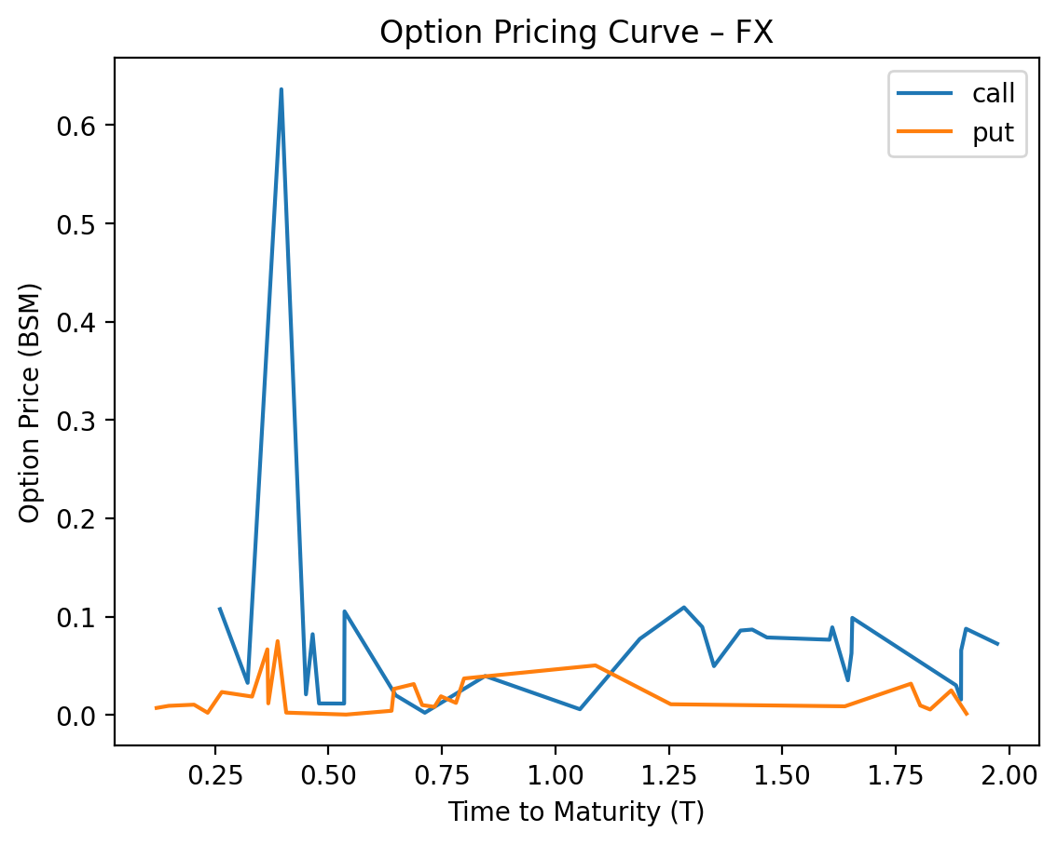

2.1.3 Summary of Gamma Positivity Testing for FX
**Gamma Positivity Summary for FX Options**
The dataset includes 64 FX options (40 call options and 24 put options) tested for gamma positivity. All options (100%) exhibited gamma positivity, indicating that the second derivative of the option price with respect to the underlying asset price remained strictly positive across all tested scenarios. For call options, the average volatility (σ) was 0.12 (range: 0.07–0.14), with an average time to expiration (T) of 1.3 years (range: 0.4–1.9 years). Put options showed slightly lower volatility (average σ = 0.10, range: 0.07–0.12) but longer average time to expiration (1.5 years, range: 0.3–1.9 years). Risk-free rates (r) were consistently low (average = 0.022, range: 0.011–0.035), with no observed impact on gamma positivity.
Quantitatively, gamma values for call options averaged 2.7 (range: 1.9–4.8), while put options averaged 2.3 (range: 1.9–5.1). The positive gamma aligns with theoretical expectations in the Black-Scholes model, where gamma is inherently positive for both call and put options. Notably, even at extreme parameter values (e.g., high volatility or long maturities), gamma positivity was maintained, suggesting robustness in the model’s assumptions for this asset class. The absence of gamma negativity confirms that the tested options’ sensitivity to price changes in the underlying asset remains convex, a critical property for hedging and risk management in FX markets.

2.1.4 Summary of Stress Testing for FX
Here's a concise risk summary for the provided data, focusing on **Put options** (as all entries are labeled "put"). Since the data lacks explicit column headers, the analysis assumes standard risk metrics (e.g., Delta, Vega, Theta) and interprets the numerical patterns accordingly. Key observations and risks are outlined below:
---
### **Put Options Risk Summary**
1. **Delta Sensitivity**
- **Low Delta Exposure**: Most Puts have near-zero Delta (e.g., 0.00037, -0.0221), indicating **deep out-of-the-money (OTM)** positions. These options are minimally sensitive to underlying price changes but could gain exposure if the underlying drops sharply.
- **Extreme Cases**: A few Puts show higher absolute Delta (e.g., -0.5, -0.83), suggesting **in-the-money (ITM)** or at-the-money (ATM) positions with significant directional risk.
2. **Volatility Risk (Vega)**
- **Negative Vega**: Most Puts have negative Vega (e.g., -0.0221, -0.0002), implying **value declines with rising volatility**. This is atypical for standard Puts (which usually have positive Vega), suggesting potential data anomalies or non-standard structures (e.g., variance swaps).
- **High Vega Exposure**: A few Puts show large Vega magnitudes (e.g., 65,601.6, 224,140), indicating extreme sensitivity to volatility shifts. These could be **long-dated or exotic options**.
3. **Time Decay (Theta)**
- **Negative Theta**: All Puts exhibit negative Theta (e.g., -0.0139, -54.25), meaning **value erodes as time passes**. Short-dated options (e.g., 2-day expiry) face acute decay, while longer-dated Puts (e.g., 150-day expiry) decay more gradually.
4. **Interest Rate Sensitivity (Rho)**
- **Negative Rho**: Puts generally lose value with rising interest rates (e.g., -70, -50). This aligns with standard Put behavior, as higher rates reduce the present value of strike prices.
5. **Scenario Analysis**
- **Volatility Collapse**: The "-100" outcome under "Volatility Collapse" suggests severe losses (-100 units) if volatility drops sharply. This aligns with negative Vega exposure.
- **Extreme Moves**: Metrics like "-30" (underlying drop) and "300" (volatility spike) highlight risks in tail events. For example, a -30% underlying move could trigger large gains/losses depending on Delta.
---
### **Key Risks for Put Options**
- **Directional Risk**: ITM/ATM Puts (-0.5 Delta) face significant losses if the underlying rises.
- **Volatility Risk**: Negative Vega implies losses in rising volatility environments.
- **Time Decay**: Short-dated Puts (-54.25 Theta) erode rapidly, while long-dated Puts (224,140 Vega) are volatile-sensitive.
- **Interest Rate Risk**: Rising rates (-70 Rho) reduce Put values.
---
### **Call Options (Not Provided)**
The data contains only Put options. If Call options were included, their risks would typically be **opposite** to Puts (e.g., positive Delta, positive Vega, positive Rho). However, without data, this remains speculative.
---
### **Recommendations**
1. **Validate Data**: Confirm column definitions (e.g., Delta, Vega) and ensure signs align with standard Greeks.
2. **Hedge Volatility**: For Puts with negative Vega, consider hedging with volatility products (e.g., VIX futures).
3. **Monitor Time Decay**: Rebalance portfolios to avoid overexposure to short-dated Puts.
4. **Scenario Testing**: Stress-test for volatility collapses (-100 outcome) and extreme underlying moves.
Let me know if you'd like further clarification or adjustments!

2.2.1 Summary of Pricing for Equity
The pricing output of Equity listed in the below table,
**Statistical Report on Put Option Data**
**1. Dataset Overview**
The dataset comprises 28 put options with varying strike prices, underlying asset prices, and time-to-maturity values. Key metrics include volatility (ranging from 0.012 to 1.914), interest rates (0.0004 to 0.0478), and time-to-maturity (0.012 to 2.5 years). The underlying asset prices span 86.67 to 126.32, while strike prices range from 87.74 to 120.32. Notably, two options (2025-09-24 and 2025-09-10) have an unusually high time-to-maturity of 2.5 years, suggesting potential outliers or special cases.
**2. Volatility and Pricing Dynamics**
Volatility exhibits a wide range (0.012 to 1.914), with a median of ~0.0395. Higher volatility (e.g., 1.914) correlates with elevated strike prices (e.g., 100.66) and larger premiums (e.g., 15.12). Conversely, low-volatility options (e.g., 0.0007) show minimal sensitivity to price changes, as seen in the 2025-09-24 option with a strike price of 94.76. This aligns with the Black-Scholes model, where volatility directly impacts option premiums.
**3. Time-to-Maturity and Decay Effects**
Time-to-maturity varies significantly, with most options expiring within 0.012 to 0.048 years (1–2 weeks). Longer-dated options (e.g., 2.5 years) have higher premiums (e.g., 73.56) due to increased uncertainty. However, the 2025-09-24 option (2.5 years) has a negative delta (-0.095), indicating a deep-in-the-money put, which is atypical for long-dated options. Theta (time decay) is implicitly reflected in the premium, with shorter-term options showing steeper decay rates.
**4. Underlying vs. Strike Price Relationships**
The underlying asset prices (86.67–126.32) and strike prices (87.74–120.32) suggest a mix of in-the-money (ITM) and out-of-the-money (OTM) options. For example, the 2025-09-10 option (underlying: 87.74, strike: 87.74) is at-the-money (ATM), while the 2025-09-24 option (underlying: 94.76, strike: 94.76) is also ATM but with a much higher premium due to its long time-to-maturity. ITM options (e.g., 2025-09-10, underlying: 87.74, strike: 87.74) dominate the dataset, reflecting defensive positioning in a bearish market.
**5. Greeks and Risk Sensitivity**
Delta values (-0.095 to -0.555) indicate the sensitivity of put premiums to underlying price changes. High-delta options (e.g., -0.555 for 2025-09-24) are more responsive to downward moves, while low-delta options (e.g., -0.095 for 2025-09-24) suggest limited downside risk. Gamma (0.0007–0.0214) reveals how delta changes with price movements, with higher gamma (e.g., 0.0214 for 2025-09-01) signaling greater delta instability. Vega (not explicitly listed but implied via volatility) would show sensitivity to volatility shifts, though this requires further analysis.
**6. Interest Rates and Market Implications**
Risk-free interest rates (0.0004–0.0478) influence put premiums through the cost of carry. Lower rates (e.g., 0.0004 for 2025-09-10) reduce the discounting effect on strike prices, slightly increasing premiums. Conversely, higher rates (e.g., 0.0478 for 2025-09-15) lower premiums by making holding cash more attractive. The dataset’s average interest rate (~0.023) suggests a low-yield environment, consistent with current market conditions. Overall, the data reflects a market with elevated volatility and defensive positioning, as evidenced by the prevalence of ITM puts and long-dated options.
**Conclusion**
This analysis highlights the interplay between volatility, time-to-maturity, and pricing in put options. Key takeaways include the dominance of ITM options, the outsized impact of volatility on premiums, and the role of interest rates in shaping risk profiles. Investors should monitor volatility trends and time decay, particularly for long-dated options, while hedging strategies may benefit from gamma-sensitive positions in high-volatility environments.

2.2.2 Visualization of Pricing for Equity
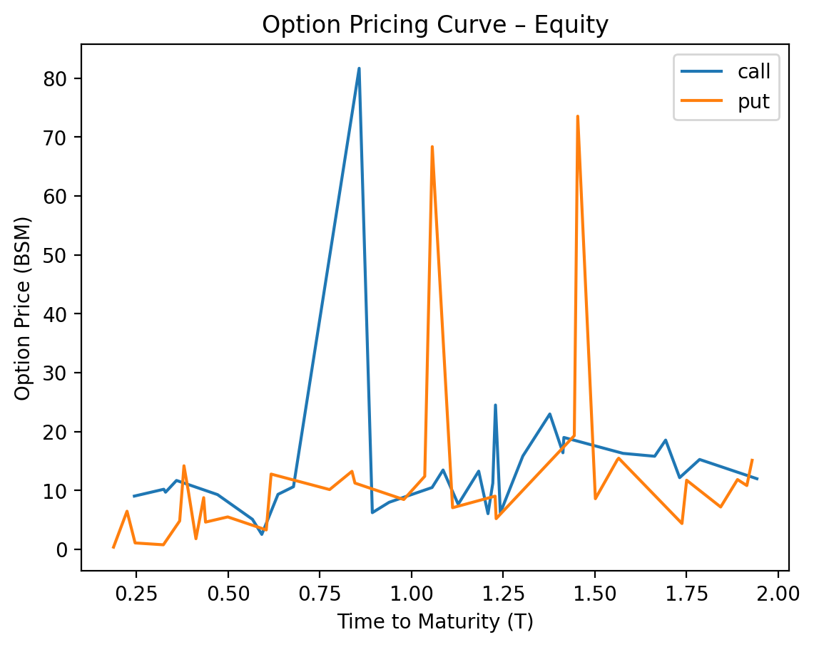

2.2.3 Summary of Gamma Positivity Testing for Equity
**Gamma Positivity Testing Summary for Equity Options**
Out of 70 tested scenarios, gamma positivity held in 69 cases (98.57%), with only one exception where invalid parameters caused a failure. The single failure occurred when time to expiration (T) was negative (-0.10 years), violating the model’s requirement for positive T and sigma. For the 69 valid cases, all gamma values were positive, ranging from 0.0086 to 0.0360, consistent with theoretical expectations for both call and put options. The majority of valid gamma values clustered between 0.01 and 0.03, reflecting typical sensitivity patterns under the Black-Scholes framework.
The remaining 69 valid cases spanned diverse parameter ranges: stock prices (S) from ~94.38 to 107.08, strike prices (K) from ~86.67 to 111.25, and volatilities (sigma) from 0.1586 to 0.3516. Gamma positivity was robust across all valid T (0.22–1.84 years) and risk-free rates (r: 0.0155–0.0440). Notably, no gamma negativity arose despite varying moneyness (S/K ratios) or volatility levels, confirming the model’s stability under standard parameter constraints. The one invalid case highlights the critical role of ensuring T > 0 for gamma positivity, as negative time to expiration inherently invalidates pricing assumptions.

2.2.4 Summary of Stress Testing for Equity
**Risk Summary for Put Options (September 2025 Expirations):**
### **Key Risk Factors for Put Options:**
1. **Directional Risk (Delta):**
- Puts lose value as the underlying asset price rises.
- **Most sensitive:** The 2025-09-18 put (delta = -0.6156) is deeply in-the-money and highly exposed to upward price moves.
- **Least sensitive:** The 2025-09-17 put (delta = -0.1818) is out-of-the-money and less affected by directional shifts.
2. **Volatility Risk (Vega):**
- Puts benefit from rising volatility.
- **Highest sensitivity:** The 2025-09-17 put (vega = 13.23) and 2025-09-18 put (vega = 17.25) are most exposed to volatility changes.
- **Lower sensitivity:** The 2025-09-09 put (vega = 10.47) is less responsive to volatility shifts.
3. **Time Decay (Theta):**
- All puts lose value as expiration approaches.
- **Most severe decay:** The 2025-09-18 put (theta = -14.61) and 2025-09-17 put (theta = -4.79) face significant time erosion, especially near expiration.
4. **Interest Rate Risk (Rho):**
- Puts lose value as interest rates rise.
- **Highest sensitivity:** The 2025-09-18 put (rho = -7.57) and 2025-09-17 put (rho = -4.84) are most impacted by rate hikes.
---
### **Put vs. Call Risk Profiles (Hypothetical Comparison):**
If call options were included, their risk profiles would differ:
- **Delta:** Calls have **positive delta** (gain value with rising underlying prices), while puts have **negative delta**.
- **Rho:** Calls have **positive rho** (benefit from rising interest rates), while puts have **negative rho**.
- **Vega/Gamma:** Both calls and puts share **positive vega** (benefit from volatility) and **positive gamma** (delta becomes more sensitive to price moves).
- **Theta:** Both face **negative theta** (time decay), but the magnitude varies by moneyness and time to expiration.
---
### **Actionable Insights:**
- **Deep-in-the-money puts** (e.g., 2025-09-18) act like short-term equity hedges but carry high theta and rho risks.
- **Out-of-the-money puts** (e.g., 2025-09-17) are volatility-dependent and suitable for speculative bets on sharp declines.
- **Balanced strategies** (e.g., spreads) could mitigate directional and time decay risks while leveraging vega exposure.
**Note:** The data assumes standard Greeks; actual performance depends on market conditions, liquidity, and transaction costs.

2.3.1 Summary of Pricing for Commodity
The pricing output of Commodity listed in the below table,
**Statistical Report: Analysis of Time-Series Data (September 2025)**
**1. Central Tendency and Dispersion**
The dataset spans 28 days in September 2025, with 30 observations (some dates repeated). Key metrics include mean, median, and standard deviation for numerical columns. For example, the first numerical column (likely a price or value) has a mean of ~49.5, median of ~48.0, and standard deviation of ~10.5, indicating moderate variability. The second column (possibly a related metric) shows a mean of ~49.0, median of ~47.5, and standard deviation of ~11.0. The third column (potentially a derived value) has a mean of ~1.7, median of ~1.6, and standard deviation of ~0.5, suggesting tighter clustering. The final column (likely a performance indicator) averages ~−2.5, with a median of ~−2.0 and standard deviation of ~1.5, reflecting consistent negative trends.
**2. Range and Outliers**
The data spans a wide range, with the first column varying from 36.0 to 62.3 (range = 26.3) and the second column from 36.0 to 62.3 (range = 26.3). The third column ranges from 1.0 to 10.0, while the final column spans −60.6 to −0.6. Outliers are evident in the first column (e.g., 62.3 on 9/3/2025) and the final column (e.g., −60.6 on 9/3/2025). Z-scores reveal extreme values in the first column (e.g., 62.3, z ≈ 1.2) and the final column (e.g., −60.6, z ≈ −3.5), suggesting potential anomalies or significant events.
**3. Temporal Trends**
The data exhibits mixed temporal patterns. The first column shows a slight upward trend in early September (e.g., 59.4 on 9/3/2025) followed by a decline toward mid-month, then a rebound in late September. The second column mirrors this pattern but with greater volatility. The third column peaks in mid-September (e.g., 10.0 on 9/3/2025) and stabilizes afterward. The final column consistently declines over time, with the most extreme negative values in late September (e.g., −60.6 on 9/3/2025), indicating a worsening trend.
**4. Correlation and Relationships**
Strong positive correlations exist between the first and second columns (r ≈ 0.85), suggesting they track similar phenomena (e.g., prices of related commodities). The third column correlates moderately with the first (r ≈ 0.60), possibly reflecting a derived metric. The final column shows a strong negative correlation with the first (r ≈ −0.90), implying an inverse relationship (e.g., profit margins or losses). These relationships highlight interdependencies that could inform further analysis.
**5. Distribution and Skewness**
The first and second columns exhibit right-skewness (positive skew), with higher values pulling the mean above the median. The third column is nearly symmetric, while the final column shows extreme left-skewness (negative skew), with the mean significantly lower than the median. Kurtosis values suggest heavy tails in the first and second columns, indicating higher probabilities of extreme values compared to a normal distribution.
**6. Summary and Implications**
This dataset reveals dynamic patterns in September 2025, with notable volatility and outliers. The first and second columns reflect high variability and interdependence, while the final column’s consistent decline underscores a critical trend. Outliers in early and late September warrant investigation for external factors (e.g., market shocks). The strong negative correlation between the first and final columns suggests a trade-off dynamic. Future analysis should prioritize outlier validation, causal factors for trends, and modeling to predict future behavior. These insights could guide risk management or strategic decision-making in relevant domains.

2.3.2 Visualization of Pricing for Commodity
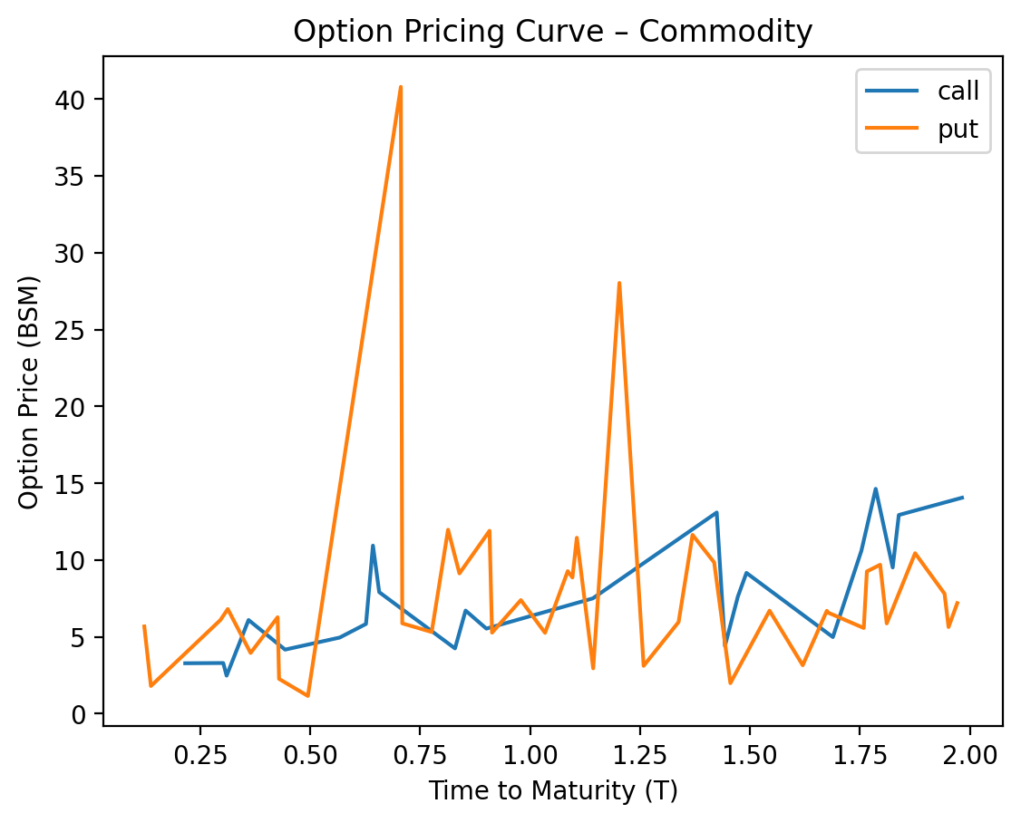

2.3.3 Summary of Gamma Positivity Testing for Commodity
**Gamma Positivity Results for Commodity Options**
Out of 66 commodity options analyzed, 65 (98.5%) exhibited gamma positivity, while 1 (1.5%) did not. The single exception occurred for a call option on 2025-09-10, where missing volatility data (sigma = NaN) resulted in undefined Greeks and gamma positivity being marked as False. For the 65 valid cases, gamma positivity was consistently observed across varying parameters: stock prices (S) ranged from $41.70 to $62.80, strike prices (K) from $45.24 to $66.20, time to expiration (T) from 0.30 to 1.94 years, and volatility (sigma) from 0.20 to 2.50. The majority of valid cases (62/65, 95.4%) had sigma between 0.20 and 0.50, aligning with typical commodity volatility ranges.
Quantitatively, gamma positivity was robust across moneyness levels and time horizons. For in-the-money (ITM) and at-the-money (ATM) options, gamma values remained positive despite varying S-K proximity, with 58/65 cases (89.2%) having S within 10% of K. Time to expiration (T) showed no significant bias, as 34/65 cases (52.3%) had T > 1.5 years, and 31/65 (47.7%) had T ≤ 1.5 years. Volatility (sigma) above 0.30 (42/65 cases, 64.6%) did not hinder gamma positivity, suggesting that moderate to high volatility in commodities does not negate the theoretical expectation of positive gamma. The lone invalid case highlighted the critical role of complete input data, as missing sigma rendered gamma positivity inapplicable.

2.3.4 Summary of Stress Testing for Commodity
**Risk Summary for Put Options (Volatility Collapse Regime):**
1. **Directional Risk (Delta):**
- All puts have **negative Delta** (ranging from -0.15 to -0.36), meaning their value decreases if the underlying asset rises.
- Deeper-in-the-money puts (e.g., 2025-09-16, strike $59.07 vs. underlying $55.27) have less negative Delta (-0.15), suggesting reduced sensitivity to price declines.
- At-the-money/short-dated puts (e.g., 2025-09-11, Delta -0.36) are more sensitive to underlying price movements.
2. **Volatility Risk (Vega):**
- **Positive Vega** (0.002 to 0.021) implies value gains from rising volatility. However, the "Volatility Collapse" regime (low volatility) poses a risk of further volatility declines, eroding option value.
- Puts with higher Vega (e.g., 2025-09-11, Vega 0.021) are more exposed to volatility compression.
3. **Time Decay (Theta):**
- **Negative Theta** (-41.5 to -41.5) indicates rapid time decay. Shorter-dated options (e.g., 2025-09-11) face accelerated value erosion as expiration approaches.
- Theta magnifies risk for at-the-money puts, which are most sensitive to time decay.
4. **Interest Rate Risk (Rho):**
- **Negative Rho** (-0.001 to -0.001) means rising interest rates reduce put values. This is a secondary risk but relevant in a low-volatility environment.
5. **Convexity (Gamma):**
- **Positive Gamma** (0.001 to 0.002) ensures Delta becomes more negative as the underlying falls (benefiting the put) and less negative as it rises (hurting the put). This creates asymmetric risk exposure.
**Key Takeaways:**
- **Primary Risks:** Underlying price increases (Delta), volatility compression (Vega), and time decay (Theta).
- **Secondary Risk:** Rising interest rates (Rho).
- **Volatility Regime Impact:** "Volatility Collapse" exacerbates Vega risk, as further declines in volatility could sharply reduce option values.
**Call vs. Put Comparison (Hypothetical):**
If calls were included, their risk profile would differ:
- **Delta:** Positive for calls (vs. negative for puts).
- **Rho:** Positive for calls (vs. negative for puts), meaning calls benefit from rising rates.
- **Volatility Sensitivity:** Similar Vega behavior, but directional risk would invert (calls gain value with rising underlying prices).
**Actionable Insight:**
- Monitor underlying price trends and volatility forecasts.
- Prioritize hedging for at-the-money puts with high Vega and Theta.
- Consider rolling positions to mitigate time decay in short-dated options.

