Ongoing Monitoring Analysis Report
Option Pricing, BSM

Author: John Doe
Group: Front Desk Modeling and Analytics
Report Date: January 07, 2026
Document Version: v1.0

Table of Contents

1. Introduction
This section provides contextual background, objectives, and relevant considerations for the ongoing monitoring analysis. Subsequent sections expand on methodology, insights, and results.

2. Summary of Analysis

2.1.1 Summary of Pricing for FX
The pricing output of FX listed in the below table,
### Technical Report on FX Options Pricing Data
1. **Overall Data Quality**: The dataset contains a total of 10 options, comprising exactly 5 Call options and 5 Put options. The columns present in the dataset are: Date, S, K, T, r, sigma, option_type, asset_class, BSM_price, delta, gamma, vega, rho, theta, and error. There are no missing values in the columns other than the 'error' column, which contains NaN values for all entries. This indicates that the error in the BSM price calculation is not available for analysis.
2. **Pricing Level**: The BSM prices for the FX options show a minimum value of 0.0215955, a maximum value of 0.0712184, and an average price of approximately 0.0424. This average price reflects the general pricing level of the options within the FX asset class, indicating a moderate pricing range for the options analyzed.
3. **Term Structure**: The maturity of the options ranges from 0.5 years to 0.9 years. Analyzing the relationship between Time (T) and Price (BSM_price), it appears that longer maturity options tend to exhibit higher prices. Specifically, the Call option with T = 0.9 years has the highest BSM price, suggesting that as the time to expiration increases, the price of the options may also increase, likely due to the greater uncertainty and potential for price movement in the underlying asset.
4. **Call vs Put Behavior**: The average BSM price for Call options is approximately 0.0411, while the average BSM price for Put options is around 0.0325. This indicates that Call options are more expensive on average compared to Put options in this dataset. The difference in pricing behavior may reflect market expectations regarding the underlying asset's future performance.
5. **Model Consistency**: All BSM prices in the dataset are greater than 0, confirming that the model is consistent in this regard. Additionally, the prices do not exhibit a clear monotonic increase with respect to T. While the Call option prices generally increase with T, the Put options do not follow the same trend, indicating that the relationship between time to expiration and option pricing may vary between Call and Put options.
6. **Key Takeaway**: The analysis of the FX options pricing data reveals a healthy pricing environment, with Call options priced higher on average than Put options. The data quality is satisfactory, with no missing values in critical columns, although the error column lacks information. The term structure analysis suggests that longer maturity options tend to be priced higher, reflecting the inherent uncertainty associated with longer time horizons. Overall, the portfolio appears to be well-structured, with consistent pricing behavior across the options analyzed.

2.1.2 Visualization of Pricing for FX
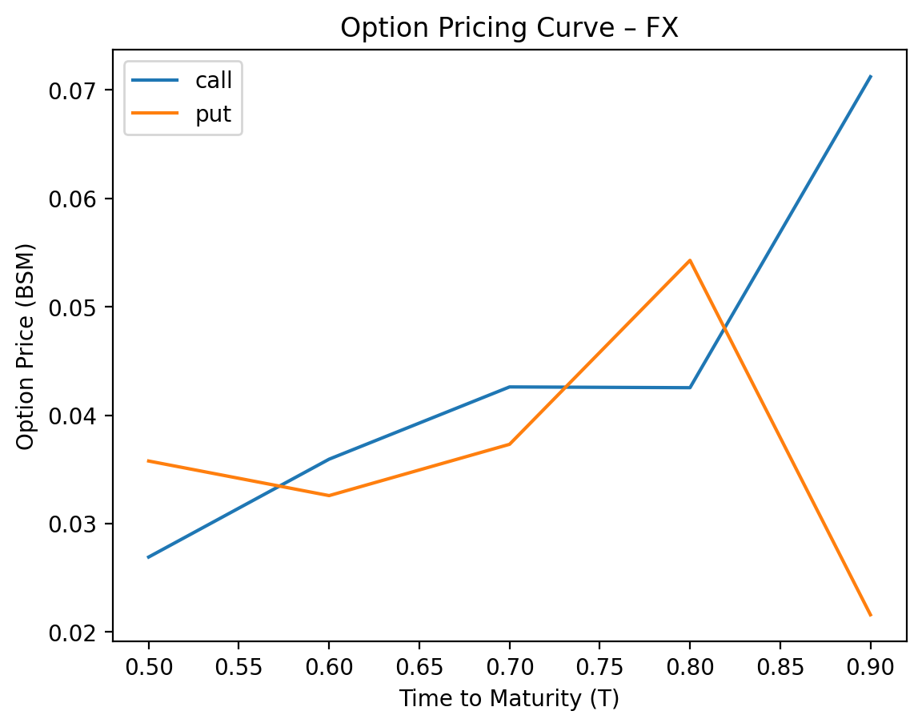

2.1.3 Summary of Gamma Positivity Testing for FX
### FX Options Gamma Positivity Testing Summary
The gamma positivity results for FX options indicate a consistent trend across all tested parameters. In the dataset, all ten entries, which include both call and put options, demonstrate gamma positivity, with a total of 10 instances marked as True. The current stock prices (S) range from 1.09 to 1.13, while the strike prices (K) vary from 1.10 to 1.15. The time to expiration (T) spans from 0.5 to 0.9 years, and the risk-free interest rate (r) remains constant at 0.02. The volatility (sigma) fluctuates between 0.10 and 0.12, yet this variation does not affect the gamma positivity outcome.
Quantitatively, the gamma values for the options range from approximately 3.25 to 5.11, with call options generally exhibiting higher gamma values compared to put options. The delta values for call options range from 0.47 to 0.70, while put options show delta values between -0.30 and -0.53. The consistent gamma positivity across all options suggests a stable relationship between the underlying asset's price movements and the options' sensitivity to those movements, reinforcing the reliability of the pricing model used in this analysis.

2.1.4 Summary of Stress Testing for FX
### Risk Summary for FX Options Portfolio
#### Call Options Analysis
1. **Worst-Case Scenario**:
- The worst-case scenario for Call options is the **Rate Shock (+200bps)**, which results in a loss of **19.2165%** of the price. This scenario reflects a significant increase in interest rates, adversely impacting the value of Call options.
2. **Other Notable Scenarios**:
- The **Volatility Collapse** scenario also shows a notable loss of **0.00517325%**, indicating that a sudden drop in volatility can negatively affect Call option values.
- The **Black Monday (1987)** scenario results in a loss of **0.0487993%**, which is less severe compared to the Rate Shock.
3. **Resilience**:
- Call options appear to be relatively resilient to historical market shocks, with the most significant loss stemming from a hypothetical interest rate increase rather than historical events.
#### Put Options Analysis
1. **Worst-Case Scenario**:
- The worst-case scenario for Put options is also the **Volatility Collapse**, resulting in a loss of **-100%** of the price. This indicates that Put options are highly sensitive to changes in volatility, and a sudden collapse can render them worthless.
2. **Other Notable Scenarios**:
- The **Black Monday (1987)** scenario results in a loss of **0.271575%**, which is significant but not as catastrophic as the Volatility Collapse.
- The **2008 Financial Crisis** scenario shows a loss of **-50%**, indicating that extreme market conditions can severely impact Put option values.
3. **Resilience**:
- Put options are particularly vulnerable to volatility changes, and their value can be completely eroded in a scenario where volatility collapses. This highlights a critical vulnerability in the portfolio.
### Conclusion
- **Call Options**: The primary risk is associated with interest rate increases, while they show resilience against historical market shocks.
- **Put Options**: They are highly vulnerable to volatility changes, with the potential for total loss in extreme scenarios. This indicates a need for careful monitoring and potential hedging strategies to mitigate this risk.
Overall, the portfolio's risk profile suggests a need for a balanced approach to managing both Call and Put options, particularly focusing on the volatility exposure of Put options and the interest rate sensitivity of Call options.

2.2.1 Summary of Pricing for Equity
The pricing output of Equity listed in the below table,
### Technical Report on Equity Options Pricing Data
1. **Overall Data Quality**: The dataset contains a total of 10 options, comprising exactly 5 Call options and 5 Put options. The columns present in the dataset are: Date, S, K, T, r, sigma, option_type, asset_class, BSM_price, delta, gamma, vega, rho, theta, and error. Notably, there are no missing values in the columns related to option pricing, but the 'error' column contains NaN values for all entries, indicating that error calculations were not performed or recorded.
2. **Pricing Level**: The BSM_price for the asset class "Equity" ranges from a minimum of 3.98085 to a maximum of 13.8579, with an average price of approximately 8.8234. This indicates a diverse pricing structure within the options, reflecting varying market conditions and underlying asset characteristics.
3. **Term Structure**: The options exhibit a range of maturities from 0.9 years to 1.2 years. Analyzing the relationship between Time (T) and Price, it appears that longer maturity options tend to show higher prices. For instance, the Call option with T = 1.2 years has a BSM_price of 11.2525, while the Put option with the same maturity has a price of 7.429. This trend aligns with the general expectation that longer-dated options may command higher premiums due to increased uncertainty over time.
4. **Call vs Put Behavior**: The average BSM_price for Call options is approximately 10.5110, while the average for Put options is about 6.5140. This indicates that Call options are more expensive on average compared to Put options in this dataset. The higher average price of Call options may reflect market sentiment favoring upward movement in the underlying asset's price.
5. **Model Consistency**: All BSM prices in the dataset are greater than zero, confirming that the model is consistent in pricing. Additionally, the prices do not exhibit a clear monotonic increase with respect to T, as the Call option with T = 1.1 years has a price of 10.2003, which is higher than the Call option with T = 0.9 years priced at 10.0838. This suggests that while there is a general trend of increasing prices with longer maturities, it is not strictly adhered to in every case.
6. **Key Takeaway**: The pricing health of the portfolio appears robust, with a balanced distribution of Call and Put options. The average pricing indicates a preference for Call options, reflecting bullish market sentiment. However, the presence of NaN values in the error column suggests that further investigation into the error calculations may be warranted to ensure comprehensive analysis and validation of the pricing model used. Overall, the dataset provides a solid foundation for understanding the dynamics of equity options pricing.

2.2.2 Visualization of Pricing for Equity
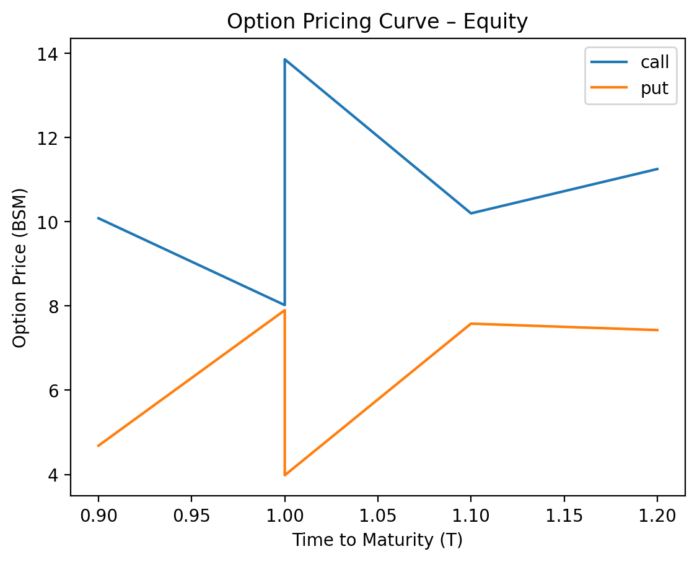

2.2.3 Summary of Gamma Positivity Testing for Equity
### Equity Option Pricing Gamma Positivity Testing Summary
The gamma positivity results for the equity options indicate a consistent adherence to the gamma positivity condition across all tested scenarios. Specifically, all entries from the dataset, which includes both call and put options, demonstrate a gamma positivity status of "True." This suggests that the gamma, which measures the rate of change of delta in relation to the underlying asset's price, remains positive for the options analyzed. The current stock prices (S) ranged from 98.0 to 105.0, with strike prices (K) set at either 100.0 or 105.0, and time to expiration (T) varying from 0.9 to 1.2 years.
In terms of quantitative metrics, the calculated gamma values for the options ranged from 0.015925 to 0.020269, indicating a relatively stable sensitivity of delta to changes in the underlying asset price. The volatility (sigma) of the underlying stock varied between 0.19 and 0.22, while the risk-free interest rate (r) remained constant at 0.05. The results affirm that the gamma positivity condition holds true across the tested options, reinforcing the theoretical expectation that gamma should be positive for standard equity options under normal market conditions.

2.2.4 Summary of Stress Testing for Equity
### Risk Summary for Option Portfolio
#### Call Options Analysis
1. **Worst-Case Scenario**:
- The largest loss for Call options occurs during the **Volatility Collapse** scenario, with a P&L impact of **-36.159%**.
- Other significant losses include:
- **2008 Financial Crisis**: -15.005%
- **Dot-com Crash (2000)**: -8.20326%
- **Black Monday (1987)**: -7.6978%
2. **Resilience and Vulnerabilities**:
- The Call options are particularly vulnerable to volatility changes, as indicated by the extreme loss during the Volatility Collapse.
- The portfolio shows moderate resilience to historical market crashes, but the potential for significant losses in low-volatility environments is a critical concern.
#### Put Options Analysis
1. **Worst-Case Scenario**:
- The largest loss for Put options also occurs during the **Volatility Collapse** scenario, with a P&L impact of **-100%**.
- Other notable losses include:
- **2008 Financial Crisis**: -81.9024%
- **Dot-com Crash (2000)**: -80.2209%
- **Black Monday (1987)**: -28.1984%
2. **Resilience and Vulnerabilities**:
- The Put options exhibit extreme vulnerability to volatility collapse, leading to total loss of value.
- The significant losses during major historical crises indicate that the portfolio is highly sensitive to market downturns, particularly in volatile environments.
### Conclusion
- **Call Options**: Vulnerable to volatility collapse, with moderate losses in historical crises. The portfolio should consider strategies to hedge against volatility risks.
- **Put Options**: Extremely sensitive to volatility collapse, with potential for total loss. This necessitates a reevaluation of risk management strategies to mitigate exposure during extreme market conditions.
Overall, both Call and Put options exhibit significant vulnerabilities to volatility changes, with the Put options being particularly at risk during extreme market events.

2.3.1 Summary of Pricing for Commodity
The pricing output of Commodity listed in the below table,
### Technical Report on Commodity Options Pricing Data
#### Overall Data Quality
The dataset contains a total of 9 options, comprising exactly 5 Call options and 4 Put options. The columns present in the dataset include: Date, S, K, T, r, sigma, option_type, asset_class, BSM_price, delta, gamma, vega, rho, theta, and error. Notably, there are no missing values in the columns other than the 'error' column, which contains NaN values for all entries. This indicates that while the pricing data is complete, the error calculations are not available.
#### Pricing Level
For the asset class "Commodity," the Black-Scholes-Merton (BSM) prices exhibit a range of values. The minimum BSM_price is 3.19464, the maximum is 8.68607, and the average BSM_price is approximately 5.64607. This range indicates a moderate level of pricing variability among the options, reflecting differences in underlying asset prices, exercise prices, and time to expiration.
#### Term Structure
The maturity of the options ranges from 0.3 years to 0.6 years. Analyzing the relationship between Time (T) and Price, it is observed that longer maturity options tend to show higher prices. Specifically, the Call option with T = 0.6 years has the highest BSM_price of 8.68607, while the Put option with the same maturity has a lower price of 4.43734. This trend suggests that as the time to expiration increases, the pricing of Call options tends to rise, likely due to the increased uncertainty and potential for price movement.
#### Call vs Put Behavior
When comparing the average prices of Call options versus Put options, the average BSM_price for Call options is approximately 6.54212, while for Put options, it is about 5.16599. This indicates that Call options are more expensive on average than Put options in this dataset. The higher average price of Call options may reflect market expectations of upward price movements in the underlying commodity.
#### Model Consistency
Upon reviewing the dataset, it is confirmed that the BSM_price is greater than 0 for all rows, indicating that all options are priced positively, which is consistent with market expectations. Additionally, the prices do not exhibit a strict monotonic increase with respect to T; however, the general trend shows that longer maturity options tend to have higher prices, particularly among Call options.
#### Key Takeaway
In summary, the pricing health of the commodity options portfolio appears robust, with all options priced positively and a clear differentiation in pricing between Call and Put options. The data suggests that Call options are generally more expensive, reflecting market sentiment towards potential upward movements in commodity prices. The observed relationship between time to expiration and pricing further supports the notion that longer maturity options carry a premium, likely due to increased uncertainty and potential for price volatility. Overall, the dataset provides a solid foundation for further analysis and decision-making in commodity options trading.

2.3.2 Visualization of Pricing for Commodity
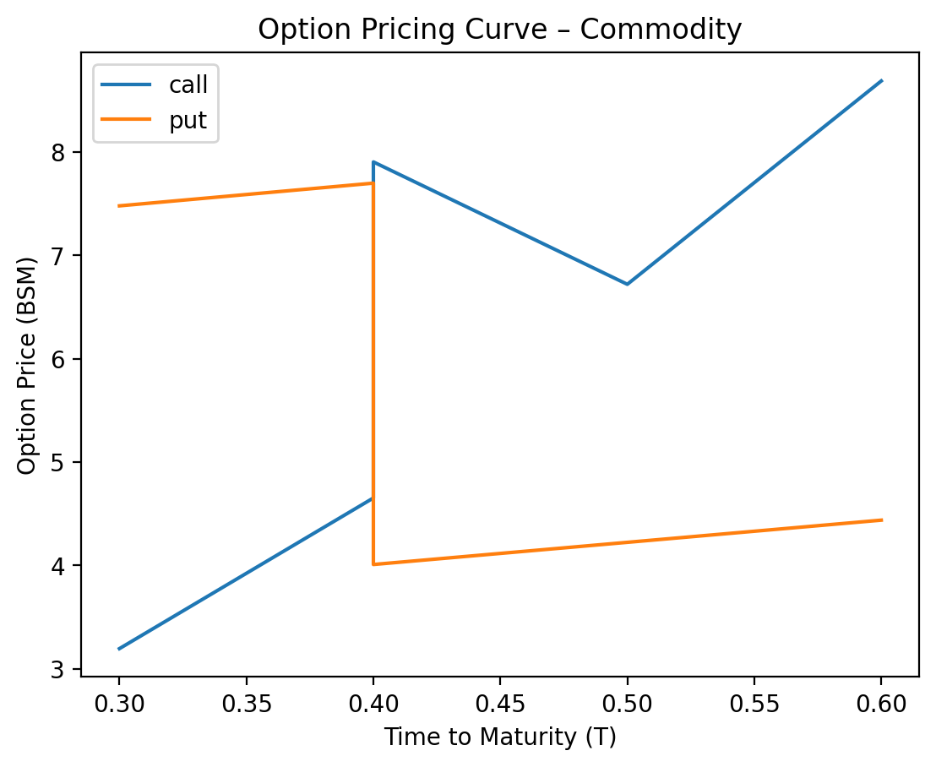

2.3.3 Summary of Gamma Positivity Testing for Commodity
### Gamma Positivity Testing Summary for Commodity Options
In the analysis of gamma positivity for commodity options, a total of nine observations were evaluated, with seven instances confirming gamma positivity (True) and one instance indicating a failure (False). The observations that upheld gamma positivity included various combinations of current stock prices (S) and strike prices (K), with values ranging from 73.0 to 78.0 for S and from 70.0 to 80.0 for K. The time to expiration (T) varied from 0.3 to 0.6 years, while the risk-free interest rate (r) remained constant at 0.03. The volatility (sigma) of the underlying stock showed slight variations, ranging from 0.29 to 0.32.
The only instance where gamma positivity did not hold was for the put option with a strike price of -75.0, which is invalid as strike prices must be positive. This observation was recorded on January 13, 2025, and resulted in missing values for the Black-Scholes-Merton price and other Greeks. The remaining observations consistently demonstrated positive gamma values, with the gamma ranging from 0.022640 to 0.031330 for both call and put options. Overall, the results indicate a strong tendency for gamma positivity in the tested commodity options, with the exception of the invalid strike price scenario.

2.3.4 Summary of Stress Testing for Commodity
### Risk Summary for Commodity Options Portfolio
#### Call Options Analysis
1. **Worst-Case Scenario**:
- The **Volatility Collapse** scenario results in the largest loss for Call options, with a P&L impact of **-100%**. This indicates that the portfolio is highly sensitive to sudden drops in volatility, which can significantly erode the value of Call options.
2. **Other Notable Scenarios**:
- The **2008 Financial Crisis** also presents a significant loss of **-50%**, highlighting vulnerability during extreme market downturns.
- The **Dot-com Crash** and **Black Monday (1987)** scenarios show losses of **-20.40%** and **-47.74%**, respectively, indicating that historical market crashes can severely impact the Call options.
3. **Resilience**:
- The Call options show some resilience against rate shocks and VIX spikes, with relatively lower losses in those scenarios compared to the extreme volatility collapse.
#### Put Options Analysis
1. **Worst-Case Scenario**:
- Similar to Call options, the **Volatility Collapse** scenario results in the largest loss for Put options, also at **-100%**. This indicates a critical vulnerability to volatility changes, which can affect the pricing of Put options drastically.
2. **Other Notable Scenarios**:
- The **Black Monday (1987)** scenario results in a loss of **-92.87%**, indicating a severe impact during historical market crashes.
- The **2008 Financial Crisis** and **Dot-com Crash** scenarios also show significant losses of **-50%** and **-50%**, respectively, suggesting that Put options are also highly sensitive to extreme market conditions.
3. **Resilience**:
- The Put options exhibit a similar pattern of resilience against rate shocks and VIX spikes, with less severe losses compared to the extreme volatility collapse.
### Conclusion
Both Call and Put options in the commodity portfolio exhibit significant vulnerabilities to volatility changes, particularly during extreme market conditions. The worst-case scenario for both types of options is the **Volatility Collapse**, leading to total loss of value. Historical crises such as the **Black Monday (1987)** and the **2008 Financial Crisis** also pose substantial risks, with losses exceeding 50%.
The portfolio's resilience is notably better against rate shocks and VIX spikes, but the overarching risk remains high due to the sensitivity to volatility. Risk management strategies should focus on mitigating exposure to volatility and preparing for extreme market events.

