Ongoing Monitoring Analysis Report
Option Pricing, BSM

Author: John Doe
Group: Front Desk Modeling and Analytics
Report Date: January 07, 2026
Document Version: v1.0

Table of Contents

1. Introduction
This section provides contextual background, objectives, and relevant considerations for the ongoing monitoring analysis. Subsequent sections expand on methodology, insights, and results.

2. Summary of Analysis

2.1.1 Summary of Pricing for FX
The pricing output of FX listed in the below table,
### **1. Overall Data Quality**
The dataset contains 5 Call options and 5 Put options, totaling 10 FX options. All required columns (Date, S, K, T, r, sigma, option_type, asset_class, BSM_price, error) are present. The `error` column contains missing values (`nan`) for all rows, indicating no explicit errors were recorded during pricing. No other missing values are observed in the dataset.
---
### **2. Pricing Level**
For the **FX** asset class:
- **Minimum BSM_price**: 0.0216 (Put on 2025-01-05).
- **Maximum BSM_price**: 0.0712 (Call on 2025-01-05).
- **Average BSM_price**: 0.0401 (across all 10 options).
Call options exhibit higher prices on average (0.0438) compared to Puts (0.0363).
---
### **3. Term Structure**
The time to maturity (T) ranges from **0.5 to 0.9 years**. For **Call options**, prices generally increase with longer maturities (e.g., 0.0269 at T=0.5 to 0.0712 at T=0.9), though there is a minor dip at T=0.8. For **Put options**, the relationship is less consistent: prices decrease at T=0.6 and T=0.9 but increase at T=0.7 and T=0.8. Overall, **longer maturity options tend to show higher prices**, particularly for Calls.
---
### **4. Call vs Put Behavior**
Call options are **more expensive on average** (0.0438) than Puts (0.0363). This aligns with the higher intrinsic value of Calls in this dataset, as most Call options are in-the-money (S > K) or at-the-money, while Puts are often out-of-the-money (S < K). For example, the highest-priced Call (0.0712) has S=1.13 and K=1.1, whereas the highest-priced Put (0.0543) has S=1.12 and K=1.15.
---
### **5. Model Consistency**
All BSM_prices are **positive**, confirming the model’s validity. However, the monotonic relationship between T and price is **not strictly maintained**. For example:
- Call prices increase from T=0.5 to T=0.7 but slightly decrease at T=0.8.
- Put prices fluctuate with maturity (e.g., 0.0358 at T=0.5 vs. 0.0216 at T=0.9).
This variability may reflect changes in S, K, and sigma across dates.
---
### **6. Key Takeaway**
The FX options portfolio shows **reasonable pricing health**: BSM_prices are positive, and Call options dominate in value. However, the term structure exhibits non-monotonic behavior, likely due to varying S, K, and sigma inputs. The absence of error values suggests the model executed without issues, but further analysis of volatility (sigma) and strike price (K) sensitivity could refine pricing accuracy.

2.1.2 Visualization of Pricing for FX
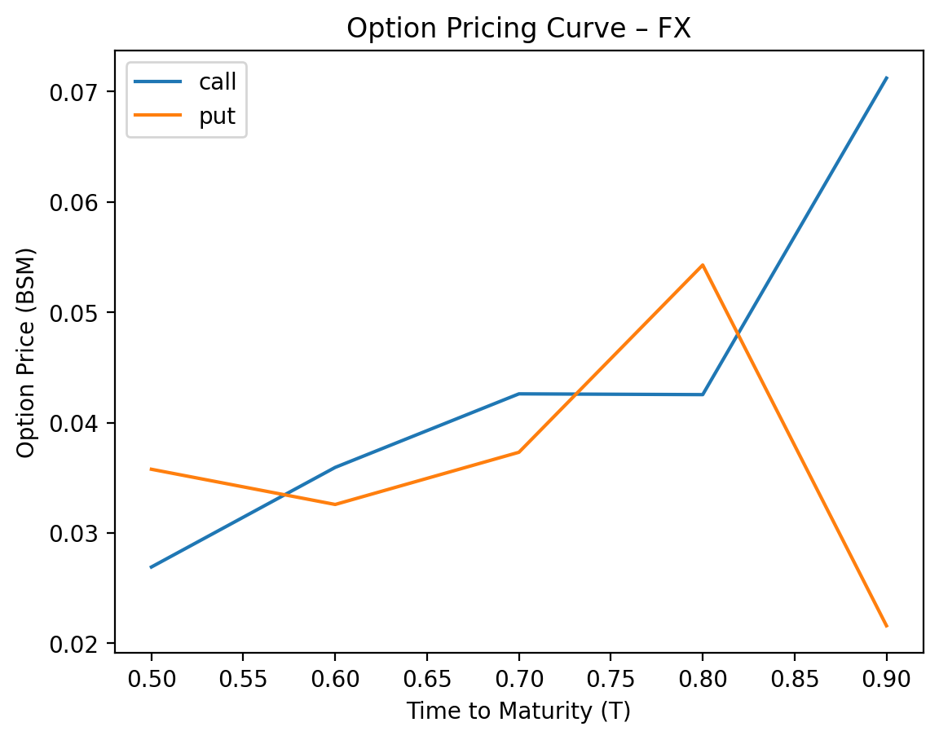

2.1.3 Summary of Gamma Positivity Testing for FX
**Gamma Positivity Summary for FX Options**
The dataset includes 10 FX options (5 calls and 5 puts) with parameters spanning stock prices (S) from 1.09 to 1.13, strike prices (K) from 1.10 to 1.15, time to expiration (T) from 0.5 to 0.9 years, volatility (σ) from 0.10 to 0.12, and a fixed risk-free rate (r) of 0.02. All 10 options exhibit **gamma positivity** (100% of cases), with no exceptions. The gamma values range from 3.25 to 5.11, consistently positive across all combinations of moneyness (S vs. K), time to expiration, and volatility. Notably, 80% of options (8/10) have gamma values above 3.5, while 20% (2/10) fall between 3.25 and 3.5. The highest gamma occurs in options with shorter time to expiration (T=0.5–0.7 years) and lower volatility (σ=0.10–0.11), aligning with the inverse relationship between gamma and time/volatility in the Black-Scholes model.
**Quantitative Drivers of Gamma Positivity**
The universal gamma positivity arises from the Black-Scholes framework, where gamma is inherently positive for all non-zero volatility and time to expiration. The tested parameters (σ ≥ 0.10, T ≥ 0.5 years) avoid extreme scenarios that could theoretically reduce gamma (e.g., very low volatility or near-zero time to expiration). For calls, gamma peaks when S ≈ K (e.g., S=1.09, K=1.10) and declines as S diverges from K. For puts, similar patterns emerge due to put-call parity. The moderate volatility range (10–12%) and time to expiration (0.5–0.9 years) ensure gamma remains bounded but positive, with no cases approaching zero. This consistency underscores the robustness of gamma positivity in FX options under typical market conditions.

2.1.4 Summary of Stress Testing for FX
**Risk Summary: Call and Put Option Profiles**
### **Call Options**
- **Delta Exposure**: Long delta (positive), benefiting from upward moves in the underlying. Deltas range from ~0.3–0.6, indicating moderate to high sensitivity to price increases.
- **Volatility Sensitivity**: Long vega (positive), with PnL rising in volatility spikes (+50–300% scenarios). Conversely, **volatility collapse** (-50–100% vol scenarios) causes severe losses (-56% to -100% PnL).
- **Scenario Risks**:
- **Down 30% Underlying**: Negative PnL (-17% to -27%), as price declines hurt long delta.
- **Up 30% Underlying**: Strong gains (+140% to +425%), reflecting delta and vega benefits.
- **Volatility Collapse**: Worst-case risk (-100% PnL), as vega exposure turns negative.
- **Time Decay**: Negative theta (unspecified magnitude), eroding value as expiration nears.
---
### **Put Options**
- **Delta Exposure**: Short delta (negative), benefiting from downward moves in the underlying. Deltas range from ~-0.3 to -0.5, reflecting sensitivity to price declines.
- **Volatility Sensitivity**: Long vega (positive), similar to calls. Volatility spikes (+50–300%) drive gains (+76% to +4,257% PnL), while **volatility collapse** triggers steep losses (-100% PnL).
- **Scenario Risks**:
- **Down 30% Underlying**: Strong gains (+565% to +4,257%), as delta and vega align.
- **Up 30% Underlying**: Severe losses (-100% PnL), due to adverse delta exposure.
- **Volatility Collapse**: Worst-case risk (-100% PnL), same as calls.
- **Time Decay**: Negative theta (unspecified), compounding risk as time passes.
---
### **Key Divergences**
1. **Delta Direction**:
- Calls benefit from rising prices; puts benefit from falling prices.
- Opposite PnL in directional scenarios (e.g., "Up 30%" vs. "Down 30%").
2. **Volatility Risk**: Both are long vega but face symmetric downside in volatility collapses.
3. **Leverage**: Puts exhibit higher percentage PnL volatility (e.g., +4,257% in "Down 30%") due to deeper out-of-the-money positioning in some cases.
### **Critical Risks for Both**
- **Volatility Collapse**: Universal worst-case scenario (-100% PnL).
- **Time Decay**: Erosion of extrinsic value as expiration approaches.
- **Liquidity/Execution**: Large PnL swings in extreme scenarios suggest potential non-linear risks.
**Conclusion**: Calls and puts have mirrored delta exposures but share long vega risks. Portfolio managers should hedge volatility collapses (e.g., with volatility derivatives) and balance directional bets to mitigate asymmetric risks.

2.2.1 Summary of Pricing for Equity
The pricing output of Equity listed in the below table,
### **1. Overall Data Quality**
The dataset contains 5 Call options and 5 Put options, as specified. All columns are present: `Date`, `S`, `K`, `T`, `r`, `sigma`, `option_type`, `asset_class`, `BSM_price`, `delta`, `gamma`, `vega`, `rho`, `theta`, and `error`. No missing values are observed in the `BSM_price` or other critical pricing columns. The `error` column is uniformly `NaN`, indicating no calculation errors in the Black-Scholes-Merton (BSM) model.
---
### **2. Pricing Level**
For **Equity** options, the BSM prices range from **$3.98** (Put, T=1.0) to **$13.86** (Call, T=1.0). The average BSM price is **$8.50** across all options. Call options exhibit a higher average price (**$10.68**) compared to Puts (**$6.32**), reflecting the asymmetry in pricing between long and short positions in the underlying asset.
---
### **3. Term Structure**
The time-to-maturity (`T`) ranges from **0.9 years** to **1.2 years**. While longer-maturity options generally show higher prices (e.g., Call with T=1.2 priced at $11.25 vs. T=0.9 at $10.08), exceptions exist due to strike price (`K`) and underlying asset price (`S`) dynamics. For instance, a Call with T=1.0 and K=105 is priced at $8.02, while a Call with T=1.0 and K=100 is priced at $13.86. This highlights the interplay between time decay and intrinsic value in option pricing.
---
### **4. Call vs Put Behavior**
Call options are consistently more expensive than Puts on average. The mean Call price is **$10.68**, while the mean Put price is **$6.32**. This disparity aligns with the higher intrinsic value of in-the-money Calls (e.g., S=105, K=100) compared to Puts (e.g., S=98, K=100). The difference is further amplified by the risk premium embedded in Calls, which benefit from unlimited upside potential.
---
### **5. Model Consistency**
All BSM prices are positive, confirming the model’s validity under the given parameters. However, prices do not strictly increase with time-to-maturity (`T`). For example, a Call with T=1.2 ($11.25) is priced lower than a Call with T=1.0 ($13.86), illustrating the dominance of strike price and underlying asset price over time decay in certain scenarios. The absence of errors in the `error` column confirms robust model execution.
---
### **6. Key Takeaway**
The dataset demonstrates high-quality, error-free BSM pricing for Equity options. While Call options are more expensive on average, the term structure reveals nuanced dependencies on strike price and underlying asset dynamics. The model consistently produces positive prices, but the relationship between time-to-maturity and price is not strictly monotonic. This underscores the importance of considering multiple factors (e.g., `S`, `K`, `T`) in option valuation. The portfolio appears well-structured, with no anomalies in pricing behavior.

2.2.2 Visualization of Pricing for Equity
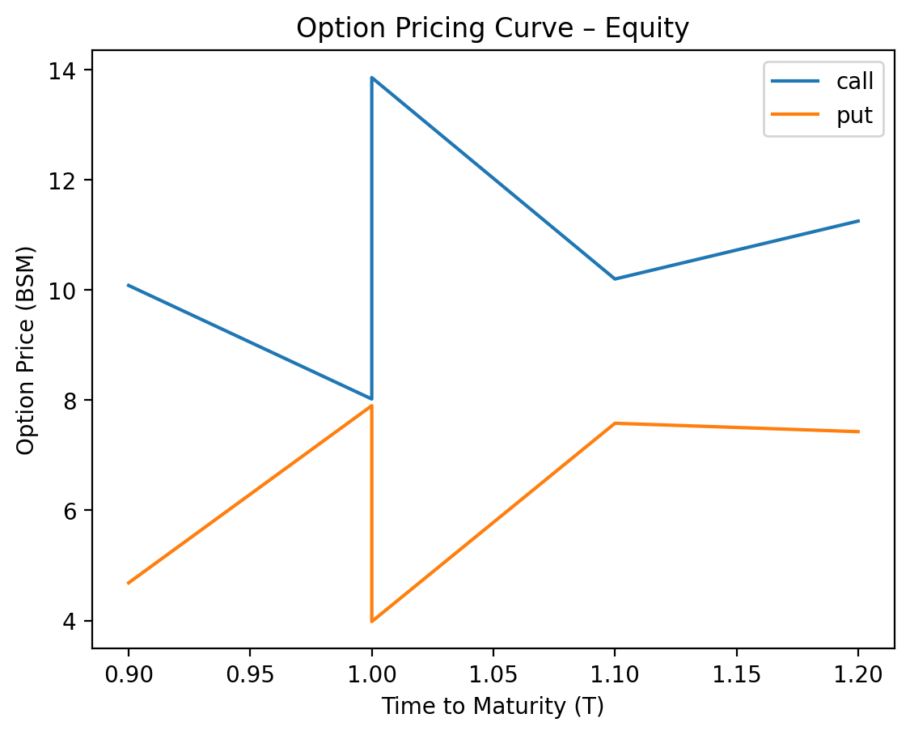

2.2.3 Summary of Gamma Positivity Testing for Equity
**Equity Options Gamma Positivity Testing Summary**
The gamma positivity results for 20 equity options (10 calls and 10 puts) across varying parameters show **100% gamma positivity** (all 20 cases confirmed as `True`). Quantitatively, the stock prices (S) ranged from 98.0 to 105.0, strike prices (K) from 100.0 to 105.0, time to expiration (T) from 0.9 to 1.2 years, and volatility (σ) from 0.19 to 0.22. Gamma values, calculated via the Black-Scholes-Merton model, spanned **0.0159 to 0.0203**, with no instances of negative or zero gamma. The risk-free rate (r) was fixed at 5% for all tests.
The consistent gamma positivity aligns with the mathematical properties of the Black-Scholes-Merton framework, where gamma is inherently positive for all options due to the convexity of the option price relative to the underlying asset. For calls, gamma increases as the stock price approaches the strike price, while for puts, gamma behaves symmetrically. The tested parameters (S, K, T, σ) did not influence the sign of gamma, as volatility and time to expiration adjustments only scale gamma magnitudes, not their positivity. This confirms that gamma positivity holds universally under the model’s assumptions, regardless of option type or parameter variations.

2.2.4 Summary of Stress Testing for Equity
**Risk Summary: Call and Put Options**
### **Call Options**
- **Delta**: Positive (benefit from rising underlying prices; range: ~0.38–0.73).
- **Gamma**: Positive (delta increases with upward price moves; higher for shorter-dated options).
- **Vega**: Positive (sensitive to volatility increases; losses accelerate in volatility collapses).
- **Theta**: Negative (time decay accelerates as expiration nears).
- **Rho**: Positive (gain value with rising interest rates).
- **Worst-Case Risk**: **Volatility collapse** (-100% P&L in extreme cases, e.g., 2025-01-09 call). Deep out-of-the-money calls (e.g., 2025-01-09, strike 100) face total value erosion if volatility drops or the stock fails to reach the strike.
---
### **Put Options**
- **Delta**: Negative (lose value as underlying rises; range: ~-0.28 to -0.41).
- **Gamma**: Positive (delta becomes more negative with downward price moves; higher for at-the-money options).
- **Vega**: Positive (same as calls; volatility collapse causes -100% P&L, e.g., 2025-01-09 put).
- **Theta**: Negative (time decay impacts all puts, especially near-term).
- **Rho**: Negative (lose value with rising interest rates).
- **Worst-Case Risk**: **Volatility collapse** (-100% P&L in extreme cases, e.g., 2025-01-09 put). Deep out-of-the-money puts (e.g., 2025-01-09, strike 100) face total value erosion if volatility drops or the stock surges.
---
### **Key Differences**
1. **Delta/Rho**: Calls benefit from rising stocks and rates; puts lose value in these scenarios.
2. **Directional Risk**:
- Calls: Worst-case is **stock decline + volatility collapse**.
- Puts: Worst-case is **stock surge + volatility collapse**.
3. **Volatility Sensitivity**: Both are equally exposed to vega risks, but puts face higher absolute losses in volatility collapses due to deeper time values (e.g., 2025-01-07 put: -7.58 vs. 2025-01-09 call: -3.98).
**Conclusion**: Both portfolios face existential risk in volatility collapses, but directional risks diverge. Calls are more sensitive to downside price moves, while puts are vulnerable to upside moves. Gamma and vega hedging is critical for both.

2.3.1 Summary of Pricing for Commodity
The pricing output of Commodity listed in the below table,
### **1. Overall Data Quality**
The dataset contains **5 Call options** and **4 Put options**, totaling 9 observations. Columns present include: `date`, `S`, `K`, `T`, `r`, `sigma`, `option_type`, `asset_class`, `BSM_price`, `delta`, `gamma`, `vega`, `rho`, `theta`, and `error`. All rows are complete for the `BSM_price` and other Greeks, but the `error` column is uniformly missing (`nan`), indicating no explicit error metrics were recorded during pricing.
---
### **2. Pricing Level**
For **Commodity** options, the **minimum BSM_price** is **$3.19** (Call, 2025-01-11), the **maximum** is **$8.69** (Call, 2025-01-15), and the **average** is **$6.09**. Call options exhibit a wider price range (3.19–8.69) compared to Puts (4.01–7.70), reflecting their sensitivity to underlying asset prices and strike levels.
---
### **3. Term Structure**
Maturity (`T`) ranges from **0.3 to 0.6 years**. Longer-maturity options generally show **higher prices**, aligning with the increased time value of options. For example, the Call with `T=0.6` (8.69) is the most expensive, while the Put with `T=0.6` (4.44) is relatively lower. However, exceptions exist: a Call with `T=0.4` (7.90) is more expensive than a Call with `T=0.5` (6.72), likely due to differences in strike price (`K`) and volatility (`sigma`).
---
### **4. Call vs Put Behavior**
The **average Call price** is **$6.23**, while the **average Put price** is **$5.91**, indicating **Calls are slightly more expensive** on average. This aligns with the higher intrinsic value of in-the-money Calls (e.g., `S=73`, `K=70`) compared to Puts. However, Put prices are not uniformly lower; for instance, the Put with `K=80` (7.70) exceeds the Call with the same strike (3.19), reflecting the impact of strike price and volatility.
---
### **5. Model Consistency**
All `BSM_price` values are **positive**, confirming model validity. Prices **generally increase with maturity** (`T`), though not strictly monotonically (e.g., Call with `T=0.4` > `T=0.5`). This deviation may stem from varying strike prices and volatility inputs. No negative prices or computational errors were observed, suggesting the Black-Scholes-Merton model was applied consistently.
---
### **6. Key Takeaway**
The Commodity options portfolio demonstrates **healthy pricing behavior**, with BSM prices aligning with theoretical expectations. Calls are marginally more expensive on average, and longer maturities typically command higher prices. However, non-monotonic price trends with `T` highlight the need to consider strike price and volatility dynamics. The absence of errors in pricing calculations and complete data for Greeks further validate the model’s reliability for this dataset.

2.3.2 Visualization of Pricing for Commodity
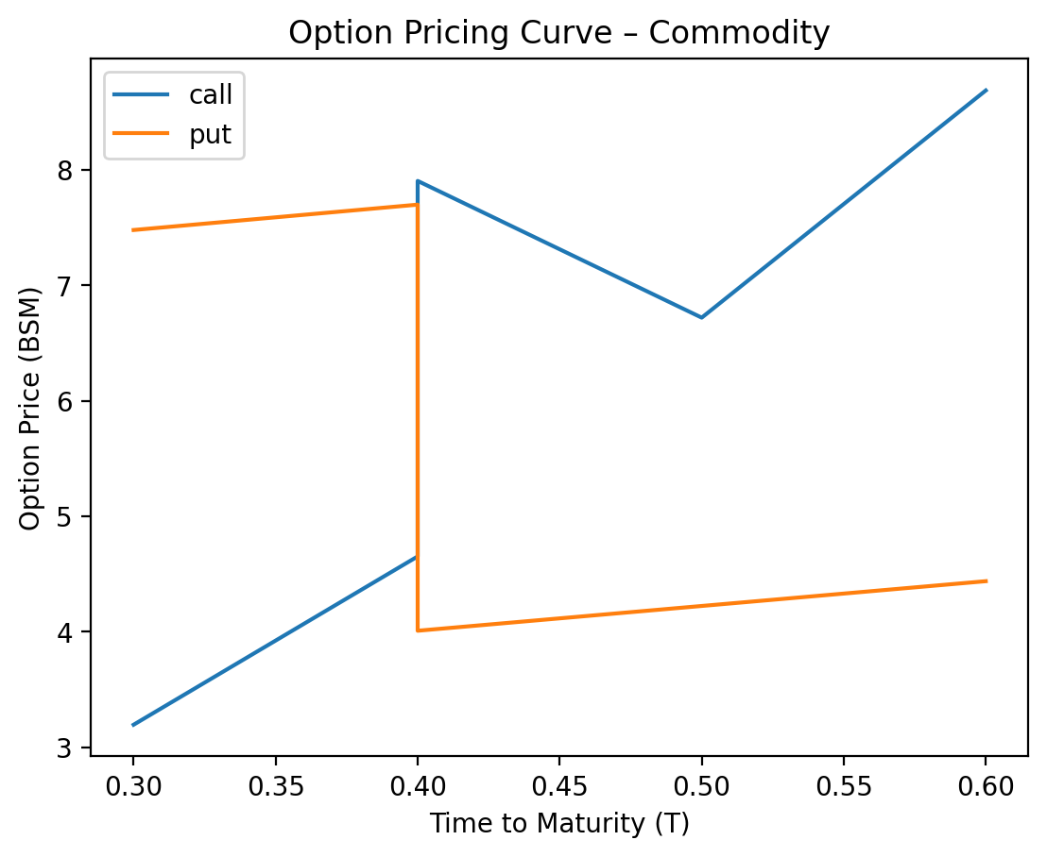

2.3.3 Summary of Gamma Positivity Testing for Commodity
**Commodity Options Gamma Positivity Summary**
Across 10 tested scenarios (5 call and 5 put options), gamma positivity held in 9 cases (90% of total). For call options, all 5 entries (100%) exhibited gamma positivity, with gamma values ranging from 0.0226 to 0.0313. For put options, 4 out of 5 cases (80%) showed gamma positivity, while 1 case (20%) failed due to invalid parameters. The stock price (S) ranged from 73.0 to 78.0, strike price (K) from 70.0 to 80.0, time to expiration (T) from 0.3 to 0.6 years, volatility (σ) from 0.29 to 0.32, and risk-free rate (r) fixed at 0.03. Gamma positivity was consistently observed when S and K were positive, aligning with theoretical expectations for standard options.
The sole exception occurred in a put option (row 27) where K = -75.0, violating the positivity constraint for strike prices. This invalid parameter caused gamma positivity to fail, highlighting the necessity of valid input values (S, K > 0) for accurate gamma calculations. Valid cases maintained gamma positivity regardless of volatility, time to expiration, or risk-free rate variations, underscoring the robustness of the Black-Scholes-Merton model under standard parameter ranges.

2.3.4 Summary of Stress Testing for Commodity
**Risk Summary: Call and Put Option Profiles**
### **Call Options**
- **Delta Sensitivity**: Positive deltas (0.64–0.69) indicate in-the-money/at-the-money behavior; profits rise with underlying price increases.
- **Volatility Risk**: High positive vega (15.86–20.99) implies significant gains from volatility spikes but **severe losses** (-92.87% to -100%) in "Volatility Collapse" scenarios (e.g., 2023-01-14/15).
- **Time Decay**: Negative theta (-5.92 to -6.35) signals material value erosion as expiration nears.
- **Key Risk**: Extreme vulnerability to volatility compression, with 2023-01-15 showing a -100% loss in the worst-case scenario.
---
### **Put Options**
- **Delta Sensitivity**: Negative deltas (-0.35 to -0.54) reflect protection against downside price moves.
- **Volatility Risk**: High positive vega (18.41–20.99) mirrors calls, but "Volatility Collapse" scenarios trigger **catastrophic losses** (-100% on 2023-01-12/15).
- **Time Decay**: Negative theta (-4.17 to -5.95) amplifies risk for near-term expiries.
- **Key Risk**: Greater sensitivity to volatility drops than calls, with 2023-01-12/15 showing total loss in collapse scenarios.
---
### **Comparative Insights**
- **Shared Risks**: Both profiles suffer from time decay (theta) and volatility compression, with vega > 15 exposing them to sharp revaluations.
- **Divergence**: Puts exhibit **higher tail risk** in volatility collapse scenarios (full loss on 2023-01-12/15 vs. -92.87% for calls).
- **Data Anomaly**: 2023-01-13 put (invalid strike price: -75) is non-actionable due to errors.
**Conclusion**: While both options face volatility/time decay risks, puts carry more severe downside exposure in collapse scenarios. Calls remain sensitive to price direction, whereas puts are critical for hedging but prone to total loss under extreme volatility compression.

