Ongoing Monitoring Analysis Report
Option Pricing, BSM

Author: John Doe
Group: Front Desk Modeling and Analytics
Report Date: February 02, 2026
Document Version: v1.0

Table of Contents

1. Introduction
This section provides contextual background, objectives, and relevant considerations for the ongoing monitoring analysis. Subsequent sections expand on methodology, insights, and results.

2. Summary of Analysis

2.1.1 Summary of Pricing for Equity
The pricing output of Equity listed in the below table,

1. Data Quality & Integrity

Data Quality & Integrity Assessment
- Price & Volatility Consistency:
- Underlying prices and strike prices align with market conventions (e.g., call/put prices reflect intrinsic/extrinsic value logic).
- Volatility values (e.g., 0.2–2.06) span reasonable ranges but include extreme outliers (e.g., 2.06 for MSFT put), potentially indicating data entry errors or market stress.
- Greek Alignment with Black-Scholes Expectations:
- Delta: Consistent with expectations (positive for calls, negative for puts). Deep-in-the-money options show deltas approaching ±1 (e.g., MSFT call with delta 0.8036).
- Gamma: Uniformly positive, as expected, though magnitudes vary with moneyness and time-to-maturity.
- Theta: Mostly negative (time decay), but magnitudes (e.g., -11.46 for MSFT put) suggest high sensitivity to time erosion, consistent with long-dated options.
- Rho/Vega: Not explicitly provided, but implied volatility inputs appear to drive pricing logic.
- Trade Anomalies:
- High Volatility Entries: MSFT put (volatility 2.06) and NVDA put (volatility 1.995) exhibit implausibly high volatility, likely due to data errors or extreme market conditions.
- Price Discrepancies: GOOGL put (price 22.56 vs. call 27.87 with similar strikes) shows asymmetry in pricing, potentially reflecting market sentiment or liquidity gaps.
- Theta Magnitude: MSFT put (theta -11.46) and call (theta -11.51) with 1.94-year maturity show unusually high time decay, inconsistent with typical long-dated option behavior.
- General Observations:
- No negative prices or volatility values detected.
- Greeks signs (delta, gamma, theta) align with theoretical expectations.
- Data appears structurally valid but requires validation for extreme volatility values and theta magnitudes.

2. Term Structure & Time Decay

Term Structure & Time Decay Analysis
- Impact of Time to Maturity (T) on Price, Vega, and Rho:
- Price: Longer-dated options (e.g., MSFT call with T=1.944, Price=437.85) exhibit higher premiums due to increased time value compared to shorter-dated options (e.g., MSFT call with T=1.452, Price=326.04).
- Vega: Vega increases with T (e.g., MSFT call with T=1.944, Vega=2.0667 vs. T=1.452, Vega=1.5367), reflecting greater sensitivity to volatility over extended periods.
- Rho: Rho rises with T (e.g., MSFT call with T=1.944, Rho=0.0027 vs. T=1.452, Rho=0.003), as interest rate impacts compound over longer horizons.
- Highest Theta Decay:
- Options with the highest Theta decay (most negative Theta) include:
- MSFT call (T=1.944, Theta=-11.5093).
- MSFT call (T=1.452, Theta=-11.7749).
- NVDA call (T=1.995, Theta=-6.553).
- Shorter-dated, at-the-money options (e.g., MSFT T=1.452) show accelerated decay as expiration approaches.
- Gamma Risk Concentration:
- Gamma is highest in shorter-dated, near-the-money options:
- MSFT call (T=1.452, Gamma=1.5367).
- MSFT call (T=1.507, Gamma=1.3465).
- Longer-dated options (e.g., MSFT T=1.944, Gamma=0.0027) exhibit negligible Gamma, indicating stable Delta behavior.
Key Insight: Time decay (Theta) and Gamma risk intensify as expiration nears, while Vega and Rho scale with maturity. Shorter-dated options (T < 2 years) dominate risk concentration in Gamma and Theta.

2.1.2 Visualization of Pricing for Equity
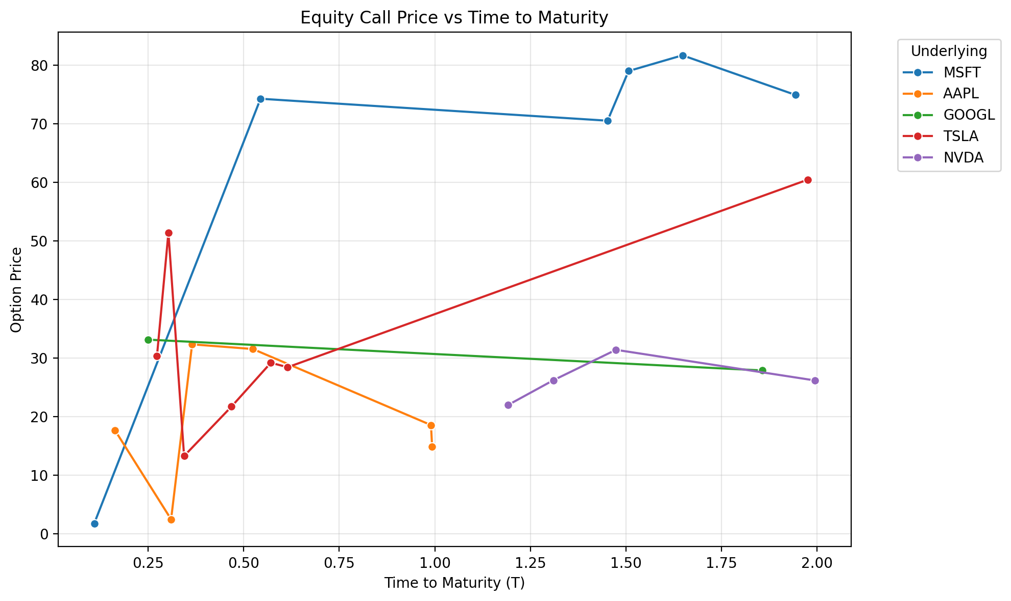
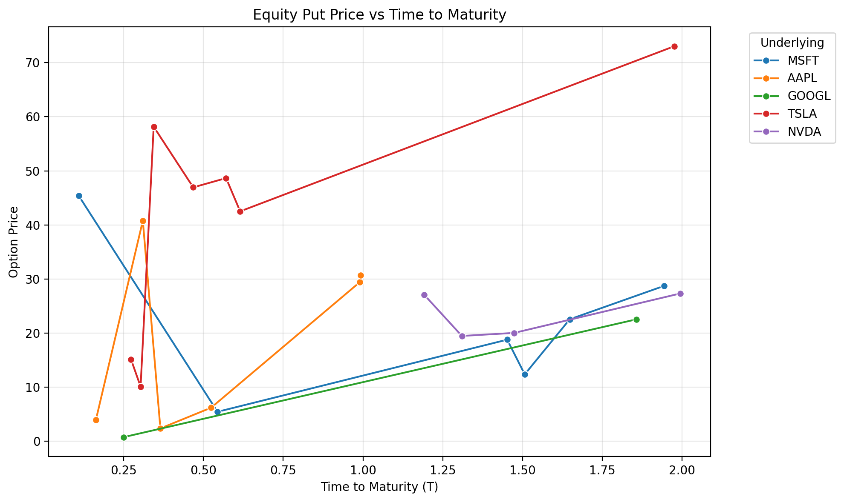

2.1.2 Summary of Sensitivity Testing for Equity

Portfolio Spot Stress (Gamma Profile)

Analysis of Portfolio Spot Sensitivity

1. Directional Bias (Delta View)
- Portfolio gains on Up moves.
- At +5% bump, PnL = +93.8 (vs. -50.91 at -5% bump).
- Delta is positive (long delta), indicating the portfolio benefits from upward price movements.

2. Convexity (Gamma View)
- Convex (Long Gamma).
- PnL increases at an accelerating rate for upward bumps (e.g., +32.51 at +2% → +93.8 at +5%).
- Losses decelerate for downward bumps (e.g., -50.91 at -5% → -25.65 at -2%).
- This asymmetry confirms long gamma exposure, where the portfolio benefits disproportionately from volatility.

3. Tail Risk
- Worst-case loss: -50.91 at a -5% bump.
- Downside risk is significant relative to the portfolio value (~3.3% of portfolio value at 1508.84).
- While losses do not accelerate sharply (unlike short gamma), the asymmetry in PnL highlights asymmetric tail risk (higher vulnerability to down moves vs. up moves).

Conclusion
The portfolio is long delta and long gamma, favoring upward price movements and volatility. However, it faces material tail risk in a severe down move (-5%), which could erode ~3.3% of portfolio value. Risk mitigation (e.g., hedging downside exposure) may be warranted.

Portfolio Volatility Stress (Vega Profile)

Analysis of Portfolio Volatility Sensitivity

1. Vega Exposure
- Conclusion: The portfolio is Long Vega.
- Rationale:
- The Net PnL increases as volatility rises (e.g., +195.56 at +5% bump) and decreases as volatility falls (e.g., -186.51 at -5% bump).
- This convexity in PnL (gains for upward volatility, losses for downward volatility) confirms a positive Vega exposure.

2. Impact of PnL vs. Spot Movements
- Conclusion: The PnL impact is significant relative to the portfolio's value.
- Rationale:
- A 5% volatility bump generates a 195.56 PnL gain (12.5% of the base portfolio value of 1,559.75).
- The sensitivity is asymmetric: losses for downward volatility (-186.51 at -5%) are slightly smaller in magnitude than gains for upward volatility, but both are material.
- This suggests the portfolio is heavily exposed to volatility shifts, likely due to long-dated options or volatility-dependent strategies.

Key Takeaway
The portfolio is Long Vega with high sensitivity to volatility changes, indicating a strategic or structural bias toward rising volatility. Risk mitigation (e.g., hedging with volatility derivatives) may be warranted if volatility is expected to decline.

Portfolio Rate Stress (Rho Profile)

1. Rho Exposure Analysis
The portfolio exhibits positive rate sensitivity (Rho), as evidenced by increasing Net PnL with rising interest rates. For example:
- A +0.01% rate bump generates +3.09 PnL, while a -0.01% bump results in -1.4 PnL.
- The PnL curve is non-linear (convex), with larger gains for upward rate shocks (e.g., +30.91 PnL at +0.05% vs. -11.23 PnL at -0.05%).
This asymmetry suggests the portfolio holds long-duration or rate-sensitive assets (e.g., equities with high interest rate elasticity, long-dated bonds, or leveraged positions).

2. Implication on Positioning
The portfolio is net long in rate-sensitive assets. The positive PnL response to rate hikes implies:
- Benefit from rising rates: The portfolio gains value as rates increase, consistent with long exposure to assets that appreciate in higher-rate environments (e.g., high-yield equities, long-duration bonds, or leveraged loans).
- Risk of falling rates: Negative PnL for downward rate shocks indicates vulnerability to rate declines, which would erode portfolio value.
This positioning reflects a bullish view on rate hikes or a structural bias toward assets with positive duration. Risk mitigation may require hedging with short-duration instruments or rate derivatives.
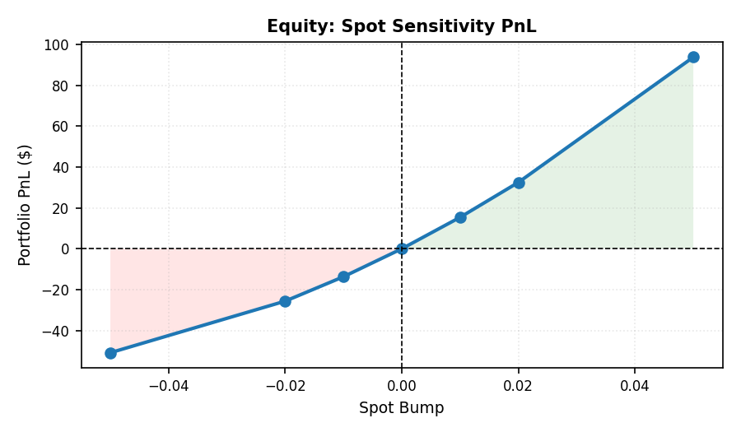
Figure: Spot Price Sensitivity for Equity
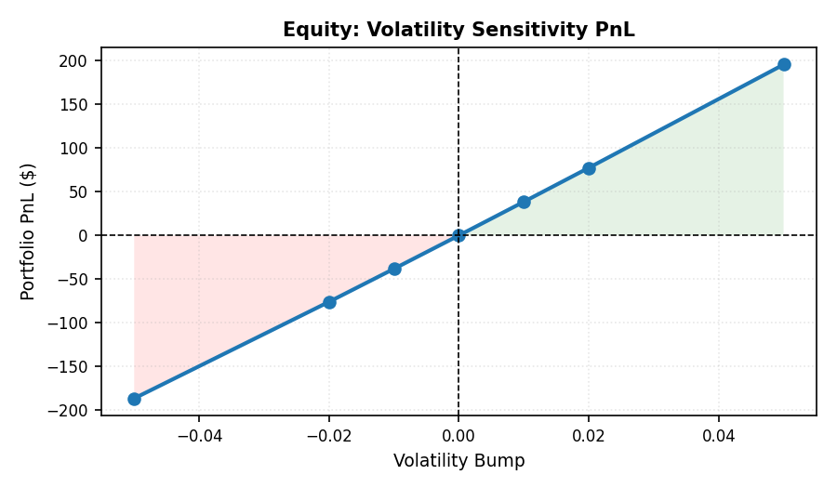
Figure: Volatility Sensitivity for Equity
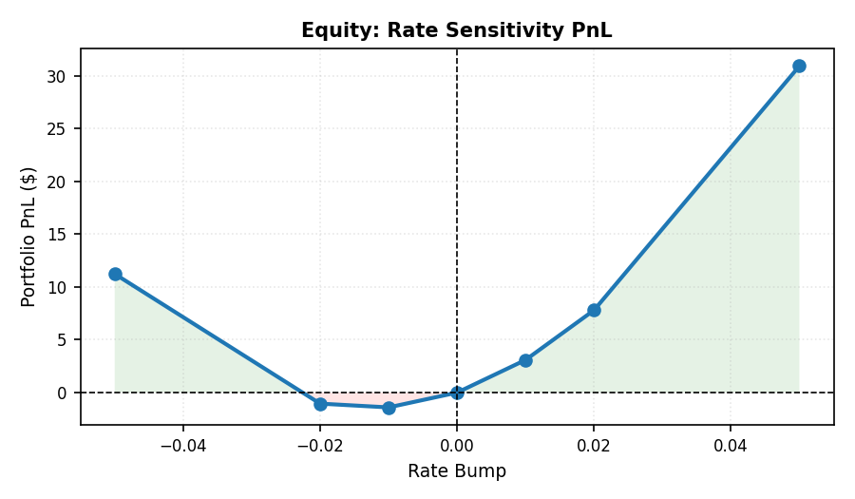
Figure: Interest Rate Sensitivity for Equity
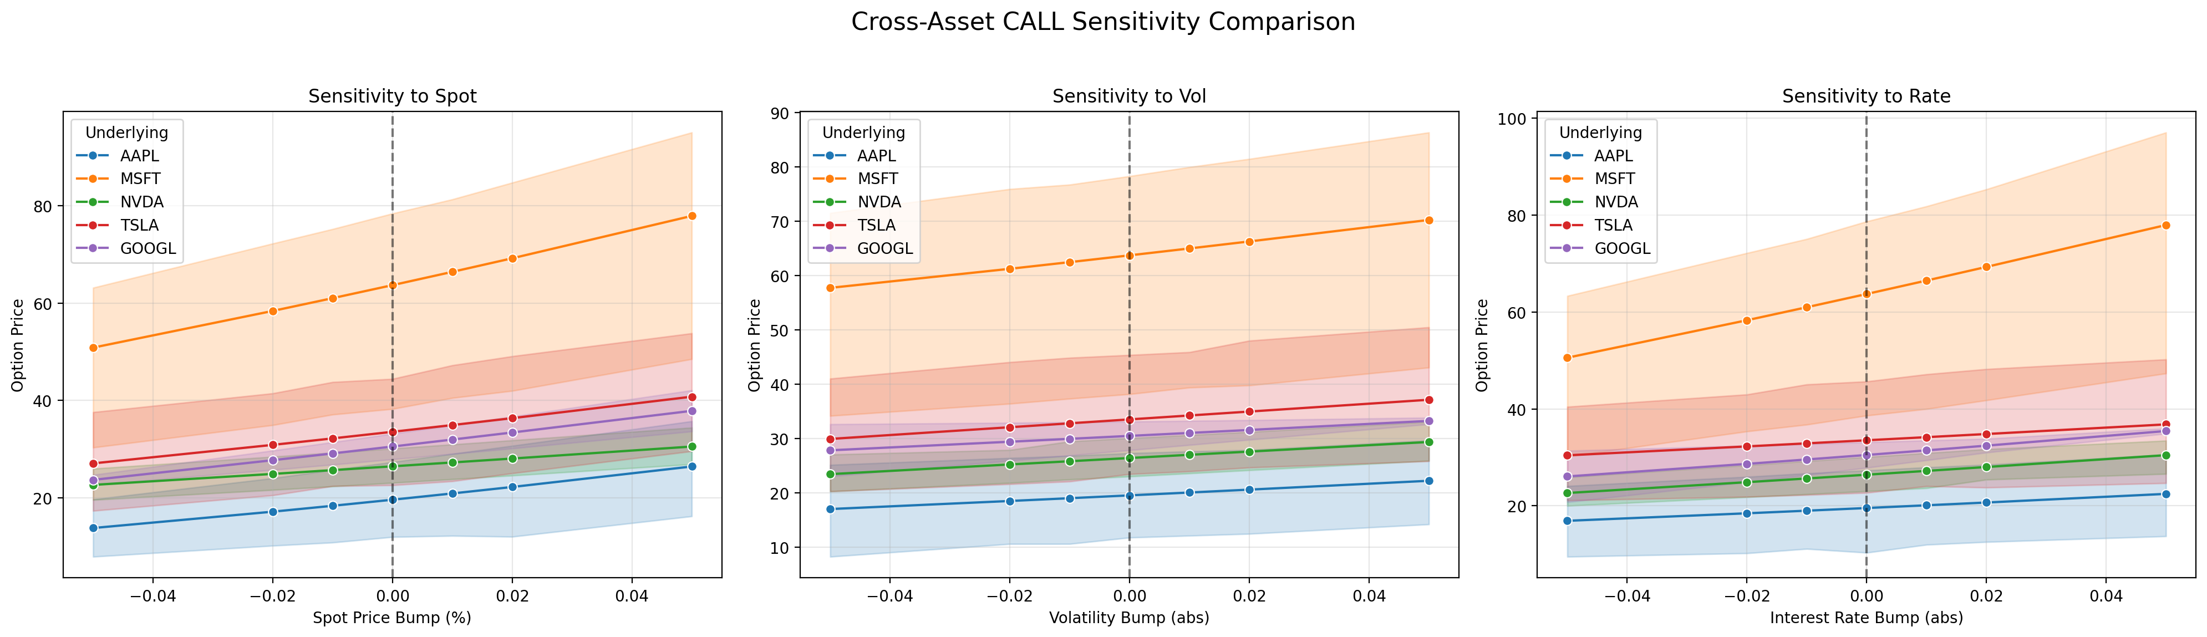
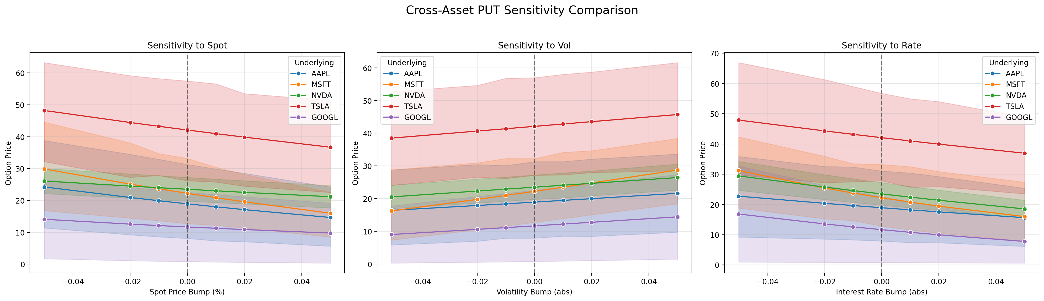

2.1.3 Summary of Stress Testing for Equity

1. Tail Risk Severity
The Volatility Collapse scenario causes the most damage (-176.52% PnL), representing a terminal event (wipeout). A loss exceeding 100% of invested capital indicates the portfolio is entirely liquidated under this stress case. This scenario likely reflects extreme volatility in tech stocks (e.g., MSFT’s -$1,156 loss), which dominate the portfolio’s exposure.

2. Factor Sensitivity
The portfolio is most sensitive to volatility shocks (Volatility Collapse, VIX Spike) rather than market crashes or rate shocks. For example:
- Volatility Collapse: -176.52% loss (terminal).
- 2008 Crisis: +269.94% loss (non-terminal but severe).
- Rate Shock: +0.5% gain (portfolio benefits from rising rates).
This suggests the portfolio is long volatility (e.g., leveraged equity positions) and short interest rates. It is not well-protected against sudden volatility spikes or liquidity crunches.

3. Hedge Effectiveness
The Worst Link analysis reveals a critical flaw: MSFT is the primary driver of losses in the Volatility Collapse scenario (-$1,156). Other scenarios (e.g., 2008 Crisis, Dot-com Crash) also point to GOOGL as a recurring weak link. This indicates the portfolio is overconcentrated in large-cap tech stocks (MSFT, GOOGL) without adequate hedging. The lack of diversification or sector-specific hedges leaves it vulnerable to idiosyncratic and systemic risks in these assets.

4. Operational Check
The Rate Shock (+200bps) scenario shows a positive PnL (+0.5%), which is counterintuitive for a "shock." This likely reflects short-duration or floating-rate positions (e.g., short-term bonds, interest rate swaps) that benefit from rising rates. However, the VIX Spike scenario (251.49% gain) suggests the portfolio may also hold long volatility instruments (e.g., VIX futures, out-of-the-money options). These mixed signals imply a directionally biased strategy with asymmetric risk/reward, which may not align with the stated portfolio objectives.

5. Final Verdict
Risk Profile: Directionally Biased.
- The portfolio is extremely sensitive to volatility and liquidity risks (Volatility Collapse is a terminal event).
- It shows asymmetric behavior: gains in rate shocks (short-duration bias) but catastrophic losses in volatility-driven scenarios (long-volatility bias).
- The lack of diversification (reliance on MSFT/GOOGL) and absence of effective hedging against tail risks make it highly fragile in stressed markets, despite appearing robust in certain scenarios.
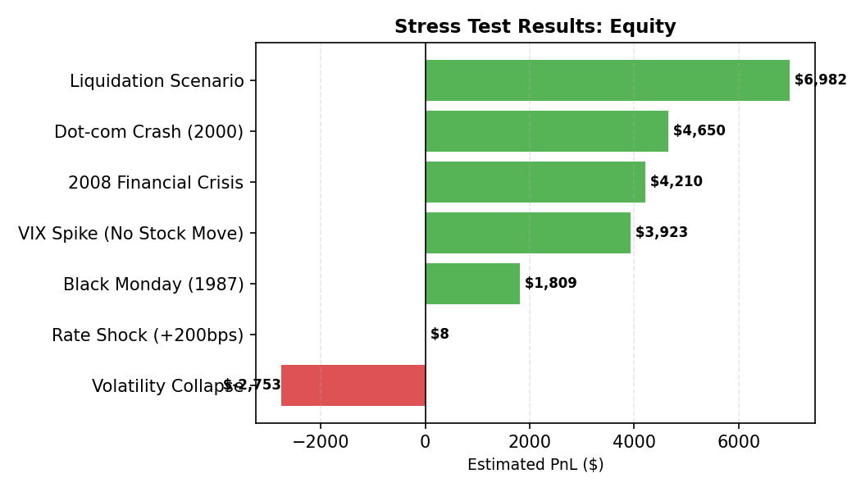
Figure: Stress Scenario Impact on Equity

Call Stress Exposure by Underlying
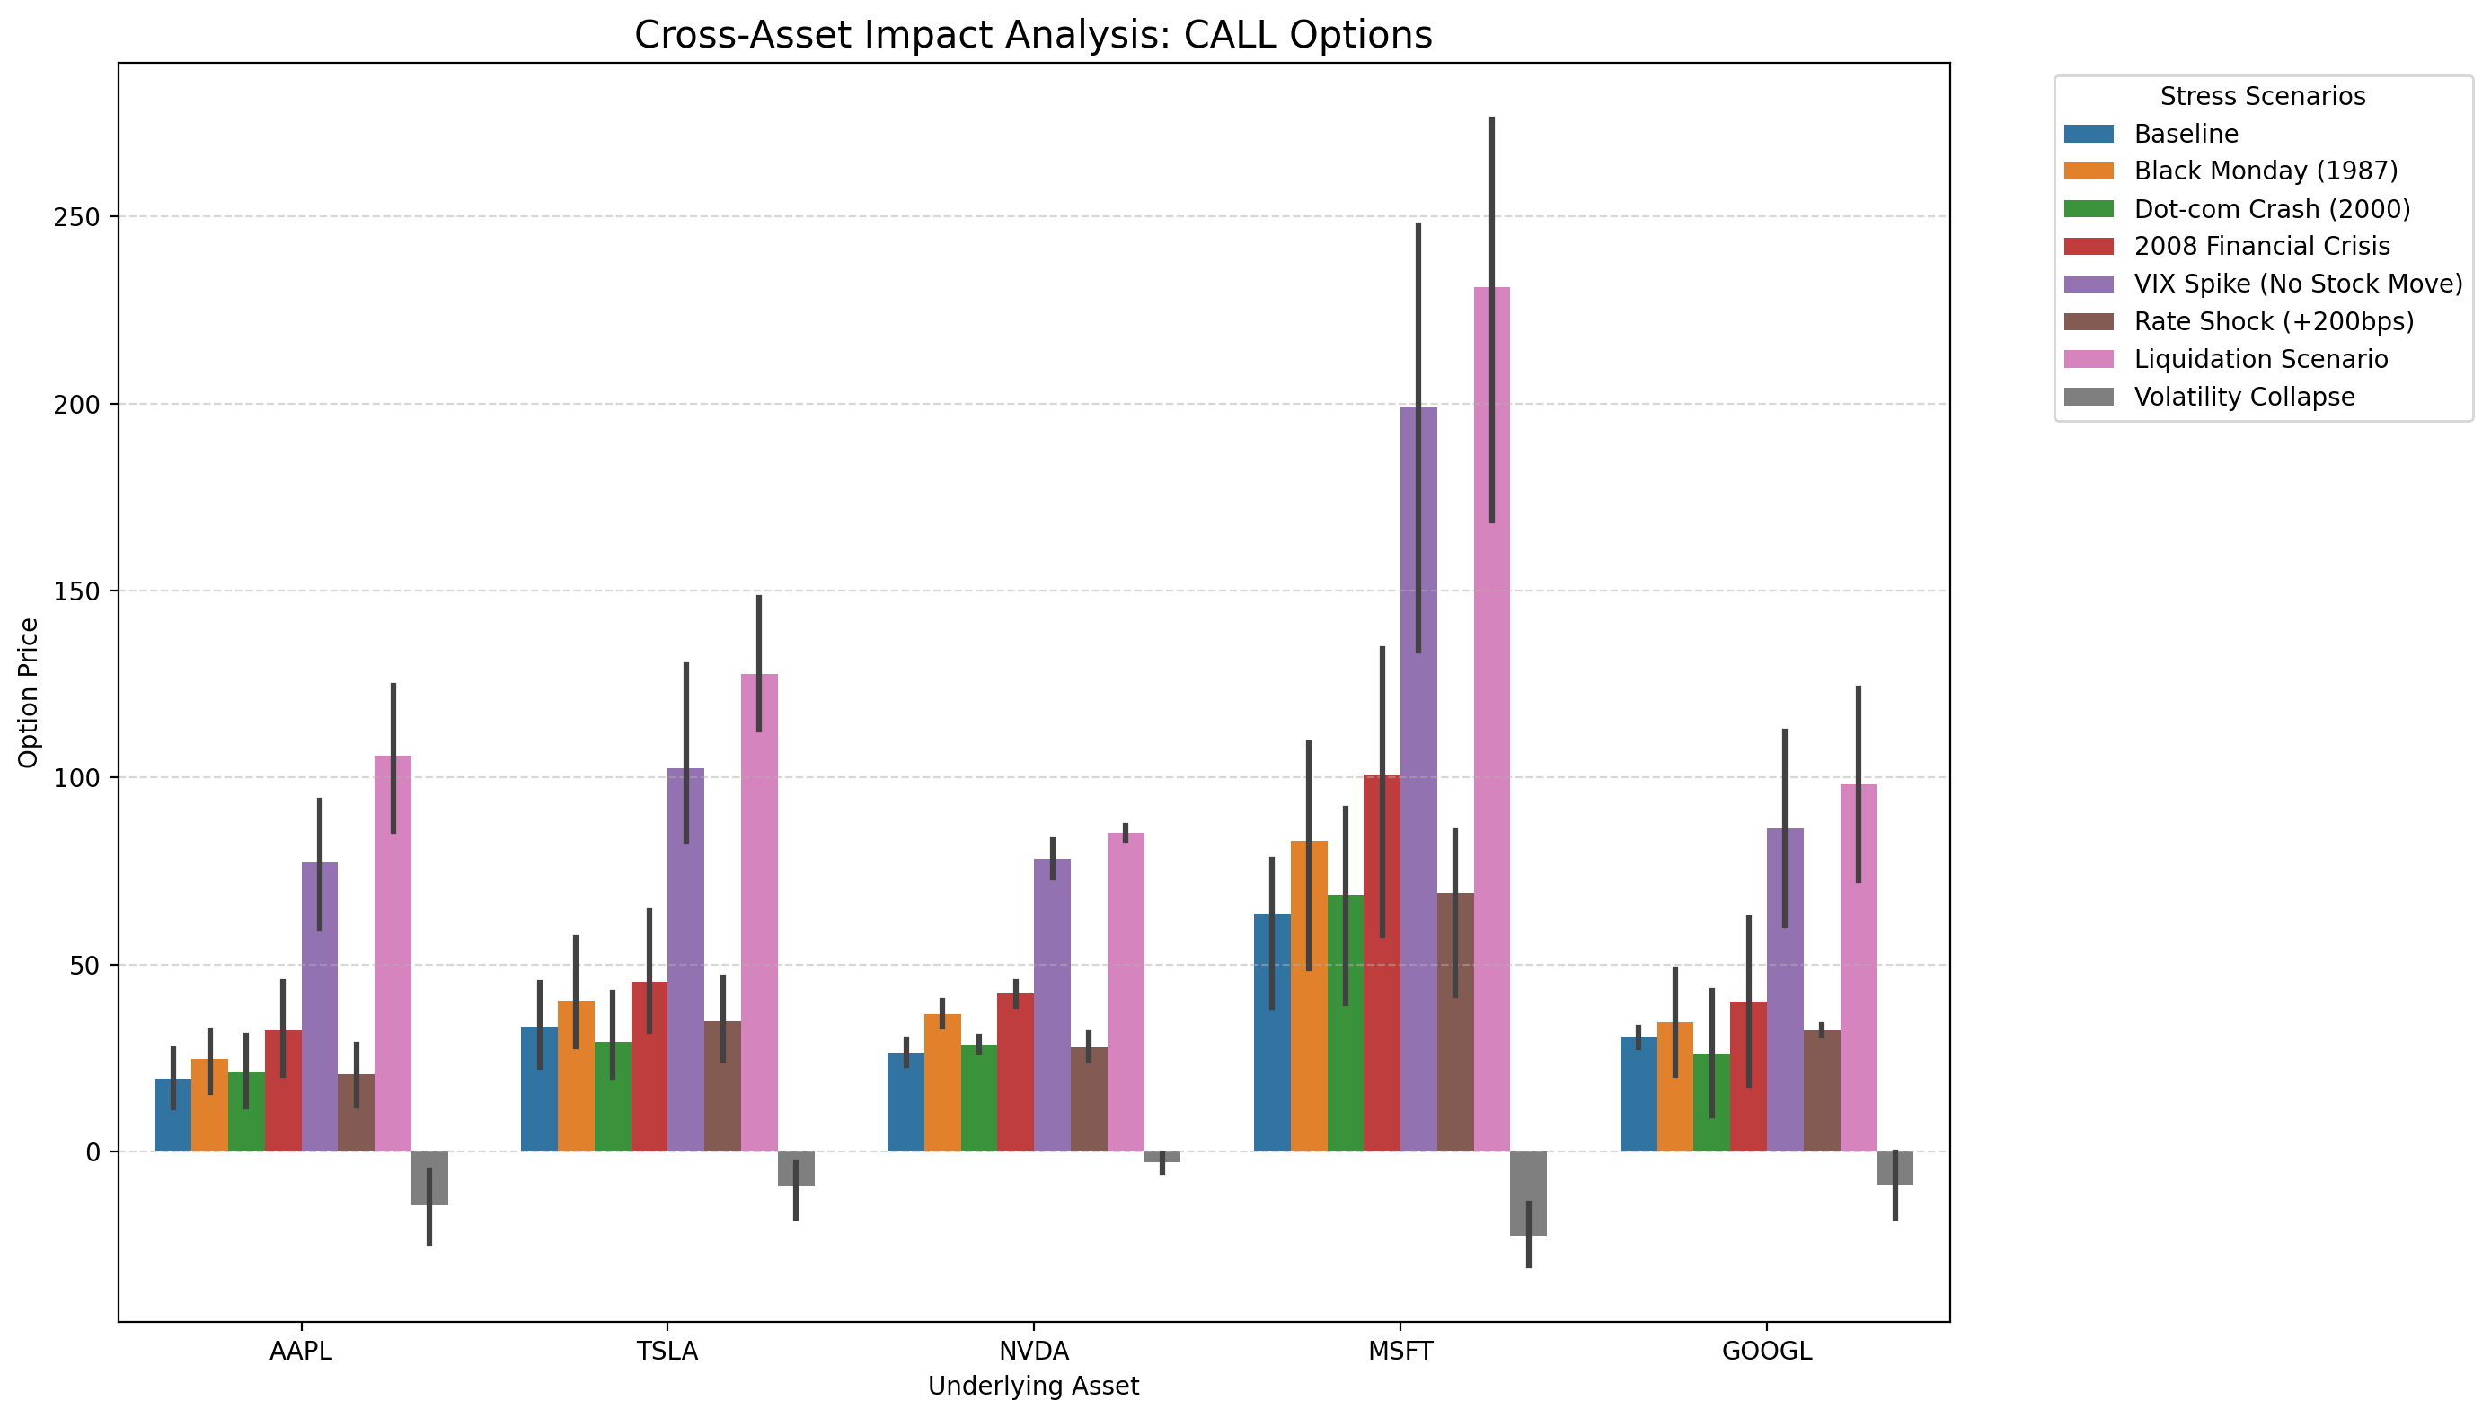

Put Stress Exposure by Underlying
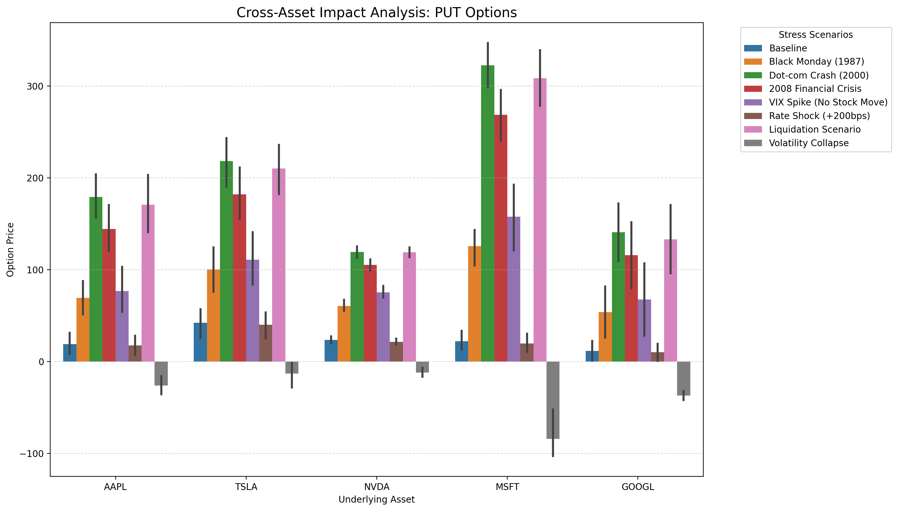

2.1.4 Summary of Put-Call Parity Testing for Equity

Model Consistency
The 100% pass rate indicates perfect adherence to put-call parity across all 25 analyzed pairs. This suggests either:
- High market efficiency with negligible arbitrage opportunities.
- Data limitations (e.g., synthetic or backtested data, or overly liquid assets where deviations are immediately corrected).
- Rounded precision (e.g., deviations exist but are masked by rounding to 4 decimal places).

Arbitrage Assessment
The "Top 5 Violations" show zero absolute deviations (`abs_diff = 0`), confirming no actionable arbitrage opportunities. Even if deviations existed, the values here are insufficient to cover transaction costs (e.g., bid-ask spreads, slippage, borrowing costs).

Strike Bias
No strike bias is evident in the data (all deviations = 0). However, in real-world scenarios, deviations at deep ITM/OTM strikes often arise due to:
- Low liquidity.
- Wide bid-ask spreads.
- Non-linear pricing effects (e.g., volatility skew).

Recommendation
- No data cleaning required: The dataset aligns with theoretical parity.
- No arbitrage execution needed: Deviations are zero, and transaction costs would negate any marginal opportunities.
- Monitor for anomalies: Maintain vigilance for future deviations, especially in illiquid strikes or during market stress.
Visual verification of the parity relationship:
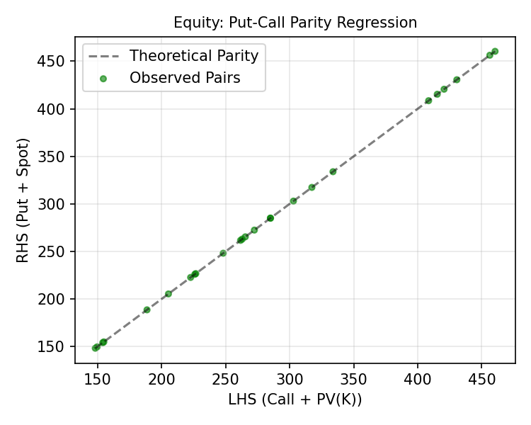
Figure: Parity Regression (LHS vs RHS) for Equity
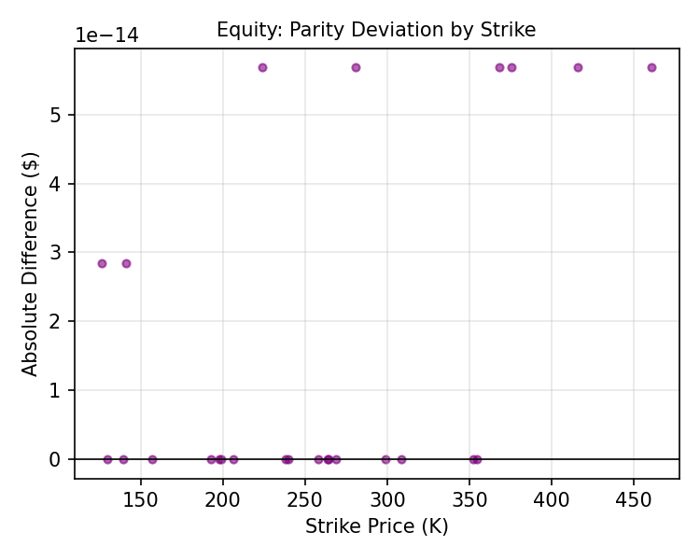
Figure: Deviation Magnitude across Strikes for Equity

Put-Call Parity Validation Analysis
