Bellman-Ford Shortest Path Algorithm DEVS Java Implementation

Danny Mangual
ECE 575
Fall 03 – Final Project
Dr. Bernard Zeigler
December 19, 2003
- Preface
Routing protocols are one of the main components on a computer network environment. They determine the best route from the source (sender) to the destination (receiver) for information transmission. Routing protocols had evolved on the past decades due to the high demand for network efficiency and reliability. Today, computer networks are not based on a single routing protocol; instead several routing protocols are enabled even sometimes on the simplest computer network in order to guarantee communication reliability.
Routing protocols have evolved such much in the past decades, that today; you can choose a single or multiple routing protocols that suitable for your specific applications and network environment. Traffic engineering mainly among other entities are responsible for the development of all these different types of routing algorithms.
Back to the beginning of the computer network era, one of the first and simplest routing protocols created was the Dijkstra's Shortest Path First algorithm. This algorithm used the number of nodes between the source and the destination to determine the shortest path among them. This type of route calculation is known as “hob based”. With the growth of computer networks and having the concern of reliability of the entire communication system, this algorithm evolved very fast into new routing algorithms.
Bellman-Ford shortest path algorithm was developed from algorithm was Dijkstra's Shortest Path First algorithm as many others. Bellman-Ford algorithm goes a step further from Dijkstra algorithm. This algorithm bases the route calculation on other network environment parameters like: link bandwidth, transmission delays, status of links and others. Bellman-Ford found with the implementation of this algorithm that sometime the shortest path based on the number of hops between the source and the destination is not the best path to follow. He showed that taking in consideration of other, more relevant, network environment characteristics you can find the more efficient route for communication exchange. As I mentioned before, many parameters are used to determine the best route. Bellman-Ford combined all these parameters into a single comparison parameter that he called “weight”.
Bellman-Ford shortest test path algorithm use this measure unit “weight” in order to determine the best route. The algorithm analyses all possible routes front the source and the destination and assign a total weight to the path. Once all the routes are analyzed, the destination chooses the transmission path based on the route with the smallest weight.
II. Objectives
The main objectives of this project are to demonstrate the performance of the Bellman-Ford shortest path algorithm using DEVS Java as the implementation suite. In future work, this model will need to make decisions dynamically during operation. For this project conditions are going to be held static (they are going to be specified at the beginning of the simulation) and the operation of the model will be based on them. Due to time constraints dynamic decision making and operation will not be implemented.

- Algorithm Pseudo code
The Bellman-Ford's algorithm works in more general case than the Dijkstra's algorithm. It can be applied to the negative-weight graph
G = (V, E) n = |V|, m = |E|
If there is a negative cycle that is reachable from the source, the Bellman-Ford's algorithm indicates that there is no solution; otherwise, it gives the shortest paths. In either case, it runs in time
O(nm)
The Bellman-Ford's algorithm is based on the concept feasible potential. We call
Y = (y_{v}: v € V)
a feasible potential if it satisfies:
y_{v} + C_{vw} >= y_{w} for all (v,w) € E
If we find a feasible potential, we also obtain the shortest paths, with the feasible potential y_{v} being the shortest path weight from the source to the node v. G has feasible potential if and only if it has no negative-weight circuit.
The Bellman-Ford's algorithm first initializes the sets y and P
Y_{r} = 0, y_{v} = INFINITY, v != r
P_{r} = 0, P_{v} = -1, v != r
If y is not feasible potential, then check all the edges (v,w) where
y_{v} + c_{vw} < y_{w}
Correct y_{w}, and P_{w}. Repeat this procedure at most n steps.
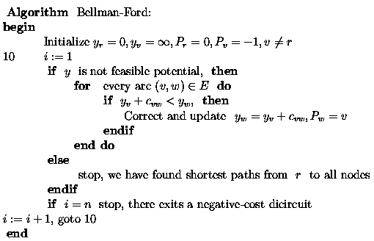
Using the example at the front page, we apply the Bellman-Ford's algorithm to it, and show the procedure step by step. For each node, we use the box to indicate tits y value, and the cycle to denotes its P.
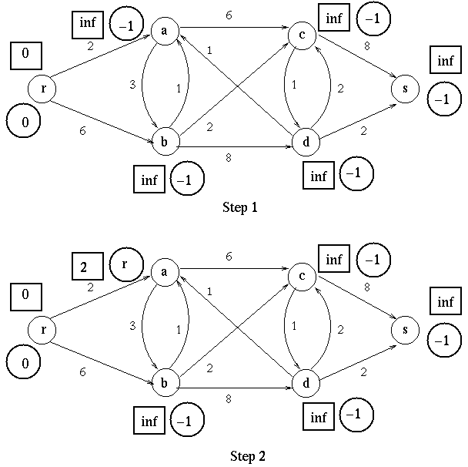
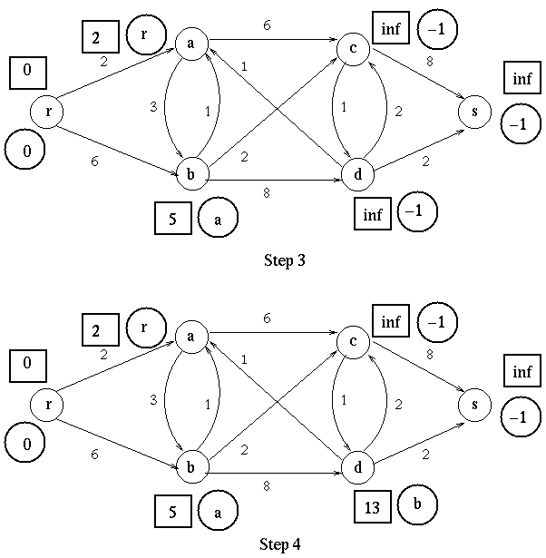
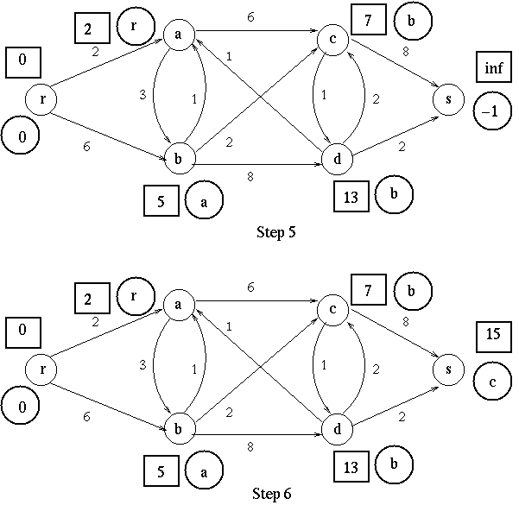

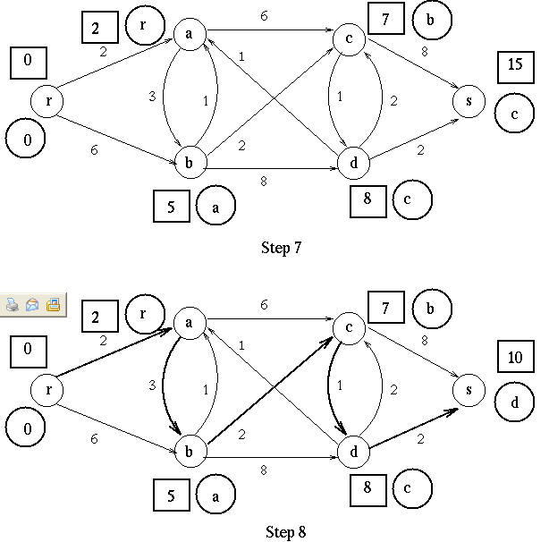
At the last step, the y values in boxes is a feasible potential, it indicates the shortest path weight from r to every node.
- Model
Network Node
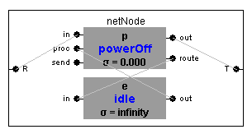
Network Node Model Diagram
This component consists of a Diagraph that contains to internal units: packetProcessor and the routeEngine. The networkNode component has one input port and one output port labeled R and T respectively. Packets arrive at the R port initially, after packet processing, packets if any, are forwarded to the T port which can be connected to other nodes for transmission. When the user decides to send a packet (information) from one node to another on the network, it needs to specify it on one of the input ports labeled as send of the packetProcessor component section
The main task of the packetProcessor is to receive the packet from the other nodes and perform processing operations like: determine the type of packet that arrive to a local node, determine processing sequence according to the current state of the node, and perform forwarding operation once a route is found.
The packetProcessor determines if packet has reached the destination. If the networkNode is not the destination, the packetProcessor forwards the packet to the routing engine, where information is appended to the packet. The packet is then forwarded back to the packetProcessor and it is forwarded to the output port. If the networkNode is the destination, the packetProcessor forwards information about the network to the routeEngine. The routing engine uses this information to build a reply message which is forwarded back to the packetProcessor and eventually to the T port.
After the packet reaches the destination the reply message that is generate at the destination if forwarded to all the nodes connected to the destination. These nodes will change their state to forwarding if the packet information contains path information that includes these nodes. If a route is already established and a new route is discovered with a lower weight, then the previous established route will be shutdown and the new route will be set up.
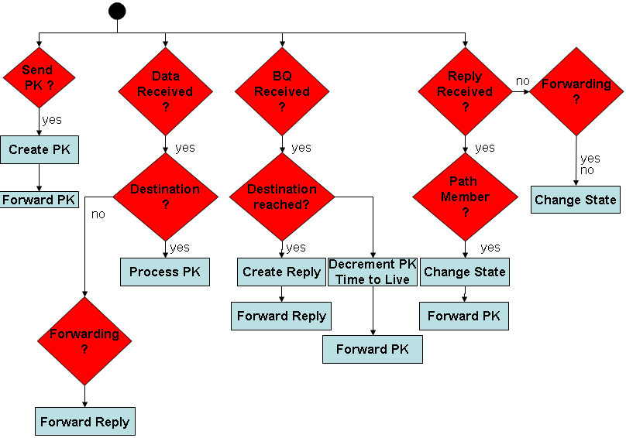
Network Node Model Pseudo diagram
Packet Model
There are three different types of packet available to the model: bq, reply and data.
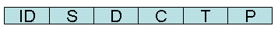
BQ packet diagram
REPLY packet diagram
DATA packet diagram
ID – Packet Type
S – Source
D – Destination
C – Total Path Cost
P – Path
I – Information
T – Time to Live
This model was implemented using a custom made link list. During the simulation when a packet is routed to a new node, information of the current node is appended at the back of the packet. This information is used by the destination’s routeEngine to build up the reply packet. The BQ packet contains a time to live field. This prevents packets from being forwarded forever (loops) on the network is the destination is no in the network structure. As the packet traverses the network, the path information is updated at the Total Path Cost field. Once the packet is received at the destination, the routeEngine uses this information in order to discard the route, set a route or update/cancel a current route already established.

Link Model
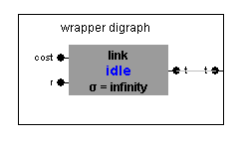
Link Model Diagram
The main task of the link model is to append link information (link weight) into the BQ packets. This information is added to the Total Path Cost on the BQ packet model. Information is only added/appended to BQ packets.
- Experimental Frame/Experiments
A computer network model was created to emulate the conditions necessaries for proper simulation and data analysis. The following is a diagram of the environment:
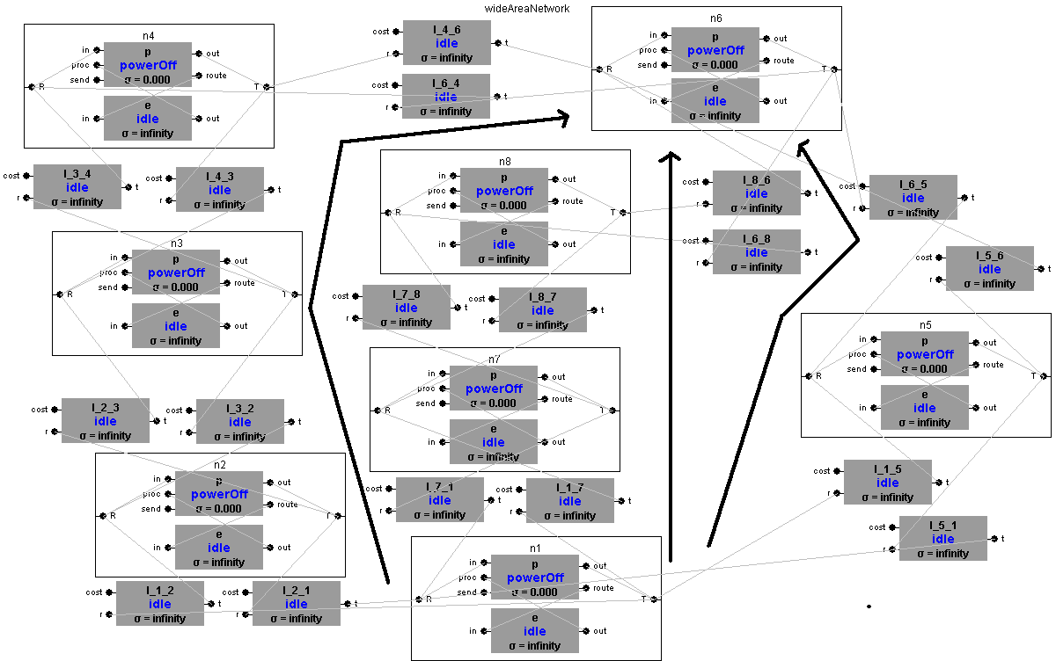
The diagram above shows three possible routes from left to right: R1, R2 and R3. The bottom node labeled n1 is the source node. On this model any node can be selected as the source. For analysis purposes n1 was selected as the source and n6 as the destination. The weights on the paths are as follow: R1 < R2 < R3. As you can see R1 should be the optimized path for transmission. During the simulation n6 will start the transmission of data as soon as it detects R3 path (R3 BQ is the first to arrive to n6). Later on, n6 will receive the update path for R2 and it will send a reply message that will shut down R3 and will enable R2. The same scenario occurs with R1. For algorithm analysis, n6 will not start data packet transmission until all BQ packets on the network are processed by n6.
Scenario can be changed to have R2 < R1 < R3. This way we can see that after R3 is enable and the shutdown when R2 update packet reached n6, any updates receive from R1 will be ignored. This is due to the fact that the update packet from R1 will have a greater weight than the previous established route. As a consequence, the state of the network will not change, having R2 as the preferred path.
- Results
Simulation showed the performance of the Bellman-Ford algorithm. As mentioned before, R3 was selected as the initial transmission path until R2 update packet reached n6. At this point R3 was shutdown and R2 was enabled. R3 was selected at the end of the simulation as the preferred path. The same scenario with R2 happened with R1. Total path cost for R3 was equal to 21, R2 equal to 10 and R1 equal 8. As the algorithm states, the route with the least cost will selected as the optimized path.
Scenario was changed to show that when the destination node receives an update packet with a weight greater than a previous established route, it will ignore the update and the network state will not change. This was done by having the following relationship: R2 < R1 < R3. This condition showed the previous statement.
Overall simulation scenarios we simulated and completed successfully. Expected results were the measurement for data and performance analysis.
- Future Work
Some future add-ons that can be incorporated to the model are having the capability of making dynamic link changes during the simulation. This will verify if the network can adapt itself to change, making the models self-aware to the system changes.
Expansion to the packet model to have a sequence field can be also incorporated. In real life models, the sequence field is use to verify if the packets were already processed by the nodes previously. This way, loops can be avoided.
- References
  - “How to Program with Java”, Deitel and Deitel, Prentice Hall – 1997
  - “Introduction to Algorithms”, 2nd, Cormen/Leiserson/Rivest/Stein – The MIT press – 2003
  - “Theory of Modeling and Simulation”, Zeigler/Praehofer/Kim, Academic Press – 2000

