To be submitted to Population Ecology

Title
How does the population dynamics of a dominant pioneer species change along secondary succession?
Population dynamics of a dominant pioneer species along a secondary succession gradient

Immigration
Survival

Authors
Gerardo Dávila, Edgar J. González, Rodrigo Muñoz, Jorge A. Meave

Affiliations

Abstract

Keywords
Integral projection model, secondary succession, pioneer species, dominant species

Introduction

In the last century a widespread process of land use change has occurred around the world, in which native vegetation, in many cases forests, is replaced by agricultural fields (Lambin & Meyfroidt, 2011). In tropical regions, these fields are usually abandoned after a few years of use, due to socioeconomic, political and productivity causes (Aide, Zimmerman, Pascarella, Rivera, & Marcano-Vega, 2000). After abandonment, a process of secondary succession starts (Letcher et al., 2015). If unperturbed, the community is capable of reaching a relatively stable state (Horn, 1974; Muñoz et al. 2021). Worldwide, many native forests are being replaced through land use change and abandonment by secondary vegetation (Meyfroidt & Lambin, 2011).
Three stages have been described in tropical forest secondary succession (Finegan, 1996; Lebrija-Trejos, Pérez-García, Meave, Poorter, & Bongers, 2011; Mora, Martínez-Ramos, Ibarra-Manríquez, Pérez-Jiménez, & Trilleras, 2015; Rozendaal et al., 2016). The first is characterized by the presence of weeds, shrubs, and climbing plants. The establishment of rapid-growth short-lived trees initiates a second stage. Under the canopy of these trees slow-growing long-lived tree seedlings develop and become dominant. Those species that establish and perform best in early successional stages are known as pioneers, while mature forest species do so in later stages. The differentiated presence and abundance of species in the three stages is determined by the environmental conditions at each successional moment, which in turn are driven by a feedback dynamics between the environment and the community (Gutiérrez & Fey, 1975; Wallace & Romney, 1980; Letcher et al., 2015). Therefore, the presence of certain pioneer species may facilitate or hinder the performance of other species depending on how they modify the environment (CITAS). In particular, dominant pioneers will play a substantial role in a community's successional dynamics.
Several studies have focused on secondary succession in tropical dry forests (Lebrija-Trejos et al., 2011; Dupuy et al., 2012; Pineda-García, Paz & Meinzer, 2013; Mora et al., 2015; Rozendaal et al., 2016). In these systems, the most important limiting factor is water availability (Lebrija-Trejos, Meave, Poorter, Pérez-García &, Bongers, 2010), which entails low plant growth rates (Rozendaal et al., 2016), and also explains why succession in these forests is dominated by very few drought-tolerant species (Markesteijn, Poorter, Paz, Sack &, Bongers, 2011; Rozendaal et al., 2016). In particular, in the tropical dry forest of the Nizanda region, Oaxaca, Mexico, Lebrija-Trejos, Bongers, Pérez-García, and Meave (2008) found a three year-long initial successional phase characterized by shrub growth. After this stage, early successional Mimosa acantholoba trees establish, becoming dominant over much of the successional process and creating a canopy that allows mature trees to settle.
Previous studies established M. acantholoba’s dominance based on its high basal area and individual density in relation to other species of the tropical dry forest of Nizanda (Romero, 2014). However, little is known about the traits that allow it; proposed characteristics are its thin leaves and high foliar dry mass content (Romero, 2014). Nevertheless, this species shares many of these traits with other non-dominant early successional species, suggesting that some other aspect of its life cycle, such as its population dynamics, may explain this pattern.
An important demographic process of the population dynamics of pioneer species in the early stages of secondary succession is the establishment of individuals. The absence of reproductive individuals during the early years of succession implies its population dynamics must depend on processes other than local reproduction. Some of these processes may be the dispersal of seeds from the surrounding forest matrix, the presence of a seed bank or the production of sprouts from remnant vegetative structures (Purata, 1986; Guevara & Laborde, 1993; Bartha, Meiners, Pickett, & Cadenasso, 2003; Muira & Yamamoto, 2003; Lebrija, 2004). In the case of M. acantholoba, no seed bank occurs in the Nizanda tropical deciduous forest (Meave et al. 2012; Mena, 2009). Furthermore, although seed rain was observed at the study site, the amount of seeds produced was very low compared to the number of trees in the plots (Cervantes, 2018), thus suggesting that seed dispersal may not play a significant role in the establishment of new individuals. However, because this information is based only on one year, we can not rule out seed rain as a source of recruits in this species. What is actually known is that M. acantholoba is the species that produces the largest number of sprouts in the community (Lebrija-Trejos, 2004), being a possible pathway for the increase in the density of its individuals. Thus, considering the contribution of sprouting may help better understand M. acantholoba’s population dynamics as a whole.
To understand the role population dynamics plays in the dominance of a pioneer species, in this study we characterized and modeled the dynamics of M. acantholoba throughout a secondary succession gradient. We achieved this by modeling M. acantholoba’s vital rates and their change along this gradient using data from a chronosequence. We then assembled these models into an integral projection model (IPM), that accounted for different recruitment sources, and estimated transient population growth rates. We expected that, at the onset of succession, the environmental conditions would promote M. acantholoba’s performance in the successional plots. Therefore, the population should increase its size during the early years of succession and decrease below in later stages due to changes in ecological conditions.

Methods

Study site

The Nizanda region (16°39'30" N, 95°00'40" W) is located on the Pacific slope of the Isthmus of Tehuantepec, Oaxaca, Mexico. The climate is warm subhumid with rains in summer (Aw₀(w)igw”) with an annual precipitation of 900 mm, concentrated almost entirely in the rainy season (June–September; Pérez-García, Meave &, Gallardo, 2001; Pérez-García, Meave, Villaseñor, Gallardo &, Lebrija-Trejos, 2010). Tropical dry forest is the dominant vegetation type (Pérez-García et al., 2001). In this region, slash-and-burn agriculture is one of the main human activities, commonly involving the abandonment of plots after a few years of use, thus entering a secondary succession process (Romero, 2014).

Study species

Mimosa acantholoba (Willd.) Poir. (synonyms Mimosa acantholoba var. eurycarpa, Mimosa eurycarpa) is a Fabaceae species, common in tropical dry forests of Mexico and Central America (Brienen, Lebrija-Trejos, Zuidema & Martínez-Romero, 2010). The species reaches more than 7 m in height and 20 cm in diameter at breast height (DBH), and presents its maximum height at approximately 40 years of age. It has deciduous leaves that fall at the end of the rainy season (November–December; Brienen et al., 2010); while fruit production runs from July to the end of November (Maldonado, 2014).

Data collection

In the study area, a chronosequence was established in 2003, consisting of 17 permanent plots, with different ages since abandonment, in which annual censuses have been carried out since then. Each year, individual height (m) and survival are recorded following the sampling method described by Lebrija-Trejos (2004). This method consists of placing, for each plot, four 20 × 5 m transects, separated by 2 m wide corridors, each divided into four 5 × 5 m quadrats. On each quadrat, all M. acantholoba individuals with a DBH ≥ 5 cm are measured; individuals with a DBH ≥ 2.5 cm are measured on eight quadrats; individuals with a DBH ≥ 1 cm are measured on four quadrats; and individuals with DBH < 1 cm and height > 30 cm on 4-m² subquadrats in eight quadrats.
We recorded reproduction data in November 2017 in 11 of the 17 permanent plots. For each individual, we recorded reproductive status and fruitset in one branch. We extrapolated the fruitset per reproductive individual by multiplying the later figure by its number of branches. We collected a sample of 98 fruits from 13 trees, covering tree size variation, and counted the number of seeds per fruit.

Modelling procedure

We modeled the population dynamics of M. acantholoba along the successional gradient through an integral projection model (IPM; Easterling, Ellner, & Dixon, 2000). IPMs allow analyzing the dynamics of populations structured by continuous stage variables (Ellner, Childs, & Rees, 2016). These are iterative models that describe the change of the population structure through a function k, called the kernel. They are represented through the equation

n_{t+1}(y) = ∫_{X}k_{t}(y, x)n_{t}(x)dx, eq. 1

where n_{t}(x) is the size structure, consisting of the number of individuals of size x (log-height, m) at successional age t (years since plot abandonment), and X is the range of all observed individual sizes. Note that in this study we are considering a kernel that changes from one time unit to the next as the dynamics changes along succession. In turn, we decomposed the kernel into seven vital-rate functions as

k_{t}(y, x) = s(x, t)g(y, x, t) + f₁(x, t)f₂(x, t)f₃(x, t)f₄(t)f₅(y), eq. 2

where s(x, t) is the probability of survival of an individual of size x at age t, g(x, y, t) is the probability that an individual of size x at age t has of changing to a size y at age t+1, f₁(x, t) is the reproduction probability of an individual of size x at age t, f₂(x, t) is the average number of fruits an individual of size x has at successional age t, f₃(x, t) is the average number of seeds in a fruit of a size x individual at age t, f₄(t) is the average recruitment probability of a seed at age t, and f₅(y) is the size distribution of recruits.
To include sprouts, which we consider to enter the population independently of the population dynamics developed so far, we include the additional functions f₆(t), which represents the number of sprouts produced at successional age t, and f₇(y), which represents the size y of these sprouts at the time of establishment.Thus, the IPM used has the form

n_{t+1}(y) = ∫_{X}k_{t}(y, x)n_{t}(x)dx + f₆(t)f₇(y). eq. 3

To model each vital rate we used generalized additive mixed models (GAMMs). For the binary variables, s and f₁, a logit link function and a binomial distribution were used; for the continuous function g we used an identity link function and a normal distribution; and for the count variables, f₂ and f₃, a log link function and a negative binomial distribution. In all these models, we considered as random effects the study plot, and for those vital rates for which more than one census year were available, the individual (nested in the plot) and the census year. The fitting of these models was performed in R (v. 4.1; R Core Team, 2021) using packages gamm4 (Wood and Scheipl, 2015) and brms (Bürkner, 2017; Bürkner, 2018). We considered the most complex models possible that could be fitted given the sample size, under the assumption that this type of models best reflects the reality of a complex system (Barr, Levy, Scheepers & Tily, 2014). Among these, the best-supported model was chosen through the sample-corrected Akaike's information criterion (AICc) using the AICcmodavg package (Mazorelle, 2019). In the case of the functions f₂ and f₃, in order to prevent the selection of models that extrapolated to biologically unrealistic values, we chose among those models that predicted a maximum value of less than twice the observed maximum of fruits and seeds, respectively.
Since no establishment data were registered in the field, we estimated recruitment probability, f₄, based on functions f₁, f₂, f₃ and the observed size structures, n_{obs}(x, t), using inverse estimation (González et al., 2016). For this purpose, we estimated, for each t, the total number of seeds produced per plot by individuals, distributed according to their size structure, as

b(t) = ∫_{X}f₁(x, t)f₂(x, t)f₃(x, t)n_{obs}(x, t)dx. eq. 4

Then, we obtained the total number of recruits from the following age t+1. Thus, f₄(t) was estimated as the proportion between the total number of recruits and b(t). Following this procedure, we obtained f₄(t) values for successional ages 2, 3, 4, 10, 24, 26, 27 and 64. With these values, we adjusted a spline with time as the explanatory variable.
The identification of recruits originating from seed germination and sprouts was inferred indirectly from the height and number of stems of individuals in the understory. To identify recruits, a k-means clustering procedure was performed and the individuals belonging to the group with the smallest sizes were classified as recruits. Only those individuals that had not been recorded in the immediate previous year were considered. From the height of these individuals, the function describing recruit sizes, f₅(y), was calculated as the associated empirical probability density. To identify sprouts, the understory individuals were filtered by considering only those with 3 or more stems in their first observation; this criterion is similar to that used by Lebrija-Trejos (2004). From the number and heights of identified sprouts produced at each successional age, we obtained the function that describes the sprout production, f₆(t), and the associated empirical probability density of sprout heights, f₇(y). Note that, since very few recruits were registered over the study years, we assume that both f₅(y) and f₇(y) do not change throughout succession.
A discretized version of the IPM was used to obtain the transient population sizes, N_{t}, and the transient population growth rates, λ_{t}, by dividing N_{t+1} by N_{t}.

Results

Vital rates

Enunciado introductorio…

The probability of survival, s, showed a positive relationship with tree size at time t, x, and a negative one with successional age, t (Fig. 1A). At the beginning of succession, nearly all trees, irrespective of size, have a high probability of survival, whereas only trees taller than 5 m survive in the mature forest.

The average change in height, i.e., the difference between tree size at t+1 and at t, y – x, displayed a negative relationship with tree size at time t, x, and a very weak negative relationship with successional age, t (Fig. 1B). As a result, trees with a height greater than 7 m have, on average, negative growth rates for all succession years. In contrast, trees with a height less than 7 m have positive growth rates throughout the succession. However, this growth is very small, being at most 0.41 m per year.

In turn, fecundity showed a positive relationship with tree height a time t, and a non-linear relationship with successional age, being higher at intermediate successional stages and lower at early and advanced stages. However, the latter pattern is more evident in medium and large trees (Fig. 1C). The average probability for a tree to reproduce was 0.34, while the maximum value was relatively low at 0.48 (Fig. S1). As for total seed production per reproductive tree, the average value predicted by the model was 231 seeds per tree, while the predicted maximum value was 2277 (Fig. 1C), about four times higher than the maximum observed of 544.

The size distribution of recruits and sprouts, f₅ and f₇, respectively, reflect the differences in size when they enter the population (Fig. 1D). While the size distribution of recruits was concentrated around 0.45 m in height, with a minimum of 0.2 m and a maximum of 0.76 m, the size distribution of sprouts had a mean of 1.39 m, with a minimum of 0.34 m and a maximum of 2.43 m. In addition, the standard deviation was higher in the sprout size distribution, at 0.46 m, with respect to the recruits distribution, at 1.21 m.

The probability of seed establishment decreased dramatically after the first years of succession (Fig. 1E). On average, the probability of establishment was very low with a value of 0.01. However, at the beginning of the succession this value is very high, with a maximum of 0.83 for the first year of abandonment, and being less than 0.1 from the fourth year onwards.

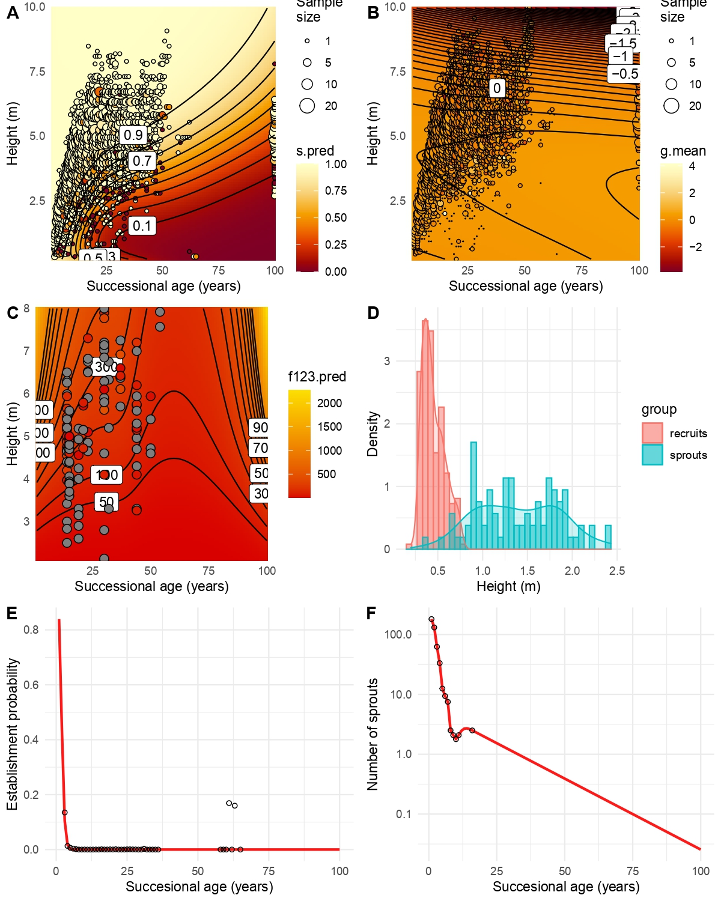

Figure 1.

Population dynamics

The population growth rate showed marked differences along the successional gradient (Fig. 2A). The first three years of the succession the growth rate was positive, with a maximum value of 3.54 in the first year. From the fourth year on, a decrease in the population began, with the lowest growth rate in the year 29, with a value of 0.65. Thereafter, a slower population decline begins until population extinction (dotted line in Fig. 2A).

The population size also changes dramatically throughout succession (Fig. 2B). The population begins the successional process with 238 sprouts, and reaches its maximum size in the fourth year, with 2063 individuals. From this point on, a rapid decline begins until, by year 38, the population becomes extinct as it reaches the one individual mark.

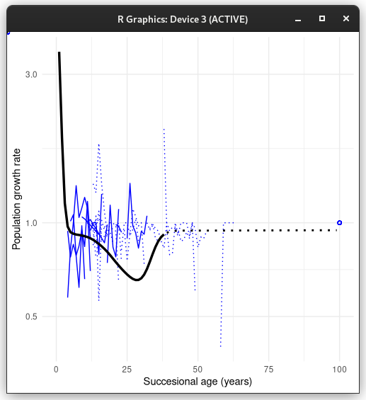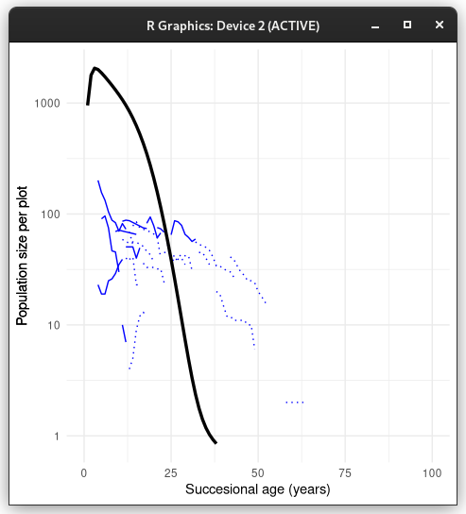

4 DISCUSSION

The study of the population dynamics of Mimosa acantholoba suggests that it experiences a negative change in the intensity of its vital processes as succession progresses, which may be strongly related to increased competition for light. Survival seems to be the process that changes most with the advancement of secondary succession, which has important repercussions on overall population dynamics. We observed strong changes in population dynamics generated only by the vital processes of individuals within the population, but these are insufficient to understand population behavior. The model that does not consider immigration predicts a population that begins to decrease from the beginning. In contrast, in the model that contemplates immigration, we observe a dynamic that is more in agreement with the available information, since the population grows rapidly at first and decreases later. The entry of recruits via immigration seems to be the most important factor in the population dynamics of M. acantholoba, especially at early ages of succession, over the vital processes of individuals within the population. However, it is necessary to consider the effect that the regrowth or seed bank may have on the entry of recruits and therefore on population dynamics.

[Idea para desarrollar]
La dinámica de la especie depende de la condición inicial del sitio. Si era bosque primario es menos probable que haya Mimosa. Si es bosque secundario se esperan muchos rebrotes. La dinámica que se está estudiando puede ser la mezcla de estos dos escenarios. No hay forma de distinguir parcelas que provenían de bosque maduro de aquellas que venían de bosque secundario.

4.1 Behaviour of survival, growth and fecundity along succession

All vital rates show a positive relationship with the height of individuals and negative with the advancement of successional age. Survival, growth, probability of reproduction and number of seeds per fruit, modeled with GLMMs, showed coefficients negatively related to successional age, although only in survival seems to have a considerable effect (Table 1). In addition, the number of fruits produced per individual and the probability of establishment, modelled by GAMMs, show this same relationship (Figs. 5 and 7). This means that changes in environmental conditions produced by the advance of successional age negatively affect M. acantholoba in all its vital processes, although not all with the same intensity, which is consistent with previous studies in which the performance of this species was observed (Lebrija-Trejos et al., 2008; Romero, 2014). On the other hand, height always had a positive relationship with all vital rates, showing higher coefficients than those associated with successional age. Therefore, the height of individuals seems to play a more important role in all cases.

Of all the vital processes, survival presents a deeper change as the successional age advances. At first, the probability of survival is close to one for all sizes, but as succession advances this probability decreases, especially for smaller individuals. Lebrija-Trejos et al. (2010) described the environmental factors characteristic of the early stages of secondary succession, such as high soil and air temperatures, as well as the low water availability in the soil. M. acantholoba has different functional attributes related to better performance under these conditions, such as high wood density, low water content in wood, narrow leaves, short leaflets, etc. (Romero, 2014). Since there are few species that grow under these conditions, they can reach large population sizes (Rozendaal et al., 2016), which may be happening in this case. However, when these conditions change, other species arrive that compete better for light, which can produce a decrease in the survival of M. acantholoba, thus reducing the population size.

In advanced ages the probability of survival decreased mainly for individuals with smaller sizes. This can be related to a decrease in recruitment, since light availability has decreased to a greater extent in the understory, causing a reduction in the production of shoots and in the establishment of recruits and, therefore, in fecundity (Maza-Villalobos et al., 2011). As succession progresses, survival decreases even for medium to large sized organisms. This supports the idea that the mechanisms that affect survival are related to the height of individuals, so competition for light could be a very relevant factor, as it is directly linked to this feature.

Many pioneer species have high growth rates in the early years of succession (Galia Selaya, Oomen, Netten, Werger &, Anten, 2008). In addition, this growth, reflected in the basal area, may be the main cause of the increase of biomass in pioneer species, above fertility (Rozendaal and Chazdon, 2015). In some systems the growth rate decreases as succession progresses, presumably due to changes in nutrient availability (Berger, Adams, Grimm &, Hildenbrandt, 2006). However, in the case of M. acantholoba, the growth rate along the succession remained constant pŕacticamente being higher for small individuals and lower for large individuals (Fig. 3). This suggests that mechanisms that affect the survival of individuals, including decreased availability of light, do not affect their growth. Regardless of the cause of the growth rate not varying much over time, this process does not appear to be the cause of the changes in the basal area along the succession. An increase in the number of individuals should explain these changes, which is consistent with the increase in the density of individuals also observed. Thus, it is difficult for the growth rate to cause important changes in population dynamics.

Like other vital processes, fecundity was higher for larger individuals and decreased with the advancement of secondary succession. Contrary to what was expected, fecundity had very low values from the beginning and did not show an increase in early ages. Within the processes understood by fecundity, the probability of establishment of recruits was particularly low, since the proportion of seeds that manage to germinate and establish is less than 0.0001. In other pioneer species this stage of the life cycle has already been identified as the bottleneck of their populations (Álvarez-Bullya & Martínez-Ramos, 1992). This may be due to decreased light availability in the understory (Maza-Villalobos, Balvarena &, Martínez-Ramos, 2011). Thus, the effect of low fecundity added to the decrease in survival causes a decrease in population size, since more individuals die than are established. The patterns observed here do not explain the observed increase in biomass. Other studies have found that recruitment is not as important in explaining changes in biomass as survival (Rozendaal & Chadzon, 2015). Due to its low values, fecundity can hardly drive the population growth or biomass increase that occurs in M. acantholoba populations.

4.2 Change in population growth rate along succession

Population growth rate calculated from the two tested demographic models, i.e. the one that contemplates the existence of immigrants and the one that does not, contrast remarkably with each other.

Population growth rate λ always decreases as the succession advances in the model that does not consider immigration. This is consistent with what was stated at the beginning and with the observations of other works in terms of biomass (Lebrija-Trejo et al., 2008; Romero, 2014), however at no point in the succession is this growth rate greater than one, which is very different from what was observed and does not explain the increase in population size or the increase in biomass that clearly occurs in reality. Considering fecundity of the individuals of the plots as the only way for recruits to join the population is insufficient to counteract the effect of mortality, that is, more individuals always die than are born. Thus, internal processes alone cannot explain the population dynamics of M. acantholoba.

4.3 Incorporation of immigration into population dynamics

When we consider the entry of recruits from outside the population via immigration, we observe a very marked change in the trend of population dynamics, since the values taken by λ for the first ages are much higher (Fig. 11), even than the values observed. As in the closed population model, λ becomes lower in advanced ages; however, in this case it stabilizes close to one, with small fluctuations along the succession. This pattern coincides better with what is known about the population of M. acantholoba in terms of basal area and density of individuals (Romero, 2014), since in the early stages of succession the population grows rapidly.

The model considering immigration adds to the first one a constant c entry of recruits each year. This entry of individuals is, at the beginning of the succession, greater than the number of individuals within the population. At this point in the succession, the environmental conditions allow these recruits to survive and grow, because the population grows rapidly. In contrast, in the mature forest stages, the environmental conditions are different and these recruits are less likely to survive long. A study conducted by van Breugel, Bongers and Martínez-Ramos (2007) observed that there is an entry of recruits of pioneer species during late stages of succession, being almost 50% of total recruitments, which supports this model. Thus, the constant entry of recruits allows the population to maintain a growth rate close to one until late stages of succession. In spite of this, the population size is very low, since the population is constituted mainly by the recruits of that year. This does not contradict the decrease in biomass or density of individuals, as these values can be very low even though λ equals one. Therefore, immigration seems to play a central role in λ's behavior, both in early and late stages of succession.

Presence of M. acantholoba in late stages appears to be due to the presence of other individuals whose fruits may disperse and provide recruits in the mature forest. Many studies have observed that species present in the secondary forest, as well as their abundances, are strongly related to those of the surrounding vegetation matrix (Purata, 1986; Guevara & Laborde, 1993; Bartha et al., 2003). It is important to consider that M. acantholoba is found in large quantities in roads and acahuales near the plots under study. Although there are no known studies on the dispersal capacity of this species, in field observations fruits have been found in places far away from adult individuals (pers. obs.). [IDEA PARA DESARROLLAR]: Es probable que las semillas que encontró Gerardo en sus trampas sean autóctonas porque es difícil que lleguen desde otros lados a trampas que están a 1m de altura (CITAR A GERARDO C.). It is possible, therefore, that without the presence of adult individuals close to the plots, the population growth rate takes values closer to zero at the end of the succession.

4.4 Methodological considerations

The experimental design in this study is based on the integration of two databases, which should be considered when interpreting the results of this work. We census the plots from which we obtained the data used to model survival and growth from 2003 to 2016. For this study, we had to obtain data on the presence and quantity of reproductive structures in order to model fertility. These data had not been previously recorded, so in 2017 we sampled in the field. In that year rains were recorded after several years of drought, possibly associated to ENSO (CITA). In addition, we observed a large number of dead M. acantholoba individuals, which showed a tearing of the wood. This phenomenon is not considered in the survival model as it is based on data recorded until 2016. Therefore, it is important to note that the environmental conditions may have been very different between the two sets of data that feed the different models. It is possible that the unusual high mortality of that year reduced the number of individuals that came to produce reproductive structures. This may imply an underestimation of the probability of reproduction modelled in f1(x, t) and therefore in fertility in general.

We carried out fruit counting and sampling in November, based on the phenological behavior of the species at the study site (Maldonado, 2014). During the field work, we could observe ripe fruits and some fruits in the soil. Therefore it is possible that the amount of fruits counted may differ from the amount of fruits actually produced. This could have reduced the number of fruits registered to model f2(x, t). No germination tests were done for this species and no studies are known to have done so, so the conversion factor from seeds to seedlings was calculated using the inverse estimation method (González, Martorell, & Bolker, 2016). It is possible that the inclusion of a germination study has greater precision to model the entire reproductive process. However, the inverse estimation method avoids dealing with a possible difference between the probability of germination in a laboratory and in the field.

It is important to keep in mind that the database that feeds growth and survival is much larger than that which feeds fecundity, making it more difficult to identify outliers in fecundity. Therefore, we cannot rule out that the low values observed in fertility may be related to all of the above. In order to understand what happens in the fertility process, it is important to have a larger database and to consider different years of sampling in order to have greater control over year-to-year variation.

It is also necessary to consider the effect that other processes may have that we did not record or contemplate in the model in this study. This species is known to have a seed bank and a high resprouting capacity. These processes result in the emergence of recruits in the population. However, in this study, immigration was considered as any entry of recruits independent of the production of seeds within the plot. Because of this, individuals recruited from the seed bank or from the regrowth of individuals believed to be dead may actually be part of this entry of individuals. If so, immigration would be overestimated, so it is important to consider these elements. However, the results show that there must be a strong external component to the population that allows Mimosa acantholoba to be so successful at the beginning of the secondary succession.

References

Lambin, E. F., & P. Meyfroidt (2011). Global land use change, economic globalization,
and the looming land scarcity. Proceedings of the National Academy of Sciences
of the United States of America 108(9) 3465-3472.

Aide, M. T., J. K. Zimmerman, J. B. Pascarella, L. Rivera, & H. Marcano-Vega (2000).
Forest regeneration in a chronosequence of tropical abandoned pastures: implications
for restoration ecology. Restoration Ecology 8(4) 328-338.

Letcher, S. G., J. R. Lasky, R. L. Chazdon, N. Norden, S. J. Wright, J. A. Meave, … G. B. Williamson (2015). Environmental gradients and the evolution of successional habitat specialization: A test case with 14
Neotropical forest sites. Journal of Ecology 103(5), 1276-1290.

Horn, H. S. (1974). The Ecology of Secondary Succession. Annual Review of Ecology and Systematics 5(1), 25-37.

Meyfroidt, P., & E. F. Lambin (2011). Global Forest Transition: Prospects for an End to
Deforestation. Vol. 36. 1, pp. 343-371. ***

Finegan, B. (1996). Pattern and process in neotropical secondary rain forest: the first 100
years of succession. Trends in Ecology and Evolution 11(3), 119-124.

Lebrija-Trejos, E., E. A. Pérez-Garcı́a, J. A. Meave, L. Poorter, & F. Bongers (2011). Environmental changes during secondary succession in a tropical dry forest in Mexico. Journal of Tropical Ecology 27(5), 477-489.

Mora, F., M. Martı́nez-Ramos, G. Ibarra-Manrı́quez, A. Pérez-Jiménez, J. Trilleras, & P.
Balvanera (2015). Testing chronosequences through dynamic approaches: time and site effects on tropical dry forest succession. Biotropica 47(1), 38-48.

Rozendaal, D. M., R. L. Chazdon, F. Arreola-Villa, P. Balvanera, T. V. Bentos, J. M.
Dupuy, J. L., ... F. Bongers (2016). Demographic drivers of aboveground biomass dynamics during secondary succession in neotropical dry and wet forests. Ecosystems 20(2), 340-353.

Gutierrez, L. T., & W. R. Fey (1975). Feedback dynamics analysis of secondary successional transients in ecosystems. Proceedings of the National Academy of Sciences of the United States of America 72(7), 2733-2737.

Wallace, A., & E. M. Romney (1980). The role of pioneer species in revegetation of
disturbed desert areas. Great Basin Naturalist Memoirs 4, 31-33. ***

Dupuy, J. M., J. L. Hernández-Stefanoni, R. A. Hernández-Juárez, E. Tetetla-Rangel, J. O.
López-Martı́nez, E. Leyequién-Abarca, ... F. May-Pat (2012). Patterns and correlates of tropical dry forest structure and composition in a highly replicated chronosequence in Yucatan, Mexico. Biotropica 44(2), 151-162.

Pineda-Garcı́a, F., H. Paz, & F. C. Meinzer (2013). Drought resistance in early and late secondary successional species from a tropical dry forest: The interplay between xylem resistance to embolism, sapwood water storage and leaf shedding. Plant, Cell and Environment 36(2), 405-418.

Lebrija-Trejos, E., J. A. Meave, L. Poorter, E. A. Pérez-Garcı́a, & F. Bongers (2010). Pathways, mechanisms and predictability of vegetation change during tropical dry forest succession. Perspectives in Plant Ecology, Evolution and Systematics 12(4), 267-275.

Markesteijn, L., L. Poorter, H. Paz, L. Sack, & F. Bongers (2011). Ecological differentiation in xylem cavitation resistance is associated with stem and leaf structural traits. Plant, Cell and Environment 34(1), 137-148.

Lebrija-Trejos, E., F. Bongers, E. A. Pérez-Garcı́a, & J. A. Meave (2008). Successional change and resilience of a very dry tropical deciduous forest following shifting agriculture. Biotropica 40(4), 422-431.

Romero-Pérez, I. E. (2014). Atributos Funcionales y Desempeño de Especies Arbóreas
Durante la Sucesión Secundaria de un Bosque Tropical Caducifolio (master’s thesis).
Universidad Nacional Autónoma de México, México.

Purata, S. E. (1986). Floristic and structural changes during old-field succession in the Mexican tropics in relation to site history and species availability. Journal of Tropical Ecology 2(3), 257-276.

Guevara, S., & J. Laborde (1993). Monitoring seed dispersal at isolated standing trees in
tropical pastures consequences for local species availability. Frugivory and seed
dispersal: ecological and evolutionary aspects. Ed. por T. H. Fleming y A. Estrada.
Dordrecht: Springer, 319-338. ***

Bartha, S., S. J. Meiners, S. T. Pickett, & M. L. Cadenasso (2003). Plant colonization windows in a mesic old field succession. Applied Vegetation Science 6(2), 205-212.

Pérez-Garcı́a, E. A., J. Meave, & C. Gallardo (2001). Vegetación y flora de la región de
Nizanda, istmo de Tehuantepec, Oaxaca, México. Acta Botánica Mexicana 56, 19-88. ***

Pérez-Garcı́a, E. A., J. A. Meave, J. L. Villaseñor, J. A. Gallardo-Cruz, & E. E. Lebrija-
Trejos (2010). Vegetation heterogeneity and life-strategy diversity in the flora of the
heterogeneous landscape of Nizanda, Oaxaca, Mexico. Folia Geobotanica 45(2), 143-161.

Brienen, R. J., E. Lebrija-Trejos, P. A. Zuidema, & M. Martı́nez-Ramos (2010). Climate-
growth analysis for a Mexican dry forest tree shows strong impact of sea surface
temperatures and predicts future growth declines. Global Change Biology 16(7), 2001-2012.

Lebrija-Trejos, E. (2004). Secondary Succession in a Tropical Dry Forest of Southern
Mexico (master’s thesis). Wageningen University, Netherlands.

Easterling, M. R., S. P. Ellner, & P. M. Dixon (2000). Size-specific sensitivity: applying a
new structured population model. Ecology 81(3), 694-708.

Ellner, S. P., Childs, D. Z., & Rees, M. (2016). Data-driven modelling of structured populations. A practical guide to the Integral Projection Model. Cham: Springer. ***

Bates, D., M. Mächler, B. M. Bolker, & S. C. Walker (2015). Fitting linear mixed-effects
models using lme4. Journal of Statistical Software 67(1), 1-48.

Wood, S., & F. Scheipl (2017). gamm4: Generalized Additive Mixed Models using ’mgcv’
and ’lme4’. R package version 0.2-5. ***

Mazerolle, M. J. (2019). AICcmodavg: Model selection and multimodel inference based
on (Q)AIC(c). R package version 2.2-2. ***

Maza-Villalobos, S., P. Balvanera, & M. Martı́nez-Ramos (2011). Early regeneration of
tropical dry forest from abandoned pastures: contrasting chronosequence and dynamic
approaches. Biotropica 43(6), 666-675.

Galia Selaya, N., R. J. Oomen, J. J. Netten, M. J. Werger, & N. P. Anten (2008). Biomass allocation and leaf life span in relation to light interception by tropical forest plants during the first years of secondary succession. Journal of Ecology 96(6), 1211-1221.

Rozendaal, D. M., & R. L. Chazdon (2015). Demographic drivers of tree biomass change
during secondary succession in northeastern Costa Rica. Ecological Applications 25(2), 506-516.

Berger, U., M. Adams, V. Grimm, & H. Hildenbrandt (2006). Modelling secondary succession of neotropical mangroves: Causes and consequences of growth reduction in pioneer species. Perspectives in Plant Ecology, Evolution and Systematics 7(4), 243-252.

Álvarez-Buylla, E. R., & M. Martı́nez-Ramos (1992). Demography and allometry of Cecropia obtusifolia, a neotropical pioneer tree - an evaluation of the climax-pioneer paradigm for tropical rain forests. The Journal of Ecology 80(2), 275-290.

Van Breugel, M., F. Bongers, & M. Martı́nez-Ramos (2007). Species dynamics during
early secondary forest succession: Recruitment, mortality and species turnover. Biotropica 39(5), 610-619.

González, E. J., C. Martorell, & B. M. Bolker (2016). Inverse estimation of integral projection model parameters using time series of population-level data. Methods in Ecology and Evolution 7(2), 147-156.

Paul-Christian Bürkner (2017). brms: An R Package for Bayesian Multilevel Models Using Stan. Journal of Statistical Software, 80(1), 1-28. doi:10.18637/jss.v080.i01

Paul-Christian Bürkner (2018). Advanced Bayesian Multilevel Modeling with the R Package brms. The R Journal, 10(1), 395-411. doi:10.32614/RJ-2018-017

Tables

Table 1. Fixed effects values associated with the generalized linear mixed models constructed to describe survival (s), individual growth (g), reproduction probability (f₁) and average number of seeds per fruit (f₃), which related linearly to log-height (x, m) and successional age (t, years since plot abandonment).

Vital rate function | Intercept | x | t | x-t interaction
s | 3.9435 | 0.7798 | -0.2014 | 0.0595
g | 0.2203 | 0.8519 | -0.0022 | 0.0015
f₁ | -3.8030 | 2.0189 | -0.0082 | 0.0003
f₃ | 1.1730 | 0.1985 | -0.0016 | -

Figures legends

Figure 1. Vital rates of Mimosa acantholoba as a function of height and successional age according to the models (background) fitted to the data (circles). a) Survival probability, b) average individual growth, c) reproduction probability, d) average fruitset per reproductive individual, e) average seed number per fruit.

Figures
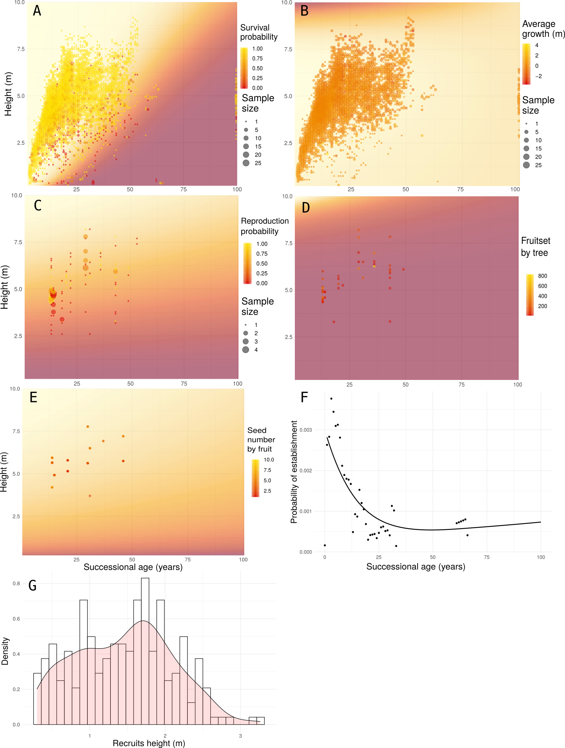

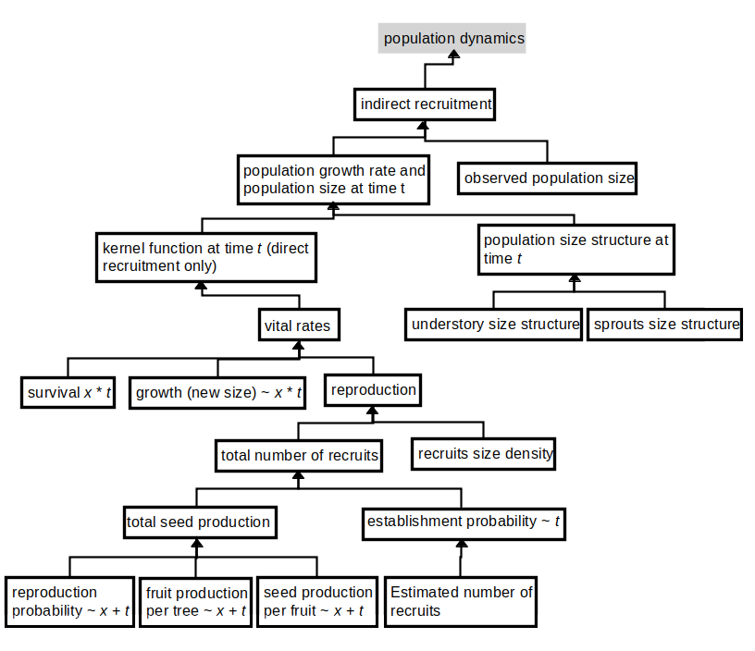

Figure 1a.
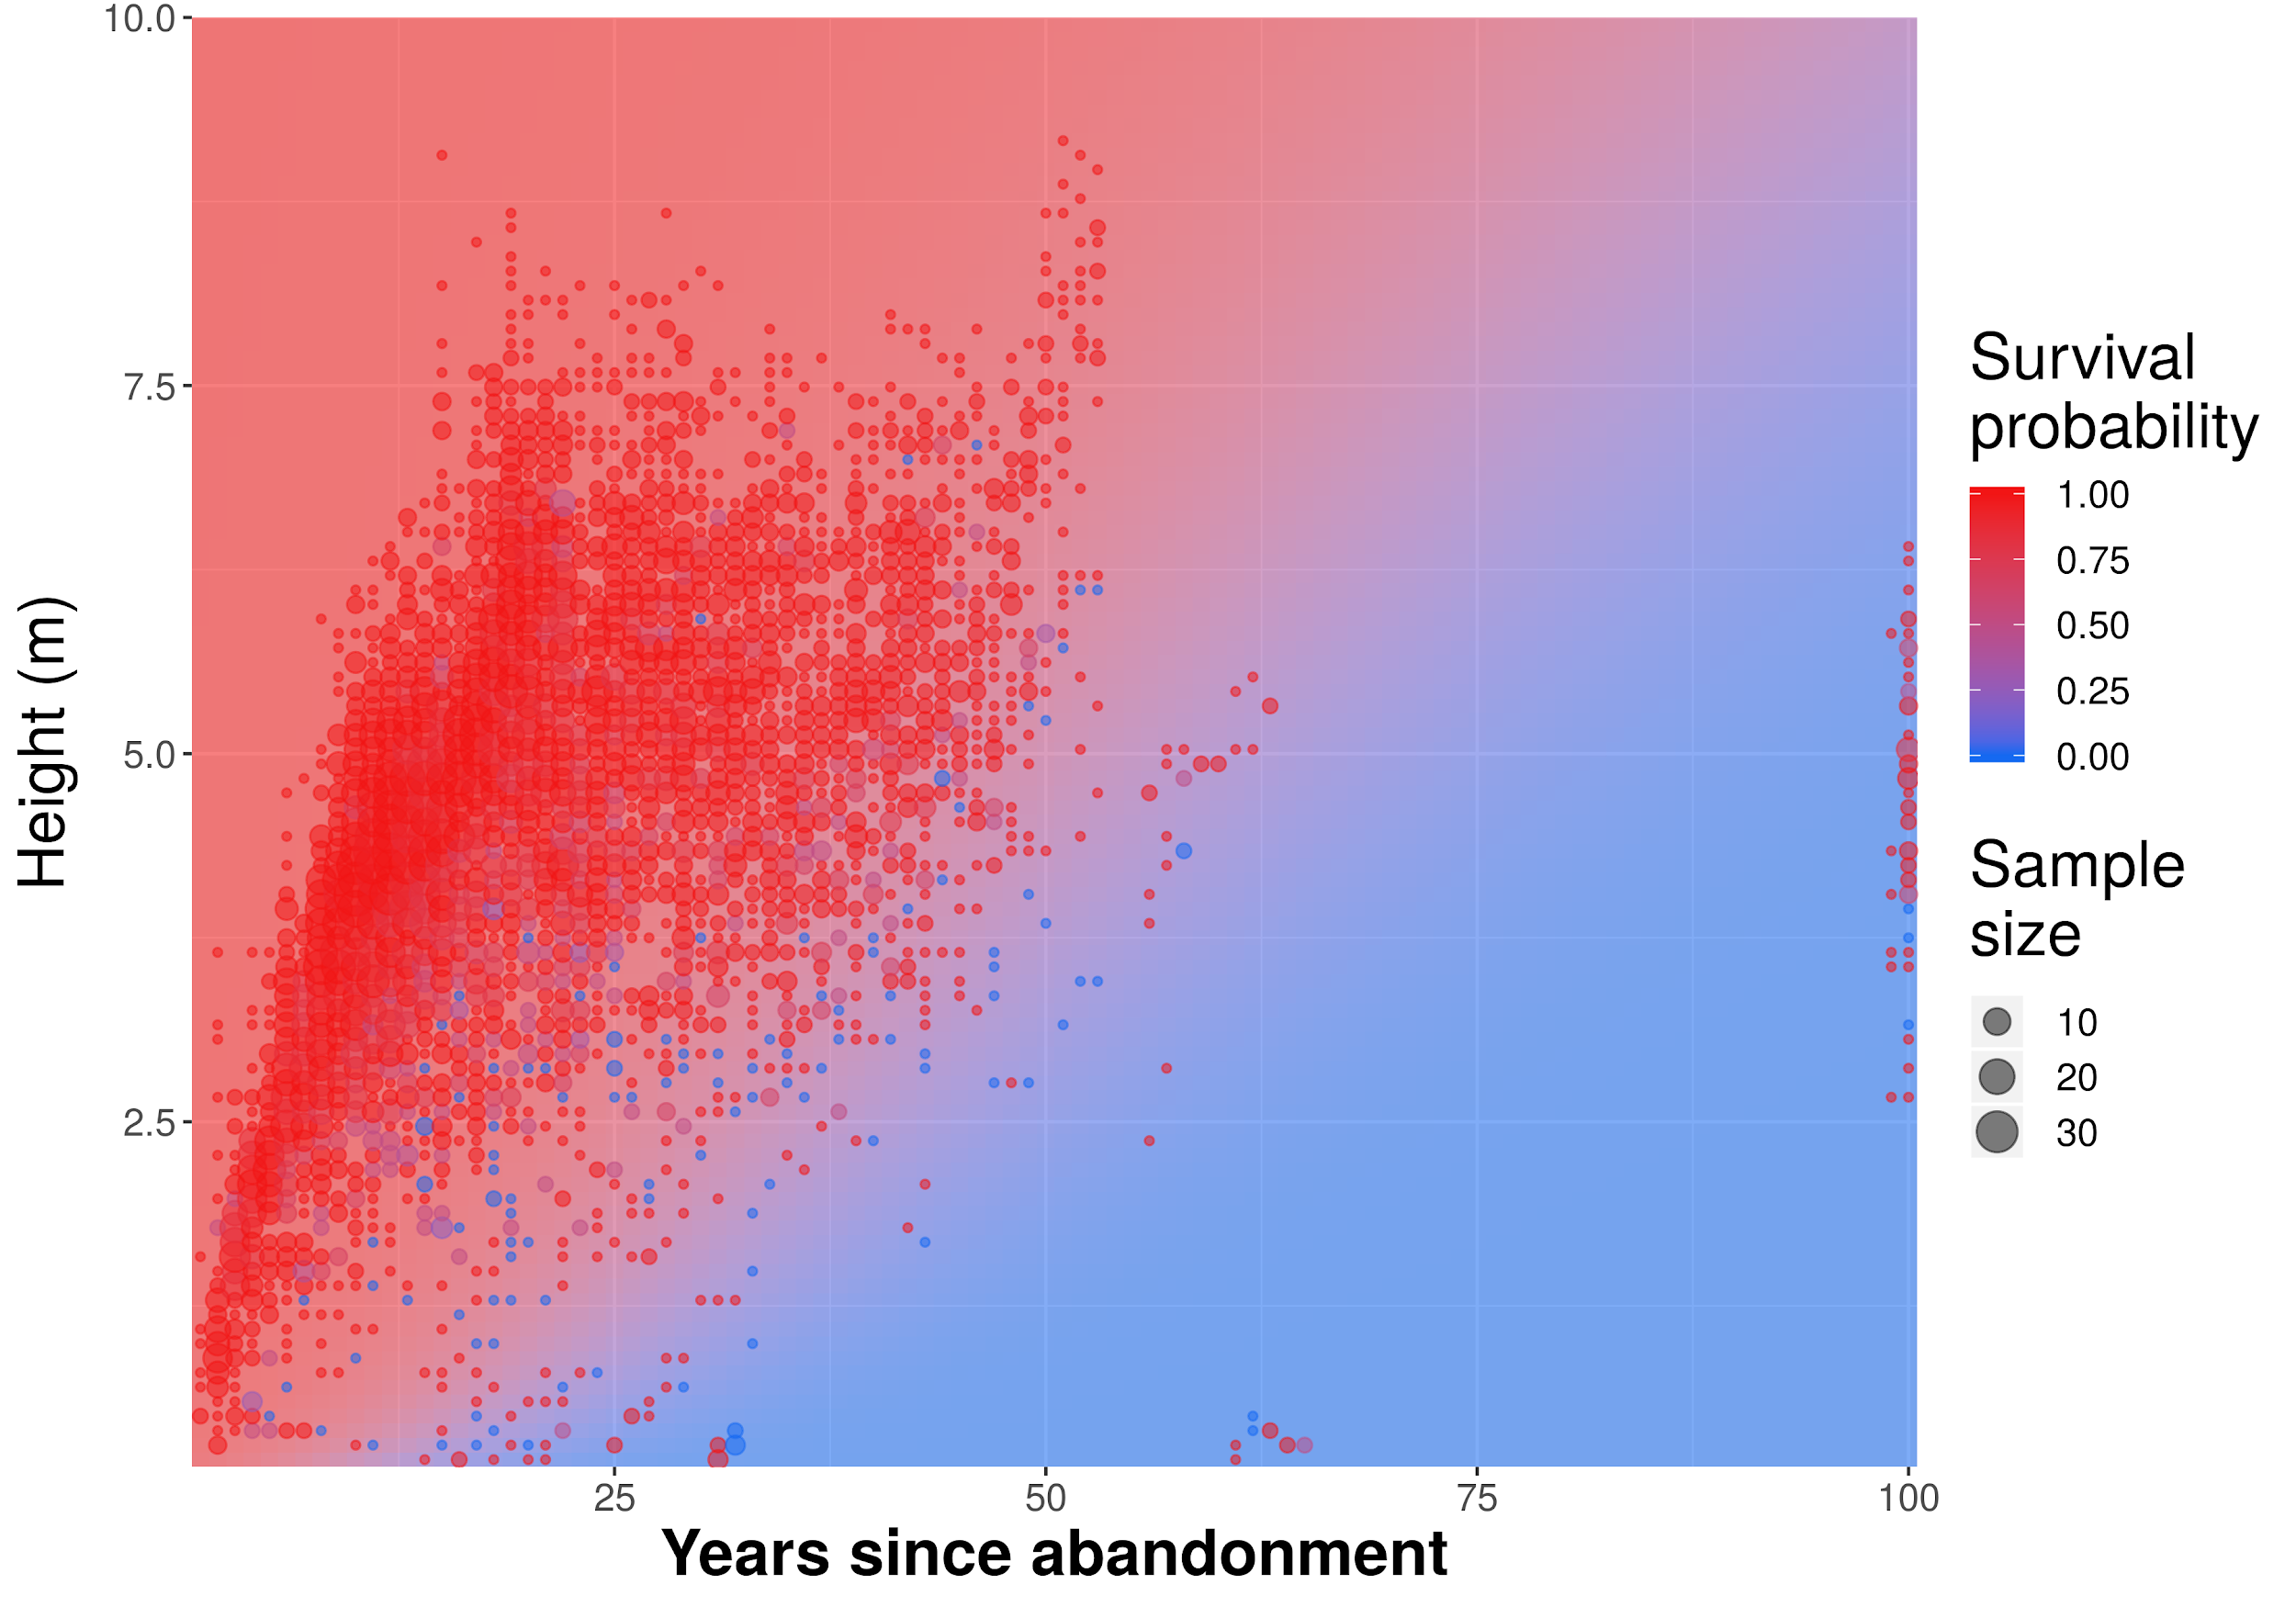

Figure 1b.
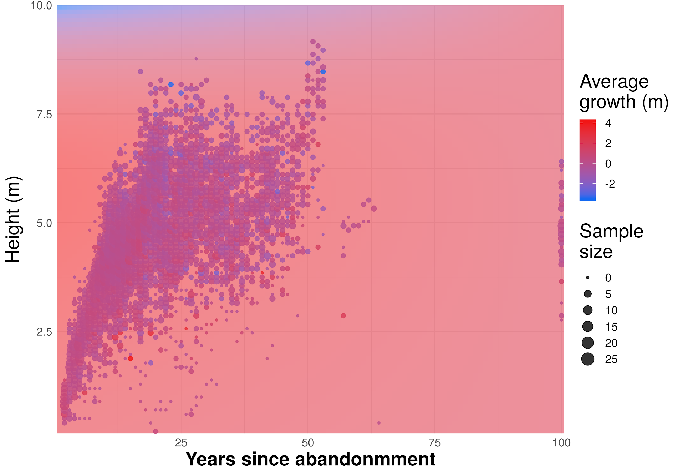

Figure 1c.
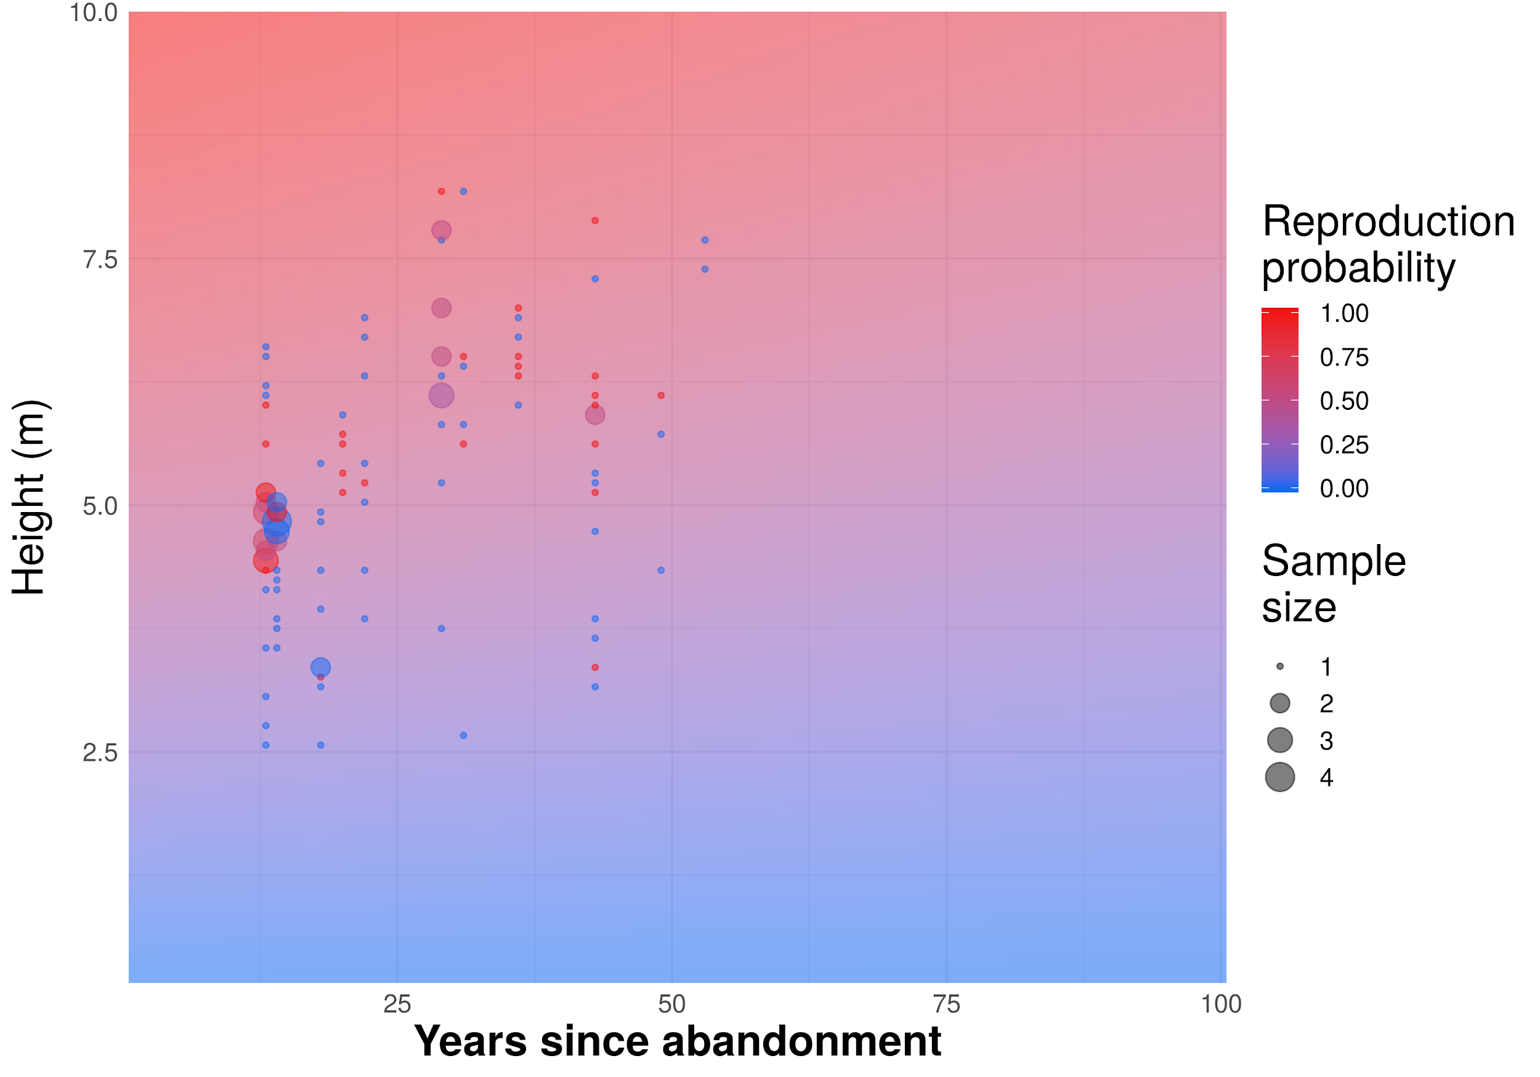

Figure 1d.
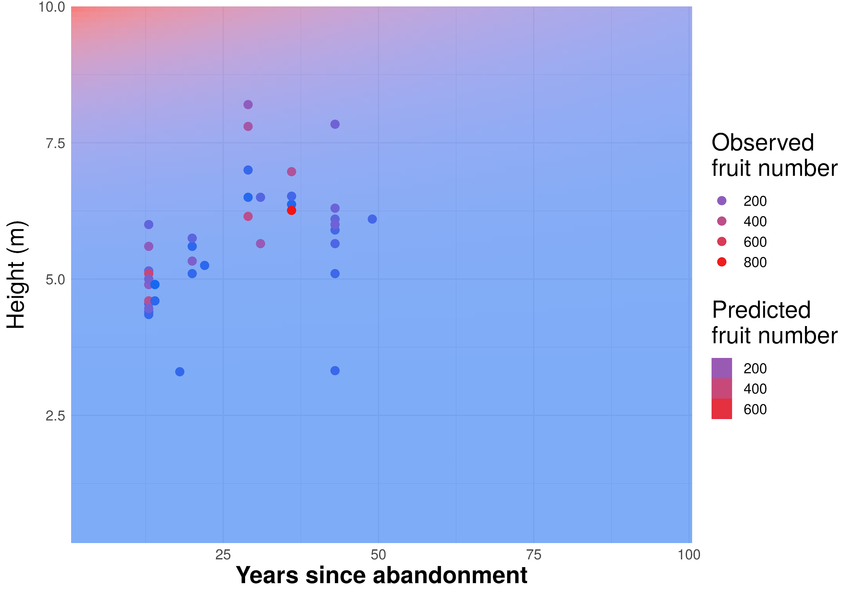

Figure 1e.
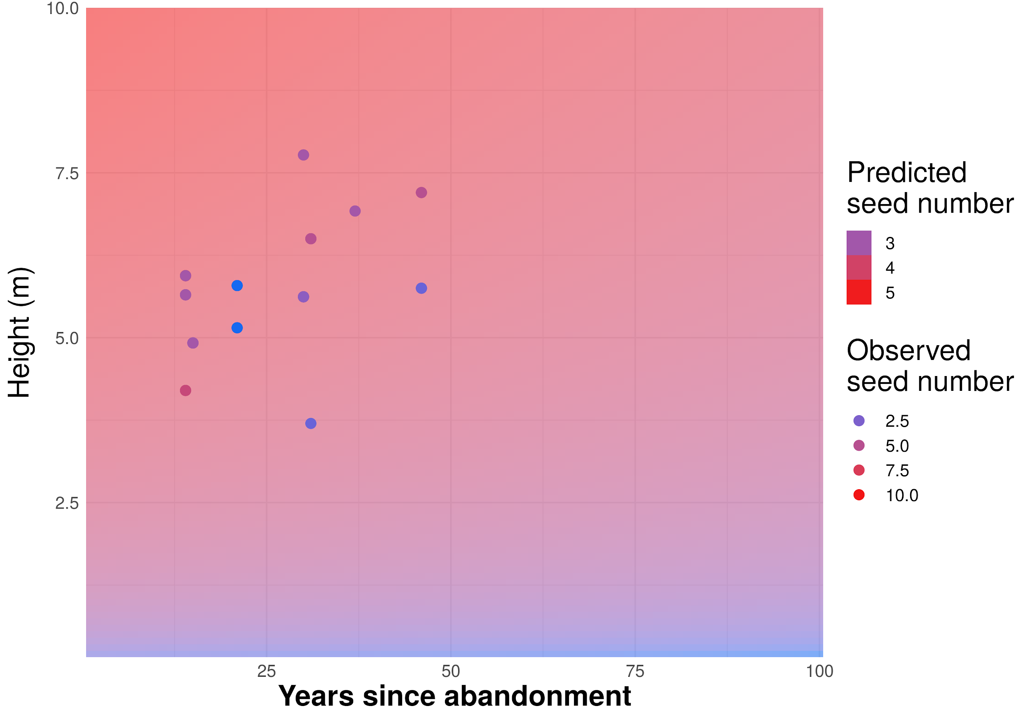

Figure 1f.
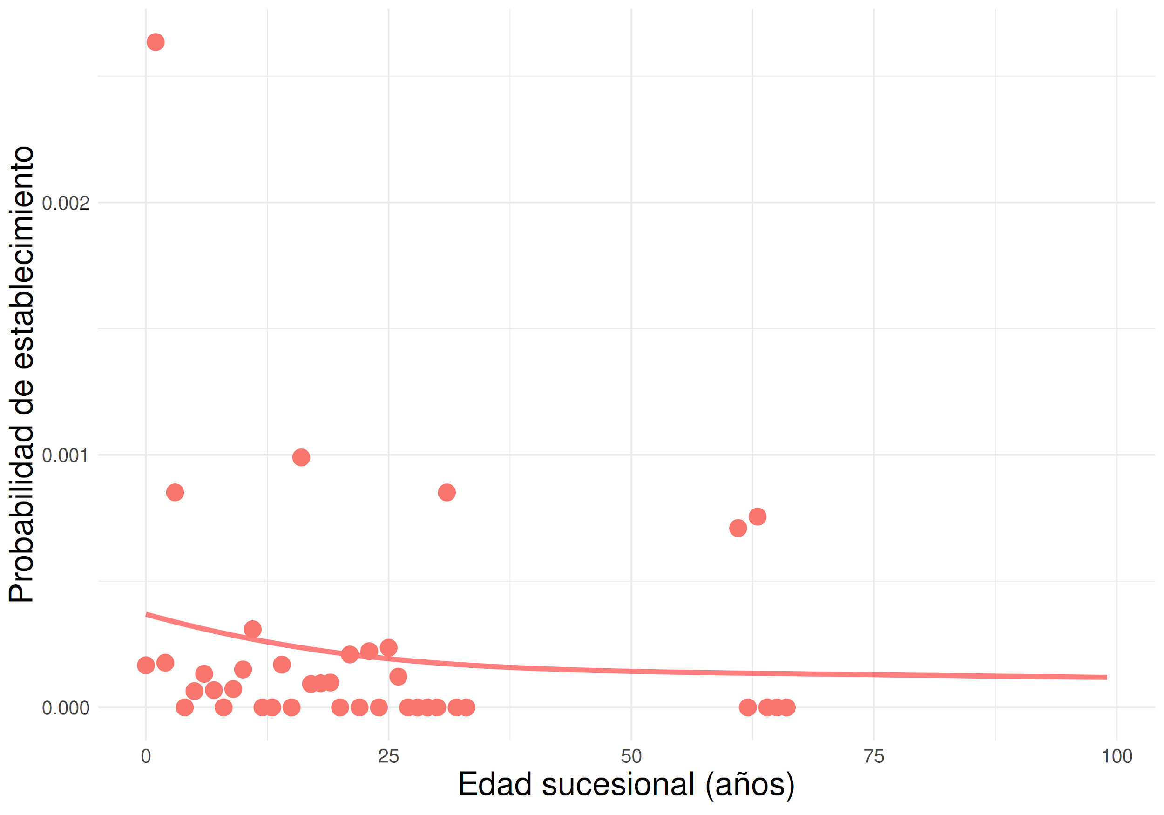

Figure 1g.


