**Web & Social Media for Enterprise**

**Assignment 1 Report- B00092974**

Starting point:

I first began this assignment by drawing out what I wanted each page to look like and what the specifics were for each page. I decided I wanted simplistic clean design for the site, I didn’t want it to be too busy and packed with images, as this can be overwhelming for users.

The fixed single column page is the “contact us” page.

I decided I wanted this page to have the gradient background and to have a form inside a div for the column and that I would place it like so:

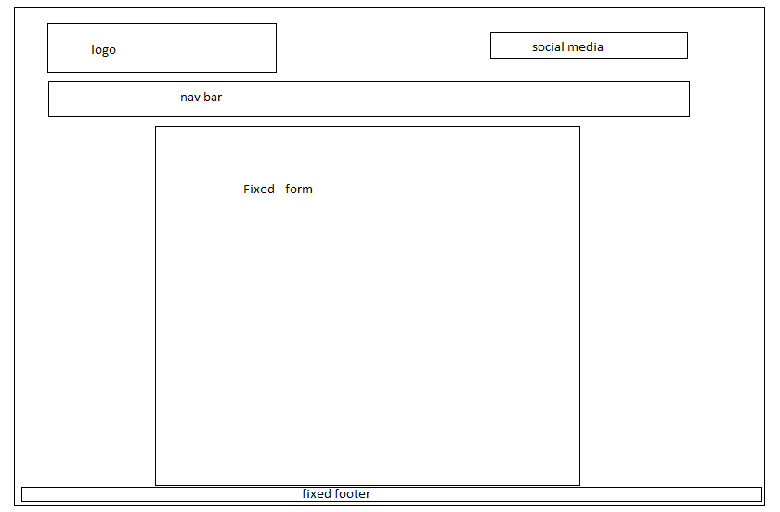

The 2-column layout page is the “index/home” page.

I decided I wanted to have 2 divs for the columns and that I would place them like so:

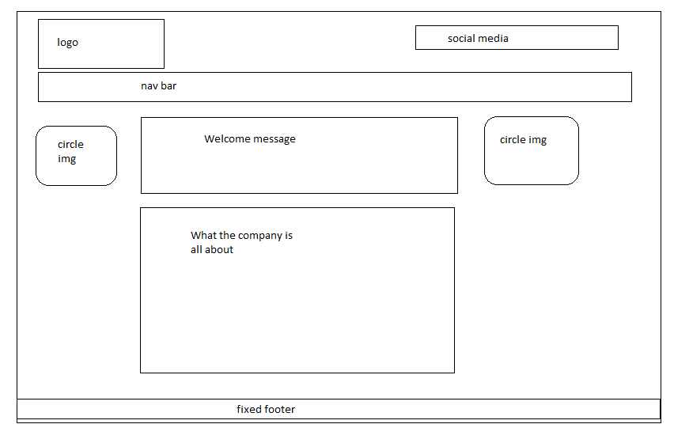

The 3-column layout page is the “about us” page on the site.

I decided I wanted to have 3 divs for each column and that I would place them like so:

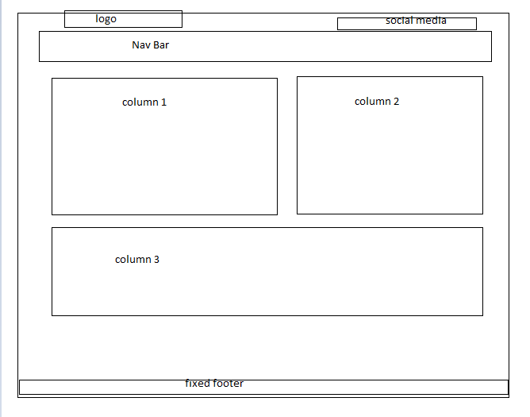

Once I had a general design for the site I chose a company to base the site on. My friend Clodagh Shortall has her own small cake business, I asked her if I could user her business Cake Cake Baby as the model for this assignment. She gave her permission for her business to be used.

I then started gathering images and videos that I wanted to use. Once I had these I started writing the code for the site. First creating the divs in each page then styling them in the CSS.

Once I had the site roughly put together I started to fix everything more in-dept to exactly how I wanted it, choosing the background image and deciding on the gradient to use, etc. I used media queries in the CSS to make the site more mobile friendly. This was my first time working with media queries it took a lot of fiddling around to get it right.

**Validator Testing**

Index/Home page:

**References:**

CSS Gradient Generator - CSS Portal. 2017. CSS Gradient Generator - CSS Portal. [ONLINE] Available at: <http://www.cssportal.com/css-gradient-generator/>. [Accessed 12 November 2017].

Quotes About Cake (144 quotes) . 2017. Quotes About Cake (144 quotes) . [ONLINE] Available at: <https://www.goodreads.com/quotes/tag/cake>. [Accessed 12 November 2017].

Cake Cake Baby - Home | Facebook. 2017. Cake Cake Baby - Home | Facebook. [ONLINE] Available at: <https://www.facebook.com/clodaghscakes>. [Accessed 12 November 2017].

Create. 2017. Free Social Media Icons | Create Blog | Create. [ONLINE] Available at: <https://www.create.net/blog/free-social-media-icons#facebook>. [Accessed 12 November 2017].

Tailor. 2017. Tailor. [ONLINE] Available at: <https://studio.tailorbrands.com/business/8344121/wizard/edit/shape?currentId=369357480&logosStepId=55257954&originalIndex=8>. [Accessed 12 November 2017].

html - changing the background on just one web page - Stack Overflow. 2017. html - changing the background on just one web page - Stack Overflow. [ONLINE] Available at: <https://stackoverflow.com/questions/15698088/changing-the-background-on-just-one-web-page>. [Accessed 12 November 2017].

Pinterest. 2017. black-and-white-brick-wall-background-white-brick-wall-image-decoration-picture-white-brick-wall.jpg (3200×2109) | ddd | Pinterest | Batu, Website and Creative. [ONLINE] Available at: <https://www.pinterest.ie/pin/381609768411056342/>. [Accessed 12 November 2017].

YouTube. 2017. Top 20 Coolest Birthday Cakes EVER (HD) - YouTube. [ONLINE] Available at: <https://www.youtube.com/watch?v=qr02ziC9r_o>. [Accessed 12 November 2017].

YouTube. 2017. HOW TO MAKE A UNICORN CAKE - NERDY NUMMIES - YouTube. [ONLINE] Available at: <https://www.youtube.com/watch?v=Xh_Neg-Hp84>. [Accessed 12 November 2017].

YouTube. 2017. #CakeSlayer Halloween: GOTHIC WEDDING CAKE | Man About Cake with Joshua John Russell - YouTube. [ONLINE] Available at: <https://www.youtube.com/watch?v=IHChvxY0xck>. [Accessed 12 November 2017].