CA2 Report: Networking + Version Control

Photon Fusion 2 Multiplayer Feature and Source Control Evidence
Student: Davin Barron
Assessment: CA2 (25%)
Repository: https://github.com/davinbarron/SETU-Advanced3DGamesDevelopment
Submission Tag: ca2-submit

Unity Networked Feature

A1: Session Setup and Spawn Baseline

Overview
A working two-client Fusion 2 baseline in Assets/Scenes/01_Sandbox/CA2_NetworkTest.unity. Two clients connect to the same named room using the lobby browser, authenticate through Unity Player Accounts and Photon Custom Auth, and spawn as independent KCC player characters.

NetworkRunner Configuration
The NetworkRunner is instantiated at runtime from a prefab after authentication completes. It is configured programmatically with:
- GameMode: Shared
- SessionName: Player-chosen via room browser UI
- SceneManager: NetworkSceneManagerDefault
- AuthValues: Custom authentication values from Unity Player Account token
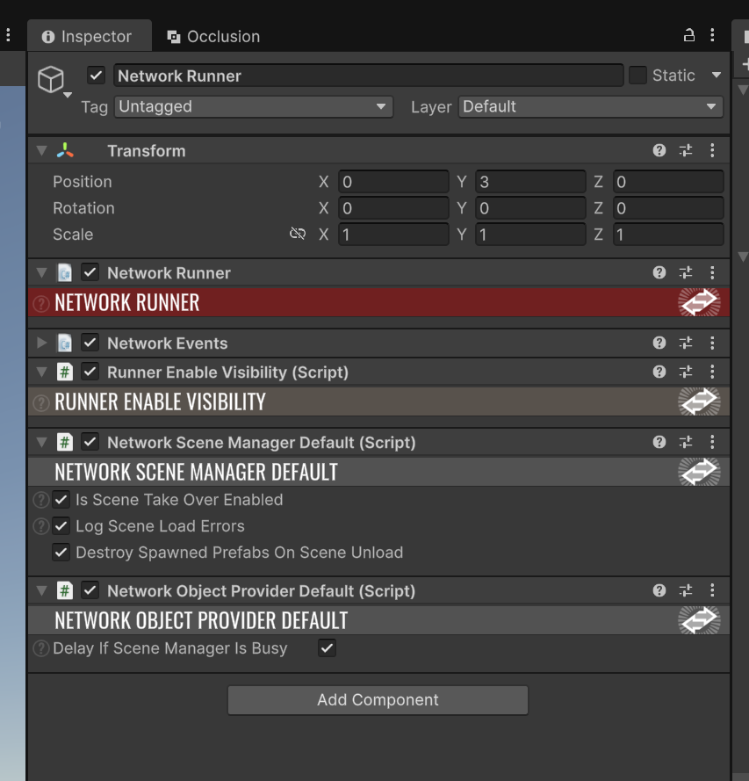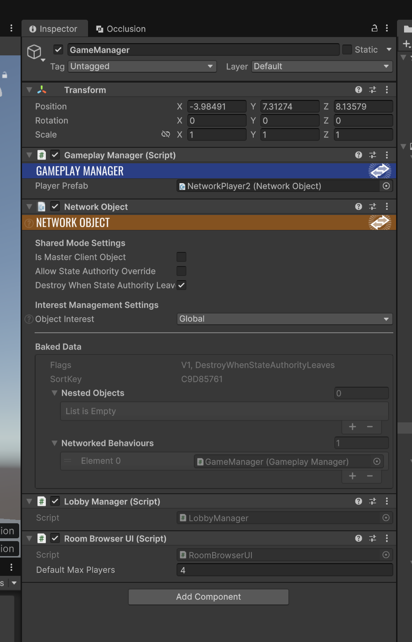

NetworkObject Prefab Setup
The player prefab has a NetworkObject component at its root. Each client spawns its own player object in GameplayManager.Spawned() when Runner.GameMode == GameMode.Shared, passing itself as the inputAuthority argument to Runner.Spawn(). This ensures the spawning client holds both StateAuthority and InputAuthority over its own player object.

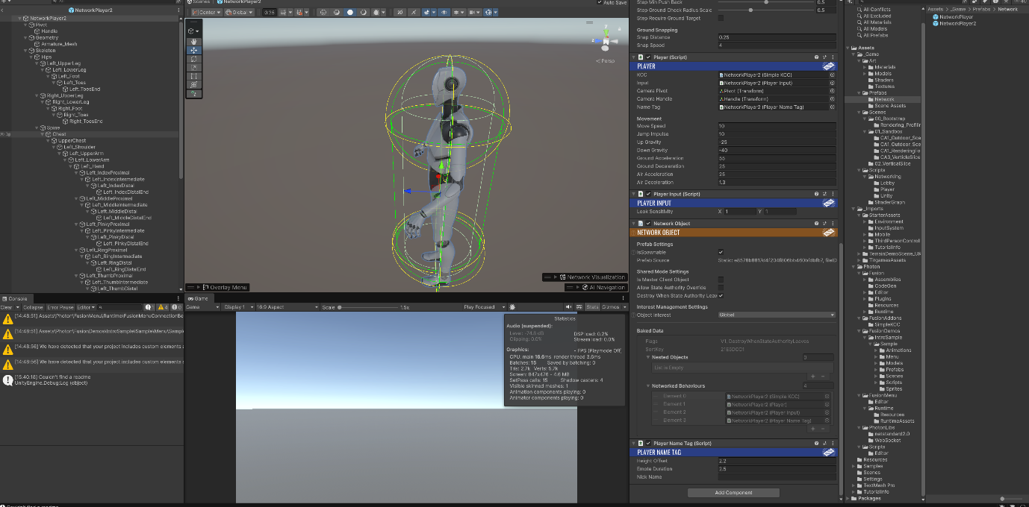

NetworkProjectConfig Registration
All networked prefabs must be registered in Fusion -> Network Project Config so Fusion can resolve them by GUID across clients.

Prefabs not registered here cannot be spawned across the network

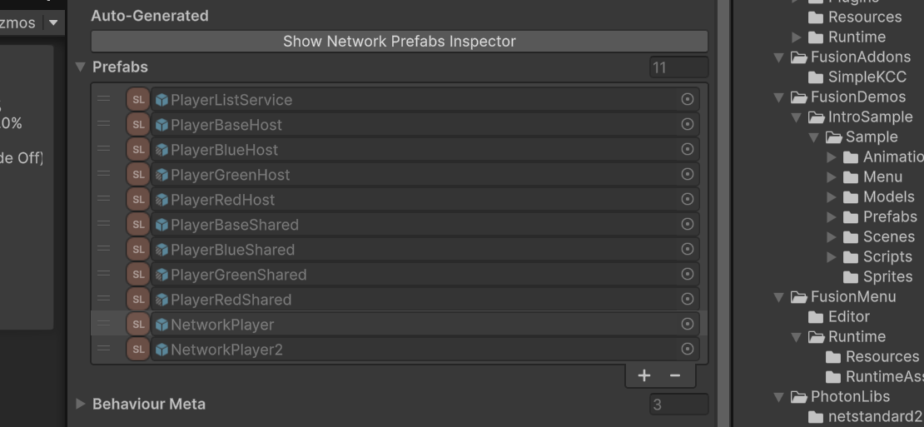

Two-Client Baseline Evidence
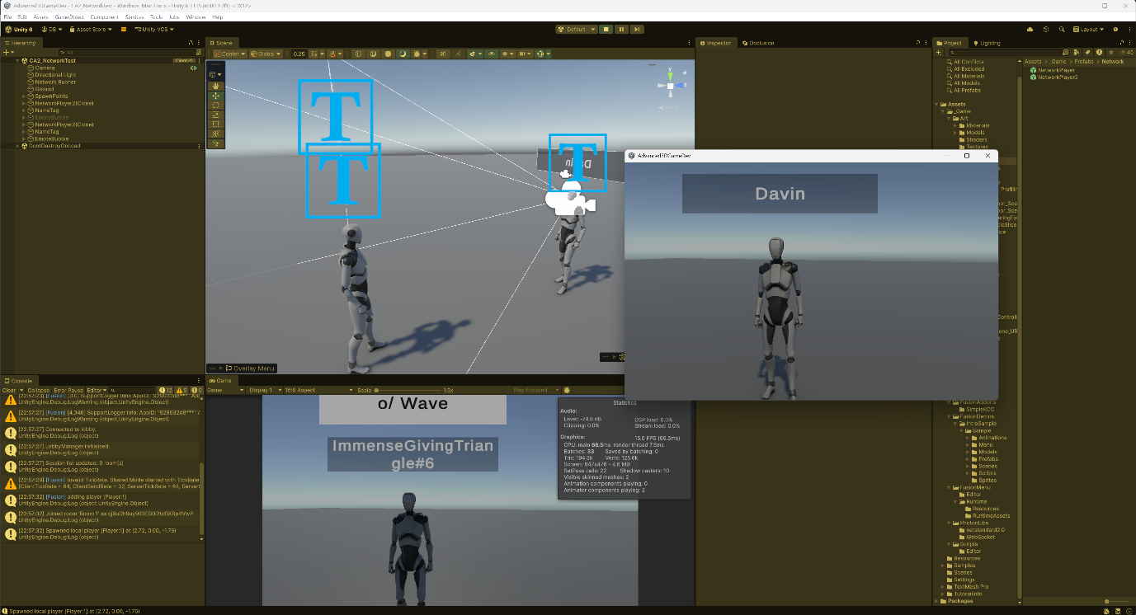

Authority Summary
- StateAuthority over each player object is held by the client that spawned it
- InputAuthority is assigned to the spawning client using the PlayerRef argument in Runner.Spawn()
- Remote clients receive replicated state and render it but cannot write to networked properties on objects they do not own

Feature Implementation and Authority Correctness

Feature Scope: Options B + C
Option C — Networked Game State (Countdown Timer):
- Countdown timer starts when 2+ players join
- Game phase system: Waiting → Countdown (5s) → Playing (60s) → GameOver
- Synchronized across both clients

Option B — Networked Pickup / Interaction (Score Orbs):
- Collectible orbs spawn around the arena
- Pickup by any client increments that player's score
- Orbs respawn after 10 seconds
- Authority-correct: only one client can claim the orb simultaneously

Win State & Rematch:
- When timer expires, player with highest score wins
- Final rankings displayed on both clients
- Players can vote to replay or return to lobby

Authority Guards in Code
GameStateManager.FixedUpdateNetwork() — StateAuthority Guard:
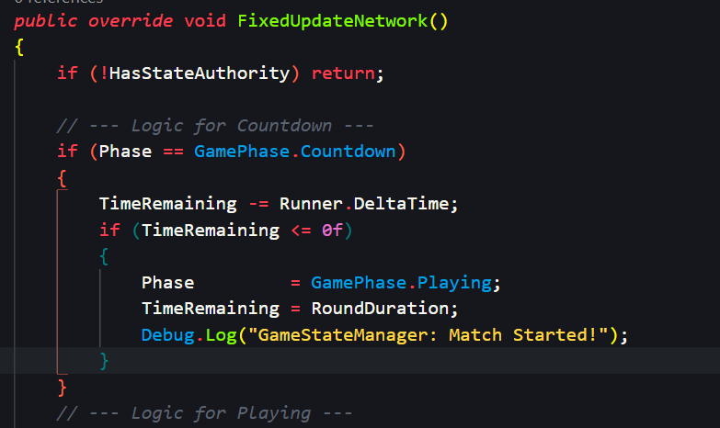
Code Evidence: Advanced3DGameDev/Assets/_Game/Scripts/Networking/Game/GameStateManager.cs

Player.AddScore() — StateAuthority Guard:
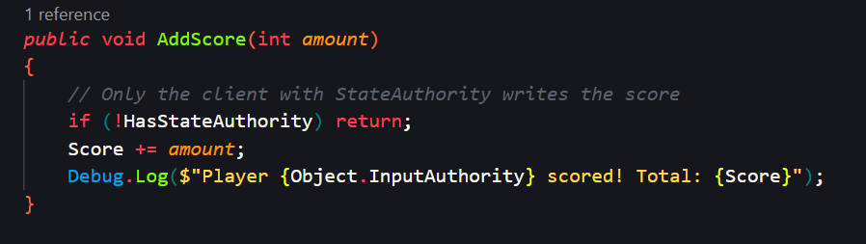
Code Evidence:
Advanced3DGameDev/Assets/Photon/Scripts/Player.cs

ScoreOrb.FixedUpdateNetwork() — Authority Controlled Pickup:
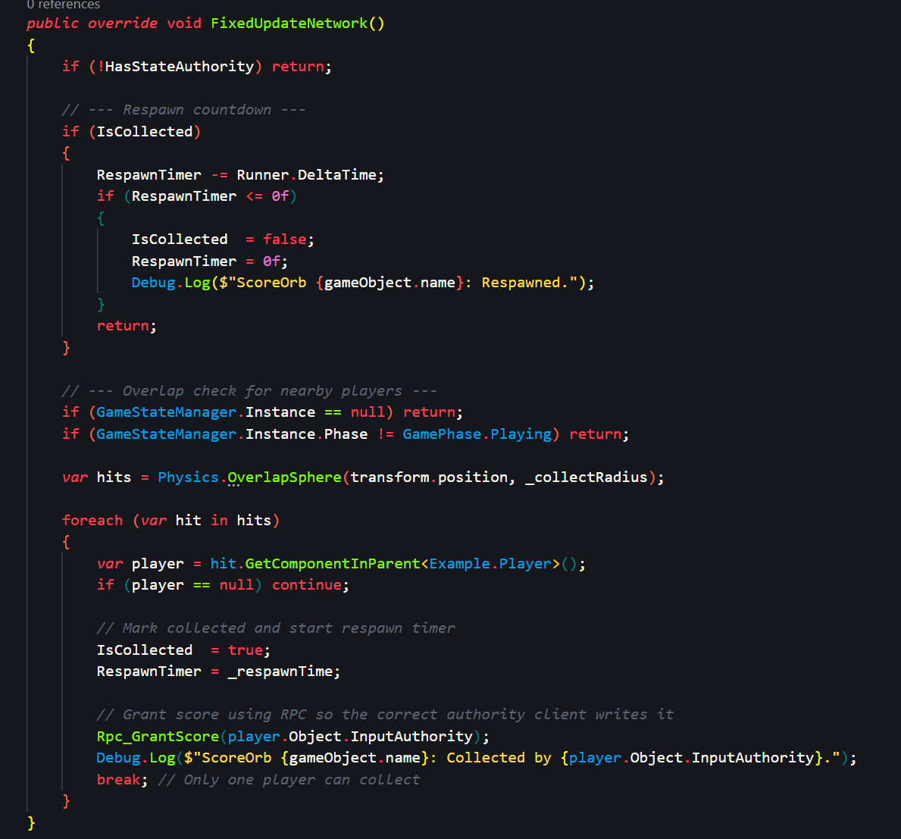
Code Evidence:
Advanced3DGameDev/Assets/_Game/Scripts/Networking/Score/ScoreOrb.cs

Synchronisation Approach: [Networked] Property vs RPC
[Networked] Properties Used:

Property | Object | Justification
TimeRemaining, Phase, Winner | GameStateManager | Persistent state needed at any point (late joiners must see current timer and game phase)
Score | Player | All clients must always know correct score for HUD display and ranking calculation
IsCollected, RespawnTimer | ScoreOrb | Visible state synchronized for both clients (orb appears/disappears on all peers simultaneously)
RematchVotes | GameStateManager | Vote count displayed on both clients in real-time

RPCs Used:

RPC | Source → Target | Justification
Rpc_PlayEmote() | InputAuthority → All | One-shot event; late joiner doesn't need emote history
Rpc_GameOver() | StateAuthority → All | Broadcast round end once; persistent Phase handles late joiners
Rpc_GrantScore() | StateAuthority → All | RPC routes scoring authority; target player's AddScore() enforces state guard
Rpc_CastVote() | All → StateAuthority | Only StateAuthority counts votes; mirrors Unreal Server RPC pattern

Why This Design:
[Networked] properties are used for persistent state because Fusion syncs them in the initial session snapshot. A late-joining client immediately sees the correct timer, correct phase, and correct scores without needing events replayed. RPCs handle one-off or short-lived events that don't need history e.g emotes, one-time broadcasts.

Video Evidence:

Pickups.mkv [01:19–02:27] Timer countdown visible on both clients simultaneously. Score orb collected by Client A; orb disappears on both clients at same frame. Score increments on both HUDs. Scoreboard shown at the end with player ranking.

Test Matrix
See: Docs/CA2_TestMatrix.md

Summary of Test Results:
- A1 Baseline (3 tests): All passed
  - Two clients authenticate and spawn correctly
  - Late joining client sees existing players
  - NetworkProjectConfig registration enforced
- Option C — Timer (7 tests): All passed
  - Waiting state for 1 player
  - Countdown starts at 2+ players
  - Phase transitions synchronized
  - Player leaving aborts round correctly
  - Non-authority clients cannot write state
- Option B — Orbs (5 tests): All passed
  - Orbs collected, scores incremented
  - Double-collection prevented by authority guard
  - Respawn timer works correctly
  - Collection disabled outside Playing phase
  - Score HUD displays correct values
- Win State (3 tests): All passed
  - Winner determined by highest score
  - Equal scores handled without crash
  - Vote panel appears after 5-second delay
- Rematch Voting (4 tests): All passed
  - Vote counters increment correctly
  - Majority voting triggers rematch
  - Double-voting prevented
  - Leave Room disconnects cleanly
- RPC Correctness (3 tests): All passed
  - Emote RPCs fire from InputAuthority to All
  - Vote RPC targets StateAuthority correctly
  - Missing player objects handled without crash

Known Issues (Documented):
- KI-1: Host client leaving room leaves remaining client stuck — StateAuthority migration not implemented
- KI-2: Host rejoining causes conflict — resolved by KI-1 fix

Unreal Replication Terminology Comparative Note
See: Docs/CA2_UnrealTerminology.md

Overview
Fusion and Unreal Engine 5 both synchronize networked state across peers, but their authority models differ fundamentally. Fusion Shared Mode distributes authority per-object; Unreal centralizes it on the server.

1. Authority
In Fusion’s Shared Mode, authority is distributed per object. A client holds StateAuthority to write networked state and InputAuthority to provide the local input driving that object.

Unreal Engine 5 uses a centralised server-authoritative model:

- The Server: Holds authority over all actors. Only the server can write to replicated state.

- Owning Client: The client that owns a specific actor. This is the Unreal equivalent of Fusion’s InputAuthority.

- Simulated Proxy: Other clients receiving state updates passively. These function like Fusion’s proxies, which read but cannot write networked data.

Fusion allows any peer to hold authority over an object, Unreal mandates that the server remains the ultimate source of truth for all replicated actors.

2. Persistence - Syncing State
Fusion’s [Networked] attribute marks properties for synchronisation, often using a ChangeDetector to handle logic when values update.
In Unreal, the equivalent is a Replicated UPROPERTY. To mirror Fusion’s detection pattern, Unreal uses the ReplicatedUsing specifier to trigger an OnRep callback function. Both engines share the same fundamental principle where a persistent state that all clients need access to must be stored in a replicated property rather than an RPC.

3. RPC - Short-Lived Events
RPCs in both engines handle short-lived events that do not require persistent state.

- InputAuthority to All (Multicast): In Fusion, this sends an event from the owner to everyone. In Unreal, this is a NetMulticast, which is called by the server to broadcast to all clients.

- All to StateAuthority (Server RPC): Fusion uses this to send data from a peer to the object owner. Unreal uses a Server RPC (UFUNCTION(Server)), where a client requests the server to perform an authoritative action.

- StateAuthority to Owning Client: This maps to Unreal’s Client RPC, specifically targeting the individual client that owns the actor.

4. Key Difference — Authority Model
The most meaningful difference is that Fusion’s Shared Mode distributes authority across peers, whereas Unreal’s standard model centralizes it on the server. In Unreal, the architecture is structurally trustless. A client cannot write to a replicated variable directly; they must send a Server RPC requesting a change, and only the server performs the write.

In Fusion Shared Mode, authority is a permission granted to a peer. The engine relies on the developer to enforce HasStateAuthority guards manually. If a guard is omitted, a client might attempt to send an RPC or modify state they do not own, leading to local simulation errors. Unreal’s model enforces strict client-server separation by design, while Fusion Shared Mode requires more deliberate authority discipline to ensure peers do not conflict.

Version Control Evidence

Commit History and Branch Structure
See: Docs/CA2_BranchStrategy.md

Commit Graph
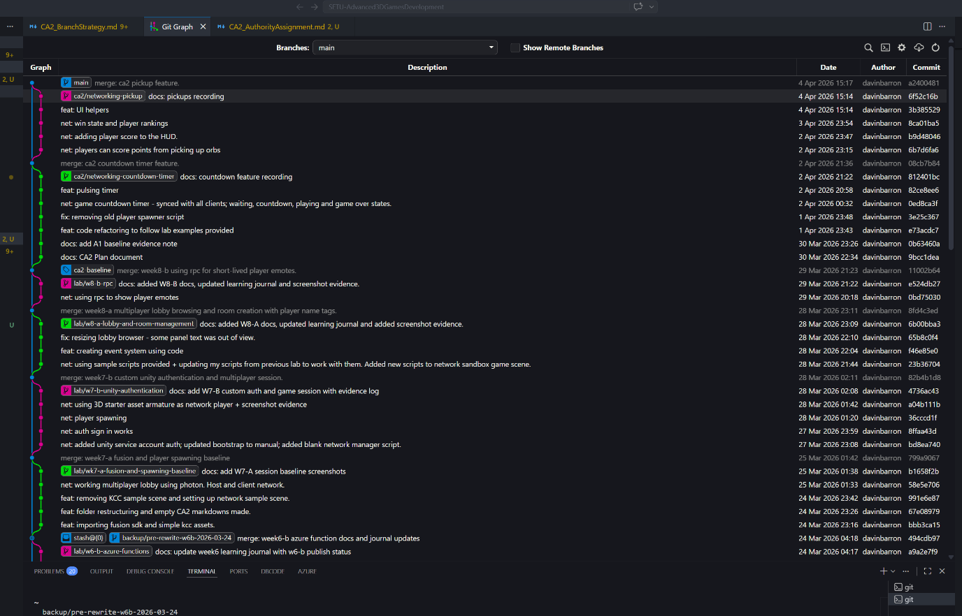
Multiple feature branches created in Week 9–10 (ca2/networking-countdown-timer, ca2/networking-pickup, ca2/networking-voting)

Each branch tested, merged back to main with descriptive merge commit

Consistent commit message convention (net:, feat:, docs:, fix:)

Work spans from Week 1 (baseline, ca1-submit) through Week 10 (ca2-submit). Can’t be fully shown in one screenshot

Branch Structure
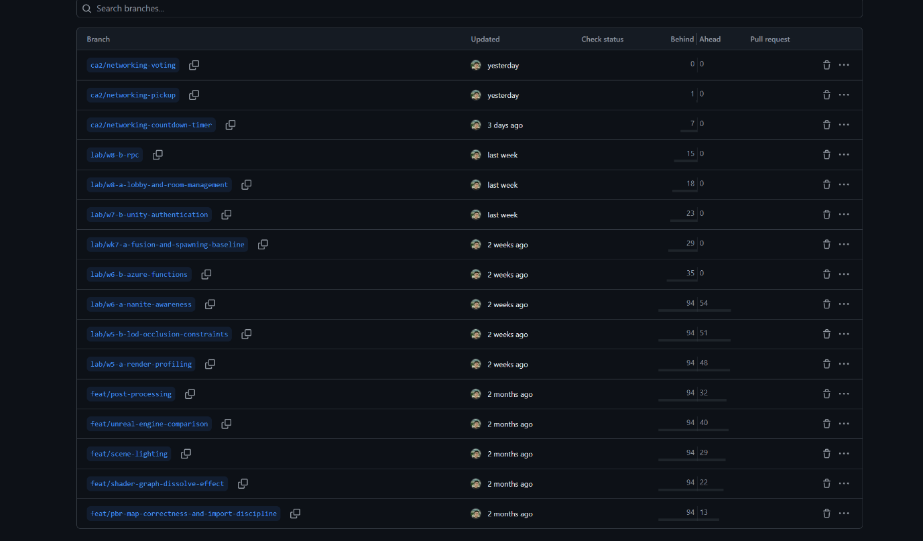

- main — stable working state
- ca2/networking-countdown-timer
- ca2/networking-pickup
- ca2/networking-voting
- Earlier feature branches visible (feat/pbr-map-correctness, feat/shader-graph-dissolve-effect, lab/w5-b-lod-occlusion-constraints, etc.)
- All branches merged back to main as seen from the git graph

All CA2 work was performed on dedicated branches created in Week 8–10, never directly on main.

Milestone Tags

All tags confirmed pushed to origin.

Branching Strategy and Lessons Learned
Summary:

- Consistent use of feature branches from Week 1 onward (not just CA2)
- One branch per milestone or coherent feature
- Merge to main only after testing and validation
- Commit message prefix convention (net:, feat:, docs:, fix:, chore:) applied from Week 1
- Main always remained in working state
- Milestone tags mark submission and review points

Lessons:
Multi-branch discipline established from the start meant that major features (CA1 rendering, Week 5 LOD work, Fusion networking) could be integrated without destabilising main.
Descriptive branch names and commit prefixes make the history self-documenting. This helps not only myself but for others who look at my history can easily tell the work I did and when I did it.

I will be continuing this pattern into CA3.

Section C: Learning Journal

Section 1: Weekly Evidence Log
See: Docs/CA2_LearningJournal.md

Week | Dates | What I worked on | Key Commits / Tags | Evidence References | Blocker / Resolution
3 | 2–9 Feb 2026 | Unity project setup; demo scene; radioactive barrel (Substance Painter/PBR). | de89f6f, 7cb0e0c, a259607 | Docs/CA1.docx | Metallic value error in Substance; corrected and documented.
4 | 10–14 Feb 2026 | Shader Graph dissolve effect; C# driver script via MaterialPropertyBlock. | f780b33, def6e34, e109884 | Docs/CA1.docx | Voronoi remap caused artifacts; fixed remap range.
4 | 15–16 Feb 2026 | UE5 dissolve replication; Unity lighting (dusk); Post-processing; CA1 packaging. | 071acb9, 7cc98f3, 5bcf922, 8f3749d | Docs/CA1.docx | Bloom too aggressive; reduced intensity.
8 | 20–22 Mar 2026 | Rendering profiling (Forward/Deferred); Blender LODs; Occlusion baking. | 6607ae5, fba1c3a, cf34910, 4a1e819 | Rendering Profiling Pack.docx, constraints.md | Single-mesh fan asset; generated LODs in Blender via Decimate.
9 | 23–24 Mar 2026 | Nanite awareness; Azure Auth function setup; Photon configuration. | 0b66531, d16489a, d4c8953, 494cdb9 | nanite_awareness.md, w6-b_azure.md | Azure UI/Zone confusion for student accounts; resolved via navigation.
9 | 24–25 Mar 2026 | W7-A Fusion KCC session; Network sandbox setup; Player spawning baseline. | bbb3ca1, 58e5e70, 991e6e8, 799a906 | Docs/Screenshots/W7-A/* | No blockers.
9 | 27–28 Mar 2026 | Unity Auth integration; Custom Photon auth; Authenticated player spawning. | 8ffaa43, bd8ea74, 82b4b1d, 4736ac4 | w7-b_unity_auth.md | GameSpawner location issue; Azure URL missing auth code key.
9 | 28–29 Mar 2026 | Lobby & Room browser; RPC Emote system (Wave/Cheer/Taunt) with speech bubbles. | 23b3670, 8fd4c3e, 0bd7503, 11002b6 | w8-a_lobby.md, w8-b_rpc_emotes.md | Missing EventSystem for UI; Emote bubble timing issues (fixed in Spawned).
10 | 1–3 Apr 2026 | CA2 Core: Phase system/timer (Opt C); Authoritative score orbs (Opt B); Win state. | e73acdc, 3e25c36, 0ed8ca3, 6b7d6fa, 8ca01ba | Docs/Screenshots/CA2/* | Rpc_CastVote authority error; changed to RpcSources.All with internal guards.
10 | 4–5 Apr 2026 | CA2 Final: UI helpers; Rematch system; Test matrix; Submission tagging. | 3b38552, 4fb2c36, f3e252d, ca2-submit | CA2_TestMatrix.md, CA2_UnrealTerminology.md | Host migration not implemented (stuck client); documented as Known Issue KI-1.

All entries reflect actual lab content and commit dates, not backfilled.

Section 2: Critical Discussion of Technical Choices
See: Docs/CA2_LearningJournal.md

1. Why I chose this feature scope
The big deciding factor for the features I decided to implement for this CA was the lab work. By Week 8 the foundation already included a working Fusion Shared Mode session with KCC character movement, Unity Player Account authentication, a lobby browser, room creation and joining, player name tags, and an RPC emote system. It was only a matter of using this foundation and building up from it. This is why I decided to go for Options B and C since they both fit naturally into the Shared Mode authority model we had already been working with.

I tackled Option C first, a networked countdown timer, since it felt like a manageable starting point that could immediately demonstrate the [Networked] property pattern across two clients. From there I added Option B, a scoring system using collectible orbs, which then enhanced Option C by giving the round a meaningful outcome, a win state based on who collected the most points.

I deliberately left out Options A and D. Option A, server-authoritative character movement, would have required switching from Shared Mode to a server or host topology, which would have meant reimplementing the session management and authority model from scratch. Option D, networked projectiles, has similar requirements and introduces hit detection complexity that wasn't covered in the labs. Both were technically interesting but would have taken longer than the time allowed and risked producing something unstable rather than a smaller, well-tested feature.

2. [Networked] Property vs RPC
I made use of several [Networked] properties and RPCs in this project, and the distinction between the two became clear through implementation.

[Networked] properties are used for persistent state — values that any client needs to be correct at any point regardless of when they joined the session. TimeRemaining, Phase, Winner, RematchVotes, and Score are all persistent because a client joining mid-round must immediately see the correct timer, the correct phase, and the correct scores without any event needing to be replayed. Fusion includes these in the initial state snapshot automatically so late joiners are never out of sync.

RPCs are the right tool for one-shot events that do not need to be preserved. Rpc_GameOver starts once when the timer hits zero — a late-joining client does not need to receive it because Phase == GameOver in the state snapshot already communicates that the round has ended. Rpc_PlayEmote starts once per keypress — there is no meaningful "current emote" state to store. If I had used a [Networked] string for the emote I would have needed timer logic to clear it and would have been treating an event as if it were state, which would have been semantically wrong and added unnecessary complexity.

From this I designed Rpc_CastVote. It uses RpcSources.All, RpcTargets.StateAuthority where any client can call it but only the StateAuthority processes it. This keeps vote counting authoritative and mirrors the Server RPC pattern from Unreal Engine, where clients send requests upward to the server for authoritative processing rather than writing state themselves.

3. A Concrete Authority Model Decision
During the initial scene setup, an early version of the player prefab had a Camera component attached to it. When a second player joined the session, both player objects existed in each client's scene and both LateUpdate() calls were trying to move Camera.main to their respective CameraHandle positions every frame. The result was that the camera flickered rapidly between the two positions, making the game completely unplayable for both clients.

I fixed this by removing the Camera component from the player prefab entirely and keep a single Main Camera in the scene. The LateUpdate() in Player.cs already had a HasInputAuthority guard so only the local player's object is allowed to move the camera. With the camera living in the scene rather than on the prefab, only one client ever repositions it per frame, and the remote player's object correctly skips LateUpdate() because it does not have HasInputAuthority.

4. One thing I would do differently
The commit `e73acdc feat: code refactoring to follow lab examples provided` shows a significant rework that I could have avoided with better planning. When I first implemented the networking layer, I wrote a custom NetworkManager script based on what I understood from the lab videos without realising that the KCC sample package already included GameplayManager for player spawning and that FusionBootstrap could be modified directly to handle authentication. Both my NetworkManager and my PlayerSpawner were essentially duplicates of scripts that already existed. Replacing them was a bit time consuming so I wish I had used the provided content from the get-go.

Section 3: Lessons Learned
- I would say one of my biggest regrets would be not starting the CA sooner. I am happy with the work I managed to produce for this CA, but it would've been better to not have to give myself extra pressure of leaving things late especially since I should've been commiting regularly each week. However, I did complete the lab work before starting the CA and I did find it helpful since it gave me a nice baseline to work with and actually made the CA a lot easier in the process. I hope to keep up with the lab content going into CA3.

- I found that `IPlayerJoined` only starts on `SimulationBehaviour` components attached to the NetworkRunner prefab, not on scene GameObjects. `GameSpawner` was placed on a scene GameObject initially and `PlayerJoined` never started despite the session connecting correctly. Moving the component to the NetworkRunner prefab resolved it immediately. Here I learned that anything that needs to respond to Fusion session events must live on the runner.

- Initially I had an issue with authentciating using my custom auth URL on the Photon dashboard. The Photon dashboard custom auth URL must include `?code=KEY` appended directly to the URL. This cost a full session to diagnose. My Azure Function Monitor showing zero invocations was a big sign that it must not have been invoked at all, if the function is never called, the problem is in the URL configuration, not the function code itself.

Appendices

Appendix A: Authority Assignment Reference
See: Docs/CA2_AuthorityAssignment.md

Brief reference for StateAuthority and InputAuthority assignment in this implementation.

Appendix B: Test Matrix
See: Docs/CA2_TestMatrix.md

Complete table of 25 test scenarios with expected and actual results. Known issues and planned fixes documented.

Appendix C: CA2 Plan
See: Docs/CA2_Plan.md

Feature scope decision, synchronisation approach (property vs RPC), and authority assignment committed Week 8 Session B.

Appendix D: Branch Strategy
See: Docs/CA2_BranchStrategy.md

Branching workflow, commit convention, and lessons learned.

Attribution and Licensing
External Assets:
- Photon Fusion 2 SDK - Photon PUN Suite by Exit Games (licensed for educational use)
- Fusion Addon SimpleKCC - Exit Games sample code included in Fusion SDK
- Unity Project Settings and InputSystem - Unity Technologies standard project template
- Photon sample scripts (GameplayManager.cs, Player.cs, PlayerManager.cs) - Exit Games KCC sample project, adapted for CA2
- Unity Third Person Controller Asset Pack

