# Overview

The Design Rationale is intended to provide designers and maker information about the design process and design decisions behind the development of the Water Gun Stand, a 3D printable stand that is accessible for users and easy to use.

# Introduction

We were inspired to create a stand for a water gun to the MMC library by Lauren Milne, a professor at Macalester College who is teaching our Human Computer Interaction class. People who are otherly-abled may not be able to hold or operate a water gun as others can. Operations of water guns includes being able to pull a trigger or pump the pressure tank, and hold/aim the water gun muzzle at objects or people.

# 

# Requirements

The goals and requirements outlined here can be used to assess if a device would meet the needs of a user, and determine when a design is sufficient for release.

## Goals

|  |  |
| --- | --- |
| G01 | Design a 3D printed stand for the water gun |
| G02 | Switch adapt the water gun |
| G03 |  |

## Functional Requirements

|  |  |
| --- | --- |
| F01 | The water gun works with a 3.5 mm switch |
| F02 |  |
| F03 |  |

## Non-functional Requirement

|  |  |
| --- | --- |
| NF01 | Using this adaptation should be easy, and doable for other volunteer makers can do it themselves |
| NF02 |  |
| NF03 |  |

## Constraints

|  |  |
| --- | --- |
| C01 |  |
| C02 |  |
| C03 |  |

# 

# Ideation

The water fun planned to be used in this project is shown below. It is a battery-operated water gun that required no pumping to squirt water out. It can be purchased [here](https://www.walmart.com/ip/Tcovle-Electric-Shark-Water-Blaster-Super-Squirter-Fast-Fill-33-ft-Long-Range-Soaker-Toys-Summer-Swimming-Pool-Beach-Party-Backyard-Outdoor-Fun-Gift/5646402785?classType=VARIANT). The idea we are attempting to solidify is to first add a 3.5 mm jack in parallel with the existing switch in the water gun, then create a stand that can hold the gun upwards and in firing position. Below is the gun which we were planning on using.

Original Water gun


# Conceptual Designs

## CONCEPT 1 – Adding the adapted switch in parallel

The original concept for the water gun adaptation was to be able to use ideas from existing MMC designs, more specifically this [switch adapted water gun](https://github.com/makersmakingchange/Switch-Adapted-Water-Gun/tree/main), this [interact switch](https://github.com/makersmakingchange/Interact-Switch), and this [light switch](https://github.com/makersmakingchange/Light-Touch-Switch), and adapt the water gun to be able to fire alongside the existing trigger. Once this was complete, we would ideally be able to create a base for the water gun that would be able to stably support it, as well as offer functionality for aiming. To access the internals of the water gun, including the wiring which we would need to modify for wiring our switches in parallel, we needed to unscrew various screws located on the gun, and once those were removed we simply pulled the gun apart. Once this was done, we drilled a small hole in an accessible part of the gun displayed below.

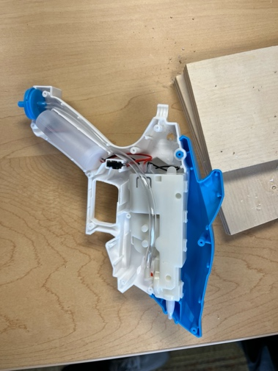

After this was completed, we worked on wiring the gun in parallel by soldering connections within the gun and connecting them to the 3.5 mm jack. Once this was done, we screwed the gun back together and connected the battery. Below are images depicting the spot we chose for the 3.5 mm jack.

where we chose to drill

# Testing

We tested this concept by plugging in the [interact switch](https://github.com/makersmakingchange/Interact-Switch) and the [light switch](https://github.com/makersmakingchange/Light-Touch-Switch), and testing the firing mechanic to make sure it fired using the adapted switches. We also made sure that the original trigger still worked.

## CONCEPT 2 – Creating the 3D printable stand

Next, we wanted to create a stand that would be a be able to hold the gun in an upright position, and allow for easy access to aiming capabilities. We did this by creating our 3D model in [Onshape](https://www.onshape.com/en/), and developing this initial model:

initial model image


This model was a bit too loose, so the water gun would shift around and not stay in place as intended. Mainly, the rear portion of the water gun would slide around too much, and the front prongs of the stand were not tight enough, so the gun would be overall unstable. This led us to create a second design:

# stand v2 3d modelslide plate 3d model

This design included adjustments in dimensions which allowed for the gun to be more stable in the stand. These included shortening the distance between the front prongs which hold on to the head of the gun, and adding small supports near the rear of the stand that would hold the rear of the gun in place. This worked wonders, as depicted below:

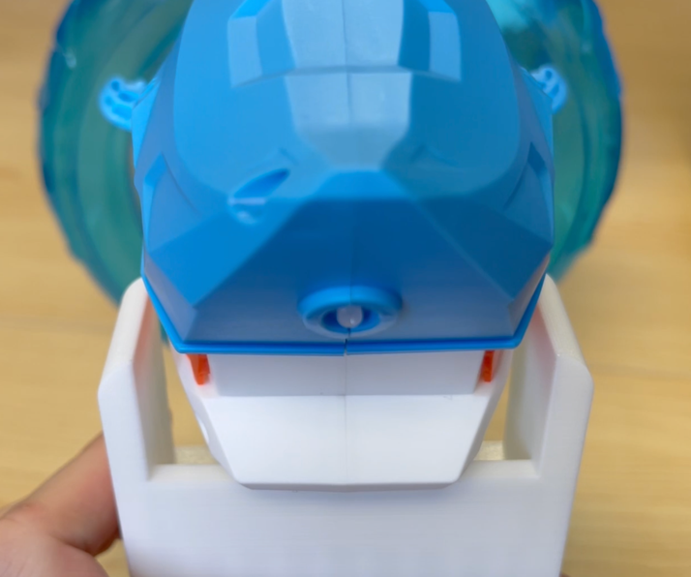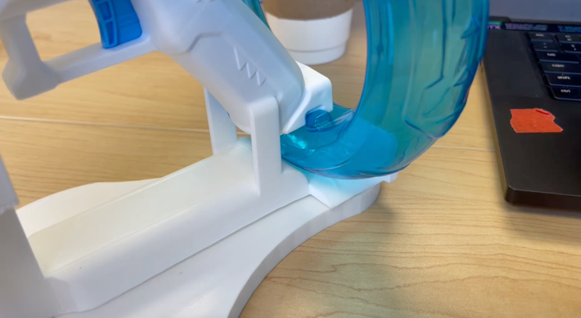

Once this was done, we added swivel functionality by including the printable swivel plate, which attaches to the water gun stand by using two small cylinders that correspond to cutouts in the swivel plate. The final design is shown below:

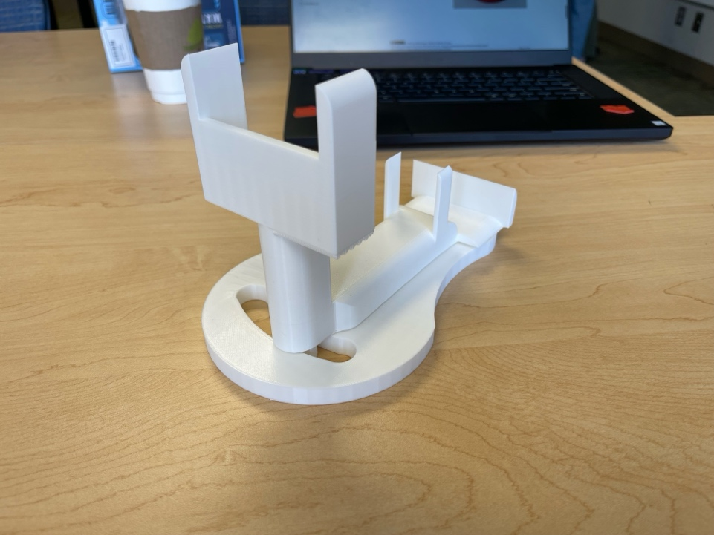

This design allows for easy aiming in a small arc shape.

# Detailed Design

Above is the final version of our water gun stand, alongside the swivel plate.

# Opportunities for Improvement

* Add a larger swivel plate so that the user can aim in a wider arc
* Add adaptations to the stand so that the user can aim vertically
* Add rubber base to the swivel plate so that it does not slide around on surfaces