Working with the web application.
- The application has 3 pages: main, partners, search pages. The data used in this pages in stored in a .csv files, data.csv, hence it can be updated any time. The csv file has the following fields: name, description, phone_number, lat, lng, address, link and categories.
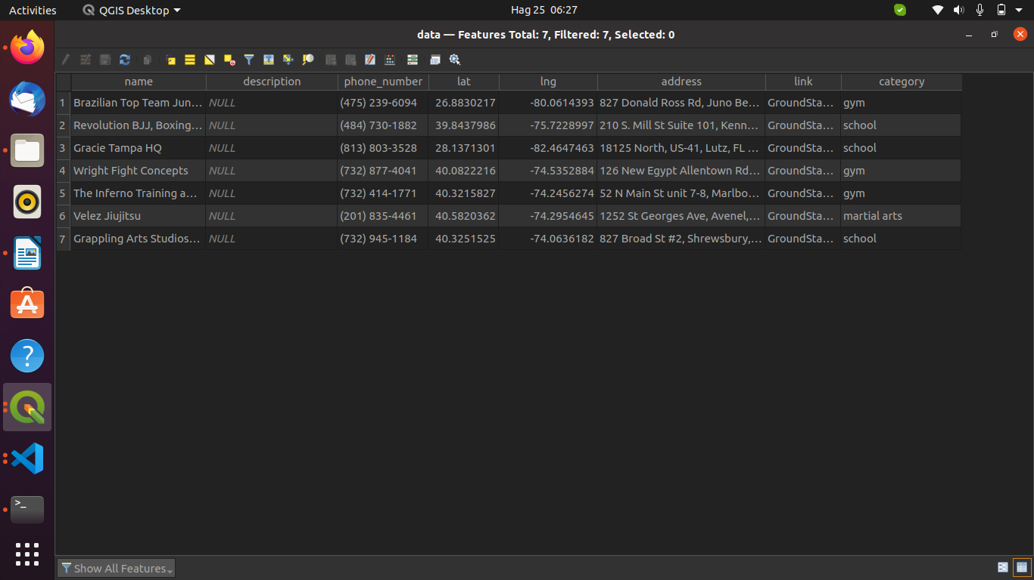
- The name field id used in the main page to search and in the search page. The lat and lng fields are used in plotting the markers on map.
- Address, link and categories are used in in creating the card used in partners page and map popup.
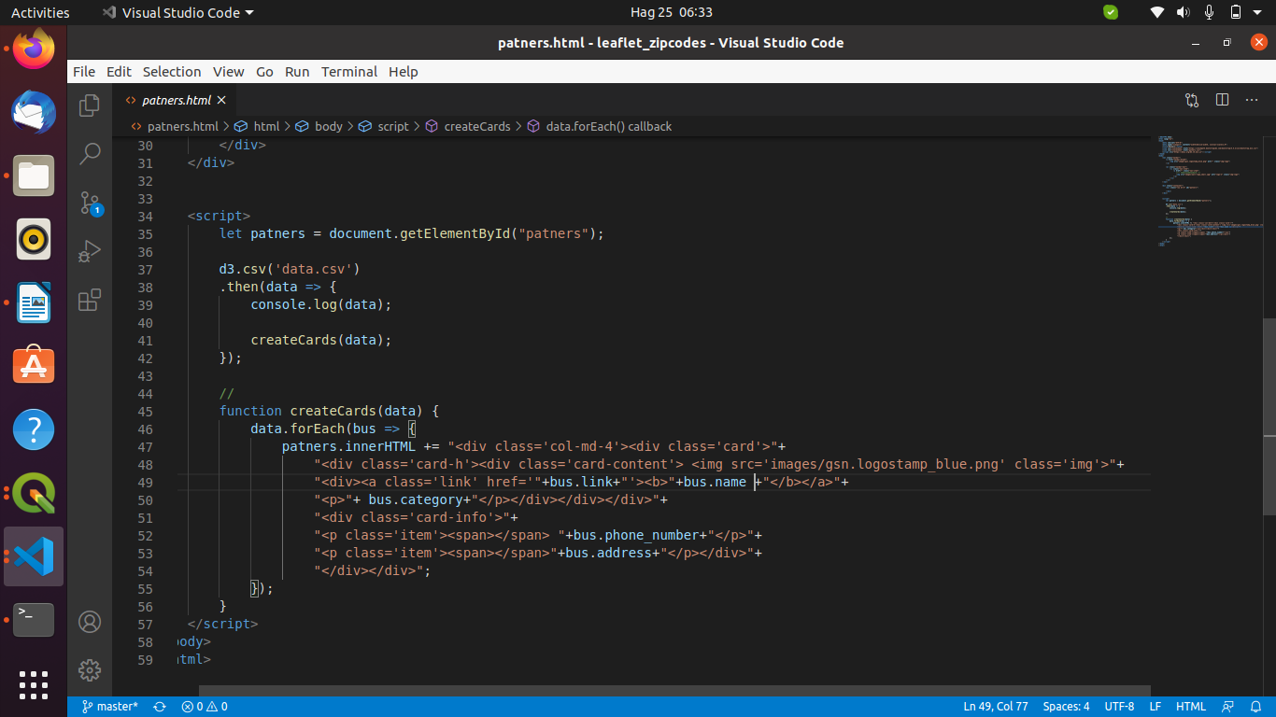
CreateCards function has been used to create cards in partners page and also in search page on popups. Therefore you can add more fields in the csv file and populate them on a given card.

The main page and search page share some functionalities, therefore, these function are written in the search.js. They include: reading the csv data using d3js, converting the data to geojson using csvtogeojson,

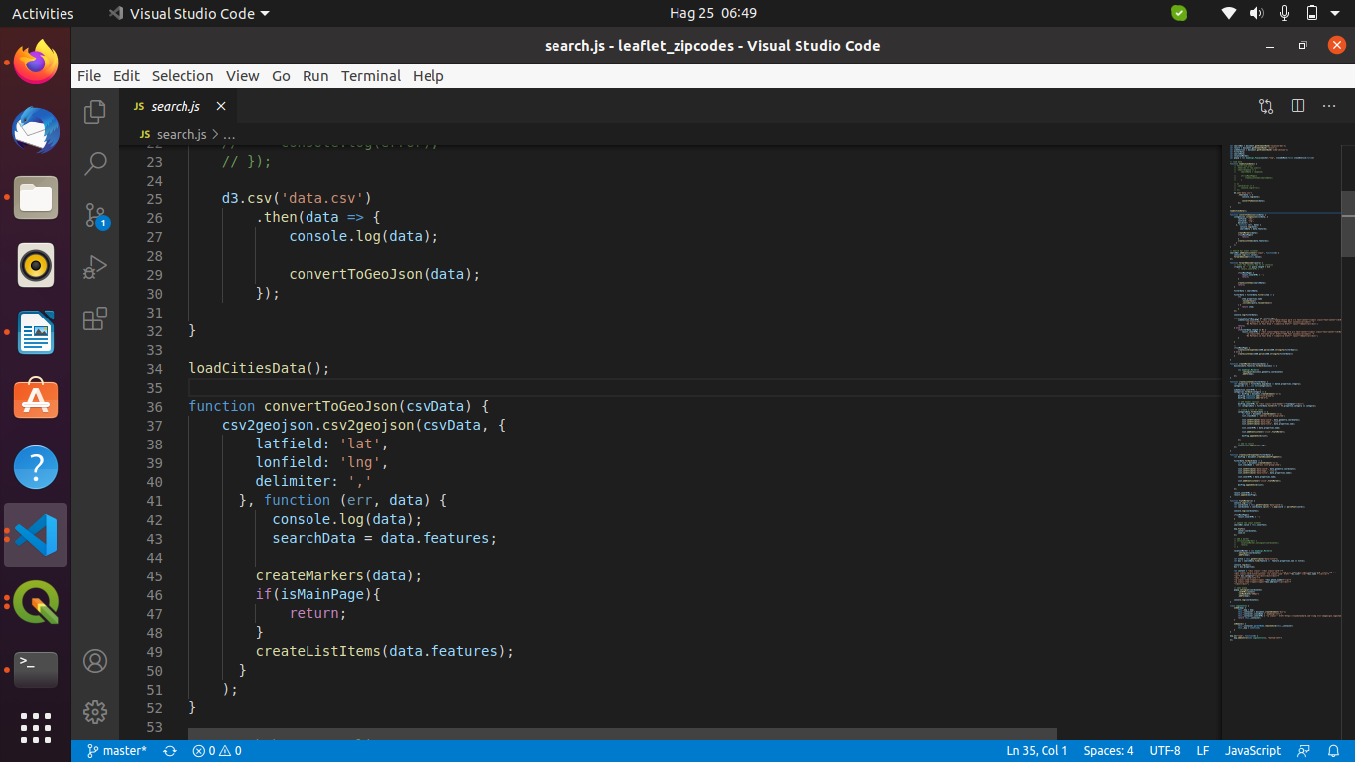

This followed by adding a event listener to the search input. The result are populated after the second keystroke. Each list item has has it event listener and attributes used to reference the data in the CSV file. Such information includes the title, coordinates.

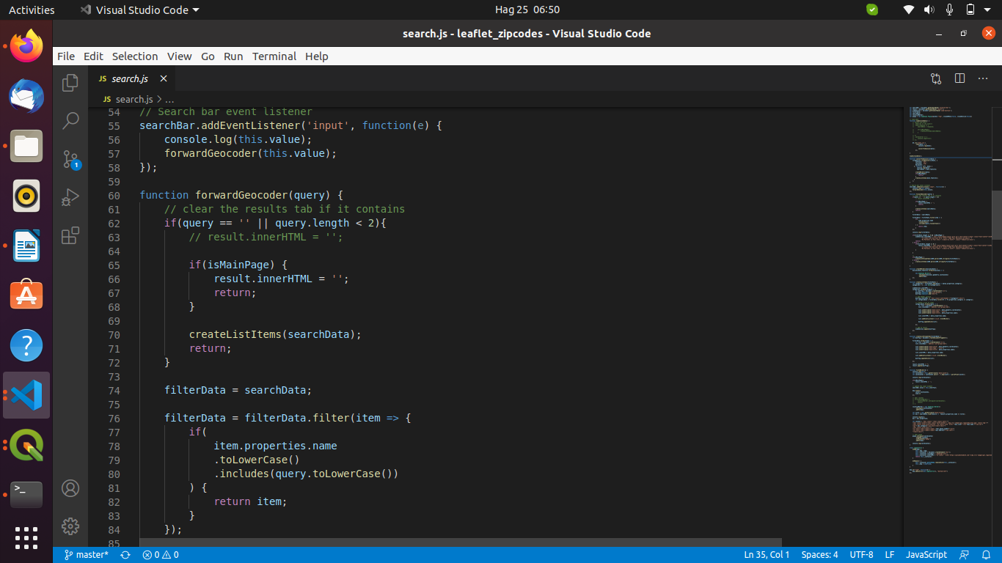

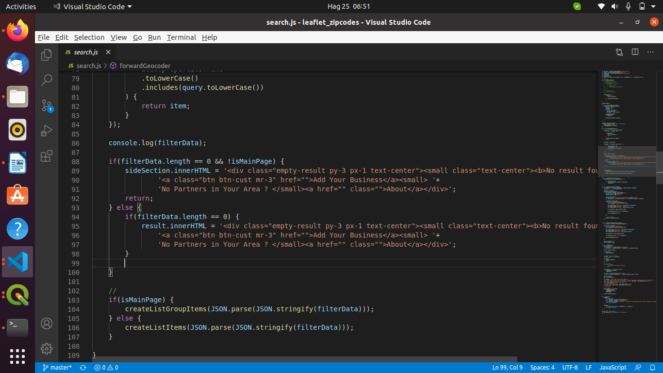
On list item click event it triggers a flyTo animation to location of the school in the map.

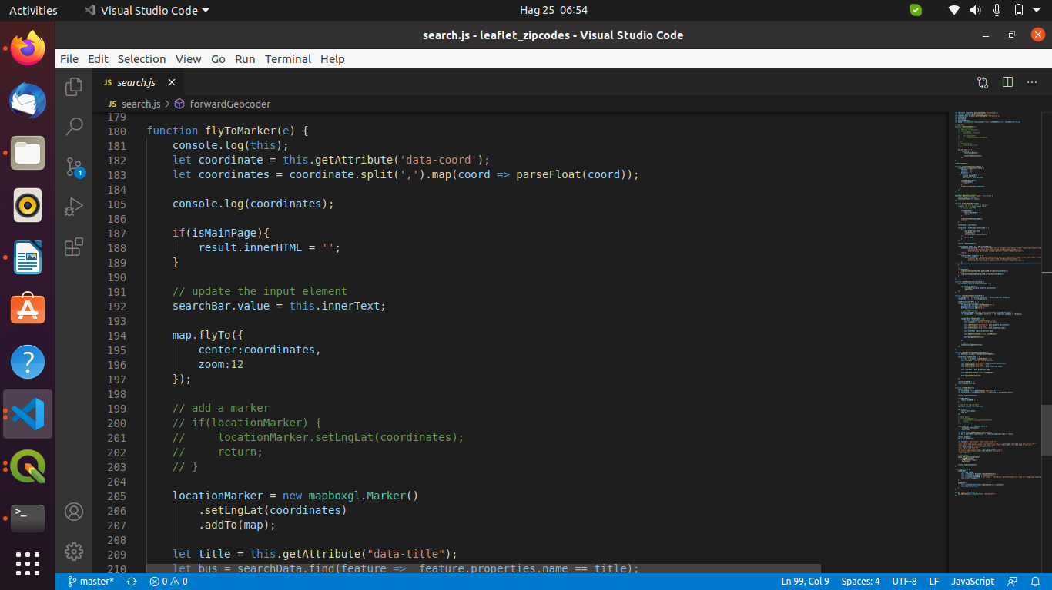
Theis is followed adding a popup to the respective marker on the map.

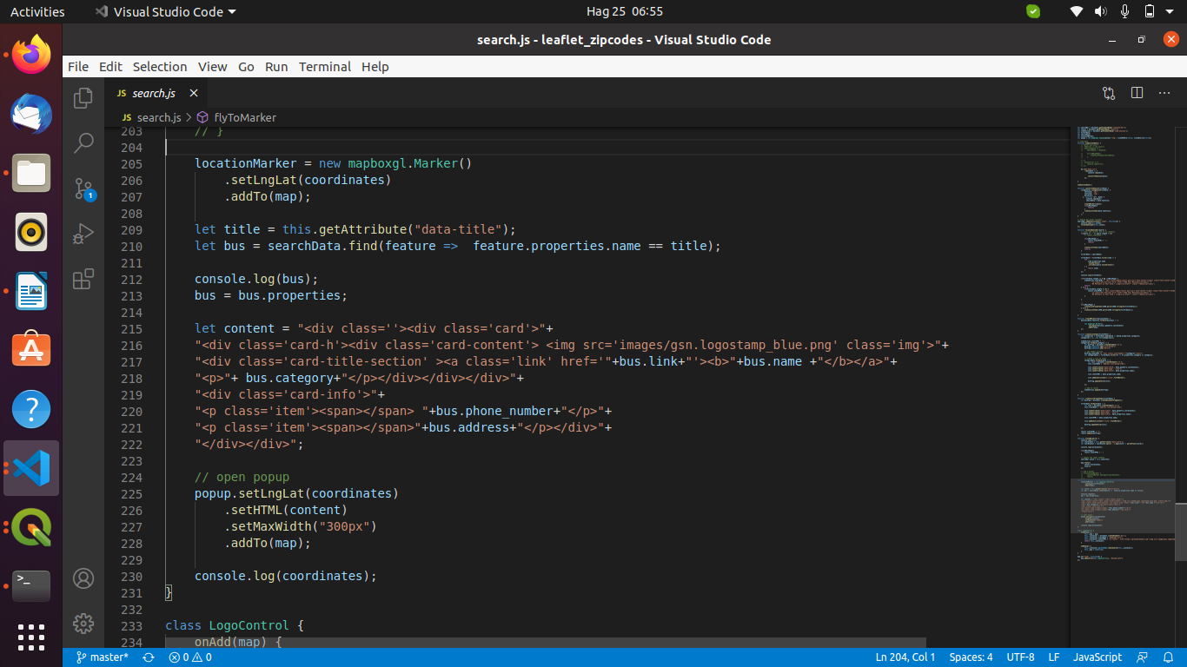
The image logo is a mapbox control created using Icontrol instance.

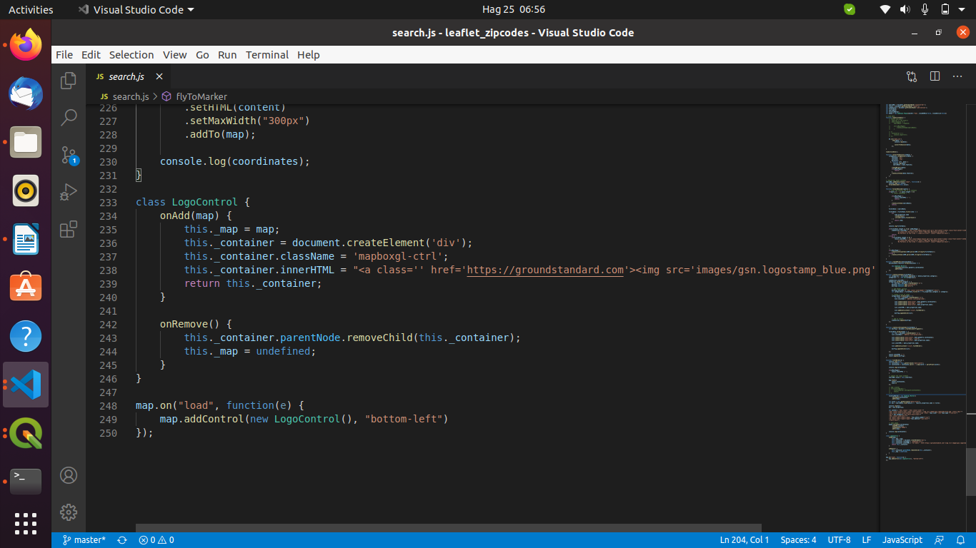
Each page has it’s own stylsheet (.css) files. You can edit any file.

