Sequence Models -

x<t> - t implies temporal index
Tx – length of the input sequence (number of words)
X(i)<t> - t th element in the sequence ith training example

After making dictionary, use one-hot encoding to represent each word.

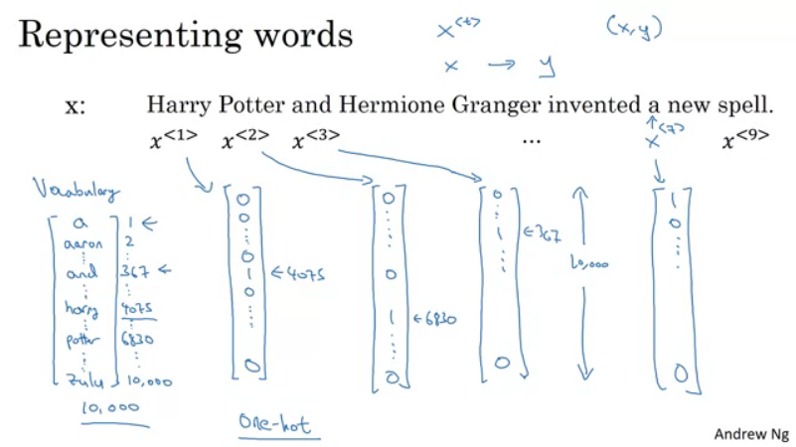
Each word is not in vocab – create unknown token.

Recurrent Neural Network Model
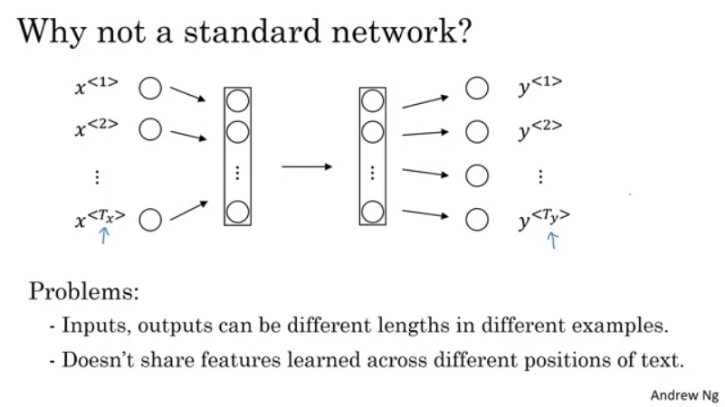
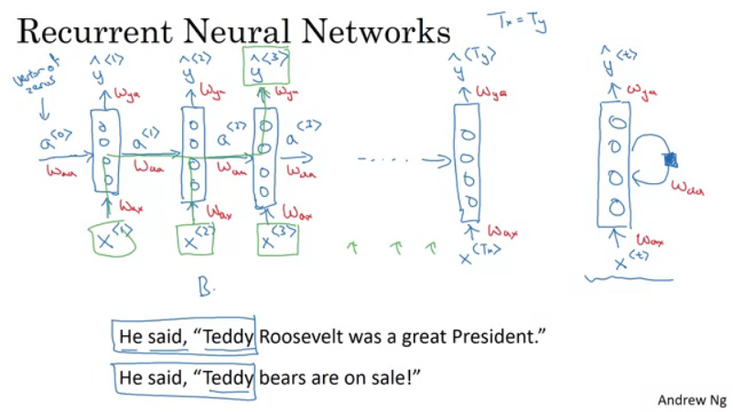
The prediction only uses earlier information but not later info.
URNN – Uni Directional Neural Networks
BRNN – Bi Directional Neural Networks
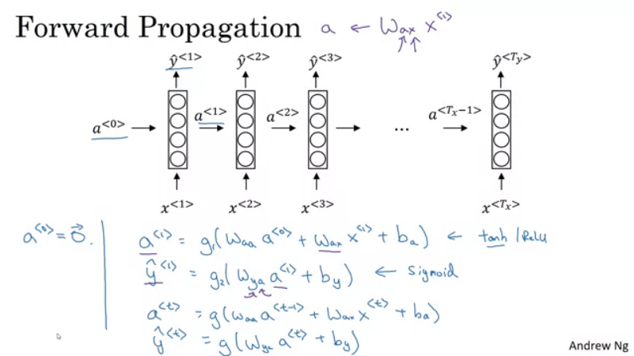

sigmoid or softmax for multi-class classification

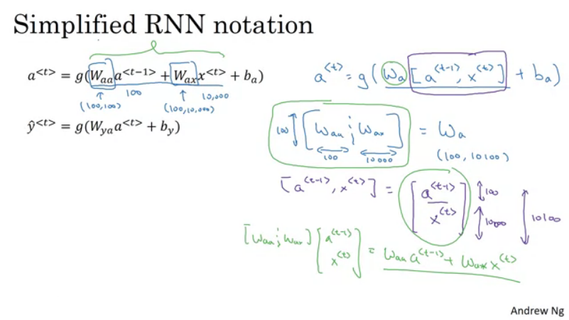
Backpropagation -

Element wise loss function.
Standard Logistic Regression Lost

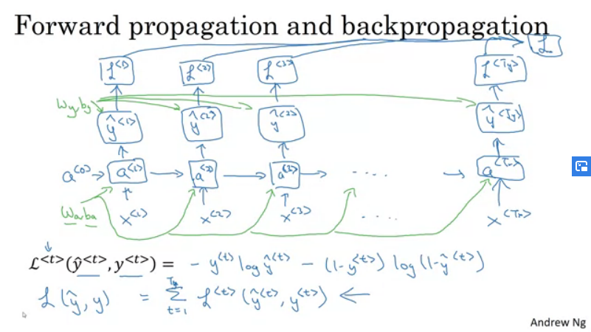

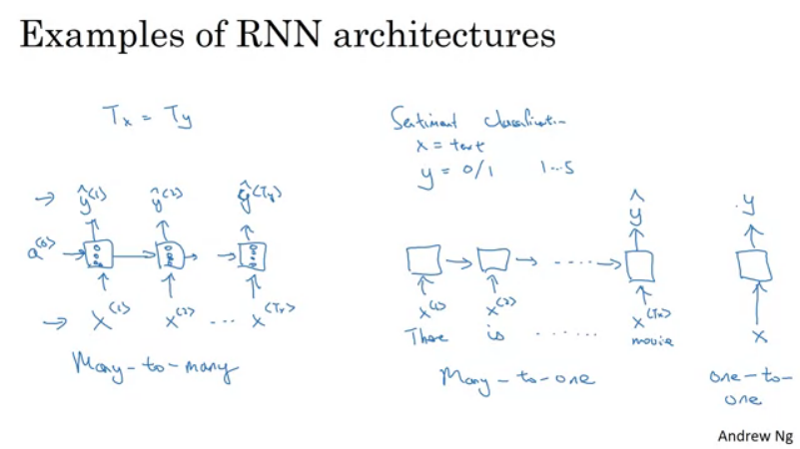

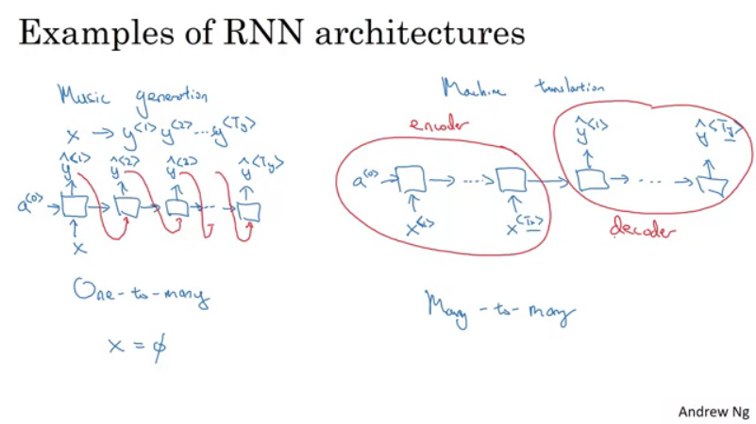

Language model and Sequence Generation -

SR picks second sentence using language modelling.
LM – estimates probability of that particular sequence of words.

Corpus – A very large body or set of english sentences.

Tokenize the sentences – Create a vocab and map to one-hot vectors.
Add extra token - <EOS> end of sentence - for the model to guess when the sentence ends.

If a word is not in vocab - <UNK> unknown word token.

y<1> - calculates whats the chance of each word to be a first word of the sequence.

The RNN learns to predict one word at a time.

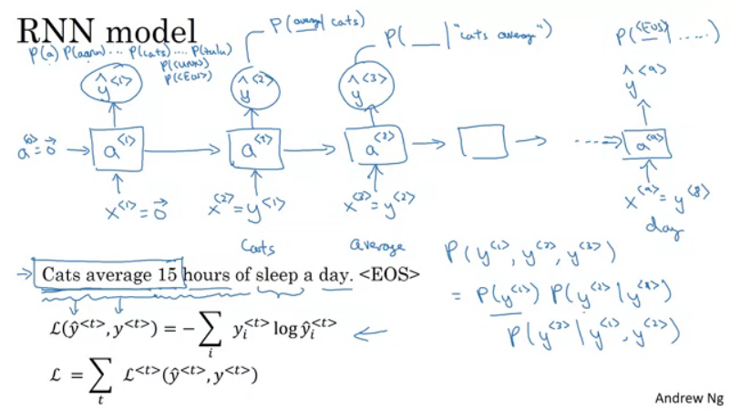

Sampling a novel Sequence

Gives 0 as input in first step.
Given the initial probabilites, pick a word randomly using this probability distribution.
Feed this word as input into next unit and repeat the steps.

If <EOS> is part of vocabolary, keep on sampling until it outputs EOS otherwise sample a set number of words.

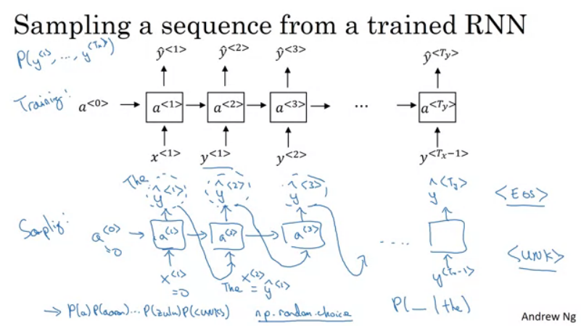
Character level models are computationaly expensive to train.

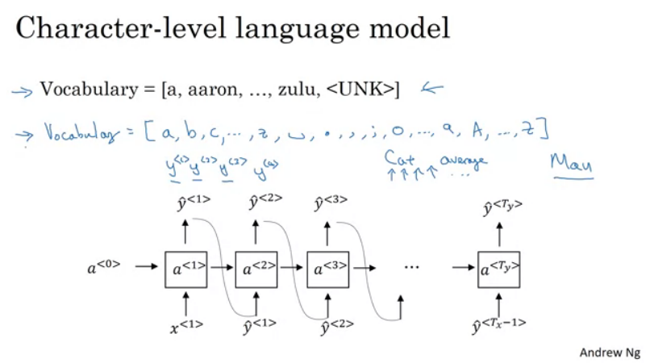

Vanishing Gradients with RNN

The language may have very long term dependencies. The RNN may not encorporate those dependencies. (Eg. Cat – was, Cats – were)

Very difficult for the error to backpropogate to the beginning of the sequence.

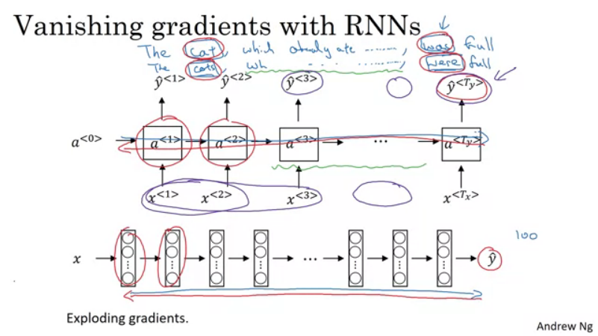
Vanishing gradients tends to be bigger problems for RNNs. Exploding gradients are easy to spot in RNNs and can be rectified by gradient clipping.

Gated Recurrent Unit -
Catch long range dependencies.

C – remembers wether the cat was singular or plural.
Ctilda – candidate value
We want to update C with Ctilda
The gate will decide whether or not we update C.
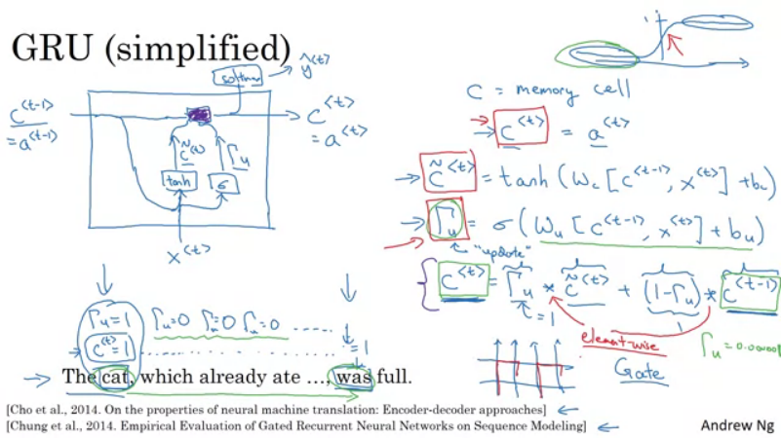
dimesnions of C = dim of a = dim of Ctild

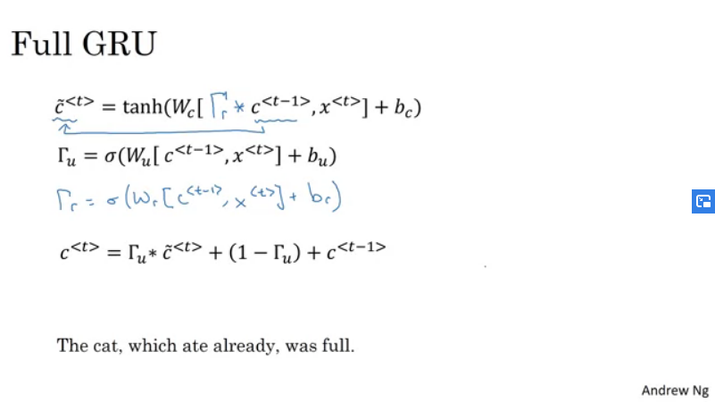

LSTM

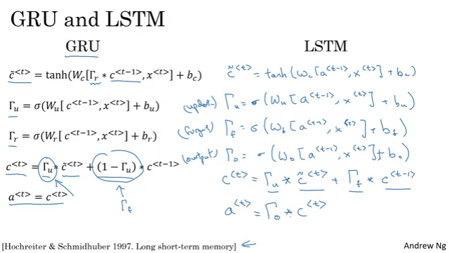
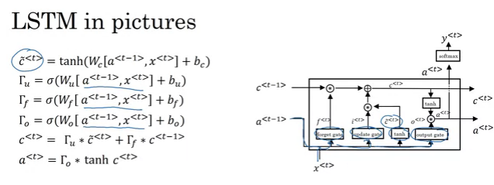
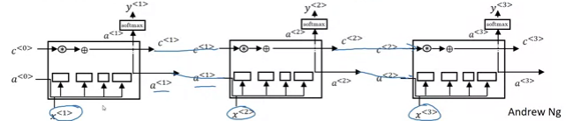

Bidirectional RNN -

