Sequence Models -
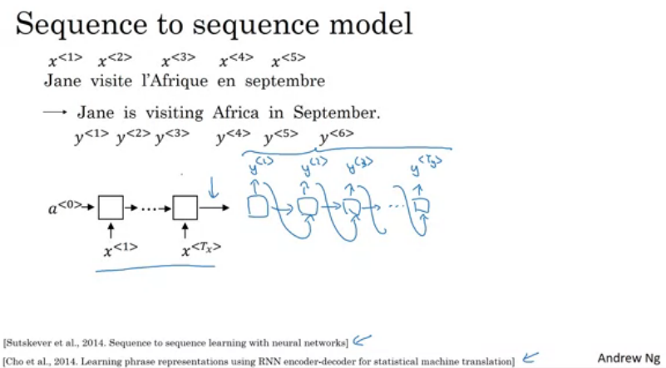

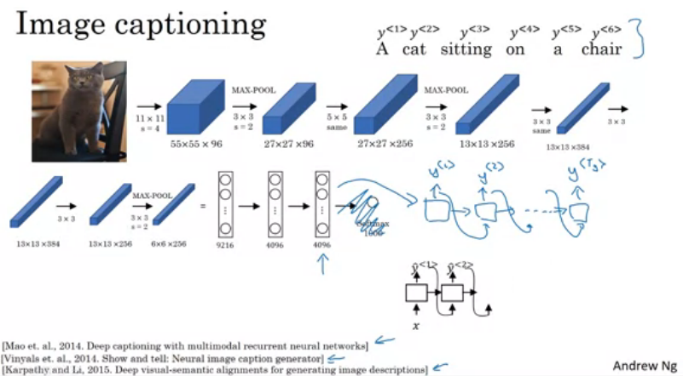

Machine Translation
Encoder Network -----> Decoder Network

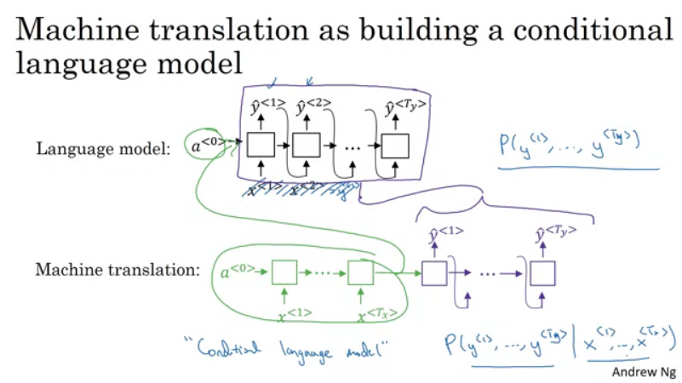

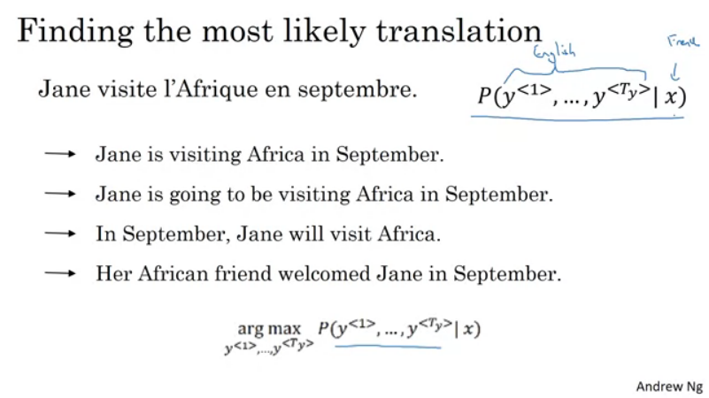
Come up with an algo that find Y that maximizes the above algorithm.

Greedy Search -

Pick each word with maximum probabilities.
P(yi / x)
Best first word – Best Second Word - .....

Does not work!

Going is a common english word. But that sentece is not the best.

Beam Search

Beam width = 3 – consider 3 possibilities at a time not one as we did in greedy search.

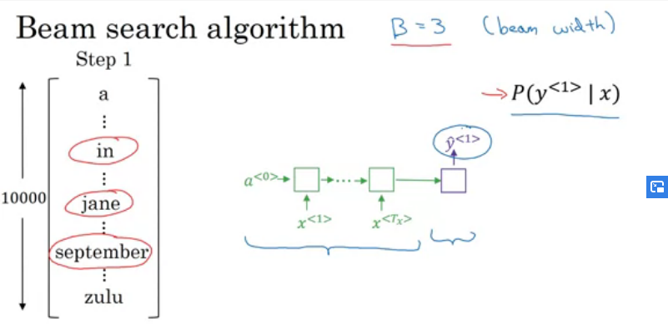

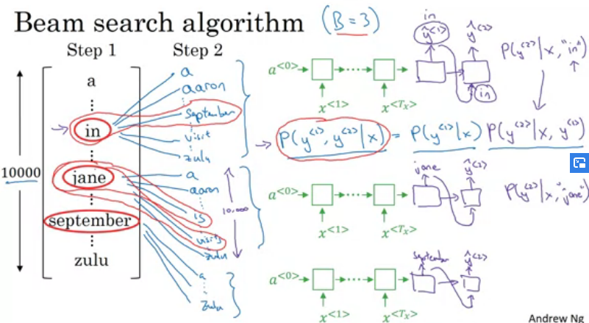

Used 3 copies of the network.

Refinements to Beam Search -

The product of probs may be too small – numerical underflow – use log instead.
Log is a strictly monotonic function.
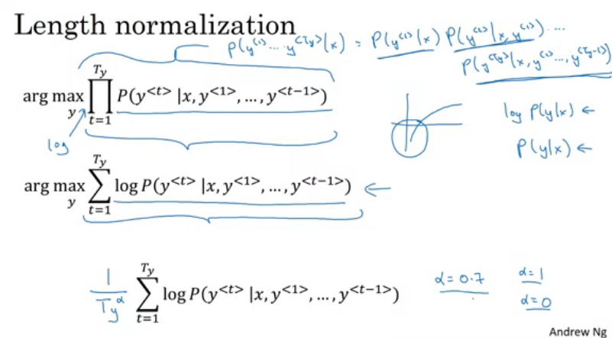

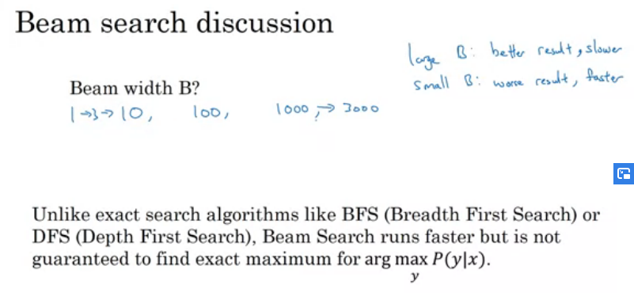

Bleu Score -

Automatically measures how good is a machine translation.

Bleu – Bilingual Evaluation Understudy

