Bounding Box Prediction -

YOLO – You Only Look One.

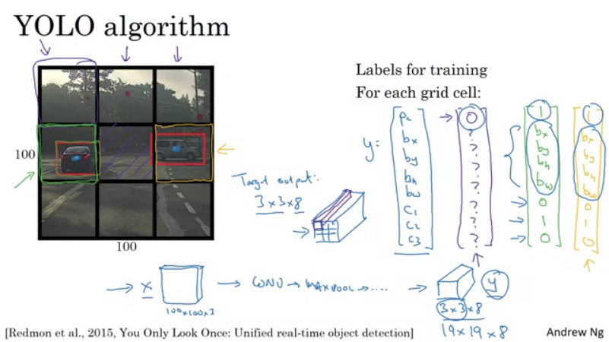
In practice you might use much finer grid.

Intersection over Union.

IoU = size of intersection / size of union

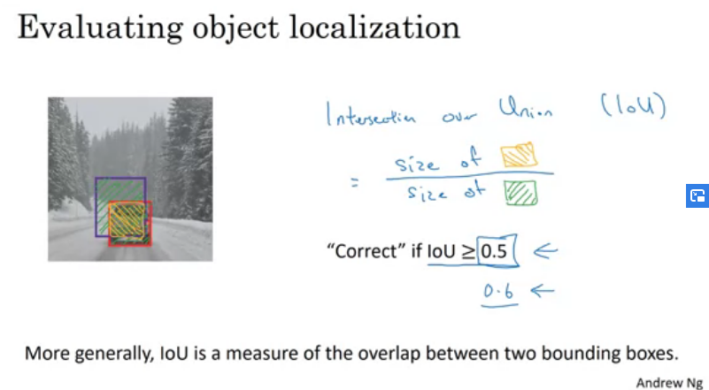

Non-Max Supression

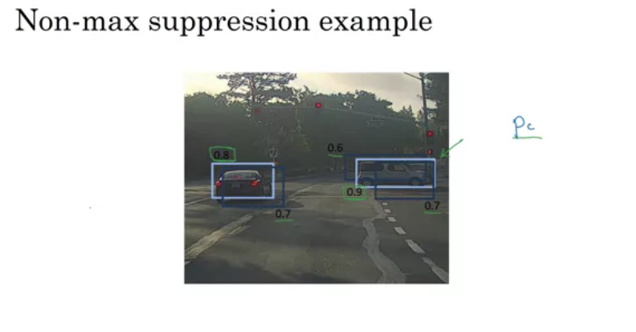
to make sure the algorithm detects the object only once.

