ResNets -

Verry deep networks difficult to train – Vanishing/Exploding Gradient Problem

Residual Block -

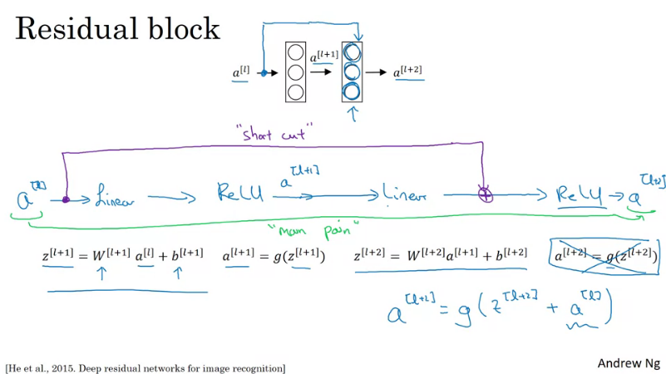
The shortcut is also called skip connections.

Residual Network -

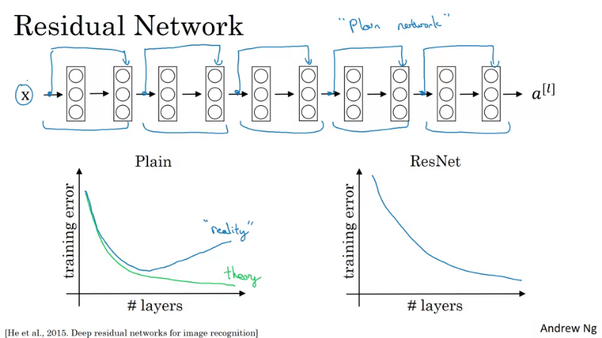
Helps in avoiding Vanishing/Exploding Gradient Problem.
Why ResNets work ?

The identity function is easy for residual block to learn.
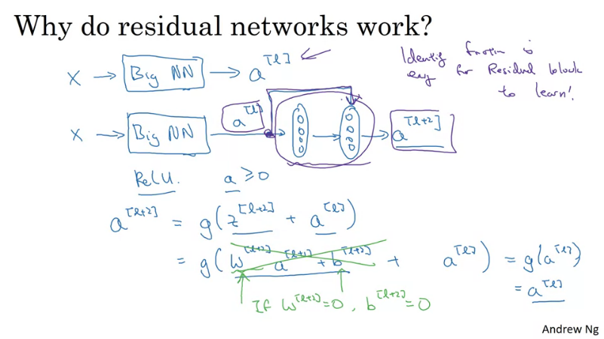
Thus adding an addition Residual Block does not hurt the performance.

1x1 Convolution -

https://stats.stackexchange.com/questions/194142/what-does-1x1-convolution-mean-in-a-neural-network
Also called Network in Network.
Check the paper for details.

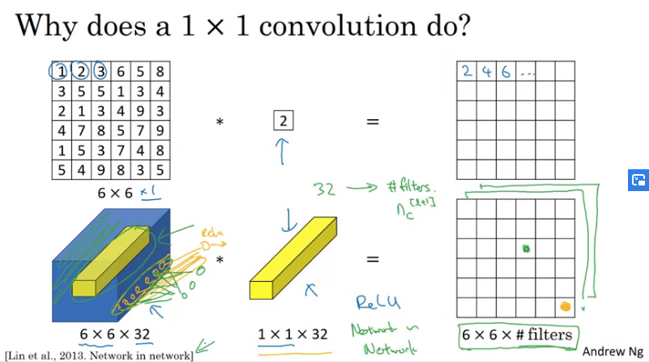
Use - To reduce number of channels.
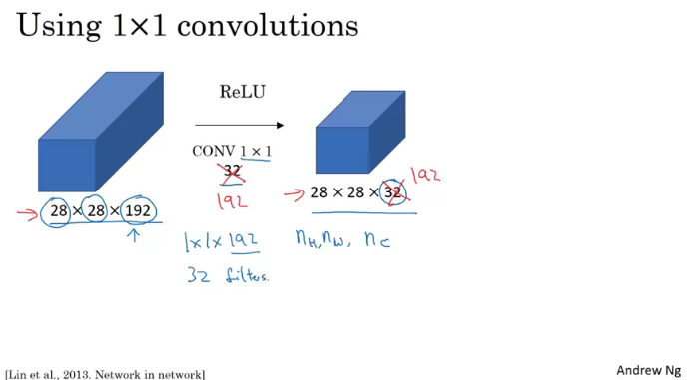
Inception Network Motivation -

*in same convolution the output dimension remains same*

In max-pool in order to make the dimension match you have to use padding.
Instead of you picking the filter size, use them all and let the model choose.

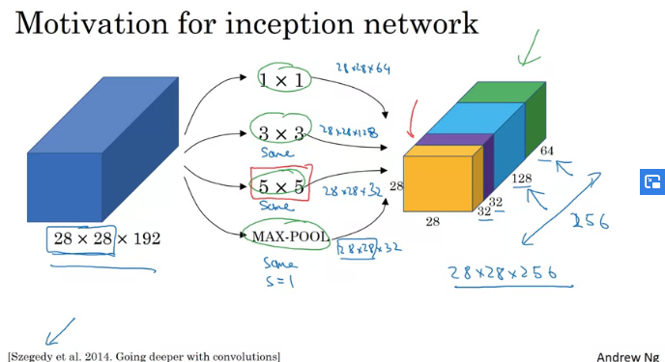

The problem of computational cost -
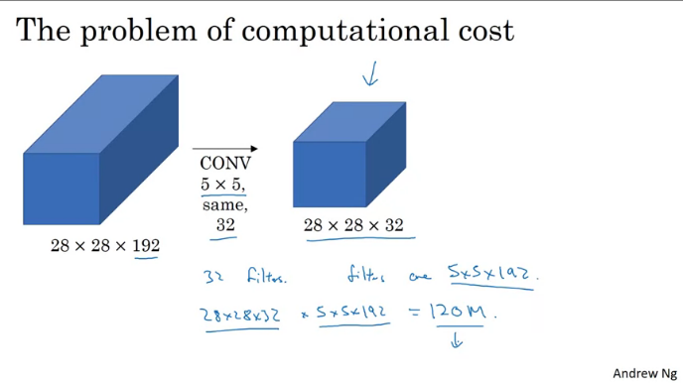

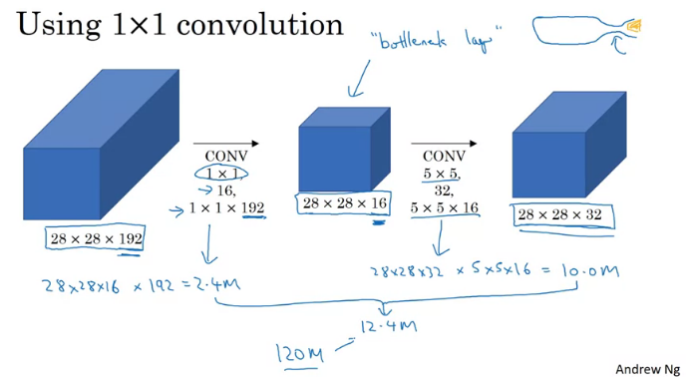
The shrinking down the representation size does not affect the performance negatively.

Inception Network -

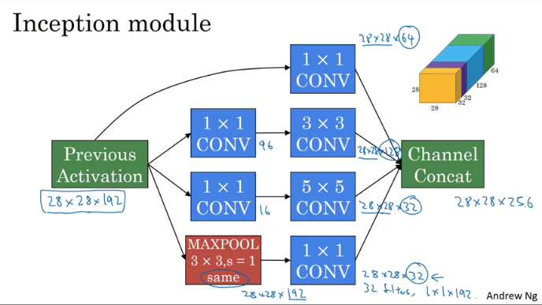
The additional side branches - take some hidden layer and try to use that for prediction.

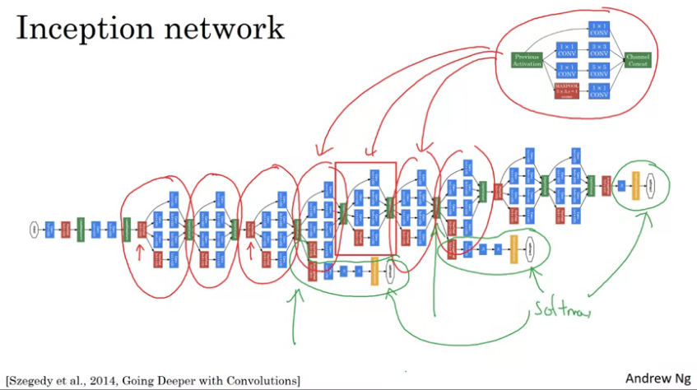

Using Open-Source Implementation -

Networks are difficult to replicate.
Researches opensource their networks on github.

Transfer Learning -

Much faster progress if use pre-trained weights.
Example – ImageNET, COCO etc.

If training set is larger we could just freeze fewer layers and train later layers.
If lot of data, use the pre-trained as initializatoin and train the whole model.

Data Augmentation -

1. Mirroring in verticle direction.
2. Random Cropping
3. Rotation
4. Shearing
5. Local Warping

Color Shifting - Add to the RGB channels different distortions.
In practice the additions are quite smalle – not a dramatic change.

Advanced – PCA

Implementing distortions durig training -

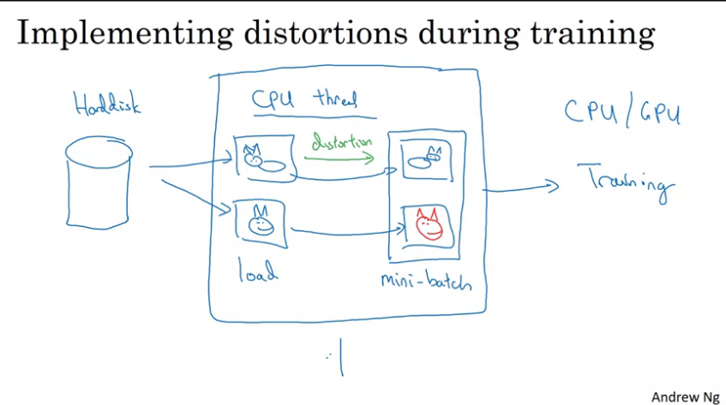

State of Computer Vision -

Data vs hand-engineering

