COM1005 – First laboratory session: The Nao Robot

Objective:
This first laboratory session with the Nao robot is for you to familiarize with the robot itself, but more importantly with the GUI that will allow you to control Nao. So have fun and play with your robot (Be careful not to have too much fun as the robot is still fragile and very expensive).

Choregraphe
Choregraphe (the equivalent of choreography in French) is the software that will allow you to connect to the Nao robot, set most of Nao's parameters, send command that the robot will have to execute and finally watch its performance (possibly debug in case of error).

Once you have launched the program from the binary, the main window should appear shortly after. Choregraphe's main window is made of:
- On the left hand side is the content of your current project, displayed in a tree like structure. There you can import new behaviour, create and delete directories and project files.
- The middle section is split in two parts:
  - The top, that is empty at the moment, is were you will be able to drag and drop boxes and link them together to build your program.
  - The bottom contains different tabs allowing you to monitor most of the robot's activity and the state of its sensors and memory. This is where you should first look is case of error (especially the log viewer).
- The Right hand side is also made of two parts:
  - At the top you will find the box libraries. This is where all the modules for programming the Nao robot are stored into different categories for ease of use. You can switch between the “standard” and “advanced” libraries with the tabs on top (only the standard library will be required for today's session). Next to the box libraries is the position library containing the basic position pre-programmed into the Nao. And finally, there is the video monitor that will show you, when connected to a real robot, what the Nao sees in real time.
  - At the bottom, you should only focus on the robot view, displaying in a virtual environment the actions and dialogues of your robot. If you double-click on some parts of the virtual robot, a window should open showing you the settings for the different joints and allowing you to modify those angles. The robot applications part will have no use for us.
- On top of all this seats the toolbar, which contains from left to right:
  - Create a new project
  - Open an existing project
  - Save the current project
  - Undo the last action
  - Redo the last action
  - Connect to a robot
  - Disconnect from a robot
  - Launch the program
  - Stop the program
  - Display the debug/errors (works only while connected to a real robot)
  - A progress bar displaying the progression in the loading process
  - The volume of Nao's speakers
  - An animation mode

  - The autonomous mode: When switched on the Nao will seek to interact with you like any bored child.
  - The rest button: Commanding Nao to get into the crouching position and set its motors' stiffness to 0.
  - The wake up button is simply the opposite of the rest button.
  - Finally, at the far end is the battery status, which will light up once you are connected to a real robot and change colour when the Nao should be connected to a power source.

Exercise

Starting the robot
To start the robot, you only need to push once on the chest button. Nao should come to life with a display of lights around its eyes and on its head.
The robot is not entirely ready for you to work with, the initialization phase can take some time, so be patient. Once the process is done Nao will say “Ogna Gnouk”.

Connecting to the robot
To connect to the robot, first check that your computer is connected to the “guest” wireless network.
Then push Nao's chest button once. Nao should tell you what its IP address is (write it down for later).
Then simply click on the connect button .
A new window should appear in front of you that looks similar to this:
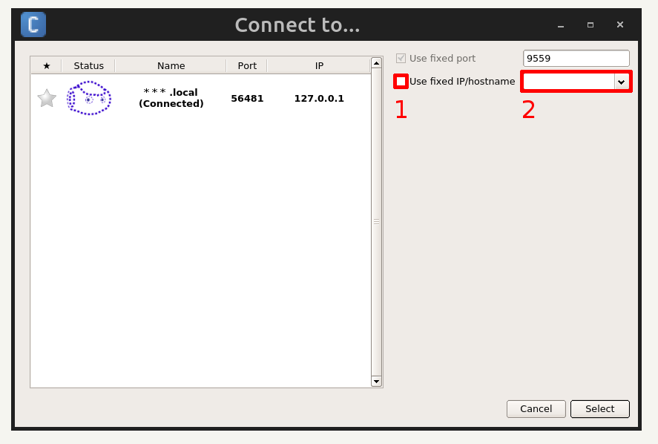
The first line on the right is the virtual robot, which you should connect to if you want to experiment with choregraphe, without being connected to a real robot.
In our case we want to access a real robot through its ip address. On the right, tick the box (marked 1) and in the corresponding field (marked 2) enter the ip address with the dots.
Finally, click onto select. The window will directly close itself and after some time you should be connected to the Nao robot and ready to send commands.

Disconnecting from the robot
Once you have made sure that no simulation is running, simply click on the disconnect button and you will be directly disconnected from the real robot and connected back to the virtual Nao.

