OpenCPI
Tutorial 4: Using Third-party Libraries in RCC Workers
OpenCPI Release develop
Revision History
Revision | Description of Change | Date
1.0 | Creation | 2019-12-12
Table of Contents
1 Overview 4
1.1 Tutorial Objectives 5
1.2 What’s Provided for This Tutorial 6
1.3 Prerequisites to Using This Tutorial 7
1.4 Documentation References 8
2 Create Component 9
2.1 Create Component Spec 10
2.2 Add Properties and Ports 11
3 Create Worker 14
3.1 Create Worker OWD and Skeleton File 15
3.2 Edit Worker OWD 16
3.3 Edit Worker Makefile 18
3.4 Write C++ Code 19
3.5 Edit Worker Skeleton File 20
3.6 Build Worker 23
4 Create Unit Test 24
4.1 Edit Unit Test Description 25
4.2 Edit Unit Test Scripts 28
4.3 Build Unit Test 34
5 Run Unit Test 35
6 Tutorial Summary 36

Overview
This tutorial continues to demonstrate the RCC worker design process that we introduced in Tutorial 3. In this tutorial, we’ll re-create the complex_mixer component from the ocpi.tutorial project that we used in Tutorial 2. As we did in Tutorial 3, we’ll step through the procedure used to create the component and its RCC worker implementation, including creating the component specification and designing, building and testing an RCC worker that implements its function.
The complex mixer component consists of a Numerically Controlled Oscillator (NCO) and a complex multiplier. It receives I/Q data on its input port and then multiplies this signal by a tone generated by the NCO, shifting the input signal in the frequency domain by the frequency of the NCO. The component properties control the NCO frequency.
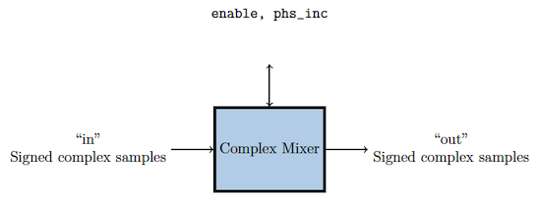
Figure 1: Complex Mixer Component Function
This tutorial shows you how to use a third-party library to implement the internal NCO tone generator for the RCC implementation of the component. To implement the NCO, we’ll use the nco module from liquid-dsp, which is a free and open-source signal processing library for software-defined radios written in C and is included in the OpenCPI installation. For details on liquid-dsp and the nco module, see the URL https://liquidsdr.org/doc/nco.

Tutorial Objectives
The purpose of this tutorial is to demonstrate how to integrate a third-party library into an RCC worker.
This tutorial shows you how to:
- Create the complex mixer component specification (properties and ports).
- Create the complex mixer worker C++ code using the liquid-dsp API and build the worker for the target platform
- Create, build and run the unit test for the RCC worker on the target platform.
It demonstrates how to use the RCC authoring model to:
- Integrate the liquid-dsp library into the RCC worker
- Create worker methods for initializing and releasing C++ resources
- Access worker data ports
- Use worker method result values to communicate worker states to the OpenCPI framework
After running this tutorial, you should understand how to use the RCC authoring model to integrate a third-party library into an RCC worker and how to use the OpenCPI unit test suite on an RCC worker implementation of a simple OpenCPI component.

What’s Provided for This Tutorial
The tutorial provides source code for the following tutorial items:
- The complex_mixer worker, written according to the API for the RCC (C++ source code) authoring model. This source code uses the liquid-dsp library that is included with OpenCPI and installed as part of the OpenCPI installation process.
- The unit test files generate.py and verify.py, written in Python
- The unit test bash shell script view.sh
This source code is available as text in the relevant sections of this document that you can copy and paste into the relevant files following the instructions given in the section.
The tutorial also provides the XML source for all of the assets used to build and run the example component, worker and tests, available as text in the relevant sections of the document.
You will also use the following script from ocpi.assets:
- The Python script code for plotting and viewing the output data, in scripts/PlotAndFft.py

Prerequisites to Using This Tutorial
Before you begin this tutorial, you should have successfully completed Tutorials 1 through 3.
This tutorial is a continuation of Tutorial 3. You’ll continue to use the DemoProject project that you used in the previous tutorial.
Before you begin this tutorial, we recommend reading Briefing 7, “Automated Test Suite Details”.

Documentation References
The documents listed in the following table provide detailed information about subjects discussed in this tutorial. The documents listed here are not required reading for this tutorial but will likely be of interest for more in-depth learning.
Table 1 - OpenCPI Reference Documentation
Title | Published By | Public URL
OpenCPI User Guide | OpenCPI | https://opencpi.gitlab.io/releases/develop/docs/OpenCPI_User.pdf
OpenCPI Application Development Guide | OpenCPI | https://opencpi.gitlab.io/releases/v1.6.0-rc.0/docs/OpenCPI_Application_Development.pdf
OpenCPI Component Development Guide | OpenCPI | https://opencpi.gitlab.io/releases/v1.6.0-rc.0/docs/OpenCPI_Component_Development.pdf
OpenCPI HDL Development Guide | OpenCPI | https://opencpi.gitlab.io/releases/v1.6.0-rc.0/docs/OpenCPI_HDL_Development.pdf
OpenCPI RCC Development Guide | OpenCPI | https://opencpi.gitlab.io/releases/v1.6.0-rc.0/docs/OpenCPI_RCC_Development.pdf

Create Component
Like we did in Tutorial 3, we need to create the OCS (OpenCPI Component Specification) for our complex mixer function that defines its properties and ports.

Create Component Spec
Recall that we created a components library for components we created in DemoProject in Tutorial 1. As we did for the new peak_detector component, we’ll create the complex mixer component spec in the components library.
To create the complex mixer component spec with AV, right-click on the components library and select new component. The new asset dialog appears. In Name, enter complex_mixer. Leave the other fields as they are and click Finish.
To create the component spec with ocpidev, run the following command from the DemoProject directory:
ocpidev create component complex_mixer
The command creates the component spec complex_mixer-spec.xml in components/specs. We’ll add properties and ports to the component spec in the next step.

Add Properties and Ports
The complex_mixer component function needs to define two properties:
- The phs_inc (“phase increment”) property, which stores the results of the computation (that is, setting the tune frequency for the input signal using the output of the internal NCO). This property is valid for both RCC and HDL component implementations.
- The enable property, which controls whether a worker implementation performs the computation on the incoming data or simply passes the incoming data through without any processing (“bypass” mode). This property is valid for both RCC and HDL component implementations.
We want to set default values for the phs_inc and enable properties in the component spec and allow the worker implementation to override these values. We’ll use the default attribute in our property definitions to specify the default values and use the writeable attribute to indicate that the worker can override them. You can read more about how the framework interprets these attributes in the OpenCPI Component Development Guide.
The complex_mixer component has the same simple port configuration as the peak_detector component and uses the same OPS. It requires one input port and one output port for communication with other components in an application and both ports will use the iqstream protocol.
To create the properties and ports in AV:
- Click the complex_mixer-spec.xml tab and then click the Design tab. In Outline, click Properties and then click Add a Property to display the OCS Properties page. (You can also right-click on Properties and then select Add Ocs Property to display it.)
- In Name, enter enable. In Type, select bool from the drop down list. In Accessibility, check Writeable.
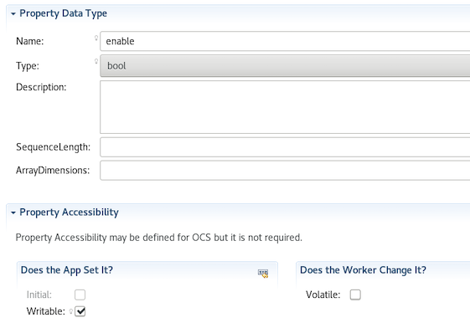
- In Outline, click Properties > Add a Property again to display the OCS Properties dialog. In Name, enter phs_inc. In Type, select short from the drop-down list. In Accessibility, check Writeable.
- In Outline, click Ports and then click Add a Port (or right-click on Ports and then select Add a Port) to display the OCS Port Definition dialog. In Name, enter in. In Protocol, select iqstream_protocol. Leave the other fields blank.
- In Outline, click Ports > Add a Port again to display the OCS Port Definition dialog. In Name, enter out. In Protocol, select iqstream_protocol. Check Producer.
- Now click the OCS Editor Source tab for the complex mixer component. We need to add the default attributes and values for these properties by hand because we can’t do it in the AV dialog. In the Source tab, enter "Default=true" for the enable property and "Default=-8192" for the phs_inc property, as shown below, highlighted in red:
<ComponentSpec>
<Property Name="enable" Type="bool" Writable="true"
Default="true"></Property>
<Property Name="phs_inc" Type="short" Writable="true"
Default="-8192"></Property>
<Port Name="in" Protocol="iqstream_protocol"></Port>
<Port Name="out" Protocol="iqstream_protocol"
Producer="true"></Port>
</ComponentSpec>
To add properties and ports from the command line, open the spec with a text editor and add the following XML code:
<ComponentSpec>
<Property Name="enable" Type="bool" Writable="true"
Default="true"/>
<Property Name="phs_inc" Type="short" Writable="true"
Default="-8192"/>
<Port Name="in" Protocol="iqstream_protocol"/>
<Port Name="out" Protocol="iqstream_protocol"
Producer="true"/>
</ComponentSpec>

Create Worker
Recall from Tutorial 3 that we implemented a run method for the peak_detector worker. This is the only required method in the RCC authoring model. We also implemented a start method for the worker; this method, along with the initialize, release and stop methods, are optional. We need to use the initialize and release methods in our complex mixer worker to prevent segmentation fault errors from being generated.
Because we’re using a third-party library in our complex mixer worker, the procedure to design it has a few more steps than the procedure we used for the peak detector worker in Tutorial 3. For the complex mixer, the steps are as follows:
- Create the worker OWD and skeleton file
- Edit the worker OWD to add information about the liquidsp library and the optional RCC authoring model methods to be used
- Edit the worker Makefile to add an RCC Makefile variable that identifies the liquidsp library to the OpenCPI framework as a prerequisite library
- Write the C++ code that uses the liquidsp API and implements the authoring model
- Edit the worker skeleton file to add the C++ code
- Build the worker for target platform

Create Worker OWD and Skeleton File
To create the complex mixer RCC worker with AV, navigate to components > specs in DemoProject and then right-click complex_mixer-spec.xml. Use the new worker selection from the context menu. Give the worker the name complex_mixer and leave all the other fields as they are. Click Finish.
To create the complex mixer worker with ocpidev, run the following command:
ocpidev create worker complex_mixer.rcc

Edit Worker OWD
Recall from Tutorial 1 that RCC worker OWDs generated by ocpidev don’t generally need to be updated. In this case, however, we need to add two attributes:
- A ControlOperations attribute that indicates our worker will have initialize and release methods; because the run method is mandatory, its presence is assumed. You can read more about this attribute in the OpenCPI Component Development Guide.
- A StaticPreReqLibs attribute that indicates our worker will use the liquidDSP library. You can read more about this attribute in the OpenCPI RCC Development Guide.
To add these attributes with AV:
- In the text editor panel, click the tab for the complex_mixer OWD and maximize it.
- In ControlOperations, check initialize and release.
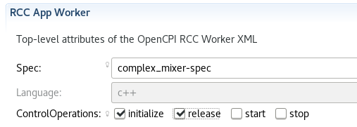
- Expand Build Attributes and scroll down until you see the StaticPreReqLibs attribute. Enter liquid into this field.
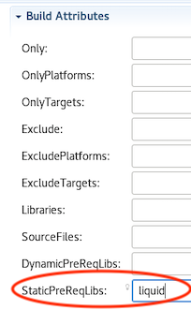
- Click the Save icon (the floppy disk icon below the top menu).
To add these attributes to the OWD from the command line, in DemoProject, open /components/complex_mixer.rcc/complex_mixer.xml with a text editor and add the following XML between the RccWorker elements (highlighted in red):
<RccWorker language='c++' spec='complex_mixer-spec' version='2'
controlOperations="initialize,release" StaticPreReqLibs="liquid"> </RccWorker>

Edit Worker Makefile
In this step, we’ll add the RCCStaticPrereqLibs RCC Makefile variable to our complex mixer worker’s Makefile. This variable specifies the names of libraries installed as OpenCPI prerequisite libraries that this worker should link against, statically, which will incorporate (copy) any referenced objects in that library into the worker's binary artifact. This setting automatically puts the library's include directory in the search path for headers. For more information about RCC Makefile variables, see the section on RCC compiler and linking options in the OpenCPI RCC Development Guide.
In DemoProject, navigate to the /components/complex_mixer.rcc subdirectory. Open the file Makefile with a text editor and add the following text highlighted in red before the worker’s include file definition:
# This is the Makefile for worker complex_mixer.rcc
RccStaticPrereqLibs=liquid
include $(OCPI_CDK_DIR)/include/worker.mk

Write C++ Code
We’ll use the nco module from liquid-dsp, which is a free and open-source signal processing library for software-defined radios written in C and is supplied with the OpenCPI installation. For details on liquid-dsp and the nco module, see the URL https://liquidsdr.org/doc/nco.
Our worker code will use the following routines from the liquid-dsp nco module:
- nco_crcf_create(type) - creates an nco object of type LIQUID_NCO or LIQUID_VCO. We’ll use this routine in our initialize method to create an NCO object of type LIQUID_NCO.
- nco_crcf_destroy(q) - destroys an nco object, freeing all internally-allocated memory. We’ll use this routine in our release method to remove the LIQUID_NCO object we created.
- nco_crcf_set_frequency(q,f) - sets the frequency f (equal to the phase step size Δθ). We’ll use this routine in our run method to ???.
- nco_crcf_set_phase(q,theta) - sets the internal nco phase to θ. We’ll use this routine in our initialize method to set the internal NCO object’s phase to 0.
- nco_crcf_step(q) - increments the internal nco phase by its internal frequency, θ←θ+Δθ. We’ll use this routine in our run method to ???
- nco_crcf_mix_down(q,x,*y) - rotates an input sample x by e−jθ, storing the result in the output sample y. We’ll use this routine in our run method to ???.
All of the I/O data samples are of type liquid_float_complex:
liquid_float_complex sample;
sample.I = 0;
sample.Q = 0;

Edit Worker Skeleton File
Navigate to your complex_mixer.cc file and open it with a text editor. Replace it with the following code:
* This file contains the implementation skeleton for
* the complex_mixer worker in C++
*/
#include "complex_mixer-worker.hh"
#include <liquid/liquid.h>
#include <cmath>
#include <iostream>
#include <climits>
using namespace OCPI::RCC; // for easy access to RCC data types
and constants
using namespace Complex_mixerWorkerTypes;
using namespace std;
#define Uscale(x) (float)((float)(x) / (pow(2,15) -1))
#define Scale(x) (int16_t)((float)(x) * (pow(2,15) -1))
class Complex_mixerWorker : public Complex_mixerWorkerBase
{
nco_crcf q;
RCCResult initialize()
{
q = nco_crcf_create(LIQUID_NCO);
nco_crcf_set_phase(q, 0.0f);
return RCC_OK;
}
RCCResult release()
{
nco_crcf_destroy(q);
return RCC_OK;
}
RCCResult run(bool /*timedout*/)
{
const IqstreamIqData* inData = in.iq().data().data();
IqstreamIqData* outData = out.iq().data().data();
const size_t num_of_elements = in.iq().data().size(); // size
in IqstreamIqData units
out.iq().data().resize(num_of_elements);
// set each time so that if the container changes it gets
updated
// might be better to put this into a write sync function
but this is for training
float phase_inc = properties().phs_inc * ((2*M_PI)/
(SHRT_MAX * 2));
nco_crcf_set_frequency(q,phase_inc);
liquid_float_complex out_sample;
liquid_float_complex in_sample;
for (unsigned int j = 0; j < num_of_elements; j++)
{
if (properties().enable)
{
in_sample.real = Uscale(inData→I);
in_sample.imag = Uscale(inData→Q);
nco_crcf_step(q);
nco_crcf_mix_down(q, in_sample, &out_sample);
outData->I = Scale(out_sample.real);
outData->Q = Scale(out_sample.imag);
inData++;
outData++;
}
else
{
outData->I = inData→I;
outData->Q = inData→Q;
inData++;
outData++;
}
}
return num_of_elements ? RCC_ADVANCE : RCC_ADVANCE_DONE;
}
};
COMPLEX_MIXER_START_INFO
// Insert any static info assignments here (memSize,
memSizes, portInfo)
// e.g.: info.memSize = sizeof(MyMemoryStruct);
COMPLEX_MIXER_END_INFO

Build Worker
Now we need to compile the complex_mixer worker for the platform on which we want to run it; for this tutorial, it’s our development host.
To build the worker with AV:
- In the OpenCPI Projects view, select the complex_mixer worker.
- Click the > button in the Operations Panel to move the worker to this panel.
- In RCC Platforms, select centos7.
- Click Build.
- If the build succeeds, you’ll see a message in the Build Status tab with the DemoProject and what you’ve built (complex_mixer, in this case) highlighted in green. You can click the Maximize button (circled in red in the figure below) to view the entire message.
To build the worker with ocpidev, run the following command from the DemoProject directory:
ocpidev build worker complex_mixer.rcc --rcc-platform centos7

Create Unit Test
Like we did in Tutorial 3, we’ll generate an OpenCPI test suite for our complex mixer worker.
To create the unit test suite for the complex_mixer worker with AV:
- In the OpenCPI Projects view, click local.DemoProject. Right click and then select asset wizard.
- In the drop-down list, select the Unit Test asset type. Leave the other fields are they are.
- Click Finish. When the operation completes, you’ll see a new complex_mixer.test subdirectory in components in the OpenCPI Projects view and the Project Explorer view and the Unit Test Editor open for the complex_mixer-test.xml file in the text editor panel.
To create the unit test with ocpidev, run the following command from the DemoProject directory:
opcidev create test complex_mixer

Edit Unit Test Description
Like we did in Tutorial 3, we need to add the generate and verify scripts with the necessary parameter values for the scripts to the unit test description for the complex mixer worker.
To edit the unit description file with AV:
- Click on the complex_mixer-test.xml tab in the text editor panel and maximize it.
- In Outline, click Inputs and then click Add. The New Inputs dialog appears. In Port, enter in. In Scripts, enter generate.py 100 12.5 32767 16384. Leave the remaining fields blank.
- In Outline, click Outputs. The New Output dialog appears. In Port, enter out. In Script, enter verify.py 100 16384. In View, enter view.sh. Leave the remaining fields blank.
- In Outline, click Properties and then click Add. In Name, enter phs_inc. Scroll down to Single Value Properties. In Value, enter -8192.
- In Outline, click Properties again and then click Add. In Name, enter enable. Scroll down to Single Value Properties. In Value, enter 0,1.
- Click Save (the floppy disk icon below the top menu bar).
To edit the unit test description file on the command line, open the complex_mixer-test.xml file with a text editor and replace the contents with the following XML:
<!-- This is the test xml for testing component "complex_mixer"
<Tests UseHDLFileIo='true'>
<!-- Here are typical examples of generating for an input port
and verifying results at an output port-
<Input Port='in' Script='generate.py 100 12.5 32767 16384'/>
<Output Port='out' Script='verify.py 100 16384' View='view.sh'/>
<!-- Set properties here.
Use Test='true' to create a test-exclusive property.
<Property Name='phs_inc' Values='-8192'/>
<Property Name='enable' Values='0,1'/>
</Tests>

Edit Unit Test Scripts
We’re going to use the input and view scripts again like we did for the peak detector worker in Tutorial 3, so we need to edit the generate.py, verify.py and view.sh scripts with our input data and our test parameters.

Edit generate.py Script
Copy and paste the following text into generate.py:
#!/usr/bin/env python
"""
Complex Mixer: Generate test input data & Validate output data
Generate args:
1. sample frequency of generated sinusoid in Hz
2. center frequency of generated sinusoid in Hz
3. amplitude of generated sinusoid
4. number of complex samples to generated
5. output file
To test the Complex Mixer, a binary data file is generated
containing complex signed 16-bit samples with a tone at a
configurable center frequency and sample frequency.
The Application XML sets the phase increment of the Mixer/NCO
to output a 1 Hz tone, sampled at 16 Hz. The output waveform's
frequency is expected to +1 Hz greater than the input waveform
frequency. The validation of the test involves performing an FFT
of the output file to ensure the max tone is located at DC or 0 Hz.
"""
import struct
import numpy as np
import sys
import os.path
if len(sys.argv) != 6:
print("Invalid arguments: usage is: generate.py <sample-freq> <target-freq> <amplitude> <num-samples> <output-file>")
sys.exit(1)
print " GENERATE (I/Q 16b binary data file):"
ofilename = sys.argv[5]
# Create cosine & sine waveforms
Fs = float(sys.argv[1]) # sample frequency
Ts = 1.0/float(Fs); # sampling interval
Ft = float(sys.argv[2]) # target frequency
AMPLITUDE = int(sys.argv[3])
NUM_SAMPLES = int(sys.argv[4]) # number of complex samples
t = np.arange(0,NUM_SAMPLES*Ts,Ts,dtype=np.float) # time vector
# Generate I/Q samples @ target freq
real = np.cos(2*np.pi*Ft*t)
imag = np.sin(2*np.pi*Ft*t)
# Initialize empty array, sized to store 16b I/Q samples
z = np.array(np.zeros(NUM_SAMPLES),
dtype=np.dtype((np.uint32, {'real_idx':(np.int16,2),
'imag_idx':(np.int16,0)})))
# Set the gain
gain_i = AMPLITUDE / max(abs(real))
gain_q = AMPLITUDE / max(abs(imag))
z['real_idx'] = np.int16(real * gain_i)
z['imag_idx'] = np.int16(imag * gain_q)
# Save data to file
f = open(ofilename, 'wb')
for i in xrange(NUM_SAMPLES):
f.write(z[i])
f.close()
# Summary
print ' # of Bytes:', NUM_SAMPLES*4
print ' # of I/Q (16b) samples:', NUM_SAMPLES/2
print ' Sample Frequency:', Fs
print ' Target Frequency:', Ft
print ' Amplitude:', AMPLITUDE

Edit verify.py Script
Copy and paste the following text into verify.py:
"""
Complex Mixer: Verify Validate output data
Verify args:
1. sample frequency of output data file
2. number of samples used in validation
3. output data file used for validation
4. input data file used for comparison
To test the Complex Mixer, a binary data file is generated
containing complex signed 16-bit samples with a tone at a
configurable center frequency and sample frequency.
The Application XML sets the phase increment of the Mixer/NCO
to output a 1 Hz tone, sampled at 16 Hz. The output waveform's
frequency is expected to +1 Hz greater than the input waveform
frequency. The validation of the test involves performing an FFT
of the output file to ensure the max tone is located at DC or 0 Hz.
"""
import struct
import numpy as np
import sys
import os.path
class color:
PURPLE = '\033[95m'
CYAN = '\033[96m'
DARKCYAN = '\033[36m'
BLUE = '\033[94m'
GREEN = '\033[92m'
YELLOW = '\033[93m'
RED = '\033[91m'
BOLD = '\033[1m'
UNDERLINE = '\033[4m'
END = '\033[0m'
"""
Ex: python verify.py {sample-freq} {number_of_samples}
{ofilename} {ifilename}
Validate:
TEST #1: Verify I & Q values are not all zeros
TEST #2: Output file matches expected size
TEST #3: Two possibilities: 1) NORMAL MODE - Target tone
tuned to DC, 2) BYPASS MODE - idata = odata
"""
if len(sys.argv) != 5:
print('Invalid arguments: usage is: verify.py
<sample-freq> <num-samples> <output-file> <input-file>')
sys.exit(1)
dt_iq_pair = np.dtype((np.uint32, {'real_idx':(np.int16,2),
'imag_idx':(np.int16,0)}))
# Read all input data as complex int16
ifilename = open(sys.argv[4], 'rb')
idata = np.fromfile(ifilename, dtype=dt_iq_pair, count=-1)
ifilename.close()
# Read all output data as complex int16
ofilename = open(sys.argv[3], 'rb')
odata = np.fromfile(ofilename, dtype=dt_iq_pair, count=-1)
ofilename.close()
num_samples = int(sys.argv[2])
sample_rate = float(sys.argv[1])
enable = os.environ.get('OCPI_TEST_enable')
phs_inc = float(os.environ.get('OCPI_TEST_phs_inc'))
data_select = os.environ.get('OCPI_TEST_data_select')
# Test that odata is not all zeros
if all(odata == 0):
print color.RED + color.BOLD + 'FAILED, values are all zero'
+ color.END
sys.exit(1)
else:
print ' PASS - File is not all zeros'
# Test that odata is the expected amount
# INCLUDES TRANSIENT and not FLUSHING of pipeline (USE THIS
FOR v1.2)
if len(odata) != len(idata):
# INCLUDES TRANSIENT and FLUSHING of pipeline (USE THIS FOR
v1.2 'ADVANCED')
#if len(odata)-6 != len(idata):
# EXCLUDES TRANSIENT and performs FLUSHING of pipeline
(USE THIS FOR POST-v1.2 'ADVANCED')
#if len(odata) != len(idata):
print color.RED + color.BOLD + 'FAILED, output file length
is unexpected' + color.END
print color.RED + color.BOLD + 'Length ofilename = ',
len(odata), 'while expected length is = '
+ color.END, len(idata)
sys.exit(1)
else:
print ' PASS - Input and output file lengths match'
if(enable == 'true'): # => NORMAL MODE
complex_data = np.array(np.zeros(num_samples), dtype=np.complex)
for i in xrange(0,num_samples):
complex_data[i] = complex(odata['real_idx'][i], odata['imag_idx'][i])
FFT = 1.0/num_samples * abs(np.fft.fft(complex_data,num_samples))
Max_FFT_freq=np.argmax(FFT)*sample_rate/num_samples
if Max_FFT_freq != 0.0:
print 'Fail: Max of FFT occurs at index: ',Max_FFT_freq,
'Hz (Should be 0)'
sys.exit(1)
else:
print ' PASS - Max of FFT occurs at index: ',Max_FFT_freq, 'Hz'
else: # => BYPASS MODE
if (data_select == 'false'):
# INCLUDES TRANSIENT and not FLUSHING of pipeline
(USE THIS FOR v1.2)
if (idata != odata).all():
# INCLUDES TRANSIENT and FLUSHING of pipeline
(USE THIS FOR v1.2 'ADVANCED')
# if (idata != odata[0:-6]).all():
# EXCLUDES TRANSIENT and performs FLUSHING of pipeline
(USE THIS FOR POST-v1.2 'ADVANCED')
# if (idata != odata).all():
print 'Fail - Bypass Mode: Input and output file
do not match'
sys.exit(1)
else:
print ' PASS - Bypass Mode: Input and output
file match'
"""
TODO: TEST IS ONLY VALID FOR HDL OUTPUT!
- NEED TO BLOCK WHEN VERIFYING RCC OUTPUT or NOT RUN
CONFIGURATION AGAINST RCC.
Else:
# Calculate NCO tone for mixing with input
system_freq = sample_rate
phase_acc_width = 16 # Configuration of the Xilinx
CORE Generator: DDS module
nco_freq = ((system_freq * phs_inc) / (2**phase_acc_width))
#print ' NCO freq (calc) = ', nco_freq
# Construct complex array of vectors for performing FFT
# (PUT FFT INTO ITS OWN FUNCTION)
data=np.zeros((len(odata)), dtype=complex)
data.real = odata['real_idx']
data.imag = odata['imag_idx']
# Perform FFT
w = np.fft.fft(data)
freqs = np.fft.fftfreq(len(w))
# Locate max Tone
idx = np.argmax(np.abs(w))
freq = freqs[idx]
#print 'Measured freq \t= ', freq
ofreq_hz = freq * system_freq
#print ' NCO freq (measured) = ', ofreq_hz
if (nco_freq != ofreq_hz):
print 'Fail: Bypass Mode: NCO does not match
expected freq: %.2f vs %.2f' % (nco_freq, ofreq_hz)
sys.exit(1)
else:
print ' PASS - Bypass Mode: NCO output
matches expected freq'
"""

Edit view.sh Script
Copy and paste the following text into view.sh:
#!/bin/bash –noprofile
$OCPI_PROJECT_DIR/scripts/plotAndFft.py $2 complex 16384 100&
$OCPI_PROJECT_DIR/scripts/plotAndFft.py $1 complex 16384 100&

Build Unit Test
Now we’ll build the unit test suite for the target platform.
To build the unit test with AV:
- In the OpenCPI Projects view, select complex-mixer.test.
- Click the > button in the Operations Panel to move the unit test to this panel.
- Click Tests.
- In RCC Platforms, select centos7.
- What about remotes v test cases selection??
- Click gen + build.
To generate and build the unit test with ocpidev, run the command:
ocpidev run test complex_mixer.test --mode gen_build --rcc-platform centos7

Run Unit Test
Now we’ll run the unit test for the complex mixer worker.
To run the unit test and view the results with AV:
- With complex_mixer.test selected In the Operations Panel, click prep+run+verify.
- Now click view.
To run the test and view the output from the command line, browse to complex_mixer.test/ and run the following ocpidev command:
ocpidev run --mode prep_run_verify --only-platform centos7 –view
You should see this output:
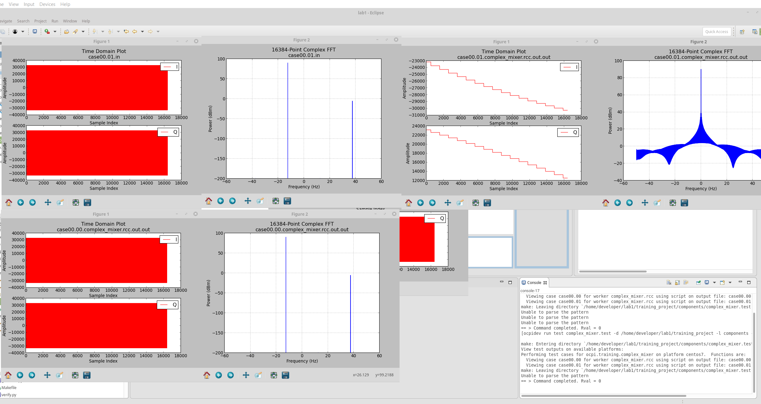

Tutorial Summary
TBS

