OpenCPI
Tutorial 9: Debugging an HDL Worker on a Hardware Platform
OpenCPI Release develop

Revision History
Revision | Description of Change | Date
1.0 | Creation from Lab 9 developed by BIA | 2019-10-01
1.1
1.2
1.3
1.4
1.5
1.6
1.7
1.8
1.9
2.0
2.1
Table of Contents
1 Overview 4
1.1 What’s Provided for This Tutorial 5
1.2 Prerequisites to Using This Tutorial 6
1.3 Documentation References 7
2 Step 1: Build HDL Worker (Xilinx XSIM) 8
3 Step 2: Build Unit Test (Xilinx XSIM) 9
4 Step 3a: Run Unit Test 10
5 Step 3a: Run Unit Test and Change Count 11
6 Step 3a: Run Unit Test and Change Count (con’t.) 12
7 Step 3b: View Simulation Signals 13
8 Step 4: Add Debug Functionality 14
9 Steps 5 and 6: Set up Unit Test for Different Worker Configurations 15
10 Steps 5 and 6: Build the Worker and Assembly for the Hardware 16
11 Step 7(a-d): Debug the HDL Worker with ocpihdl 17
11.1 Step 7a: Run Unit Test (e3xx) 18
11.2 Step 7b: Confirm Debug Mode 19
11.3 Step 7c: Collect Worker Assembly Information 21
11.4 Step 7d: Use ocpihdl to Debug the Worker 22
11.5 Step 7d: Found the Bug 23
12 Using a Property to Toggle Debugging 24
13 Using ocpihdl on a Simulator 25

Overview
This tutorial demonstrates how to debug OpenCPI applications, including how to:
- Observe property values with ocpiview and ocpihdl
- Enable and disable debugging with ocpi_debug
- Step through an application
- Manage the states/properties of workers with ocpihdl
In this tutorial, we will use a single "counter" HDL application worker counter.hdl. The purpose of this worker is to increment a counter vector until reaching a max value. We will discover that something is wrong with the worker.
The flow of application debugging demonstrated in this tutorial is as follows:
- Build the HDL App Worker for a simulator.
- Build the HDL Assembly for a simulator.
- Test the HDL App Worker and view the results.
- Add debug functionality to the worker.
- Rebuild the HDL App worker for target device(s).
- Rebuild the HDL Assembly for target platform(s).
- Debug the HDL App worker using ocpihdl.

What’s Provided for This Tutorial
The tutorial provides the following files:
- counter.hdl/ - includes the counter HDL worker, in plain and debug versions.
- counter.test/ - includes the Unit Test Description XML for the "counter" component
- counter-spec.xml

Prerequisites to Using This Tutorial
Before starting with the tutorial, copy the provided files as follows:
- Copy "counter.hdl/" directory to the components library
From: ~/<opencpi-installation-dir>/projects/tutorial/provided/lab9/counter.hdl/
To: ~/<opencpi-installation-dir>/projects/tutorial/tutorial/components
- Copy "counter.test/" directory to the components library
From: ~/<opencpi-installation-dir>/projects/tutorial/provided/lab9/counter.test/
To: ~/<opencpi-installation-dir>/projects/tutorial/components
- Copy "counter-spec.xml" to components/specs
From: ~/<opencpi-installation-dir>/projects/tutorial/provided/lab9/counter-spec.xml
To: ~/<opencpi-installation-dir>/projects/tutorial/components/specs

Documentation References
The documents listed in the following table provide detailed information about subjects discussed in this tutorial. The documents listed here are not required reading for this tutorial but will likely be of interest for more in-depth learning.
Table 1 - OpenCPI Reference Documentation
Title | Published By | Public URL
OpenCPI Overview | OpenCPI | https://opencpi.gitlab.io/releases/v2.0.1/docs/Overview.pdf
OpenCPI User Guide | OpenCPI | https://opencpi.gitlab.io/releases/v2.0.1/docs/OpenCPI_User.pdf
OpenCPI Application Development Guide | OpenCPI | https://opencpi.gitlab.io/releases/v2.0.1/docs/OpenCPI_Application_Development.pdf
OpenCPI Component Development Guide | OpenCPI | https://opencpi.gitlab.io/releases/v2.0.1/docs/OpenCPI_Component_Development.pdf
OpenCPI HDL Development Guide | OpenCPI | https://opencpi.gitlab.io/releases/v2.0.1/docs/OpenCPI_HDL_Development.pdf
OpenCPI RCC Development Guide | OpenCPI | https://opencpi.gitlab.io/releases/v2.0.1/docs/OpenCPI_RCC_Development.pdf

Step 1: Build HDL Worker (Xilinx XSIM)
To build the HDL worker using the AV GUI:
- "Refresh" the Project Explorer panel.
- "Refresh" the OpenCPI Projects panel.
- Add the worker to the Project Operations panel.
- Check the “HDL Targets” box and highlight "xsim" under "xilinx".
- Check the "Assets" radio button.
- Click "Build".
- Review the console window messages to ensure this step is error free.
To build the HDL worker using the ocpidev command:
TBD

Step 2: Build Unit Test (Xilinx XSIM)
To build the unit test using the AV GUI:
- Remove the worker from the Project Operations panel.
- Add the unit test to the Project Operations panel.
- Highlight "xsim" in the HDL Platforms panel.
- “HDL Targets” box unchecked.
- Check the "Tests" radio button.
- Click "gen + build".
- Review the console window messages and address any errors.
To build the unit test using the ocpidev command:
TBD

Step 3a: Run Unit Test
First, run the unit test suite for the target simulation platform.
Using the AV GUI:
- Add the unit test to the Project Operations panel.
- Highlight "xsim" in the “HDL Platforms” panel (leave the HDL Targets box unchecked).
- Click "prep + run" to run tests.
- Review the console window messages and address any errors.
Using the ocpidev command:
TBD
Next, validate the output:
- Open the log file (run/xsim/case00.00.counter-1.hdl.log) and confirm the property value:
counter.counter = "10"
The "max" property is currently set to "10" by counter-test.xml.
The "counter" property reached its maximum value of "10" as expected.

Step 3a: Run Unit Test and Change Count
First, edit counter.test/counter-test.xml to test the value "9" for the "max" property.
Next, regenerate the application XML.
Using the AV GUI:
- Add the unit test to the Project Operations panel.
- Highlight "xsim" in the HDL Platforms panel (leave the HDL Targets box unchecked).
- Check the "Tests" radio button.
- Click "gen + build".
- Review the console window messages and address any errors.
Using the ocpidev command:
TBD
Finally, review gen/applications/*.xml(s) to ensure the max value has been updated.

Step 3a: Run Unit Test and Change Count (con’t.)
Rerun the Unit Test with the new maximum value.
Using the AV GUI:
- Check "keep simulations" so that we can see the waveform output later on.
- Click "prep + run" to run the tests.
Using the ocpidev command:
- In a terminal window, browse to counter.test/ and then run:
$ ocpidev run test counter.test -d /home/training/training_project -l components --mode prep_run --only-platform xsim --only-platform centos7 --keep-simulations
- Be sure to specify the option “--keep-simulations” so that we can view the simulation output.
Now open the log file (run/xsim/case00.00.counter-1.hdl.log) and review the property value:
Output:
counter.counter = "10"
The counter PASSED the maximum value of "9"! HOW IS THIS POSSIBLE?

Step 3b: View Simulation Signals
To view the simulation results, in a terminal window, run the command:
$ ocpiview run/xsim/case00.00.counter.hdl.simulation &
Navigate to the counter object (add the “worker” signals to wave window).
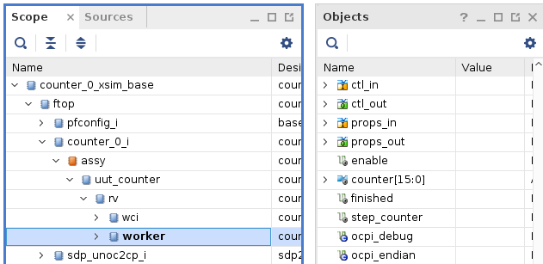
Note the change in the counter value:
Counting by two, not one.

Step 4: Add Debug Functionality
In counter.hdl:
$ cp counter-debug.vhd counter.vhd
$ cp counter-debug.xml counter.xml
Now observe what is done to add debugging/stepping functionality:
- In counter.xml, there is a new "step" property and the "max" property is extended from OCS so that we can read it using ocpihdl.
- In counter.vhd, when the "ocpi_debug" parameter is true, "enable" depends on "step".
These changes enable the counting operation based on the ocpi_debug flag. When the step property is written as true, perform a single counter increment (single step):
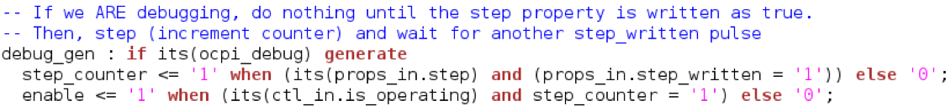
Otherwise, proceed normally.
Note that counter.hdl supports two build configurations as defined in the counter-build.xml:
<build>
<configuration id='0'>
<parameter name='ocpi_debug' value='false'/>
</configuration>
<configuration id='1'>
<parameter name='ocpi_debug' value='true'/>
</configuration>
</build>
The ocpi_debug parameter is provided by the framework, which allows the worker to build separate implementations, both with and without debugging behavior.

Steps 5 and 6: Set up Unit Test for Different Worker Configurations
Edit the counter-test.xml to set ocpi_debug to false and true
<Property Name='ocpi_debug' Values='false,true'></Property>
"Clean" counter.hdl and counter.test.
Using the AV GUI: [TBD]
Using the ocpidev command: TBD]

Steps 5 and 6: Build the Worker and Assembly for the Hardware
First, build the HDL Worker for Zynq targets.
Using the AV GUI:
- Add the App Worker to the Project Operations panel.
- Check the HDL Targets box and highlight "zynq".
- Check "Assets" Radio Button.
- Click "Build".
- Review the console window messages and address any errors.
Using the ocpidev command:
TBD
Next, build the unit test suite for the target hardware platform.
Using the AV GUI:
- Remove the app worker from the Project Operations panel.
- Add the unit test to the Project Operations panel.
- Highlight "e3xx" in the “HDL Platforms” panel (leave the HDL Targets box unchecked).
- Check the "Tests" radio button.
- Click "gen + build".
- Review the console window messages and address any errors.
Using the ocpidev command:
TBD
NOTE: The build process takes 5-10 minutes to complete.

Step 7(a-d): Debug the HDL Worker with ocpihdl
This part of the tutorial consists of the following steps:
- Exec ute on the target hardware platform
- Confirm debug mode
- Collect HDL worker/assembly information
- Debug the HDL worker using ocpihdl

Step 7a: Run Unit Test (e3xx)
Set up the deployment platform and run the tests. Note: you can find details about the setup process in the E3xx Getting Started Guide.

Set up Deployment Platform
To set up the deployment platform:
- Connect to the serial port via USB on the rear of Ettus E310 on the host: "screen /dev/e3xx_0 115200".
- Boot and log in into Petalinux on the E310. User/Password = root:root.
- Verify that the host and the E310 have valid IP addresses. For training, they should both be on the same subnet.
- Run the setup script on the E310:
"source /mnt/card/opencpi/mynetsetup.sh <Host IP address>"

Run Unit Test
To run the unit test on the remote platform using the AV GUI:
- Add counter.test to the Project Operations panel.
- Check “Tests”.
- Select the "remotes" radio button.
- Click "+remotes".
- Change the remote variable text to use Ettus E310’s IP and point to the tutorial project:
{IP of Ettus E310}=root=root=/mnt/tutorial
- Select the newly created remote. This will be the target remote test system. Unselected remotes will not run.
- Highlight "e3xx" in the HDL Platforms panel (leave the HDL Targets box unchecked).
- Click "prep + run" to run tests.
- Review the console window messages and address any errors.
To run the unit test on the remote platform using the ocpidev command:
TBD

Step 7b: Confirm Debug Mode
The application is now running on the Ettus E310. We have the application "hanging". It is in debug mode and waiting for our input. Let’s see what the state of the worker is by going to the logs.
- Open the log file (run/e3xx/case00.00.counter-1.hdl.log)
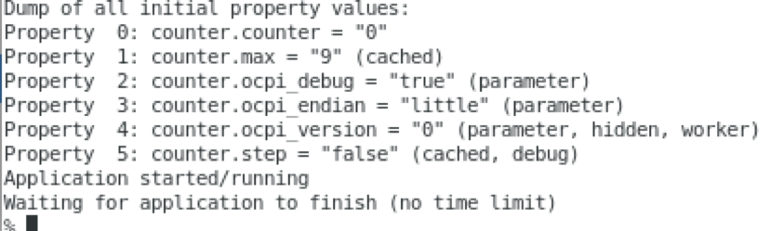
On the Ettus E310, we can now use ocpihdl to control the worker. For reference, here is output of ocpihdl:
Major commands/modes:
search [-i <interface>] # search for OpenCPI HDL devices, limit ethernet to <interface>
emulate [-i <interface>] # emulate an HDL device on ethernet, on first or specified interface
ethers # list available ethernet interfaces
probe <hdl-dev> # see if a specific HDL device is available
get [<instance> [<property]] # get info from bitstream
set <instance> <property> <value> # set property value for worker instance
control <instance> <operation> # perform reset, unreset, or control operation
status <instance> # show status of worker/instance
testdma # test for DMA memory setup
admin <hdl-dev> # dump admin information (reading only) for <hdl-device>
wadmin <hdl-dev> <offset> <value> # write admin word <value> for <hdl-device> at <offset>
radmin <hdl-dev> <offset> # read admin word for <hdl-device> at <offset>
settime <hdl-dev> # set the GPS time of the device to syste time
deltatime <hdl-dev> # measure round trip and difference between host and device
dump <hdl-dev> # dump all state/status of <platform> including all workers
reset <hdl-dev> # reset platform
flash <hdl-dev> # flash load platform
bram <infile> <outfile> # create a BRAM file from in input file
unbram <infile> <outfile> # recreate the original file from a BRAM file
uuid -p <platform> -c <part> <outputfilename>
wclear <hdl-dev> <worker> # clear worker status errors
wdump <hdl-dev> <worker> # dump worker's control plane registers
wop <hdl-dev> <worker> <op> # perform control operation on worker
ops are: initialize, start, stop, release, after, before
wread <hdl-dev> <worker> <offset>[/size] # perform config space read of size bytes at offset, default 4
wreset <hdl-dev> <worker> # assert reset for worker
wunreset <hdl-dev> <worker> # deassert (enable) worker
wwctl <hdl-dev> <worker> <val> # write worker control register
wwpage <hdl-dev> <worker> <val> # write worker window register
wwrite <hdl-dev> <worker> <offset>[/size] <value> # perform config space write of size bytes at offset
# generate UUID verilog file
load <hdl-dev> <file> # load bitstream from file
unload <hdl-dev> # revert device to unloaded state: no bitstream
getxml <hdl-dev> <file> # Extract the xml metadata from the device into the file
imulate # run simulator inside created sim: device
Options: (values are either directly after the letter or in the next argument)
-l <level> # set log levels
-i <interface> # set ethernet interface to use
-d <hdl-device> # identify a specific hdl device to use
-p <hdl-platform> # specify a particular hdl platform (e.g. ml605)
-c <hdl-part> # specify a particular part/chip (e.g. xc6vlx240t
-s <spin-clocks> # clocks to credit/run the sim between control messages
-t <sleep-usecs> # delay time letting sim run between credits
-T <sim-time> # total simulation time before terminating
-D # turn off simulation dumping
-e <sim-executable> # simulator executable "bitstream" file
-A # make the simulator publically available on the LAN
-v # be verbose
-x # print numeric values in hex rather than decimal
<worker> can be multiple workers such as 1,2,3,4,5. No ranges.
<hdl-dev> examples: 3 # PCI device 3 (i.e. 0000:03:00.0)
0000:04:00.0 # PCI device 0000:04:00.0
PCI:0001:05:04.2 # fully specified PCI device
a0:00:b0:34:55:67 # ethernet MAC address on first up+connected interface
eth0/a0:00:b0:34:55:67 # ethernet address on a specific interface
Ether:eth1/a0:00:b0:34:55:67 # fully specified Ethernet-based device

Step 7c: Collect Worker Assembly Information
View the currently loaded workers and their indices:
$ ocpihdl get
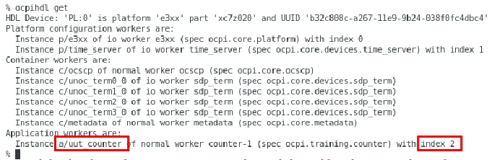
Use this index (or "counter-1") to identify the worker from now on.

Step 7d: Use ocpihdl to Debug the Worker
Execute:
ocpihdl get -v 2 ("-v" to list property values)
Note the property values:
- counter: 0
- max: 9
- ocpi_debug: true
- step=false
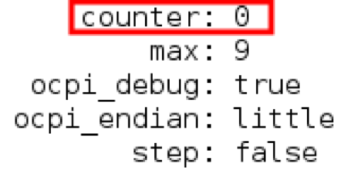
Also try:
ocpihdl get -v counter-1
Now execute:
ocpihdl set 2 step true
ocpihdl get -v 2
Note : counter : 2
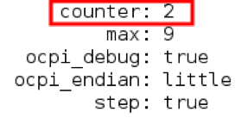
Continue setting "step" to true and note how the value of counter changes. When counter reaches "max", step one last time and the application will complete. You will see the following output back on the development host:
Open the log file to see the final output (run/e3xx/case00.01.counter-1.hdl.log):
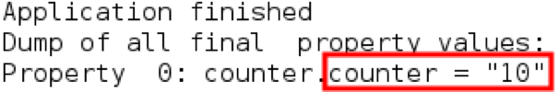

Step 7d: Found the Bug
By now, you have discovered the bug using one or more of the following methods:
- Viewing the log files and observing the output for different max values
- Viewing the simulated counter signals using ocpiview
- Using debug properties and ocpihdl to step through the application
The bug: We are incrementing the counter by 2 each step. You can fix the bug in counter.vhd, disable debugging, rebuild, and rerun.
This is a very simple example, but ocpihdl can be very helpful for debugging and controlling OpenCPI applications.

Using a Property to Toggle Debugging
You can use a property instead of a parameter to toggle debugging Instead of (or in conjunction with) ocpi_debug. This method allows you to turn off debugging using runtime ocpihdl commands.
If time permits:
- Replace ocpi_debug with a property (not a parameter).
- Note that you can no longer use the "generate" statements.
- Rebuild.
- Run.
- Step a few times.
- Set the debug flag to false.
- Let the application complete.

Using ocpihdl on a Simulator
Using ocpihdl on a simulator is not recommended. You must specify the HDL device with every ocpihdl command. For example:
$ ocpihdl status -d sim:… -v status 2
To make this easier, save the string:
$ ocpihdl search (to identify the device)
$ SIM="-d sim:127.0.0.1:49876"
This string will be different every time a simulator starts. Then, for example:
$ ocpihdl status $SIM -v status 2

