Tutorial 4: Creating a Complex Mixer Component
The goal of this tutorial is to create a complex mixer component as a part of the project from Tutorial 2 that we are building from scratch.
The complex mixer component receives I/Q data and multiplies this signal by a tone that is generated using a Numerically Controlled Oscillator (NCO). This action causes the input signal to be shifted in the frequency domain by the frequency of the NCO that is generated in the worker. The worker’s properties control the NCO frequency.
The objectives of this tutorial are to learn how RCC workers can import a third-party library (liquid dsp) functionality into a worker and to reiterate C++ conventions for accessing port data and properties and framework interactions RCC_ADVANCE vs. RCC_OK.
In this tutorial, we show you how to:
- Create the complex mixer component, ports and properties.
- Create and build the complex mixer RCC worker, including the import of third-party library liquid_dsp functionality.
- Create, build and run the complex mixer worker unit test.
This tutorial is a continuation of Tutorial 3. This means you will be using the same training_project as you used in Tutorial 3.

Step 1: Create Complex Mixer Component
First, create a component called complex mixer with the following parameters:
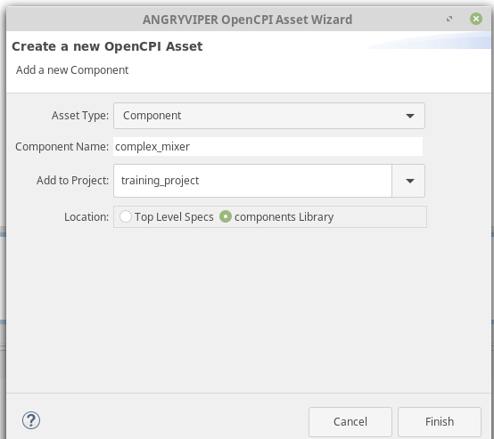
Add the property called enable with the following parameters:
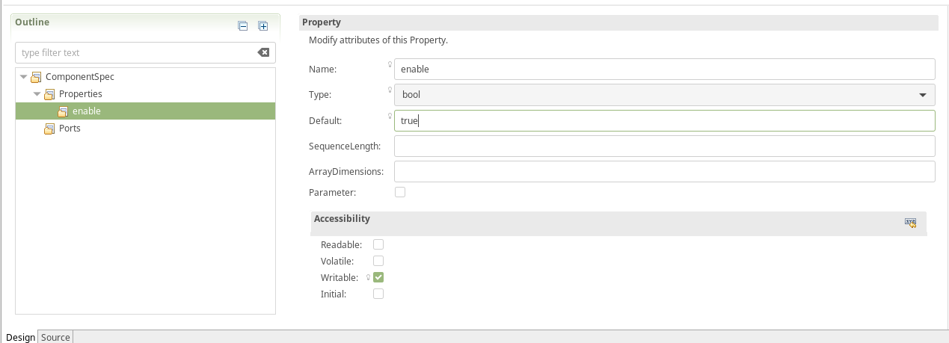
Add a property called phs_inc with the following parameters:
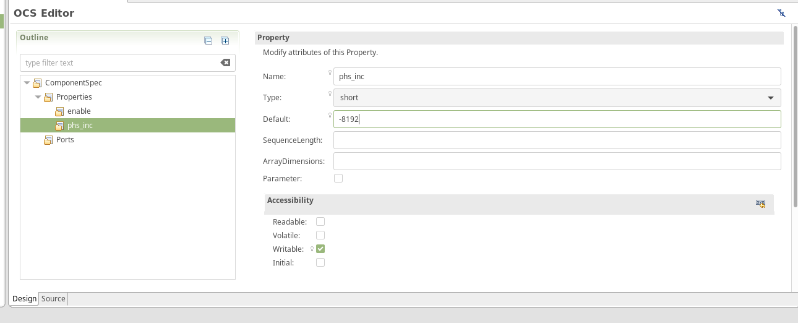
Create a port called in with the following values:
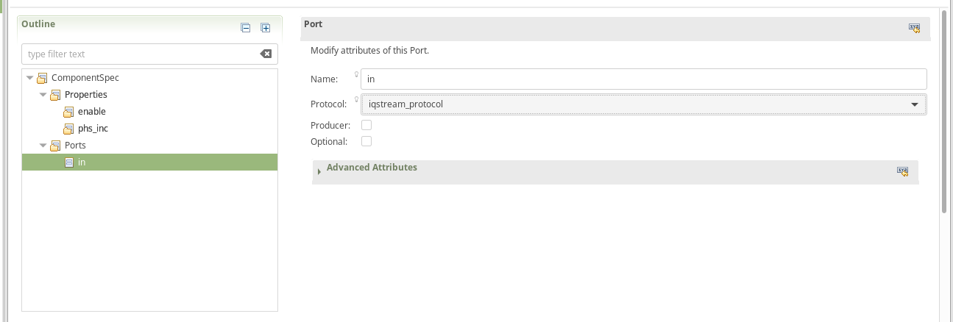
Create a port called out with the following values:
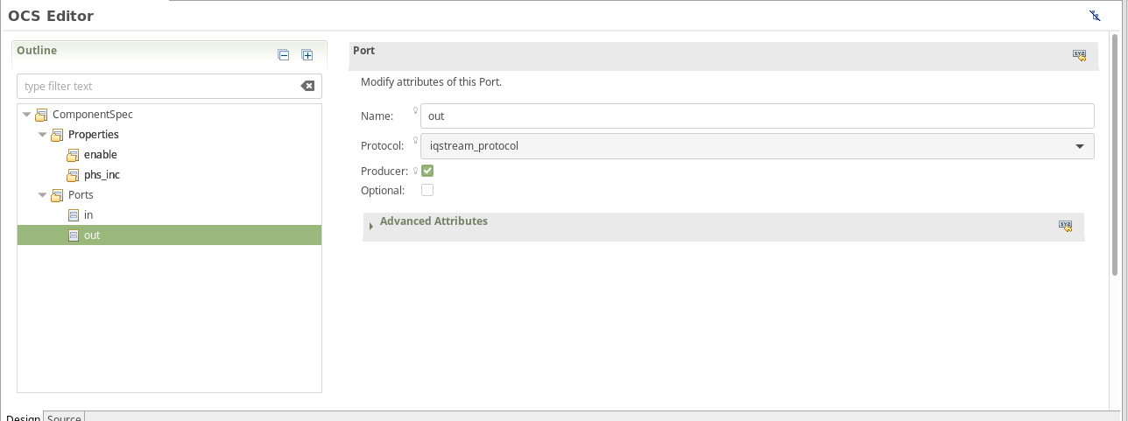

Step 2: Create complex_mixer Worker
Create a worker called complex_mixer with the following parameters:
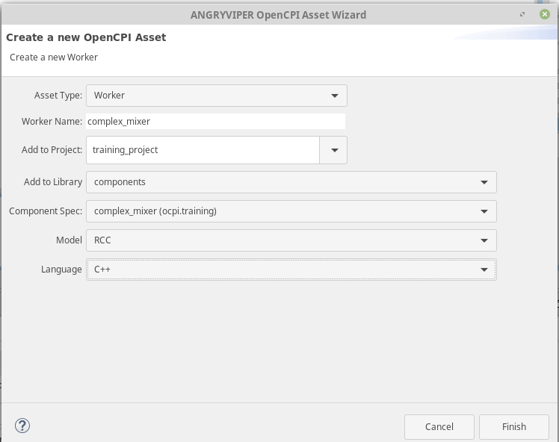
Make sure to check the initialize and release on your RCC worker; otherwise, you’ll get a segmentation fault.
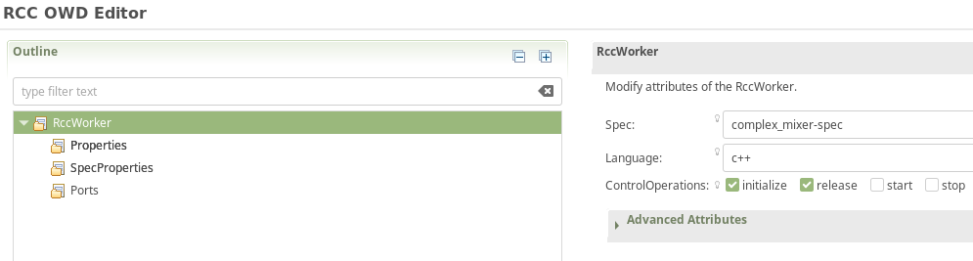

Step 3: Edit complex_mixer Worker
Now we’ll edit the complex_mixer worker.
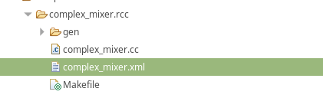
Add the property data select with the following parameters:
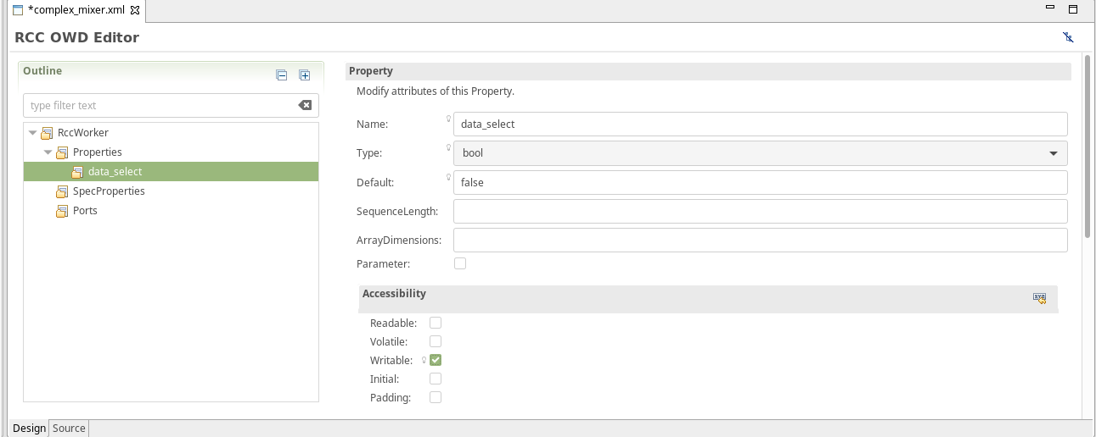
Go into the Makefile in the complex_mixer.rcc directory.
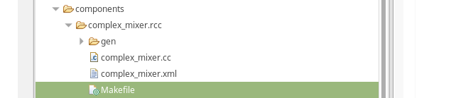

Add the following text to the Makefile:

# This is the Makefile for worker complex_mixer.rcc
# Make sure you add this below before the include
RccStaticPrereqLibs=liquid
include $(OCPI_CDK_DIR)/include/worker.mk

Go into your complex_mixer.cc file:

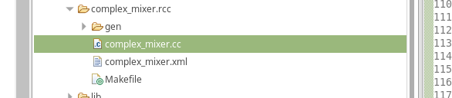
Replace it with the following code:
/*
* This file is protected by Copyright. Please refer to the COPYRIGHT file
* distributed with this source distribution.
*
* This file is part of OpenCPI <http://www.opencpi.org>
*
* OpenCPI is free software: you can redistribute it and/or modify it under the
* terms of the GNU Lesser General Public License as published by the Free
* Software Foundation, either version 3 of the License, or (at your option) any
* later version.
*
* OpenCPI is distributed in the hope that it will be useful, but WITHOUT ANY
* WARRANTY; without even the implied warranty of MERCHANTABILITY or FITNESS FOR
* A PARTICULAR PURPOSE. See the GNU Lesser General Public License for more
* details.
*
* You should have received a copy of the GNU Lesser General Public License
* along with this program. If not, see <http://www.gnu.org/licenses/>.
*/

/*
* THIS FILE WAS ORIGINALLY GENERATED ON Wed Mar 30 09:48:42 2016 EDT
* BASED ON THE FILE: complex_mixer.xml
* YOU *ARE* EXPECTED TO EDIT IT
*
* This file contains the implementation skeleton for the complex_mixer worker in C++
*/

#include "complex_mixer-worker.hh"
#include <liquid/liquid.h>
#include <cmath>
#include <iostream>
#include <climits>

using namespace OCPI::RCC; // for easy access to RCC data types and constants
using namespace Complex_mixerWorkerTypes;
using namespace std;

#define Uscale(x) (float)((float)(x) / (pow(2,15) -1))
#define Scale(x) (int16_t)((float)(x) * (pow(2,15) -1))

class Complex_mixerWorker : public Complex_mixerWorkerBase
{
nco_crcf q;

RCCResult initialize()
{
q = nco_crcf_create(LIQUID_NCO);
nco_crcf_set_phase(q, 0.0f);

return RCC_OK;
}

RCCResult release()
{
nco_crcf_destroy(q);

return RCC_OK;
}

RCCResult run(bool /*timedout*/)
{
const IqstreamIqData* inData = in.iq().data().data();
IqstreamIqData* outData = out.iq().data().data();
const size_t num_of_elements = in.iq().data().size(); // size in IqstreamIqData units
out.iq().data().resize(num_of_elements);

// set each time so that if the container changes it gets updated
// might be better to put this into a write sync function but this is for training
float phase_inc = properties().phs_inc * ((2*M_PI)/(SHRT_MAX * 2));
nco_crcf_set_frequency(q,phase_inc);

liquid_float_complex out_sample;
liquid_float_complex in_sample;

for (unsigned int j = 0; j < num_of_elements; j++)
{
if (properties().enable)
{
in_sample.real = Uscale(inData->I);
in_sample.imag = Uscale(inData->Q);

nco_crcf_step(q);
nco_crcf_mix_down(q, in_sample, &out_sample);
outData->I = Scale(out_sample.real);
outData->Q = Scale(out_sample.imag);

inData++;
outData++;
}
else
{
outData->I = inData->I;
outData->Q = inData->Q;
inData++;
outData++;
}
}

return num_of_elements ? RCC_ADVANCE : RCC_ADVANCE_DONE;
}
};

COMPLEX_MIXER_START_INFO
// Insert any static info assignments here (memSize, memSizes, portInfo)
// e.g.: info.memSize = sizeof(MyMemoryStruct);
COMPLEX_MIXER_END_INFO

Step 4: Build complex_mixer Worker
Build the worker for CentOS 7 and Xilinx13_3 (Zedboard/FMCOMMS2) or Xilinx13_4 (E310):
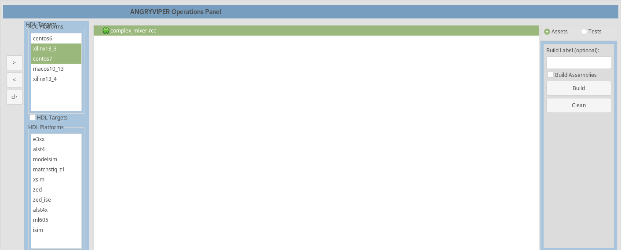

Step 5: Create complex_mixer Unit Test
Create a complex_mixer unit test with the following parameters:
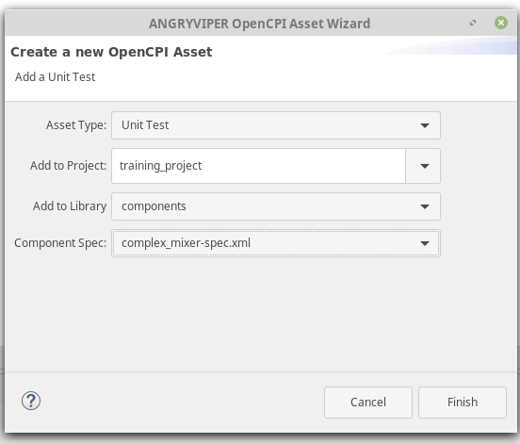
Go into your complex mixer-test.xml.
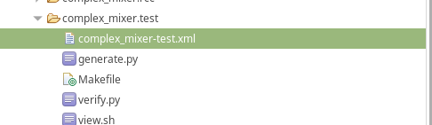
Add an input called in with the following parameters:
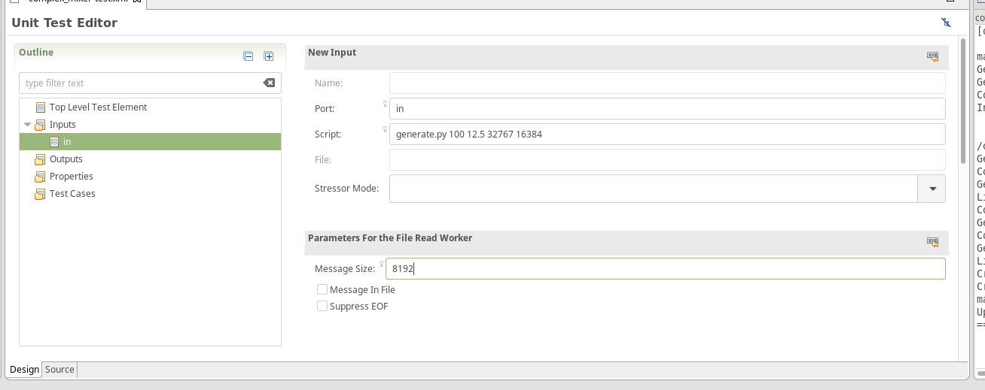
Create an output called out with the following parameters:
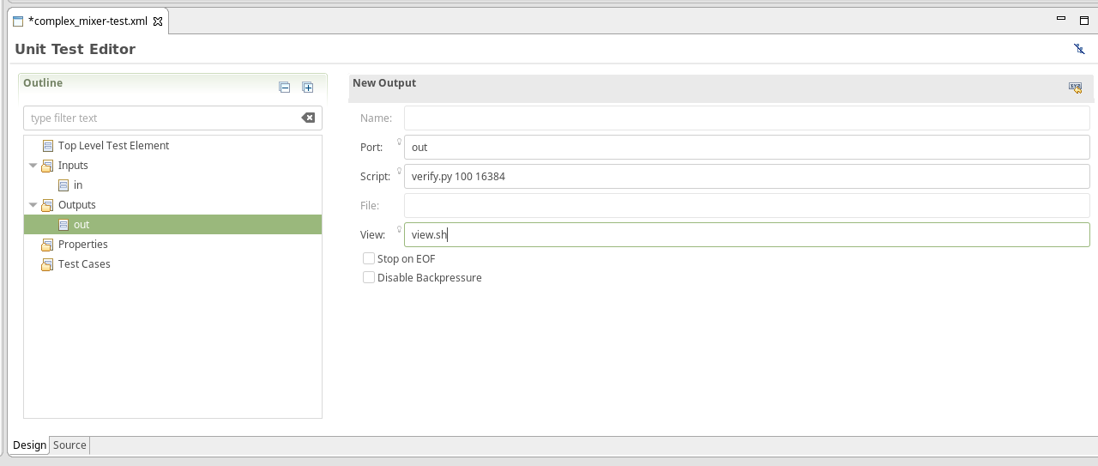
Create a property called phs_inc:
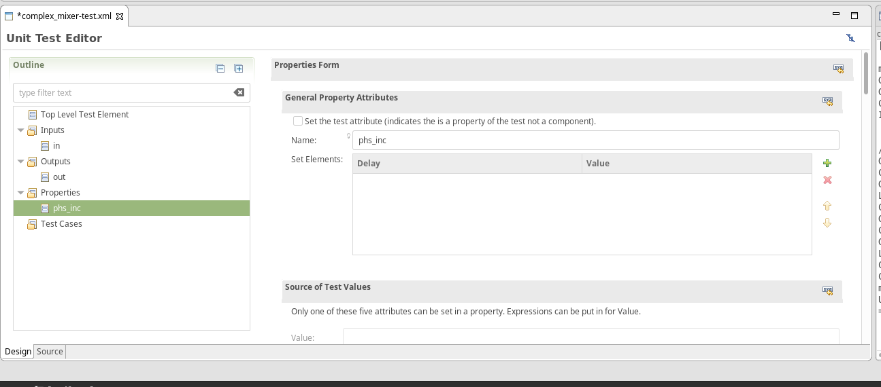
Scroll down in phs_inc to the values parameter and place the number -8192 in it:
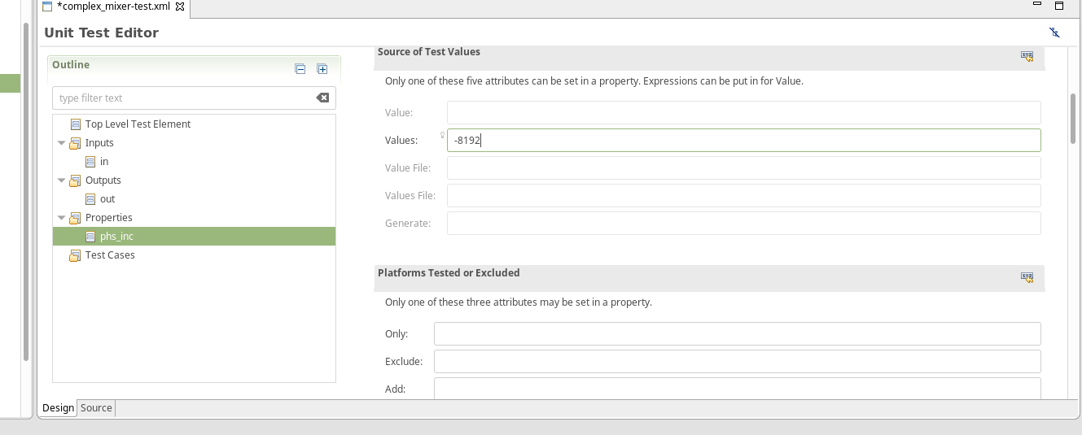
Create a property called enable:
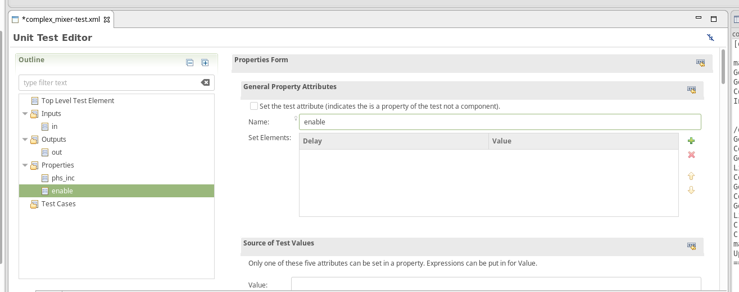
Scroll down in enable and put 0,1 in the values parameter:
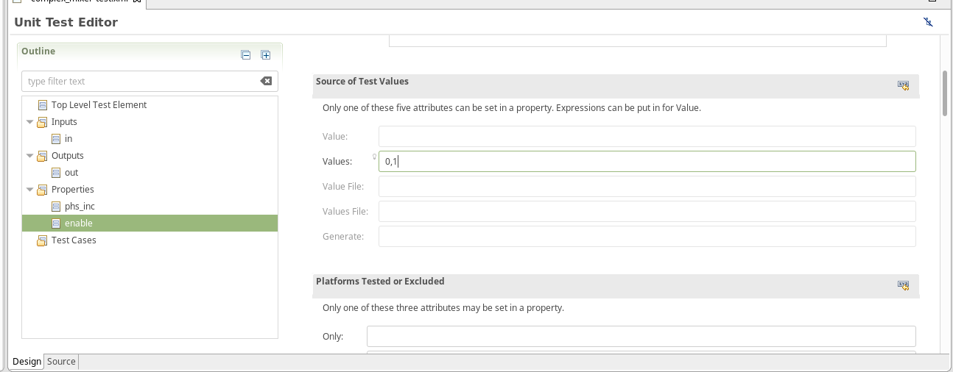

Step 6: Edit generate.py Script
Copy and paste the following text into generate.py:
#!/usr/bin/env python
# This file is protected by Copyright. Please refer to the COPYRIGHT file
# distributed with this source distribution.
#
# This file is part of OpenCPI <http://www.opencpi.org>
#
# OpenCPI is free software: you can redistribute it and/or modify it under the
# terms of the GNU Lesser General Public License as published by the Free
# Software Foundation, either version 3 of the License, or (at your option) any
# later version.
#
# OpenCPI is distributed in the hope that it will be useful, but WITHOUT ANY
# WARRANTY; without even the implied warranty of MERCHANTABILITY or FITNESS FOR
# A PARTICULAR PURPOSE. See the GNU Lesser General Public License for more
# details.
#
# You should have received a copy of the GNU Lesser General Public License along
# with this program. If not, see <http://www.gnu.org/licenses/>.

"""
Complex Mixer: Generate test input data & Validate output data

Generate args:
1. sample frequency of generated sinusoid in Hz
2. center frequency of generated sinusoid in Hz
3. amplitude of generated sinusoid
4. number of complex samples to generated
5. output file

To test the Complex Mixer, a binary data file is generated containing complex
signed 16-bit samples with a tone at a configurable center frequency and sample
frequency.

The Application XML sets the phase increment of the Mixer/NCO to output a 1 Hz tone,
sampled at 16 Hz. The output waveform's frequency is expected to +1 Hz greater than
the input waveform frequency. The validation of the test involves performing an FFT
of the output file to ensure the max tone is located at DC or 0 Hz.
"""
import struct
import numpy as np
import sys
import os.path

if len(sys.argv) != 6:
print("Invalid arguments: usage is: generate.py <sample-freq> <target-freq> <amplitude> <num-samples> <output-file>")
sys.exit(1)
print " GENERATE (I/Q 16b binary data file):"

ofilename = sys.argv[5]
# Create cosine & sine waveforms
Fs = float(sys.argv[1]) # sample frequency
Ts = 1.0/float(Fs); # sampling interval
Ft = float(sys.argv[2]) # target frequency
AMPLITUDE = int(sys.argv[3])
NUM_SAMPLES = int(sys.argv[4]) # number of complex samples
t = np.arange(0,NUM_SAMPLES*Ts,Ts,dtype=np.float) # time vector
# Generate I/Q samples @ target freq
real = np.cos(2*np.pi*Ft*t)
imag = np.sin(2*np.pi*Ft*t)
# Initialize empty array, sized to store 16b I/Q samples
z = np.array(np.zeros(NUM_SAMPLES),
dtype=np.dtype((np.uint32, {'real_idx':(np.int16,2), 'imag_idx':(np.int16,0)})))
# Set the gain
gain_i = AMPLITUDE / max(abs(real))
gain_q = AMPLITUDE / max(abs(imag))
z['real_idx'] = np.int16(real * gain_i)
z['imag_idx'] = np.int16(imag * gain_q)

# Save data to file
f = open(ofilename, 'wb')
for i in xrange(NUM_SAMPLES):
f.write(z[i])
f.close()

# Summary
print ' # of Bytes:', NUM_SAMPLES*4
print ' # of I/Q (16b) samples:', NUM_SAMPLES/2
print ' Sample Frequency:', Fs
print ' Target Frequency:', Ft
print ' Amplitude:', AMPLITUDE

Step 7: Edit verify.py Script
Copy and paste the following text into verify.py:
#!/usr/bin/env python
# This file is protected by Copyright. Please refer to the COPYRIGHT file
# distributed with this source distribution.
#
# This file is part of OpenCPI <http://www.opencpi.org>
#
# OpenCPI is free software: you can redistribute it and/or modify it under the
# terms of the GNU Lesser General Public License as published by the Free
# Software Foundation, either version 3 of the License, or (at your option) any
# later version.
#
# OpenCPI is distributed in the hope that it will be useful, but WITHOUT ANY
# WARRANTY; without even the implied warranty of MERCHANTABILITY or FITNESS FOR
# A PARTICULAR PURPOSE. See the GNU Lesser General Public License for more
# details.
#
# You should have received a copy of the GNU Lesser General Public License along
# with this program. If not, see <http://www.gnu.org/licenses/>.

"""
Complex Mixer: Verify Validate output data

Verify args:
1. sample frequency of output data file
2. number of samples used in validation
3. output data file used for validation
4. input data file used for comparison

To test the Complex Mixer, a binary data file is generated containing complex
signed 16-bit samples with a tone at a configurable center frequency and sample
frequency.
The Application XML sets the phase increment of the Mixer/NCO to output a 1 Hz tone,
sampled at 16 Hz. The output waveform's frequency is expected to +1 Hz greater than
the input waveform frequency. The validation of the test involves performing an FFT
of the output file to ensure the max tone is located at DC or 0 Hz.
"""
import struct
import numpy as np
import sys
import os.path

class color:
PURPLE = '\033[95m'
CYAN = '\033[96m'
DARKCYAN = '\033[36m'
BLUE = '\033[94m'
GREEN = '\033[92m'
YELLOW = '\033[93m'
RED = '\033[91m'
BOLD = '\033[1m'
UNDERLINE = '\033[4m'
END = '\033[0m'

"""
Ex: python verify.py {sample-freq} {number_of_samples} {ofilename} {ifilename}
Validate:
TEST #1: Verify I & Q values are not all zeros
TEST #2: Output file matches expected size
TEST #3: Two possibilities: 1) NORMAL MODE - Target tone tuned to DC, 2) BYPASS MODE - idata = odata
"""

if len(sys.argv) != 5:
print('Invalid arguments: usage is: verify.py <sample-freq> <num-samples> <output-file> <input-file>')
sys.exit(1)
dt_iq_pair = np.dtype((np.uint32, {'real_idx':(np.int16,2), 'imag_idx':(np.int16,0)}))
# Read all input data as complex int16
ifilename = open(sys.argv[4], 'rb')
idata = np.fromfile(ifilename, dtype=dt_iq_pair, count=-1)
ifilename.close()

# Read all output data as complex int16
ofilename = open(sys.argv[3], 'rb')
odata = np.fromfile(ofilename, dtype=dt_iq_pair, count=-1)
ofilename.close()

num_samples = int(sys.argv[2])
sample_rate = float(sys.argv[1])
enable = os.environ.get('OCPI_TEST_enable')
phs_inc = float(os.environ.get('OCPI_TEST_phs_inc'))
data_select = os.environ.get('OCPI_TEST_data_select')

# Test that odata is not all zeros
if all(odata == 0):
print color.RED + color.BOLD + 'FAILED, values are all zero' + color.END
sys.exit(1)
else:
print ' PASS - File is not all zeros'

# Test that odata is the expected amount
# INCLUDES TRANSIENT and not FLUSHING of pipeline (USE THIS FOR v1.2)
if len(odata) != len(idata):
# INCLUDES TRANSIENT and FLUSHING of pipeline (USE THIS FOR v1.2 'ADVANCED')
#if len(odata)-6 != len(idata):
# EXCLUDES TRANSIENT and performs FLUSHING of pipeline (USE THIS FOR POST-v1.2 'ADVANCED')
#if len(odata) != len(idata):
print color.RED + color.BOLD + 'FAILED, output file length is unexpected' + color.END
print color.RED + color.BOLD + 'Length ofilename = ', len(odata), 'while expected length is = ' + color.END, len(idata)
sys.exit(1)
else:
print ' PASS - Input and output file lengths match'

if(enable == 'true'): # => NORMAL MODE
complex_data = np.array(np.zeros(num_samples), dtype=np.complex)
for i in xrange(0,num_samples):
complex_data[i] = complex(odata['real_idx'][i], odata['imag_idx'][i])
FFT = 1.0/num_samples * abs(np.fft.fft(complex_data,num_samples))
Max_FFT_freq=np.argmax(FFT)*sample_rate/num_samples
if Max_FFT_freq != 0.0:
print 'Fail: Max of FFT occurs at index: ',Max_FFT_freq, 'Hz (Should be 0)'
sys.exit(1)
else:
print ' PASS - Max of FFT occurs at index: ',Max_FFT_freq, 'Hz'
else: # => BYPASS MODE
if (data_select == 'false'):
# INCLUDES TRANSIENT and not FLUSHING of pipeline (USE THIS FOR v1.2)
if (idata != odata).all():
# INCLUDES TRANSIENT and FLUSHING of pipeline (USE THIS FOR v1.2 'ADVANCED')
# if (idata != odata[0:-6]).all():
# EXCLUDES TRANSIENT and performs FLUSHING of pipeline (USE THIS FOR POST-v1.2 'ADVANCED')
# if (idata != odata).all():
print 'Fail - Bypass Mode: Input and output file do not match'
sys.exit(1)
else:
print ' PASS - Bypass Mode: Input and output file match'
"""

TODO: TEST IS ONLY VALID FOR HDL OUTPUT!
- NEED TO BLOCK WHEN VERIFYING RCC OUTPUT or NOT RUN CONFIGURATION AGAINST RCC.

else:
# Calculate NCO tone for mixing with input
system_freq = sample_rate
phase_acc_width = 16 # Configuration of the Xilinx CORE Generator: DDS module
nco_freq = ((system_freq * phs_inc) / (2**phase_acc_width))
#print ' NCO freq (calc) = ', nco_freq
# Construct complex array of vectors for performing FFT
# (PUT FFT INTO ITS OWN FUNCTION)
data=np.zeros((len(odata)), dtype=complex)
data.real = odata['real_idx']
data.imag = odata['imag_idx']
# Perform FFT
w = np.fft.fft(data)
freqs = np.fft.fftfreq(len(w))
# Locate max Tone
idx = np.argmax(np.abs(w))
freq = freqs[idx]
#print 'Measured freq \t= ', freq
ofreq_hz = freq * system_freq
#print ' NCO freq (measured) = ', ofreq_hz
if (nco_freq != ofreq_hz):
print 'Fail: Bypass Mode: NCO does not match expected freq: %.2f vs %.2f' % (nco_freq, ofreq_hz)
sys.exit(1)
else:
print ' PASS - Bypass Mode: NCO output matches expected freq'
"""

Step 8: Edit view.sh Script
Copy and paste the following text into view.sh:
#!/bin/bash --noprofile
# This file is protected by Copyright. Please refer to the COPYRIGHT file
# distributed with this source distribution.
#
# This file is part of OpenCPI <http://www.opencpi.org>
#
# OpenCPI is free software: you can redistribute it and/or modify it under the
# terms of the GNU Lesser General Public License as published by the Free
# Software Foundation, either version 3 of the License, or (at your option) any
# later version.
#
# OpenCPI is distributed in the hope that it will be useful, but WITHOUT ANY
# WARRANTY; without even the implied warranty of MERCHANTABILITY or FITNESS FOR
# A PARTICULAR PURPOSE. See the GNU Lesser General Public License for more
# details.
#
# You should have received a copy of the GNU Lesser General Public License along
# with this program. If not, see <http://www.gnu.org/licenses/>.

$OCPI_PROJECT_DIR/scripts/plotAndFft.py $2 complex 16384 100&
$OCPI_PROJECT_DIR/scripts/plotAndFft.py $1 complex 16384 100&

Step 9: Run the complex_mixer Unit Test
Place the complex_mixer test in the operations panel:
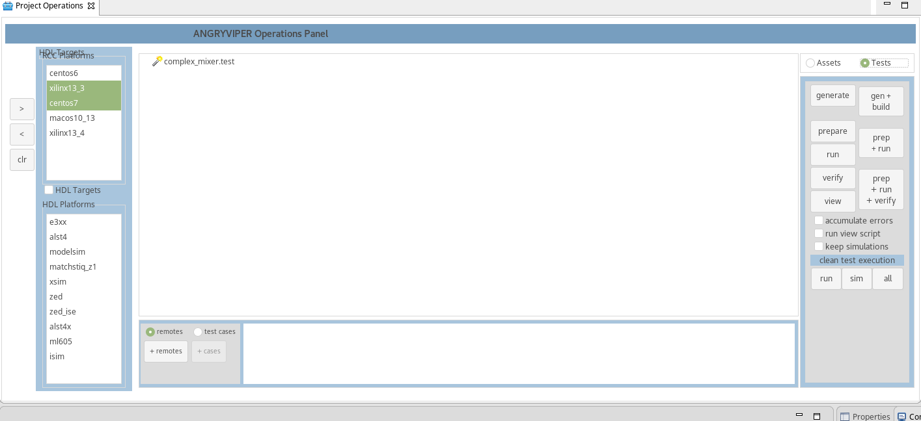
- Click gen + build.
- Click prep + run + verify.
- Click view.
You should have an output like this:
