Tutorial 5: Creating a Time Demux Component
This tutorial shows you how to create a time demux component. The time demux component receives I/Q sample data that has time stamps interleaved within it. It recovers the original data stream and writes it out while also providing a second stream that contains only the timestamps. Having the data separated allows additional processing by tools expecting "just data”; for example, plotting an FFT.
The objectives of this tutorial are to learn how RCC workers can:
- Use different protocols on different ports - Nonstandard input:output port ratio (1:2 vs. 1:1)
- Process incoming data based on message type (OpCode) - I/Q data with timestamps
This tutorial also reiterates:
- C++ conventions - accessing port data and properties
- Framework interactions - RCC_ADVANCE vs. RCC_OK
Note: This tutorial builds on the previous tutorial as we are recreating training_project.

Step 1: Create time_demux Component
Create a component called time_demux:
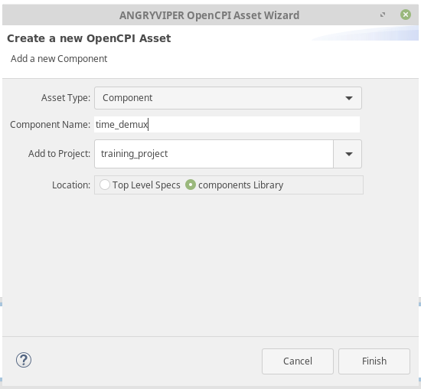
Create a property called Current_Second that is type uLong:
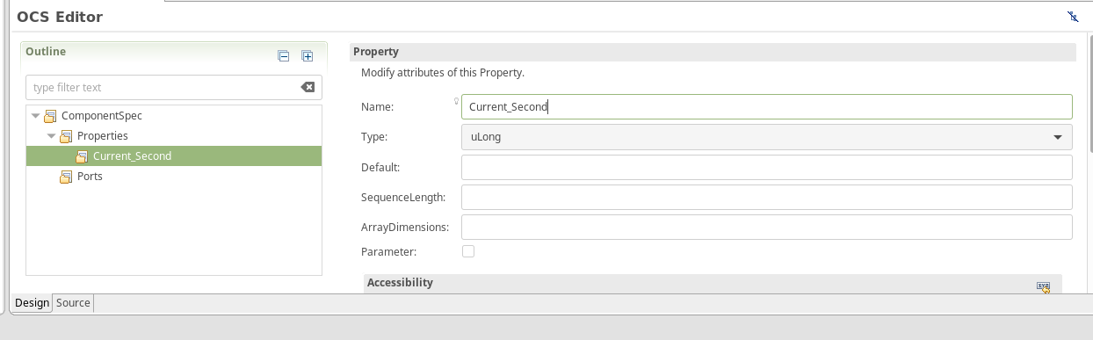
Scroll down and check the volatile box for Current_Second:
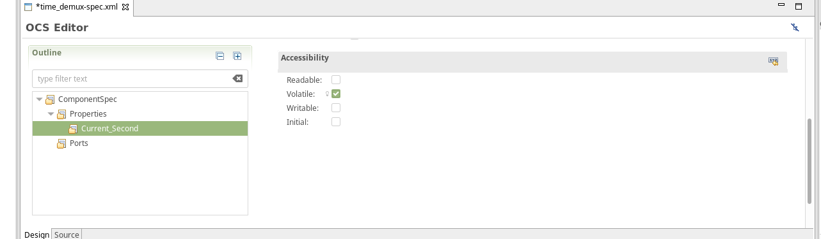
Create a property called Messages_Read that is type uLongLong:
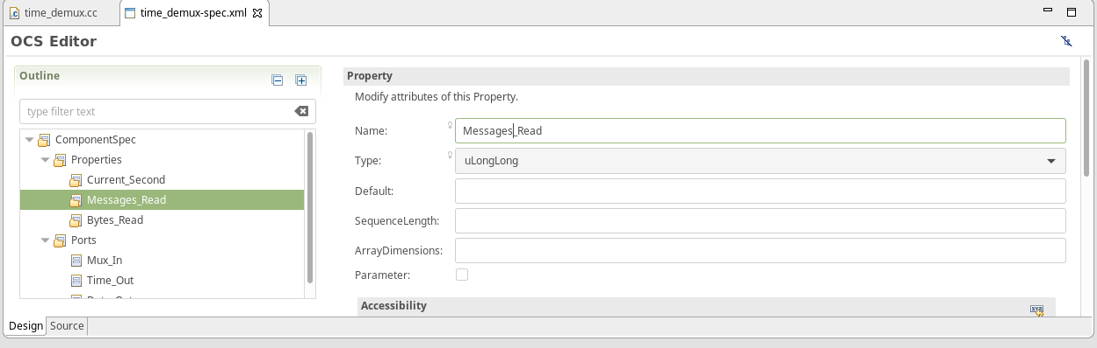
Scroll down and check the volatile box for Message_Read:
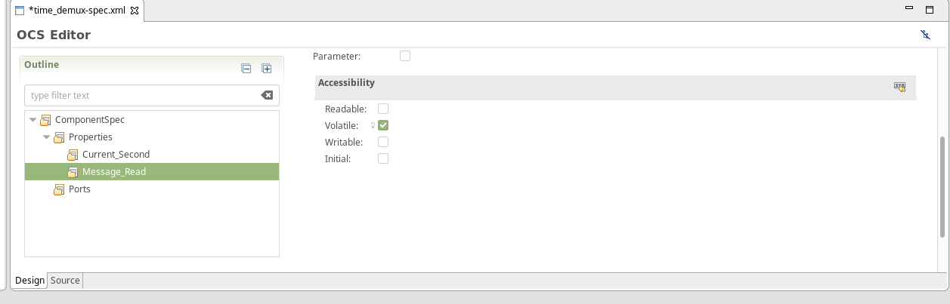
Create a property called Bytes_Read with property uLongLong:
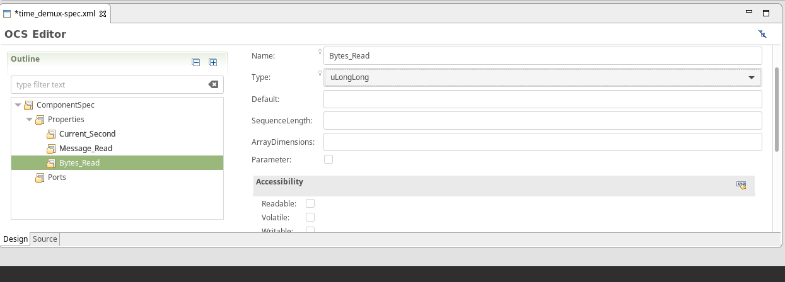
Scroll down and check the volatile box for Bytes_Read:
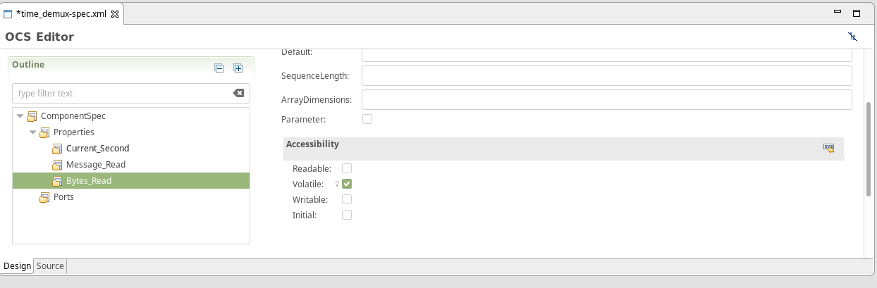
Create a port called Mux_In with iqstream_with_sync_protocol as the protocol:
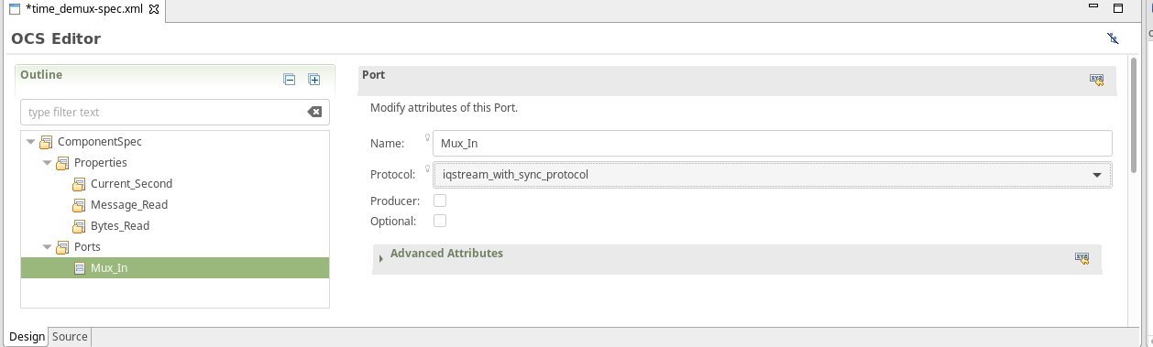
Create a port Time_Out with iqstream_with_sync_protocol as the protocol. Make sure to check the producer box.
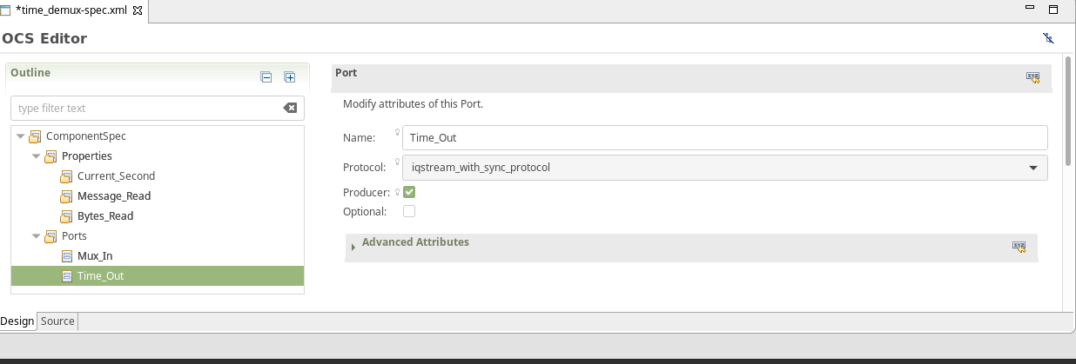
Create a port called Data_Out with iqstream_protocol as its protocol. Make sure to check the producer box.
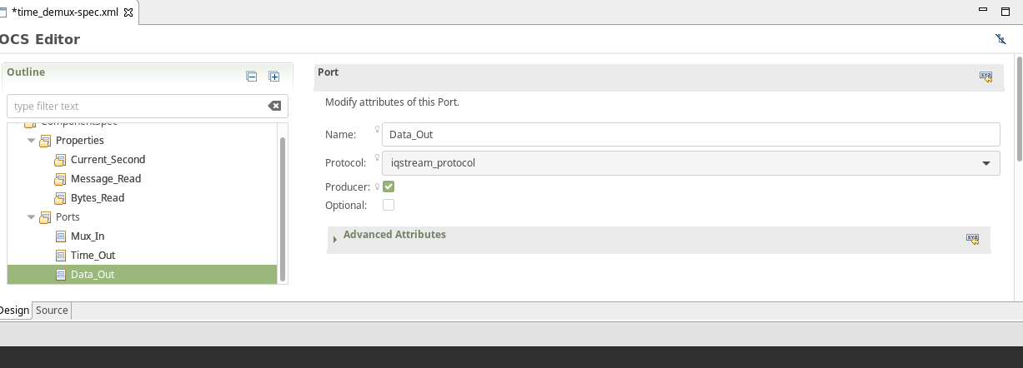

Step 2: Create time_demux Worker
Create a worker called time_demux with the following parameters:
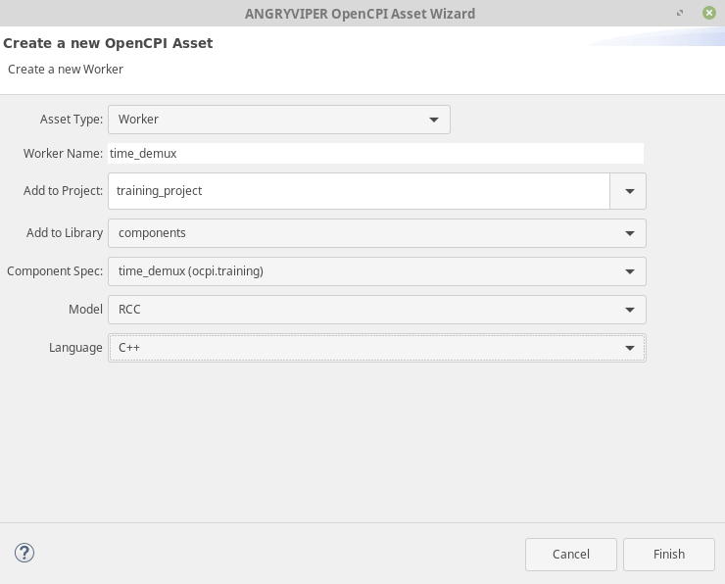
Open the Worker time_demux.xml file and check Start. The RCC code for the time_demux worker includes a “start” method which is part of the Control Plane worker life-cycle states. Since the Control Plane does not automatically call all of the life-cycle methods, it is necessary to indicate in the XML file that any implemented life-cycle method must be called.
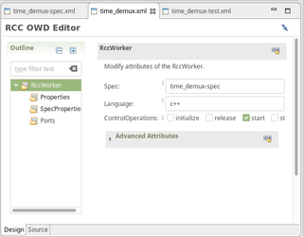

Step 3: Edit time_demux.cc
Go into your placeholder time_demux.cc file and paste in the following text:
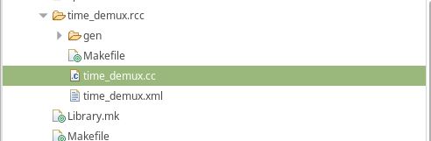

/*
* This file is protected by Copyright. Please refer to the COPYRIGHT file
* distributed with this source distribution.
*
* This file is part of OpenCPI <http://www.opencpi.org>
*
* OpenCPI is free software: you can redistribute it and/or modify it under the
* terms of the GNU Lesser General Public License as published by the Free
* Software Foundation, either version 3 of the License, or (at your option) any
* later version.
*
* OpenCPI is distributed in the hope that it will be useful, but WITHOUT ANY
* WARRANTY; without even the implied warranty of MERCHANTABILITY or FITNESS FOR
* A PARTICULAR PURPOSE. See the GNU Lesser General Public License for more
* details.
*
* You should have received a copy of the GNU Lesser General Public License
* along with this program. If not, see <http://www.gnu.org/licenses/>.
*/

// Note: This file uses C++11; you must add the proper compiler command line to the Makefile
// for each target platform, e.g:
// RccExtraCompileOptionsCC_centos7+=--std=c++11

#include <cstring>
#include <iostream>
#include "time_demux-worker.hh"

using namespace OCPI::RCC; // for easy access to RCC data types and constants
using namespace Time_demuxWorkerTypes;

class Time_demuxWorker : public Time_demuxWorkerBase {
static const bool verbose = false;

RCCResult start() {
// Guarantee that only Time opcode is sent on Time_Out port:
Time_Out.setDefaultOpCode(Iqstream_with_syncTime_OPERATION);
return RCC_OK;
}

// Internal helper function to manipulate counters
void increment_counters(size_t bytecount) {
++properties().Messages_Read;
properties().Bytes_Read += bytecount;
}

RCCResult run(bool /*timedout*/) {
// Determine opcode
switch (Mux_In.opCode()) {
case Iqstream_with_syncIq_OPERATION:
{
const size_t num_of_elements = Mux_In.iq().data().size();
// Insert IQ opcode logic here (update properties, allocate output, copy sequence, send)
if (verbose) std::cerr << "Received " << num_of_elements << " " << sizeof(IqstreamIqData) << "-byte values." << std::endl;
increment_counters(Mux_In.length());
Data_Out.iq().data().resize(num_of_elements);
const auto *iptr = Mux_In.iq().data().data();
/* ^ ^ ^ ^------ The Iqstream_with_syncIqData structs
* | | \------------- The argument of the IqOp (returns Mux_InPort::IqOp::DataArg object)
* | \------------------ The opcode (returns Mux_InPort::IqOp object)
* \------------------------- The port
*/
auto *optr = Data_Out.iq().data().data();
/* ^ ^ ^ ^------ The IqstreamIqData structs
* | | \------------- The argument of the IqOp (returns Data_OutPort::IqOp::DataArg object)
* | \------------------ The opcode (returns Data_OutPort::IqOp object)
* \--------------------------- The port
*/
for (size_t i = 0; i < num_of_elements; ++i, ++iptr, ++optr) {
// *optr++ = *iptr++; // Does not work; structs are different type!
optr->I = iptr->I;
optr->Q = iptr->Q;
}
Data_Out.advance();
} // case statement anonymous block for stack variables
break;
case Iqstream_with_syncTime_OPERATION:
// Insert Time opcode logic here (update properties, copy scalar, send)
increment_counters(sizeof(uint64_t));
properties().Current_Second = static_cast<uint32_t>(Mux_In.Time().time() >> 32);
if (verbose) std::cerr << "Timestamp: " << properties().Current_Second << std::endl;
Time_Out.Time().time() = Mux_In.Time().time();
/* ^ ^ ^------ The single uint64_t (no need for wrapper class providing length, etc.)
* | \------------- The opcode (returns Time_Out::TimeOp object)
* \---------------------- The port
*/
Time_Out.advance();
break;
default: // Iqstream_with_syncSync_OPERATION and any unknowns
// do nothing (but record message received)
increment_counters(0);
} // opcode switch
Mux_In.advance();
return RCC_OK; // Cannot use RCC_ADVANCE because both output ports never used in a single cycle.
}
}; // end class Time_demuxWorker

TIME_DEMUX_START_INFO
// Insert any static info assignments here (memSize, memSizes, portInfo)
// e.g.: info.memSize = sizeof(MyMemoryStruct);
TIME_DEMUX_END_INFO

Step 4: Build Worker
Build your worker for CentOS 7.
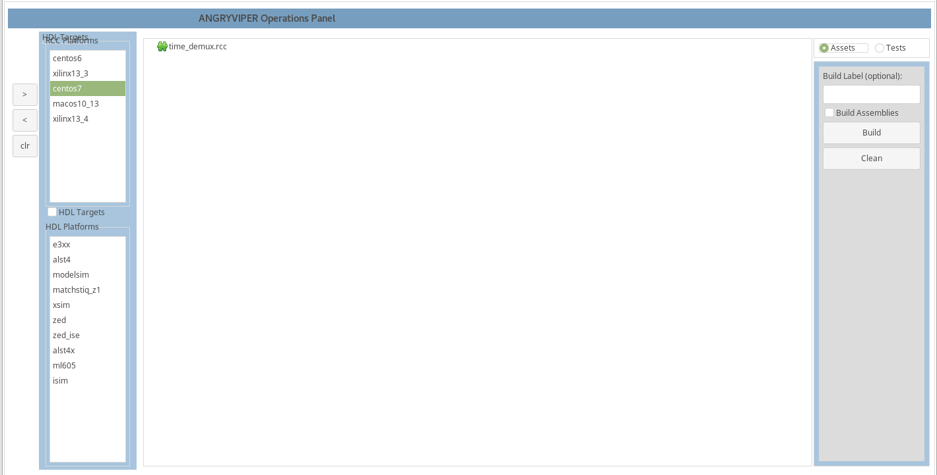

Step 5: Create Unit Test
Create a unit test for time_demux by copying the time_demux.test folder from the GitLab training/provided/lab5 folder into the components library.
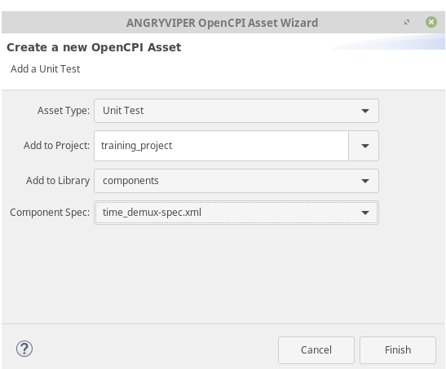
Confirm that the components library contains the folder and that it contains the following items:
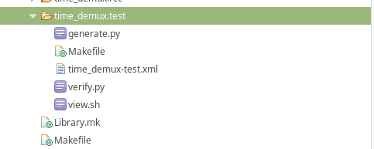

Step 6: Build Unit Test
Click gen + build from the tests tab and make sure you have CentOS 7 selected.
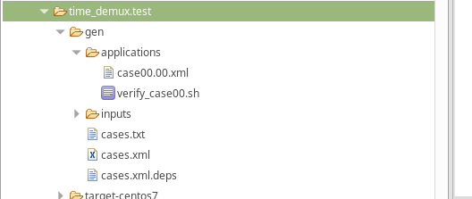
Refresh your time_demux.test directory.

Step 7: Run Unit Test on Development Host
To run the unit test on development host, click the "prep + run + verify" button. The test should run quickly. Upon completion, you should see "PASSED" along with final values for the min/max peaks.
Click the "view" button to view the test results. Plots of input and output (time and frequency domain) will pop up.

Step 8: Run Unit Test on Target Platform
To run the unit test on the target SDR platform:
- Build the Unit Test Suite for the target software platform:
Use the IDE to "Add" the Unit Test to the Project Operations panel
Highlight xilinx13_4 (E310) or xilinx13_3 (Zedboard/FMCOMMS2) in the RCC Platforms panel.
Select the "Tests" radio button.
Click gen + build.
Review the console window messages and address any errors.
- Using the command-line terminal (of the development host) approach to running unit tests on remote platforms:
Set OCPI_REMOTE_TEST_SYSTEMS, as shown:
$ export OCPI_REMOTE_TEST_SYSTEMS={IP of target platform}=root=root=/mnt/training_project
Browse to time_demux.test/ and execute the following command:
$ ocpidev run --mode prep_run_verify –only-platforms {xilinx13_4 | xilinx_13_3}
This command runs the unit test remotely (over ssh) on the target platform.
Also try:
$ ocpidev run --mode prep_run_verify --only-platform xilinx13_4 --view {limits platforms to test}
$ ocpidev run --mode prep_run_verify {run on all available platforms, no plotting}
$ ocpidev run --mode verify {verify previous results}
$ ocpidev run --mode view {plot previous results}

