OpenCPI
Tutorial 7hw: Using HDL Primitive Libraries
OpenCPI Release: v2.4.6
Revision History
Revision | Description of Change | Date
1.0 | Creation from Lab 7 developed by BIA | 2019-10-01
2.4 | Update for release 2.4.0 | 2022-01-20
2.4.1 | Update for patch release 2.4.1 | 2022-02-11
2.4.3 | Update GUI and CLI to reflect changes in ocpidev | 2022-08-24
Table of Contents
1 Overview 4
1.1 Tutorial Objectives 6
1.2 What’s Provided for This Tutorial 7
1.3 Prerequisites to Using This Tutorial 8
1.4 Documentation References 9
2 Create New Project 10
3 Create HDL Primitive Library 11
4 Copy HDL Primitive Library Files from the Tutorial Project 12
5 Build HDL Primitive Library 13
6 Create Component Library 14
7 Create Component 15
7.1 Create Component Spec 16
7.2 Add Component Properties and Ports 17
8 Create Worker 18
8.1 Update HDL Worker Skeleton Files 19
8.2 Build Worker 20
9 Create Unit Test 21
9.1 Copy OpenCPI Test Suite Description File 23
9.2 Copy Unit Test Scripts from Tutorial Project 24
9.3 Build Unit Test 25
10 Run Unit Test (XSIM) 26
11 View Unit I/O Test Plots (XSIM) 27
12 View Simulation Waveforms (XSIM) 28
13 Run Unit Test (ADALM-PLUTO) 29
14 Tutorial Summary 31

Overview
Note: This tutorial demonstrates the same steps as Tutorial 7, but it includes a hardware platform in the demonstration; in this case, it is the ADALM-PLUTO device (In OpenCPI, this is the plutosdr HDL platform).
This tutorial introduces you to HDL primitives and primitive libraries. HDL primitives are HDL assets that are lower level than workers. They can be used as building blocks for workers and are useful for HDL workers when there is lower-level code that is reused or shared in different workers. Using HDL primitives is also useful when there are non-OpenCPI code modules that are imported and need to be left untouched so that they remain useful outside of OpenCPI.
HDL primitives are the preferred way in OpenCPI to store and present reusable HDL for use in multiple workers. Using HDL primitives is not required, but it is recommended practice.
HDL primitives can be libraries or cores. An HDL primitive library is a collection of modules compiled from source code that can be referenced in HDL worker code, while an HDL primitive core is a single module. This tutorial demonstrates how to create an HDL primitive library and use it in HDL worker code. Our example is the Automatic Gain Control (AGC) Complex component (agc_complex) in the ocpi.tutorial project. This component inputs complex signed samples, drives the amplitude of both I and Q input rails to a reference level, and outputs complex signed samples.
The response time and output level of the circuit are programmable, as is the ability to update/hold the gain differential used in the feedback loop. The size of the averaging window used for peak detection is build-time programmable using the avg_window parameter, which is recommended to be a power-of-two to enable hardware division implementation with shift registers.
The ref property controls the desired output amplitude, while the mu property controls the AGC time constant, thus determining the response time of the circuit.
This implementation uses three multipliers per I/Q rail to process input data at the clock rate; that is, this worker can handle a new input value every clock cycle. This circuit produces output one clock cycle after each valid input, but the input-to-output latency is actually three valid clock cycles.
The AGC Complex worker uses the OpenCPI iqstream_protocol for both input and output ports (see $OCPI_ROOT_DIR/projects/core/specs/iqstream_protocol.xml). This protocol defines an interface of 16-bit complex signed samples. The data_width “parameter” property for the HDL worker can be used to reduce the worker’s internal data width to less than 16 bits.
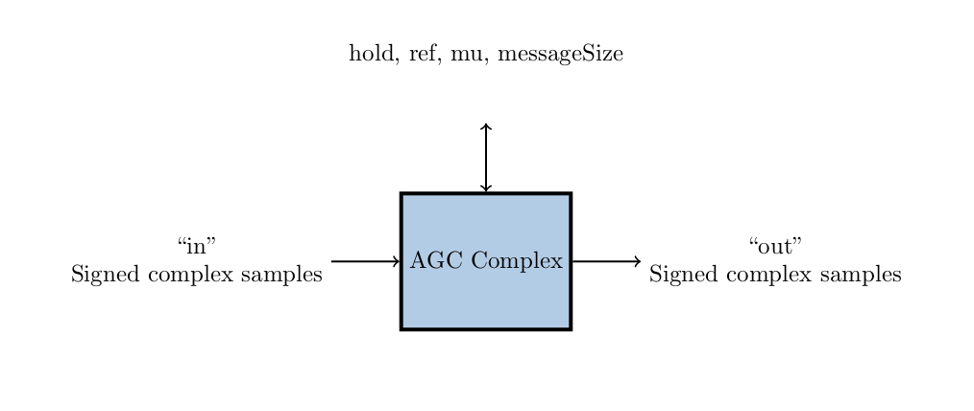Figure 1: AGC Complex Component Function

Tutorial Objectives
The purpose of this tutorial is to demonstrate how to create an HDL primitive library and use it in an HDL worker. It shows you how to:
- Create the HDL primitive library to be used by the AGC complex worker.
- Create the AGC complex component, HDL worker, and component unit test suite (aka “unit test”) and build the worker and unit test for the xsim and plutosdr platforms.
- Run the component unit test suite on the xsim and plutosdr platforms and view the generated output.
The provided source files show:
- A primitive library package declaration file that enables VHDL code to instantiate all entities and modules in the primitive library.
- A primitive library VHDL source file that implements a simple automatic gain control (AGC) with two independent channels for I and Q respectively. This file in particular stores the record signal names.
Note: This part of the tutorial requires a machine with HDL platform support for the ADALM-PLUTO hardware device (HDL platform plutosdr). Details of how to set up and configure the platform are beyond the scope of this tutorial.

What’s Provided for This Tutorial
The built-in OpenCPI tutorial project ocpi.tutorial provides source code for the following items in this tutorial:
- The HDL primitive source and package declaration VHDL files, in hdl/prims/agc.vhd and hdl/prims/prims_pkg.vhd
- The VHDL source code for the agc_complex worker, in components/agc_complex.hdl/agc_complex.vhd
- The unit test scripts generate.py and verify.py, written in Python
- The unit test bash shell script view.sh
The ocpi.tutorial project also provides the XML source for all of the assets used to build and run the example component, worker and tests.
Instructions for copying these items from the ocpi.tutorial project into the “demo” tutorial project are provided in the relevant sections of this document. The source code for these items is also available as text in the relevant sections of this document that you can copy and paste into the relevant files following the instructions given in the section.
Note: when copying and pasting text from this document, be sure to remove any line breaks in code or command lines. The backslash character (\) is used in command lines (where feasible) to indicate a line break.

Prerequisites to Using This Tutorial
This tutorial (Tutorial 7hw) has the system prerequisites described in OpenCPI Tutorial 1: Component-based Development. See the prerequisites section in Tutorial 1 for details. In addition to these requirements, this tutorial uses the plutosdr platform, and so the corresponding OSP should be downloaded and installed. See the section “Installation Steps for Platforms” in the OpenCPI Installation Guide.
Before you begin this tutorial, you should have successfully completed Tutorials 1-6.
We recommend reading the following briefings and guides before getting started with this tutorial:
- Briefing 9 HDL Assemblies. This briefing introduces HDL assembly concepts and terminology.
- Briefing 10 HDL Primitives. This briefing introduces HDL primitives concepts and terminology.
- The “HDL Primitives” section in the OpenCPI HDL Development Guide.

Documentation References
The documents listed in the following table provide detailed information about subjects discussed in this tutorial. The documents listed here are not required reading for this tutorial but will likely be of interest for more in-depth learning.
Table 1 - OpenCPI Reference Documentation
Title | Published By | Public URL
OpenCPI User Guide | OpenCPI | https://opencpi.gitlab.io/releases/v2.4.6/docs/OpenCPI_User.pdf
OpenCPI Application Development Guide | OpenCPI | https://opencpi.gitlab.io/releases/v2.4.6/docs/OpenCPI_Application_Development_Guide.pdf
OpenCPI Component Development Guide | OpenCPI | https://opencpi.gitlab.io/releases/v2.4.6/docs/OpenCPI_Component_Development_Guide.pdf
OpenCPI HDL Development Guide | OpenCPI | https://opencpi.gitlab.io/releases/v2.4.6/docs/OpenCPI_HDL_Development_Guide.pdf
OpenCPI RCC Development Guide | OpenCPI | https://opencpi.gitlab.io/releases/v2.4.6/docs/OpenCPI_RCC_Development_Guide.pdf

Create New Project
We’ll create a new, clean project for this tutorial; we’ll call it DemoProject7.
To create the project using the OpenCPI GUI:
- From the GUI menu bar at the top of the window, select Create > Project.
- The New Project dialog is displayed. In Project Name, enter DemoProject7.
- In Project Dependencies, enter ocpi.assets,ocpi.tutorial.
- Check Register project.
- Click OK. When the operation finishes, you’ll see the DemoProject7 project directory as well as a some other generated files.
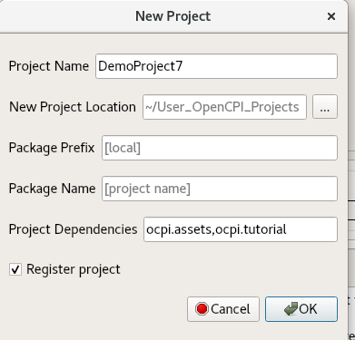
To create the new project from the command line, use the following ocpidev command:
ocpidev -D ocpi.assets -D ocpi.tutorial create project DemoProject7 --register

Create HDL Primitive Library
You must now create and build the HDL primitive library.
To create the project using the OpenCPI GUI:
- From the GUI menu bar at the top of the window, select Create > HDL >Primitive Library.
- The New HDL Primitive Library dialog is displayed. In Primitive Lib Name, enter prims.
- From the Associated Project drop-down list, select DemoProject7.
- Click OK.
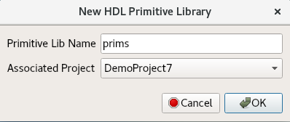
To create the primitive library from the command line, use the following ocpidev command from the DemoProject7/ directory:
ocpidev create hdl primitive library prims

Copy HDL Primitive Library Files from the Tutorial Project
Next, we need to copy the provided primitive source file agc.vhd and primitive package prims_pkg.vhd from the ocpi.tutorial project directly into the primitive library. Navigate to the hdl/primitives/prims/ subdirectory in DemoProject7 and then use the commands:
cp $OCPI_ROOT_DIR/projects/tutorial/hdl/primitives/prims/agc.vhd .
cp $OCPI_ROOT_DIR/projects/tutorial/hdl/primitives/prims/prims_pkg.vhd .
Now that you’ve copied the files, you can open and examine the contents. You'll see that agc.vhd implements the AGC component logic and that prims.pkg.vhd enables the primitive source code to be callable by HDL workers.

Build HDL Primitive Library
Now we'll build the HDL primitive library we just copied from the tutorial project for the target HDL platforms (xsim and plutosdr).
To build from the OpenCPI GUI:
- In the Platforms panel, check HDL, select xsim and uncheck RCC. Once the build finishes, come back to this step but select plutosdr instead.
- In the Project Explorer panel, select primitives.
- Right-click primitives and then select Build.
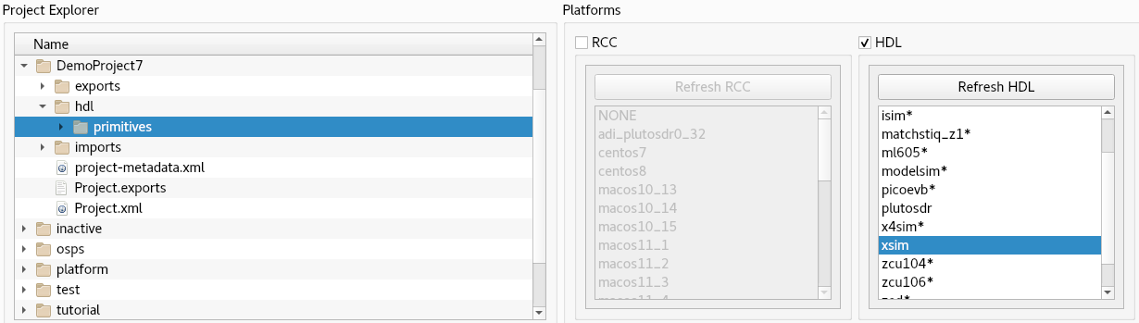
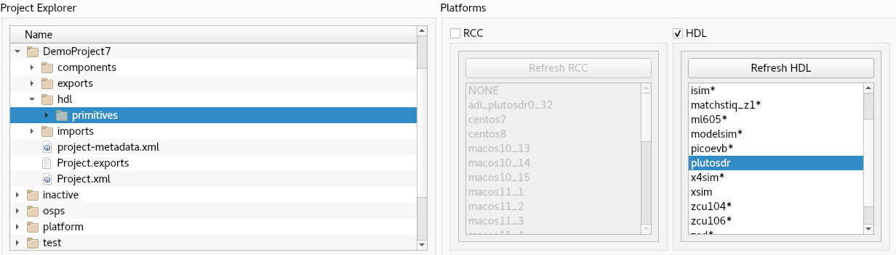
To build from the command line, first build the primitive library for the xsim HDL platform by running the following ocpidev command from DemoProject7/hdl/primitives/:
ocpidev build --hdl-platform xsim
Next, build the primitive library for the plutosdr HDL platform with the ocpidev command:
ocpidev build --hdl-platform plutosdr

Create Component Library
Before we can create our component, we need to create a component library for it.
To create the components library in the OpenCPI GUI:
- From the GUI menu bar at the top of the window, select Create > Component Library.
- The New Library dialog is displayed. In Library Name, enter components.
- From the Associated Project drop-down list, select DemoProject7.
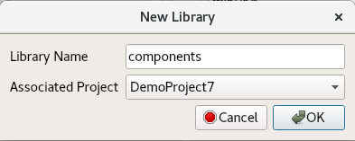
- Click OK.
To create the components library with ocpidev, run the following command in the DemoProject7/ directory:
ocpidev create library components
You should now see a lib/ directory and a components.xml file in the components/ directory. We need to edit the components.xml file. Using a text editor, open and edit components/components.xml so that it has the following content:
<library
HdlLibraries='prims'
/>

Create Component
Now we need to create the OCS (OpenCPI Component Specification) for agc_complex that defines its properties and ports.

Create Component Spec
We’ll create our agc_complex component spec in the components library we just created.
To create the component in the OpenCPI GUI:
- From the GUI menu bar at the top of the window, select Create > Component Spec.
- The New Component dialog is displayed. In Component Name, enter agc_complex.
- Select DemoProject7 from the Associated Project drop-down list.
- The Associated Library field will auto-set to components.
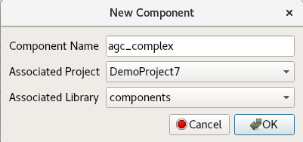
- Click OK.
To create the component spec with ocpidev, run the following command in the DemoProject7/components/ directory:
ocpidev create component agc_complex

Add Component Properties and Ports
The previous command created the component spec agc_complex-spec.xml in components/agc_complex.comp/. We must now add properties and ports to the component spec.
To do so, we’ll simply copy the reference spec agc_complex-spec.xml directly from ocpi.tutorial into our DemoProject7/components/agc_complex.comp/ directory:
# cd to the agc_complex.comp/ directory in DemoProject7
cd DemoProject7/components/agc_complex.comp/

cp
$OCPI_ROOT_DIR/projects/tutorial/components/specs/agc_complex-spec.xml .

Create Worker
We will now create the HDL worker.
To create the worker in the OpenCPI GUI:
- From the GUI menu bar at the top of the window, select Create > Worker.
- The New Worker dialog is displayed. In Worker Name, enter agc_complex.
- From the Associated Project drop-down list, select DemoProject7.
- For Model, select HDL. Language should then automatically select VHDL.
- From the Associated Library drop-down list, confirm components is selected.
- From the Component Spec drop-down list, select agc_complex.
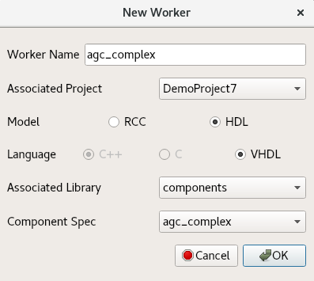
- Click OK.
To create the worker with ocpidev, run the following command in the DemoProject7/components/ directory:
ocpidev create worker agc_complex.hdl

Update HDL Worker Skeleton Files
We will now populate the skeleton files in the previously-generated agc_complex.hdl/ directory with reference files from the tutorial project.
Use the following commands to copy the files for agc_complex.vhd and agc_complex.xml from the ocpi.tutorial project:
# cd to the agc_complex.hdl/ directory in DemoProject7
cd components/agc_complex.hdl/
cp $OCPI_ROOT_DIR/projects/tutorial/components/agc_complex.hdl/agc_complex.vhd .
cp $OCPI_ROOT_DIR/projects/tutorial/components/agc_complex.hdl/agc_complex.xml .
You can examine these files for more context. The agc_complex.vhd file in particular holds good information to look into as it has an explanation of the agc circuit. This file allows the worker to function properly.
In agc_complex.hdl/gen/, you’ll see an assortment of files that do not need to be edited. They are automatically generated when the worker has been created, and if they are removed will be recreated when the ocpidev build command is invoked.

Build Worker
If all goes well, we can now build the worker from the components/agc_complex.hdl/ directory.
To build from the OpenCPI GUI:
- In the Platforms panel, check HDL. select xsim, and uncheck RCC. After this builds, repeat these steps but with plutosdr selected.
- In the Project Explorer panel, select components.
- Right-click agc_complex.hdl and then select Build.
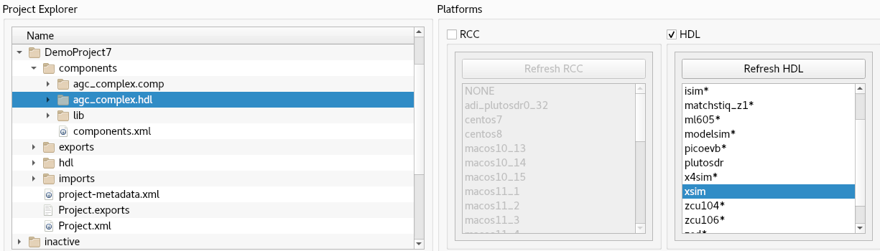
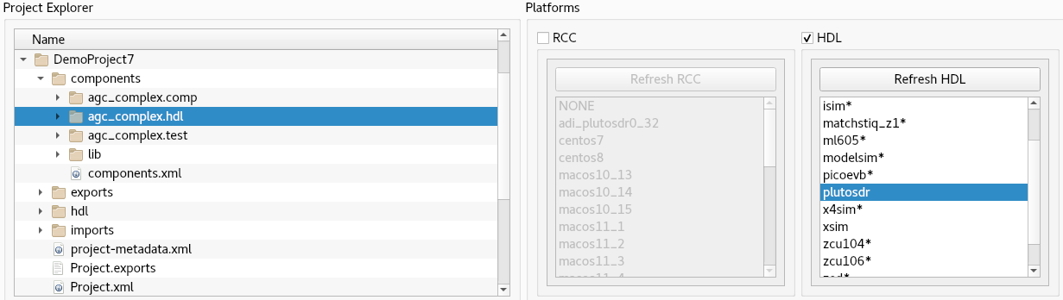
To build the worker for xsim from the command line, run the following ocpidev command in the components/agc_complex.hdl/ directory in DemoProject7:
ocpidev build --hdl-platform xsim
Next, build the worker for plutosdr with the ocpidev command:
ocpidev build --hdl-platform plutosdr
Navigate to components/agc_complex.hdl/. There should be two new subdirectories target-<platform> - one for xsim (target-xsim) and one for plutosdr (target-zynq) that contain the artifacts needed to run the worker on these platforms.

Create Unit Test
Now we’ll generate an OpenCPI component test suite (aka “unit test”) for our agc_complex worker.
To create the unit test in the OpenCPI GUI:
- From the GUI menu bar at the top of the window, select Create > Component Test Suite.
- The New Unit Test dialog displayed. From the Associated Project drop-down list, select DemoProject7.
- From the Associated Library drop-down list, confirm components is selected.
- From the drop-down list in Component Spec, select agc_complex.
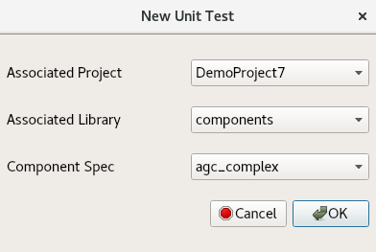
- Click OK.
To create the unit test from the command line, run the following ocpidev command from the DemoProject7/components/ directory:
ocpidev create test agc_complex
Now run the tree command to observe the files created:
agc_complex.test
├── generate.py
├── agc_complex-test.xml
├── verify.py
└── view.sh
The files of interest here are:
- agc_complex-test.xml. This is the OpenCPI Test Suite Description (OTSD) XML file. It specifies the test cases and the defaults that apply to all test cases.
- generate.py. This is a stub file for an optional script that you can create to generate input test data for ports or property value files. There is one script for each input port.
- verify.py. This is a stub file for an optional script that you can create to verify output test data produced by output ports. There is one script for each output port..
- view.sh. This is a stub file for an optional script that you can create to view the results of a test execution; for example, a plot. This script may not be necessary or appropriate for many workers. It can work as a helpful aid in the development process, but it is not meant for long-term testing and re-testing.
We want to use the generate, verify and view scripts in this tutorial, so we’ll need to edit the OTSD file to specify them and create the code for each script. The next sections describe these steps.

Copy OpenCPI Test Suite Description File
We now have a skeleton agc_complex-test.xml file that we need to fill out. To do this, we'll simply copy the reference OTSD XML file from the tutorial project with the command:
# cd to test suite (aka unit test) directory in DemoProject7
cd components/agc_complex.test/
cp $OCPI_ROOT_DIR/projects/tutorial/components/agc_complex.test/agc_complex-test.xml .

Copy Unit Test Scripts from Tutorial Project
Now we need to create code for the empty generate.py, verify.py and view.sh scripts we created when we created the unit test. To do this, we'll simply copy the unit test scripts provided in the tutorial project into our DemoProject7 unit test directory.

Copy generate.py and verify.py Files
We will simply use the reference files for these items from ocpi.tutorial. The commands to copy the files into our existing project are shown below:
# cd to test suite directory in DemoProject7
cd components/agc_complex.test/
cp $OCPI_ROOT_DIR/projects/tutorial/components/agc_complex.test/generate.py .
cp $OCPI_ROOT_DIR/projects/tutorial/components/agc_complex.test/verify.py .

Edit view.sh Script
Now open the view.sh script with a text editor and then copy and paste the following lines at the end of the file (highlighted in red):
#!/bin/bash --noprofile
# Use this script to view your input and output data.
# Args: <list-of-user-defined-args> <input-file> <output-file>
$OCPI_ROOT_DIR/projects/tutorial/scripts/plotAndFft.py $2 complex 32768 100&
$OCPI_ROOT_DIR/projects/tutorial/scripts/plotAndFft.py $1 complex 32768 100&
Note: Make sure your test scripts have read and execute permissions before using them to build and run the agc_complex unit test. For example, in the agc_complex.test/ directory:
chmod 755 generate.py
chmod 755 verify.py
chmod 755 view.sh

Build Unit Test
Now we’ll build the unit test for the target platforms.
To build from the OpenCPI GUI:
- In the Platforms panel, check HDL, select xsim, and uncheck the RCC box. After this builds, repeat these steps but with plutosdr selected.
- In the Project Explorer panel, select components.
- Right-click agc_complex.test and select Build.
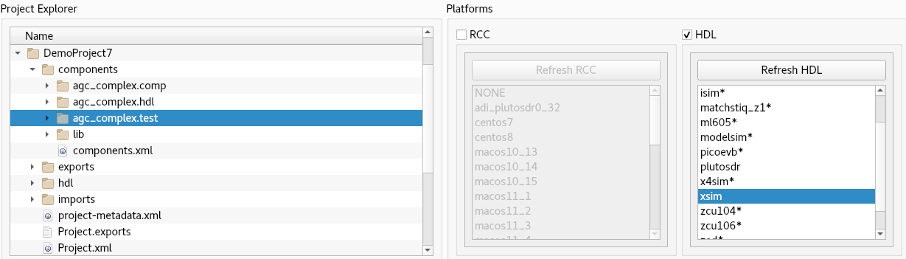
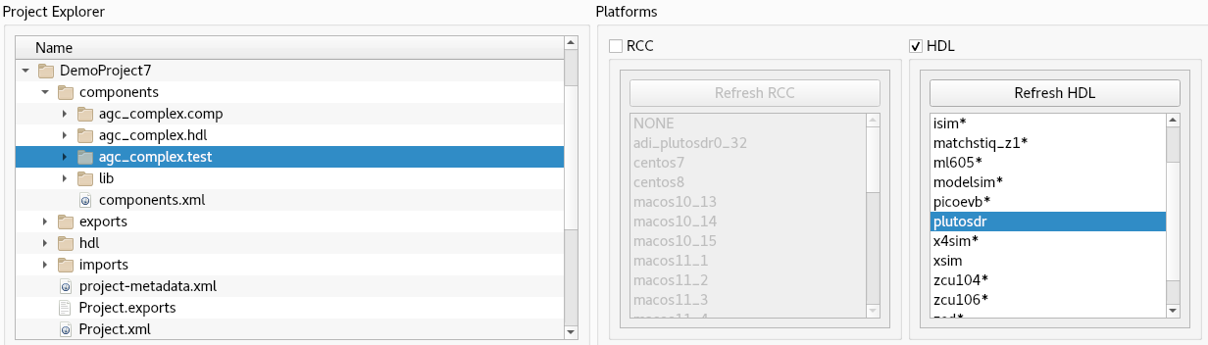
To generate and build the unit test for the xsim HDL platform from the command line, run the following ocpidev command from the components/agc_complex.test/ directory:
ocpidev build --hdl-platform xsim
To generate and build the unit test for the plutosdr HDL platform from the command line, run the ocpidev command from the components/agc_complex.test/ directory:
ocpidev build --hdl-platform plutosdr

Run Unit Test (XSIM)
We will now run the unit test in components/agc_complex.test/on the xsim HDL platform.
To run the unit test with the OpenCPI GUI:
- In the Platforms panel, check HDL, select xsim, and uncheck the RCC box.
- In the Project Explorer panel, select components.
- Select agc_complex.test.
- In the Unit Tests panel, under Phases, leave Start Action and End Action set to All.
- In the Unit Tests panel, under Options, check Run View Script and Keep Simulations.
- Under Options, check Prep/Run/Verify Phases.
- The greyed-out options below will now be available. Click Only-Platform.
- Now click Run Unit Test.
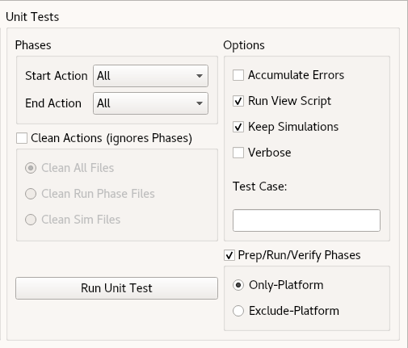
To run the unit test from the command line, use the following ocpidev command from the components/agc_complex.test/ directory:
ocpidev run --mode all --only-platform xsim --keep-simulations \
--view

View Unit I/O Test Plots (XSIM)
The following figures show the output:
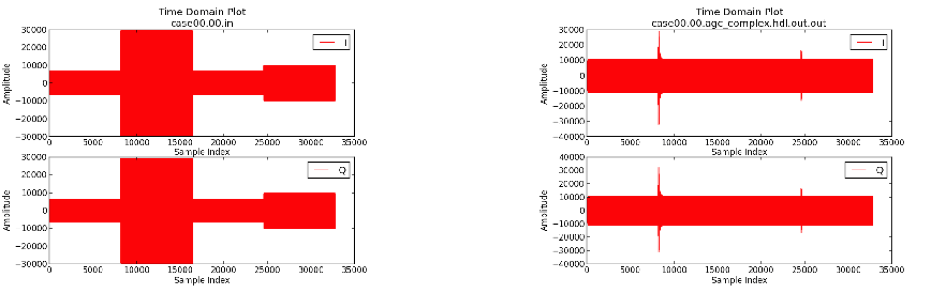
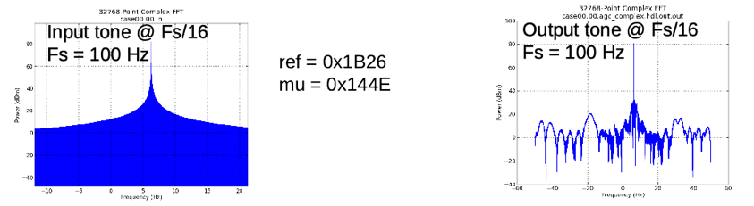

View Simulation Waveforms (XSIM)
Note: In order to view simulation waveforms, you must have checked "keep simulations" in the OpenCPI GUI or have used the --keep-simulations option on the ocpidev command line.
In a terminal window, browse to agc_complex.test/ and execute the following command:
ocpiview run/xsim/case00.00.agc_complex.hdl.simulation/ &
You’ll want to expand agc_complex_0_frw_0_xsim_base by using the arrow to the left and then right-clicking pfconfig_i. Click on Add to Wave Window. For more information on using ocpiview, see the section “Navigating the Simulator” in Tutorial 6.
You should see the following output:
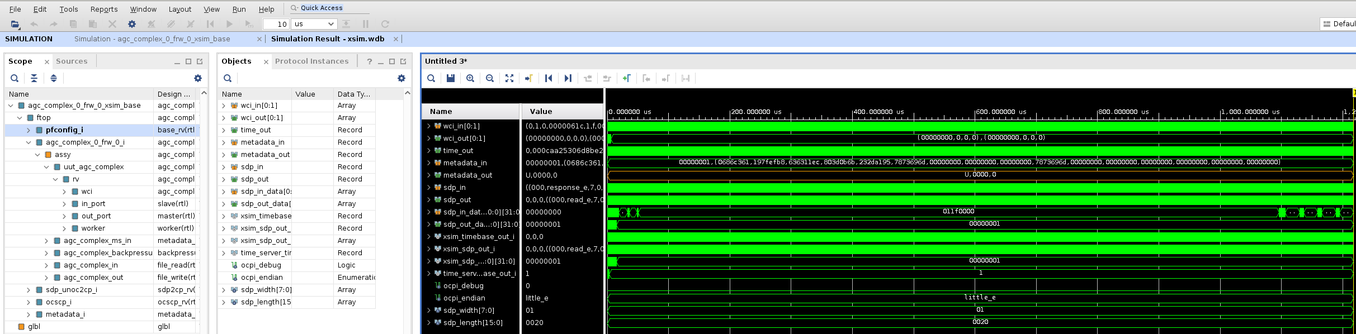

Run Unit Test (ADALM-PLUTO)
First we’ll check that the ADALM-PLUTO device is connected.
Note: Details of how to set up and configure this platform are beyond the scope of this tutorial. See the section “Installation Steps for Platforms” in the OpenCPI Installation Guide for information about downloading and installing the corresponding OSP.
export OCPI_SERVER_ADDRESSES=<Pluto_IP>:12345
ocpiremote status -p analog
The output should be something similar to:
Executing remote configuration command: status
Server is running with port: 12345 and pid: 26224
Now we can run the unit test on the plutosdr HDL platform and view the results. From the command line in the DemoProject7/components/agc_complex.test directory, run the following ocpidev command:
ocpidev run --mode all --only-platform plutosdr \
--keep-simulations --view
The output should be identical to that of the simulator output. The main difference is that you should see that the test runs faster on hardware.
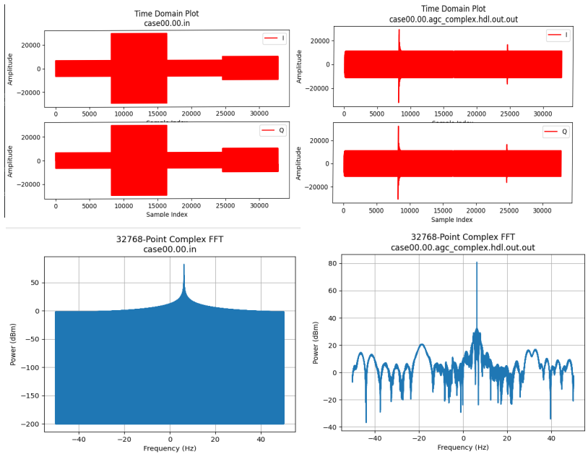

Tutorial Summary
Now that you’ve completed this tutorial, you should be familiar with the basic concepts of HDL primitives and how they are used to store and present reusable HDL. In other existing OpenCPI projects, you should also be able to see how the primitive library is used for multiple workers instead of just the one shown in this tutorial. You can now move on to Tutorial 8 (or Tutorial 8hw), which demonstrates how to use third-party primitive cores in HDL application workers.

