OpenCPI
Tutorial 9a: Using OpenCPI Debugging Tools

Revision History
Revision | Description of Change | Date
1.0 | Creation from Couse developed by BIA | 2019-10-01
1.1 | Updated to add section from Tutorial 9hw on using ocpihdl on a simulator | 2022-01-03
1.2
1.3
1.4
1.5
1.6
1.7
1.8
1.9
2.0
2.1
Table of Contents
1 Overview 4
1.1 What’s Provided for This Tutorial 5
1.2 Prerequisites to Using This Tutorial 6
1.3 Documentation References 7
2 Using ocpihdl 8
2.1 Finding the Available HDL Devices on a Target FGPA-based Platform 9
2.2 Loading/Probing the Bitstream 10
2.3 Controlling Workers 11
2.4 Viewing Worker Information from the Bitstream 12
2.5 Using ocpihdl on a Simulator 14
3 Debugging with ocpi_debug 15
4 Execution and Debug Utilities 16

Overview
This guide briefly describes how to use the debugging tools provided with OpenCPI to:
- Collect HDL device/worker information
- Review worker lifecycle
- Control worker state
- Change and view worker properties
- Debug workers
Tutorial 9: Debugging an HDL Worker on a Hardware Platform provides an example of how to debug OpenCPI applications with OpenCPI debugging utilities.

What’s Provided for This Tutorial
There are currently no items provided for this tutorial.

Prerequisites to Using This Tutorial
Before you begin this tutorial, you should have successfully completed Tutorial 1b, “Introduction to Component-based Development”.

Documentation References
The documents listed in the following table provide detailed information about subjects discussed in this tutorial. The documents listed here are not required reading for this tutorial but will likely be of interest for more in-depth learning.
Table 1 - OpenCPI Reference Documentation
Title | Published By | Public URL
OpenCPI Overview | OpenCPI | https://opencpi.gitlab.io/releases/develop/docs/Overview.pdf
OpenCPI User Guide | OpenCPI | https://opencpi.gitlab.io/releases/develop/docs/OpenCPI_User.pdf
OpenCPI Application Development Guide | OpenCPI | https://opencpi.gitlab.io/releases/develop/docs/OpenCPI_Application_Development.pdf
OpenCPI Component Development Guide | OpenCPI | https://opencpi.gitlab.io/releases/develop/docs/OpenCPI_Component_Development.pdf
OpenCPI HDL Development Guide | OpenCPI | https://opencpi.gitlab.io/releases/develop/docs/OpenCPI_HDL_Development.pdf
OpenCPI RCC Development Guide | OpenCPI | https://opencpi.gitlab.io/releases/develop/docs/OpenCPI_RCC_Development.pdf

Using ocpihdl
We can use ocpihdl to:
- Probe the XML of the currently loaded bitstream
- Display currently loaded workers
- View/change worker status
- Set/change worker properties
- Reset workers
- Step through an application
When run without options, ocpihdl prints out all of its uses.

Finding the Available HDL Devices on a Target FGPA-based Platform
$ ocpihdl search
This command provides information for available HDL devices, including:
- Name
- Date of bitstream creation
- Platform
- Part
- UUID (unique identifier of the bitstream)

Loading/Probing the Bitstream
To examine the XML packaged into any artifact (including bitstreams):
$ ocpixml get <.so or .bitz artifact filename>
To load a bitstream:
$ ocpihdl load <path to bitstream>
To examine the XML packaged into a currently loaded bitstream:
$ ocpihdl getxml <output-file>
$ ocpihdl getxml <output-file>
$ grep controlOperation <output-file>
- What controlOperations are implemented by each worker?
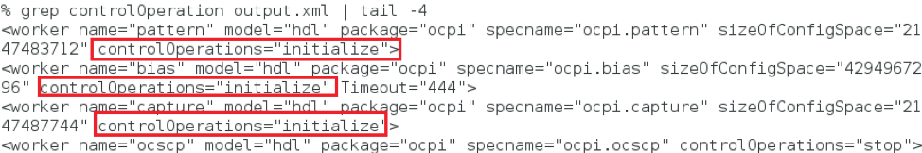
To remove the bitstream from the FPGA:
$ ocpihdl unload
This command is most commonly used when the system’s processor functions independently from the programmable logic.
CAUTION: Unloading an FPGA that implements a PCIe interface may result in the card being unusable and may require a system reboot.

Controlling Workers
The following figure shows the worker life cycle:
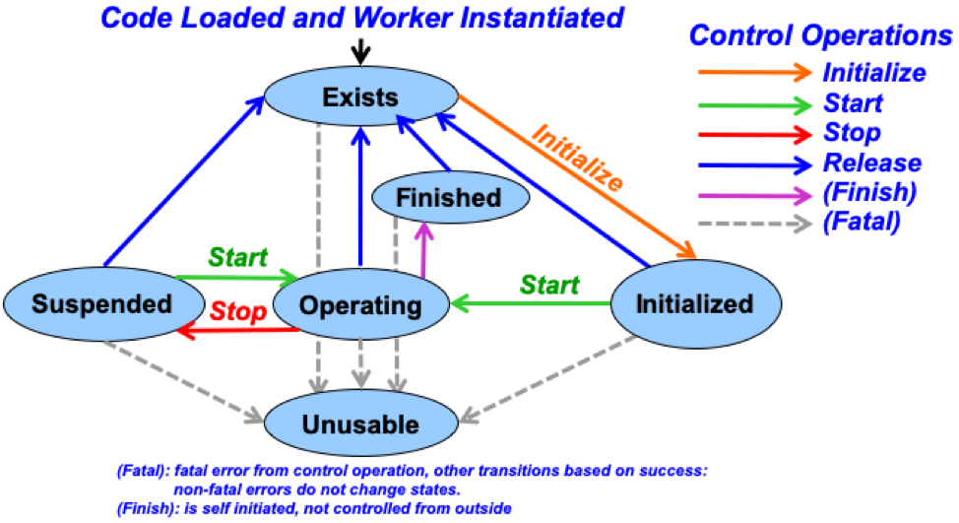
To find a worker index and other information, use:
$ ocpihdl get
You can specify <index/worker-name> (and even <property>) here.
To reset or unreset the control reset signal into workers, use:
$ ocpihdl wreset/wunreset <index>
To perform other control operations on workers, use”
$ ocpihdl wop <index> start/initialize/stop
To set worker properties, use:
$ ocpihdl set <index/worker-name> <property> <value>
To observe worker state, use:
$ ocpihdl status <index/worker-name>
Add the -v option to the command line to view worker properties.

Viewing Worker Information from the Bitstream
Use:
$ ocpihdl get
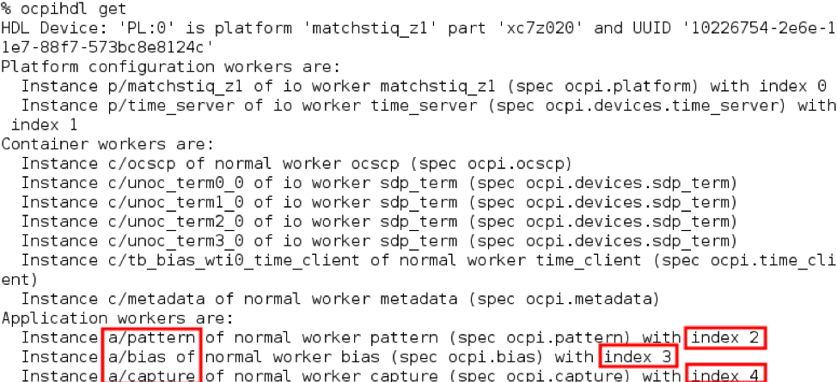
We can identify them by their indices.
If the worker is "RESET"
$ ocpihdl wunreset <index>
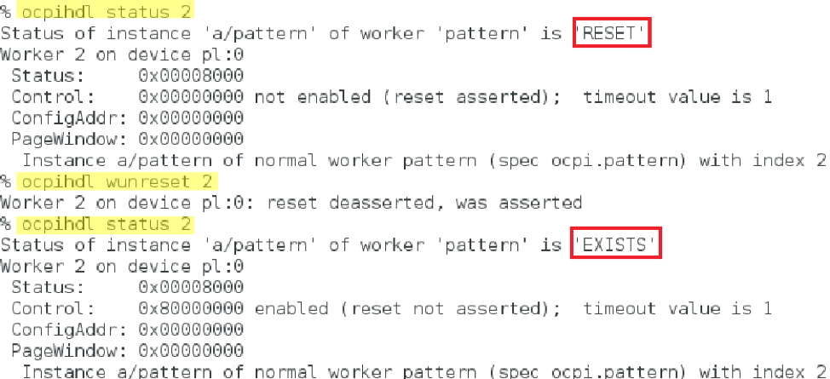
If the worker implements the "initialize" controlOperation:
$ ocpihdl wop <index> initialize
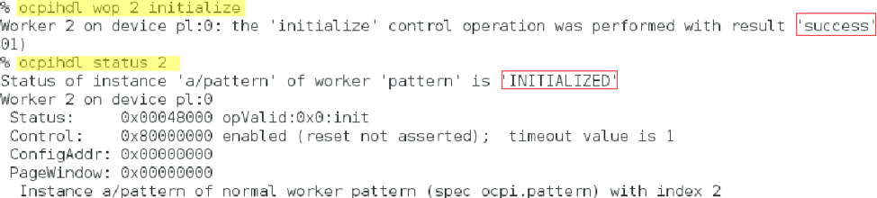
Ultimately, to bring the worker to "OPERATING":
$ ocpihdl wop <index> start
Writable worker properties can be changed:
$ ocpihdl set <index/worker-name> <property> <value>
Readable (the explicit flag, not the concept) / Volatile properties can be read:
$ ocpihdl status -v <index/worker-name>
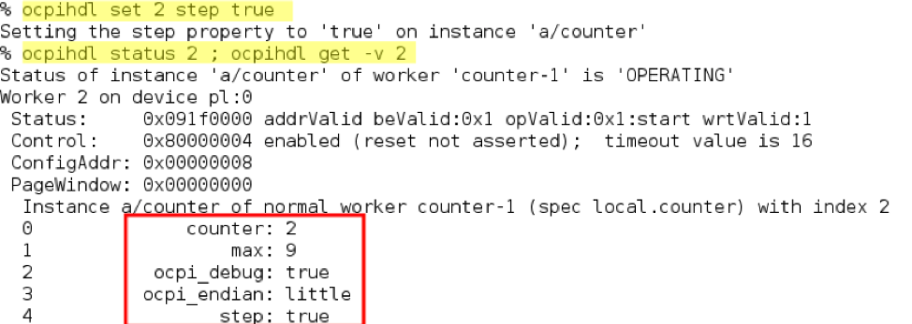

Using ocpihdl on a Simulator
FIXME PLAN: Add this information to this tutorial (Tutorial 9a), which is destined to be reverted to a briefing, which is what it was originally.
FIXME: Per Jim, I don’t think this works for *any* simulator anymore. Verified it won’t work for “xsim”. Here are Jim’s comments on the matter from a Slack conversation:
That tutorial was written when a simulator could be run in “server” mode. That feature does not work and is non-trivial to bring it back to life. It would be a fine idea to do so, since there are definitely benefits to it.
Basically we made a sort of transition to running the simulation containers as subprocesses of the application (e.g. ocpirun) so that it was easy to run on simulators without making any special provision of running them separately (i.e. ocpirun auto-launches them under the covers if any workers are assigned to them).
The previous mode required you to start a separate (simulation server) process that ran the simulator as a sort of remote container.
That server mode has the advantage that it was persistent (and thus more like a real FPGA hardware container), and thus you could run (and simulate) serially running multiple applications on the same bitstream without reload.
The code was cloned to do it the current way (ugh, ptui), and the client side for the server mode code was left in the code base in HdlSimDriver.cc
Whereas the current/used code is in HdlLSimDevice (local simulation device).
So HdlSimDriver.cc would have to be reengineered to share lots of code with HdlLSimDevice.cc. The server-side code (to run the simulator as a server), is run by the “simulate” verb of the ocpihdl command (e.g. “ocpihdl simulate”).
I had to go back to 2015 to find the server-side code that the HdlLSimDevice code was cloned from...
Using ocpihdl on a simulator is not recommended. You must specify the HDL device with every ocpihdl command. For example:
$ ocpihdl status -d sim:… -v status 2
To make this easier, save the string:
$ ocpihdl search (to identify the device)
$ SIM="-d sim:127.0.0.1:49876"
This string will be different every time a simulator starts. Then, for example:
$ ocpihdl status $SIM -v status 2

Debugging with ocpi_debug
There is a worker parameter that can enable debugging. Set this parameter to true in the OWD before building workers for debugging and add debugging functionality to worker the that depends on ocpi_debug.
In VHDL: "ocpi_debug":
In C++, "<WORKER_NAME>_OCPI_DEBUG":

Execution and Debug Utilities
- Log level:
export OCPI_LOG_LEVEL=8
ocpirun -l 8 (lowercase L)
OCPI_LOG_LEVEL=10 make tests
- "ocpirun -C" finds containers, including simulators.
- "ocpiview" is used to view simulation waveform results
- printf/cout
- ocpi_debug OWD parameter
- gdb

