OpenCPI
Tutorial 8: Using Third-Party HDL Primitive Cores

Revision History
Revision | Description of Change | Date
1.0 | Creation from Lab 8 developed by BIA | 2019-10-01
1.1 | Add content, test CLI instructions, update/test GUI instructions | 2021-12-28
1.2
1.3
1.4
1.5
1.6
1.7
1.8
1.9
2.0
2.1
Table of Contents
1 Overview 4
1.1 What’s Provided for This Tutorial 5
1.2 Prerequisites to Using This Tutorial 6
1.3 Documentation References 7
2 Create New Project 8
3 Create Component Library 9
4 Create Component 10
4.1 Create Component Spec 11
4.2 Add Properties and Ports 12
5 Create Worker 13
6 Edit Worker OWD 14
6.1 Add data_select Property 15
6.2 Convert Data Port Interface for Parallel Transmission 16
7 Build Worker 17
8 Copy Third-Party Cores to Worker 18
9 Copy/Edit VHDL Source Code 19
10 Build Worker 20
11 Review Build Log and Artifacts 21
12 Unit Test – Simulation 22
13 Create Unit Test 23
14 Build Unit Test and its Artifacts 24
14.1 Build Unit Test 25
14.2 Review OCS Artifacts 26
14.3 Review Build Artifacts 27
15 Run Unit Test (Xilinx XSIM) 28
16 Examine I/O Test Plots (Xilinx XSIM) 29
17 View Simulation Waveforms (Xilinx XSIM) 30
18 Tutorial Summary 31

Overview
This tutorial describes how to create an HDL worker that uses HDL primitive cores imported from a third party; in this example, Vivado. It demonstrates how to design, build and test a complex mixer HDL worker (complex_mixer.hdl) for execution on a Xilinx XSIM simulator. The HDL worker is a “work-alike” to the complex mixer RCC worker discussed in Tutorial 4: Creating a Complex Mixer.
The tutorial shows you how to:
- Set OCS and OWD properties (XML)
- Convert the data port interface from interleaved to parallel (OWD)
- Route data/messages through the worker "pass-thru" (VHDL)
- Wrap Vivado IP (third-party) cores (netlist, VHDL)
- Run the OpenCPI unit test framework on multiple platforms (XML, Python)
A third-party core is an HDL primitive core that is not included in the OpenCPI framework. These cores allow you to implement functions that you couldn’t do otherwise and are optimized for the technology so that they use the resources optimally. In this tutorial, Vivado is the third-party core that we are using.

What’s Provided for This Tutorial
In this tutorial, you will re-use the complex_mixer.test/ directory that you implemented in Tutorial 4. Remember that there is one <component>.test/ directory per component specification.
The items provided for this tutorial are:
- The complex_mixer HDL worker VHDL source code annotated with information on how it is designed, located in projects/tutorial/components/complex_mixer.hdl/complex_mixer.vhd
- The following third-party core files (Vivado IP output files) located in /projects/tutorial/components/complex_mixer.hdl/vivado_ip/:
complex_multiplier[_stub.vhd|.edf] and dds_complier[_stub.vhd|.edf]
complex_multiplier_sim_net.vhd and dds_compiler_sim_net.vhd

Prerequisites to Using This Tutorial
Before you begin this tutorial, we recommend reading the following briefings:
- Briefing 9, “HDL Assemblies”
- Briefing 10, “HDL Primitives”

Documentation References
The documents listed in the following table provide detailed information about subjects discussed in this tutorial. The documents listed here are not required reading for this tutorial but will likely be of interest for more in-depth learning.
Table 1 - OpenCPI Reference Documentation
Title | Published By | Public URL
OpenCPI User Guide | OpenCPI | https://opencpi.gitlab.io/releases/latest/docs/OpenCPI_User_Guide.pdf
OpenCPI Application Development Guide | OpenCPI | https://opencpi.gitlab.io/releases/latest/docs/OpenCPI_Application_Development_Guide.pdf
OpenCPI Component Development Guide | OpenCPI | https://opencpi.gitlab.io/releases/latest/docs/OpenCPI_Component_Development_Guide.pdf
OpenCPI HDL Development Guide | OpenCPI | https://opencpi.gitlab.io/releases/latest/docs/OpenCPI_HDL_Development_Guide.pdf
OpenCPI RCC Development Guide | OpenCPI | https://opencpi.gitlab.io/releases/latest/docs/OpenCPI_RCC_Development_Guide.pdf

Create New Project
As we did in Tutorial 4, we’ll create a new, clean project for Tutorial 8; we’ll call it DemoProject8. This project has the same requirements as the project we created for Tutorial 3.
To create DemoProject8 using the OpenCPI GUI:
- Start OpenCPI GUI.
- From the top menu bar, select Create > Project…
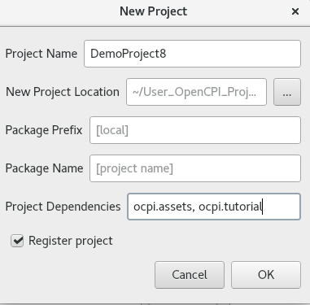
- In the New Project dialog, enter the Project Name and Project Dependencies.
- Check Register project.
- Leave all of the other fields as they are and click OK.
- You should now see DemoProject8 displayed in the OpenCPI Project Explorer view.
To create the DemoProject8 project with ocpidev, use the command:
ocpidev -D ocpi.assets -D ocpi.tutorial create project DemoProject8 --register
We need to make the same modifications to the Project.xml file as we did in Tutorial 4 as well as make some new ones as described below for Tutorial 8. Open the Project.xml file with a text editor and add the following two lines after the ProjectDependencies attribute:
HdlLibraries='prims'
ComponentLibraries='util_comps'
and then save and close the file.

Create Component Library
We can use the top-level components directory as our library like we did in Tutorial 4.
To create the components library with the OpenCPI GUI:
- From the GUI menu bar at the top of the window, select Create > Component Library...
- In Associated Project, select DemoProject8 . Click OK to create the component library
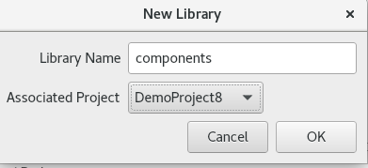
- The components library is displayed in the Project Explorer view.
Again, notice that the GUI executes ocpidev commands to carry out its operations and that they are visible in the Console tab window on the right. You can follow along and familiarize yourself with the ocpidev commands by checking the console window after you perform an operation.
To create the components library with ocpidev, run the following command in the DemoProject8 directory:
ocpidev create library components

Create Component
Like we did in Tutorial 4, we need to create the OCS (OpenCPI Component Specification) for our complex mixer function that defines its properties and ports.

Create Component Spec
As we did for the new peak_detector component, we’ll create the complex mixer component spec in the components library.
To create the complex mixer component spec with the OpenCPI GUI:
- From the GUI menu bar at the top of the window, select Create > Component Spec…
- The New Component dialog appears. In Component Name, enter complex_mixer. Leave Associated Library set to None.
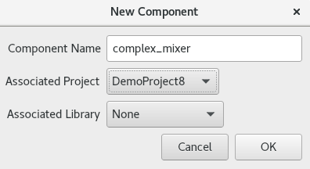
- Click OK. When the operation completes, you should see a specs subdirectory in the components directory displayed in the Project Explorer view.
To create the component spec with ocpidev, run the following command from the DemoProject8/components directory:
ocpidev create component complex_mixer
The command creates the component spec complex_mixer-spec.xml in components/specs. We’ll add properties and ports to the component spec in the next step.

Add Properties and Ports
The complex_mixer component function needs to define two properties:
- The phs_inc (“phase increment”) property, which stores the results of the computation (that is, setting the tune frequency for the input signal using the output of the internal NCO). This property is valid for both RCC and HDL component implementations.
- The enable property, which controls whether a worker implementation performs the computation on the incoming data or simply passes the incoming data through without any processing (“bypass” mode). This property is valid for both RCC and HDL component implementations.
We want to set default values for the phs_inc and enable properties in the component spec and allow the worker implementation to override these values. We’ll use the default attribute in our property definitions to specify the default values and use the writeable attribute to indicate that the worker can override them. You can read more about how the framework interprets these attributes in the OpenCPI Component Development Guide.
The complex_mixer component has the same simple port configuration as the peak_detector component and uses the same OPS. It requires one input port and one output port for communication with other components in an application and both ports will use the iqstream protocol.
To define the properties and ports using OpenCPI GUI:
- Edit the component specification XML by right clicking the XML file under the specs directory in the Project Explorer view and clicking Edit File. This action opens the XML document using your default file editor.
To add properties and ports from the command line, open the spec with a text editor and add the following XML code (highlighted in red) between the ComponentSpec elements:
<ComponentSpec>
<Property Name="enable" Type="bool" Writable="true"
Default="true"/>
<Property Name="phs_inc" Type="short" Writable="true"
Default="-8192"/>
<Port Name="in" Protocol="iqstream_protocol"/>
<Port Name="out" Protocol="iqstream_protocol"
Producer="true"/>
</ComponentSpec>

Create Worker
To create the worker using the OpenCPI GUI:
- Create > Worker...
Worker Name: complex_mixer
Associated Project: <Tutorial Project Name>
Model: HDL
Language: VHDL
Associated Library: components
Component: complex_mixer (ocpi.tutorial)
- Click OK.
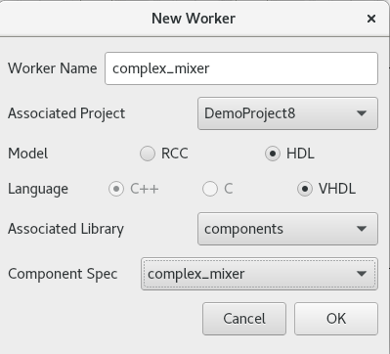
- This is generally what it should look like in the GUI.
- Use the Project Explorer to examine the auto-generated directories and files:
components/{worker}.hdl/ - Worker directory with Author Model suffix (.hdl)
components/{worker}.hdl/{worker}.xml - OWD XML file
components/{worker}.hdl/{worker}.vhd - VHDL (architecture) skeleton file
components/{worker}.hdl/gen/ - OCPI worker build artifacts ({worker}-impl.vhd contains the entity)
To create the worker using the ocpidev command:
ocpidev create worker complex_mixe.hdl -S complex_mixer

Edit Worker OWD
Now we’ll add the worker properties to the skeleton worker OWD.

Add data_select Property
First, reference the “Worker Properties” table in the complex mixer component data sheet. The worker has the data_select property, which selects the data to output in bypass mode (input or NCO). The default value for this property is 0 (false).
Ensure that all attributes and default values are set for each property/parameter according to the component's data sheet.
Command Line:
Open up complex_mixer.xml with preferred editor and add the properties and parameters according to the data sheet.
In the OpenCPI GUI, you want to right click complex_mixer.xml and click Edit File.
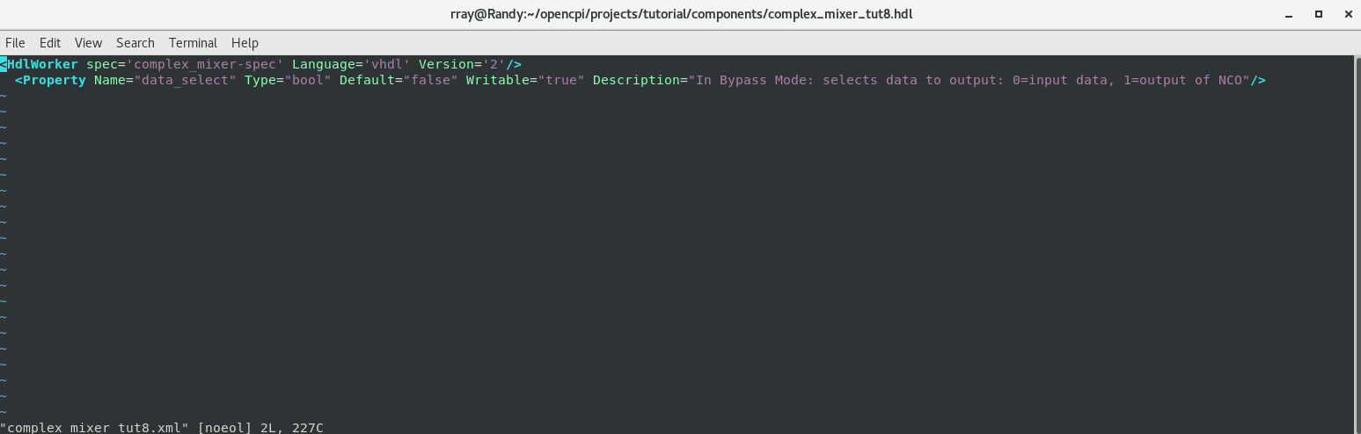
Once the editor window opens, you can add what is needed. It should look like this (This screenshot shows using vim to edit. Depending on the default editor, the screen may look different).

Convert Data Port Interface for Parallel Transmission
By default, the iqstream_protocol is interleaved 16-bit I/Q sample data. We need to convert the data port interface from interleaved to parallel.
Command Line:
Open up complex_mixer.xml with preferred editor and add the port configurations by examining the “Worker Interfaces” table in the data sheet.
Determine the port configuration settings by examining the "Worker Interfaces" table in the component data sheet.
Using the OpenCPI GUI:
- Right click complex_mixer.xml and click Edit File.
- Once the editor window opens, you can add what is needed. It should look like this (This screenshot shows using vim to edit. Depending on default editor, the screen may look different).
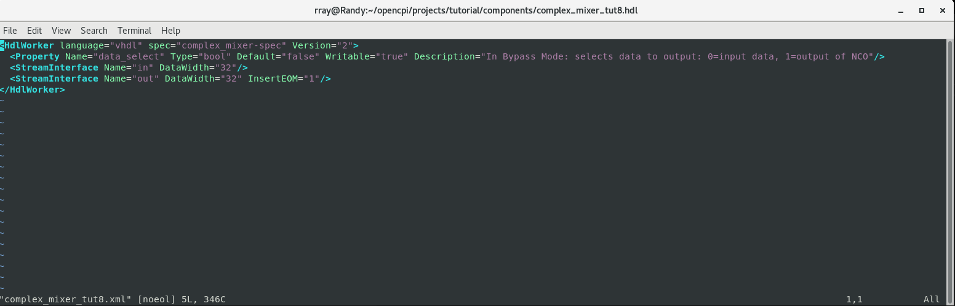
Expanding the data interface to 32 bit allows 16-bit I and 16-bit Q data to be transmitted simultaneously; that is, in parallel.

Build Worker
Now build the worker with the changes from the OWD.
To build the code using the OpenCPI GUI:
- In the GUI, check the checkbox for HDL.
- Scroll down to xsim in the HDL Panel and click on xsim.
- Right click the newly created worker.
- Click "Build".
- Review the Console window messages to ensure this step is error free and check the job manager and look for the green color that signals success.
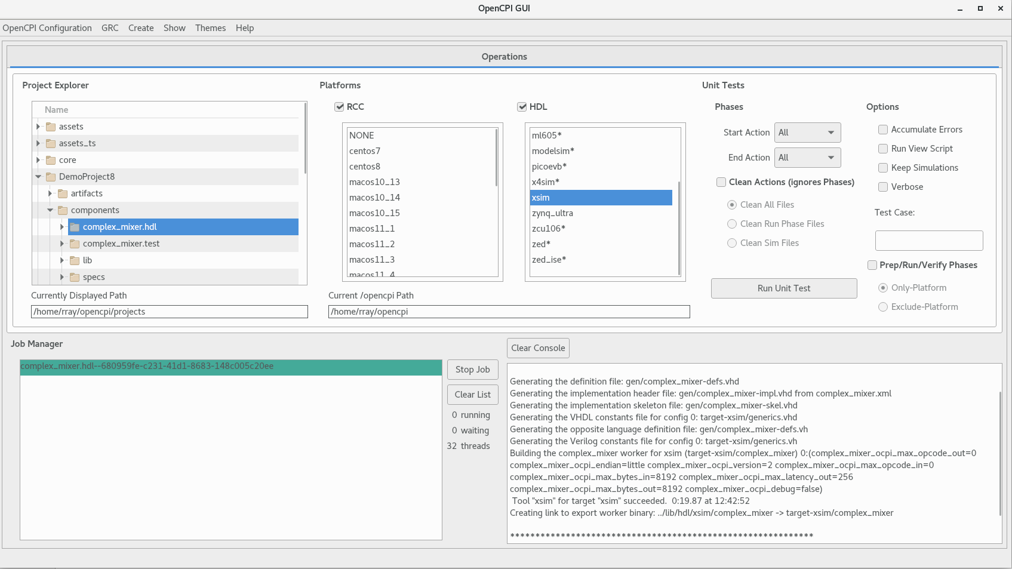
Using the ocpidev command:
ocpidev --hdl-platform xsim build worker complex_mixer.hdl

Copy Third-Party Cores to Worker
First, copy the provided third-party HDL primitive core directory vivado_ip into the complex_mixer.hdl directory:
cd ~/<opencpi-installation-dir>/projects/DemoProject8/components/complex_mixer.hdl/
cp -r ~/<opencpi-installation-dir>/projects/tutorial/components/complex_mixer.hdl/vivado_ip/ .

Copy/Edit VHDL Source Code
The skeleton {worker}-skel.vhd file is an empty architecture. The entity is generated VHDL based on the OCS and OWD and is located in the gen/{worker}-impl.vhd.
To modify the worker source code:
- Replace the skeleton .vhd file with the .vhd provided for this tutorial. It contains descriptions of how the VHDL source code is designed:
cd ~/<project-location>/components/complex_mixer.hdl
cp ~/<opencpi-installation-dir>/projects/tutorial/components/complex_mixer.hdl/complex_mixer.vhd .
cp
~/<opencpi-installation-dir>/projects/tutorial/components/complex_mixer.hdl/Makefile .
- This tutorial also needs this makefile to be run correctly
- Now look at the VHDL source code. Starting at the top, look at the source code following the commented instructions (look for “TODO”). These lines are focused on the ports and properties added in this tutorial. Read the comments so you have an idea of how and why tese things were done.

Build Worker
Now build the HDL worker only for XSIM targets.
To build the code using the OpenCPI GUI:
- In the GUI, check the checkbox for HDL.
- Scroll down to xsim in the HDL Panel and click on xsim.
- Right click the newly created worker.
- Click "Build".
- Review the Console window messages to ensure this step is error free and check the job manager and look for the green color that signals success.
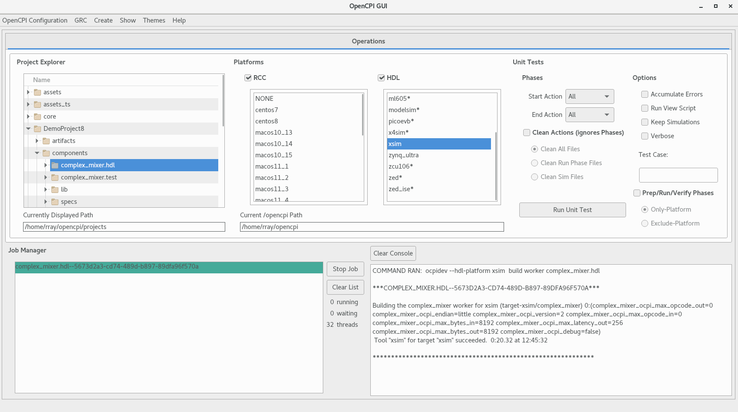
To build the code with ocpidev:
ocpidev --hdl-platform xsim build worker complex_mixer.hdl

Review Build Log and Artifacts
The end of build log should look like the following example, if free of errors:
COMMAND RAN: ocpidev –hdl-platform xsim build worker complex_mixer.hdl

***COMPLEX_MIXER.HDL--27503D3E-015A-4975-BA54-071D9FEEBD8D***

Building the complex_mixer worker for xsim (target-xsim/complex_mixer) 0: (complex_mixer_ocpi_max_opcode_out=0
complex_mixer_ocpi_endian=little complex_mixer_ocpi_version=2 complex_mixer_ocpi_max_bytes_in=8192 complex_mixer_ocpi_max_latency_out=256 complex_mixer_ocpi_max_bytes_out=8192 complex_mixer_ocpi_max_opcode_in=0 complex_mixer_ocpi_debug=false)
Tool "xsim" for target "xsim" succeeded. 0:05.24 at 11:40:16
Observe the new artifacts directory {worker}.hdl/: "target-xsim/". This directory contains output files from their respective FPGA vendor tools (in this case, simply Xilinx Vivado) in addition to a framework auto-generated file named generics.vhd that contains parameter configuration settings of the HDL worker for the particular "target-". Also the second line with the random letters and numbers is just the thread represented by the GUI so it will be different every time you run the worker.

Unit Test – Simulation
In this section, we demonstrate how to use the framework's unit test suite to generate:
- OpenCPI Application Specification (OAS) XML file(s) - Used by the framework for running the executable on a simulation platform; in this case, the target simulation platform is Xilinx XSIM Simulation Server.
- OpenCPI HDL Assembly Description (OHAD) XML file(s) - Used by the framework to build an executable for the target simulation platform; in this case, the target simulation platform is Xilinx XSIM (xsim).
- Input test data file(s) based on user-provided scripts.
- Various scripts to manage the execution of the applications onto the target platform(s).

Create Unit Test
We will re-use the unit test from the"work-alike" third-party LiquidDSP RCC worker we created in Tutorial 4. To recreate this test go to tutorial 4 and run steps 6-6.2. The description file is located in the "complex_mixer.test/" directory and is named complex_mixer-test.xml. Here is the current content:
<Tests UseHDLFileIo='true'>
<Input Port='in' Script='generate.py 100 12.5 32767 16384'></Input>
<Output Port='out' Script='verify.py 100 16384' View='view.sh'></Output>
<Property Name='phs_inc' Values='8192'></Property>
<Property Name='enable' Values='0,1'></Property>
</Tests>
Now we’ll change this XML to add the OWD property. Edit the unit test description file complex_mixer-test.xml to include the HDL worker-specific property (OWD) highlighted in red as shown below:
<Tests UseHDLFileIo='true'>
<Input Port='in' Script='generate.py 100 12.5 32767 16384'></Input>
<Output Port='out' Script='verify.py 100 16384' View='view.sh'></Output>
<Property Name='phs_inc' Values='8192'></Property>
<Property Name='enable' Values='0,1'></Property></Property>
<Property Name=”data_select” Values=”0,1”/></Property>
</Tests>
When "bypass" is enabled, "data_select" routes either the input data or NCO output to the output data port.
Also, for this unit test to run correctly, you need to copy this makefile to DemoProject8, so do the following:
cd
~/<project-location>/components/complex_mixer.test
cp
~/<opencpi-installation-dir>/projects/tutorial/components/complex_mixer.test/Makefile .

Build Unit Test and its Artifacts
Now we’ll build the unit test and examine the generated artifacts.

Build Unit Test
First, build the unit test suite for target simulation platform.
Using the OpenCPI GUI:
- Highlight complex_mixer.test in the project explorer
- Highlight "xsim" in the HDL Platforms panel
- In the drop-down for start action put Generate.
- In the drop-down for End Action put Build.
- Click Run Unit Test.
- Review the console window messages and address any errors.
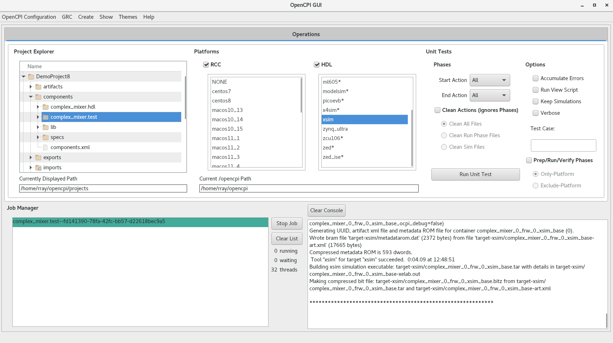
Using the ocpidev command:
ocpidev run --hdl-platform xsim --mode gen_build test complex_mixer.test

Review OCS Artifacts
Next, observe the new artifacts in {OCS}.test/gen/:
- cases.txt – "human-readable" file that lists various test configurations.
- cases.xml – used by the framework to execute tests.
- cases.xml.deps – list of dependent files.
- applications/ - OAS files and scripts used by the framework to execute applications.
- assemblies/ - used by the framework to build bitstreams.

Review Build Artifacts
Finally, observe the new artifacts in complex_mixer.test/gen/assemblies/complex_mixer_0_frw/:
- complex_mixer_0_frw.xml – generated assembly XML (OHAD).
- gen/ - artifacts generated/used by the framework.
- lib/ - artifacts generated/used by the framework.
- target-xsim/ - artifacts generated/used by the framework and FPGA tools.
- container-complex_mixer_0_frw_xsim_base/:
gen/ - artifacts generated/used by the framework
target_xsim/:
- artifacts generated/used by the framework and output files from FPGA tools
- execution file for execution onto a simulation platform

Run Unit Test (Xilinx XSIM)
In this step, we’ll run the unit test suite for the target simulation platform.
To run the unit test using the OCPI GUI:
- Currently you can only do 2 modes in the Gui at the same time.
- Highlight complex_mixer.test in the project explorer
- Highlight "xsim" in the HDL Platforms panel.
- Check "keep simulations".
- In Start Action drop down select All and in the End Action drop down select All.
- Click Run Unit Test.
- Review the console window messages and address any errors.
- Once that has been done then switch Start Action to verify and End action to Verify and click Run Unit test again
- Review the console window messages and address any errors
- This screenshot was taken while it was running
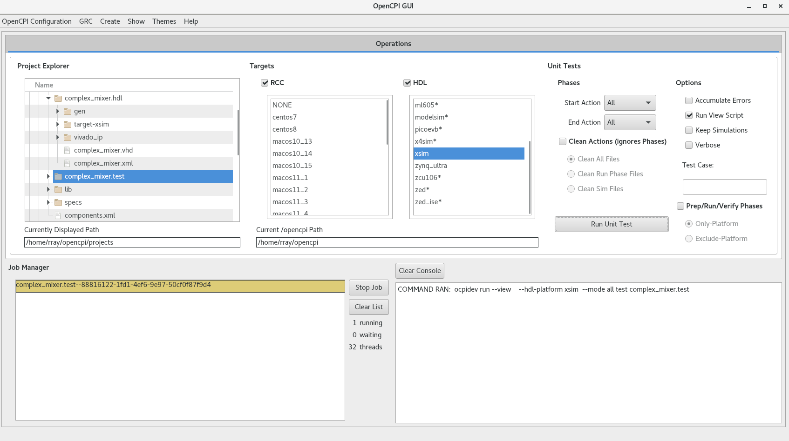
To run the unit test using the ocpidev command, execute the following command within the {component}.test/ directory:
$ ocpidev run --mode prep_run_verify --only-platform xsim --keep-simulations –view

Examine I/O Test Plots (Xilinx XSIM)
Here are the I/O test plots:
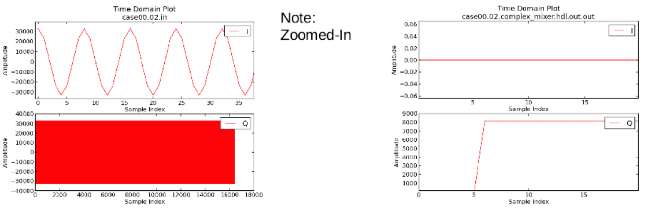
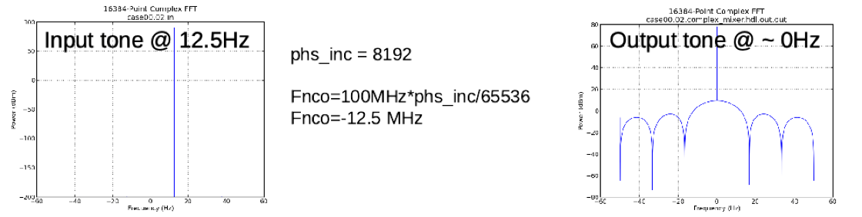

View Simulation Waveforms (Xilinx XSIM)
Note: In order to view simulation waveforms, you must have checked "keep simulations" in the OpenCPI GUI or have used the --keep-simulations option on the ocpidev command line when you ran the unit test.
To view the simulation waveforms:
- In a terminal window, browse to the complex_mixer.test/ directory.
- Execute the following ocpiview command:
$ ocpiview run/xsim/case00.00.complex_mixer.hdl.simulation/ &
You should see the following output:
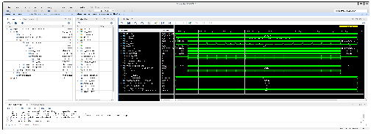

Tutorial Summary
In this tutorial, we created a complex_mixer component. Once you created that we showed you how to create a complex_mixer worker that uses the Vivado third-party cores. You were also able to build for the worker and successfully able to create a unit test for the worker you created. Overall, you were able to see the power of using third party cores for workers.

