OpenCPI
Tutorial 10: Introduction to OpenCPI Application Development
OpenCPI Release: v2.4.5

Revision History
Revision | Description of Change | Date
1.0 | Creation from Lab 1 developed by CNF | 2019-10-01
1.1 | Updated for Digital Radio Controller (DRC) | 2021-12-01
1.2 | Updates to GUI and CLI to reflect ocpidev changes | 2022-08-31
1.3 | Update language regarding CentOS7 to make it clear that there are other available platforms | 2023-01-20
1.4
1.5
1.6
1.7
1.8
1.9
2.0
2.1
Table of Contents
1 Overview 4
1.1 Tutorial Objectives 6
1.2 What’s Provided for This Tutorial 7
1.3 Prerequisites to Using This Tutorial 8
1.4 Documentation References 9
2 Create Project 10
3 Create OAS 12
4 Copy Reference FSK DRC Data Files 13
5 Edit OAS 14
6 Create and Build fsk_modem HDL Assembly 20
6.1 Create fsk_modem HDL Assembly Description 21
6.2 Update HDL Assembly Description 22
6.3 Copy Container XML and Constraints 26
6.4 Build HDL Assembly 27
7 Run FSK Application 28
8 Troubleshooting 30
9 Tutorial Summary 31

Overview
This tutorial focuses on OpenCPI application development and introduces you to more complex application scenarios and goals. Our example is the OpenCPI FSK DRC fsk_dig_radio_ctrlr reference application, which is a software-defined radio (SDR) demo application that uses the Frequency-Shift Keying (FSK) protocol to perform FSK modulation and demodulation and the OpenCPI Digital Radio Controller (DRC) utility to configure and use the radio frequency (RF) I/O hardware. We will re-create this reference application and run it on the ADALM-PLUTO (plutosdr) hardware platform.
The application's function is to transmit to and receive a JPEG image from a radio device using the FSK protocol and the DRC utility. The OpenCPI components mfsk_mapper, zero_pad, fir_real_sse, phase_to_amp_cordic, rp_cordic, baudTracking, and real_digitizer from the built-in ocpi.asset project's component libraries implement the FSK protocol, while the file_read and file_write utilities from the ocpi.core project handle the file I/O. The drc component from the ocpi.platform project performs the DRC function.
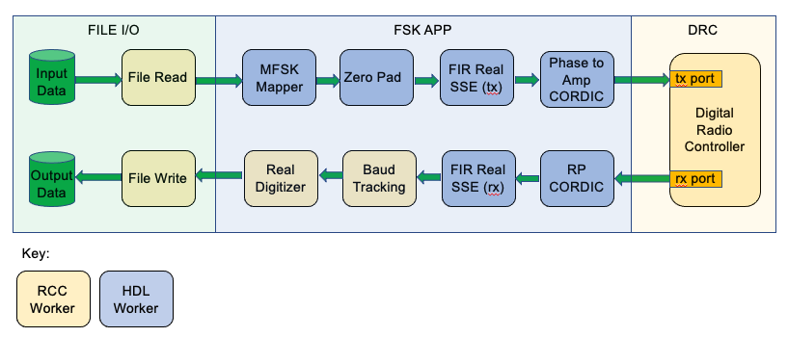
Figure 1: OpenCPI FSK DRC Reference Application
As shown in the figure:
- OpenCPI RCC and HDL application workers perform the FSK modulation and demodulation.
- OpenCPI RCC application workers handle the file I/O.
- A DRC RCC device proxy worker controls the RF I/O ports. See the section “Controlling Slave Workers from Proxies” in the OpenCPI RCC Development Guide for details on device proxy workers and how they function.
For details on the components used in the FSK DRC reference application, consult the component data sheets. Detailed information about the DRC utility can be found in the OpenCPI Application Development Guide in the section “Utility Components for Applications” and also in Briefing 14.

Tutorial Objectives
This tutorial demonstrates how to create an SDR application that uses FSK modulation and demodulation for data transmit/receive and the DRC utility for radio hardware configuration and control. It also demonstrates how to design an HDL assembly for execution on a target hardware platform.
The tutorial shows you how to:
- Create the SDR application using components that exist in OpenCPI built-in projects and input data and target platform-specific XML files from the OpenCPI fsk_dig_radio_ctrlr reference application.
- Create and build an HDL assembly to run on the ADALM-PLUTO radio device (the plutosdr HDL platform in OpenCPI).
- Deploy the application.
After running this tutorial, you should understand the general process of developing an SDR application from existing components and how to use the DRC utility to configure and control a radio.

What’s Provided for This Tutorial
This tutorial directs you to use OpenCPI assets and scripts from the built-in OpenCPI projects ocpi.core, ocpi.assets, and ocpi.platform. You will also use assets and data files from the PLUTO SDR OSP ocpi.osp.plutosdr.
Instructions for copying required XML files and data files from these projects into the “demo” project that you create as part of the tutorial exercises are provided in the relevant sections of this document. The XML source for these items is also available as text in the relevant sections of this document that you can copy and paste into the relevant files following the instructions given in the section.
Note: when copying and pasting text, be sure to remove any line breaks in copied code and commands.
Note that all of the OpenCPI built-in projects described in the OpenCPI User Guide including the projects referenced here are built for the CentOS7 (centos7) and ADALM-PLUTO (plutosdr) platforms as part of the OpenCPI installation process. You do not need to build, register or import these projects in order to use them in this tutorial. Development hosts other than CentOS7 can also be used. If you are using a development host other than CentOS7, replace centos7 with your development host’s name.
You will need to download and build the PLUTO SDR OSP ocpi.osp.plutosdr to use it in this tutorial. See the OpenCPI Installation Guide for instructions.

Prerequisites to Using This Tutorial
This tutorial (Tutorial 10) has the system prerequisites described in OpenCPI Tutorial 1: Component-based Development. See the prerequisites section in Tutorial 1 for details.
In addition to these requirements, this tutorial uses the plutosdr platform, and so the corresponding OSP should be downloaded and installed. See the section “Installation Steps for Platforms” in the OpenCPI Installation Guide.
Before you begin this tutorial, you should have successfully completed Tutorial 1 through Tutorial 9.
We recommend reading Briefing 14 An Introduction to the Digital Radio Controller (DRC) model and APIs, for Controlling and Configuring RF I/O in OpenCPI Systems that are “radios” (SDRs) before getting started with this tutorial.
For a guide on using the ocpiremote tool, see the video: OpenCPI - Framework Installation – Zedboard. It is timestamped and begins when ocpiremote is being set up and executed. Note: It will be necessary to disable the firewall for ocpiremote to function properly. For more information, see the section “Using Remote Containers from Client/Development Systems” in the OpenCPI Application Development Guide and the ocpiremote(1) man page.

Documentation References
The documents listed in the following table provide detailed information about subjects discussed in this tutorial. The documents listed here are not required reading for this tutorial but will likely be of interest for more in-depth learning.
Table 1 - OpenCPI Reference Documentation
Title | Published By | Public URL
OpenCPI Overview | OpenCPI | https://opencpi.gitlab.io/releases/v2.4.5/docs/Overview.pdf
OpenCPI User Guide | OpenCPI | https://opencpi.gitlab.io/releases/v2.4.5/docs/OpenCPI_User.pdf
OpenCPI Application Development Guide | OpenCPI | https://opencpi.gitlab.io/releases/v2.4.5/docs/OpenCPI_Application_Development.pdf
OpenCPI Component Development Guide | OpenCPI | https://opencpi.gitlab.io/releases/v2.4.5/docs/OpenCPI_Component_Development.pdf
OpenCPI HDL Development Guide | OpenCPI | https://opencpi.gitlab.io/releases/v2.4.5/docs/OpenCPI_HDL_Development.pdf
OpenCPI RCC Development Guide | OpenCPI | https://opencpi.gitlab.io/releases/v2.4.5/docs/OpenCPI_RCC_Development.pdf

Create Project
First, we need to create an OpenCPI project in which to develop our FSK DRC demo application. We'll call it DemoProject10.
To create the project using the OpenCPI GUI:
- Start the OpenCPI GUI.
- From the top menu bar, select Create > Project…
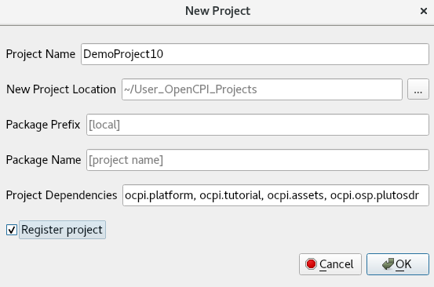
- In the New Project dialog, enter DemoProject10 in Project Name.
- In Project Dependencies, enter ocpi.platform ocpi.tutorial ocpi.assets ocpi.osp.plutosdr.
- Check Register project box.
- Leave all of the other fields blank and click OK.
You should now see DemoProject10 displayed in the OpenCPI Project Explorer panel. Subsequent sections of this tutorial show both ways to perform the steps described in the section: with the GUI and with the CLI. You can use either method; using both methods is redundant.
To create a new project from the command line, use the following ocpidev command:
ocpidev -D ocpi.platform -D ocpi.tutorial -D ocpi.osp.plutosdr -D ocpi.assets create project DemoProject10 --register
In the Project.xml file, add the following line after the ProjectDependencies attribute:
ComponentLibraries='components comms_comps dsp_comps misc_comps util_comps'

Create OAS
We need to create an OAS (aka “app XML”) for our fsk_drc_demo application. We’ll use the same technique to create it that we used in Tutorial 2: we’ll create an empty OAS in the applications/ directory and then edit this XML file to add our definitions.
We’ll call our application fsk_drc_demo.
To create the OAS using the OpenCPI GUI:
- From the top menu bar, select Create > Application.
- In Application Name, enter fsk_drc_demo.xml.
- Using the Associated Project drop-down list, select DemoProject10.
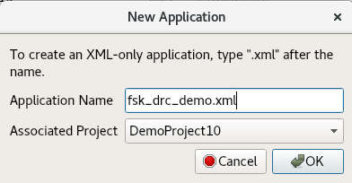
- Click OK. Check the output console panel on the bottom right to view the ocpidev command that the GUI executes to create the example application. As you work through the tutorial, you can follow along and familiarize yourself with the ocpidev commands by checking the console window after you perform an operation using the GUI.
- When the operation completes, you’ll see the new application fsk_drc_demo displayed in the OpenCPI Project Explorer panel.
To create the OAS with ocpidev, run the following command from the DemoProject10/ directory:
ocpidev -X create application fsk_drc_demo
The -X option to ocpidev directs the tool to create the empty OAS in the applications directory.

Copy Reference FSK DRC Data Files
Our fsk_drc_demo.xml application needs the following data files in order to run:
- opencpi.jpeg – the input data file that will be transmitted through the Tx port and ultimately received on the Rx port.
- rx_rrcos_taps.dat – Filter coefficients that define the response of the receive FIR Filter component named rx_fir_real.
- tx_rrcos_taps.dat – Filter coefficients that define the response of the transmit FIR Filter component named tx_fir_real.
These data files are part of the fsk_drc_dig_radio_crtlr reference application in the PLUTO SDR OSP you downloaded and installed as a prerequisite to this tutorial, in the location:
<path-to-plutosdr-osp>/applications/fsk_drc_dig_radio_crtlr/
We'll simply copy these files into our DemoProject10: run the following command from the DemoProject10/applications/ directory:
cp -rf <path-to-plutosdr-osp>/applications/fsk_dig_radio_ctrlr/{opencpi.jpeg,rx_rrcos_taps.dat,tx_rrcos_taps.dat} .

Edit OAS
Now we’ll edit our fsk_drc_demo.xml OAS with the necessary XML definitions.
First, we need to add the following component instances:
- One instance of file_read. The component spec file file_read_spec.xml resides in the ocpi.core project in the specs/ directory of the components library.
- One instance of the mfsk_mapper component. The component spec file mfsk_mapper-spec.xml resides in the ocpi.assets project in the specs/ directory of the components/comms_comps library.
- One instance of the zero_pad component. The component spec file zero_pad-spec.xml resides in the ocpi.assets project in the specs/ directory of the components/util_comps library.
- Two instances of the fir_real_sse component: one to filter on the transmit side which we’ll name tx_fir_real, and one to filter on the receive side named rx_fir_real. The component spec file fir_real_sse-spec.xml resides in the ocpi.assets project in the specs/ directory of the components/dsp_comps library.
- One instance of the phase_to_amp_cordic component. The component spec phase_to_amp_cordic-spec.xml resides in the ocpi.assets project in the specs/ directory of the components/dsp_comps library.
- One instance of the drc component. The component spec drc-spec.xml resides in the ocpi.platform project in the specs/ project.
- One instance of the rp_cordic component. The component spec rp_cordic-spec.xml resides in the ocpi.assets project in the specs/ directory of the components/dsp_comps library.
- One instance of the Baudtracking_simple component. The component spec baudTracking-spec.xml resides in the ocpi.assets project in the specs/ directory of the components/dsp_comps library.
- One instance of the real_digitizer component. The component spec real_digitizer-spec.xml resides in the ocpi.assets project in the specs/ directory of the components/dsp_comps library.
- One instance of the file_write component, to receive the output data from the real_digitizer. The component spec file_write_spec.xml resides in the ocpi.core project in the specs/ directory of the components library.
Next, we need to specify the component properties:
- For the file_read instance, we need to set values for four properties: the fileName property, which we’ll set to our input file opencpi.jpeg, the messagesInFile property, which we’ll set to false, the opcode property set to 1 and the granularity property also set to a value of 1 (the number of samples that will constitute a message).
- For the mfsk_mapper instance, we need to set the values of one property: the property symbols that we’ll set to the value -32768,32767. The symbols property controls the values that can appear on the output.
- For the zero_pad instance, we need to set the value of the num_zeros property to 38, which sets the number of zeroes between the output samples.
- For the tx_fir_real instance, we need to set the value of the taps property to tx_rrcos_taps.dat, which is our already generated file.
- For the phase_to_amp_cordic instance, we need to set values for four properties: magnitude should be set to 20000, DATA_WIDTH should be 16 (our input and output sizes) DATA_EXT to 6 (the number of extension bits) and stages set to 5 (the number of CORDIC stages implemented).
- For the drc instance, we need to specify a configurations property that defines a radio configuration with two channels: one for receive (rx=true) and one for transmit (rx=false). We also need to specify the start property so that this radio configuration is activated when the application starts. For more information on DRC component concepts and properties, see the section “DRC Properties” in the OpenCPI Application Development Guide.
- For the rp_cordic instance, we need to set three values which are similar to the phase_to_amp_cordic instance: DATA_WIDTH should be 16, DATA_EXT should be set to 6 and stages set to 5.
- For the rx_fir_real instance, we’ll set the Model to HDL and the taps property to rx_rrcos_taps.dat, which is our already generated file.
- For the baudTracking instance, we need to set three properties: bypass should be set to false (true passes the input to the output without processing), the SPB ( samples per baud) property should be 39, and the BaudAvrCount should be set to 10 (this is our number of bauds used to determine drift).
- For the real_digitizer instance, we need to set the value of the need_sync property to true (to find the baud synchronizing pattern; in this case, 0xFACE), and the enable_printing property to true (when the pattern is found, print the data).
- For the file_write instance, we need to set the fileName property to the data output file fsk_drc_demo_out.bin and messagesInFile to false.
We also need to specify 11 connections. We’ll use the shorthand Connect= in the instance element for all of the connections except for the ports we need to rename. For these, we’ll use the full Port Instance= definition in the Connection element.
Unlike what we did for Tutorial 1 and 2, we won’t specify a done attribute for this application. Instead, when the command is run, we’ll specify a duration for which the application should run.
To update the empty OAS, open DemoProject10/applications/fsk_drc_demo.xml with a text editor.
Now replace the contents with the following XML:
<Application>
<!--========================================================================-→
<!-- FSK modulation/TX algorithm components sending data to the DRC tx port -->
<Instance Component="ocpi.core.file_read" Connect="mfsk_mapper">
<Property Name="fileName" Value="opencpi.jpeg"/>
<Property Name="messagesInFile" Value="false"/>
<Property Name="opcode" Value="1"/>
<Property Name="granularity" Value="1"/>
</Instance>
<Instance Component="ocpi.assets.comms_comps.mfsk_mapper" Connect="zero_pad">
<Property Name="symbols" Value="-32768,32767"/>
</Instance>
<Instance Component="ocpi.assets.util_comps.zero_pad" Connect="tx_fir_real">
<Property Name="num_zeros" Value="38"/>
</Instance>
<Instance Component="ocpi.assets.dsp_comps.fir_real_sse" Name="tx_fir_real"
Connect="phase_to_amp_cordic">
<Property Name="taps" ValueFile="tx_rrcos_taps.dat"/>
</Instance>
<Instance Component="ocpi.assets.dsp_comps.phase_to_amp_cordic" Connect="drc" from='out' to='tx'>
<Property Name="magnitude" Value="20000"/>
<Property Name="DATA_WIDTH" Value="16"/>
<Property Name="DATA_EXT" Value="6"/>
<Property Name="STAGES" Value="5"/>
</Instance>
<!--==========================================================================-->
<!-- FSK demodulation/RX algorithm components with input from the DRC RX port -->
<Connection>
<Port Instance="drc" Name="rx"/>
<Port Instance="rp_cordic" Name="in"/>
</Connection>
<Instance Component="ocpi.assets.dsp_comps.rp_cordic" Model="hdl"
Connect="rx_fir_real">
<Property Name="DATA_WIDTH" Value="16"/>
<Property Name="DATA_EXT" Value="6"/>
<Property Name="STAGES" Value="5"/>
</Instance>
<Instance Component="ocpi.assets.dsp_comps.fir_real_sse" Name="rx_fir_real"
Model="hdl" Connect="baudTracking">
<Property Name="taps" ValueFile="rx_rrcos_taps.dat"/>
</Instance>
<Instance Component="ocpi.assets.dsp_comps.baudTracking" Connect="real_digitizer">
<Property Name="bypass" Value="false"/>
<Property Name="SPB" Value="39"/> <!-- samples/baud -->
<Property Name="BaudAvrCount" Value="10"/>
</Instance>
<Instance Component="ocpi.assets.dsp_comps.real_digitizer" Connect="file_write">
<!-- look for 0xFACE sync pattern -->
<Property Name="need_sync" Value="true"/>
<!-- prints out when 0xFACE sync pattern is found →
<Property Name="enable_printing" Value="true"/>
</Instance>
<Instance Component="ocpi.core.file_write">
<!-- ACI relies on this property being set here in the OAS -->
<Property Name="fileName" Value="fsk_drc_demo_out.bin"/>
<Property Name="messagesInFile" Value="false"/>
</Instance>
<!--==========================================================================-->
<!-- The DRC component, specifying channel configurations -->
<Instance Component="ocpi.platform.drc">
<property name='configurations'
Value="{description first,
channels {{rx true,
tuning_freq_MHz 2450,
bandwidth_3dB_MHz 0.24,
sampling_rate_Msps 0.25,
samples_are_complex true,
gain_mode auto,
tolerance_tuning_freq_MHz 0.01,
tolerance_sampling_rate_Msps 0.01,
tolerance_gain_dB 1},
{rx false,
tuning_freq_MHz 2450,
bandwidth_3dB_MHz 0.24,
sampling_rate_Msps 0.25,
samples_are_complex true,
gain_mode manual,gain_dB -30,
tolerance_bandwidth_3dB_MHz 0,
tolerance_tuning_freq_MHz 0.01,
tolerance_sampling_rate_Msps 0.01,
tolerance_gain_dB 1}}}"/>
<property name='start' value='0'/>
</Instance>
</Application>

Create and Build fsk_modem HDL Assembly
To run our application, we’ll need an HDL assembly. Here we’ll include all the HDL workers that we’ll need for our application. For this tutorial, we will only be making the one assembly unlike in Tutorial 2.

Create fsk_modem HDL Assembly Description
We’ll name this HDL assembly fsk_modem. Note the use of all lowercase characters in the assembly name. Assembly names must not use uppercase characters because some FPGA tools cannot handle them.
To create the HDL assembly with the OpenCPI GUI:
- From the top menu bar, select Create > HDL > Assembly...
- In Assembly Name, enter fsk_modem.
- Using the Associated Project drop-down list, select DemoProject10.
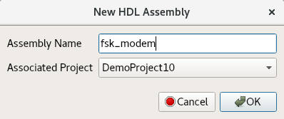
- Click OK.
- When the operation completes, the new assembly is displayed in the OpenCPI Project Explorer panel.
To create the HDL assembly with ocpidev, run the following command from the DemoProject10/ directory:
ocpidev create hdl assembly fsk_modem

Update HDL Assembly Description
Now we need to update the HDL assembly description (OpenCPI HDL Assembly Description, or OHAD) to define the HDL workers to be used, the connections between them, and the connections to the rest of the application.
To update the HDL assembly OHAD with the OpenCPI GUI:
- Locate the fsk_modem.xml OHAD using the Project Explorer panel, right-click it and then select Edit File.
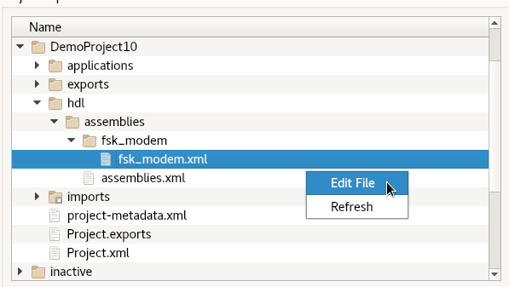
- Update the file as described below and then save and close it.
To update the HDL assembly OHAD from the command line, navigate to the fsk_modem directory and then open fsk_modem.xml with a text editor.
Now insert the following XML (highlighted in red) between the HdlAssembly tags:
<HdlAssembly>
<!-- TX Chain Connections -->
<Instance Worker="mfsk_mapper">
<Property Name="M_p" Value="2"/>
</Instance>
<Instance Worker="zero_pad">
<Property Name="DWIDTH_p" Value="16"/>
</Instance>
<Instance Worker="fir_real_sse_for_xilinx" Name="tx_fir_real">
<Property Name="DATA_WIDTH_p" Value="16"/>
<Property Name="COEFF_WIDTH_p" Value="16"/>
<Property Name="NUM_TAPS_p" Value="64"/>
</Instance>
<Instance Worker="phase_to_amp_cordic">
<Property Name="DATA_WIDTH" Value="16"/>
<Property Name="DATA_EXT" Value="6"/>
<Property Name="STAGES" Value="5"/>
</Instance>
<Instance Worker="cic_int">
<Property Name="N" Value="3"/>
<Property Name="M" Value="1"/>
<Property Name="R" Value="16"/>
<Property Name="ACC_WIDTH" Value="28"/>
</Instance>
<Instance Worker="iqstream_to_cswm"/>
<Connection Name="in_to_asm_tx_path" External="consumer">
<Port Instance="mfsk_mapper" Name="in"/>
</Connection>
<Connection>
<Port Instance="mfsk_mapper" Name="out"/>
<Port Instance="zero_pad" Name="in"/>
</Connection>
<Connection>
<Port Instance="zero_pad" Name="out"/>
<Port Instance="tx_fir_real" Name="in"/>
</Connection>
<Connection>
<Port Instance="tx_fir_real" Name="out"/>
<Port Instance="phase_to_amp_cordic" Name="in"/>
</Connection>
<Connection>
<Port Instance="phase_to_amp_cordic" Name="out"/>
<Port Instance="cic_int" Name="in"/>
</Connection>
<Connection>
<Port Instance="cic_int" Name="out"/>
<Port Instance="iqstream_to_cswm" Name="in"/>
</Connection>
<Connection Name="out_from_asm_tx_path_to_dac" External="producer">
<Port Instance="iqstream_to_cswm" Name="out"/>
</Connection>
<!-- RX Chain Connections -->
<Instance Worker="cswm_to_iqstream"/>
<!-- OpenCPI issue #1318 - AD9363 contains AGC,dc offset, iq correction -->
<Instance Worker="dc_offset_filter">
<Property Name="PEAK_MONITOR_p" Value="true"/>
</Instance>
<Instance Worker="iq_imbalance_fixer">
<Property Name="PEAK_MONITOR_p" Value="true"/>
</Instance>
<Instance Worker="complex_mixer">
<Property Name="NCO_DATA_WIDTH_p" Value="12"/>
<Property Name="INPUT_DATA_WIDTH_p" Value="12"/>
<Property Name="PEAK_MONITOR_p" Value="true"/>
<Property Name="CORDIC_STAGES_p" Value="12"/>
</Instance>
<Instance Worker="cic_dec">
<Property Name="N" Value="3"/>
<Property Name="M" Value="1"/>
<Property Name="R" Value="16"/>
<Property Name="ACC_WIDTH" Value="28"/>
</Instance>
<Instance Worker="rp_cordic">
<Property Name="DATA_WIDTH" Value="16"/>
<Property Name="DATA_EXT" Value="6"/>
<Property Name="STAGES" Value="5"/>
</Instance>
<Instance Worker="fir_real_sse_for_xilinx" Name="rx_fir_real">
<Property Name="DATA_WIDTH_p" Value="16"/>
<Property Name="COEFF_WIDTH_p" Value="16"/>
<Property Name="NUM_TAPS_p" Value="64"/>
</Instance>
<Connection Name="in_to_asm_rx_path_from_adc" External="consumer">
<Port Instance="cswm_to_iqstream" Name="in"/>
</Connection>
<Connection>
<Port Instance="cswm_to_iqstream" Name="out"/>
<Port Instance="complex_mixer" Name="in"/>
</Connection>
<Connection>
<Port Instance="complex_mixer" Name="out"/>
<Port Instance="cic_dec" Name="in"/>
</Connection>
<Connection>
<Port Instance="cic_dec" Name="out"/>
<Port Instance="rp_cordic" Name="in"/>
</Connection>
<Connection>
<Port Instance="rp_cordic" Name="out"/>
<Port Instance="rx_fir_real" Name="in"/>
</Connection>
<Connection Name="out_from_asm_rx_path" External="producer">
<Port Instance="rx_fir_real" Name="out"/>
</Connection>
</HdlAssembly>
Note: For reference, essentially the same OHAD exists in the ocpi.plutosdr project at hdl/assemblies/fsk_modem/fsk_modem.xml.
You’ll notice here that some of these instances were not shown in our application OAS. This is because the DRC is able to infer that some of these instances will be necessary when the application is run and will automatically pull them in. Taking a look at the XML for the DRC, located at ocpi.osp.plutosdr/hdl/devices/drc_plutosdr.rcc, we can see which components the DRC will instantiate.

Copy Container XML and Constraints
Our HDL assembly needs an HDL container XML file to connect its multiple interconnects. You can read more about container XML files in the section “HDL Container XML Files” in the OpenCPI HDL Development Guide. We also need to reference an FPGA constraints file for our target platform and use a Makefile that contains some special instructions.
All of these items exist as reference files in the PLUTO SDR OSP you downloaded and installed according to the pre-requisites for this tutorial. We'll simply copy these files from the PLUTO SDR OSP into our DemoProject10 so we can use them. Navigate to DemoProject10/hdl/assemblies/fsk_modem and then copy the files with this command:
cp -L <path-to-plutosdr-osp>/hdl/assemblies/fsk_modem/{cnt.xml,plutosdr_data_src_qadc_ad9361_sub_data_sink_qdac_ad9361_sub_mode_2_cmos.xdc,Makefile} .

Build HDL Assembly
Now we need to build the HDL assembly for the RCC and HDL platforms to create the FPGA artifact for the application.
To build the HDL assembly with the OpenCPI GUI:
- In the Platforms panel, make sure RCC is not checked, check HDL and select the plutosdr HDL platform.
- In the Project Explorer panel, expand the assemblies subdirectory in DemoProject10 and then select fsk_modem.
- Right-click fsk_modem and then select Build.
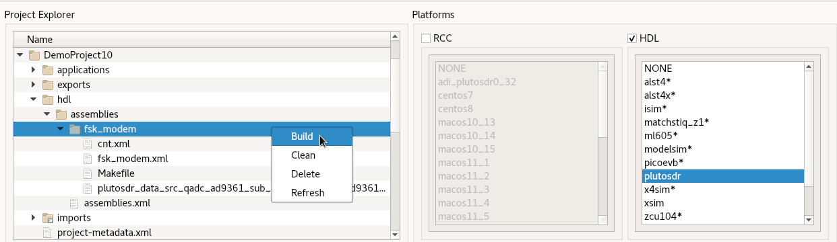
The build process takes a few minutes to run. If it’s successful, you’ll see a message in the Job Manager panel with what you’ve built.
To build the HDL assembly with ocpidev, run the following command from the DemoProject10/hdl/assemblies/fsk_modem/ directory:
ocpidev build --hdl-platform plutosdr
The build takes a couple of minutes to run. You can confirm that it succeeded by locating the *.bitz file in the artifacts/ subdirectory of DemoProject10. This file is the artifact file to be used when the application runs on the HDL platform.

Run FSK Application
First we’ll check that the ADALM-PLUTO device is connected. Details of how to set up and configure the deployment platform are beyond the scope of this tutorial. See the prerequisites section in this tutorial for more information.
To get the status of the deployment platform:
- export OCPI_SERVER_ADDRESSES=<Pluto_IP>:12345
- ocpiremote status -p analog
There should be output that reads something similar to:
Executing remote configuration command: status
Server is running with port: 12345 and pid: 26224
Now we can run the fsk_drc_demo application on the plutosdr platform with the ocpidev run utility.
Navigate to the DemoProject10/applications/ directory.
Execute ocpidev run to start the application:
ocpidev run application fsk_drc_demo -- -d -v -t 30 -wdrc=drc_plutosdr -P drc=centos7 -P file_write=centos7 -P file_read=centos7
In this command, we are telling ocpidev run to:
- Write property values to stderr before starting the application and after it is done (-d).
- Be verbose (-v).
- Run the application for 30 seconds; if the application does not finish in this amount of time, the command will exit with an error (-t 30).
- Choose the instance of the drc RCC worker that runs on the plutosdr platform (-wdrc=drc_plutosdr).
- Run the drc, file_write, and file_read RCC workers on the centos7 platform (-P).
- Run our fsk_drc_demo OAS XML.
Now run the following command from the same directory (DemoProject10/applications/):
eog fsk_drc_demo_out.bin
If you see the following image, the application ran successfully.


Troubleshooting
To view a detailed log while running on your hardware platform, use the command:
export OCPI_LOG_LEVEL=8
Double-check your spelling for typos inside the component properties.
Problems relating to library entries not found:
- .gz library files were missing from the assets/exports.
- dsp_comps library HDL assemblies were cleaned and rebuilt to resolve missing .gz libraries.

Tutorial Summary
Now that this tutorial has been completed, you should be more familiar with more complex applications and HDL assemblies and how to include the DRC utility in an application to control a radio. As always, the briefings and guides listed and linked to in this tutorial provide more information and finer details on the subjects discussed in this tutorial.

