OpenCPI
Tutorial 9: Debugging an HDL Worker on a Hardware Platform

Revision History
Revision | Description of Change | Date
1.0 | Creation from Lab 9 developed by BIA | 2019-10-01
1.1 | Initial updates for OpenCPI v2.4.0 release | 2022-01-03
1.2
1.3
1.4
1.5
1.6
1.7
1.8
1.9
2.0
2.1
Table of Contents
1 Overview 4
1.1 What’s Provided for This Tutorial 5
1.2 Prerequisites to Using This Tutorial 6
1.3 Documentation References 7
2 Build “tcounter” HDL Worker (Xilinx XSIM) 8
3 Build “tcounter” Unit Test (Xilinx XSIM) 9
4 Run “tcounter” Unit Test 10
5 Run “tcounter” Unit Test and Change Count 11
6 Run “tcounter” Unit Test with New Count 12
7 View Simulation Signals 13
8 Add Debug Functionality 14
9 Set up Unit Test for Different Worker Configurations 15
10 Build Worker HDL Assembly for the Hardware 16
11 Debug HDL Worker with ocpihdl 17
11.1 Run Unit Test (plutosdr) 18
11.2 Confirm Debug Mode 19
11.3 Collect Worker Assembly Information 21
11.4 Use ocpihdl to Debug HDL Worker 22
11.5 Found the Bug 24

Overview
This tutorial demonstrates how to debug OpenCPI applications, including how to:
- Observe property values with the ocpiview and ocpihdl tools
- Enable and disable debugging with the ocpi_debug built-in framework parameter
- Step through an application
- Manage the states/properties of workers with ocpihdl
In this tutorial, we will use a single "counter" HDL application worker tcounter.hdl. The purpose of this worker is to increment a counter vector until reaching a max value. We will discover that something is wrong with the worker.
The flow of application debugging demonstrated in this tutorial is as follows:
- Build the HDL worker for a simulator.
- Build the HDL assembly for a simulator.
- Test the HDL worker and view the results.
- Add debug functionality to the HDL worker.
- Rebuild the HDL worker for target device(s).
- Rebuild the HDL assembly for target platform(s).
- Debug the HDL worker using ocpihdl.

What’s Provided for This Tutorial
The following files and directories in the “projects/tutorial” directory under the OpenCPI root directory are used by this tutorial:
- tcounter.hdl/ - includes the counter HDL worker, in plain and debug versions.
- tcounter.test/ - includes the Unit Test Description XML for the "counter" component
- specs/tcounter-spec.xml – the component specification (OCS) for the “counter” component

Prerequisites to Using This Tutorial
This tutorial is designed to be run on a machine that has:
- The default OpenCPI source code installation (the latest OpenCPI source installed and built on CentOS 7)
- The default third-party FPGA simulator xsim installation (the Xilinx Vivado XSim simulator installed with the free, unlicensed variant, WebPack, of the Xilinx Vivado Design Suite HLx Edition tool set)
- Additional HDL platform support for the hardware device used in the later steps of this tutorial. The plutosdr platform is used as an example.
- (optional) The OpenCPI GUI development tool (optionally installed with OpenCPI as a GUI alternative to the OpenCPI command-line tools)
The OpenCPI Installation Guide describes how to install these items. This tutorial assumes that you have, at a minimum, this OpenCPI environment set up on your development host.
To be able to use the OpenCPI command line tools, you need to run the OpenCPI environment setup script opencpi-setup.sh on your development host. If you have not already done so, follow the procedure in the OpenCPI User Guide to run this script.

Documentation References
The documents listed in the following table provide detailed information about subjects discussed in this tutorial. The documents listed here are not required reading for this tutorial but will likely be of interest for more in-depth learning.
Table 1 - OpenCPI Reference Documentation
Title | Published By | Public URL
OpenCPI User Guide | OpenCPI | https://opencpi.gitlab.io/releases/latest/docs/OpenCPI_User.pdf
OpenCPI Application Development Guide | OpenCPI | https://opencpi.gitlab.io/releases/latest/docs/OpenCPI_Application_Development.pdf
OpenCPI Component Development Guide | OpenCPI | https://opencpi.gitlab.io/releases/latest/docs/OpenCPI_Component_Development.pdf
OpenCPI HDL Development Guide | OpenCPI | https://opencpi.gitlab.io/releases/latest/docs/OpenCPI_HDL_Development.pdf
OpenCPI RCC Development Guide | OpenCPI | https://opencpi.gitlab.io/releases/latest/docs/OpenCPI_RCC_Development.pdf

Build “tcounter” HDL Worker (Xilinx XSIM)
Note: this may already be done as a byproduct of installing the xsim platform.
To build the “tcounter” HDL worker using the OpenCPI GUI:
- In the “Project Explorer” panel, navigate to
tutorial->components->tcounter.hdl
- Expand the tcounter.hdl folder.
- If folders named target-xsim and target-1-xsim exist, skip to “Build tcounter Unit Test” on the next page. Otherwise...
- In the “Platforms” panel, uncheck the “RCC” box, check the “HDL” box, and select “xsim” as the HDL platform.
- In the “Project Explorer” panel, right-click on tcounter.hdl and select “Build”.
- Review the “Job Manager” and console windows to ensure the worker built successfully: if the job completed without error, the entry in the “Job Manager” window should have a green background.
- Optional: Note the “COMMAND RAN:” line in the console output window and compare with the ocpidev command in the paragraph below.
To build the HDL worker using the ocpidev command:
- cd $OCPI_ROOT_DIR/projects/tutorial
- ocpidev build worker tcounter.hdl --hdl-platform=xsim

Build “tcounter” Unit Test (Xilinx XSIM)
To build the “tcounter” unit test using the OpenCPI GUI:
- In the “Project Explorer” panel, select and expand the tcounter.test folder.
- Leave the “Platforms” panel settings as they were for “Build tcounter HDL Worker” on the previous page.
- In the “Project Explorer” panel, right-click on tcounter.test and select “Build”. The build job will take several seconds to complete: be patient.
- Review the “Job Manager” and console windows to ensure the unit test built successfully: if the job completed without error, the entry in the “Job Manager” window should have a green background. In the “Project Explorer” panel, there should now be a gen folder in the tcounter.test folder.
- Optional: Note the “COMMAND RAN:” line in the console output window and compare with the ocpidev command in the paragraph below.
To build the unit test using the ocpidev command:
- cd $OCPI_ROOT_DIR/projects/tutorial
- ocpidev build test tcounter.test --hdl-platform=xsim

Run “tcounter” Unit Test
First, run the unit test suite for the target simulation platform.
Using the OpenCPI GUI:
- Leave the “Platforms” panel settings as they were for “Build tcounter Unit Test” on the previous page.
- In the “Project Explorer” panel, ensure tcounter.test is selected.
- Click "Run Unit Test”. This will take several seconds to complete.
- Review the “Job Manager” and console windows to ensure the unit test ran successfully: if the job completed without error, the entry in the “Job Manager” window should have a green background.
- Optional: Note the “COMMAND RAN:” line in the console output window and compare with the ocpidev command in the paragraph below.
Using the ocpidev command:
- cd $OCPI_ROOT_DIR/projects/tutorial/components
- ocpidev run test tcounter --hdl-platform=xsim
Next, validate the output:
- Open the log file (tcounter.test/run/xsim/case00.00.tcounter.hdl.log) and confirm the final property value:
tcounter.tcounter = "10"
The "max" property is currently set to "10" by tcounter-test.xml.
The "tcounter" property reached its maximum value of "10" as expected.

Run “tcounter” Unit Test and Change Count
First, edit tcounter.test/tcounter-test.xml to test the value "9" for the "max" property.
Next, regenerate the application XML.
Using the OpenCPI GUI:
- Leave the “Platforms” panel settings as they were for “Build tcounter Unit Test”.
- In the “Project Explorer” panel, right-click on tcounter.test and select “Build”. The build job will complete much more quickly than it did the first time.
- Review the “Job Manager” and console windows to ensure the unit test built successfully: if the job completed without error, the entry in the “Job Manager” window should have a green background.
- Optional: Note the “COMMAND RAN:” line in the console output window and compare with the ocpidev command in the paragraph below.
Using the ocpidev command:
- cd $OCPI_ROOT_DIR/projects/tutorial
- ocpidev build test tcounter.test --hdl-platform=xsim
Finally, review tcounter.test/gen/applications/*.xml to ensure the max value has been updated to “9”.

Run “tcounter” Unit Test with New Count
Rerun the unit test with the new maximum value.
Using the OpenCPI GUI:
- Leave the “Platforms” panel settings as they were for “Build tcounter Unit Test”.
- In the “Project Explorer” panel, ensure tcounter.test is selected.
- In the “Unit Tests” panel, check "Keep Simulations" so that we can see the waveform output later on.
- Click "Run Unit Test”. This will take several seconds to complete.
- Review the “Job Manager” and console windows to ensure the unit test ran successfully: if the job completed without error, the entry in the “Job Manager” window should have a green background.
- Optional: Note the “COMMAND RAN:” line in the console output window and compare with the ocpidev command in the paragraph below.
Using the ocpidev command:
- cd $OCPI_ROOT_DIR/projects/tutorial/components
- ocpidev run test tcounter --hdl-platform=xsim \
--keep-simulations
Validate the output:
- Open the log file (tcounter.test/run/xsim/case00.00.tcounter.hdl.log) and review the final property values:
tcounter.tcounter = "10"
tcounter.max = “9”
The counter (tcounter.tcounter) EXCEEDED the maximum value of "9"! HOW IS THIS POSSIBLE?

View Simulation Signals
To view the simulation results, in a terminal window run the following command in the component unit test’s directory ($OCPI_ROOT_DIR/projects/tutorial/components/tcounter.test):
$ ocpiview run/xsim/case00.00.tcounter.hdl.simulation &
Note: Basic ocpiview “driving instructions” may be found in Section 7.2 of OpenCPI Tutorial 6.
Navigate to the “s_tcounter” object: right-click on it and select “Add to Wave Window”.
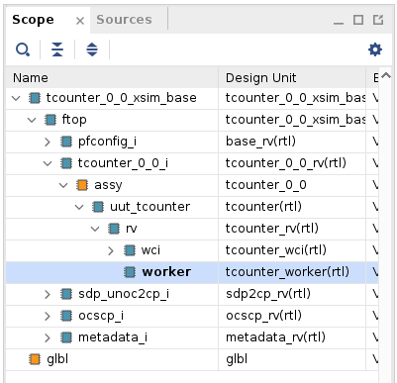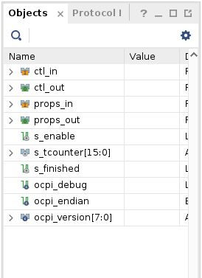
Note the change in the counter value:
Counting by two, not one.

Add Debug Functionality
In the tcounter.hdl/ directory:
$ cp tcounter-debug.vhd tcounter.vhd
$ cp tcounter-debug.xml tcounter.xml
Now observe what is done to add debugging/stepping functionality:
- In tcounter.xml, there is a new "step" property and the "max" property is extended from the OCS so that we can read it using ocpihdl.
- In tcounter.vhd, when the ocpi_debug parameter is true, "enable" depends on "step".
These changes enable the counting operation based on the built-in ocpi_debug parameter. When the “step” property is written as “true”, perform a single counter increment (single step):
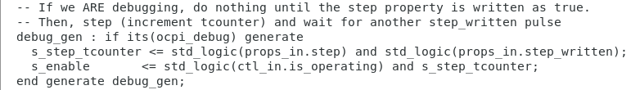
Otherwise, proceed normally.
Note that tcounter.hdl supports two build configurations as defined in tcounter-build.xml:
<build>
<configuration id='0'>
<parameter name='ocpi_debug' value='false'/>
</configuration>
<configuration id='1'>
<parameter name='ocpi_debug' value='true'/>
</configuration>
</build>
The ocpi_debug parameter is a build-time “parameter” property provided by the framework that allows the worker to build separate implementations, both with and without debugging behavior. You can read more about the ocpi_debug parameter property and about build-time parameter properties in general in the OpenCPI Component Development Guide.

Set up Unit Test for Different Worker Configurations
In the tcounter.test/ directory:
$ cp tcounter-test-debug.xml tcounter-test.xml
This effectively sets ocpi_debug to “false” and “true”:
<Property Name='ocpi_debug' Values='false,true'></Property>
Now, clean (delete build products) for “tcounter.hdl” and “tcounter.test”.
Using the OpenCPI GUI:
- In the “Project Explorer” panel, right-click on tcounter.hdl and select “Clean”.
- In the “Project Explorer” panel, right-click on tcounter.test and select “Clean”.
Using the ocpidev command:
- cd $OCPI_ROOT_DIR/projects/tutorial
- ocpidev clean worker tcounter.hdl
- ocpidev clean test tcounter.test

Build Worker HDL Assembly for the Hardware
Note: The intent is to make this tutorial as platform-agnostic as possible. The plutosdr platform is used as an example in the following steps.
First, build the “tcounter” HDL worker for the appropriate HDL target / HDL platform, e.g., zynq/plutosdr:
Using the OpenCPI GUI:
- In the “Platforms” panel, select “plutosdr” as the HDL platform.
- In the “Project Explorer” panel, right-click on tcounter.hdl and select “Build”. The build job will take several seconds to complete: be patient.
- Review the “Job Manager” and console windows to ensure the worker built successfully: if the job completed without error, the entry in the “Job Manager” window should have a green background.
- Optional: Note the “COMMAND RAN:” line in the console output window and compare with the ocpidev command in the paragraph below.
Using the ocpidev command with --hdl-platform=plutosdr as an example:
- cd $OCPI_ROOT_DIR/projects/tutorial
- ocpidev build worker tcounter.hdl --hdl-platform=plutosdr
Next, build the “tcounter” unit test suite for the target hardware platform. This build will take 5-10 minutes to complete.
Using the OpenCPI GUI:
- Leave the “Platforms” panel settings as they were for the previous tcounter.hdl build.
- In the “Project Explorer” panel, right-click on tcounter.test and select “Build”.
- Review the “Job Manager” and console windows to ensure the unit test built successfully: if the job completed without error, the entry in the “Job Manager” window should have a green background.
- Optional: Note the “COMMAND RAN:” line in the console output window and compare with the ocpidev command in the paragraph below.
Using the ocpidev command:
- cd $OCPI_ROOT_DIR/projects/tutorial
- ocpidev build test tcounter.test --hdl-platform=plutosdr

Debug HDL Worker with ocpihdl
This part of the tutorial consists of the following steps:
- Execute on the target hardware platform
- Confirm debug mode
- Collect HDL worker/assembly information
- Debug the HDL worker using ocpihdl, the command-line tool for performing HDL development tasks. For a description of ocpihdl command syntax, see the ocpihdl(1) man page. For details on how this tool is used in HDL development, see the OpenCPI HDL Development Guide.

Run Unit Test (plutosdr)
Ensure availability of the deployment platform (network-accessible and running ocpiserve) and run the tests. Details of how to set up and configure the deployment platform are beyond the scope of this tutorial.

Confirm Availability of Deployment Platform (plutosdr)
To get the status of the deployment platform:
- export OCPI_SERVER_ADDRESSES=<Pluto_IP>:12345
- ocpiremote status -p analog
Look for output similar to the following:
Executing remote configuration command: status
Server is running with port: 12345 and pid: 26224

Run Unit Test
To run the unit test on the remote platform using the OpenCPI GUI:
- Exit and restart the GUI to pick up the OCPI_SERVER_ADDRESSES setting.
- In the “Project Explorer” panel navigate to
tutorial->components->tcounter.test (select tcounter.test).
- In the “Platforms” panel, uncheck “RCC”, check “HDL”, and select plutosdr as the HDL platform.
- Click "Run Unit Test”. Do NOT wait for this process to complete: proceed to the next section.
To run the unit test on the remote platform using the ocpidev command:
- cd $OCPI_ROOT_DIR/projects/tutorial/components
- ocpidev run test tcounter --hdl-platform=plutosdr

Confirm Debug Mode
The application is now running on the Pluto. We have the application "hanging". It is in debug mode and waiting for our input. Let’s see what the state of the worker is by going to the logs.
- Examine the log file (run/plutosdr/case00.01.tcounter-1.hdl.log). Note that the running application will time out after 3600 seconds (1 hour).
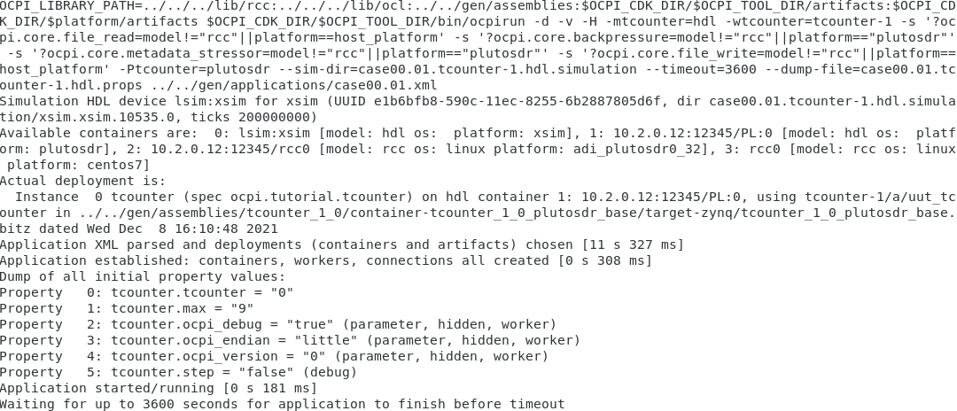
On the Pluto (use ssh root@<Pluto_IP> with password “analog”), we can now use ocpihdl to control the worker. For reference, here is output of ocpihdl:
Major commands/modes:
search [-i <interface>] # search for OpenCPI HDL devices, limit ethernet to <interface>
emulate [-i <interface>] # emulate an HDL device on ethernet, on first or specified interface
ethers # list available ethernet interfaces
probe <hdl-dev> # see if a specific HDL device is available
get [<instance> [<property]] # get info from bitstream
set <instance> <property> <value> # set property value for worker instance
control <instance> <operation> # perform reset, unreset, or control operation
status <instance> # show status of worker/instance
testdma # test for DMA memory setup
admin <hdl-dev> # dump admin information (reading only) for <hdl-device>
wadmin <hdl-dev> <offset> <value> # write admin word <value> for <hdl-device> at <offset>
radmin <hdl-dev> <offset> # read admin word for <hdl-device> at <offset>
settime <hdl-dev> # set the GPS time of the device to syste time
deltatime <hdl-dev> # measure round trip and difference between host and device
dump <hdl-dev> # dump all state/status of <platform> including all workers
reset <hdl-dev> # reset platform
flash <hdl-dev> # flash load platform
bram <infile> <outfile> # create a BRAM file from in input file
unbram <infile> <outfile> # recreate the original file from a BRAM file
uuid -p <platform> -c <part> <outputfilename>
wclear <hdl-dev> <worker> # clear worker status errors
wdump <hdl-dev> <worker> # dump worker's control plane registers
wop <hdl-dev> <worker> <op> # perform control operation on worker
ops are: initialize, start, stop, release, after, before
wread <hdl-dev> <worker> <offset>[/size] # perform config space read of size bytes at offset, default 4
wreset <hdl-dev> <worker> # assert reset for worker
wunreset <hdl-dev> <worker> # deassert (enable) worker
wwctl <hdl-dev> <worker> <val> # write worker control register
wwpage <hdl-dev> <worker> <val> # write worker window register
wwrite <hdl-dev> <worker> <offset>[/size] <value> # perform config space write of size bytes at offset
# generate UUID verilog file
load <hdl-dev> <file> # load bitstream from file
unload <hdl-dev> # revert device to unloaded state: no bitstream
getxml <hdl-dev> <file> # Extract the xml metadata from the device into the file
imulate # run simulator inside created sim: device
Options: (values are either directly after the letter or in the next argument)
-l <level> # set log levels
-i <interface> # set ethernet interface to use
-d <hdl-device> # identify a specific hdl device to use
-p <hdl-platform> # specify a particular hdl platform (e.g. ml605)
-c <hdl-part> # specify a particular part/chip (e.g. xc6vlx240t
-s <spin-clocks> # clocks to credit/run the sim between control messages
-t <sleep-usecs> # delay time letting sim run between credits
-T <sim-time> # total simulation time before terminating
-D # turn off simulation dumping
-e <sim-executable> # simulator executable "bitstream" file
-A # make the simulator publically available on the LAN
-v # be verbose
-x # print numeric values in hex rather than decimal
<worker> can be multiple workers such as 1,2,3,4,5. No ranges.
<hdl-dev> examples: 3 # PCI device 3 (i.e. 0000:03:00.0)
0000:04:00.0 # PCI device 0000:04:00.0
PCI:0001:05:04.2 # fully specified PCI device
a0:00:b0:34:55:67 # ethernet MAC address on first up+connected interface
eth0/a0:00:b0:34:55:67 # ethernet address on a specific interface
Ether:eth1/a0:00:b0:34:55:67 # fully specified Ethernet-based device

Collect Worker Assembly Information
View the currently loaded workers and their indices:
$ cd sandbox
$ . ./setup.sh
$ cat system.xml # to get device name for ocpihdl
$ ocpihdl -d PL:0 -p plutosdr get
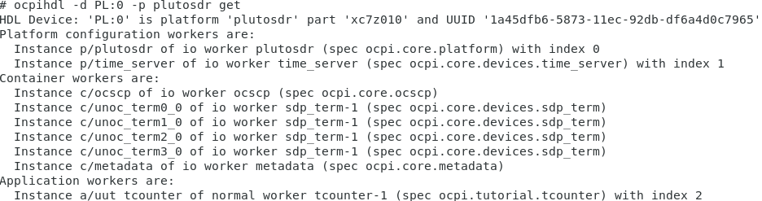
Note the last line in the above output: you can use index “2” or “tcounter-1” to identify the worker from now on.

Use ocpihdl to Debug HDL Worker
Execute:
ocpihdl -d PL:0 -p plutosdr get -v 2 ("-v" to list property values)
Note the property values:
- tcounter: 0
- max: 9
- ocpi_debug: true
- step=false
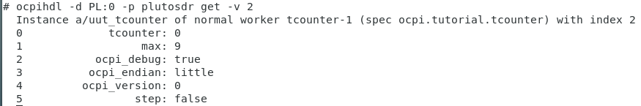
Also try:
ocpihdl -d PL:0 -p plutosdr get -v tcounter-1
Now execute:
ocpihdl -d PL:0 -p plutosdr set 2 step true
ocpihdl -d PL:0 -p plutosdr get -v 2
Notice “tcounter: 2” in the output:
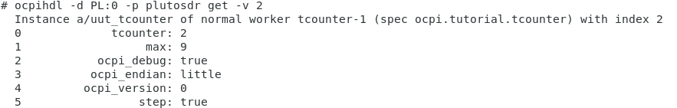
Continue setting "step" to true and note how the value of “tcounter” changes. When “tcounter” reaches "max", step one last time and the application will complete. You will see the following output back on the development host:
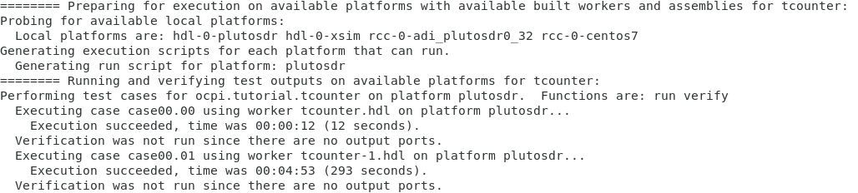
If you ran the unit test using the OpenCPI GUI, you’ll find the above output in the console window, and notice that the job in the “Job Manager” window now has a green background because the unit test job completed successfully.
Examine the log file (run/plutosdr/case00.01.tcounter-1.hdl.log) and note the final property values:
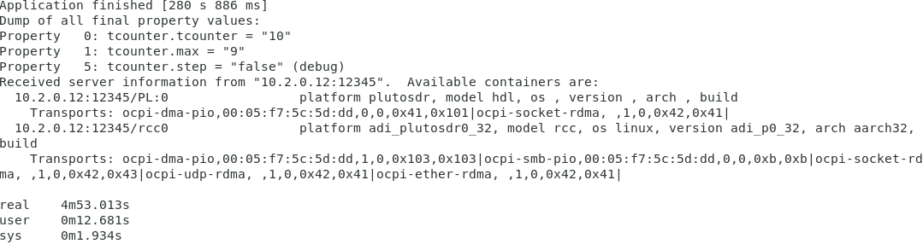

Found the Bug
By now, you have discovered the bug using one or more of the following methods:
- Viewing the log files and observing the output for different max values
- Viewing the simulated counter signals using ocpiview
- Using debug properties and ocpihdl to step through the application
The bug: We are incrementing the counter by 2 each step. You can fix the bug in tcounter.vhd, disable debugging, rebuild, and rerun.
This is a very simple example, but ocpihdl can be very helpful for debugging and controlling OpenCPI applications.

