OpenCPI
Tutorial 6: Creating a Simple HDL Worker
OpenCPI Release develop

Revision History
Revision | Description of Change | Date
1.01 | Creation from Lab 5 developed by CNF | 2019-10-01
1.1
1.2
1.3
1.4
1.5
1.6
1.7
1.8
1.9
1.9.1
2.0
2.1
Table of Contents
1 Overview 4
1.1 What’s Provided 5
1.2 Prerequisites to Using This Tutorial 6
1.3 Documentation References 7
2 Worker Development Flow 8
3 Component Requirements 9
4 Step 1: Use Pre-existing OPS or Create New 10
5 Step 2: Use Pre-existing OCS or Create New 11
6 Step 3: Create Worker 12
7 Step 3: Build Skeleton Code 13
8 Step 3: Configure Data Port for Parallel 14
9 Step 3: Configure for Version 2 HDL API 15
10 Step 3: Modify Worker Source Code 16
11 Step 4: Build Worker Source Code 17
12 Step 4: Review Build Logs and Artifacts 18
13 Steps 5 to 7: Unit Test Simulation 19
14 Step 5: Create Unit Test 20
15 Step 6: Build Unit Test (Xilinx XSIM) 21
16 Step 7: Run Unit Test (Xilinx XSIM) 22
17 Step 7 (cont’d.): Unit Test I/O Plots (Xilinx XSIM) 23
18 Step 7 (cont’d.): View Simulation Waveforms (Xilinx XSIM) 24

Overview
The objective of this tutorial is to design, build and test an HDL application worker. The worker function is peak detection of a data stream (peak_detector.hdl) with the following properties:
- Volatile Properties: Signed Min/Max (OWD)
- Configure Data Port Interfaces: Interleaved to Parallel (OWD)
- Routes data/messages through the worker "pass-thru" (VHDL)
This tutorial demonstrates Automated Unit Testing on multiple platforms (XML, Python) with the Xilinx Vivado xsim simulator.
The peak detector HDL worker performs the same function as the simple RCC worker demonstrated in Tutorial 3.

What’s Provided
The following items are provided for this tutorial:
- Component data sheet for peak_detector in ~/<opencpi-installation-dir>/projects/tutorial/provided/doc.
- Scripts for generating and validating data that you created for peak_detector in Tutorial 3 (in ~/<opencpi-installation-dir>/projects/tutorial/provided/peak_detector.test/). Re-use these scripts. Recall that there is one {component}.test/ per OCS. The same as implemented in Tutorial 3.
- Script for plotting I/Q data in ~/<opencpi-installation-dir>/projects/tutorial/scripts/plotAndFft.py.
- Worker VHDL with "commented" instructions in ~/<opencpi-installation-dir>/projects/tutorial/provided/lab6/peak_detector.vhd.

Prerequisites to Using This Tutorial
Before you begin this tutorial, you should have successfully completed Tutorials 1b through 5. We also recommend reading Briefing 8, “HDL Application Workers” before you get started with the tutorial.

Documentation References
The documents listed in the following table provide detailed information about subjects discussed in this tutorial. The documents listed here are not required reading for this tutorial but will likely be of interest for more in-depth learning.
Table 1 - OpenCPI Reference Documentation
Title | Published By | Public URL
OpenCPI Overview | OpenCPI | https://opencpi.gitlab.io/releases/v2.1.0-rc.1/docs/Overview.pdf
OpenCPI User Guide | OpenCPI | https://opencpi.gitlab.io/releases/v2.1.0-rc.1/docs/OpenCPI_User.pdf
OpenCPI Application Development Guide | OpenCPI | https://opencpi.gitlab.io/releases/v2.1.0-rc.1/docs/OpenCPI_Application_Development.pdf
OpenCPI Component Development Guide | OpenCPI | https://opencpi.gitlab.io/releases/v2.1.0-rc.1/docs/OpenCPI_Component_Development.pdf
OpenCPI HDL Development Guide | OpenCPI | https://opencpi.gitlab.io/releases/v2.1.0-rc.1/docs/OpenCPI_HDL_Development.pdf
OpenCPI RCC Development Guide | OpenCPI | https://opencpi.gitlab.io/releases/v2.1.0-rc.1/docs/OpenCPI_RCC_Development.pdf

Worker Development Flow
- Component (OCS): Use pre-existing or create new.
- Protocol (OPS): Use pre-existing or create new.
- Create new worker (Modify OWD, Makefile, and source HDL/RCC code).
- Build the worker for the target device(s).
- Create the unit test ({component}-test.xml, generate, verify and view scripts).
- Build the unit test.
- Run the unit test.

Component Requirements
What are the requirements of this component?
Given an input of complex numbers, the "peak_detector" component is meant to find the biggest I or Q sample and the smallest I or Q sample. The basic idea is:
- current_biggest = max(current_biggest,max(I,Q))
- current_smallest = min(current_smallest,min(I,Q))
- Pass input of complex numbers to the output ports

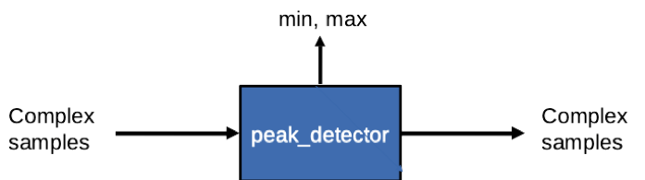

Step 1: Use Pre-existing OPS or Create New
- Identify the OPS(es) declared by this component. Examine the "Component Ports" table in the Component data sheet:
- Determine whether or not the OPS(es) exists:
Current project's component library?
~/<opencpi-installation>/projects/tutorial/components/specs
Other projects' components/specs/ directories within scope
Intersection of Project-registry and ProjectDependencies= in {my_project}/Project.mk
- If NO to all questions ⇨ Create new OPS
ANSWER: REUSE. The OPS XML file is available from the framework.

Step 2: Use Pre-existing OCS or Create New
- Review Component Spec Properties and Ports in the component data sheet. Use the Properties and Ports information to answer the following questions
- Determine whether or not the OCS that satisfies the requirements exists:
Current project's component library?
~/<opencpi-installation-dir>/projects/tutorial/components/specs/
Other projects' components/specs/ directories within scope
Intersection of Project-registry and ProjectDependencies= in {my_project}/Project.mk
- If NO to all questions ⇨ Create new OCS
ANSWER: REUSE. The OCS XML file is available from ocpi.tutorial.

Step 3: Create Worker
Via the IDE:
- File → New → Other → ANGRYVIPER → OpenCPI Asset Wizard
- Asset Type: Worker
- Worker Name: peak_detector
- Add To Project: ocpi.tutorial
- Model: HDL
- Programming Language: VHDL
- Add To Library: components
- Component: peak_detector (ocpi.tutorial)
- Finish
- Refresh the Project Explorer, then Refresh the OpenCPI Projects
- Use the Project Explorer to examine the auto-generated directories and files
components/{worker}.hdl/ - Worker directory with Author Model suffix (.hdl)
components/{worker}.hdl/Makefile - Includes a standard makefile fragment from the OCPI CDK
components/{worker}.hdl/{worker}.xml - OWD XML file
components/{worker}.hdl/{worker}.vhd - VHDL (architecture) skeleton file
components/{worker}.hdl/gen/ - OCPI worker build artifacts ({worker}-impl.vhd contains the Entity!)

Step 3: Build Skeleton Code
Why? Because, although not very exciting, this step proves the skeleton source code is buildable and that the build engine is functional.
To build generated skeleton code:
- In the IDE, add the worker to the Project Operations panel.
- Check the HDL Targets box and highlight "xsim".
- Check the "Assets" radio button.
- Click "Build".
- Review the Console window messages to ensure this step is error-free.
- Refresh the Project Explorer panel and review the newly generated build artifacts in target-xsim/.

Step 3: Configure Data Port for Parallel
- Convert the data port interface from Interleaved to Parallel. Note: iqstream_protocol is default interleaved 16-bit I/Q sample data.
- Determine the port configuration settings by examining the "Worker Interfaces" table in the Component data sheet.
- Edit the OWD via the IDE: HDL App Worker OWD HDL Editor ("Design" tab)
Highlight “Ports” from the “Outline”.
Click “Add a StreamInterface” and fill in the name "in" and set "DataWidth" to “32”.
Highlight “Ports” from the “Outline”.
Click “Add a StreamInterface” and fill in the name "out" and set "DataWidth" to “32”.
Expanding the data interface to 32 bit allows 16-bit I and 16-bit Q data to be transmitted simultaneously; that is, parallel.

Step 3: Configure for Version 2 HDL API
The v1.5 release of the IDE does not provide a field for declaring Version 2 HDL API, so the XML must be manually modified:
- Edit OWD via the IDE: HDL App Worker OWD HDL Editor.
- Switch the tab from “Design” to “Source”.
- Add the top-level attribute Version=”2”.
- Add InsertEOM=”1” to the “out” port.
<HdlWorker language='vhdl' spec='peak_detector-spec' Version=”2”>
<StreamInterface Name=”in” DataWidth=”32”></StreamInterface>
<StreamInterface Name=”in” DataWidth=”32” InsertEOM=”1”></StreamInterface>
</HdlWorker>

Step 3: Modify Worker Source Code
The skeleton .vhd file is an empty architecture. The entity is generated VHDL based on the OCS and the OWD, and located in the gen/{worker}-impl.vhd. We want to replace the skeleton .vhd file with the provided .vhd. This file contains instructions to modify the VHDL source code:
cd ~/<opencpi-installation-dir>/projects/tutorial/components/peak_detector.hdl/
cp -f ~/<opencpi-installation-dir>/projects/tutorial/provided/lab6/peak_detector.vhd .
Open the VHDL in a text editor. Starting at the top, modify the source code per the commented instructions (look for “TODO”). A high-level summary of required modifications is provided:
Define the constant.
Make general signal and data port assignments.
Assign the volatile output properties.

Step 4: Build Worker Source Code
Build the HDL worker for the XSIM target:
- In the IDE, add the worker to the Project Operations panel.
- Check the HDL Targets box and highlight "xsim" under "xilinx".
- Check the "Assets" radio button.
- Click "Build".
- Review the Console window messages and address any errors.

Step 4: Review Build Logs and Artifacts
The end of the build log should look something like the following text, if free of errors:
Configuration:
build ocpi.tutorial.components.peak_detector.hdl HDL: xsim

[ocpidev -d /home/opencpi/projects/tutorial build worker peak_detector.hdl -l components --hdl-target xsim ]

make: Entering directory `/home/opencpi/projects/tutorial/components/peak_detector.hdl'
Generating the definition file: gen/peak_detector-defs.vhd
Generating the implementation header file: gen/peak_detector-impl.vhd from peak_detector.xml
Generating the implementation skeleton file: gen/peak_detector-skel.vhd
Generating the VHDL constants file for config 0: target-xsim/generics.vhd
Generating the opposite language definition file: gen/peak_detector-defs.vh
Generating the Verilog constants file for config 0: target-xsim/generics.vh
Building the peak_detector worker for xsim (target-xsim/peak_detector) 0:(peak_detector_ocpi_endian=little peak_detector_ocpi_max_bytes_out=8192 peak_detector_ocpi_max_latency_out=256 peak_detector_ocpi_version=2 peak_detector_ocpi_max_opcode_in=0 peak_detector_ocpi_max_opcode_out=0 peak_detector_ocpi_max_bytes_in=8192 peak_detector_ocpi_debug=false)
Tool "xsim" for target "xsim" succeeded. 0:02.79 at 09:10:26
make[1]: Entering directory `/home/opencpi/projects/tutorial/components'
make[1]: Leaving directory `/home/opencpi/projects/tutorial/components'
make: Leaving directory `/home/opencpi/projects/components/peak_detector.hdl'
Updating project metadata...
== > Command completed. Rval = 0
Now review the artifact {worker}.hdl/: "target-xsim/". This directory contains output files from the respective FPGA vendor tools (in this case, simply Xilinx Vivado) in addition to a framework auto-generated file, generics.vhd. which contains parameter configuration settings of the HDL worker for the particular "target-*".

Steps 5 to 7: Unit Test Simulation
Use the framework's unit test suite to generate:
- OAS (OpenCPI Application Specification) XML file(s). This item is used by the framework for running the executable on a simulation platform. In this case, the target simulation platform is Xilinx XSIM Simulation Server.
- OHAD (OpenCPI HDL Assembly Description) XML file(s). This item is used by the framework to build an executable for the target simulation platform. In this case, the target simulation platform is Xilinx XSIM (xsim).
- Input test data file(s) based on user-provided scripts.
- Various scripts to manage the execution of the applications onto the target platform(s).

Step 5: Create Unit Test
We’ll re-use the unit test from the "work-alike" simple RCC worker created in Tutorial 3. It’s located in the "peak_detector.test/" directory. Here is the current content:
<Tests useHDLFileIo='true'>
<Input Port='in' Script='generate.py 32768'/>
<Output Port='out' Script='verify.py 32768' View='view.sh'/>
</Tests>

Step 6: Build Unit Test (Xilinx XSIM)
Build the unit test suite for the target simulation platform.
Using the IDE:
- Add the Unit Test to the Project Operations panel.
- Highlight "xsim" the HDL Platforms panel (leave the HDL Targets box unchecked).
- Check the "Tests" radio button.
- Click "gen + build".
- Review the console window messages and address any errors.
Using the ocpidev command:
TBD
Observe the new artifacts in {OCS}.test/gen/:
- cases.txt – "human-readable" file listing various test configurations
- cases.xml – used by the framework to execute tests
- cases.xml.deps – list of dependent files
- applications/ – OAS files and scripts used by the framework to execute applications
- assemblies/ – used by the framework to build bitstreams
Observe the new artifacts in peak_detector.test/gen/assemblies/peak_detector_0_frw
- peak_detector_0_frw.xml – generated assembly XML (OHAD)
- gen/ – artifacts generated/used by framework
- lib/ – artifacts generated/used by framework
- target-xsim/ – artifacts generated/used by framework and FPGA tools
- container-peak_detector_0_frw_xsim_base/
gen/ – artifacts generated/used by framework
target_xsim/:
- artifacts generated/used by framework and output files from FPGA tools
- execution file for launching onto a simulation platform

Step 7: Run Unit Test (Xilinx XSIM)
Now run the unit test for the target simulation platform.
Using the IDE:
- Add the Unit Test (.test) to the Project Operations panel.
- Highlight "xsim" the HDL Platforms panel (HDL Targets box unchecked).
- Check "keep simulations".
- Check "run view script".
- Click "prep+run+verify" to run the tests. Simulation takes approximately 1 minute to complete.
- Review the console window messages and address any errors. Completion of each test case is reported in the console with a "PASSED" along with final values for the min/max peaks.
Using ocpidev, execute the following command line within the {component}.test/ directory:
$ ocpidev run --mode prep_run_verify --only-platform xsim --keep-simulations –view

Step 7 (cont’d.): Unit Test I/O Plots (Xilinx XSIM)

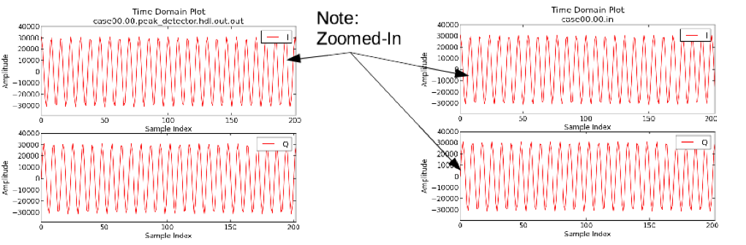

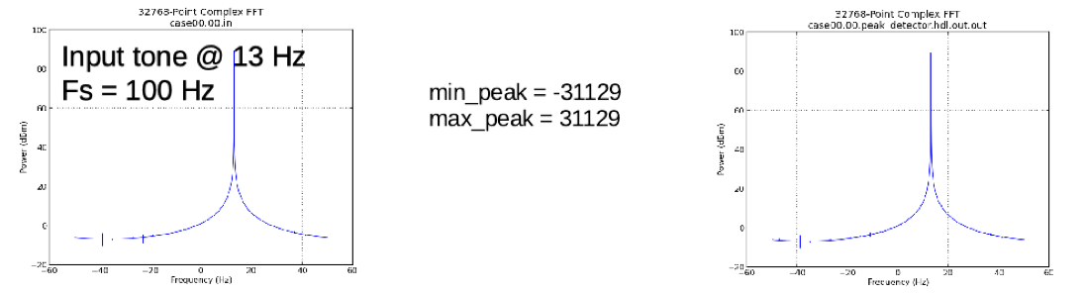

Step 7 (cont’d.): View Simulation Waveforms (Xilinx XSIM)
To perform this step, you must have checked "keep simulations" in the IDE used the –keep-simulations option on the ocpidev run command line.
In a terminal window, browse to peak_detector.test/ and execute:
$ ocpiview run/xsim/case00.00.peak_detector.hdl.simulation &
