OpenCPI
Tutorial 8: Using Third-Party HDL Primitive Cores
OpenCPI Release: v2.4.5
Revision History
Revision | Description of Change | Date
1.0 | Creation from Lab 8 developed by BIA | 2019-10-01
1.1 | Add content, test CLI instructions, update/test GUI instructions | 2021-12-28
1.2 | Update GUI screenshots, update for external review comments | 2022-02-11
1.3 | Update GUI and CLI to reflect ocpidev changes | 2022-08-30
Table of Contents
1 Overview 4
1.1 What’s Provided for This Tutorial 5
1.2 Prerequisites to Using This Tutorial 6
1.3 Documentation References 7
2 Create New Project 8
3 Create Component Library 10
4 Create Component 11
4.1 Create Component Spec 12
4.2 Add Properties and Ports 13
5 Create Worker 14
6 Edit Worker OWD 15
6.1 Add data_select Property 16
6.2 Convert Data Port Interface for Parallel Transmission 17
7 Build Worker 18
8 Copy Third-Party Cores to Worker 19
9 Copy/Edit VHDL Source Code 20
10 ReBuild Worker 21
11 Review Build Log and Artifacts 22
12 Unit Test – Simulation 23
13 Create Unit Test 24
13.1 Build Unit Test 26
13.2 Review OCS Artifacts 27
13.3 Review Build Artifacts 28
14 Run Unit Test (Xilinx XSIM) 29
15 Examine I/O Test Plots (Xilinx XSIM)› 30
16 View Simulation Waveforms (Xilinx XSIM) 34
17 Tutorial Summary 35

Overview
This tutorial describes how to create an HDL worker that uses HDL primitive cores imported from a third party; in this example, Vivado. It demonstrates how to design, build and test a complex mixer HDL worker for execution on a Xilinx XSIM simulator. The HDL worker is a “work-alike” to the complex mixer RCC worker discussed in Tutorial 4.
The tutorial shows you how to:
- Set OCS and OWD properties (XML)
- Convert the data port interface from interleaved to parallel (OWD)
- Route data/messages through the worker "pass-through" (VHDL)
- Wrap Vivado IP (third-party) cores (netlist, VHDL)
- Run the OpenCPI unit test framework on multiple platforms (XML, Python)
A third-party core is an HDL primitive core that is not included in the OpenCPI framework. These cores allow you to implement functions that you couldn’t do otherwise and are optimized for the technology so that they make best use of the available resources. In this tutorial, Vivado is the third-party core that we are using.

What’s Provided for This Tutorial
In this tutorial, you will re-use the complex mixer component test suite that you implemented in Tutorial 4. Remember that there is one component unit test suite (aka “unit test”) per component specification.
The OpenCPI built-in tutorial project ocpi.tutorial provides the following items for this tutorial:
- The complex mixer HDL worker VHDL source code annotated with information on how it is designed, located in projects/tutorial/components/complex_mixer_tutorial.hdl/
complex_mixer_tutorial.vhd
- The following third-party core files (Vivado IP output files) located in /projects/tutorial/components/complex_mixer_tutorial.hdl/
vivado_ip/:
complex_multiplier[_stub.vhd|.edf] and dds_compiler[_stub.vhd|.edf]
complex_multiplier_sim_net.vhd and dds_compiler_sim_net.vhd
The tutorial also provides the XML source for all of the assets used to build and run the example component, worker and tests described in this tutorial.
Instructions for copying these items from the ocpi.tutorial project into the “demo” tutorial project are provided in the relevant sections of this document. The source code for these items is also available as text in the relevant sections of this document that you can copy and paste into the relevant files following the instructions given in the section.
Note: when copying and pasting text from this document, be sure to remove any line breaks in code or command lines. The backslash character (\) is used in command lines (where feasible) to indicate a line break.

Prerequisites to Using This Tutorial
This tutorial (Tutorial 8) has the same system prerequisites as Tutorial 1, “Component-based Development”. See the prerequisites section in Tutorial 1 for details.
Before you begin this tutorial, you should have successfully completed Tutorials 1 through 7.
We recommend reading the following briefings before getting started:
- Briefing 9, “HDL Assemblies”
- Briefing 10, “HDL Primitives”

Documentation References
The documents listed in the following table provide detailed information about subjects discussed in this tutorial. The documents listed here are not required reading for this tutorial but will likely be of interest for more in-depth learning.
Table 1 - OpenCPI Reference Documentation
Title | Published By | Public URL
OpenCPI User Guide | OpenCPI | https://opencpi.gitlab.io/releases/v2.4.5/docs/OpenCPI_User_Guide.pdf
OpenCPI Application Development Guide | OpenCPI | https://opencpi.gitlab.io/releases/v2.4.5/docs/OpenCPI_Application_Development_Guide.pdf
OpenCPI Component Development Guide | OpenCPI | https://opencpi.gitlab.io/releases/v2.4.5/docs/OpenCPI_Component_Development_Guide.pdf
OpenCPI HDL Development Guide | OpenCPI | https://opencpi.gitlab.io/releases/v2.4.5/docs/OpenCPI_HDL_Development_Guide.pdf
OpenCPI RCC Development Guide | OpenCPI | https://opencpi.gitlab.io/releases/v2.4.5/docs/OpenCPI_RCC_Development_Guide.pdf

Create New Project
As we did in Tutorial 4, we’ll create a new, clean project for Tutorial 8; we’ll call it DemoProject8. This project has the same requirements as the project we created for Tutorials 3 and 4.
To create DemoProject8 using the OpenCPI GUI:
- Start OpenCPI GUI.
- From the top menu bar, select Create > Project…
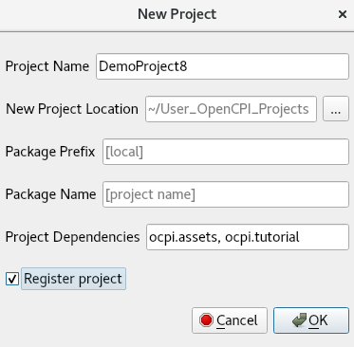
- In the New Project dialog, enter the Project Name, DemoProject8.
- In Project Dependencies, enter ocpi.assets, ocpi.tutorial.
- Check Register project.
- Leave all of the other fields as they are and click OK.
- You should now see DemoProject8 displayed in the OpenCPI Project Explorer view.
To create the DemoProject8 project with ocpidev, use the command:
ocpidev -D ocpi.assets -D ocpi.tutorial create project DemoProject8 --register
We need to make the same modifications to the Project.xml file as we did in Tutorial 4 as well as make some new ones as described below for Tutorial 8. Open the Project.xml file with a text editor and add the following two lines after the ProjectDependencies attribute:
HdlLibraries='prims'
ComponentLibraries='util_comps'
and then save and close the file.

Create Component Library
We can use the top-level components/ directory as our library like we did in Tutorial 4.
To create the components library with the OpenCPI GUI:
- From the GUI menu bar at the top of the window, select Create > Component Library...
- In Library Name, enter components.
- In Associated Project, select DemoProject8. Click OK to create the component library.
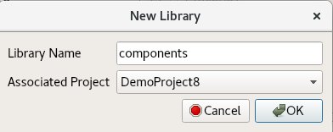
- The components library is now displayed in the Project Explorer view.
Again, notice that the GUI executes ocpidev commands to carry out its operations and that they are visible in the Console tab window on the right. You can follow along and familiarize yourself with the ocpidev commands by checking the console window after you perform an operation.
To create the components library with ocpidev, run the following command in the DemoProject8 directory:
ocpidev create library components

Create Component
Like we did in Tutorial 4, we need to create the OCS (OpenCPI Component Specification) for our complex mixer function that defines its properties and ports.

Create Component Spec
As we did in Tutorial 4, we’ll create the complex mixer component spec in the components library.
To create the complex mixer component spec with the OpenCPI GUI:
- From the GUI menu bar at the top of the window, select Create > Component Spec…
- The New Component dialog appears. In Component Name, enter complex_mixer.
- In Associated Library, select DemoProject8.
- Leave Associated Library set to components.
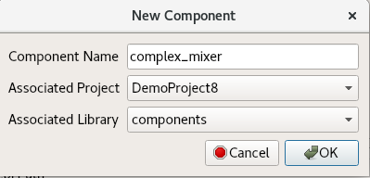
- Click OK. When the operation completes, you should see a complex_mixer.comp subdirectory in the components directory displayed in the Project Explorer view.
To create the component spec with ocpidev, run the following command from the DemoProject8/components/ directory:
ocpidev create component complex_mixer
The command creates the component spec complex_mixer-spec.xml in components/complex_mixer.comp/. We’ll add properties and ports to the component spec in the next step.

Add Properties and Ports
Our complex_mixer component function needs to define two properties:
- The phs_inc (“phase increment”) property, which stores the results of the computation (that is, setting the tune frequency for the input signal using the output of the internal NCO). This property is valid for both RCC and HDL component implementations.
- The enable property, which controls whether a worker implementation performs the computation on the incoming data or simply passes the incoming data through without any processing (“bypass” mode). This property is valid for both RCC and HDL component implementations.
We want to set default values for the phs_inc and enable properties in the component spec and allow the worker implementation to override these values. We’ll use the default attribute in our property definitions to specify the default values and use the writeable attribute to indicate that the worker can override them. You can read more about how the framework interprets these attributes in the OpenCPI Component Development Guide.
The complex_mixer component has the same simple port configuration as the peak_detector component and uses the same OPS. It requires one input port and one output port for communication with other components in an application and both ports will use the iqstream protocol.
To add properties and ports from the command line, open the spec with a text editor.
Add the following XML code (highlighted in red) between the ComponentSpec elements:
<ComponentSpec>
<Property Name="enable" Type="bool" Writable="true"
Default="true"/>
<Property Name="phs_inc" Type="short" Writable="true"
Default="-8192"/>
<Port Name="in" Protocol="iqstream_protocol"/>
<Port Name="out" Protocol="iqstream_protocol"
Producer="true"/>
</ComponentSpec>

Create Worker
To create the worker using the OpenCPI GUI:
- Create > Worker...
Worker Name: complex_mixer
Associated Project: DemoProject8
Model: HDL
Language: VHDL
Associated Library: components
Component: complex_mixer (ocpi.tutorial)
- Click OK.
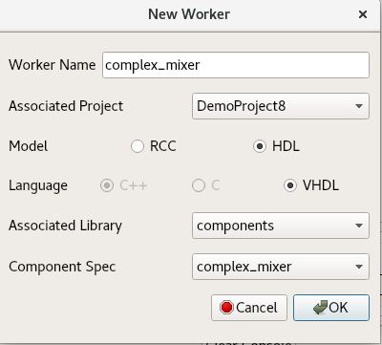
To create the worker using the ocpidev, run the following command in the DemoProject8/components/ directory:
ocpidev create worker complex_mixer.hdl -S complex_mixer
Now examine the auto-generated directories and files:
components/complex_mixer.hdl/ - Worker directory with author model suffix (.hdl)
components/complex_mixer.hdl/complex_mixer.xml - OWD XML file
components/complex_mixer.hdl/complex_mixer.vhd - VHDL (architecture) skeleton file
components/complex_mixer.hdl/gen/ - OCPI worker build artifacts (complex_mixer-impl.vhd contains the entity)

Edit Worker OWD
Now we’ll add the worker properties to the skeleton worker OWD.

Add data_select Property
First, reference the “Worker Properties” table in the complex mixer component data sheet. The worker has the data_select property, which selects the data to output in bypass mode (input or NCO). The default value for this property is 0 (false).
Ensure that all attributes and default values are set for each property/parameter according to the component's data sheet.
In the OpenCPI GUI, right-click complex_mixer.xml and then click Edit File. This action opens the XML file using your system's default handler for XML files, where you can edit the file if the GUI supports that function for the handler. Make the changes described below. When you finish editing the file, click Save and then close the file.
To add the properties from the command line, open complex_mixer.xml with a text editor.
Now add the properties and parameters according to the data sheet.
Next, add the data_select property (highlighted in red):
<HdlWorker language='vhdl' spec='complex_mixer-spec' Version="2">
<Property Name="data_select" Type="bool" Default="false" Writable="true" Description="In Bypass Mode: selects data to output: 0=input data, 1=output of NCO"></Property>
</HdlWorker>

Convert Data Port Interface for Parallel Transmission
By default, the iqstream_protocol is interleaved 16-bit I/Q sample data. We need to convert the data port interface from interleaved to parallel.
Determine the port configuration settings by examining the "Worker Interfaces" table in the component data sheet.
Using the OpenCPI GUI:
- Right click complex_mixer.xml and click Edit File. This action opens the XML file using your system's default handler for XML files, where you can edit the file if the GUI supports that function for the handler. Make the changes described below. When you finish editing the file, click Save and then close the file.
From the command line, open complex_mixer.xml with a text editor.
Add the port configurations shown in the “Worker Interfaces” table in the data sheet.
Now you can add StreamInterfaces for each port as shown below.
<HdlWorker language='vhdl' spec='complex_mixer-spec' Version="2">
<Property Name="data_select" Type="bool" Default="false" Writable="true" Description="In Bypass Mode: selects data to output: 0=input data, 1=output of NCO"></Property>
<StreamInterface Name="in" DataWidth="32"></StreamInterface>
<StreamInterface Name="out" DataWidth="32" InsertEOM="1"></StreamInterface>
</HdlWorker>
Expanding the data interface to 32 bit allows 16-bit I and 16-bit Q data to be transmitted simultaneously; that is, in parallel.

Build Worker
Now build the worker with the changes from the OWD.
To build the code using the OpenCPI GUI:
- In the Platforms view, check HDL.
- Scroll down to xsim and click it.
- Right-click the newly created worker.
- Click Build.
- Review the console window messages to ensure this step is error free and check the Job Manager and look for the green color that signals success.
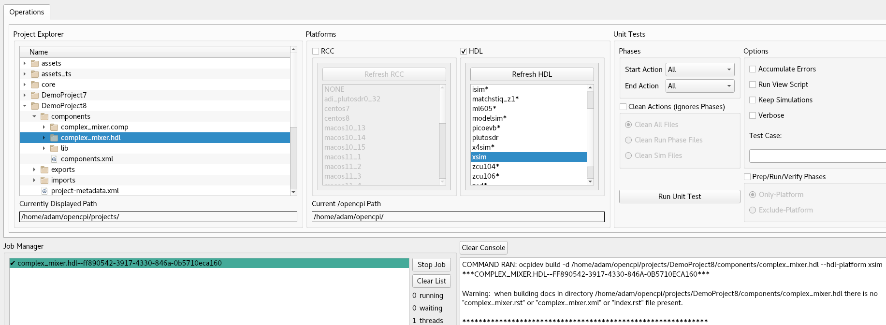
To build the worker using ocpidev, run the following command from the DemoProject8/components/complex_mixer.hdl/ directory:
ocpidev build --hdl-platform xsim

Copy Third-Party Cores to Worker
First, copy the provided third-party HDL primitive core directory vivado_ip into the complex_mixer.hdl directory:
cd $OCPI_ROOT_DIR/projects/DemoProject8/components/complex_mixer.hdl/
cp -r $OCPI_ROOT_DIR/projects/tutorial/components/complex_mixer_tutorial.hdl/vivado_ip/ .

Copy/Edit VHDL Source Code
The skeleton <worker-name>-skel.vhd file is an empty architecture. The entity is generated VHDL based on the OCS and OWD and is located in gen/<worker-name>-impl.vhd. To implement the worker source code, we’ll simply copy the reference worker source code (and the worker Makefile) from the complex_mixer_tutorial.hdl/ directory in the tutorial project as follows:
Copy the worker source code:
- Replace the skeleton .vhd file with the .vhd provided for this tutorial. It contains descriptions of how the VHDL source code is designed:
cd $OCPI_ROOT_DIR/projects/DemoProject8/components/complex_mixer.hdl
cp $OCPI_ROOT_DIR/projects/tutorial/components/complex_mixer_tutorial.hdl/complex_mixer_tutorial.vhd complex_mixer.vhd
cp
$OCPI_ROOT_DIR/projects/tutorial/components/complex_mixer_tutorial.hdl/Makefile .
- This tutorial also needs this makefile to be run correctly. This is because it was not a simple component to convert to a make-less implementation.
Now look at the VHDL source code. Starting at the top, look at the source code following the commented instructions. These lines are focused on the ports and properties added in this tutorial. Read the comments so you have an idea of how and why these things were done.

ReBuild Worker
Now build the HDL worker only for XSIM targets.
To build the code using the OpenCPI GUI:
- In the Platforms view, check HDL.
- In the Platforms view, select xsim.
- Right-click the newly created worker.
- Click Build.
- Review the console window messages to ensure this step is error free and check the Job Manager and look for the green color that signals success.
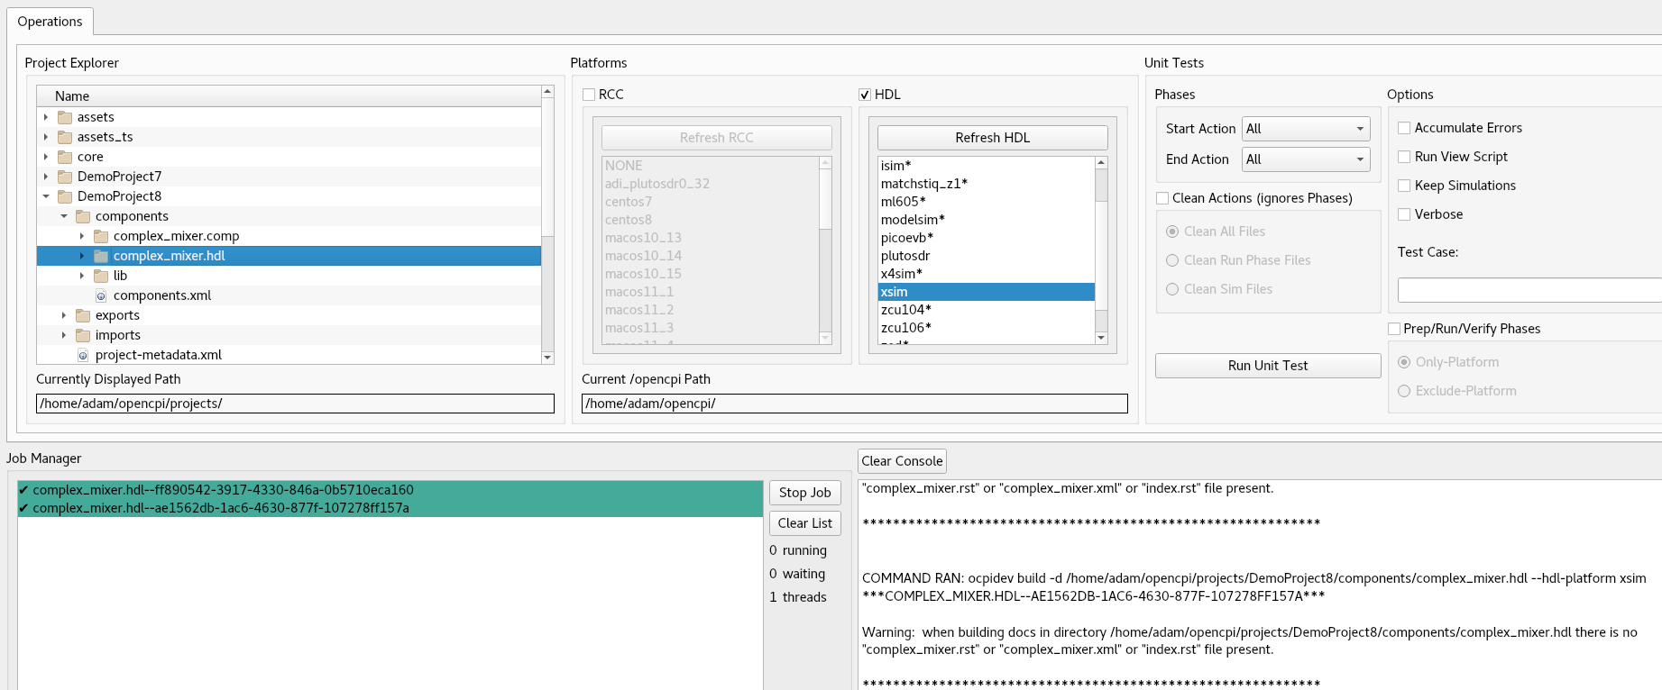
To build the worker with ocpidev, run the following command from the DemoProject8/components/complex_mixer.hdl/ directory:
ocpidev build --hdl-platform xsim

Review Build Log and Artifacts
The end of build log should look like the following example, if free of errors:
COMMAND RAN: ocpidev build --hdl-platform xsim

***COMPLEX_MIXER.HDL--27503D3E-015A-4975-BA54-071D9FEEBD8D***
Building the complex_mixer worker for xsim (target-xsim/complex_mixer) 0:(complex_mixer_ocpi_max_opcode_out=0
complex_mixer_ocpi_endian=little complex_mixer_ocpi_version=2 complex_mixer_ocpi_max_bytes_in=8192 complex_mixer_ocpi_max_latency_out=256 complex_mixer_ocpi_max_bytes_out=8192 complex_mixer_ocpi_max_opcode_in=0 complex_mixer_ocpi_debug=false)
Tool "xsim" for target "xsim" succeeded. 0:05.24 at 11:40:16
Observe the new artifacts directory complex_mixer.hdl/: "target-xsim/". This directory contains output files from their respective FPGA vendor tools (in this case, simply Xilinx Vivado) in addition to a framework auto-generated file named generics.vhd that contains parameter configuration settings of the HDL worker for the particular "target-".
If you're using the OpenCPI GUI, the second line with the random letters and numbers is just the thread represented by the GUI. It will be different every time you run the worker.

Unit Test – Simulation
In this section, we demonstrate how to use the framework's component unit test suite (aka “unit test”) to generate:
- OpenCPI Application Specification (OAS) XML file(s) - used by the framework for running the executable on a simulation platform; in this case, the target simulation platform is Xilinx XSIM Simulation Server.
- OpenCPI HDL Assembly Description (OHAD) XML file(s) - used by the framework to build an executable for the target simulation platform; in this case, the target simulation platform is Xilinx XSIM (xsim).
- Input test data file(s) based on user-provided scripts.
- Various scripts to manage the execution of the applications onto the target platform(s).

Create Unit Test
For this tutorial, we will copy the unit test from the tutorial project, under projects/tutorial/components/complex_mixer.test/.
To create the unit test with the OpenCPI GUI:
- From the GUI menu bar at the top of the window, select Create > Component Test Suite…
- Choose DemoProject8 from the Associated Project drop-down list.
- Choose components from the Associated Library drop-down list.
- Choose complex_mixer from the Component Spec drop-down list.
- Click OK. When the operation completes, you’ll see a new complex_mixer.test subdirectory in components in the Project Explorer panel.
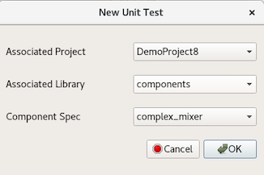
To create the unit test with ocpidev, run the following command from the DemoProject8/components/ directory:
ocpidev create test complex_mixer
The description file is located in the complex_mixer.test/ directory and is named complex_mixer-test.xml. We’ll change this XML to add the OWD property. Edit the unit test description file complex_mixer-test.xml to include all of the content shown below:
<Tests UseHDLFileIo='true'>
<Input Port='in' Script='generate.py 100 12.5 32767 16384'></Input>
<Output Port='out' Script='verify.py 100 16384' View='view.sh'></Output>
<Property Name='phs_inc' Values='8192'></Property>
<Property Name='enable' Values='0,1'></Property>
<Property Name='data_select' Values='0,1'></Property>
</Tests>
When "bypass" is enabled, "data_select" routes either the input data or NCO output to the output data port.
To copy the contents of the tutorial project's test directory and then delete the extra XML file, perform the following commands:
cd $OCPI_ROOT_DIR/<your-top-level-projects-dir>/DemoProject8/components/complex_mixer.test

cp $OCPI_ROOT_DIR/projects/tutorial/components/complex_mixer_tutorial.test/* .

rm complex_mixer_tutorial-test.xml
Change permissions of the copied files as shown below.
$ chmod 777 generate.py
$ chmod 777 verify.py
$ chmod 777 view.sh

Build Unit Test
First, build the unit test for target simulation platform.
Using the OpenCPI GUI:
- Highlight complex_mixer.test in the Project Explorer.
- Highlight xsim in the HDL Platforms view.
- Right-click on complex_mixer.test and select Build.
- Review the console window messages and address any errors.
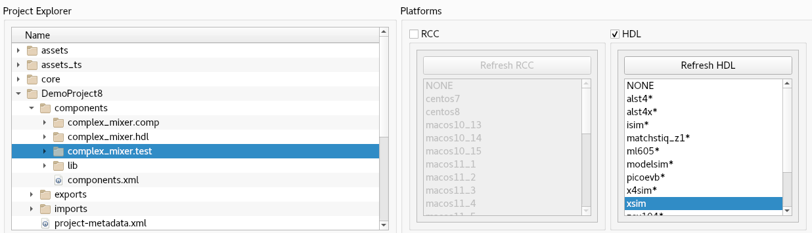
To build the unit test with ocpidev, run the following command from the DemoProject8/components/complex_mixer.test/ directory:
ocpidev build --hdl-platform xsim

Review OCS Artifacts
Next, observe the new artifacts in complex_mixer.test/gen/:
- cases.txt – "human-readable" file that lists various test configurations.
- cases.xml – used by the framework to execute tests.
- cases.xml.deps – list of dependent files.
- applications/ - OAS files and scripts used by the framework to execute applications.
- assemblies/ - used by the framework to build bitstreams.

Review Build Artifacts
Finally, observe the new artifacts in complex_mixer.test/gen/assemblies/complex_mixer_0_frw/:
- complex_mixer_0_frw.xml – generated assembly XML (OHAD).
- gen/ - artifacts generated/used by the framework.
- lib/ - artifacts generated/used by the framework.
- target-xsim/ - artifacts generated/used by the framework and FPGA tools.
- container-complex_mixer_0_frw_xsim_base/:
gen/ - artifacts generated/used by the framework
target_xsim/:
- artifacts generated/used by the framework and output files from FPGA tools
- execution file for execution onto a simulation platform

Run Unit Test (Xilinx XSIM)
In this step, we’ll run the unit test for the target simulation platform.
To run the unit test using the OpenCPI GUI:
- Note: currently you can only do two modes in the GUI at the same time.
- Highlight complex_mixer.test in the Project Explorer.
- Highlight xsim in the HDL Platforms view.
- Check Keep Simulations.
- Select All in both Start Action and End Action.
- Click Run Unit Test.
- Review the console window messages and address any errors.
- Once that has been done, then switch Start Action to Verify and End Action to Verify, check Run View Script and click Run Unit Test again.
- Review the console window messages and address any errors.
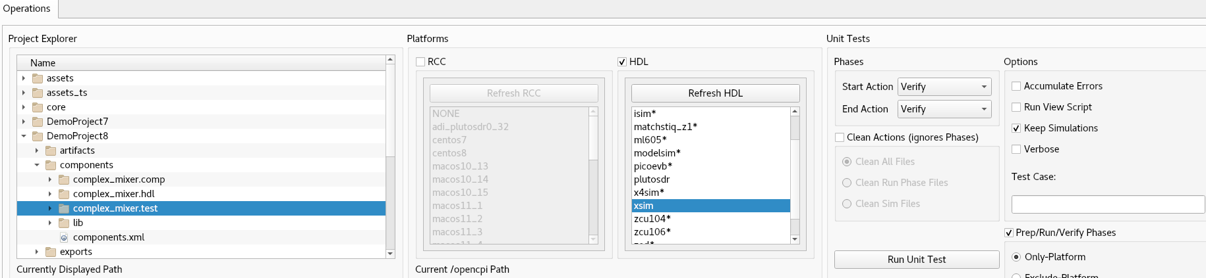
To run the unit test using the ocpidev command, execute the following command within the complex_mixer.test/ directory:
$ ocpidev run --mode prep_run_verify --only-platform xsim \
--keep-simulations --view

Examine I/O Test Plots (Xilinx XSIM)›
The following table shows the test case variables.
Test Case Variables
Test Case | enable | data_select | Output
case00.00 | 0 | 0 | input signal
case00.001 | 0 | 1 | NCO signal
case00.02 | 1 | 0 | input signal
case00.03 | 1 | 0 | input signal
Here are the I/O test plots:
Case00.00 ( enable = 0, data_select = 0)
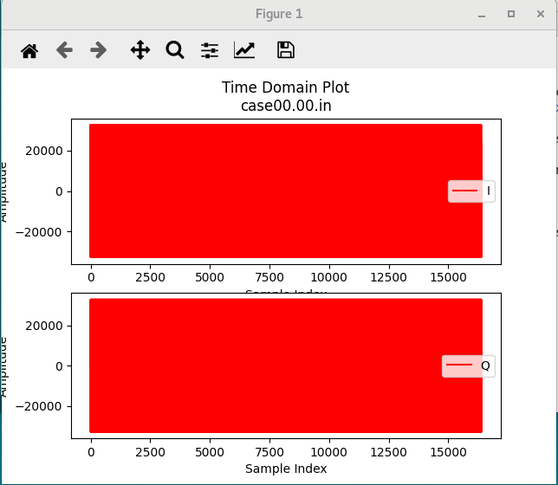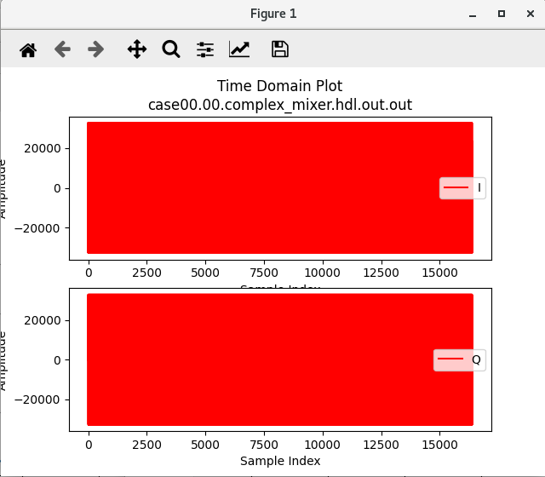

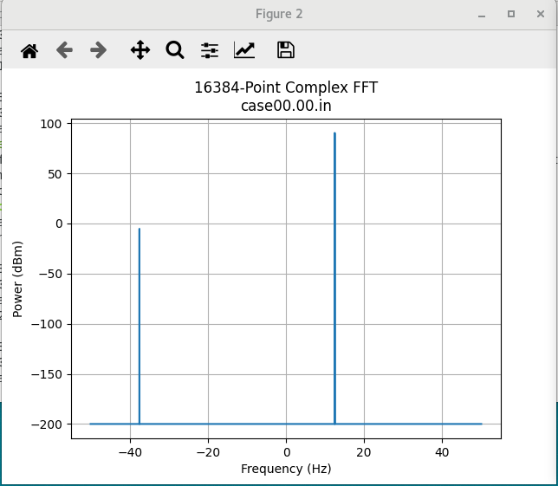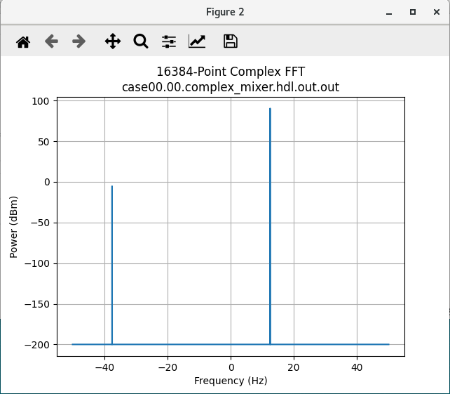
Input signal is passed through with no conversion.
Case00.01 (enable = 0, data_select = 1)
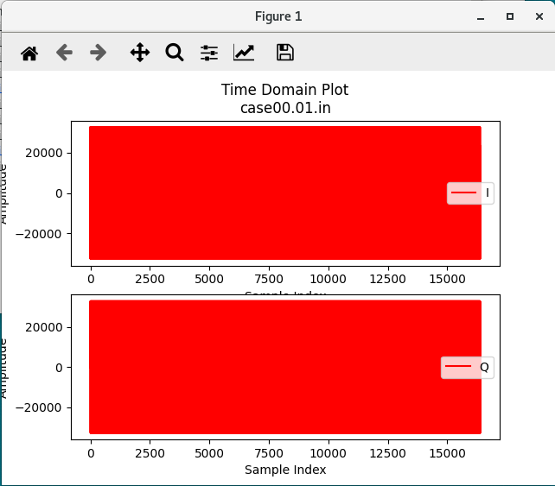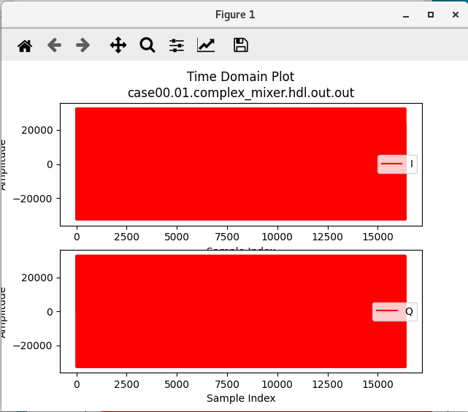
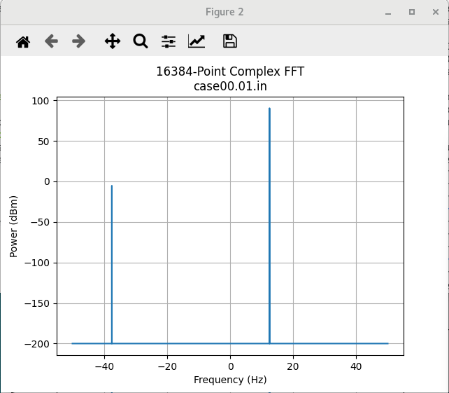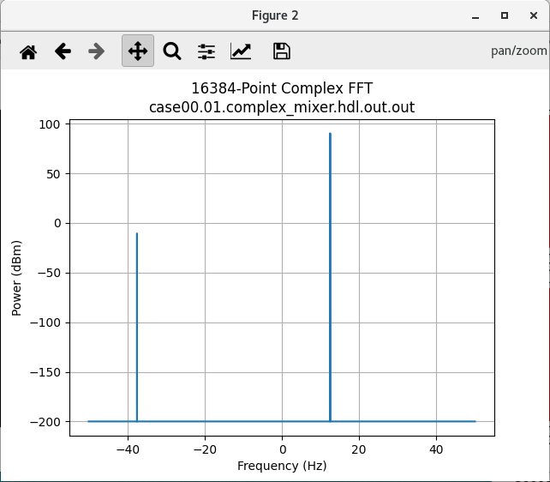
NCO signal is passed to output.

Case00.02 (enable = 1, data_select = 0)
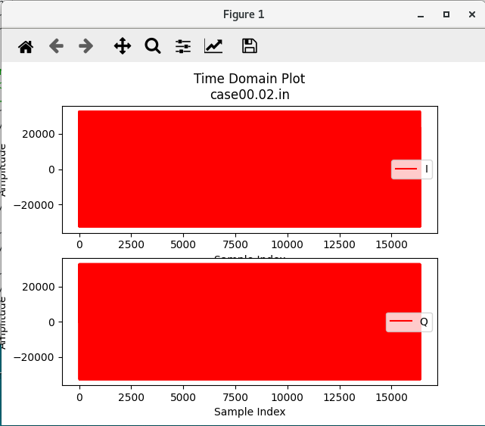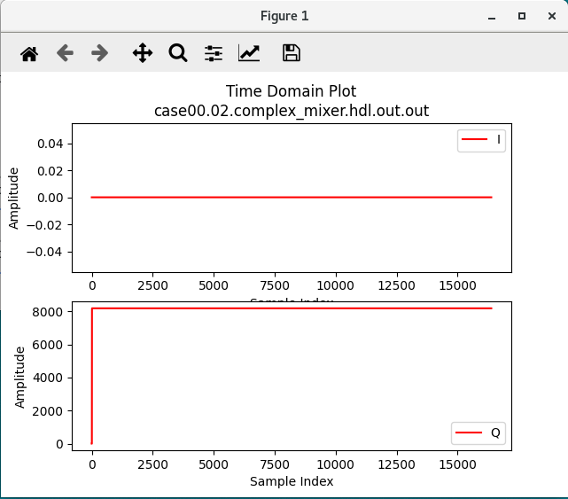

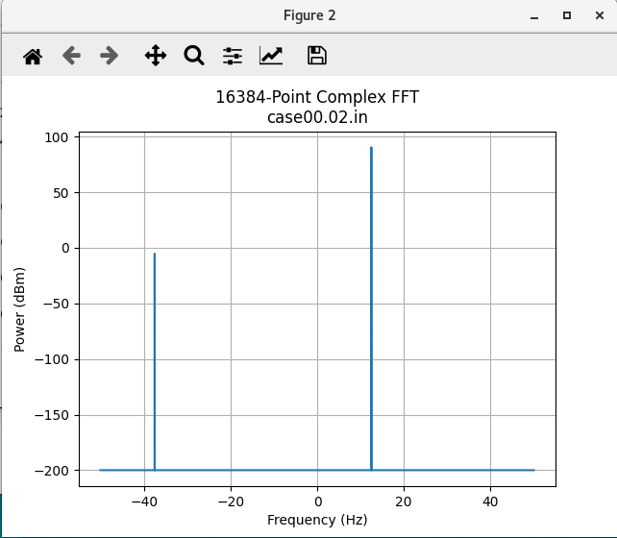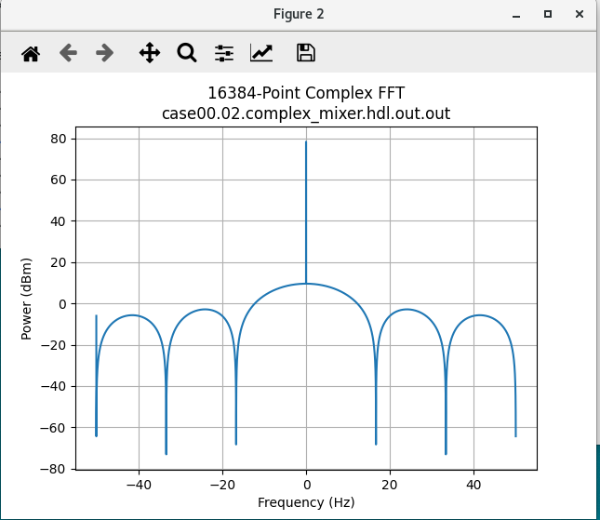

Case00.03 (enable = 1, data_select = 1)
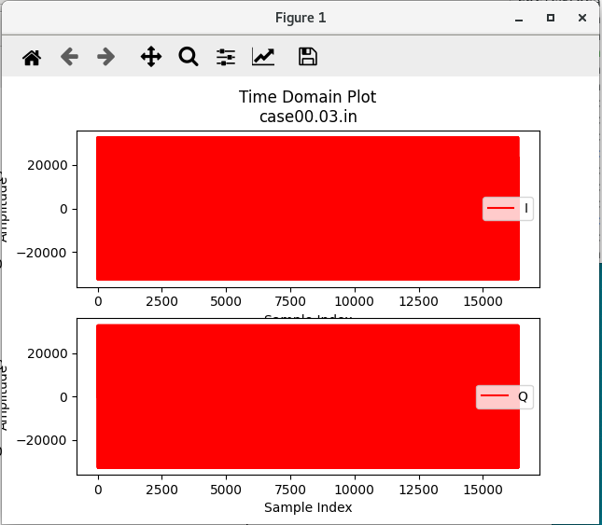
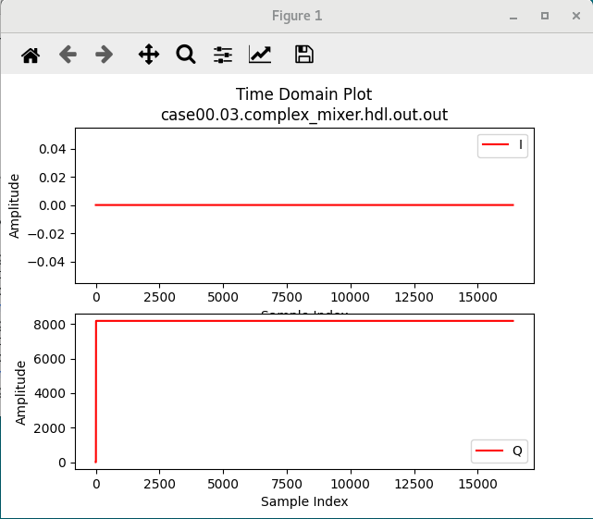

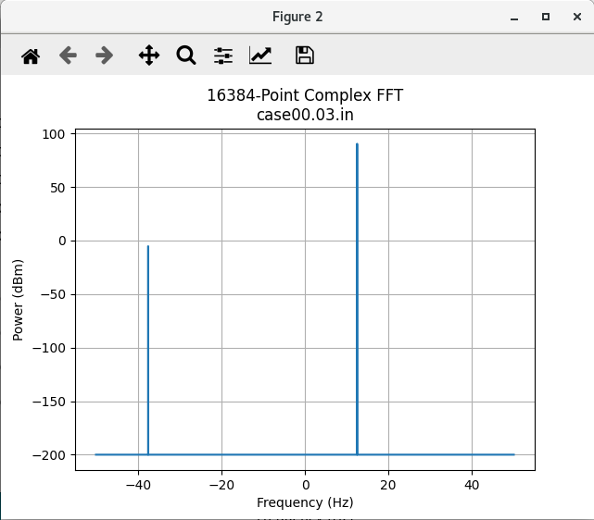
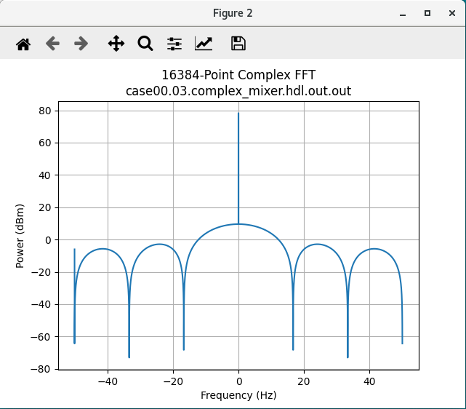

View Simulation Waveforms (Xilinx XSIM)
Note: In order to view simulation waveforms, you must have checked Keep Simulations in the OpenCPI GUI or have used the --keep-simulations option on the ocpidev command line when you ran the unit test.
To view the simulation waveforms:
- In a terminal window, browse to the complex_mixer.test/ directory.
- Run the following ocpiview command:
ocpiview run/xsim/case00.00.complex_mixer.hdl.simulation/ &
You should see the following output:
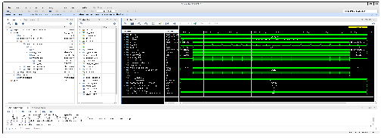

Tutorial Summary
In this tutorial, we created a complex_mixer component. Once you created that, we showed you how to create a complex_mixer HDL application worker that uses the Vivado third-party cores. You were also able to build the worker and successfully create a unit test for the worker you created. Overall, you were able to see the power of using third-party cores for HDL application workers.

