OpenCPI
Tutorial 3: Developing an RCC Worker
OpenCPI Release develop
Revision History
Revision | Description of Change | Date
1.0 | Creation | 2019-12-12
Table of Contents
1 Overview 5
1.1 Tutorial Objectives 6
1.2 What’s Provided for This Tutorial 7
1.3 Prerequisites to Using This Tutorial 8
1.4 Documentation References 9
2 Re-use DemoProject 10
3 Create Component 12
3.1 Create Component Spec 13
3.2 Create Component Properties and Ports 15
4 Create Worker 16
4.1 Create RCC Worker OWD and Skeleton File 17
4.2 Write RCC Worker C++ Code 18
4.3 Update RCC Worker Skeleton File 22
4.4 Build RCC Worker 25
5 Create Unit Test 26
5.1 Edit Unit Test Description File 29
5.2 Edit Test Scripts 32
5.3 Build Unit Test 38
6 Run Unit Test 39
7 Tutorial Summary 41

Overview
This tutorial introduces you to the RCC worker authoring model and the OpenCPI unit test suite for workers. Our example is the peak_detector component in the ocpi.tutorial project. We used this component, both its RCC and its HDL implementations, in our application and assemblies in Tutorial 2. In this tutorial, we’ll step through the procedure used to create the component and its RCC worker implementation. We’ll create a component specification for the peak_detector component and then design, build and test an RCC worker that implements its function.
The peak detector function is to calculate and report the signed maximum and minimum peaks in the I/Q data arriving at its input port and then pass this input data through unchanged to its output port. Given an input of complex numbers, the peak detector component finds the biggest I I or Q sample and the smallest I or Q sample. The process is as follows:
- current_biggest = max(current_biggest,max(I,Q))
- current_smallest = min(current_smallest,min(I,Q))
- Pass input complex samples to the output port
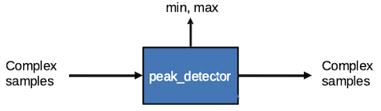
Figure 1: Peak Detector Component Function

Tutorial Objectives
The purpose of this tutorial is to demonstrate the design process for an RCC worker implementation, including how to use the OpenCPI unit test suite.
This tutorial shows you how to:
- Create the peak detector component specification (properties and ports).
- Create the peak detector worker C++ code and build the RCC worker for the target platform.
- Create, build and run the unit test for the RCC worker on the target platform.
It demonstrates how to use the RCC authoring model to:
- Implement component spec (OCS) properties as worker-local variables
- Access worker data ports
- Create worker methods for initializing local variables and running worker code
- Use worker method result values to communicate worker states to the OpenCPI framework
After running this tutorial, you should understand the basics of the RCC authoring model and how to use the OpenCPI unit test suite on an RCC worker implementation of a simple OpenCPI component.

What’s Provided for This Tutorial
The tutorial provides source code for the following tutorial items:
- The peak_detector worker, written according to the API for the RCC (C++ source code) authoring model.
- The unit test files generate.py and verify.py, written in Python
- The unit test bash shell script view.sh
This source code is available as text in the relevant sections of this document that you can copy and paste into the relevant files following the instructions given in the section.
The tutorial also provides the XML source for all of the assets used to build and run the example component, worker and tests, available as text in the relevant sections of the document.
You will also use the following script from ocpi.tutorial:
- The Python script code for plotting and viewing the output data, in scripts/PlotAndFft.py

Prerequisites to Using This Tutorial
Before you begin this tutorial, you should have successfully completed Tutorial 1, “Component-based Development” and Tutorial 2, “Designing Applications and HDL Assemblies”.
We recommend reading the following briefings before getting started with the tutorial:
- Briefing 4, “Component and Worker Overview”
- Briefing 5, “Automated Test Suite – Introduction”
- Briefing 6, “OpenCPI RCC Development”

Documentation References
The documents listed in the following table provide detailed information about subjects discussed in this tutorial. The documents listed here are not required reading for this tutorial but will likely be of interest for more in-depth learning.
Table 1 - OpenCPI Reference Documentation
Title | Published By | Public URL
OpenCPI User Guide | OpenCPI | https://opencpi.gitlab.io/releases/develop/docs/OpenCPI_User.pdf
OpenCPI Application Development Guide | OpenCPI | https://opencpi.gitlab.io/releases/develop/docs/OpenCPI_Application_Development.pdf
OpenCPI Component Development Guide | OpenCPI | https://opencpi.gitlab.io/releases/develop/docs/OpenCPI_Component_Development.pdf
OpenCPI HDL Development Guide | OpenCPI | https://opencpi.gitlab.io/releases/develop/docs/OpenCPI_HDL_Development.pdf
OpenCPI RCC Development Guide | OpenCPI | https://opencpi.gitlab.io/releases/develop/docs/OpenCPI_RCC_Development.pdf

Re-use DemoProject
We’ll continue to use the DemoProject project we created and used in Tutorial 1 and 2 for this tutorial. If you have deleted DemoProject, create it again with the following ocpidev command:
ocpidev -D ocpi.assets -D ocpi.tutorial create project DemoProject --register
If you want to use AV to create assets in DemoProject, you need to import it into AV. Do not use AV to create OpenCPI projects.
To import the DemoProject project:
- Start AV.
- Select File > Import. Select Existing Projects into Workspace and then click Next.
- In the Import Projects dialog, make sure Select Root Directory is checked and then click Browse on the right.
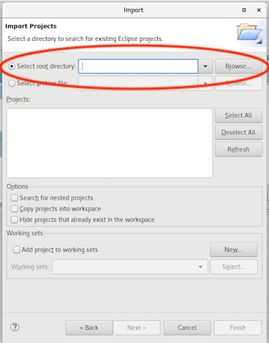
- Navigate to the directory where you created DemoProject and then click OK. You’ll see local.DemoProject listed and selected.
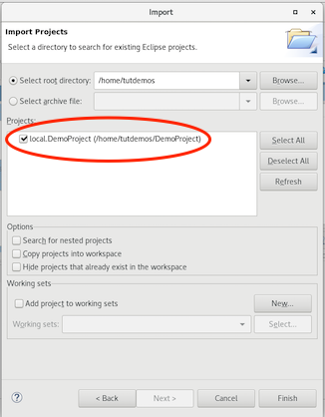
- Leave all of the other fields blank and click Finish. The local.DemoProject project is displayed in the (Eclipse) Project Explorer view.
- In the OpenCPI Projects view, click Refresh. You should now see local.DemoProject displayed in the OpenCPI Projects view.
Note: Make sure the Project.mk file in the DemoProject directory includes the following two lines:
ComponentLibraries+=util_comps
HDlLibraries+=prims
If these lines are not in the Project.mk file, open it with a text editor and add them at the end of the file.

Create Component
Now we need to create the OCS (OpenCPI Component Specification) for our peak detector function that defines its properties and ports.

Create Component Spec
Recall that we created a components library for components we created in DemoProject in Tutorial 1. We’ll create our new peak_detector component spec in that library.
To create the component spec with AV:
- In the OpenCPI Projects view, click on the components library. Right click and then select new component.
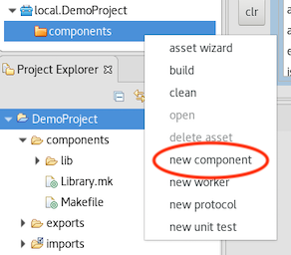
- The asset creation dialog for a component appears. In Component Name, enter peak_detector. Leave the other fields as they are so that AV uses the default values.
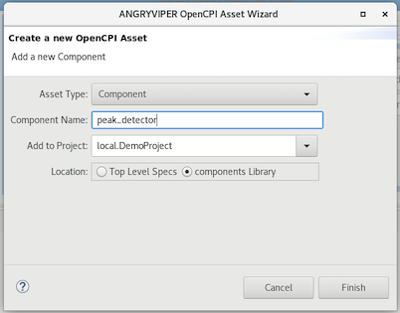
- Click Finish. When the operation completes, the peak_detector-spec.xml file should be listed in the specs subdirectory of the components directory in the Project Explorer and displayed in the OCS Editor in the text editor panel.
To create the component spec with ocpidev, run the following command from the DemoProject directory:
ocpidev create component peak_detector
The command creates the component spec peak_detector-spec.xml in components/specs. We’ll add properties and ports to the component spec in the next step.

Create Component Properties and Ports
The peak_detector component function requires two properties: a max_peak property that returns the most positive I or Q value and a min_peak property that returns the most negative I or Q value. The worker implementation of the component uses these properties to keep track of maximum and minimum peak amplitudes and will change their values during execution, so they should be declared as volatile properties.
The peak_detector component also requires one input port and one output port for communication with other components in an application; both ports will use the iqstream protocol.
To create the properties and ports in AV:
- Click the peak_detector-spec.xml tab and then click the Design tab. In Outline, click Properties and then click Add a Property to display the OCS Properties page. (You can also right-click on Properties and then select Add Ocs Property to display it.)
- In Name, enter min_peak. In Type, select short from the drop down list. In Accessibility, check Volatile.
- In Outline, click Properties > Add a Property again to display the OCS Properties dialog. In Name, enter max_peak. In Type, select short from the drop-down list. In Accessibility, check Volatile.
- In Outline, click Ports and then click Add a Port (or right-click on Ports and then select Add a Port) to display the OCS Port Definition dialog. In Name, enter in. In Protocol, select iqstream_protocol. Leave the other fields blank.
- In Outline, click Ports > Add a Port again to display the OCS Port Definition dialog. In Name, enter out. In Protocol, select iqstream_protocol. Check Producer.
- Now click the Source tab for the peak_detector component. You can see the two properties and two ports defined in XML between the ComponentSpec elements.
- Click Save (the floppy disk icon below the top menu bar).
To create the properties and ports from the command line, open peak_detector-spec.xml with a text editor and add the following XML between the ComponentSpec elements (highlighted in red):
<ComponentSpec>
<Property Name="min_peak" Type="uShort" Volatile="true"/>
<Property Name="max_peak" Type="uShort" Volatile="true"/>
<Port Name="in" Protocol="iqstream_protocol"/>
<Port Name="out" Protocol="iqstream_protocol" Producer="true"/>
</ComponentSpec>

Create Worker
We’ve defined the peak_detector component spec. Now we need to create the workers that implement them. In our case, we only need to create one implementation – an RCC implementation – which uses the RCC authoring model.
Recall from the OpenCPI User’s Guide and the introductory briefings that workers run on containers, which provide the runtime environment for executing workers and manage their execution on a processor. An RCC worker implements worker methods called by the container and can also call container methods.
RCC workers use symbols, data types and ordinals defined in a header file that is generated for the worker when it is created. These elements are based on the component spec (OCS), protocol spec (OPS) and worker description (OWD) and include the implementation name, the control operations implemented, the properties that require notification, the static memory allocation requirements of the implementation code and the minimum number of buffers required at each port. The information in the OCS, OPS and OWD is used to drive the code generation and build process for the worker. An RCC worker can call a small subset of Posix and ISO-C runtime libraries that provide the minimal environment required of embedded systems. You can read more about these local services and about RCC worker OWD elements, the RCC worker interface and RCC worker code generation in the OpenCPI RCC Development Guide.
In Tutorial 1, we created an RCC worker, which generated an rcc subdirectory with the worker’s OWD XML file and a “skeleton” source code file in the C++ language that we updated to include the C++ code for the worker. We’ll do the same thing here for our peak_detector worker.

Create RCC Worker OWD and Skeleton File
To create the worker with AV:
- In the OpenCPI Projects view, expand local.DemoProject and then navigate to components > specs.
- Select peak_detector-spec.xml. Right click and then select new worker from the context menu.
- The asset creation dialog for a worker appears. In Worker Name, enter peak_detector. Leave the displayed values in the other fields as they are.
- Click Finish. When the operation completes, you should see a tab labeled peak_detector.xml displayed in the text editor panel and the RCC App Worker OWD Design Editor displayed in the tab. The Project Explorer should show a subdirectory peak_detector.rcc in the components directory.
To create the worker with ocpidev, run the following command in the DemoProject directory:
ocpidev create worker peak_detector.rcc
Recall from Tutorial 1 that the suffix of the worker's name - .rcc in this case - directs the tool to generate an RCC worker.
Run the tree command and you’ll see that the components directory now has a subdirectory peak_detector.rcc with the files peak_detector.xml (the OWD) and peak_detector.cc (the skeleton file).
Recall from Tutorial 1 that an RCC worker’s OWD does not usually need to be changed, so we don’t need to do anything with peak_detector.xml. The peak_detector.cc skeleton file is the basis for writing the worker’s execution code. We need to add the C++ code that implements our peak detector function to this file; we’ll create this code in the next step.
In peak_detector.rcc/gen, you’ll see the generated header file peak_detector-worker.hh. Do not edit this file. It contains the type definitions and declarations customized for this worker. You’ll also see a peak_detector-skel.cc file in the gen subdirectory. This file exists as a backup copy of the skeleton file and should not be touched.

Write RCC Worker C++ Code
The peak_detector worker uses two local variables to keep track of the maximum and minimum peak amplitudes. To ensure that the peaks are detected correctly, the worker needs to initialize the variable that keeps track of the maximum peak to the most negative value represented in a signed 16-bit number (-32768) and initialize the variable that keeps track of the minimum peak to the most positive value represented in a signed 16-bit number (32767).
On completion, the peak_detector worker returns the most positive I or Q sample value with the max_peak property and the most negative with the min_peak property. This is not the value of the vector represented by I and Q, but simply the max/min value of the I and Q samples taken independently. The worker uses the OpenCPI iqstream protocol for both input and output ports (specified by the OPS iqstream-protocol.xml in the opci.core project). The iqstream protocol defines an interface of 16-bit complex signed samples. You can find the OPS for the iqstream protocol in <opencpi_install_path>/projects/core/specs/iqstream-protocol.xml.
To implement these functions, our peak_detector worker code needs to:
- Declare the persistent local variables min_buff and max_buff for the min_peak and max_peak properties.
- Provide a start method that initializes these local variables.
- Provide a run method that checks for end of input data, makes sure there is room on the output port for the output data, performs the necessary function for the component and advances the ports.
The next sections describe how to write this code for the peak_detector worker. For details on RCC worker methods and on developing RCC workers, see the OpenCPI RCC Development Guide.

Write Initialization Code
We need to put the persistent local variables min_buff and max_buff into the body of the Peak_detectorWorker class, which exists in the generated skeleton file. These internal buffers should match the short type defined for the min_peak and max_peak properties in the OCS. We then initialize them in the start RCC worker method: max_buff to most negative (-32767) and min_buff to most positive (32768) values. We use the start method because we’re initializing property values and so that initialization occurs both when the worker is first started and when it is resumed after being suspended. Write the following code:
class Peak_detectorWorker : public Peak_detectorWorkerBase {
int16_t max_buff, min_buff;
RCCResult start(){
max_buff = -32768; // initialize max to most neg
min_buff = 32767; // initialize min to most pos
return RCC_OK;
}
Note the RCCResult type declared in the start method. All worker methods use the RCCResult type as a return value to indicate to the container on which they’re executing what to do when the worker method returns. Here, the RCCResult value RCC_OK indicates to the container that the worker has succeeded without error and that normal execution can continue.

Write End of File Checking Code
We need the worker’s run method to check for end-of-file status on the input port so that the worker can determine when there’s no more input data to process. Checking for end-of-file status has the syntax:
if(<PortInName>.eof()) {
<PortOutName>.setEOF();
return RCC_DONE;
}
The RCCResult value RCC_DONE indicates to the container that the worker needs no further execution and allows the container to release resources like I/O buffers. For details on RCCResult values, see the OpenCPI RCC Development Guide.
For peak_detector.cc, write the following code for the run method:
if(in.eof()) {
out.setEOF();
return RCC_DONE;
}

Write Output Port Checking Code
Our run RCC worker method also needs to make sure there is room on the output port for the outgoing I/Q data. The syntax is:
const size_t num_of_elements =
<PortInName>.<OpName>().<ArgName>().size();
<PortOutName>.<OpName>().<ArgName>().resize(num_of_elements);
<PortOutName>.setOpCode(<PortInName>.opCode());
In an OpenCPI Protocol Specification (OPS), a message is called an operation and a field in a message is called an argument. Here, <OpName> is the name of the operation – in our case, iq – and <ArgName> is the name of the argument – in our case, data. An opCode indicates which protocol operation a given message represents. When methods deal with opCodes, they are dealing with an ordinal for the message in a buffer. The opCode identifies which type of message is in the buffer, among those defined by the protocol. OpCode values are zero-origin in the order of how the operations are defined in the protocol (OPS) XML file. For details, see the description of the OpenCPI Protocol Specification the OpenCPI Component Development Guide and the OPS iqstream_protocol.xml in <opencpi_install_path>/projects/core/specs/.
The RCC authoring model provides buffer management data members and methods. Here, the opCode method retrieves the opcode of the input buffer and the setOpCode method sets it in the output port. For details, see the OpenCPI RCC Development Guide.
To implement this syntax for peak_detector.cc, write the following code for the run method:
const size_t num_of_elements = in.iq().data().size();
out.iq().data().resize(num_of_elements);
out.setOpCode(in.opCode());

Write Run Function Code
The run RCC worker method needs to create pointer objects for reading input data and writing output data. The syntax is:
const <ProtocolNameOpNameArgName> * idata =
<PortInName>.<OpName>().<ArgName>().data();
<ProtocolNameOpNameArgName> * odata =
<PortOutName>.<OpName>().<ArgName>().data();
To implement this syntax, add the following code to the peak_detector.rcc run method:
const IqstreamIqData *idata = in.iq().data().data();
IqstreamIqData *odata = out.iq().data().data();
Is the input a sequence or an array? If it is one of these structures, the run method for the RCC worker needs to iterate through the elements. Recall that max_peak is the greatest value of either I or Q and min_peak is the smallest value of either I or Q. Write the following code for the peak_detector.cc run method:
for ( ) { // decrement through num_of_elements
// 1. determine max peak and min peak
*odata++=*idata++ // 2. copy this message to output buffer
}
// 4. set properties().max_peak & set properties().min_peak
// to the calculated max_buff and min_buff
// 3. Do work
for (unsigned n = num_of_elements; n; n--) {
max_buff = std::max(std::max(idata→I,idata→Q),max_buff);
min_buff = std::min(std::min(idata→I,idata→Q),min_buff);
*odata++ = *idata++; // copy this message to output buffer
}
properties().max_peak = max_buff;
properties().min_peak = min_buff;
Note that peak_detector.rcc must include the algorithm standard template library to use the max and min functions for sequences (highlighted in red in the code example above.) Be sure to include it at the start of your C++ code like this:
#include <algorithm>

Write Advance Port Code
The run RCC worker method is finished when the length of the input buffer is zero. Add the following code to the peak_detector.cc run method to signal the container to advance the ports:
return num_of_elements ? RCC_ADVANCE : RCC_ADVANCE_DONE;
The RCCResult value RCC_ADVANCE tells the container to advance the ports that were ready when the run method was called, while the value RCC_ADVANCE_DONE tells the container to advance the ports and that the worker is entering the finished state like RCC_DONE.
Now we’re ready to update the worker skeleton file with the C++ code we’ve written.

Update RCC Worker Skeleton File
Now we’ll add the C++ source code we just created to the peak_detector.cc skeleton file.
If you’re using AV, you can use the Project Explorer to locate the worker skeleton file. Select it and then right-click. Select Open (or Open with) to open it with a text editor. With the worker’s skeleton file tab open, click the Maximize button at the top right to maximize its display. When you finish editing the file, click Save (the floppy disk icon in the tool bar underneath the main menu) and then click the Restore button at the top right to collapse the file tab.

Using a text editor, replace the code in the peak_detector.cc skeleton file in components/peak_detector.rcc/peak_detector.cc with the following C++ code:
#include <algorithm>
#include "peak_detector-worker.hh"
using namespace OCPI::RCC; // for easy access to RCC data types
// and constants using namespace Peak_detectorWorkerTypes;
class Peak_detectorWorker : public Peak_detectorWorkerBase {
int16_t max_buff, min_buff;
RCCResult start(){
max_buff = -32768;
min_buff = 32767;
return RCC_OK;
/* Other valid: */
// max_buff = std::numeric_limits<int16_t>::min();
// add #include <limits>
// min_buff = std::numeric_limits<int16_t>::max();
// add #include <limits>
// max_buff = int16_t(pow(2,(double((sizeof(idata→I)*8)-1))));
// add #include <cmath>
// min_buff = (-1)*max_neg-1;
}
RCCResult run(bool /*timedout*/) {
// determine if end of file
if (in.eof()) {
out.setEOF();
return RCC_DONE;
}
// 1. Make sure there is room on the output port
const size_t num_of_elements = in.iq().data().size();
out.iq().data().resize(num_of_elements);
out.setOpCode(in.opCode());
// 2. Do work
const IqstreamIqData *idata = in.iq().data().data();
IqstreamIqData *odata = out.iq().data().data();
for (unsigned n = num_of_elements; n; n--) {// n is length in sequence elements of input
max_buff = std::max(std::max(idata→I,idata→Q),max_buff);
min_buff = std::min(std::min(idata→I,idata→Q),min_buff);
*odata++ = *idata++; // copy this message to output buffer
}
properties().max_peak = max_buff;
properties().min_peak = min_buff;
// 3. Advance ports
return num_of_elements ? RCC_ADVANCE : RCC_ADVANCE_DONE;
}
};
PEAK_DETECTOR_START_INFO
// Insert any static info assignments here (memSize, memSizes, portInfo)
// e.g.: info.memSize = sizeof(MyMemoryStruct);
PEAK_DETECTOR_END_INFO

Build RCC Worker
Now we need to compile the peak_detector worker for the platform on which we want to run it; for this tutorial, it’s our development host. Although workers are normally built as part of building an entire component library or as part of an entire project, we’ll build our peak_detector worker separately.
To build the worker with AV:
- In the OpenCPI Projects view, select the peak_detector worker.
- Click the > button in the Operations Panel to move the worker to this panel.
- In RCC Platforms, select centos7.
- Click Build.
- If the build succeeds, you’ll see a message in the Build Status tab with the DemoProject and what you’ve built (peak_detector, in this case) highlighted in green. You can click the Maximize button to view the entire message.
To build the worker with ocpidev, run the following command from the DemoProject directory:
ocpidev build worker peak_detector.rcc --rcc-platform centos7
Navigate to components/peak_detector.rcc. There should be a new subdirectory target-centos7 that contains the artifacts needed to run the worker on this platform. Make sure the file peak_detector.o (highlighted in red in the output of the ls -l command below) exists in this subdirectory:
ls -l target-centos7
peak_detector_assy-art.xml
peak_detector_assy.xml
peak_detector_dispatch.c
peak_detector_dispatch.o
peak_detector_dispatch.o.deps
peak_detector.o
peak_detector.o.deps
peak_detector.so
peak_detector_s.so
Next, we’ll create the unit test for peak_detector and then run it.

Create Unit Test
An OpenCPI unit test suite is a collection of test cases that allow functional testing of all workers that implement a component specification across all available platforms for which the workers have been built. A component’s unit test suite is contained in a subdirectory named <component>.test in a component library. The test suite can be applied to all of the workers in the library that implement that component’s OCS, regardless of authoring model and/or language.
For more information on the OpenCPI unit test suite feature and how to use it, see the OpenCPI Component Development Guide.
We’ll use the OpenCPI unit test suite feature to generate:
- An application XML (OAS) that the OpenCPI framework can use to run the worker on a given platform
- Input test files
A unit test consists of the following phases:
- The generate phase, which creates the gen subdirectory and generates the input data, OAS, OHAD and case configuration(s)
- The build phase, which builds the HDL assemblies for the target platforms. This phase is only relevant for HDL workers.
- The prepare phase, which creates the run subdirectory, examines the available built workers and platforms and creates the execution scripts
- The run phase, which executes the tests
- The verify phase, which verifies the results
We’ll use combinations of these phases as we create, build and run our peak_detector unit test.
To create the unit test suite for the peak_detector worker with AV:
- In the OpenCPI Projects view, click local.DemoProject. Right click and then select asset wizard.
- In the drop-down list, select the Unit Test asset type. Leave the other fields are they are.
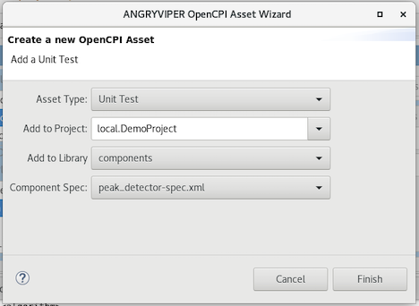
- Click Finish. When the operation completes, you’ll see a new peak_detector.test subdirectory in components in the OpenCPI Projects view and the Project Explorer view and the Unit Test Editor open for the peak_detector-test.xml file in the text editor panel. Use the Project Explorer view to observe the files created.
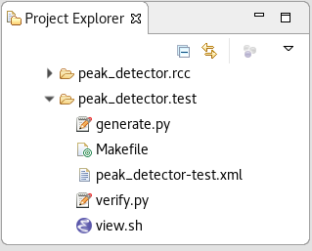

To create the unit test with ocpidev, run the following command from the DemoProject directory:
opcidev create test peak_detector
Now run the tree command to observe the files created:
peak_detector.test
├── generate.py
├── Makefile
├── peak_detector-test.xml
├── verify.py
└── view.sh
The files of interest here are:
- peak_detector-test.xml. This is the test suite description file. It specifies the test cases and the defaults that apply to all test cases.
- Makefile. This is the test suite makefile, analogous to Makefiles for the other OpenCPI assets like libraries, components, workers and so on.
- generate.py. This is a stub file for an optional script that you can create to generate input test data for ports or property value files. There is one script for each input port.
- verify.py. This is a stub file for an optional script that you can create to verify output test data produced by output ports. There is one script for each output port..
- view.sh. This is a stub file for an optional script that you can create to view the results of a test execution; for example, a plot. This script may not be necessary or appropriate for many workers. It can work as a helpful aid in the development process, but it is not meant for long-term testing and re-testing.
We want to use the generate, verify and view scripts in this tutorial, so we’ll need to edit the test suite description file to specify them and create the code for each script. The next sections describe these steps.

Edit Unit Test Description File
In this step, we’ll edit the unit test description file peak_detector-test.xml. We need to add the generate and verify scripts with the sample size 32768 as parameters to the scripts. We’ll also set up the test to use HDL file I/O. It’s not applicable for testing our RCC worker, but we’ll need it in a later tutorial, where we’ll use this same test on an HDL implementation of the peak detector worker.
To edit the unit description file with AV:
- Click on the peak_detector-test.xml tab in the text editor panel and maximize it. You’ll see the following dialog:
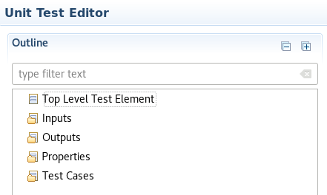
- In Outline, click Inputs and then click Add. The New Inputs dialog appears. In Ports, enter in. In Script, enter generate.py 32768. Leave the remaining fields blank.
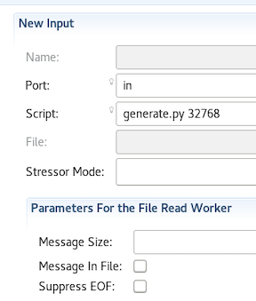
- In Outline, click Outputs. The New Output dialog appears. In Port, enter out. In Script, enter verify.py 32768. In View, enter view.sh. Leave the remaining fields blank.
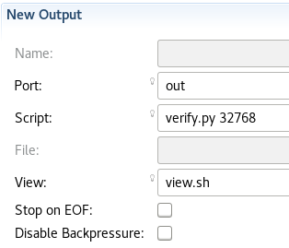
Click Save (the floppy disk icon below the top menu bar.
To edit the unit test description file on the command line, open the peak_detector-test.xml file with a text editor and make the following changes:
- Uncomment the Input and Output elements
- Edit the Input element to add the value 32768 as the sample size parameter to the generate.py script:
Script='generate.py 32768'
- Edit the Output element to add the value 32768 as the sample size parameter to the verify.py script:
Script='verify.py 32768'
Your peak_detector-test.xml file should now look like this:
<Tests Use HDLFileIo='true'>
Input Port='in' Script='generate.py 32768'/>
Output Port='out' Script='verify.py 32768' View='view.sh'/>
</Tests>

Edit Test Scripts
Now we need to create code for the empty generate.py, verify.py and view.sh scripts we created when we created the unit test. We’ll use the code provided in the next sections for this purpose.

Edit generate.py Script
Open the generate.py script with a text editor and then copy and paste the following text into the file:
#!/usr/bin/env python
"""Generate idata for Peak Detector (binary data file).
Generate args:
- amount to generate (number of complex signed 16-bit samples)
- target file
To test the Peak Detector, a binary data file is generated
containing complex signed 16-bit samples with a tone at 13 Hz.
The input data is passed through the worker, so the output file
should be identical to the input file. The worker measures
the minimum and maximum amplitudes found within the complex
data stream. These values, reported as properties, are compared
with min/max calculations performed within the script.
"""
import struct
import shutil
import numpy as np
import sys
import os.path
class color:
PURPLE = '\033[95m'
CYAN = '\033[96m'
DARKCYAN = '\033[36m'
BLUE = '\033[94m'
GREEN = '\033[92m'
YELLOW = '\033[93m'
RED = '\033[91m'
BOLD = '\033[1m'
UNDERLINE = '\033[4m'
END = '\033[0m'
def generate(argv):
print "*** Generate input (binary data file) ***"
if len(argv) < 2:
print("Exit: Enter number of input samples (int:1 to ?)")
return
elif len(argv) < 3:
print("Exit: Enter an input filename")
return
filename = argv[2]
num_samples = int(argv[1])
# Create an input file with a single tone at 13 Hz; Fs=100 Hz
Tone13 = 13
Fs = 100
Ts = 1.0/float(Fs)
t = np.arange(0,num_samples*Ts,Ts,dtype=np.float)
real = np.cos(Tone13*2*np.pi*t)
imag = np.sin(Tone13*2*np.pi*t)
out_data = np.array(np.zeros(num_samples), dtype=np.dtype((np.uint32, {'real_idx':(np.int16,2), 'imag_idx':(np.int16,0)})))
# pick a gain at 95% max value - i.e. back off a little
# to avoid file eneration overflow. This results in
# complex amplitudes that swing between +31k and -31k
# within an int16. We must use the same gain on both rails to
# avoid I/Q spectral image
gain = 32768*0.95 / max(abs(real))
out_data['real_idx'] = np.int16(real * gain)
out_data['imag_idx'] = np.int16(imag * gai
# Save data file
f = open(filename, 'wb')
for i in xrange(0,num_samples):
f.write(out_data[i])
f.close()
print 'Output filename: ', filename
print 'Number of samples: ', num_samples
print '*** End of file generation ***\n'
def main():
print "\n","*"*80
print "*** Python: Peak Detector ***"
generate(sys.argv)
if __name__ == '__main__':
main()

Edit verify.py Script
Open the verify.py script with a text editor and then copy and paste the following text into the file:
#!/usr/bin/env python
"""Validate odata for Peak Detector (binary data file).
Validate args:
- amount to validate (number of complex signed 16-bit samples)
- target file
To test the Peak Detector, a binary data file is generated
containing complex signed 16-bit samples with a tone at 13 Hz.
The input data is passed through the worker, so the output file
should be identical to the input file. The worker measures
the minimum and maximum amplitudes found within the complex
data stream. These values, reported as properties, are compared
with min/max calculations performed within the script.
"""
import struct
import shutil
import numpy as np
import sys
import os.path
import os
import re
class color:
PURPLE = '\033[95m'
CYAN = '\033[96m'
DARKCYAN = '\033[36m'
BLUE = '\033[94m'
GREEN = '\033[92m'
YELLOW = '\033[93m'
RED = '\033[91m'
BOLD = '\033[1m'
UNDERLINE = '\033[4m'
END = '\033[0m'
def validation(argv):
print "*** Validate output against expected data ***"
if len(argv) < 2:
print ("Exit: Need to know how many samples")
return
elif len(argv) < 3:
print("Exit: Enter an output filename")
return
num_samples = int(argv[1])
# strip off output extension and replace with 'log'
# ('.out.out'=>'.log')
logname = os.path.splitext(argv[2])[0]
logname = os.path.splitext(logname)[0] + ".log"
if not os.path.isfile(logname):
logname = os.path.splitext(logname)[0] + ".remote_log"
# Parse the logfile for the final values of max/min peaks
# Normally, we would access these via environment variables:
# OCPI_TEST_max_peak, OCPI_TEST_min_peak
# Due to an inconsistency in the unit test framework,
# the final values of these properties are captured
# correctly in the environment variables
# for RCC workers, but not HDL.
with open(logname, 'rb') as log:
for line in log:
max_obj = re.search("Property \d+:
peak_detector.max_peak = \"(-?\d+)\".*", line)
if max_obj: #max_obj[1]:
max_peak = int(max_obj.group(1))
min_obj = re.search("Property \d+:
peak_detector.min_peak = \"(-?\d+)\".*", line)
if min_obj: #[1]:
min_peak = int(min_obj.group(1))
if not min_peak or not max_peak:
print("Exit: log file does not contain max/min peak
final values")
return
#Read all of input data file as complex int16
print 'File to validate: ', argv[2]
ofile = open(argv[2], 'rb')
dout = np.fromfile(ofile, dtype=np.dtype((np.uint32,
{'real_idx':(np.int16,2), 'imag_idx':(np.int16,0)})), count=-1)
ofile.close()
#Ensure dout is not all zeros
if all(dout == 0):
print color.RED + color.BOLD + 'FAILED, values are all
zero' + color.END
return
#Ensure that dout is the expected amount of data
if len(dout) != num_samples:
print color.RED + color.BOLD + 'FAILED, input file
length is unexpected' + color.END
print color.RED + color.BOLD + 'Length dout = ', len(dout),
'while expected length is = ' + color.END, num_samples
return
# Calculate the maximum in python for verification
pymin = min(min(dout['real_idx']), min(dout['imag_idx']))
pymax = max(max(dout['real_idx']), max(dout['imag_idx']))
print 'uut_min_peak = ', min_peak
print 'uut_max_peak = ', max_peak
print 'file_min_peak = ', pymin
print 'file_max_peak = ', pymax
if (min_peak != pymin) or (max_peak != pymax):
print color.RED + color.BOLD + 'FAILED, min/max values
do not match' + color.END
return
print 'Data matched expected results.'
print color.GREEN + color.BOLD + 'PASSED' + color.END
print '*** End validation ***\n'
def main():
print "\n","*"*80
print "*** Python: Peak Detector ***"
validation(sys.argv)
if __name__ == '__main__':
main()

Edit view.sh Script
Open the view.sh script with a text editor and then copy and paste the following text into the file:
#!/bin/bash –noprofile
# Use this script to view your input and output data.
# Args: <list-of-user-defined-args> <input-file> <output-file>
$OCPI_PROJECT_DIR/scripts/plotAndFft.py $2 complex 32768 100&
$OCPI_PROJECT_DIR/scripts/plotAndFft.py $1 complex 32768 100&

Build Unit Test
Now we’ll build the unit test suite for the target platform.
To build the unit test with AV:
- In the OpenCPI Projects view, select peak-detector.test.
- Click the > button in the Operations Panel to move the unit test to this panel.
- Click Tests.
- In RCC Platforms, select centos7.
- What about remotes v test cases selection??
- Click gen + build.
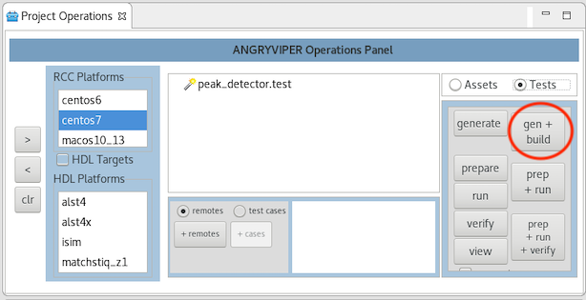
To generate and build the unit test with ocpidev, run the command:
ocpidev run test peak_detector.test --mode gen_build --rcc-platform centos7
Navigate to peak_detector.test/gen/ and observe the artifacts created. The following files and directories are of interest:
- cases.txt. This file is user-readable and lists various test configurations.
- cases.xml. This file is used by the OpenCPI framework to execute tests.
- cases.xml.deps. This file contains a list of dependent files.
- applications/. This directory contains OAS files and scripts used by the OpenCPI framework to execute applications.

Run Unit Test
Now we’ll run the unit test and view the results.
To run the unit test and view the results with AV:
- In the Operations Panel, click prep+run+verify.
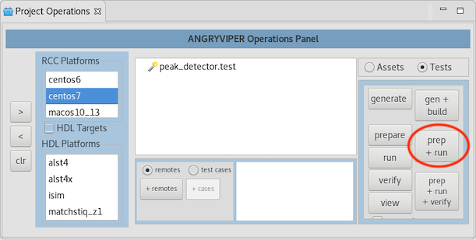
- Now click view.
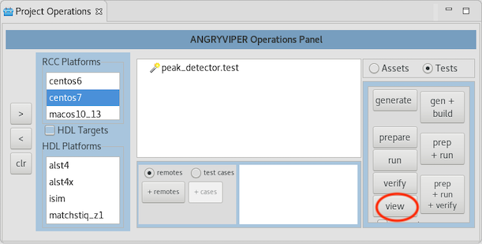

To run the test and view the output from the command line, browse to peak_detector.test/ and run the following ocpidev command:
ocpidev run --mode prep_run_verify --only-platform centos7 –view
You should see this output:
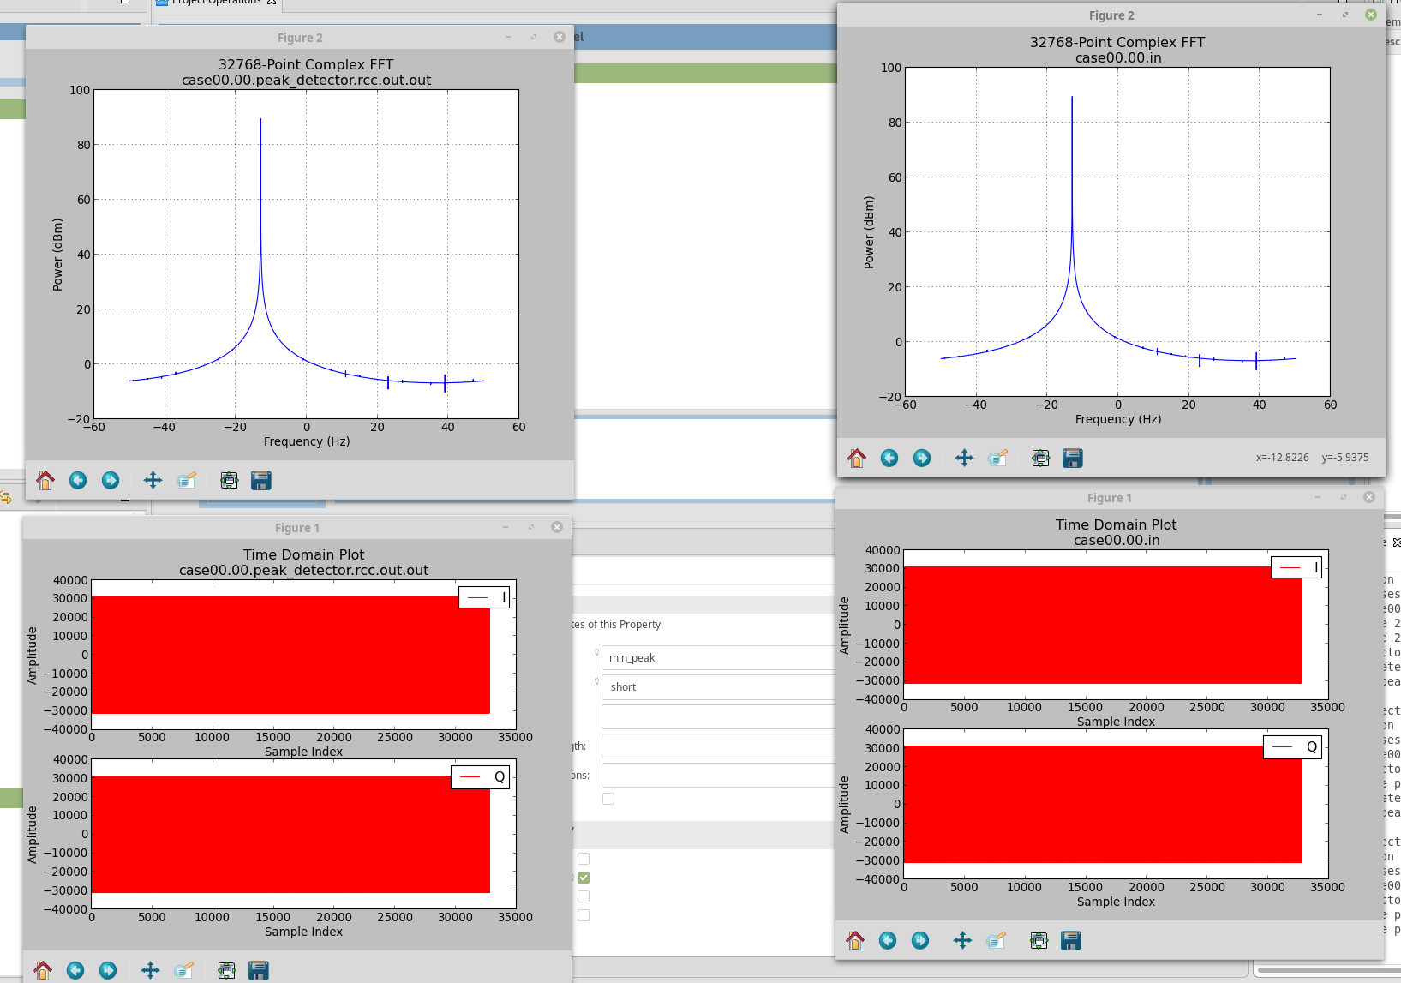

Tutorial Summary
Now that you’ve completed this tutorial, you should be familiar with the basic concepts of the RCC authoring model and how to use it to develop an RCC worker and the OpenCPI unit test suite and how to use OpenCPI tools to perform unit testing on an RCC worker.

