OpenCPI
Tutorial 7: Using HDL Primitive Libraries

Revision History
Revision | Description of Change | Date
1.0 | Creation from Lab 7 developed by BIA | 2019-10-01
1.1 | Update for release 2.4.0 | 2021-12-10
1.2
1.3
1.4
1.5
1.6
1.7
1.8
1.9
2.0
2.1
Table of Contents
1 Overview 4
1.1 Tutorial Objectives 6
1.2 What’s Provided for This Tutorial 7
1.3 Prerequisites to Using This Tutorial 8
1.4 Documentation References 9
2 Create New Project 10
3 Create HDL Primitive Library 11
4 Copy HDL Primitive Library Files from the Tutorial Project 12
5 Build HDL Primitive Library 13
6 Create Component Library 14
7 Create Component 15
7.1 Create Component Spec 16
7.2 Add Component Properties and Ports 17
8 Create Worker 18
8.1 Update HDL Worker Skeleton Files 19
8.2 Build Worker 20
9 Create Unit Test 21
9.1 Copy Unit Test Description File 22
9.2 Copy Test Scripts from Tutorial Project 23
9.3 Build Unit Test 24
10 Run Unit Test 25
11 View Unit I/O Test Plots 26
12 View Simulation Waveforms 27
13 Tutorial Summary 28

Overview
This tutorial introduces you to HDL primitives and primitive libraries. HDL primitives are HDL assets that are lower level than workers. They can be used as building blocks for workers and are useful for HDL workers when there is lower-level code that is reused or shared in different workers. Using HDL primitives is also useful when there are non-OpenCPI code modules that are imported and need to be left untouched so that they remain useful outside of OpenCPI.
HDL primitives are the preferred way in OpenCPI to store and present reusable HDL for use in multiple workers. Using HDL primitives is not required, but it is recommended practice.
HDL primitives can be libraries or cores. An HDL primitive library is a collection of modules compiled from source code that can be referenced in HDL worker code, while an HDL primitive core is a single module. This tutorial demonstrates how to create an HDL primitive library and use it in HDL worker code. Our example is the agc_complex component in the ocpi.tutorial project.
This component inputs complex signed samples, drives the amplitude of both I and Q input rails to a reference level, and outputs complex signed samples.
The response time and output level of the circuit are programmable, as is the ability to update/hold the gain differential used in the feedback loop. The size of the averaging window used for peak detection is build-time programmable using the avg_window parameter, which is recommended to be a power-of-two to enable hardware division implementation with shift registers.
The ref property controls the desired output amplitude, while the mu property controls the AGC time constant, thus determining the response time of the circuit.
This implementation uses three multipliers per I/Q rail to process input data at the clock rate - i.e. this worker can handle a new input value every clock cycle. This circuit will produce output one clock cycle after each valid input, but the input-to-output latency is actually three valid clock cycles.
The AGC Complex worker uses the OCPI iqstream_protocol for both input and output ports. The iqstream_protocol defines an interface of 16-bit complex signed samples. The data_width parameter may be used to reduce the worker’s internal data width to less than 16-bits.
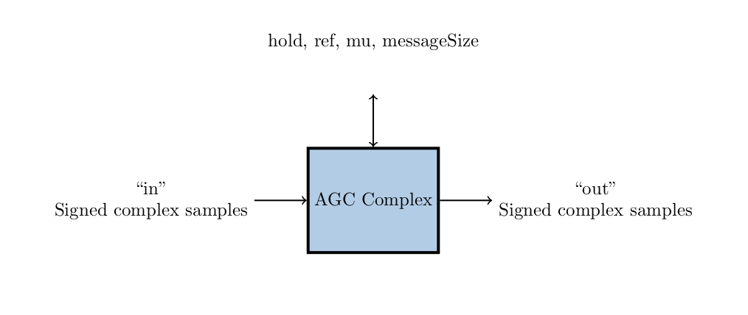Figure 1: AGC Complex Component Function

Tutorial Objectives
The purpose of this tutorial is to demonstrate how to create an HDL primitive library and use it in an HDL worker. It shows you how to:
- Create the HDL primitive library to be used by the AGC complex worker
- Create the AGC complex component, HDL worker, and component unit test suite and build the worker and unit test for the xsim platform
- Run the component unit test on the xsim platform and view the generated output
The provided source files show:
- A primitive library package declaration file that enables VHDL code to instantiate all entities and modules in the primitive library.
- A primitive library VHDL source file that implements a simple automatic gain control (AGC) with two independent channels for I and Q respectively. This file in particular stores the record signal names.

What’s Provided for This Tutorial
This tutorial provides source code for the following tutorial items:
- The HDL primitive source and package declaration VHDL files, in hdl/prims/agc.vhd and hdl/prims/prims_pkg.vhd
- The VHDL source code for the agc_complex worker, in components/agc_complex.hdl/agc_complex.vhd
- The unit test files generate.py and verify.py, written in Python
- The unit test bash shell script view.sh
This source code is available as text in the relevant sections of this document that you can copy and paste into the relevant files following the instructions given in the section.
The tutorial also provides the XML source for all of the assets used to build and run the example component, worker and tests, available as text in the relevant sections of the document.

Prerequisites to Using This Tutorial
Before you begin this tutorial, you should have successfully completed Tutorial 1, “Component-based Development”.
We recommend reading the following briefings and guides:
- Briefing 9, “HDL Assemblies”. This briefing introduces HDL assembly concepts and terminology.
- Briefing 10, “HDL Primitives”. This briefing introduces HDL primitives concepts and terminology.
- The HDL Primitives section in the OpenCPI_HDL_Development_Guide.

Documentation References
The documents listed in the following table provide detailed information about subjects discussed in this tutorial. The documents listed here are not required reading for this tutorial but will likely be of interest for more in-depth learning.
Table 1 - OpenCPI Reference Documentation
Title | Published By | Public URL
OpenCPI User Guide | OpenCPI | https://opencpi.gitlab.io/releases/latest/docs/OpenCPI_User.pdf
OpenCPI Application Development Guide | OpenCPI | https://opencpi.gitlab.io/releases/latest/docs/OpenCPI_Application_Development_Guide.pdf
OpenCPI Component Development Guide | OpenCPI | https://opencpi.gitlab.io/releases/latest/docs/OpenCPI_Component_Development_Guide.pdf
OpenCPI HDL Development Guide | OpenCPI | https://opencpi.gitlab.io/releases/latest/docs/OpenCPI_HDL_Development_Guide.pdf
OpenCPI RCC Development Guide | OpenCPI | https://opencpi.gitlab.io/releases/latest/docs/OpenCPI_RCC_Development_Guide.pdf

Create New Project
We’ll create a new, clean project for Tutorial 7; we’ll call it DemoProject7.
To create the project using the OpenCPI GUI:
- From the GUI menu bar at the top of the window, select Create > Project
- The New Project dialog will appear. In the Project Name field, enter DemoProject7.Using the drop-down on the New Project Location field, select the opencpi/projects directory.
- In the Project Dependencies field, enter ocpi.assets,ocpi.tutorial.
- Click the Register project box.
- Click OK. When the operation finishes, you’ll see the DemoProject7 project directory as well as a some generated files being an exports directory, imports, Project.exports, project-metadata.xml, and Project.xml.
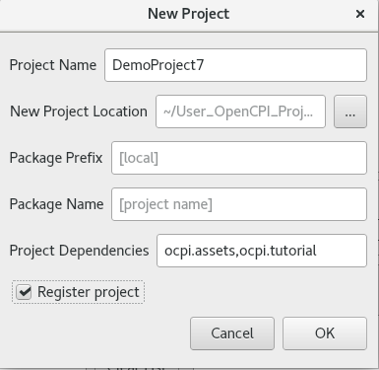
To create the new project using the CLI, use the following ocpidev command:
ocpidev -D ocpi.assets -D ocpi.tutorial create project DemoProject7 --register

Create HDL Primitive Library
You must now create and build the HDL primitive library. Follow the command below from the DemoProject7 directory.
To create the project using the OpenCPI GUI:
- From the GUI menu bar at the top of the window, select Create > HDL >Primitive LIbrary
- The New HDL Primitive Library dialog will appear. In the Primitive Lib Name field, enter prims.
- Using the drop-down on the Associated Project field, select the DemoProject7 directory.
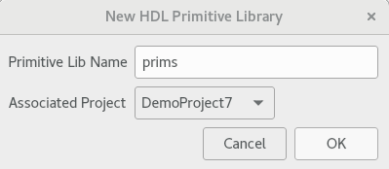
To create the primitive library using the CLI, use the following ocpidev command:
ocpidev create hdl primitive library prims

Copy HDL Primitive Library Files from the Tutorial Project
Next, we need to copy the provided primitive source file agc.vhd and primitive package prims_pkg.vhd into the primitive library. Below are the instructions to copy the file directly:
cp $OCPI_ROOT_DIR/projects/tutorial/hdl/primitives/prims/agc.vhd $OCPI_ROOT_DIR/projects/DemoProject7/hdl/primitives/prims
cp $OCPI_ROOT_DIR/projects/tutorial/hdl/primitives/prims/prims_pkg.vhd $OCPI_ROOT_DIR/projects/DemoProject7/hdl/primitives/prims
Now that you’ve copied the files, you can open and examine the contents. You'll see that agc.vhd implements the AGC component logic and that prims.pkg.vhd enables the primitive source code to be callable by HDL workers.

Build HDL Primitive Library
In the hdl/primitives directory, run the following command.
To build from the OpenCPI GUI:
- In the Platforms view, check the box labeled HDL and select xsim.
- In the Project Explorer view, select primitives.
- Right-click primitives and select Build.
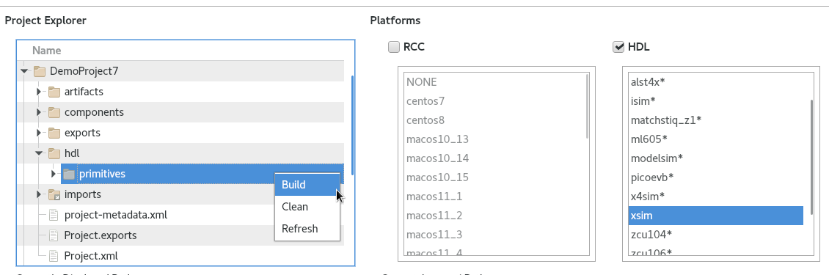
To build the primitive library using the CLI, use the following ocpidev command:
ocpidev build --hdl-platform xsim

Create Component Library
Before we can create our component, we need to create a component library for it.
To create the components library in the OpenCPI GUI:
- From the GUI menu bar at the top of the window, select Create > Component Library
- The New Library dialog will appear. In the Library Name field, enter components.
- Using the drop-down on the Associated Project field, select the DemoProject7.
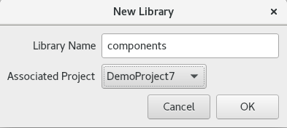
To create the components library with ocpidev, run the following command in the DemoProject7 directory:
ocpidev create library components
You should now see a lib directory and a components.xml file. We need to edit the components.xml. Using a text editor, open and edit components/components.xml:
<library
HdlLibraries='prims'
/>

Create Component
Now we need to create the OCS (OpenCPI Component Specification) for agc_complex that defines its properties and ports.

Create Component Spec
We’ll create our agc_complex component spec in the components library we just created.
To create the component in the OpenCPI GUI:
- From the GUI menu bar at the top of the window, select Create > Component Spec
- The New Library dialog will appear. In the Component Name field, enter agc_complex.
- Using the drop-down on the Associated Project field, select the DemoProject7 directory.
- Using the drop-down on the Associated Library field, leave as None.
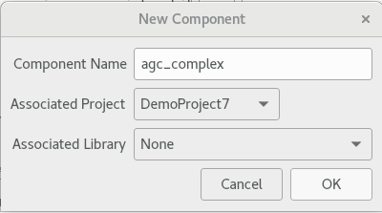
To create the component spec with ocpidev, run the following command in the DemoProject7/components directory:
ocpidev create component agc_complex

Add Component Properties and Ports
The previous command created the component spec agc_complex-spec.xml in components/specs. We must now add properties and ports to the component spec.
To do so, directly copy the contents from ocpi.tutorial into agc_complex-spec.xml:
cp $OCPI_ROOT_DIR/projects/tutorial/components/specs/agc_complex-spec.xml $OCPI_ROOT_DIR/projects/DemoProject7/components/specs/.

Create Worker
We will now create the HDL worker for the HDL simulator target.
To create the worker in the OpenCPI GUI:
- From the GUI menu bar at the top of the window, select Create > Worker
- The New Worker dialog will appear. In the Worker Name field, enter agc_complex.
- Using the drop-down on the Associated Project field, select the DemoProject7 directory.
- For the Model field, select HDL. The Language field should then automatically select VHDL.
- Using the drop-down on the Component Spec field, select agc_complex.
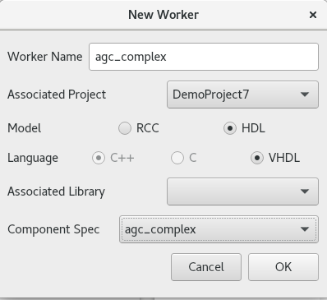
To create the worker using the ocpidev command:
ocpidev create worker agc_complex.hdl

Update HDL Worker Skeleton Files
We will now populate the skeleton files in the previously generated agc_complex.hdl directory.
Follow the commands below to copy over the files for agc_complex.vhd and agc_complex.xml:
cp $OCPI_ROOT_DIR/projects/tutorial/components/agc_complex.hdl/agc_complex.vhd $OCPI_ROOT_DIR/projects/DemoProject7/components/agc_complex.hdl/.
cp $OCPI_ROOT_DIR/projects/tutorial/components/agc_complex.hdl/agc_complex.xml $OCPI_ROOT_DIR/projects/DemoProject7/components/agc_complex.hdl/.
You can examine these files for more context. The agc_complex.vhd file in particular holds good information to look into as it has an explanation of the agc circuit. This file allows the worker to function properly
In agc_complex.hdl/gen, you’ll see an assortment of files that do not need to be edited. They are automatically generated when the worker has been created, and if they are removed will be recreated when the ocpidev build command is invoked.

Build Worker
If all goes well, we can now build the worker. In the components directory, run the following command.
To build from the OpenCPI GUI:
- In the Targets view check the box labeled HDL, and xsim.
- In the Project Explorer view, select components.
- Right-click agc_complex.hdl and select Build.
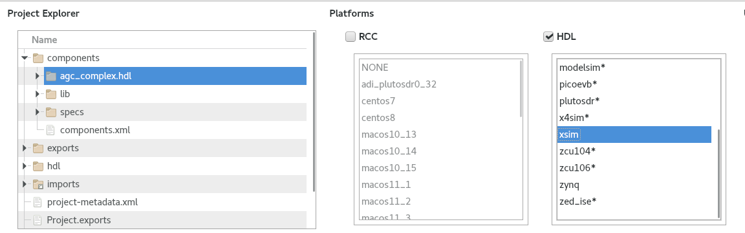
Navigate to components/agc_complex.hdl. There should be a new subdirectory target-xsim that contains the artifacts needed to run the worker on this platform.
To build the worker using the CLI command, use the following ocpidev command:
ocpidev build agc_complex.hdl --hdl-platform xsim

Create Unit Test
Now we’ll generate an OpenCPI test suite for our agc_complex worker.
To create the unit test in the OpenCPI GUI:
- From the GUI menu bar at the top of the window, select Create > Component Test Suite
- The New Unit Test dialog will appear. Using the drop-down on the Associated Project field, select the DemoProject7 directory.
- Using the drop-down on the Component Spec field, select agc_complex.
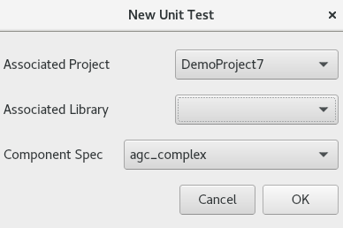
To create the unit test using the CLI, run the following ocpidev command from the DemoProject7/components directory:
ocpidev create test agc_complex
Now run the tree command to observe the files created:
agc_complex.test
├── generate.py
├── agc_complex-test.xml
├── verify.py
└── view.sh
The files of interest here are:
- agc_complex-test.xml. This is the test suite description file. It specifies the test cases and the defaults that apply to all test cases.
- generate.py. This is a stub file for an optional script that you can create to generate input test data for ports or property value files. There is one script for each input port.
- verify.py. This is a stub file for an optional script that you can create to verify output test data produced by output ports. There is one script for each output port..
- view.sh. This is a stub file for an optional script that you can create to view the results of a test execution; for example, a plot. This script may not be necessary or appropriate for many workers. It can work as a helpful aid in the development process, but it is not meant for long-term testing and re-testing.
We want to use the generate, verify and view scripts in this tutorial, so we’ll need to edit the test suite description file to specify them and create the code for each script. The next sections describe these steps.

Copy Unit Test Description File
We now have a skeleton agc_complex-test.xml script that we need to fill out.
To do this, copy the file from the tutorial project with the command below:
cp $OCPI_ROOT_DIR/projects/tutorial/components/agc_complex.test/agc_complex-test.xml $OCPI_ROOT_DIR/projects/DemoProject7/components/agc_complex.test/.

Copy Test Scripts from Tutorial Project
Now we need to create code for the empty empty generate.py, verify.py and view.sh scripts we created when we created the unit test.. To do this, we'll simply copy the test scripts provided in tutorial project into our DemoProject7 test directory.
Note: Make sure your test scripts have read and execute permissions before using them to build and run the agc_complex unit test. For example, in the agc_complex.test directory:
chmod 777 generate.py
chmod 777 verify.py
chmod 777 view.sh

Copy generate.py Script
We will use the scripts from ocpi.tutorial. The commands to copy the contents into our existing project are listed below:
cp $OCPI_ROOT_DIR/projects/tutorial/components/agc_complex.test/generate.py $OCPI_ROOT_DIR/projects/DemoProject7/components/agc_complex.test/.

Copy verify.py Script
cp $OCPI_ROOT_DIR/projects/tutorial/components/agc_complex.test/verify.py $OCPI_ROOT_DIR/projects/DemoProject7/components/agc_complex.test/.

Edit view.sh Script
Open the view.sh script with a text editor and then copy and paste the following lines at the end of the file (highlighted in red):
#!/bin/bash --noprofile
# Use this script to view your input and output data.
# Args: <list-of-user-defined-args> <input-file> <output-file>
$OCPI_ROOT_DIR/projects/tutorial/scripts/plotAndFft.py $2 complex 32768 100&
$OCPI_ROOT_DIR/projects/tutorial/scripts/plotAndFft.py $1 complex 32768 100&

Build Unit Test
Now we’ll build the unit test suite for the target platform.
To build from the OpenCPI GUI:
- In the Platforms view check the box labeled HDL, and xsim.
- In the Project Explorer view, select components.
- Right-click agc_complex.test and select Build.
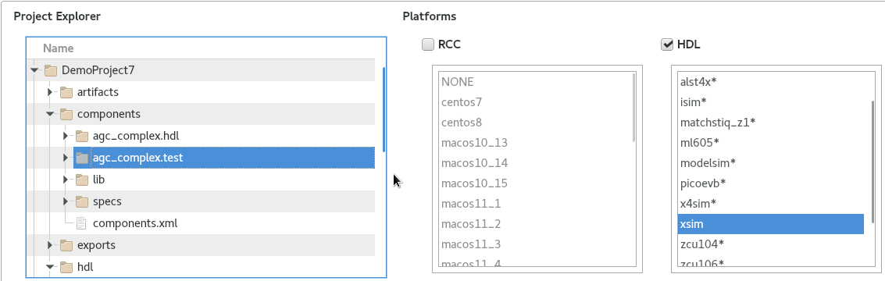
To generate and build the unit test using the CLI, run following the ocpidev command:
ocpidev build test --hdl-platform xsim

Run Unit Test
We will now run the unit test in components/agc_complex.test.
Using the OpenCPI GUI, select agc_complex.test under Project Explorer. Check the HDL box and select xsim. Under Phases, make no change. Under Options, check Keep Simulations and Run View Script.
To run from the OpenCPI GUI:
- In the Platforms view check the box labeled HDL, and xsim.
- In the Project Explorer view, select components.
- Select agc_complex.test.
- In the Unit Tests view, under the Options field, click the boxes for Run View Script and Keep Simulations.
- Click on the box for Prep/Run/Verify Phases.
- The greyed out options below will now be available. Click on Only Platforms.
- Now click on Run Unit Test.
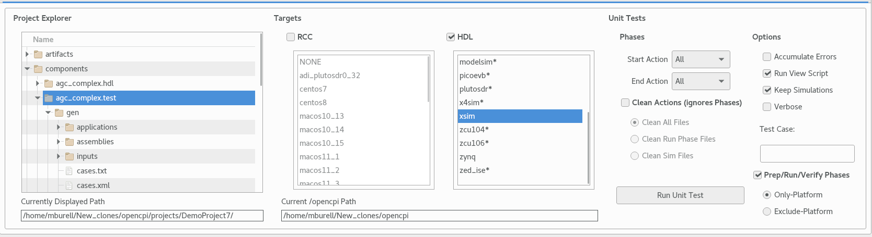
To run the test using the CLI, use the following ocpidev command:
ocpidev run --only-platform xsim --keep-simulations --view

View Unit I/O Test Plots
The following figures show the output:
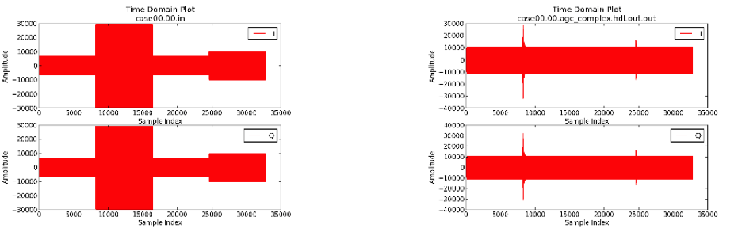
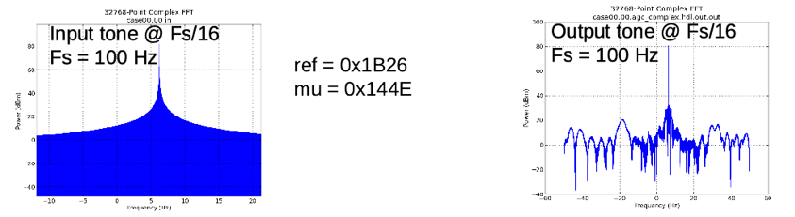

View Simulation Waveforms
Note: In order to view simulation waveforms, you must have checked "keep simulations" in the OpenCPI GUI or have used the --keep-simulations option on the ocpidev command line.
In a terminal window, browse to agc_complex.test/ and execute the following command:
ocpiview run/xsim/case00.00.agc_complex.hdl.simulation/ &
You’ll want to expand agc_complex_0_frw_0_xsim_base by using the arrow to the left then right clicking pfconfig_i. Click on Add to Wave Window. For more information on using ocpiview, refer to section 7.2 in Tutorial 6.
You should see the following output:
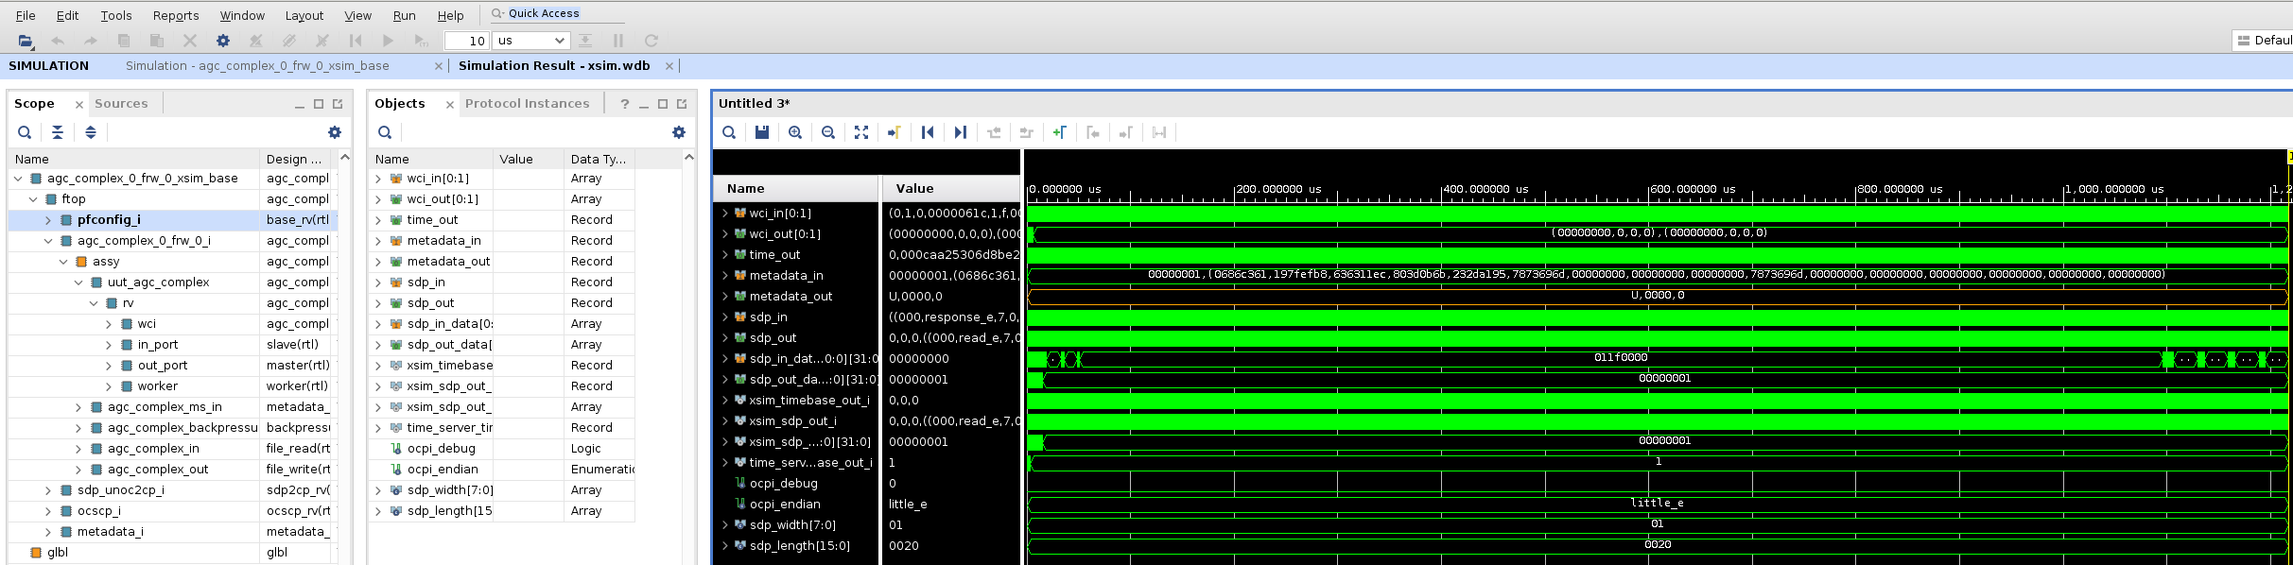

Tutorial Summary
Now that you’ve completed this tutorial, you should be familiar with the basic concepts of HDL primitives and how they are utilized to store and present reusable HDL. In other existing OpenCPI Projects, you should also be able to see how the primitive library is used for multiple workers instead of just the one shown in this tutorial.

