OpenCPI
Tutorial 2: Designing Applications and HDL Assemblies
OpenCPI Release develop
Revision History
Revision | Description of Change | Date
1.0 | Creation | 2019-12-12
Table of Contents
1 Overview 5
1.1 Tutorial Objectives 8
1.2 What’s Provided for This Tutorial 9
1.3 Prerequisites to This Tutorial 10
1.4 Documentation References 11
2 Create New Project 12
3 Create Application 16
3.1 Create Initial Application OAS 17
3.2 Update Empty App XML (OAS) 18
3.3 Copy I/Q Data Input File from Tutorial Project to DemoProject2 23
4 Create, Build and Run Assembly 1 24
4.1 Create Assembly 1 Description 25
4.2 Update Assembly 1 Description 26
4.3 Build Assembly 1 28
4.4 Run Application with Assembly 1 29
4.5 View Results of Assembly 1 Application Run 30
5 Create, Build and Run Assembly 2 32
5.1 Create Assembly 2 Description 33
5.2 Update Assembly 2 Description 34
5.3 Build Assembly 2 36
5.4 Run Application with Assembly 2 37
5.5 View Results of Assembly 2 Application Run 38
6 Tutorial Summary 39

Overview
This tutorial explains how to create an application from components that exist in other libraries in other projects and how to create different HDL assemblies for the application that use different combinations of software (RCC) and FPGA (HDL) workers to execute the application on the target platforms.
The application consists of OpenCPI-provided components with implementations for RCC and HDL platforms. The target application execution platforms are the Xilinx Xsim FPGA simulator (HDL) and the CentOS7 development host (RCC).
The application is an I/Q (“in-phase/quadrature, complex) signal modulator/demodulator that:
- Reads I/Q sample data from a file.
- Performs peak detection, complex mixing, automatic gain control, and timestamping on the I/Q sample data.
- Writes the resulting I/Q sample data and timestamps to two different files
The application will use the following components:
- Four I/Q data processing components developed for this tutorial and provided in the OpenCPI built-in tutorial project – peak_detector, complex_mixer, agc_complex and time_demux
- The timestamper component provided in the OpenCPI built-in assets project
- Two OpenCPI utility components provided in the OpenCPI built-in core project: one to read data into the application from a file (file_read) one one to write output data to files on the development host (file_write)
The following figure illustrates the application data flow and the components used by the application:
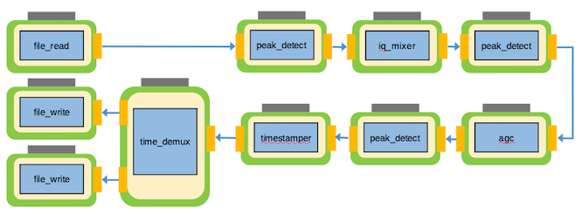
Figure 1: I/Q Data Processing Application
The components used in the data processing flow perform the following tasks:
- The peak detector component peak_detector receives I/Q data on its input port, calculates and records the maximum and minimum peaks, and then passes the I/Q data unchanged to its output port.
- The complex mixer component complex_mixer consists of a numerically controlled oscillator (NCO) and a complex multiplier. It receives I/Q data on its input port, multiplies the input data with the output of the NCO and then sends the frequency-shifted version of the input data to its output port.
- The automatic gain control (AGC) complex component agc_complex receives I/Q data on its input port, drives the amplitude of both the I and Q input rails to the specified output amplitude and then sends the gain-controlled I/Q data to its output port.
- The timestamper component timestamper receives I/Q data on its input port, prepends it with a timestamp and sends the timestamped I/Q data to its output port.
- The time demux component time_demux receives the I/Q data with the interleaved timestamps on its input port, decouples the original I/Q data from the timestamp data and then sends two separate streams, one with the data and one with the timestamps, to its output ports.
An OpenCPI application can be run using different combinations of workers running on software or HDL platforms. Depending on the resources of the intended deployment platform, more HDL workers than RCC workers could be desirable in some cases, and more RCC workers than HDL workers could be desirable in other cases. The first step is to look at the application as a whole and decide which workers should run where. Once you have made this decision, you create one or more HDL assemblies to specify the subset(s) of the application’s workers that should run on the HDL platform.
This tutorial defines two different HDL assemblies for the example application: one that runs a majority of the application workers in software and one that runs a majority of the application’s workers on the HDL platform. The application is the same, but the HDL workers that run on the HDL platform differ depending on which assembly is used at runtime. The following figure illustrates this concept:
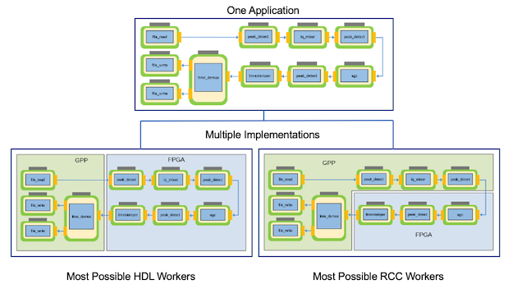
Figure 2: I/Q Data Processing Application and HDL Assemblies

Tutorial Objectives
The purpose of this tutorial is to demonstrate the process of creating an OpenCPI application from existing OpenCPI component assets and the procedure for creating different assemblies that run the same application using different combinations of RCC and HDL workers.
The tutorial demonstrates how to:
- Create an application using components that exist in OpenCPI built-in projects.
- Select the components in the application that can be deployed on the FPGA.
- Create and build two different HDL assemblies, both of which the application can use. One assembly runs the application with most of its workers running on the RCC platform; in this case, the development host. The other runs the application with most of its workers running on the HDL platform; in this case, the xsim FPGA simulator.
- Deploy the application with ocpidev run using both of the HDL assemblies you created.
This tutorial shows you how to develop the application and each HDL assembly and how to run the application using each HDL assembly.
After running this tutorial, you should understand the general process of developing an application from existing components and how to create different HDL assemblies for executing an application on HDL platforms.

What’s Provided for This Tutorial
This tutorial directs you to use OpenCPI assets and scripts provided in the built-in OpenCPI projects ocpi.tutorial and ocpi.assets.
In the course of running the tutorial, you will use the following assets from ocpi.tutorial:
- The OCS XML files (component specs) for the peak_detector, complex_mixer, agc_complex and time_demux workers, in components/specs/<component-name>.xml
- The OWD XML files for the peak_detector (RCC and HDL), complex_mixer, (RCC and HDL), agc_complex (HDL) and time_demux (RCC) workers, in components/<worker-name>.hdl/<worker-name.xml and components/<worker-name>.rcc/<worker-name.xml
- The VHDL and/or C/C++ source code for the peak_detector (.cc and .vhd), complex_mixer (.cc and .vhd), agc_complex (.vhd) and time_demux workers (.rcc), in components/<worker-name>.hdl/ and components/<worker-name>.rcc
- The binary input data to the file_read component, in applications/idata/lab2_input_file.bin
You will also use the following scripts from ocpi.tutorial:
- The Python script code for plotting and viewing the output complex data, in scripts/PlotAndFft.py
- The Python script code for viewing the output time data, in scripts/print_timestamps.py
The tutorial also provides the source code and XML source for all of the assets and scripts you create during tutorial execution as text in the relevant sections of the document that you copy and paste into the relevant files following the instructions given in the section.
Note that all of the OpenCPI built-in projects described in the OpenCPI User Guide including the projects referenced here are built for the CentOS 7 and Xilinx Vivado® XSim platforms as part of the OpenCPI installation process. You do not need to build, register or import these projects in order to use them in this tutorial.

Prerequisites to This Tutorial
Before you begin this tutorial, you should have successfully completed Tutorial 1, “Component-based Development”.
We recommend reading the following briefings before getting started with the tutorial:
- Briefing 1, “Introduction to OpenCPI”. This briefing introduces OpenCPI positioning, priorities and background as well as component and application terminology.
- Briefing 2, “Introduction to Application Development with OpenCPI”. This briefing discusses OpenCPI elements and concepts from an application development perspective and introduces OpenCPI tools and building blocks for application development.

Documentation References
The documents listed in the following table provide detailed information about subjects discussed in this tutorial. The documents listed here are not required reading for this tutorial but will likely be of interest for more in-depth learning.
Table 1 - OpenCPI Reference Documentation
Title | Published By | Public URL
OpenCPI User Guide | OpenCPI | https://opencpi.gitlab.io/releases/v1.7.0-rc.1/docs/OpenCPI_User.pdf
OpenCPI Application Development Guide | OpenCPI | https://opencpi.gitlab.io/releases/v1.7.0-rc.1/docs/OpenCPI_Application_Development.pdf
OpenCPI Component Development Guide | OpenCPI | https://opencpi.gitlab.io/releases/v1.7.0-rc.1/docs/OpenCPI_Component_Development.pdf
OpenCPI HDL Development Guide | OpenCPI | https://opencpi.gitlab.io/releases/v1.7.0-rc.1/docs/OpenCPI_HDL_Development.pdf
OpenCPI RCC Development Guide | OpenCPI | https://opencpi.gitlab.io/releases/v1.7.0-rc.1/docs/OpenCPI_RCC_Development.pdf

Create New Project
We need to create a new, clean project for Tutorial 2; we’ll call it DemoProject2. This project has the following requirements:
- It needs to declare that it depends on assets in the ocpi.tutorial and ocpi.assets projects because we’ll be using assets from these projects in the application and assemblies we’ll create. We’ll use the -D option to ocpidev to specify these project dependencies.
- It needs to tell the OpenCPI tools to look for workers in the util_comps subdirectory of the components directory in the ocpi.assets project because we’ll be using a component and workers from this library when we build our application and assemblies. We’ll use the -y option with the ComponentLibraries variable to specify this library.
- It needs to tell the OpenCPI tools to look for HDL primitive libraries in the prims HDL primitives library in this project and in the projects on which this project depends because some of the HDL workers we’ll use in our assemblies use this library. We’ll use the -Y option to ocpidev with the HdlLibraries variable to specify this library.
To create the project, use the following ocpidev command:
ocpidev -y util_comps -Y prims -D ocpi.assets -D ocpi.tutorial create project DemoProject2 --register
If you want to use AV to create assets in DemoProject, you need to import it into AV. Do not use AV to create OpenCPI projects.
To import the DemoProject2 project:
- Start AV.
- Select File > Import. Select Existing Projects into Workspace and then click Next.
- In the Import Projects dialog, make sure Select Root Directory is checked and then click Browse on the right.
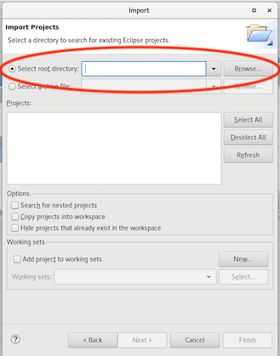
- Navigate to the directory where you created DemoProject2 and then click OK. You’ll see local.DemoProject2 listed and selected.
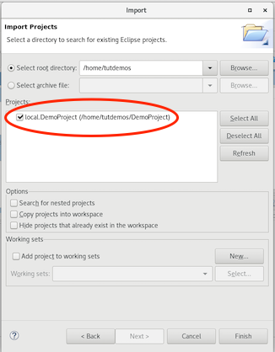
- Leave all of the other fields blank and click Finish. The local.DemoProject2 project is displayed in the (Eclipse) Project Explorer view.
- In the OpenCPI Projects view, click Refresh. You should now see local.DemoProject2 displayed in the OpenCPI Projects view.

Create Application
Recall from Tutorial 1 that the OAS for an application specifies the components to be instantiated, how the workers are to be connected, and how they should be configured via their properties. We’ll use the same technique we used in Tutorial 1 to create our application OAS: we’ll create an empty OAS in the applications directory and then edit the file to add our definitions.

Create Initial Application OAS
We’ll name our application IQapp.
To create the initial OAS in AV:
- In the OpenCPI Projects view, right-click on local.DemoProject2 and choose the asset wizard.
- In the drop-down list, select Application for the asset type.
- In Application Name, enter IQapp.
- Check XML Only App.
- Click Finish.
- When the operation completes, you’ll see the new application IQapp displayed in the OpenCPI Projects view and the Project Explorer view. The initial OAS is displayed in the text editor panel.
To create the initial OAS with ocpidev, run the following command from the DemoProject2 directory:
ocpidev -X create application IQapp
The -X option to ocpidev directs the tool to create the empty OAS in the applications directory.

Update Empty App XML (OAS)
Now we’ll edit IQapp.xml with the necessary XML definitions. We need to add the following component instances:
- One instance of file_read. The component spec file file_read-spec.xml resides in the ocpi.core project in the components library.
- Three instances of the peak_detector component. The component spec file peak_detector-spec.xml resides in the ocpi.tutorial project in the components library. Each instance must have a unique name to distinguish it from the other instances of the same component. We’ll name the instances peak_detector_file_out, peak_detector_agc_in and peak_detector_agc_out.
- One instance of the complex_mixer component. The component spec file complex_mixer-spec.xml resides in the ocpi.tutorial project in the components library.
- Once instance of the agc_complex component. The component spec file agc_complex-spec.xml resides in the ocpi.tutorial project in the components library.
- One instance of the timestamper component. The component spec timestamper-spec.xml resides in the ocpi.assets project in the components/util_comps.
- One instance of the time_demux component. The component spec time_demux-spec.xml resides in the ocpi.tutorial project in the components library.
- Two instances of the file_write component, one to receive the output data from peak_detector_agc_out, which we’ll name file_write_data, and one to receive the timestamp data from time_demux, which we’ll name file_write_time. The component spec file_write-spec.xml resides in the ocpi.core project in the components library.
Next, we need to set property values for four of these component instances:
- For the file_read instance, we need to set values for two properties: the fileName property, which we’ll set to our input file IQapp_input_file.bin and the messageSize property, which we’ll set to the value 2048.
- For the agc_complex instance, we need to set the values of two properties: the property mu that we’ll set to the value 0x144E and the property ref that we’ll set to the value 0x1B26. The mu property controls the AGC time constant, which determines the circuit’s response time, while the ref property controls the desired output amplitude.
- For the file_write_time instance, we need to set the value of the fileName property to the time output file IQapp_time_output_file.bin.
- For the file_write_data instance, we need to set the fileName property to the data output file IQapp_data_output_file.bin.
We also need to specify 9 connections. We’ll use the shorthand Connect= in the instance element for the all of the connections except for the ports we need to rename. For these, we’ll use the full Port Instance= definition in the Connection element.
Finally, as we did for Tutorial 1, we’ll specify:
- The package ID for our project (package= attribute). The package attribute is the default package prefix for all instances in the application and helps to reduce typing for whatever project most of the instances come from when writing XML.
- The component instance that signifies that the application has finished executing (done= attribute). In this case, it’s file_write_data.
To update the empty OAS using AV:
- In the OAS diagram, delete the nothing worker (click it and then click the red X).
- In the Project Explorer window, navigate to peak_detector-spec.xml in ocpi.tutorial > components > specs. Select it and then drag and drop it into the OAS diagram. Right-click on the icon and select Show in Properties View. In Name, enter peak_detector_file_out. The name on the icon changes. Repeat this step to create peak_detector_agc_in and peak_detector_agc_out instances; maximize and minimize the OAS diagram as necessary to display and work with the components.
- Drag and drop the remaining component specs into the OAS diagram. You’ll need to drag and drop file_write-spec.xml twice and then rename each instance to file_write_data and file_write_time like you did with peak_detector-spec.xml.
- When you’re finished adding component instances, your diagram should look something like this:
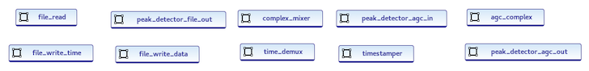
- Next, set the required property values for the file_read, agc_complex, file_write_time and file_write_data instances: In the OAS diagram, click Details and then locate the instance in Outline. Click the Properties node displayed under the instance name and then click Add a Property. In the Instance Property dialog, fill in the Name and Value fields and leave the other fields blank. When you’re finished with this step, your diagram should look something like this:
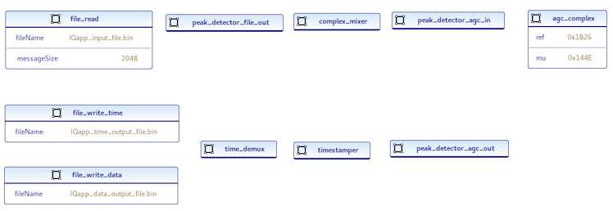
- Now make the connections: In the OAS diagram, click file_read. In Palette, click Simple Connection. Drag the cursor to peak_detector_file_out and then click the instance icon. Do the same thing to connect peak_detector_file_out port out to complex_mixer port in, complex_mixer port out to peak_detector_agc_in port in, peak_detector_agc_in port out to agc_complex port in, agc_complex port out to peak_detector_agc_out port in, and peak_detector_agc_out port out to timestamper port in. The diagram should now look something like this:
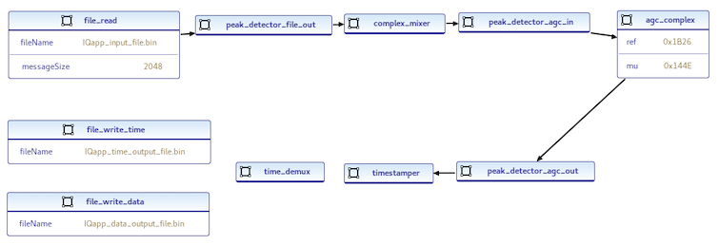
- Next, add the advanced connections: In the OAS diagram, click on timestamper. In Palette, click Advanced Connection. Drag the cursor to the time_demux icon and then click it. In the Define Connection dialog, double-click on in in Port Name and change it to Mux_In.
- Now click on time_demux and make an advanced connection to file_write_data. In the Define Connection dialog, change out to Data_Out.
- Click on time_demux again and make an advanced connection to file_write_time. In the Define Connection dialog, change out to Time_Out. Your diagram should now look something like this:
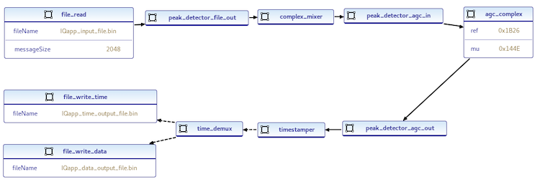
- You’ve finished making the connections, but you still need to set the application properties: Click anywhere in the OAS diagram. The Application properties dialog is displayed on the right. In Name, enter IQapp. In Package, enter local.DemoProject2. In Done, enter file_write_data. Leave MaxProcessors blank.
- Click Save All (the stacked floppy disks icon below the top menu bar) to save your work.
To update the empty OAS from the command line, in the DemoProject2 directory, open applications/IQapp.xml with a text editor and then replace the contents with the following XML:
<Application Name="IQapp" package="local.DemoProject2"
done="file_write_data">
<Instance component="ocpi.core.file_read"
name="file_read" Connect="peak_detector_file_out">
<Property Name="fileName" value="IQapp_input_file.bin"/>
<Property Name="messageSize" Value="2048"/>
</Instance>
<Instance component="ocpi.tutorial.peak_detector"
name="peak_detector_file_out" Connect="complex_mixer"/>
<Instance component="ocpi.tutorial.complex_mixer"
name="complex_mixer" Connect="peak_detector_agc_in"/>
<Instance component="ocpi.tutorial.peak_detector"
name="peak_detector_agc_in" Connect="agc_complex"/>
<Instance component="ocpi.tutorial.agc_complex"
name="agc_complex" Connect="peak_detector_agc_out">
<Property Name="mu" Value="0x144E"/>
<Property Name="ref" Value="0x1B26"/>
</Instance>
<Instance component="ocpi.tutorial.peak_detector"
name="peak_detector_agc_out" Connect="timestamper"/>
<Instance component="ocpi.assets.util_comps.timestamper"
name="timestamper"/>
<Connection>
<Port instance="timestamper" name="out"/>
<Port instance="time_demux" name="Mux_In"/>
</Connection>
<Instance component="ocpi.tutorial.time_demux"
name="time_demux"/>
<Connection>
<Port instance="time_demux" name="Time_Out"/>
<Port instance="file_write_time" name="in"/>
</Connection>
<Connection>
<Port instance="time_demux" name="Data_Out"/>
<Port instance="file_write_data" name="in"/>
</Connection>
<Instance component="ocpi.core.file_write"
name="file_write_time">
<Property Name="fileName"
value="IQapp_time_output_file.bin"/>
</Instance>
<Instance component="ocpi.core.file_write"
name="file_write_data">
<Property Name="fileName"
value="IQapp_data_output_file.bin"/>
</Instance>
</Application>
Note: For reference, this application XML exists in the ocpi.tutorial project at applications/lab2_app.xml.

Copy I/Q Data Input File from Tutorial Project to DemoProject2
We’ve created the application and identified the components it will use. Now we need to provide the I/Q data input file that will drive the application’s data processing. The ocpi.tutorial project provides an example input file that we can use. You’ll find it in:
<opencpi_install_path>/projects/tutorial/applications/idata/lab2_input_file.bin
Navigate to DemoProject2/applications and then copy and rename this file to IQapp_input_file.bin:
mv $OCPI_CDK_DIR/../projects/tutorial/applications/idata/lab2_input_file.bin IQapp_input_file.bin
Now we’ve set up the application. The next task is to identify the workers that will be used and on which platform they will run.

Create, Build and Run Assembly 1
Recall from Tutorial 1 that an HDL assembly is a subset of an application’s workers that can be run on HDL platforms. Applications can be executed to leverage various HDL assemblies. First, you determine one or more configurations of which workers run where – an RCC platform or an HDL platform – and then you create an HDL assembly of the workers that are to run on HDL platforms for each configuration.
For this assembly, we’ll choose to run all of the application’s workers that have both an RCC and an HDL implementation as RCC workers on the RCC platform. Consequently, the HDL assembly for this configuration will consist of the HDL-only workers – agc_complex and timestamper – and the peak_detector HDL worker because it manages the data to and from agc_complex. These workers will run in the HDL assembly on an HDL platform.

Create Assembly 1 Description
We’ll name this assembly IQapp_min_hdl_assembly since it uses the minimum number of HDL workers.
To create the assembly with AV:
- Right-click on local.DemoProject2 and then select asset wizard.
- In the drop-down list, select the HDL assembly asset type.
- In Assembly Name, enter IQapp_min_hdl_assembly.
- In Add to Project, leave local.DemoProject2 selected.
- Click Finish. When the operation completes, the new assembly is displayed in the OpenCPI Projects view and the OHAD Design Editor for the assembly is open in the text editor panel.
To create the assembly with ocpidev, run the following command from the DemoProject2 directory:
ocpidev create hdl assembly IQapp_min_hdl_assembly

Update Assembly 1 Description
Now we need to update the HDL assembly description to define the HDL workers to be used, the connections between them, and the connections to the rest of the application.
To update the HDL assembly OHAD with the AV OHAD Design Editor:
- In the OHAD diagram, delete the nothing worker (click it and then click the red X).
- Add the ocpi.tutorial workers: in the Project Explorer view, navigate to the ocpi.tutorial project and then select the agc_complex worker’s OWD XML (components/agc_complex.hdl/agc_complex.xml). Drag and drop it into the OHAD Design Editor diagram. Follow the same step for the peak_detector worker (ocpi.tutorial/components/peak_detector.hdl/peak_detector.xml)
- Add the ocpi.assets worker: In the Project Explorer view, navigate to ocpi.assets and then select the timestamper worker (ocpi.assets/components/util_comps/timestamper.hdl/timestamper.xml). Drag and drop it into the OHAD diagram.
- Define the external connections: click on agc_complex to display the Properties tab on the right. In External, enter in. Now click on timestamper to display the Properties tab. In External, enter out.
- Make the HDL worker connections: click on agc_complex. in Palette on the right, click Simple Connection. Drag the cursor to peak_detector and click it. Do the same step from peak_detector to timestamper.
- Your OHAD diagram should now look like this:
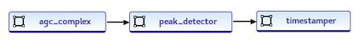
- Click Save (the floppy disk icon below the top menu bar) to save your work.
To update the HDL assembly OHAD from the command line, navigate to the IQapp_min_hdl_assembly directory. Open IQapp_min_hdl_assembly.xml with a text editor and then insert the following XML (highlighted in red) between the HdlAssembly tags:
<HdlAssembly>
<Instance worker="agc_complex" name="agc_complex"
external="in" connect="peak_detector"/>
<Instance worker="timestamper" name="timestamper"
external="out"/>
<Instance worker="peak_detector"
name="peak_detector" connect="timestamper"/>
</HdlAssembly>
Note: For reference, this assembly XML exists in the ocpi.tutorial project at hdl/assemblies/lab2_most_rcc_assy/lab2_most_rcc_assy.xml.

Build Assembly 1
Now we need to build the HDL assembly for the RCC and HDL platforms to create the FPGA artifact for the application.
To build the assembly with AV:
- In the OpenCPI Projects view, expand the assemblies subdirectory in local.DemoProject2 and then select IQapp_min_hdl_assembly.
- In the Operations panel, click the > button to move the assembly into the panel.
- In HDL Platforms, select xsim.
- Check Build Assemblies.
- Click Build.
The build process takes a few minutes to run. If it’s successful, you’ll see a message in the Build Status tab with DemoProject2 and what you’ve built.
To build the HDL assembly with ocpidev, run the following command from the DemoProject2 directory:
ocpidev build hdl assembly IQapp_min_hdl_assembly --hdl-platform xsim
The build takes a couple of minutes to run. You can confirm that it succeeded by locating the *.gz file in the artifacts subdirectory of DemoProject2. This file is the artifact file to be used when the application runs on the HDL platform.

Run Application with Assembly 1
To run the application with the “minimum number of HDL workers” assembly, run the following command from the DemoProject2 directory:
ocpidev run application IQapp -- -t 1 -d -v -mcomplex_mixer=rcc
The application runs the HDL assembly on the HDL platform while running the other workers on the RCC platform. The file_write_data and file_write_time workers write the output from the application to the files IQapp_data_output_file.bin and IQapp_time_output_file.bin respectively. We’ll compare the data input to the application to the data output by it in the next step.

View Results of Assembly 1 Application Run
Now we’ll use a Python script from the ocpi.tutorial project to render the IQ data generated by the application to displayable format.
From the DemoProject2 directory, run the plotAndFft.py script as follows:
python3 $OCPI_CDK_DIR/../projects/tutorial/scripts/plotAndFft.py IQapp_input_file.bin complex 32768 100
python3 $OCPI_CDK_DIR/../projects/tutorial/scripts/plotAndFft.py IQapp_data_output_file.bin complex 32768 100
You should see the results shown in the following figures.
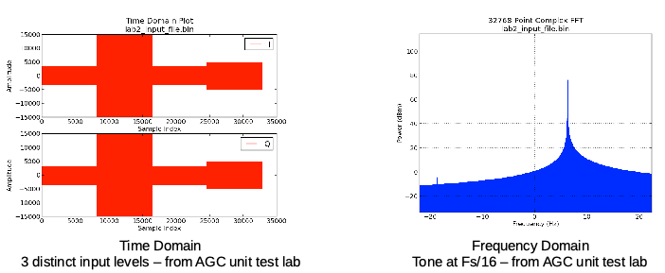
Figure 3: Expected Result – Input Data
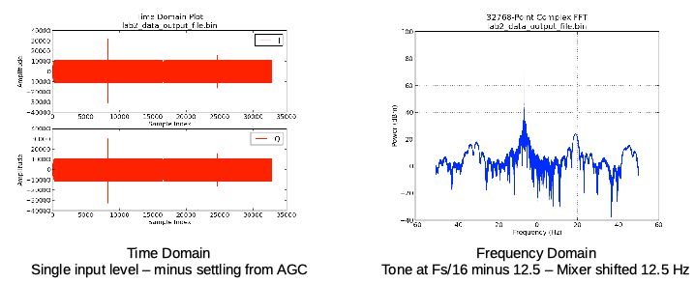
Figure 4: Expected Result – Output Data
Next, we’ll run a Python script from the ocpi.tutorial project to view the time data.
From the DemoProject2 directory, run the print_timestamps.py script as follows:
python3 $OCPI_CDK_DIR/../projects/tutorial/scripts/print_timestamps.py IQapp_time_output_file.bin
You should see the following results:
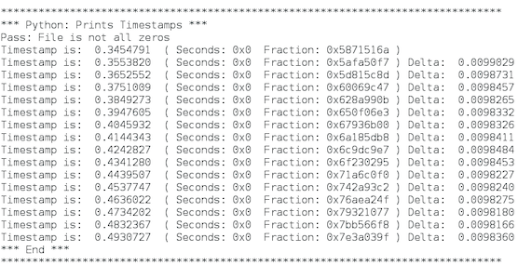
Timestamps are incrementing and roughly uniformly spaced (but affected by software bottlenecks because they are stamped at the end of processing).
Now that we’ve run the application with the HDL assembly with the fewest HDL workers, we’ll create and build the HDL assembly with the most HDL workers and then run the application with it.

Create, Build and Run Assembly 2
For this assembly, we’ll choose to run all of the application’s workers that have an HDL implementation on the HDL platform. Consequently, the HDL assembly for this configuration will consist of the HDL-only workers agc_complex and timestamper plus the three instances of the peak_detector worker and the complex_mixer worker since these workers have HDL implementations.

Create Assembly 2 Description
As we did for Assembly 1, we’ll first create the HDL assembly description. We’ll name this assembly IQapp_max_hdl_assembly.
To create the HDL assembly description with AV:
- Right-click on local.DemoProject2 and then select asset wizard.
- In the drop-down list, select the HDL assembly asset type.
- In Assembly Name, enter IQapp_max_hdl_assembly.
- In Add to Project, leave local.DemoProject selected.
- Click Finish. When the operation completes, the new assembly is displayed in the OpenCPI Projects view and the OHAD Design Editor for the assembly is open in the text editor panel.
To create the HDL assembly description with ocpidev, run the following command from the DemoProject2 directory:
ocpidev create hdl assembly IQapp_max_hdl_assembly

Update Assembly 2 Description
Next, we’ll update the HDL assembly XML we just created following the steps we took for the RCC version.
To update the HDL assembly OHAD with the AV OHAD Design Editor:
- Delete the nothing worker in the OHAD diagram.
- Drag and drop the agc_complex worker OWD (components/agc_complex.hdl/agc_complex.xml in the tutorial project) from the Project Explorer view to the OHAD diagram. Follow the same step for the complex_mixer worker (components/complex_mixer.hdl/complex_mixer.xml) and the timestamper worker (components/util_comps/timestamper.hdl/timestamper.xml in the assets project).
- Drag and drop the peak_detector worker OWD (components/peak_detector.hdl/peak_detector.xml in the tutorial project) from the Project Explorer into the OHAD diagram. Click on the icon in the OHAD diagram. In the Properties tab on the right, change the value in Name to peak_detector_agc_in. Repeat this step to create two more peak_detector worker instances, changing their names to peak_detector_agc_out and peak_detector_file_out.
- Define the external connections: click on peak_detector_file_out to display the Properties tab on the right. In External, enter in. Now click on timestamper to display the Properties tab. In External, enter out.
- Make the HDL worker connections: Click peak_detector_file_out and then click Simple Connection in Palette on the right. Drag the cursor to complex_mixer and click it. Do the same step for complex_mixer to peak_detector_agc_in, for peak_detector_agc_in to agc_complex, for agc_complex to peak_detector_agc_out, and for peak_detector_agc_out to timestamper. Your OHAD diagram should now look like this:
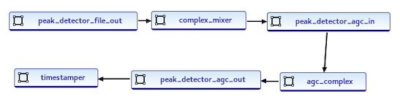
- Click Save (the floppy disk icon below the top menu bar) to save your work.
To update the HDL assembly OHAD from the command line, navigate to the IQapp_min_hdl_assembly directory. Open IQapp_min_hdl_assembly.xml with a text editor and then insert the following XML (highlighted in red) between the HdlAssembly tags:
<HdlAssembly>
<Instance worker="peak_detector"
name="peak_detector_file_out"
external="in" connect="complex_mixer"/>
<Instance worker="complex_mixer"
name="complex_mixer"
connect="peak_detector_agc_in"/>
<Instance worker="peak_detector"
name="peak_detector_agc_in" connect="agc_complex"/>
<Instance worker="agc_complex"
name="agc_complex" connect="peak_detector_agc_out"/>
<Instance worker="peak_detector"
name="peak_detector_agc_out" connect="timestamper"/>
<Instance worker="timestamper"
name="timestamper" external="out"/>
</HdlAssembly>
Note: For reference, this assembly XML exists in the tutorial project at hdl/assemblies/lab2_most_hdl_assy/lab2_most_hdl_assy.xml.

Build Assembly 2
Now we need to build the HDL assembly for the HDL and RCC platforms to create the FPGA artifact for the application.
To build the assembly with AV:
- In the OpenCPI Projects view, expand the assemblies subdirectory in local.DemoProject2 and then select IQapp_max_hdl_assembly.
- In the Operations panel, click the > button to move the assembly into the panel.
- In HDL Platforms, select xsim.
- Check Build Assemblies.
- Click Build.
The build process takes a few minutes to run. If it’s successful, you’ll see a message in the Build Status tab with DemoProject2 and what you’ve built.
To build the HDL assembly with ocpidev, run the following command from the DemoProject2 directory:
ocpidev build hdl assembly IQapp_max_hdl_assembly --hdl-platform xsim
The build takes a couple of minutes to run. You can confirm that it succeeded by locating the *.gz file in the artifacts subdirectory of DemoProject2. This file is the artifact file to be used to run the application on the HDL platform.

Run Application with Assembly 2
After you’ve built the assembly, execute the following ocpidev command from the DemoProject2 directory:
ocpidev run application IQapp -- -t 1 -d -v -mcomplex_mixer=hdl

View Results of Assembly 2 Application Run
Run the tutorial project’s plotAndFft.py script again to plot the output file:
python3 $OCPI_CDK_DIR/../projects/tutorial/scripts/plotAndFft.py IQapp_data_output_file.bin complex 32768 100
You should get the results shown in the following figure.
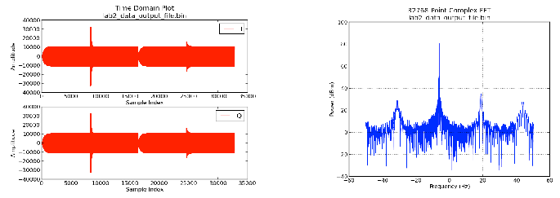
Figure 5: Expected Result – Output Data
Expected Result Delta Explained
The differences you can see in the plots of the output data between the mostly RCC vs mostly HDL application are primarily a result of the precision of the math computations performed by the different authoring model implementations of the complex mixer. Specifically, the RCC worker uses the third-party LiquidDSP library, which performs floating-point computations (truncated to int16) while the HDL worker performs all fixed-point (16-bit) computations. While the difference is enough to be observed in the plots below, the system designer must determine whether the performance is sufficient for a given target application.
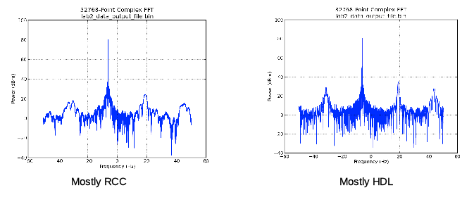

Tutorial Summary
Now that you’ve completed this tutorial, you should be familiar with the general process of developing an application from existing components and developing different HDL assemblies to use when running the application on an HDL platform and how to use the OpenCPI tools to perform these tasks.

