OpenCPI
Tutorial 6hw: Creating a Simple HDL Worker
OpenCPI Release develop

Revision History
Revision | Description of Change | Date
1.00 | Re-formatted BIA lab from slide to ODT | 2019-10-01
1.1
1.2
1.3
1.4
1.5
1.6
1.7
1.8
1.9
2.0
2.1
Table of Contents
1 Overview 5
1.1 What’s Provided for This Tutorial 6
1.2 Prerequisites to Using This Tutorial 7
1.3 Documentation References 8
2 Worker Development Flow 9
3 Component Requirements 10
4 Step 1: Use Pre-existing OPS or Create New 11
5 Step 2: Use Pre-existing OCS or Create New 12
6 Step 3: Create Worker 13
7 Step 3: Build Skeleton Code 14
8 Step 3: Configure Data Port for Parallel 15
9 Step 3: Configure for Version 2 HDL API 16
10 Step 3: Modify Worker Source Code 17
11 Step 4: Build Worker Source Code 18
12 Step 4: Review Build Logs and Artifacts 19
13 Step 5a to 7a: Unit Test Simulation 20
14 Step 5a: Create Unit Test 21
15 Step 6a: Build Unit Test (Xilinx XSIM) 22
16 Step 6a: Review Build Artifacts (XSIM) 23
17 Step 7a: Run Unit Test (Xilinx XSIM) 24
17.1 From the IDE 25
17.2 From a Terminal Window 26
18 Step 7a: Unit Test I/O Plots (Xilinx XSIM) 27
19 Step 7a: View Simulation Waveforms (Xilinx XSIM) 28
20 Steps 5b to 7b: Unit Test on Ettus E310 29
21 Step 5b: Create Unit Test 30
22 Step 6b: Build Unit Test 31
23 Step 6b: Review Build Logs (e3xx) 32
24 Step 6b: Review Build Artifacts (e3xx) 33
25 Step 7b: Run Unit Test (e3xx) 34
26 Step 7b: Run Unit Test (e3xx) 35
27 Step 7b: Run Unit Test (e3xx) 36

Overview
The objective of this tutorial is to design, build and test an HDL application worker. The worker function is peak detection of a data stream (peak_detector.hdl) with the following properties:
- Volatile Properties: Signed Min/Max (OWD)
- Configure Data Port Interfaces: Interleaved to Parallel (OWD)
- Routes data/messages through the worker "pass-thru" (VHDL)
This tutorial demonstrates Automated Unit Testing on multiple platforms (XML, Python) with the Xilinx XSIM simulator on the Ettus E310 (Xilinx Zynq-7020) hardware.
The peak detector HDL worker performs the same function as the simple RCC worker demonstrated in Tutorial 3.

What’s Provided for This Tutorial
The following items are provided for this tutorial:
- Component data sheet for peak_detector in ~/<opencpi-installation-dir>/projects/tutorial/provided/doc.
- Scripts for generating and validating data that you created for peak_detector in Tutorial 3 (in ~/<opencpi-installation-dir>/projects/tutorial/provided/lab6/peak_detector.test/). Re-use these scripts. Recall that there is one {component}.test/ directory per OCS. The same as implemented in Tutorial 3.
- Script for plotting I/Q data in ~/<opencpi-installation-dir>/projects/tutorial/provided/lab6/scripts/plotAndFft.py.
- Worker VHDL with "commented" instructions in ~/<opencpi-installation-dir>/projects/tutorial/provided/lab6/peak_detector.vhd.

Prerequisites to Using This Tutorial
Before you begin this tutorial, you should have successfully completed Tutorials 1b through 5. We also recommend reading Briefing 8, “HDL Application Workers” before you get started with the tutorial.

Documentation References
The documents listed in the following table provide detailed information about subjects discussed in this tutorial. The documents listed here are not required reading for this tutorial but will likely be of interest for more in-depth learning.
Table 1 - OpenCPI Reference Documentation
Title | Published By | Public URL
OpenCPI Overview | OpenCPI | https://opencpi.gitlab.io/releases/v1.7.1/docs/Overview.pdf
OpenCPI User Guide | OpenCPI | https://opencpi.gitlab.io/releases/v1.7.1/docs/OpenCPI_User.pdf
OpenCPI Application Development Guide | OpenCPI | https://opencpi.gitlab.io/releases/v1.7.1/docs/OpenCPI_Application_Development.pdf
OpenCPI Component Development Guide | OpenCPI | https://opencpi.gitlab.io/releases/v1.7.1/docs/OpenCPI_Component_Development.pdf
OpenCPI HDL Development Guide | OpenCPI | https://opencpi.gitlab.io/releases/v1.7.1/docs/OpenCPI_HDL_Development.pdf
OpenCPI RCC Development Guide | OpenCPI | https://opencpi.gitlab.io/releases/v1.7.1/docs/OpenCPI_RCC_Development.pdf

Worker Development Flow
- Component (OCS): Use pre-existing or create new.
- Protocol (OPS): Use pre-existing or create new.
- Create new worker (Modify OWD, Makefile, and source HDL/RCC code).
- Build the worker for the target device(s).
- Create the unit test ({component}-test.xml, generate, verify and view scripts).
- Build the unit test.
- Run the unit test.

Component Requirements
What are the requirements of this component?
Given an input of complex numbers, the "peak_detector" component is meant to find the biggest I or Q sample and the smallest I or Q sample. The basic idea is:
- current_biggest = max(current_biggest,max(I,Q))
- current_smallest = min(current_smallest,min(I,Q))
- Pass input of complex numbers to the output ports
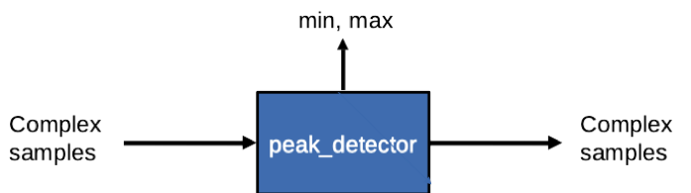

Step 1: Use Pre-existing OPS or Create New
- Identify the OPS(es) declared by this component. Examine the "Component Ports" table in the component data sheet:
- Determine whether or not the OPS(es) exists:
Current project's component library?
~/<opencpi-installation-dir>/projects/tutorial/components/specs
Other projects' components/specs/ directories within scope
Intersection of Project-registry and ProjectDependencies= in {my_project}/Project.mk
- If NO to all questions ⇨ Create new OPS
ANSWER: REUSE. The OPS XML file is available from the framework.

Step 2: Use Pre-existing OCS or Create New
- Review Component Spec Properties and Ports in the component data sheet. Use the Properties and Ports information to answer the following questions
- Determine whether or not the OCS that satisfies the requirements exists:
Current project's component library?
~/<opencpi-installation-dir>/projects/tutorial/components/specs/
Other projects' components/specs/ directories within scope
Intersection of Project-registry and ProjectDependencies= in {my_project}/Project.mk
- If NO to all questions ⇨ Create new OCS
ANSWER: REUSE. The OCS XML file is available from ~/<opencpi-installation-dir>/projects/tutorial.

Step 3: Create Worker
Via the IDE:
- File → New → Other → ANGRYVIPER → OpenCPI Asset Wizard
- Asset Type: Worker
- Worker Name: peak_detector
- Add To Project: ocpi.tutorial
- Model: HDL
- Programming Language: VHDL
- Add To Library: components
- Component: peak_detector (ocpi.tutorial)
- Finish
- Refresh the Project Explorer, then Refresh the OpenCPI Projects
- Use the Project Explorer to examine the auto-generated directories and files
components/{worker}.hdl/ - Worker directory with Author Model suffix (.hdl)
components/{worker}.hdl/Makefile - Includes a standard makefile fragment from the OCPI CDK
components/{worker}.hdl/{worker}.xml - OWD XML file
components/{worker}.hdl/{worker}.vhd - VHDL (architecture) skeleton file
components/{worker}.hdl/gen/ - OCPI worker build artifacts ({worker}-impl.vhd contains the Entity!)

Step 3: Build Skeleton Code
Why? Because, although not very exciting, this step proves the skeleton source code is buildable and that the build engine is functional.
To build generated skeleton code:
- In the IDE, add the worker to the Project Operations panel.
- Check the HDL Targets box and highlight "xsim" and "zynq", under "xilinx".
- Check the "Assets" radio button.
- Click "Build".
- Review the Console window messages to ensure this step is error-free.
- Refresh the Project Explorer panel and review the newly generated build artifacts in target-xsim/ and target-zynq/.

Step 3: Configure Data Port for Parallel
- Convert the data port interface from Interleaved to Parallel. Note: iqstream_protocol is default interleaved 16-bit I/Q sample data.
- Determine the port configuration settings by examining the "Worker Interfaces" table in the Component data sheet.
- Edit the OWD via the IDE: HDL App Worker OWD HDL Editor ("Design" tab)
Highlight “Ports” from the “Outline”.
Click “Add a StreamInterface” and fill in the name "in" and set "DataWidth" to “32”.
Highlight “Ports” from the “Outline”.
Click “Add a StreamInterface” and fill in the name "out" and set "DataWidth" to “32”.
Expanding the data interface to 32 bit allows 16-bit I and 16-bit Q data to be transmitted simultaneously; that is, parallel.

Step 3: Configure for Version 2 HDL API
The v1.5 release of the IDE does not provide a field for declaring Version 2 HDL API, so the XML must be manually modified:
- Edit OWD via the IDE: HDL App Worker OWD HDL Editor.
- Switch the tab from “Design” to “Source”.
- Add the top-level attribute Version=”2”.
- Add InsertEOM=”1” to the “out” port.
<HdlWorker language='vhdl' spec='peak_detector-spec' Version=”2”>
<StreamInterface Name=”in” DataWidth=”32”></StreamInterface>
<StreamInterface Name=”in” DataWidth=”32” InsertEOM=”1”></StreamInterface>
</HdlWorker>

Step 3: Modify Worker Source Code
The skeleton .vhd file is an empty architecture. The entity is generated VHDL based on OCS and OWD, and located in the gen/{worker}-impl.vhd. We want to replace the skeleton .vhd file with the provided .vhd. This file contains instructions to modify the VHDL source code:
cd ~/<opencpi-installation-dir>/projects/tutorial/components/peak_detector.hdl/
cp -f ~/<opencpi-installation-dir>/projects/tutorial/provided/lab6/peak_detector.vhd .
Open the VHDL in a text editor. Starting at the top, modify the source code per the commented instructions (look for “TODO”). A high-level summary of required modifications is provided:
- Define the constant.
- Make general signal and data port assignments.
- Assign the volatile output properties.

Step 4: Build Worker Source Code
- Build the HDL Worker for XSIM and Zynq targets.
- In the IDE, add the Worker to the Project Operations panel.
- Check the HDL Targets box and highlight "xsim" and "zynq", under "xilinx".
- Check the "Assets" radio button.
- Click "Build".
- Review the Console window messages and address any errors.

Step 4: Review Build Logs and Artifacts
The end of the build log should look something like the following text, if free of errors:
Configuration:
build ocpi.tutorial.components.peak_detector.hdl HDL: xsim zynq

[ocpidev -d /home/opencpi/projects/tutorial build worker peak_detector.hdl -l components --hdl-target xsim --hdl-target zynq]

make: Entering directory `/home/opencpi/projects/tutorial/components/peak_detector.hdl'
Generating the definition file: gen/peak_detector-defs.vhd
Generating the implementation header file: gen/peak_detector-impl.vhd from peak_detector.xml
Generating the implementation skeleton file: gen/peak_detector-skel.vhd
Generating the VHDL constants file for config 0: target-xsim/generics.vhd
Generating the opposite language definition file: gen/peak_detector-defs.vh
Generating the Verilog constants file for config 0: target-xsim/generics.vh
Building the peak_detector worker for xsim (target-xsim/peak_detector) 0:(peak_detector_ocpi_endian=little peak_detector_ocpi_max_bytes_out=8192 peak_detector_ocpi_max_latency_out=256 peak_detector_ocpi_version=2 peak_detector_ocpi_max_opcode_in=0 peak_detector_ocpi_max_opcode_out=0 peak_detector_ocpi_max_bytes_in=8192 peak_detector_ocpi_debug=false)
Tool "xsim" for target "xsim" succeeded. 0:02.79 at 09:10:26
Generating the VHDL constants file for config 0: target-zynq/generics.vhd
Generating the Verilog constants file for config 0: target-zynq/generics.vh
Building worker core "peak_detector" for target "zynq" 0:(peak_detector_ocpi_endian=little peak_detector_ocpi_max_bytes_out=8192 peak_detector_ocpi_max_latency_out=256 peak_detector_ocpi_version=2 peak_detector_ocpi_max_opcode_in=0 peak_detector_ocpi_max_opcode_out=0 peak_detector_ocpi_max_bytes_in=8192 peak_detector_ocpi_debug=false) target-zynq/peak_detector.edf
Tool "vivado" for target "zynq" succeeded. 0:37.06 at 09:11:04
make[1]: Entering directory `/home/opencpi/projects/tutorial/components'
make[1]: Leaving directory `/home/opencpi/projects/tutorial/components'
make: Leaving directory `/home/opencpi/projects/tutorial/components/peak_detector.hdl'
Updating project metadata...
== > Command completed. Rval = 0
Now review artifacts {worker}.hdl/: "target-xsim/" and "target-zynq/". These directories contain output files from their respective FPGA vendor tools (in this case, simply Xilinx Vivado) in addition to a framework auto-generated file, generics.vhd. which contains parameter configuration settings of the HDL worker for the particular "target-*".

Step 5a to 7a: Unit Test Simulation
Use the framework's unit test suite to generate:
- OAS (OpenCPI Application Specification) XML file(s). This item is used by the framework for running the executable on a simulation platform. In this case, the target simulation platform is Xilinx XSIM Simulation Server.
- OHAD (OpenCPI HDL Assembly Description) XML file(s). This item is used by the framework to build an executable for the target simulation platform. In this case, the target simulation platform is Xilinx XSIM (xsim).
- Input test data file(s) based on user-provided scripts.
- Various scripts to manage the execution of the applications onto the target platform(s).

Step 5a: Create Unit Test
We’ll re-use the unit test from the "work-alike" simple RCC worker created in Tutorial 3. It’s located in the peak_detector.test/ directory. Here is the current content:
<Tests useHDLFileIo='true'>
<Input Port='in' Script='generate.py 32768'/>
<Output Port='out' Script='verify.py 32768' View='view.sh'/>
</Tests>

Step 6a: Build Unit Test (Xilinx XSIM)
Build the unit test suite for the target simulation platform:
- In the IDE, add the Unit Test to the Project Operations panel.
- Highlight "xsim" the HDL Platforms panel (leave HDL Targets box unchecked).
- Check the "Tests" radio button.
- Click "gen + build".
- Review the console window messages and address any errors.
Observe the new artifacts in {OCS}.test/gen/:
- cases.txt – "Human-readable" file listing various test configurations
- cases.xml – Used by the framework to execute tests
- cases.xml.deps – List of dependent files
- applications/ – OAS files and scripts used by framework to execute applications
- assemblies/ – Used by the framework to build bitstreams

Step 6a: Review Build Artifacts (XSIM)
Observe the new artifacts in peak_detector.test/gen/assemblies/peak_detector_0_frw
- peak_detector_0_frw.xml – generated assembly XML (OHAD)
- gen/ – artifacts generated/used by framework
- lib/ – artifacts generated/used by framework
- target-xsim/ – artifacts generated/used by framework and FPGA tools
- container-peak_detector_0_frw_xsim_base/
gen/ – artifacts generated/used by framework
target_xsim/:
- artifacts generated/used by framework and output files from FPGA tools
- execution file for launching onto a simulation platform

Step 7a: Run Unit Test (Xilinx XSIM)
You can use the IDE or the command line in a terminal window to run the unit test for the target simulation platform.

From the IDE
- In the IDE, add the Unit Test (.test) to the Project Operations panel.
- Highlight "xsim" the HDL Platforms panel (HDL Targets box unchecked).
- Check "keep simulations".
- Check "run view script".
- Click "prep+run+verify" to run the tests. Simulation takes approximately 1 minute to complete.
- Review the Console window messages and address any errors. Completion of each test case is reported in Console with a "PASSED" along with final values for the min/max peaks.

From a Terminal Window
In a terminal window, execute within the {component}.test/
$ ocpidev run --mode prep_run_verify --only-platform xsim --keep-simulations –view

Step 7a: Unit Test I/O Plots (Xilinx XSIM)
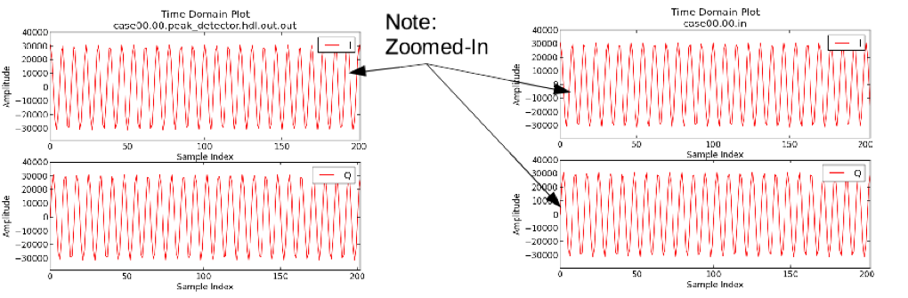
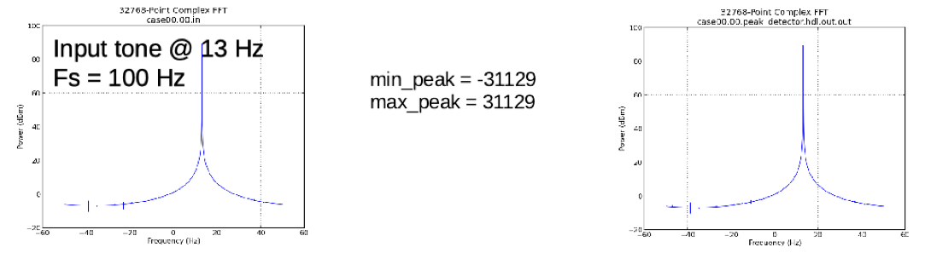

Step 7a: View Simulation Waveforms (Xilinx XSIM)
To perform this step, you must have checked "keep simulations" or ran:
$ ocpidev run --mode prep_run_verify --only-platform xsim --keep-simulations --view
In a terminal window, browse to peak_detector.test/ and execute:
$ ocpiview run/xsim/case00.00.peak_detector.hdl.simulation &
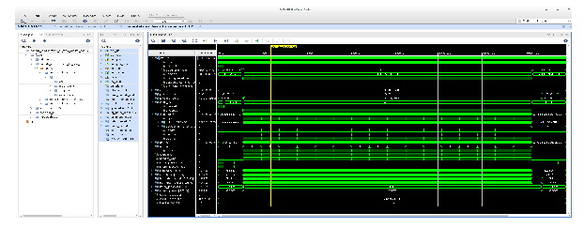

Steps 5b to 7b: Unit Test on Ettus E310
Use the framework's unit test suite to generate:
- OAS (OpenCPI Application Specification) XML file(s). The framework uses this item for running the bitstream on hardware platform. In this case, the target hardware platform is Ettus E310
- OHAD (OpenCPI HDL Assembly Description) XML file(s). The framework uses this item to build a bitstream for the target hardware platform. In this case, the target hardware platform is Ettus E310 (e3xx).
- Input test data file(s) based on user provided scripts.
- Various scripts to manage the execution of the applications onto the target platform(s).

Step 5b: Create Unit Test
We’ll re-use the unit test from the"work-alike" simple RCC worker we created in Tutorial 3 and used in the simulation step (5a) of this tutorial. The description file is located in the peak_detector.test/ directory and is named peak_detector-test.xml. There are no changes required.

Step 6b: Build Unit Test
Build the unit test suite for the target hardware platform:
- In the IDE, add the Unit Test to the Project Operations panel.
- Highlight "e3xx" the HDL Platforms panel (leave the HDL Targets box unchecked).
- Check the "Tests" radio button.
- Click "gen+build" to build tests.
- Review the Console window messages and address any errors.
NOTE: The build process takes 5-10 minutes to complete.

Step 6b: Review Build Logs (e3xx)
The following example shows a successful build. Only the end portion is shown.
Building container core "peak_detector_0_e3xx_z1_base" for target "zynq" 0:(sdp_width=1 ocpi_debug=false ocpi_endian=little) target-zynq/peak_detector_0_e3xx_base.edf
Generating UUID, artifact xml file and metadata ROM file for container peak_detector_0_e3xx_base (0).
Wrote bram file 'target-zynq/metadatarom.dat' (1876 bytes) from file 'target-zynq/peak_detector_0_e3xx_base-art.xml' (12690 bytes)
Tool "vivado" for target "zynq" succeeded. 0:45.34 at 12:58:31
Creating link to export worker binary: ../../peak_detector_0/lib/hdl/zynq/peak_detector_0_e3xx_base.edf -> target-zynq/peak_detector_0_e3xx_base.edf
Creating link from ../../peak_detector_0/lib/hdl -> gen/peak_detector_0_e3xx_base.xml to expose the container-peak_detector_0_e3xx_base implementation xml.
Creating link from ../../peak_detector_0/lib/hdl/zynq/peak_detector_0_e3xx_base.vhd -> target-zynq/peak_detector_0_e3xx_base-defs.vhd to expose the definition of worker peak_detector_0_e3xx_base.
Creating link from ../../peak_detector_0/lib/hdl/zynq/peak_detector_0_e3xx_base.v -> target-zynq/peak_detector_0_e3xx_base-defs.vh to expose the other-language stub for worker peak_detector_0_e3xx_base.
For peak_detector_0 on e3xx using config base: creating optimized DCP file using "opt_design". Details in opt.out
Time: 0:38.66 at 12:59:10
Tool "vivado" for target "zynq" succeeded on stage "opt".
For peak_detector_0 on e3xx using config base: creating placed DCP file using "place_design". Details in place.out
Time: 0:54.32 at 13:00:04
Tool "vivado" for target "zynq" succeeded on stage "place".
For peak_detector_0 on e3xx using config base: creating routed DCP file using "route_design". Details in route.out
Time: 1:03.33 at 13:01:08
Tool "vivado" for target "zynq" succeeded on stage "route".
Generating timing report (RPX) for peak_detector_0 on e3xx using base using "report_timing". Details in timing.out
Time: 0:28.55 at 13:01:36
Tool "vivado" for target "zynq" succeeded on stage "timing".
For peak_detector_0 on e3xx using config base: Generating Xilinx Vivado bitstream file target-zynq/peak_detector_0_e3xx_base.bit. Details in bit.out
Time: 0:41.37 at 13:02:18
Tool "vivado" for target "zynq" succeeded on stage "bit".
Making compressed bit file: target-zynq/peak_detector_0_e3xx_base.bit.gz from target-zynq/peak_detector_0_e3xx_base.bit and target-zynq/peak_detector_0_e3xx_base-art.xml

Step 6b: Review Build Artifacts (e3xx)
Observe the new artifacts in peak_detector.test/gen/assemblies/peak_detector_0/:
- peak_detector_0.xml – generated assembly XML (OHAD)
- gen/ – artifacts generated/used by framework
- lib/ – artifacts generated/used by framework
- target-zynq/ – artifacts generated/used by framework and FPGA tools
- container-peak_detector_0_e3xx_base/
gen/ – artifacts generated/used by framework
target_zynq/
- artifacts generated/used by framework and output files from FPGA tools
- bitstream file for execution onto a hardware platform

Step 7b: Run Unit Test (e3xx)
Note: more detail on this process can be found in the Ettus E3xx Getting Started Guide.
Set up the deployment platform:
- Connect to serial port via USB on rear of Ettus E310 on host:
"screen /dev/e3xx_0 115200"
- Boot and log in into Petalinux on E310:
User/Password = root:root
- Verify Host and E310 have valid IP addresses. For training, they should both be on the same subnet.
- Run setup script on E310:
"source /mnt/card/opencpi/mynetsetup.sh <Host ip address>"

Step 7b: Run Unit Test (e3xx)
Using the IDE approach to running unit tests on remote platforms:
- In the “Project Operations” panel, select "remotes" radio button.
- Click "+remotes".
- Change remote variable text to use Ettus E310’s IP and point to the training project:
{IP of Ettus E310}=root=root=/mnt/training_project
- Select the newly created remote. This will be the target remote test system. Unselected remotes will not be targeted.
- Add the unit test to the Project Operations panel.
- Highlight "e3xx" the HDL Platforms panel (HDL Targets box unchecked).
- Check "run view script".
- Click "prep + run + verify" to run tests.
- Review the Console window messages and address any errors.
Alternatively, from a terminal window:
- Execute the following commands within the {component}.test/
$ OCPI_REMOTE_TEST_SYSTEMS={IP of Ettus E310}=root=root/mnt_training \
ocpidev run --mode prep_run_verify --only-platform e3xx --keep-simulations --view

Step 7b: Run Unit Test (e3xx)
The Python script verifies output data from the unit test:
============ Verifying test cases for platform xsim
Performing test cases for ocpi.training.peak_detector on platform xsim. Functions are: verify
Verifying case case00.00 for worker peak_detector.hdl using script on output file: case00.00.peak_detector.hdl.out.out
('File to validate: ', 'case00.00.peak_detector.hdl.out.out')
('uut_min_peak = ', -31129)
('uut_max_peak = ', 31129)
('file_min_peak = ', -31129)
('file_max_peak = ', 31129)
Verification for port out: PASSED
Perform an md5sum to ensure the output of the XSIM and E310 tests are the same:
peak_detector.test$ md5sum run/*/*.out
- 747a9fa9fbd73607c474e60782cb4cd3 run/centos7/case00.01.peak_detector.rcc.out.out
- 747a9fa9fbd73607c474e60782cb4cd3 run/xilinx13_4/case00.01.peak_detector.rcc.out.out
- 747a9fa9fbd73607c474e60782cb4cd3 run/xsim/case00.00.peak_detector.hdl.out.out
- 747a9fa9fbd73607c474e60782cb4cd3 run/e3xx/case00.00.peak_detector.hdl.out.out

