OpenCPI Tutorial 0:
Setting up an OpenCPI GUI Workspace

Revision History
Revision | Description of Change | Date
1.0 | Creation from Lab 0 developed by CNF | 2019-10-01
1.1
1.2
1.3
1.4
1.5
1.6
1.7
1.8
1.9
2.0
2.1
Table of Contents
1 References 4
2 About This Tutorial 5
3 Prerequisites to Running This Tutorial 6
4 Setting up an Empty Workspace 7
4.1 Open Eclipse 8
4.2 Select Directory Workspace 10
4.3 Launch Workspace 11
4.4 Correct a Partial Window or Workspace (Optional) 12
5 Importing OpenCPI Projects 14
5.1 Import the Project Files 15
5.2 Select Existing Projects into Workspace 16
5.3 Browse Root Directory 17
5.4 Select ocpi_projects 19
5.5 Select Projects 21

References
This document depends on information provided in the documents listed in the following table.
Table 1 - Table of Reference Documents
Title | Published By | Link
Briefing 1: Introduction to OpenCPI | OpenCPI | Public URL: https://opencpi.github.io/releases/1.x.0.rc/doc//OpenCPI_xxxxx.pdf
Briefing 2: Introduction to OpenCPI, focusing on Application Developers | OpenCPI | Public URL: https://opencpi.github.io/releases/1.x.0.rc/doc//OpenCPI_xxxxx.pdf
OpenCPI Overview | OpenCPI | Public URL: https://opencpi.github.io/releases/1.5.0.rc/doc//OpenCPI_Overview.pdf
OpenCPI Application Development Guide | OpenCPI | Public URL: https://opencpi.github.io/releases/1.5.0.rc/doc/OpenCPI_Application_Development.pdf
OpenCPI Component Development Guide | OpenCPI | Public URL: https://opencpi.github.io/releases/1.5.0.rc/doc/OpenCPI_Component_Development.pdf

About This Tutorial
OpenCPI provides a plug-in to the Eclipse IDE called the ANGRYVIPER GUI. You can choose to use this GUI to perform the procedures demonstrated in the OpenCPI tutorials. This tutorial is a reference for procedures that you will use in subsequent OpenCPI tutorials if you are using the ANGRYVIPER GUI plug-in to the Eclipse IDE. The purpose of this tutorial is to remove any repetitive steps that may later seem redundant as you are completing the other tutorials. This tutorial demonstrates how to:
- Set up a new blank Eclipse workspace
- Import the OpenCPI projects into your workspace for use in subsequent tutorials

Prerequisites to Running This Tutorial
To perform this tutorial, you must first:
- Install and build OpenCPI using one of the following methods:
Installation from source. This method is described in the OpenCPI Installation Guide.
Installation from RPM packages. This method is described in the RPM Installation Guide.
Installation from a pre-built, pre-configured Virtual Box snapshot.
- Install the ANGRYVIPER GUI plug-in for the Eclipse IDE. Installation instructions are provided in the RPM Installation Guide.
- Read Briefing 1, “Introduction to OpenCPI” and Briefing 2, “Introduction to OpenCPI, focusing on Application Developers”. These briefings describe concepts and tools.

Setting up an Empty Workspace
Use this procedure to create a new, blank workspace each time you create a new project. This way, you don’t get confused with previous projects/workspaces.

Open Eclipse
Step 1 is to open Eclipse from your OpenCPI installation.
If you have performed the VirtualBox installation procedure to install OpenCPI, you can open it from VirtualBox, as shown in the following figure:
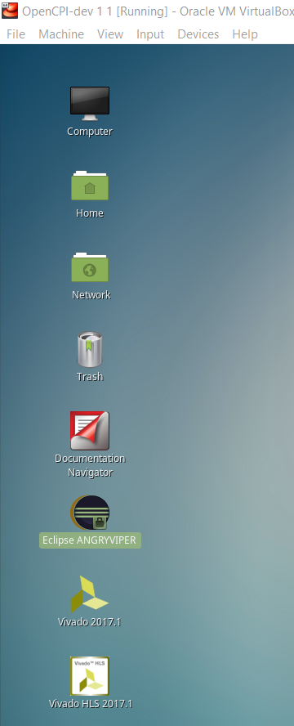
The following window pops up:
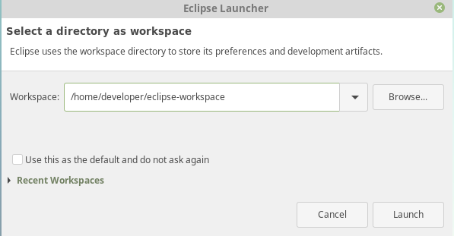

Select Directory Workspace
Step 2 is to set up your OpenCPI workspace.
Click Browse. The following dialog pops up:
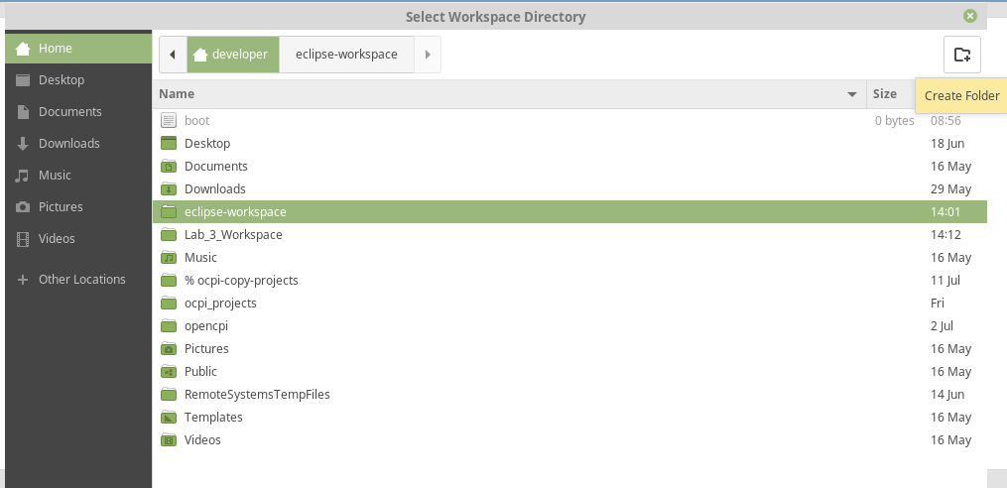
Select Developer, and then on the top right corner select the Create Folder tab. Name the workspace whatever you want, just keep the name in mind. Click OK to open it.
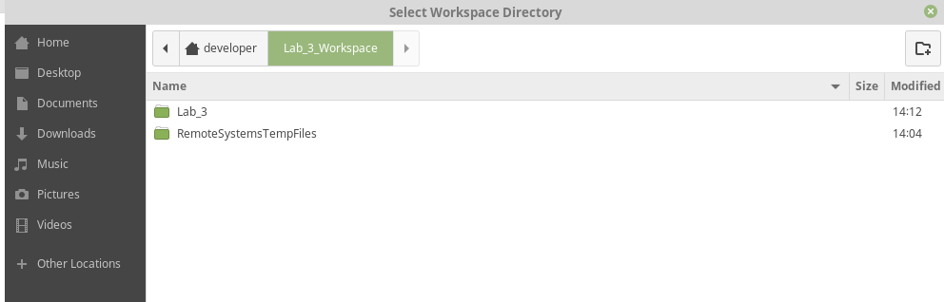

Launch Workspace
Once you know you are in the new directory you created, click Launch.
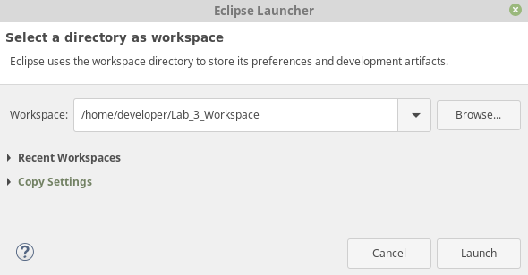

Correct a Partial Window or Workspace (Optional)
You may get a partial window or the welcome page that is not the full Eclipse workspace. In this situation, select Window > Perspective > Open Perspective > Other:
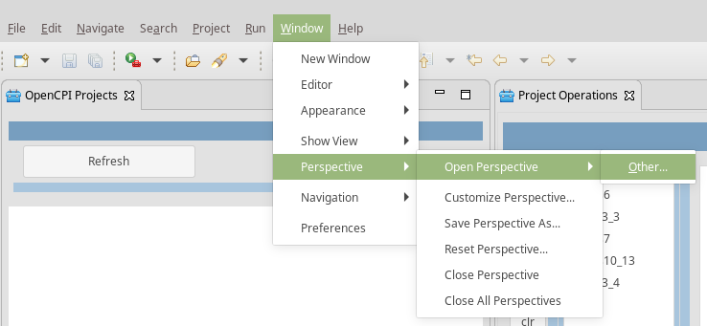
Highlight the ANGRYVIPER Perspective and then click Open:
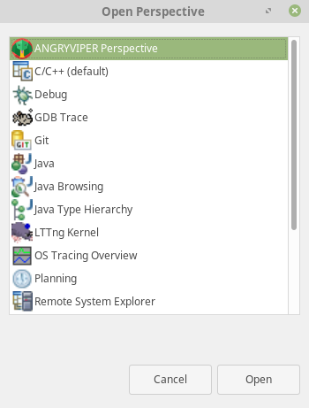
Your window should now look like this:
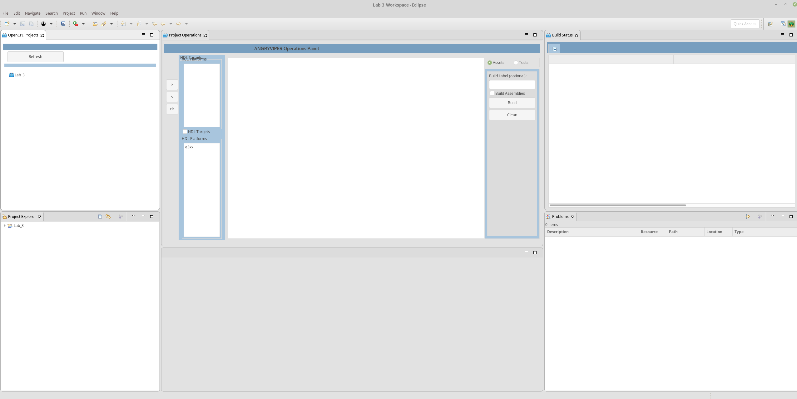
This is what a blank workspace looks like. You will need to start with this for every tutorial.

Importing OpenCPI Projects
Importing a project into the ANGRYVIPER GUI workspace makes it visible in your workspace so that you can use it for application development. The following OpenCPI projects are essential for OpenCPI application development. They allow you to build your projects on different platforms:
- core – basic components (read and write files)
- assets – various component libraries
- assets_ts – components for timestamping
- bsp_e310 – unique device workers, card definition and the E310 BSP
Tutorials 1-9 require the core and assets projects. Tutorials 6hw-9hw additionally require the bsp_e310 project if you intend to run them on the Ettus E310 platform.
In this procedure, we’ll import the core, assets and bsp_310 projects.
Note: Sometimes the target platforms aren’t displayed on the Operations panel. You can also use this procedure to fix this problem.

Import the Project Files
Import the files from the ocpi_projects directory: go to the top left corner and select File > Import:
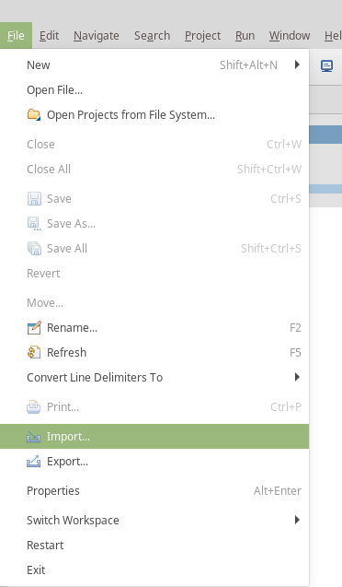

Select Existing Projects into Workspace
In the window that pops up, select Existing Projects into Workspace:
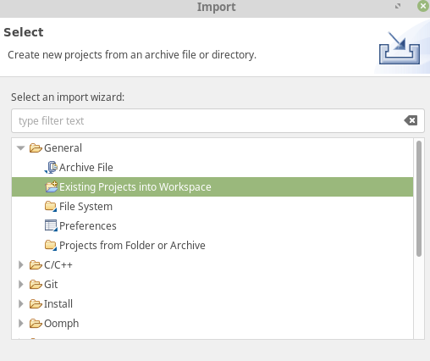

Browse Root Directory
In the window that pops up, check select root directory and then click Browse.
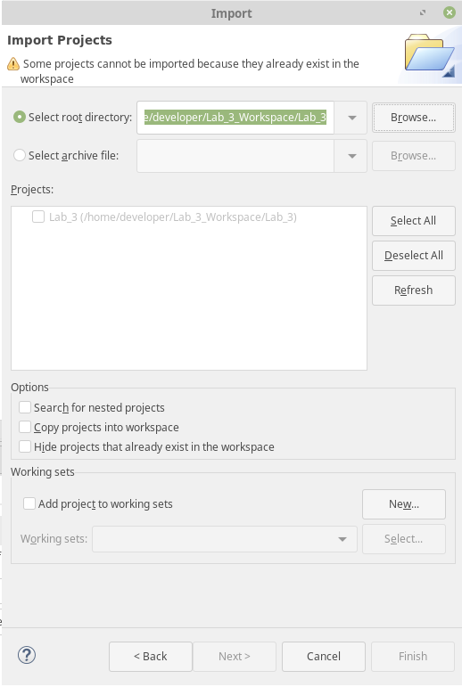
The following dialog pops up:
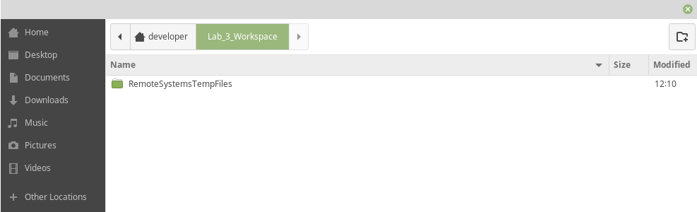

Select ocpi_projects
Go to Developer (or whatever your user space is) and highlight ocpi_projects:
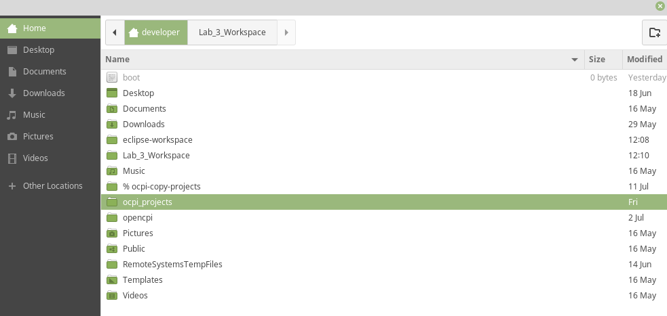
Select OK. The following window is displayed:
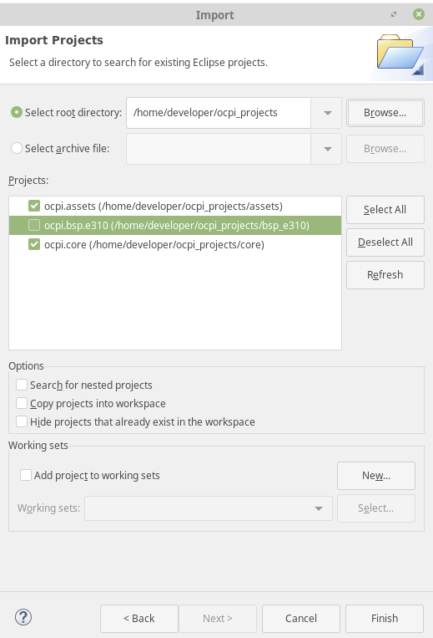

Select Projects
Leave ocpi.core, ocpi.bsp_e310 and ocpi.assets and checked and then click Finish.
You should end up with these three projects in your Project Explorer and OpenCPI Projects window. Here is an example:
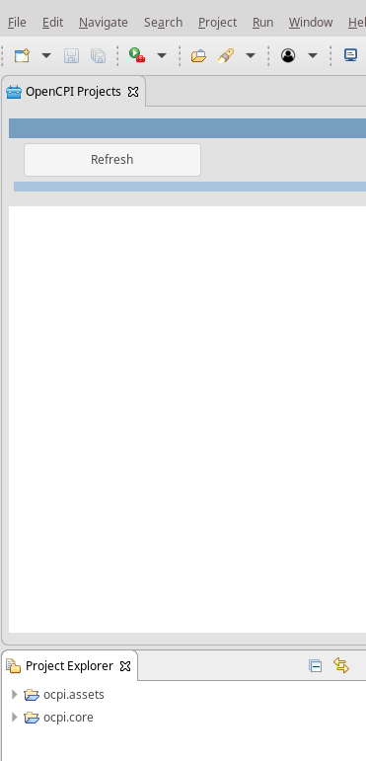
Click Refresh in the OpenCPI Projects window to display all of the projects:
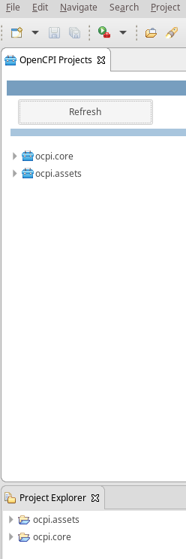
Done!
We recommend registering your imported projects before continuing with the tutorials. It also helps if you go ahead and build them for the target platform on which you plan to run them.

