OpenCPI Tutorial 1:
Introduction to OpenCPI Application Development

Revision History
Revision | Description of Change | Date
1.0 | Creation from Lab 1 developed by CNF | 2019-10-01
1.1
1.2
1.3
1.4
1.5
1.6
1.7
1.8
1.9
2.0
2.1
Table of Contents
1 References 4
2 About This Tutorial 5
3 Prerequisites to Running This Tutorial 6
4 Build the Application Assembly for the Simulator 7
5 Create the FSK Data 8
6 Register Your Projects 10
7 Create the FSK Application 11
8 Create file_read Component Instance 14
9 Add Property Values to Components 16
10 Make Connections 27
11 End the Application 29
12 Run the FSK Application 30
13 Troubleshooting 31

References
This document depends on information provided in the documents listed in the following table.
Table 1 - Table of Reference Documents
Title | Published By | Link
Briefing 1: Introduction to OpenCPI | OpenCPI | Public URL: https://opencpi.github.io/releases/1.x.0.rc/doc//OpenCPI_xxxxx.pdf
Briefing 2: Introduction to OpenCPI, focusing on Application Developers | OpenCPI | Public URL: https://opencpi.github.io/releases/1.x.0.rc/doc//OpenCPI_xxxxx.pdf
Tutorial 0: Setting up an OpenCPI GUI Workspace | OpenCPI | Public URL: https://opencpi.github.io/releases/1.x.0.rc/doc//OpenCPI_xxxxx.pdf
OpenCPI Overview | OpenCPI | Public URL: https://opencpi.github.io/releases/1.5.0.rc/doc//OpenCPI_Overview.pdf
OpenCPI Application Development Guide | OpenCPI | Public URL: https://opencpi.github.io/releases/1.5.0.rc/doc/OpenCPI_Application_Development.pdf
OpenCPI Component Development Guide | OpenCPI | Public URL: https://opencpi.github.io/releases/1.5.0.rc/doc/OpenCPI_Component_Development.pdf

About This Tutorial
This tutorial demonstrates the OpenCPI application development workflow and gives a general overview of the process. It shows you how to:
- Create an App XML file (called an “OpenCPI Application Specification” or “OAS”) for the OpenCPI Frequency-Shift Keying (FSK) reference application with the command-line OpenCPI ocpidev utility or the GUI-based Eclipse ANGRYVIPER (AV) IDE. An App XML file describes an application’s component connections and initial component property settings.
- Run the FSK reference application with the OpenCPI ocpirun utility on one of the simulator platforms supported by OpenCPI:
Mentor Graphics ModelSim DE 10.6a/10.4c (platform name modelsim)
Xilinx Vivado 2017.1 (platform name xsim)
Xilinx ISE 14.7 (platform name ise)
The OpenCPI ociprun utility uses the generated App XML during the execution of the application on the target platform.
The goal of this tutorial is to send an image over a wire using the FSK protocol.
The FSK reference application is an OpenCPI demo application that performs FSK modulation/demodulation:
Modulation: Read Input File → FSK Symbol Mapper → Zero-pad → Pulse Shape → FM Modulate → Interpolate
Demodulation: Decimate → Demodulate → Filter → Baud Track → Digitize → Write Output File
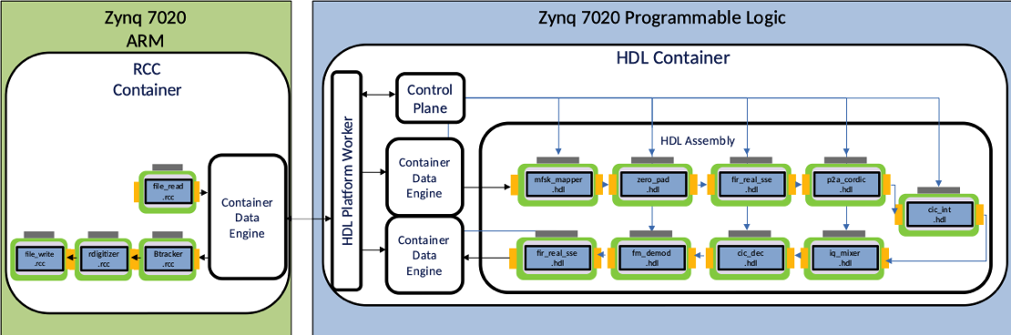
For more information about the FSK reference application, see the OpenCPI FSK App Guide and the OpenCPI FSK App Getting Started Guide. For more information about the OpenCPI Application Specification, ocpidev and ocpirun, see the OpenCPI Application Development Guide. For more information about OpenCPI components, see the OpenCPI Component Development Guide.

Prerequisites to Running This Tutorial
To perform this tutorial, you must first:
- Install and build OpenCPI using one of the following methods:
Installation from source. This method is described in the OpenCPI Installation Guide.
Installation from RPM packages. This method is described in the RPM Installation Guide.
Installation from a pre-built, pre-configured Virtual Box snapshot.
- Install the ANGRYVIPER GUI plug-in for the Eclipse IDE. Installation instructions are provided in the RPM Installation Guide.
- Read Briefing 1, “Introduction to OpenCPI” and Briefing 2, “Introduction to OpenCPI, focusing on Application Developers”. These briefings describe concepts and tools.
- (optional) Follow Tutorial 0, “Setting up the OpenCPI GUI Workspace” to set up an empty Eclipse workspace and import the OpenCPI projects into it. This step is only necessary if you are using the ANGRYVIPER Eclipse plug-in to follow the tutorial.

Build the Application Assembly for the Simulator
First, you need to build the application assembly to run on your chosen simulator.
Using ocpidev:
ocpidev build -d assets –rcc-platform centos7 –hdl-platform <your-simulator-platform>
where the value of your-simulator-platform is modelsim, xsim or isim.
Using the ANGRYVIPER GUI:
- From the OpenCPI Project view, right-click on your assets project and then use the > to move it over to the Operations panel. Do the same with core.
- In the Project Operations tab, select centos7 for the RCC platform and modelsim, xsim or isim for the HDL platform.
- Check build assemblies. The build takes about 10 minutes.

Create the FSK Data
Next, you’ll create the FSK data for the application.
Navigate to the idata directory of your assets project’s FSK application. lab1_tut should be replaced with the directory in which your workspace resides.
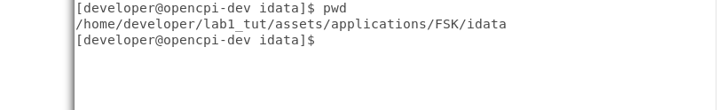
Create a file called rx_rrcos_taps.dat with the values below. MAKE SURE THERE ARE NO TABS OR SPACES in the lines where the numbers reside. Copy this file and then rename it to tx_rrcos_taps.dat. We will reference these files later in the tutorial. Also note that there is an Os.jpeg in idata that we will use as an input file to send over the wire.
Here are the values to supply (lines 1-64):
85
96
105
111
115
116
114
109
100
88
72
53
31
6
-21
-50
-81
-113
-145
-177
-207
-235
-259
-280
-295
-305
-307
-302
-287
-263
-229
-184
-128
-60
20
112
217
334
462
602
752
912
1081
1257
1441
1629
1821
2015
2209
2402
2593
2779
2958
3130
3292
3443
3581
3705
3814
3906
3981
4038
4076
4096

Register Your Projects
You need to register your core and assets projects if they’re not already registered.
Using ocipdev: TBD
Using the ANGRYVIPER GUI:
- Right-click on the assets and core projects to register them. If you see the unregister option when you right-click them, the projects are already registered.
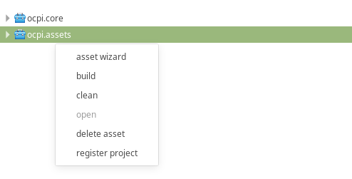

Create the FSK Application
Now you need to create the FSK application.
Using ocpidev: TBD

Using the ANGRYVIPER GUI:
- Right-click on assets and select the asset wizard:
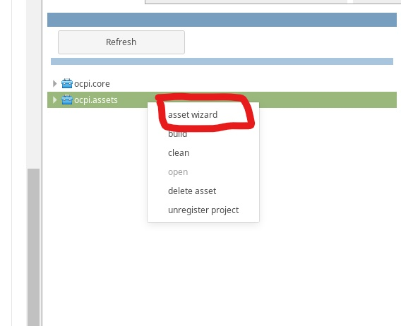
- Name your application fsk_loopback and make it XML only.
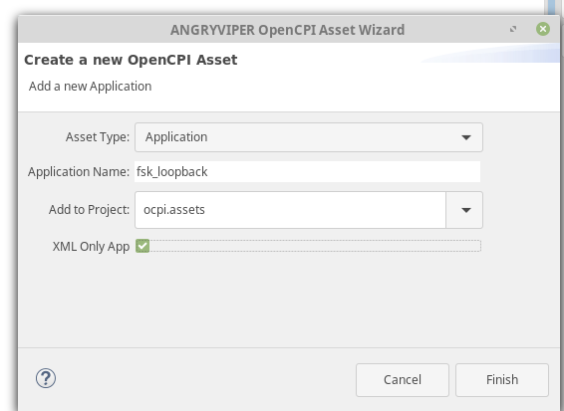
Now you see the OAS diagram for this XML. Note: You can delete the ocpi.core.nothing component. This worker is automatically placed by the framework to ensure that the generated OAS can be executed without editing the generated file.
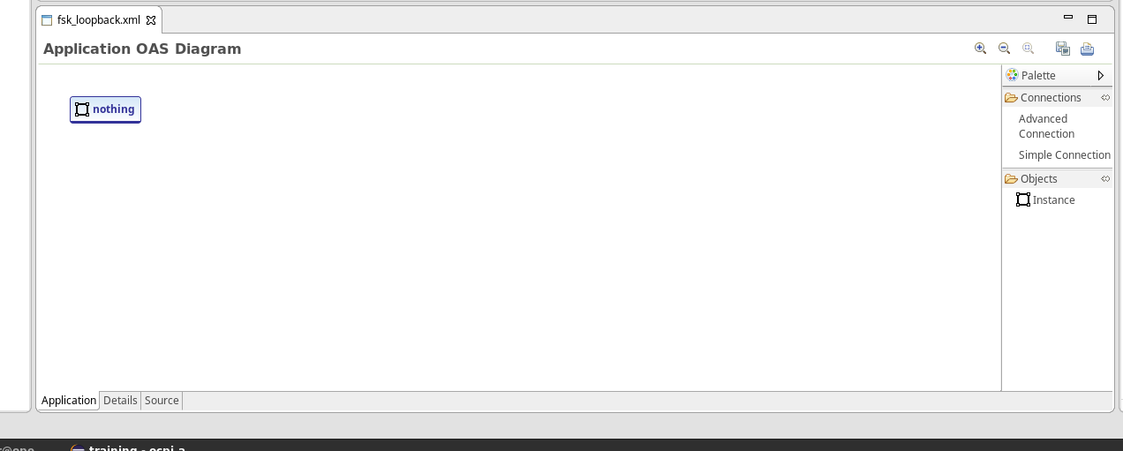
The following image shows all of the component specs that will be placed in our OAS diagram XML:
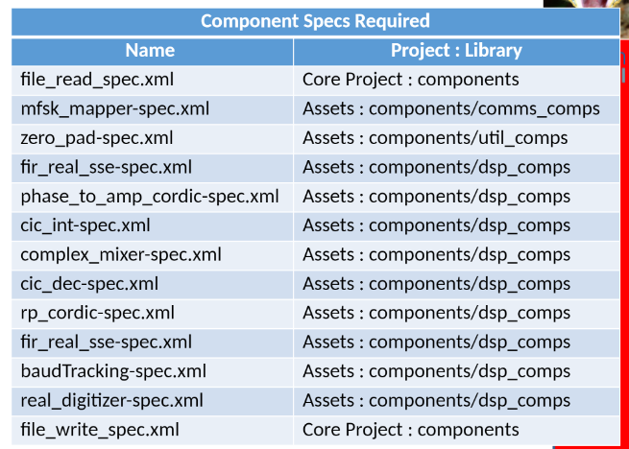

Create file_read Component Instance
The next step is to create the file_read component instance for the FSK application.
Using ocpidev: TBD
Using the ANGRYVIPER GUI:
- Right-click on the OAS diagram and click Add Instance.
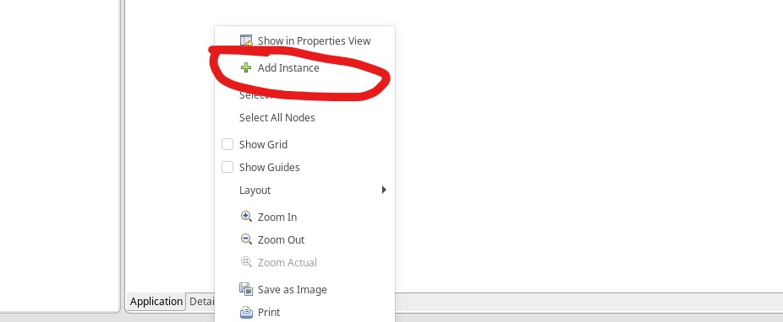
NOTE: instances are ordered alphabetically so the instance zero_padding appears before anything else because it starts with a z. You may have an instance called zero_padding or something else that is not one of the instances required.

NO WORRIES! we can change this by double-clicking on the instance we just created.

Notice how an arrow appears. Click it to show a drop-down menu of available instances.
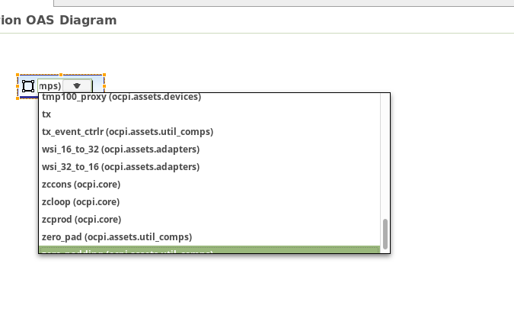
Let’s select file_read for our first instance in this project.


Add Property Values to Components
Now you need to add property values to your components. The following image contains all of the property values you need to edit for each of the components listed in “Creating the FSK Application”.
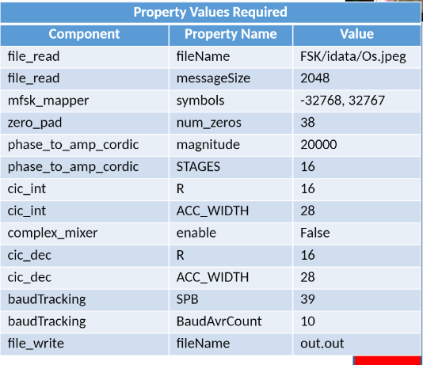
NOTE: The value of file_read is dependent on where the Os.jpeg image is located. Consider your environment when you mount the folders to run on the hardware platform. You would probably have a value of /mnt/ocpi_assets/applications/FSK/idata/Os.jpeg.
Using ocpidev: TBD
Using the ANGRYVIPER GUI, click on our instance. We see that two paper tabs are displayed on the right side. Click the bottom one to show this instance in the Properties view.
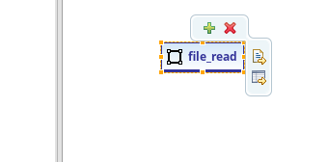
Alternatively, you can right-click on the instance to get the following drop-down menu.
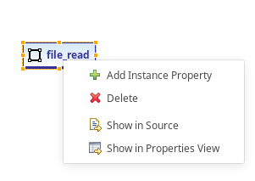
On the right side of your screen, a Properties tab should be displayed.
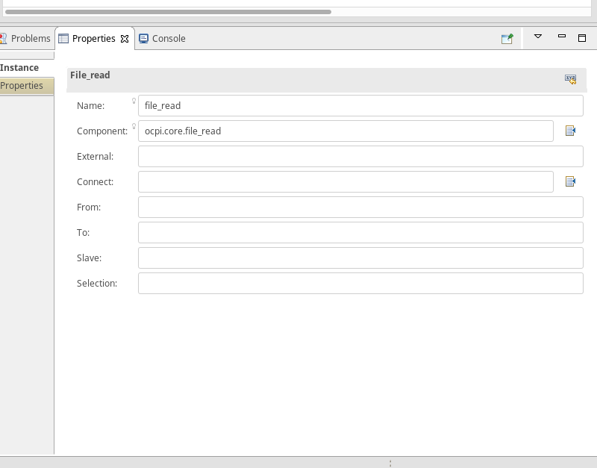
NOTE: Notice the component parameter. ocpi.core.file_read is the component you are using. You can change the name if you need more than one file_read for an application with no effect on the component parameter.
Click the Properties tab to change the properties of the instance you created.
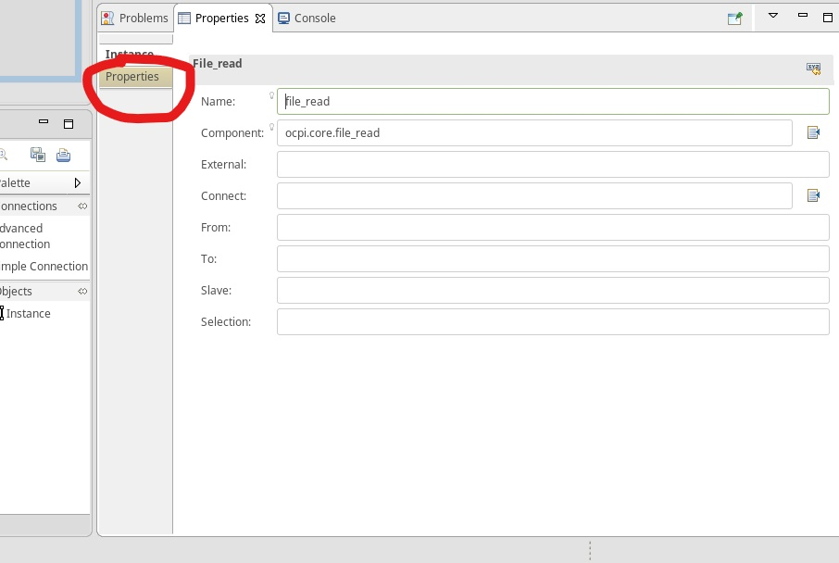
You get a blank screen:
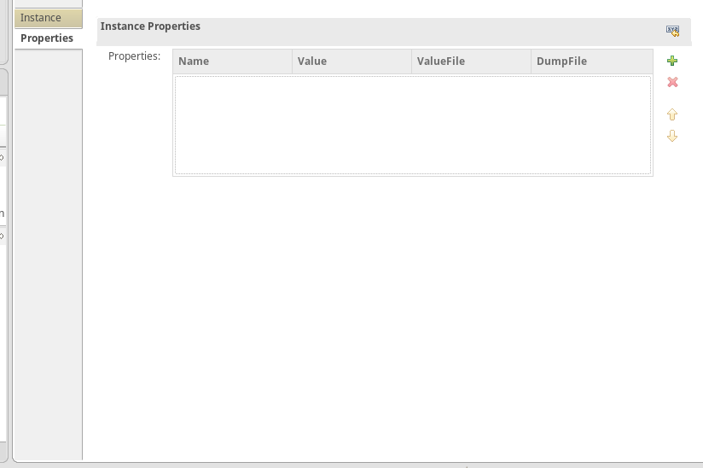
Click the green plus button to add a property:
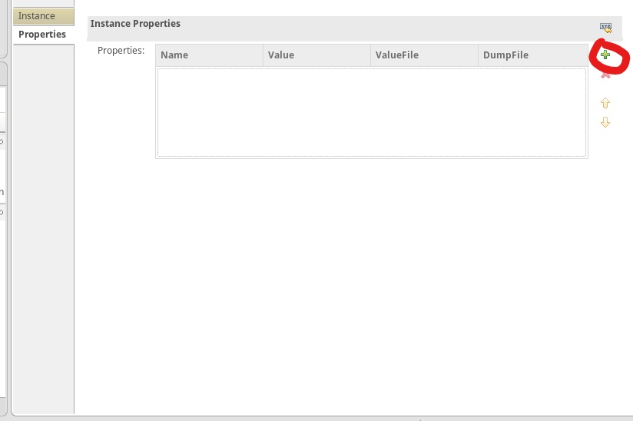
Based on the property values shown in the previous Property Values Required image, you should have something like this for your file_read instance:
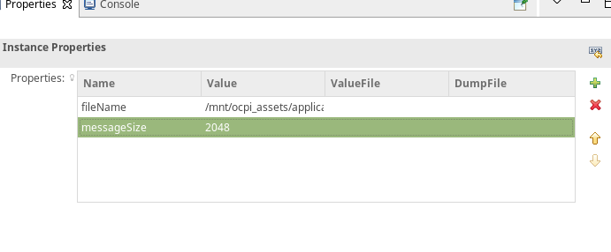
In your OAS diagram, you should see something like this:
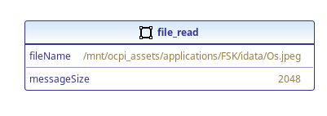f
In this project, we need to add two fir_real_sse instances to our OAS diagram. Notice the little 'x' on the instance. This is happening because these two instances we created have the same name. This is bad.
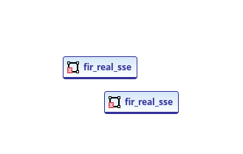
To fix this problem, click on the instance and then change the name in the Properties view to rx_fir for one instance and tx_fir for the other instance.
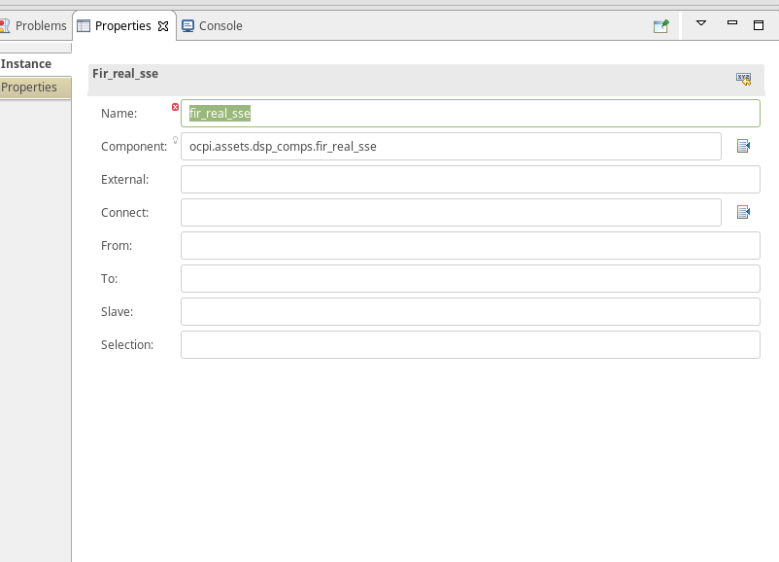
Now we have no errors.
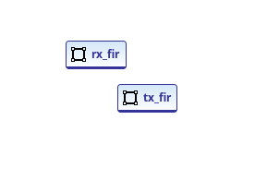
The fir_real_sse instances have a property called taps:
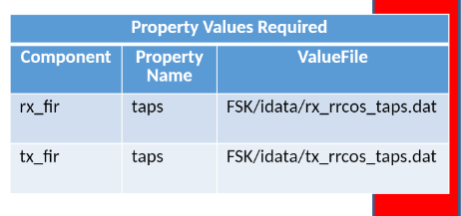
Change the items shown in the figure above in each of the respective instances we just created. The value of ValueFile is going to be the directory where rx_rrcos_taps.dat and tx_rrcos_taps.dat are stored. We created these files in Step 5.
Also consider that you are going to be mounting these files over a network. So it would look something like this:
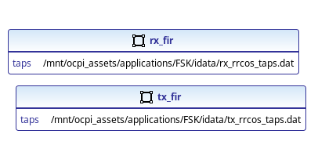
Now, looking at the following table, repeat the steps you did for file_read for the remaining instances.
Once you do this, you have will have something like this image:
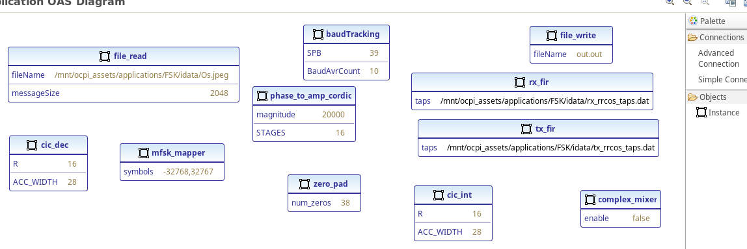
This looks messy. Let’s reorder it so it’s easier to make connections.
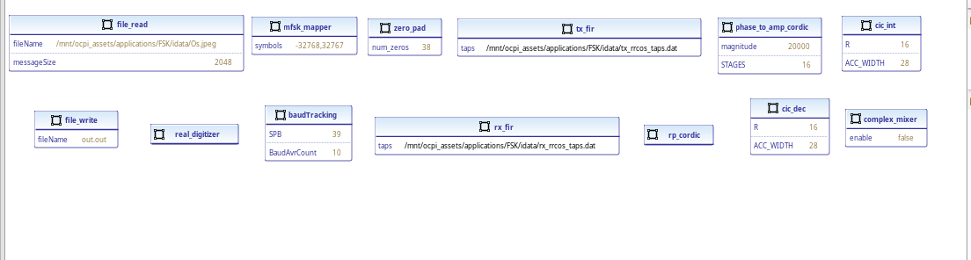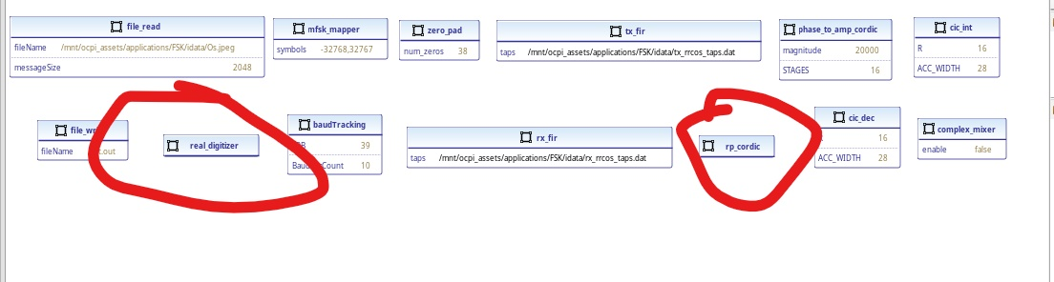
Notice the new components real_digitizer and rp_cordic. Don’t worry about editing their properties.

Make Connections
The next step is to make connections between components in the application.
To make connections using ocpidev:
TBD
To make connections using the ANGRYVIPER GUI, click the Advanced Connection tab in the OAS view and then click the start of the connection and the end of the connection. Don’t worry about connection names for this project.
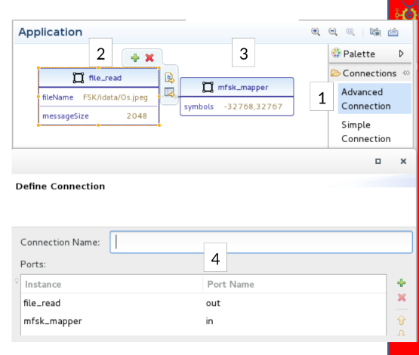
The result will look like something similar to this:
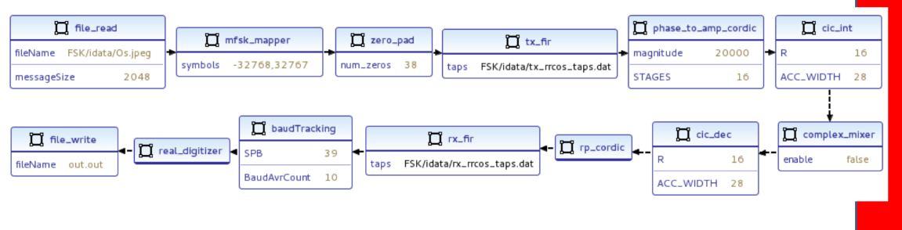
NOTE: The only unique values should be fileName for the file_read instance, because it’s a path to your Os.jpeg and the two taps values for tx_fir and rx_fir respectively, because the data file location is unique to your setup.

End the Application
An important step is to make sure that you end the application so that it doesn’t go into an infinite loop.
Using ocpidev: TBD
Using the ANGRYVIPER GUI, click on the white space of the OAS view and you will get something like this:
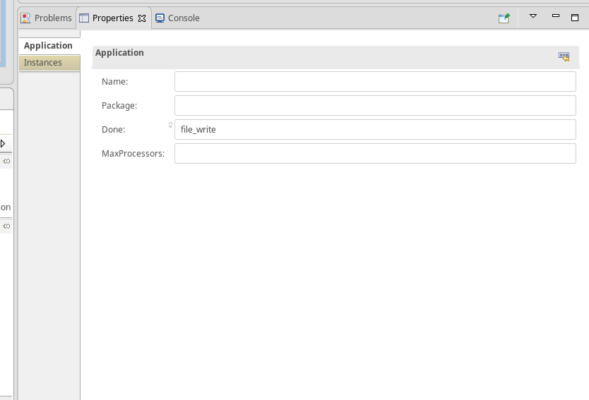
Your Done: parameter will be blank. Replace it with file_write.

Run the FSK Application
Now you can run the FSK application with the ocpirun utility.
On your CentOS7 development host, navigate to the directory where your fsk_loopback application resides.
Set the OCPI_LIBRARY_PATH to where your exports are located for your core and assets projects:
Execute ocpirun to start the application:
ocpirun -v fsk_loopback.xml
On your host machine, go to your assets applications folder.
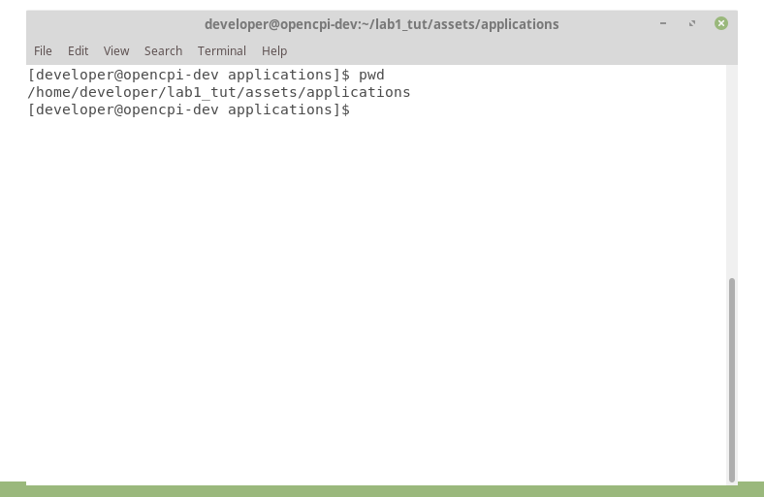
Run eog out.out. If an image appears, the tutorial is successful.
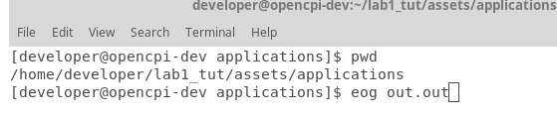

Troubleshooting
$ export OCPI_LOG_LEVEL=8 to view a detailed log while running on your hardware platform.
When building ocpi.core and ocpi.assets with the ANGRYVIPER GUI, be sure the Build Assemblies checkbox is checked.
Double-check your spelling for typos inside the component properties.
Problems regarding library entries not found:
- .gz library files were missing from the assets/exports.
- dsp_comps assemblies were cleaned and rebuilt to resolve missing .gz libraries.
- OCPI_LIBRARY_PATH export may not be referencing the correct exports path for assets and core.

