OpenCPI
Tutorial 4: Using Third-party Libraries in RCC Workers
OpenCPI Release: v2.4.7
Revision History
Revision | Description of Change | Date
1.0 | Creation | 2019-12-12
1.1 | Update for release 2.2.0 (remove refs to Makefile/*mk, change to XML) | 2021-07-03
1.2 | Update for release 2.3.0 (complete makeless updates) | 2021-08-15
1.3 | Update for use with OpenCPI GUI | 2021-11-14
1.4 | Update for release 2.4.1 (incorporate feedback, change GUI section variable name) | 2022-03-02
1.5 | Update for release 2.4.3 (fix discrepancies) | 2022-08-31
1.6 | Update language regarding CentOS7 to make it clear that there are other available platforms | 2023-01-20
1.7 | Update file names for release 2.5 | 2023-01-25
Table of Contents
1 Overview 4
1.1 Tutorial Objectives 5
1.2 What’s Provided for This Tutorial 6
1.3 Prerequisites to Using This Tutorial 7
1.4 Documentation References 8
2 Create New Project 9
3 Create Components Library 11
4 Create Component 12
4.1 Create Component Spec 13
4.2 Add Properties and Ports 15
5 Create Worker 17
5.1 Create Worker OWD and Skeleton File 18
5.2 Edit Worker OWD 19
5.3 Write C++ Code 20
5.4 Update RCC Worker Skeleton File 21
5.5 Build Worker 25
6 Create Unit Test 26
6.1 Edit Test Suite Description 27
6.2 Update Unit Test Scripts 28
6.3 Build Unit Test 29
7 Run Unit Test 30
8 Tutorial Summary 33

Overview
This tutorial continues to demonstrate the RCC worker design process that we introduced in Tutorial 3. In this tutorial, we’ll re-create the complex_mixer component from the ocpi.tutorial project that we used in Tutorial 2. As we did in Tutorial 3, we’ll step through the procedure used to create the component and its RCC worker implementation, including creating the component specification and designing, building and testing an RCC worker that implements its function. The example RCC platform used in this tutorial is centos7, but different development hosts can be used. If you are using a development host other than CentOS7, replace centos7 with the relevant name (example, ubuntu20_04).
The complex mixer component consists of a Numerically Controlled Oscillator (NCO) and a complex multiplier. It receives I/Q data on its input port and then multiplies this signal by a tone generated by the NCO, shifting the input signal in the frequency domain by the frequency of the NCO. The component properties control the NCO frequency.
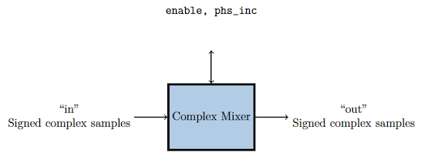
Figure 1: Complex Mixer Component Function
This tutorial shows you how to use a third-party library to implement the internal NCO tone generator for the RCC implementation of the component. To implement the NCO, we’ll use the nco module from liquid-dsp, which is a free and open-source signal processing library for software-defined radios written in C and is included in the OpenCPI installation. For details on liquid-dsp and the nco module, see the URL https://liquidsdr.org/doc/nco.

Tutorial Objectives
The purpose of this tutorial is to demonstrate how to integrate a third-party library into an RCC worker.
This tutorial shows you how to:
- Create the complex mixer component specification (properties and ports).
- Create the complex mixer worker C++ code using the liquid-dsp API and build the worker for the target platform.
- Create, build and run the unit test for the RCC worker on the target platform.
It demonstrates how to use the RCC authoring model to:
- Integrate the liquid-dsp library into the RCC worker
- Create worker methods for initializing and releasing C++ resources
- Access worker data ports
- Use worker method result values to communicate worker states to the OpenCPI framework
After running this tutorial, you should understand how to use the RCC authoring model to integrate a third-party library into an RCC worker and how to use the OpenCPI unit test suite on an RCC worker implementation of a simple OpenCPI component.

What’s Provided for This Tutorial
The OpenCPI built-in project ocpi.tutorial provides source code for the following items in this tutorial:
- The complex_mixer_tutorial.rcc worker, written according to the API for the RCC (C++ source code) authoring model. This source code uses the liquid-dsp library that is included with OpenCPI and installed as part of the OpenCPI installation process.
- The unit test files generate.py and verify.py, written in Python
- The unit test bash shell script view.sh
The tutorial also provides the XML source for all of the assets used to build and run the example component, worker and tests described in this tutorial.
You will also use the following script from the ocpi.tutorial project:
- The Python script code for plotting and viewing the output data, in scripts/PlotAndFft.py
Instructions for copying these items from the ocpi.tutorial project into the “demo” tutorial project are provided in the relevant sections of this document. The source code for these items is also available as text in the relevant sections of this document that you can copy and paste into the relevant files following the instructions given in the section.
Note: when copying and pasting text from this document, be sure to remove any line breaks in code or command lines.

Prerequisites to Using This Tutorial
This tutorial (Tutorial 4) has the same system prerequisites as OpenCPI Tutorial 1: Component-based Development. See the prerequisites section in Tutorial 1 for details.
Before you begin this tutorial, you should have successfully completed Tutorials 1 through 3.
We recommend reading Briefing 7 OpenCPI Unit Test Framework Details before getting started with this tutorial.

Documentation References
The documents listed in the following table provide detailed information about subjects discussed in this tutorial. The documents listed here are not required reading for this tutorial but will likely be of interest for more in-depth learning.
Table 1 - OpenCPI Reference Documentation
Title | Published By | Public URL
OpenCPI User Guide | OpenCPI | https://opencpi.gitlab.io/releases/latest/docs/OpenCPI_User.pdf
OpenCPI Application Development Guide | OpenCPI | https://opencpi.gitlab.io/releases/latest/docs/OpenCPI_Application_Development.pdf
OpenCPI Component Development Guide | OpenCPI | https://opencpi.gitlab.io/releases/latest/docs/OpenCPI_Component_Development.pdf
OpenCPI HDL Development Guide | OpenCPI | https://opencpi.gitlab.io/releases/latest/docs/OpenCPI_HDL_Development.pdf
OpenCPI RCC Development Guide | OpenCPI | https://opencpi.gitlab.io/releases/latest/docs/OpenCPI_RCC_Development.pdf

Create New Project
As we did in Tutorial 3, we’ll create a new, clean project for Tutorial 4; we’ll call it DemoProject4. This project has the same requirements as the project we created for Tutorial 3.
To create DemoProject4 using the OpenCPI GUI:
- Start the OpenCPI GUI.
- From the GUI menu bar at the top of the window, select Create > Project…
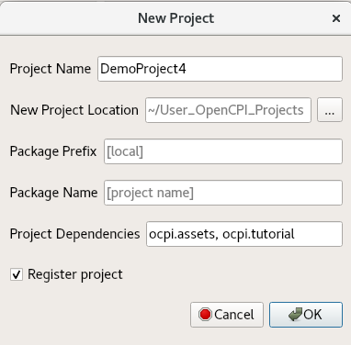
- In the New Project dialog, enter DemoProject4 in Project Name.
- In Project Dependencies, enter ocpi.assets, ocpi.tutorial.
- Check Register project.
- Leave all of the other fields as they are and click OK.
- You should now see DemoProject4 displayed in the OpenCPI Project Explorer panel. Like the other tutorials, subsequent sections show both ways to perform the steps described in the section: with the GUI and with the CLI. You can use either method; using both methods is redundant.
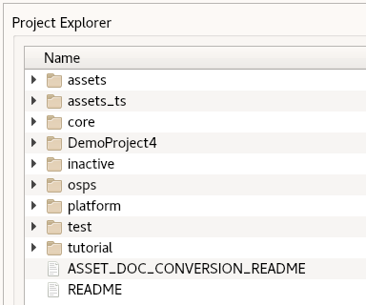
Notice that the GUI executes ocpidev commands to carry out its operations and that they are visible in the Console view on the bottom right. You can follow along and familiarize yourself with the ocpidev commands by checking the console window after you perform an operation.
To create the new project on the command line, use the following ocpidev command:
ocpidev -D ocpi.assets -D ocpi.tutorial create project DemoProject4 --register

Create Components Library
We can use the top-level components/ directory as our library like we did in Tutorial 3.
To create the components library with the OpenCPI GUI:
- From the GUI menu bar at the top of the window, select Create > Component Library...
- In the Associated Project drop-down list, select DemoProject4. Click OK to create the component library.
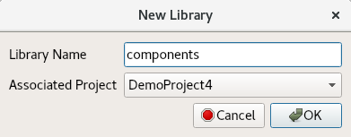
- The components library is displayed in the Project Explorer panel.
To create the components library with ocpidev, run the following command in the DemoProject4 directory:
ocpidev create library components

Create Component
Like we did in Tutorial 3, we need to create the OCS (OpenCPI Component Specification) for our complex mixer function that defines its properties and ports.

Create Component Spec
As we did for the new peak_detector component in Tutorial 3, we’ll create the complex mixer component spec in the components/ library.
To create the complex mixer component spec with the OpenCPI GUI:
- From the GUI menu bar at the top of the window, select Create > Component Spec…
- In Component Name, enter complex_mixer. Leave Associated Library set to None.
- Choose DemoProject4 from the Associated Project drop-down list.
- The drop-down menu for Associated Library should automatically select components.
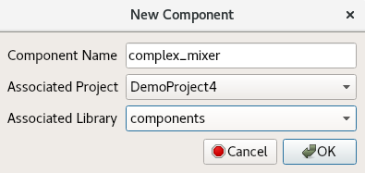
- Click OK. When the operation completes, you should see a complex_mixer.comp/ subdirectory in the components/ directory displayed in the Project Explorer view.
- Use the Project Explorer or OpenCPI Projects panel to expand the complex_mixer.comp/ directory. You should see the component spec you just created complex_mixer-comp.xml.
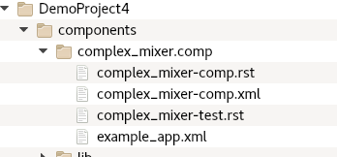
To create the component spec with ocpidev, run the following command from the DemoProject4/components/ directory:
ocpidev create component complex_mixer
The command creates the component spec complex_mixer-comp.xml in components/complex_mixer.comp/. We’ll add properties and ports to the component spec in the next step.

Add Properties and Ports
The complex_mixer component function needs to define two properties:
- The phs_inc (“phase increment”) property, which stores the results of the computation (that is, setting the tune frequency for the input signal using the output of the internal NCO). This property is valid for both RCC and HDL component implementations.
- The enable property, which controls whether a worker implementation performs the computation on the incoming data or simply passes the incoming data through without any processing (“bypass” mode). This property is valid for both RCC and HDL component implementations.
We want to set default values for the phs_inc and enable properties in the component spec and allow the worker implementation to override these values. We’ll use the default attribute in our property definitions to specify the default values and use the writeable attribute to indicate that the worker can override them. You can read more about how the framework interprets these attributes in the OpenCPI Component Development Guide.
The complex_mixer component has the same simple port configuration as the peak_detector component and uses the same OPS. It requires one input port and one output port for communication with other components in an application and both ports will use the iqstream protocol.
To define the properties and ports using OpenCPI GUI:
- You can edit the component specification XML by right-clicking the complex_mixer-comp.xml file under the complex_mixer.comp directory in the Project Explorer panel and then clicking Edit File. This action opens the XML file using your system's default handler for XML files, where you can edit the file if the GUI supports that function for the handler. Make the changes described below. When you finish editing the file, click Save and then close the file.
To add properties and ports from the command line, open the spec with a text editor.
Now add the following XML code (highlighted in red) between the ComponentSpec elements:
<ComponentSpec>
<Property Name="enable" Type="bool" Writable="true" Default="true"/>
<Property Name="phs_inc" Type="Short" Writable="true" Default="8192"/>
<DataInterfaceSpec Name="in" Producer="false" Protocol="iqstream_protocol.xml"/>
<DataInterfaceSpec Name="out" Producer="true" Protocol="iqstream_protocol.xml"/>
</ComponentSpec>

Create Worker
Recall from Tutorial 3 that we implemented a run method for the peak_detector worker. This is the only required method in the RCC authoring model. We also implemented a start method for the worker; this method, along with the initialize, release and stop methods, are optional. We need to use the initialize and release methods in our complex mixer worker to prevent segmentation fault errors from being generated.
Because we’re using a third-party library in our complex mixer worker, the procedure to design it has a few more steps than the procedure we used for the peak detector worker in Tutorial 3.
For the complex mixer, the steps are as follows:
- Create the worker OWD and skeleton file
- Edit the worker OWD to add information about the liquidsp library and the optional RCC authoring model methods to be used
- Write the C++ code that uses the liquidsp API and implements the authoring model
- Edit the worker skeleton file to add the C++ code
- Build the worker for target platform

Create Worker OWD and Skeleton File
To create the complex mixer RCC worker with the OpenCPI GUI:
- From the GUI menu bar at the top of the window, select Create > Worker…
- In Worker Name, enter complex_mixer.
- Choose DemoProject4 from the Associated Project drop-down list.
- Choose complex_mixer from the Component Spec drop-down list.
- We want to use RCC as the authoring model and C++ as the language, so leave all the other fields as they are.
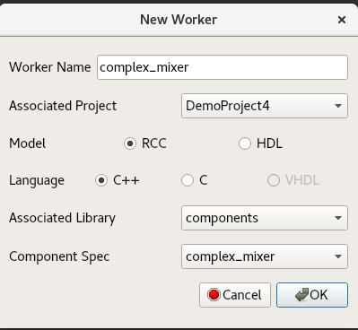
- Click OK. When the operation completes, you should see a new directory appear in the Project Explorer panel.
To create the complex_mixer worker with ocpidev, run the following command in the DemoProject4/components/ directory:
ocpidev create worker complex_mixer.rcc

Edit Worker OWD
Recall from Tutorial 1 that RCC worker OWDs generated by ocpidev don’t generally need to be updated. In this case, however, we need to add two attributes:
- A ControlOperations attribute that indicates our worker will have initialize and release methods; because the run method is mandatory, its presence is assumed. You can read more about this attribute in the OpenCPI Component Development Guide.
- A StaticPreReqLibs attribute that indicates our worker will use the liquidDSP library. You can read more about this attribute in the OpenCPI RCC Development Guide.
If you’re using the OpenCPI GUI, you can use the Project Explorer to locate the worker OWD and open it for editing. Select it, right-click it, and then select Edit File from the context menu. This action opens the XML file using your system's default handler for XML files, where you can edit the file if the GUI supports that function for the handler. Make the updates described below. When you finish editing the file, click Save and then close the file.
To add these attributes to the OWD from the command line, in DemoProject4, open
/components/complex_mixer.rcc/complex_mixer-rcc.xml with a text editor.
Now add the following XML (highlighted in red) between the RccWorker elements:
<RccWorker spec='complex mixer'
Language='c++'
Version='2'
controlOperations="initialize,release" StaticPreReqLibs="liquid"/>

Write C++ Code
We’ll use the nco module from liquid-dsp, which is a free and open-source signal processing library for software-defined radios written in C and is supplied with the OpenCPI installation. For details on liquid-dsp and the nco module, see the URL https://liquidsdr.org/doc/nco.
Our worker code will use the following routines from the liquid-dsp nco module:
- nco_crcf_create(type) - creates an nco object of type LIQUID_NCO or LIQUID_VCO. We’ll use this routine in our initialize method to create an NCO object of type LIQUID_NCO.
- nco_crcf_destroy(q) - destroys an nco object, freeing all internally-allocated memory. We’ll use this routine in our release method to remove the LIQUID_NCO object we created.
- nco_crcf_set_frequency(q,f) - sets the frequency f (equal to the phase step size Δθ). We’ll use this routine in our run method.
- nco_crcf_set_phase(q,theta) - sets the internal nco phase to θ. We’ll use this routine in our initialize method to set the internal NCO object’s phase to 0.
- nco_crcf_step(q) - increments the internal nco phase by its internal frequency, θ←θ+Δθ. We’ll use this routine in our run method.
- nco_crcf_mix_down(q,x,*y) - rotates an input sample x by e−jθ, storing the result in the output sample y. We’ll use this routine in our run method.
All of the I/O data samples are of type liquid_float_complex:
liquid_float_complex sample;
sample.I = 0;
sample.Q = 0;

Update RCC Worker Skeleton File
Now we’ll add the C++ source code to the complex_mixer.cc skeleton file. To do this, you can either:
- Copy the tutorial project's complex_mixer_tutorial.cc reference file directly into your DemoProject4/components/complex_mixer.rcc/ subdirectory, overwriting the skeleton file. If you choose this method, you will need to edit the .cc file and remove all instances of the strings _tutorial and _TUTORIAL from the file.
- Open the skeleton file for editing and copy/paste the code provided below to it.
You can choose to do one or the other. Doing both is redundant.

Copy Tutorial Project Reference File
To copy the file directly from the tutorial project, navigate to the complex_mixer.rcc/ subdirectory in DemoProject4 and then use the command:
cp $OCPI_ROOT_DIR/projects/tutorial/components/complex_mixer_tutorial.rcc/complex_mixer_tutorial.cc complex_mixer.cc

Now open the complex_mixer.cc file with a text editor and remove all instances of the strings _tutorial and _TUTORIAL from the file.
Once you've copied the file into your project, you can move to the next section to learn more about what the C++ code does.

Edit Worker Skeleton File
If you’re using the OpenCPI GUI, you can use the Project Explorer to locate the worker skeleton file and open it for editing.
To edit the worker skeleton file using the OpenCPI GUI:
- Navigate to the complex_mixer.cc file in the Project Explorer view.
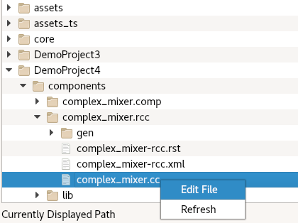
- Right-click it and then click Edit File. This action opens the XML file using your system's default handler for XML files, where you can edit the file if the GUI supports that function for the handler. Make the changes described below. When you finish editing the file, click Save and then close the file.
To edit the worker skeleton file from the command line, navigate to the components/complex_mixer.rcc/complex_mixer.cc file and open it with a text editor.
Now replace the contents of the skeleton file with the following code:
#include "complex_mixer-worker.hh"
#include <liquid/liquid.h>
#include <cmath>
#include <iostream>
#include <climits>

using namespace OCPI::RCC; // for easy access to RCC data types and constants
using namespace Complex_mixerWorkerTypes;
using namespace std;

#define Uscale(x) (float)((float)(x) / (pow(2,15) -1))
#define Scale(x) (int16_t)((float)(x) * (pow(2,15) -1))

class Complex_mixerWorker : public Complex_mixerWorkerBase
{
nco_crcf q;

RCCResult initialize()
{
q = nco_crcf_create(LIQUID_NCO);
nco_crcf_set_phase(q, 0.0f);

return RCC_OK;
}

RCCResult release()
{
nco_crcf_destroy(q);

return RCC_OK;
}

RCCResult run(bool /*timedout*/)
{
const IqstreamIqData* inData = in.iq().data().data();
IqstreamIqData* outData = out.iq().data().data();
const size_t num_of_elements = in.iq().data().size(); // size in IqstreamIqData units
out.iq().data().resize(num_of_elements);

// set each time so that if the container changes it gets updated
// might be better to put this into a write sync function but this is for training
float phase_inc = properties().phs_inc * ((2*M_PI)/(SHRT_MAX * 2));
nco_crcf_set_frequency(q,phase_inc);

liquid_float_complex out_sample;
liquid_float_complex in_sample;

for (unsigned int j = 0; j < num_of_elements; j++)
{
if (properties().enable)
{
in_sample.real = Uscale(inData->I);
in_sample.imag = Uscale(inData->Q);
nco_crcf_step(q);
nco_crcf_mix_down(q, in_sample, &out_sample);
outData->I = Scale(out_sample.real);
outData->Q = Scale(out_sample.imag);

inData++;
outData++;
}
else
{
outData->I = inData->I;
outData->Q = inData->Q;
inData++;
outData++;
}
}

return num_of_elements ? RCC_ADVANCE : RCC_ADVANCE_DONE;
}
};

COMPLEX_MIXER_START_INFO
// Insert any static info assignments here (memSize, memSizes, portInfo)
// e.g.: info.memSize = sizeof(MyMemoryStruct);
COMPLEX_MIXER_END_INFO

Build Worker
Now we need to compile the complex_mixer worker for the platform on which we want to run it; for this tutorial, it’s our development host (centos7).
To build the worker with OpenCPI GUI:
- In the Platforms panel, check RCC and select centos7.
- In the Project Explorer panel, select the complex_mixer.rcc worker directory.
- Right-click and select Build.
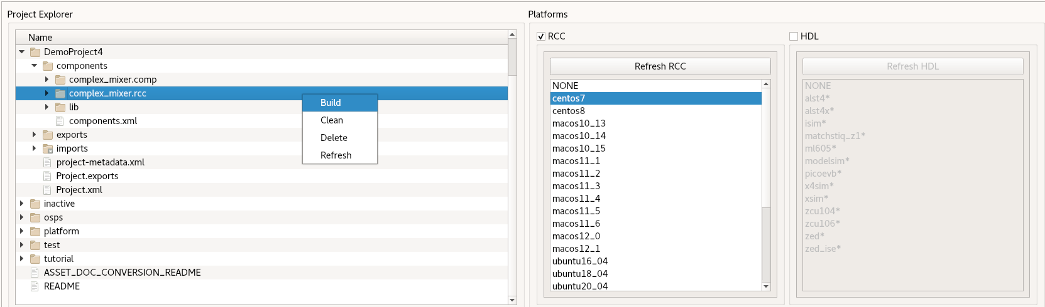
- If the build succeeds, you’ll see a message in the Job Manager panel with what you’ve built (complex_mixer, in this case) highlighted in green.
To build the worker with ocpidev, run the following command from the DemoProject4 directory:
ocpidev build worker complex_mixer.rcc --rcc-platform centos7

Create Unit Test
Like we did in Tutorial 3, we’ll generate an OpenCPI component unit test suite (aka “unit test”) for our complex mixer worker.
To create the unit test for the complex_mixer worker with the OpenCPI GUI:
- From the GUI menu bar at the top of the window, select Create > Component Test Suite...
- In the Associated Project drop-down list, select DemoProject4.
- In the Component Spec drop-down list, select complex_mixer.
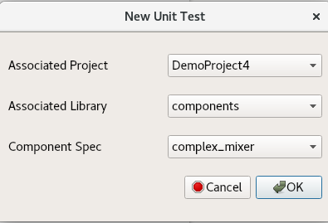
- Click OK. When the operation completes, you’ll see a new complex_mixer.test subdirectory in components in the Project Explorer panel.
To create the unit test with ocpidev, run the following command from the DemoProject4/components directory:
ocpidev create test complex_mixer

Edit Test Suite Description
Like we did in Tutorial 3, we need to add the generate and verify scripts with the necessary parameter values for the scripts to the OpenCPI Test Suite Description (OTSD) for the complex mixer worker.
To edit the test suite description with the OpenCPI GUI:
- Navigate to the complex_mixer-test.xml file in the Project Explorer view.
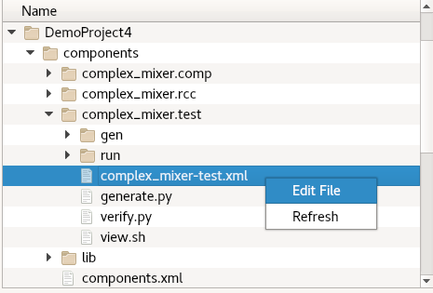
- Right-click it and then click Edit File. This action opens the XML file using your system's default handler for XML files, where you can edit the file if the GUI supports that function for the handler. Make the changes described below. When you finish editing the file, click Save and then close the file.
To edit the test suite description from the command line, open the components/complex_mixer.test/complex_mixer-test.xml file with a text editor.
Now replace the contents of the file with the following XML:
<!-- This is the test xml for testing component "complex_mixer" -->
<Tests UseHDLFileIo='true'>
<!-- Here are typical examples of generating for an input port
and verifying results at an output port -->
<Input Port='in' Script='generate.py 100 12.5 32767 16384'/>
<Output Port='out' Script='verify.py 100 16384' View='view.sh'/>
<!-- Set properties here. Use Test='true' to create a test-exclusive property. -->
<Property Name='phs_inc' Values='8192'/>
<Property Name='enable' Values='0,1'/>
</Tests>

Update Unit Test Scripts
We’re going to use the input and view unit test scripts again like we did for the peak detector worker in Tutorial 3, so we need to update the generate.py, verify.py, and view.sh scripts with our input data and our test parameters. As in Tutorial 3, make sure these files have read and execute permissions before proceeding to build and run the complex_mixer unit test.

Copy generate.py Script from Tutorial Project
The ocpi.tutorial project provides a reference generate.py script that you can simply copy into your DemoProject4 instead of editing the empty file you just created. To do this, in DemoProject4, navigate to the components/complex_mixer.test/ subdirectory and use the command:
cp $OCPI_ROOT_DIR/projects/tutorial/components/complex_mixer_tutorial.test/generate.py .

Copy verify.py Script from Tutorial Project
The ocpi.tutorial project provides a reference verify.py script that you can simply copy into your DemoProject4 instead of editing the empty file you just created. To do this, in DemoProject4, navigate to the components/complex_mixer.test/ subdirectory and use the command:
cp $OCPI_ROOT_DIR/projects/tutorial/components/complex_mixer_tutorial.test/verify.py .

Copy and Edit view.sh Script (Editing Required)
The ocpi.tutorial project provides a reference view.sh script that you can simply copy into your DemoProject4 instead of editing the empty file you just created. To do this, in DemoProject4, navigate to the components/complex_mixer.test/ subdirectory and use the command:
cp $OCPI_ROOT_DIR/projects/tutorial/components/complex_mixer_tutorial.test/view.sh .
Note: Make sure your test scripts have read and execute permissions before using them to build and run the unit test. For example:
chmod 755 generate.py
chmod 755 verify.py
chmod 755 view.sh

Build Unit Test
Now we’ll build the unit test for the target platform, which is our development host.
To build the unit test with the OpenCPI GUI:
- In the Project Explorer panel, select complex-mixer.test.
- In the Platforms view, make sure RCC is checked and centos7 is highlighted.
- Right-click complex-mixer.test and then select Build.
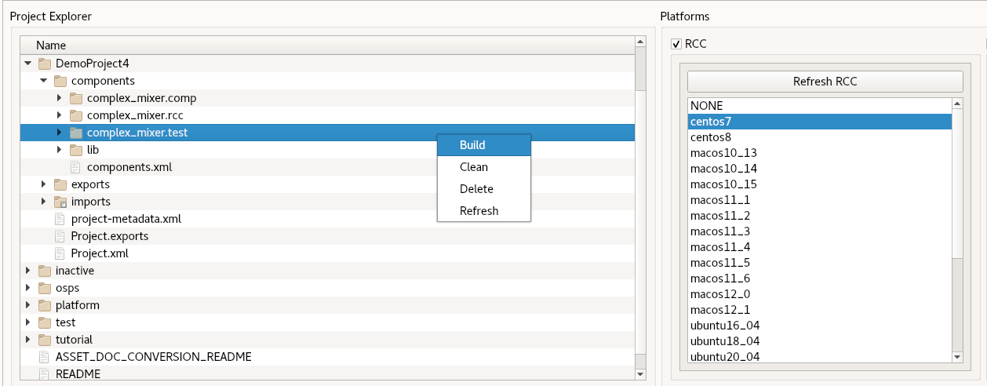
To build the unit test with ocpidev, run the following command from the components/complex_mixer.test/ directory in DemoProject4:
ocpidev build test --rcc-platform centos7

Run Unit Test
Now we’ll run the unit test for the complex mixer worker.
To run the unit test and view the results with the OpenCPI GUI:
- In the Project Explorer, select complex-mixer.test.
- In Platforms, make sure RCC is checked and centos7 is highlighted.
- In the Start Action drop-down menu, select Prepare.
- In the End Action drop-down menu, select Verify.
- Check Run View Script.
- Check Prep/Run/Verify Phases.
- Click Run Unit Test.
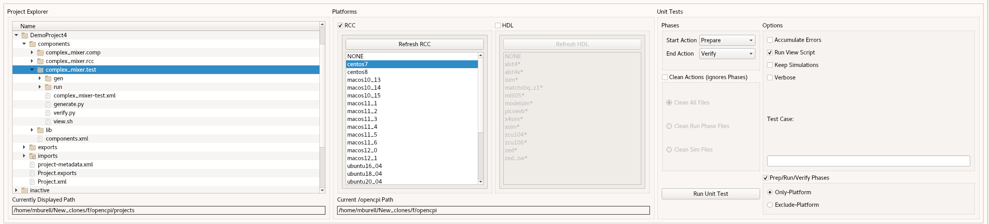
To run the test and view the output from the command line, run the following ocpidev command from DemoProject4/components/:
ocpidev run --mode prep_run_verify --only-platform centos7 --view
You should see this output:

Case00.00: enable = 0
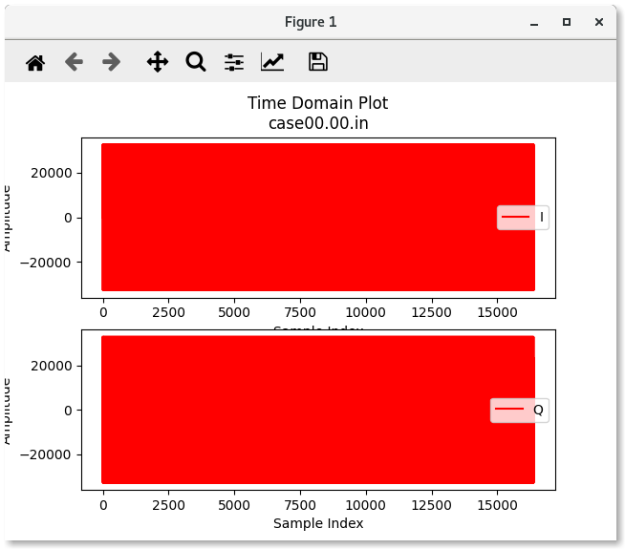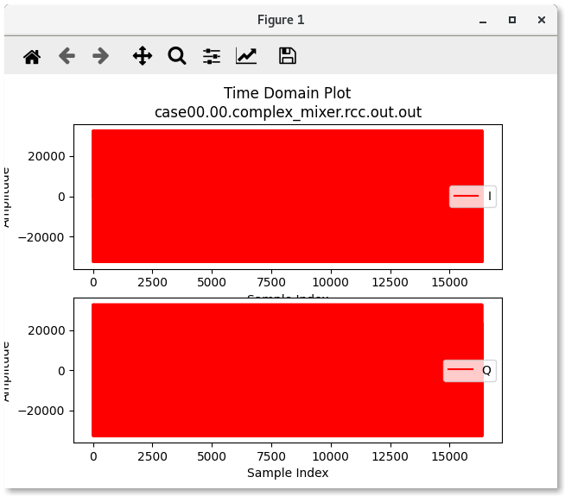
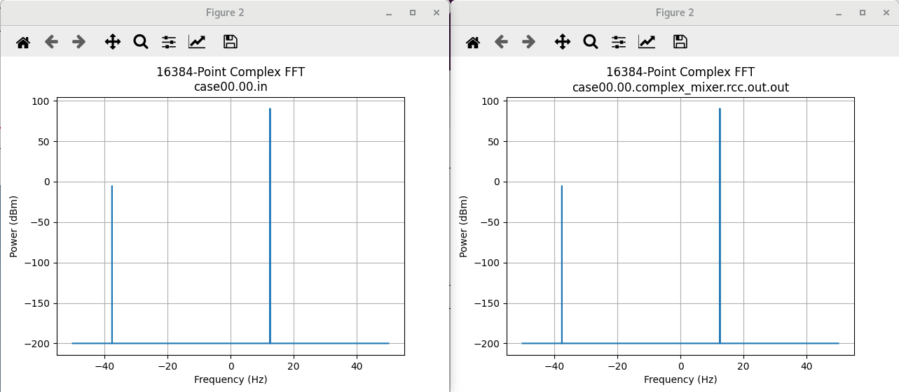
Case00.01: enable = 1
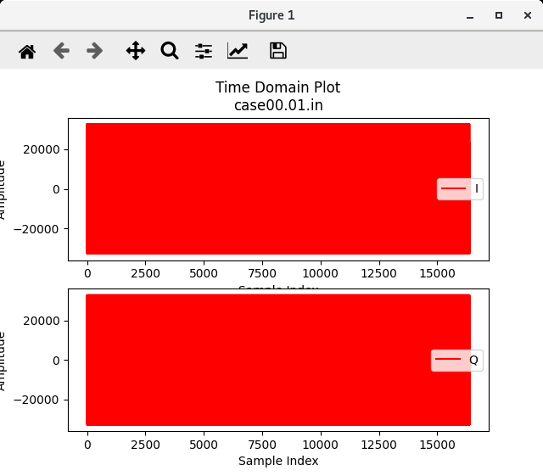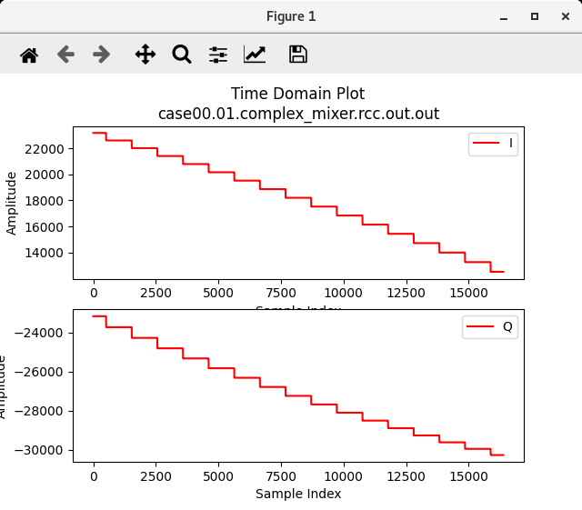
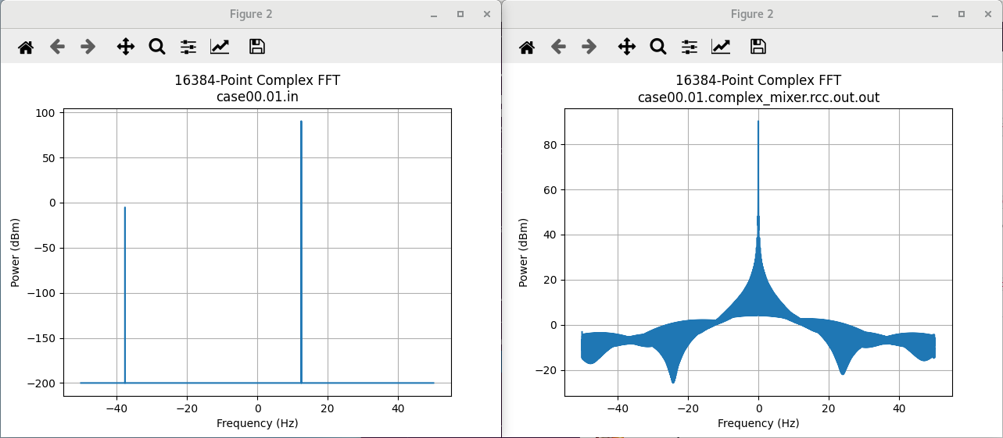

Tutorial Summary
Now that you’ve completed this tutorial, you should be familiar with the basic concepts of developing an RCC worker that integrates a third-party library and running OpenCPI component unit tests on RCC workers. You can now proceed to Tutorial 5, which demonstrates how to use multiple opcodes in RCC workers.

