OpenCPI
Tutorial 9: Debugging an HDL Worker on a Hardware Platform
OpenCPI Release: v2.4.6
Revision History
Revision | Description of Change | Date
1.0 | Creation from Lab 9 developed by BIA | 2019-10-01
1.1 | Updates for OpenCPI v2.4.0 release | 2022-01-03
1.2 | Updates for OpenCPI 2.4.1 patch release | 2022-02-27
1.3 | Updates to GUI and CLI to reflect ocpidev changes | 2022-08-29
Table of Contents
1 Overview 4
1.1 What’s Provided for This Tutorial 5
1.2 Prerequisites to Using This Tutorial 6
1.3 Documentation References 7
2 Build “tcounter” HDL Worker (XSIM) 8
3 Build “tcounter” Unit Test (XSIM) 9
4 Run “tcounter” Unit Test 10
5 Run “tcounter” Unit Test and Change Count 11
6 Run “tcounter” Unit Test with New Count 12
7 View Simulation Signals 13
8 Add Debug Functionality 14
9 Set up Unit Test for Different Worker Configurations 15
10 Build HDL Worker/Assembly for Target Hardware 16
11 Debug HDL Worker with ocpihdl 17
11.1 Run Unit Test (ADALM-PLUTO) 18
11.2 Confirm Debug Mode 19
11.3 Collect Worker Assembly Information 21
11.4 Use ocpihdl to Debug HDL Worker 22
11.5 Found the Bug 24
12 Tutorial Summary 25

Overview
This tutorial demonstrates how to debug OpenCPI applications, including how to:
- Observe property values with the ocpiview and ocpihdl tools
- Enable and disable debugging with the ocpi_debug built-in framework parameter
- Step through an application
- Manage the states and properties of workers with ocpihdl
In this tutorial, we will use a single "counter" HDL application worker tcounter.hdl. The purpose of this worker is to increment a counter vector until reaching a max value. We will discover that something is wrong with the worker and use OpenCPI debugging tools and techniques to find the cause of the problem.
The flow of application debugging demonstrated in this tutorial is as follows:
- Build the HDL worker for the target simulator.
- Test the HDL worker on the target simulator and view the results.
- Add debug functionality to the HDL worker.
- Build the HDL assembly for the target hardware device.
- Debug the HDL worker using ocpihdl.
The target platforms for this tutorial are the Vivado® Simulator (xsim HDL platform) and the ADALM-PLUTO hardware device (plutosdr HDL platform).
Unlike Tutorials 1 through 8, which ask you to create a new “demo” project in which to create your assets and run the tutorial, this tutorial has you work directly in the OpenCPI tutorial project ocpi.tutorial under the OpenCPI installation directory ($OCPI_ROOT_DIR/projects/tutorial/).

What’s Provided for This Tutorial
The following files and directories in the projects/tutorial/components/ directory under the OpenCPI root directory are used by this tutorial:
- tcounter.hdl/ - includes the counter HDL worker, in plain and debug versions.
- tcounter.test/ - includes the OpenCPI Test Suite Description XML for the "counter" component
- specs/tcounter-spec.xml – the component specification (OCS) for the “counter” component

Prerequisites to Using This Tutorial
This tutorial (Tutorial 9) has the system prerequisites described in Tutorial 1: Component-based Development. See the prerequisites section in Tutorial 1 for details.
In addition to these requirements, this tutorial uses the plutosdr platform, and so the corresponding OSP should be downloaded and installed. See the section “Installation Steps for Platforms” in the OpenCPI Installation Guide.
Before you begin this tutorial, you should have successfully completed Tutorial 1 through Tutorial 8.
We recommend reading the following briefings before getting started with the tutorial:
- Briefing 16 OpenCPI Debugging Tools
For a guide on using the ocpiremote tool, see the video: OpenCPI - Framework Installation – Zedboard. It is timestamped and begins when ocpiremote is being set up and executed. Note: It will be necessary to disable the firewall for ocpiremote to function properly. For more information, see the section “Using Remote Containers from Client/Development Systems” in the OpenCPI Application Development Guide and the ocpiremote(1) man page.

Documentation References
The documents listed in the following table provide detailed information about subjects discussed in this tutorial. The documents listed here are not required reading for this tutorial but will likely be of interest for more in-depth learning.
Table 1 - OpenCPI Reference Documentation
Title | Published By | Public URL
OpenCPI User Guide | OpenCPI | https://opencpi.gitlab.io/releases/v2.4.6/docs/OpenCPI_User.pdf
OpenCPI Application Development Guide | OpenCPI | https://opencpi.gitlab.io/releases/v2.4.6/docs/OpenCPI_Application_Development.pdf
OpenCPI Component Development Guide | OpenCPI | https://opencpi.gitlab.io/releases/v2.4.6/docs/OpenCPI_Component_Development.pdf
OpenCPI HDL Development Guide | OpenCPI | https://opencpi.gitlab.io/releases/v2.4.6/docs/OpenCPI_HDL_Development.pdf
OpenCPI RCC Development Guide | OpenCPI | https://opencpi.gitlab.io/releases/v2.4.6/docs/OpenCPI_RCC_Development.pdf

Build “tcounter” HDL Worker (XSIM)
Note: this may already be done as a byproduct of installing the xsim platform.
To build the tcounter HDL worker using the OpenCPI GUI:
- In the Project Explorer panel, navigate to
tutorial->components->tcounter.hdl.
- Expand the tcounter.hdl folder.
- If folders named target-xsim and target-1-xsim exist, skip to “Build tcounter Unit Test” on the next page. Otherwise, proceed with the next steps.
- In the Platforms panel, uncheck RCC, check HDL, and select xsim as the HDL platform.
- In the Project Explorer panel, right-click on tcounter.hdl and select Build.
- Review the Job Manager and output console panels to ensure the worker built successfully: if the job completed without error, the entry in the Job Manager panel should have a green background.
- Optional: Note the “COMMAND RAN:” line in the output console panel and compare it to the ocpidev command in the paragraph below.
To build the HDL worker using the ocpidev command:
- cd $OCPI_ROOT_DIR/projects/tutorial/components/tcounter.hdl/
- ocpidev build --hdl-platform xsim

Build “tcounter” Unit Test (XSIM)
To build the tcounter component unit test suite (aka “unit test”) using the OpenCPI GUI:
- In the Project Explorer panel, select and expand the tcounter.test folder.
- Leave the Platforms panel settings as they were for “Build tcounter HDL Worker” on the previous page.
- In the Project Explorer panel, right-click on tcounter.test and select Build. The build job will take several seconds to complete: be patient.
- Review the Job Manager and output console panels to ensure the unit test built successfully: if the job completed without error, the entry in the Job Manager window should have a green background. In the Project Explorer panel, there should now be a gen folder in the tcounter.test folder.
- Optional: Note the “COMMAND RAN:” line in the output console panel and compare it to the ocpidev command in the paragraph below.
To build the tcounter component unit test suite (aka “unit test”) using the ocpidev command:
- cd $OCPI_ROOT_DIR/projects/tutorial/components/tcounter.test
- ocpidev build --hdl-platform xsim

Run “tcounter” Unit Test
First, run the unit test for the target simulation platform.
Using the OpenCPI GUI:
- Leave the Platforms panel settings as they were for “Build tcounter Unit Test” on the previous page.
- In the Project Explorer panel, ensure tcounter.test is selected.
- Click Run Unit Test. This will take several seconds to complete.
- Review the Job Manager and output console panels to ensure the unit test ran successfully: if the job completed without error, the entry in the Job Manager panel should have a green background.
- Optional: Note the “COMMAND RAN:” line in the output console panel and compare it to the ocpidev command in the paragraph below.
Using the ocpidev command:
- cd $OCPI_ROOT_DIR/projects/tutorial/components/tcounter.test
- ocpidev run --mode prep_run_verify --only-platform=xsim
Next, validate the output:
- Open the log file (tcounter.test/run/xsim/case00.00.tcounter.hdl.log) and confirm the final property value:
tcounter.tcounter = "10"
The max property is currently set to "10" by tcounter-test.xml.
The tcounter property reached its maximum value of "10" as expected.

Run “tcounter” Unit Test and Change Count
First, edit tcounter.test/tcounter-test.xml to test the value "9" for the max property.
Next, rebuild the unit test to regenerate the application XML.
Using the OpenCPI GUI:
- Leave the Platforms panel settings as they were for “Build tcounter Unit Test”.
- In the Project Explorer panel, ensure tcounter.test is selected.
- Click Run Unit Test. This will take several seconds to complete.
- Review the Job Manager and output console panels to ensure the unit test built successfully: if the job completed without error, the entry in the Job Manager panel should have a green background.
- Optional: Note the “COMMAND RAN:” line in the output console panel and compare it to the ocpidev command in the paragraph below.
Using the ocpidev command:
- cd $OCPI_ROOT_DIR/projects/tutorial/components/tcounter.test/
- ocpidev run --mode prep_run_verify --only-platform=xsim
Finally, review tcounter.test/gen/applications/*.xml to ensure the max value has been updated to “9”.

Run “tcounter” Unit Test with New Count
Rerun the unit test with the new maximum value.
Using the OpenCPI GUI:
- Leave the Platforms panel settings as they were for “Build tcounter Unit Test”.
- In the Project Explorer panel, ensure tcounter.test is selected.
- In the Unit Tests panel, check Keep Simulations so that we can see the waveform output later on.
- Click Run Unit Test. This will take several seconds to complete.
- Review the Job Manager and output console panels to ensure the unit test ran successfully: if the job completed without error, the entry in the Job Manager panel should have a green background.
- Optional: Note the “COMMAND RAN:” line in the output console panel and compare it to the ocpidev command in the paragraph below.
Using the ocpidev command:
- cd $OCPI_ROOT_DIR/projects/tutorial/components/tcounter.test/
- ocpidev run --mode prep_run_verify --hdl-platform xsim --keep-simulations
Validate the output:
- Open the log file (tcounter.test/run/xsim/case00.00.tcounter.hdl.log) and review the final property values:
tcounter.tcounter = "10"
tcounter.max = “9”
The counter (tcounter.tcounter) EXCEEDED the maximum value of "9"! HOW IS THIS POSSIBLE?

View Simulation Signals
To view the simulation results, in a terminal window run the following command in the component unit test’s directory ($OCPI_ROOT_DIR/projects/tutorial/components/tcounter.test):
ocpiview run/xsim/case00.00.tcounter.hdl.simulation &
Note: Basic ocpiview “driving instructions” may be found in the section “Navigating the Simulator” in Tutorial 6.
Navigate to the s_tcounter object: right-click on it and select Add to Wave Window.
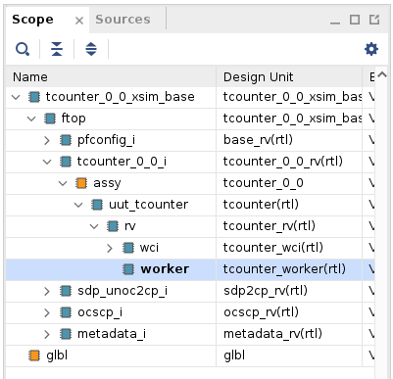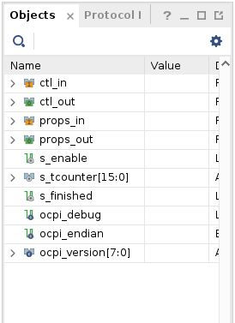
Note the change in the counter value:
Counting by two, not one.

Add Debug Functionality
In the tcounter.hdl/ directory:
$ cp tcounter-debug.vhd tcounter.vhd
$ cp tcounter-debug.xml tcounter.xml
Now observe what is done to add debugging/stepping functionality:
- In tcounter.xml, there is a new step property and the max property is extended from the OCS so that we can read it using ocpihdl.
- In tcounter.vhd, when the ocpi_debug parameter is true, "enable" depends on "step".
These changes enable the counting operation based on the built-in ocpi_debug parameter. When the step property is written as true, perform a single counter increment (single step):
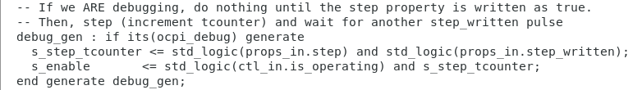
Otherwise, proceed normally.
Note that tcounter.hdl supports two build configurations as defined in tcounter-build.xml:
<build>
<configuration id='0'>
<parameter name='ocpi_debug' value='false'/>
</configuration>
<configuration id='1'>
<parameter name='ocpi_debug' value='true'/>
</configuration>
</build>
The ocpi_debug parameter is a build-time “parameter” property provided by the framework that allows the worker to build separate implementations, both with and without debugging behavior. You can read more about the ocpi_debug parameter property and about build-time parameter properties in general in the OpenCPI Component Development Guide.

Set up Unit Test for Different Worker Configurations
In the tcounter.test/ directory, issue the command:
cp tcounter-test-debug.xml tcounter-test.xml
This action effectively sets ocpi_debug to “false” and “true”:
<Property Name='ocpi_debug' Values='false,true'></Property>
Now, clean (delete build products) for tcounter.hdl and tcounter.test.
Using the OpenCPI GUI:
- In the Project Explorer panel, right-click on tcounter.hdl and select Clean.
- In the Project Explorer panel, right-click on tcounter.test and select Clean.
Using the ocpidev command:
- cd $OCPI_ROOT_DIR/projects/tutorial/components/tcounter.hdl/
      - ocpidev clean
      - cd $OCPI_ROOT_DIR/projects/tutorial/components/tcounter.test/
- ocpidev clean

Build HDL Worker/Assembly for Target Hardware
Note: The intent is to make this tutorial as platform-agnostic as possible. The plutosdr platform is used as an example in the following steps.
First, build the tcounter HDL worker for the appropriate HDL target / HDL platform; in this case, zynq/plutosdr:
Using the OpenCPI GUI:
- In the Platforms panel, select plutosdr as the HDL platform.
- In the Project Explorer panel, right-click on tcounter.hdl and select Build. The build job will take several seconds to complete: be patient.
- Review the Job Manager and output console panels to ensure the worker built successfully: if the job completed without error, the entry in the Job Manager panel should have a green background.
- Optional: Note the “COMMAND RAN:” line in the output console panel and compare it to the ocpidev command in the paragraph below.
Using the ocpidev command with --hdl-platform plutosdr as an example:
- cd $OCPI_ROOT_DIR/projects/tutorial/components/tcounter.hdl
- ocpidev build --hdl-platform plutosdr
Next, build the tcounter component test suite for the target hardware platform. This build will take 5-10 minutes to complete.
Using the OpenCPI GUI:
- Leave the Platforms panel settings as they were for the previous tcounter.hdl build.
- In the Project Explorer panel, right-click on tcounter.test and select Build.
- Review the Job Manager and output console panels to ensure the unit test built successfully: if the job completed without error, the entry in the Job Manager panel should have a green background.
- Optional: Note the “COMMAND RAN:” line in the output console panel and compare it to the ocpidev command in the paragraph below.
Using the ocpidev command:
- cd $OCPI_ROOT_DIR/projects/tutorial/components/tcounter.test/
- ocpidev build --hdl-platform plutosdr

Debug HDL Worker with ocpihdl
This part of the tutorial consists of the following steps:
- Execute on the target hardware platform
- Confirm debug mode
- Collect HDL worker/assembly information
- Debug the HDL worker using ocpihdl, the command-line tool for performing HDL development tasks. For a description of ocpihdl command syntax, see the ocpihdl(1) man page. For details on how this tool is used in HDL development, see the OpenCPI HDL Development Guide.

Run Unit Test (ADALM-PLUTO)
Ensure availability of the hardware platform (network-accessible and running ocpiserve) and run the tests.
Note: Details of how to set up and configure the hardware platform are beyond the scope of this tutorial. See the section “Installation Steps for Platforms” in the OpenCPI Installation Guide for instructions on downloading and installing the corresponding OSP.

Confirm Availability of Hardware Platform (ADALM-PLUTO)
To get the status of the deployment platform:
- export OCPI_SERVER_ADDRESSES=<Pluto_IP>:12345
- ocpiremote status -p analog
Look for output similar to the following:
Executing remote configuration command: status
Server is running with port: 12345 and pid: 26224

Run Unit Test
To run the unit test on the remote platform using the OpenCPI GUI:
- Exit and restart the GUI to pick up the OCPI_SERVER_ADDRESSES setting.
- In the Project Explorer panel, navigate to
tutorial > components > tcounter.test (select tcounter.test).
- In the Platforms panel, uncheck RCC, check HDL, and select plutosdr as the HDL platform.
- Click Run Unit Test. DO NOT wait for this process to complete: proceed to the next section.
To run the unit test on the remote platform using the ocpidev command:
- cd $OCPI_ROOT_DIR/projects/tutorial/components/tcounter.test/
- ocpidev run --mode prep_run_verify --hdl-platform plutosdr

Confirm Debug Mode
The application is now running on the ADALM-PLUTO device. We have the application "hanging". It is in debug mode and waiting for our input. Let’s see what the state of the worker is by going to the logs.
- Examine the log file (run/plutosdr/case00.01.tcounter-1.hdl.log). Note that the running application will time out after 3600 seconds (1 hour).
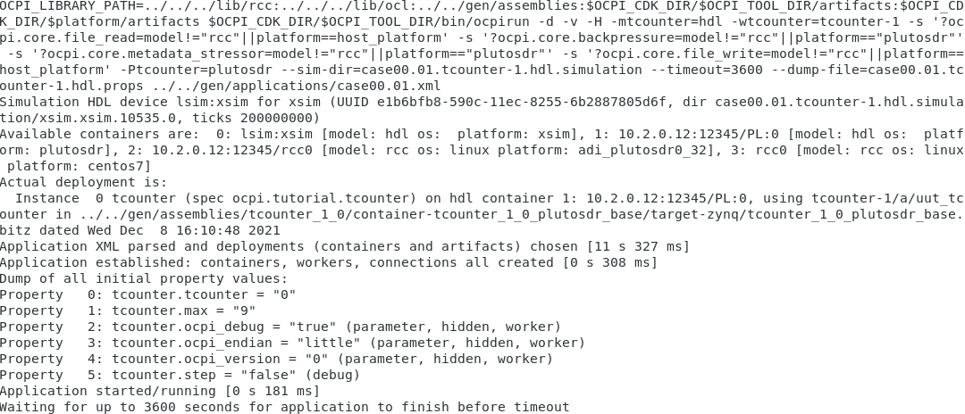
On the ADALM-PLUTO (use ssh root@<Pluto_IP> with password “analog”), we can now use ocpihdl to control the worker. For reference, here is output of ocpihdl:
Major commands/modes:
search [-i <interface>] # search for OpenCPI HDL devices, limit ethernet to <interface>
emulate [-i <interface>] # emulate an HDL device on ethernet, on first or specified interface
ethers # list available ethernet interfaces
probe <hdl-dev> # see if a specific HDL device is available
get [<instance> [<property]] # get info from bitstream
set <instance> <property> <value> # set property value for worker instance
control <instance> <operation> # perform reset, unreset, or control operation
status <instance> # show status of worker/instance
testdma # test for DMA memory setup
admin <hdl-dev> # dump admin information (reading only) for <hdl-device>
wadmin <hdl-dev> <offset> <value> # write admin word <value> for <hdl-device> at <offset>
radmin <hdl-dev> <offset> # read admin word for <hdl-device> at <offset>
settime <hdl-dev> # set the GPS time of the device to syste time
deltatime <hdl-dev> # measure round trip and difference between host and device
dump <hdl-dev> # dump all state/status of <platform> including all workers
reset <hdl-dev> # reset platform
flash <hdl-dev> # flash load platform
bram <infile> <outfile> # create a BRAM file from in input file
unbram <infile> <outfile> # recreate the original file from a BRAM file
uuid -p <platform> -c <part> <outputfilename>
wclear <hdl-dev> <worker> # clear worker status errors
wdump <hdl-dev> <worker> # dump worker's control plane registers
wop <hdl-dev> <worker> <op> # perform control operation on worker
ops are: initialize, start, stop, release, after, before
wread <hdl-dev> <worker> <offset>[/size] # perform config space read of size bytes at offset, default 4
wreset <hdl-dev> <worker> # assert reset for worker
wunreset <hdl-dev> <worker> # deassert (enable) worker
wwctl <hdl-dev> <worker> <val> # write worker control register
wwpage <hdl-dev> <worker> <val> # write worker window register
wwrite <hdl-dev> <worker> <offset>[/size] <value> # perform config space write of size bytes at offset
# generate UUID verilog file
load <hdl-dev> <file> # load bitstream from file
unload <hdl-dev> # revert device to unloaded state: no bitstream
getxml <hdl-dev> <file> # Extract the xml metadata from the device into the file
imulate # run simulator inside created sim: device
Options: (values are either directly after the letter or in the next argument)
-l <level> # set log levels
-i <interface> # set ethernet interface to use
-d <hdl-device> # identify a specific hdl device to use
-p <hdl-platform> # specify a particular hdl platform (e.g. ml605)
-c <hdl-part> # specify a particular part/chip (e.g. xc6vlx240t
-s <spin-clocks> # clocks to credit/run the sim between control messages
-t <sleep-usecs> # delay time letting sim run between credits
-T <sim-time> # total simulation time before terminating
-D # turn off simulation dumping
-e <sim-executable> # simulator executable "bitstream" file
-A # make the simulator publically available on the LAN
-v # be verbose
-x # print numeric values in hex rather than decimal
<worker> can be multiple workers such as 1,2,3,4,5. No ranges.
<hdl-dev> examples: 3 # PCI device 3 (i.e. 0000:03:00.0)
0000:04:00.0 # PCI device 0000:04:00.0
PCI:0001:05:04.2 # fully specified PCI device
a0:00:b0:34:55:67 # ethernet MAC address on first up+connected interface
eth0/a0:00:b0:34:55:67 # ethernet address on a specific interface
Ether:eth1/a0:00:b0:34:55:67 # fully specified Ethernet-based device

Collect Worker Assembly Information
View the currently loaded workers and their indices:
cd sandbox
. ./setup.sh
cat system.xml # to get device name for ocpihdl
ocpihdl -d PL:0 -p plutosdr get
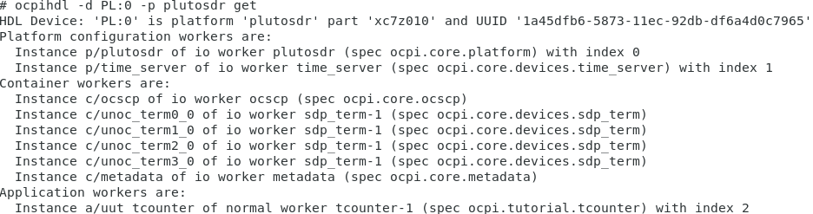
Note the last line in the above output: you can use index “2” or “tcounter-1” to identify the worker from now on.

Use ocpihdl to Debug HDL Worker
Execute:
ocpihdl -d PL:0 -p plutosdr get -v 2 ("-v" to list property values)
Note the property values:
- tcounter: 0
- max: 9
- ocpi_debug: true
- step=false
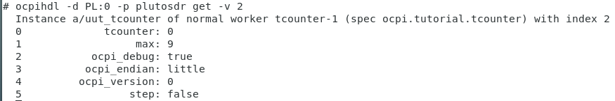
Also try:
ocpihdl -d PL:0 -p plutosdr get -v tcounter-1
Now execute:
ocpihdl -d PL:0 -p plutosdr set 2 step true
ocpihdl -d PL:0 -p plutosdr get -v 2
Notice “tcounter: 2” in the output:
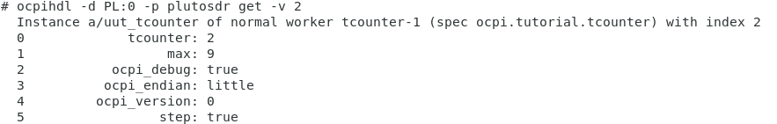
Continue setting step to true and note how the value of tcounter changes. When tcounter reaches max, step one last time and the application will complete. You will see the following output back on the development host:
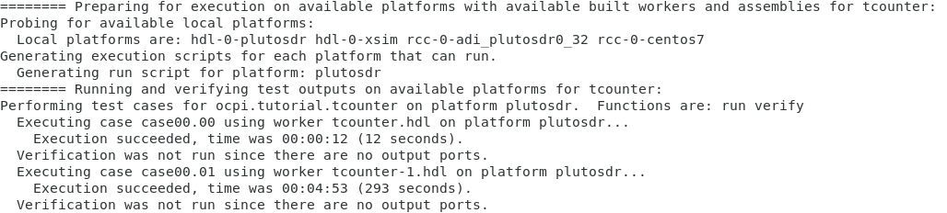
If you ran the unit test using the OpenCPI GUI, you’ll find the above output in the output console panel, and that the job in the Job Manager panel now has a green background because the unit test job completed successfully.
Examine the log file (run/plutosdr/case00.01.tcounter-1.hdl.log) and note the final property values:
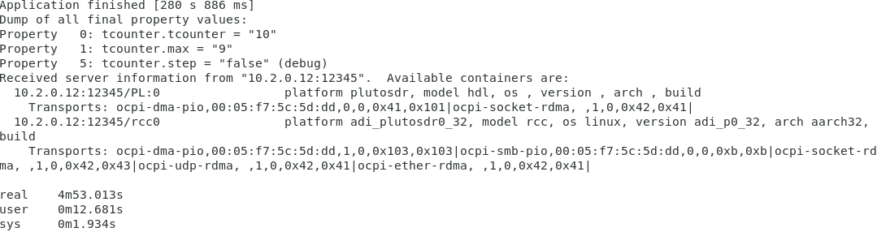

Found the Bug
By now, you have discovered the bug using one or more of the following methods:
- Viewing the log files and observing the output for different max values
- Viewing the simulated counter signals using ocpiview
- Using debug properties and ocpihdl to step through the application
The bug: We are incrementing the counter by 2 each step. You can fix the bug in tcounter.vhd, disable debugging, rebuild, and rerun.

Tutorial Summary
Now that you’ve completed this tutorial, you should be familiar with the basic concepts and procedure for debugging an OpenCPI application with ocpihdl, ocpi_debug, and the other debugging tools. This is a very simple example, but ocpihdl can be very helpful for debugging and controlling OpenCPI applications.

