OpenCPI
Tutorial 2: Creating Worker Assemblies
OpenCPI Release 1.6.0rc2

Revision History
Revision | Description of Change | Date
1.01 | Creation from Lab 2 developed by CNF | 2019-10-01
1.1
1.2
1.3
1.4
1.5
1.6
1.7
1.8
1.9
1.9.1
2.0
2.1
Table of Contents
1 Overview 4
1.1 What’s Provided for This Tutorial 5
1.2 Prerequisites to This Tutorial 6
1.3 Documentation References 7
2 Create Application 8
3 Select Components 9
4 Add Component Properties and Values 10
5 Make Connections and Modify Port Names 11
6 Create Assembly with RCC Workers 14
7 Build Project and Assemblies 17
8 Run Application with RCC Worker Assembly 18
9 Build HDL Worker Assembly and Run Application 20

Overview
Once you’ve selected the components required for an application, the next step is to identify, specify and build the subset of components that will execute in the FPGA. This part of the application is called the HDL assembly. Applications can be executed to leverage various HDL assemblies.
The application used in this tutorial uses components developed during tutorial execution in addition to components included with OpenCPI. The application:
- Reads I/Q sample data from a file.
- Performs complex mixing, automatic gain control, and timestamping on the I/Q sample data.
- Writes the resulting I/Q sample data and timestamps to two different files.
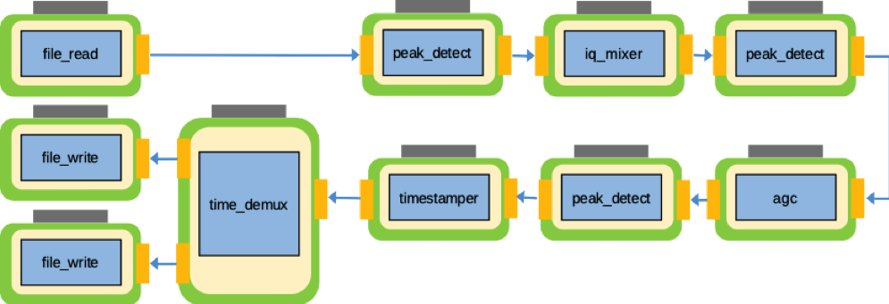
The goal of this tutorial is to show you that assemblies can be made with mostly RCC workers or mostly HDL workers. Understanding when and why to do this is outside the scope of this tutorial; this topic goes into the development process and the goals you have for your applications.
The tutorial shows you how to:
- Create an application using existing workers from an imported project.
- Select the application components that can be deployed on the FPGA.
- Create and build two different HDL assemblies that can be used by the application.
- Deploy the application with ocpirun using both of the HDL assemblies you created.
There will not be as much hand-holding in this tutorial as there was in Tutorial 1.

What’s Provided for This Tutorial
This tutorial uses OpenCPI assets provided in the built-in OpenCPI project ocpi.tutorial.

Prerequisites to This Tutorial
Before you begin this tutorial, you should have successfully completed Tutorial 1b, “Introduction to Component-based Development”.
We recommend reading the following briefings before getting started with the tutorial:
- Briefing 1, “Introduction to OpenCPI”. This briefing introduces OpenCPI positioning, priorities and background as well as component and application terminology.
- Briefing 2, “Introduction to Application Development with OpenCPI”. This briefing discusses OpenCPI elements and concepts from an application development perspective and introduces OpenCPI tools and building blocks for application development.
- Briefing 3, “OpenCPI Concepts”.

Documentation References
The documents listed in the following table provide detailed information about subjects discussed in this tutorial. The documents listed here are not required reading for this tutorial but will likely be of interest for more in-depth learning.
Table 1 - OpenCPI Reference Documentation
Title | Published By | Public URL
OpenCPI Overview | OpenCPI | https://opencpi.gitlab.io/releases/v1.6.0-rc.0/docs/Overview.pdf
OpenCPI User Guide | OpenCPI | https://opencpi.gitlab.io/releases/develop/docs/OpenCPI_User.pdf
OpenCPI Application Development Guide | OpenCPI | https://opencpi.gitlab.io/releases/v1.6.0-rc.0/docs/OpenCPI_Application_Development.pdf
OpenCPI Component Development Guide | OpenCPI | https://opencpi.gitlab.io/releases/v1.6.0-rc.0/docs/OpenCPI_Component_Development.pdf
OpenCPI HDL Development Guide | OpenCPI | https://opencpi.gitlab.io/releases/v1.6.0-rc.0/docs/OpenCPI_HDL_Development.pdf
OpenCPI RCC Development Guide | OpenCPI | https://opencpi.gitlab.io/releases/v1.6.0-rc.0/docs/OpenCPI_RCC_Development.pdf

Create Application
Right-click on your tutorial project and choose the asset wizard:
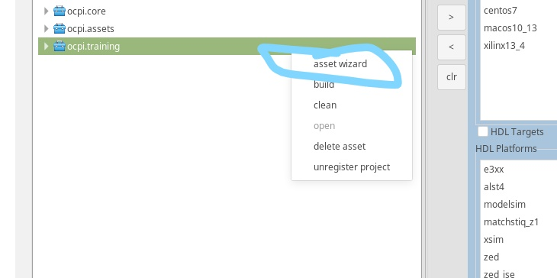
We are going to create an application called lab2_app as an XML-only file.
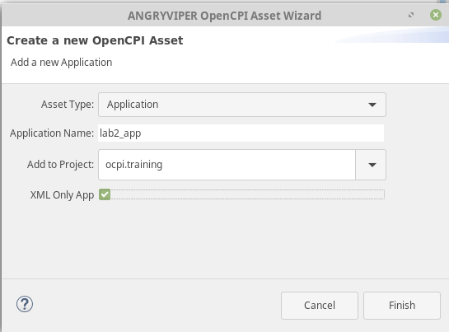

Select Components
The following image shows a table that lists the component specs that are required for this tutorial:
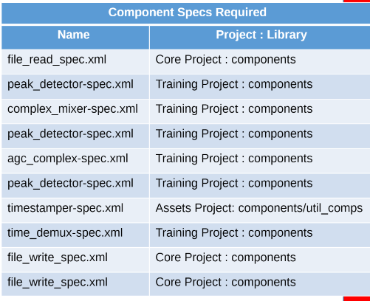
For this application, you are using three instances of peak_detector and two instances of file_write. As shown in Tutorial 1, you need to rename these instances to avoid name conflicts.
You should add these components to the OAS diagram for your lab2_app, as shown below:
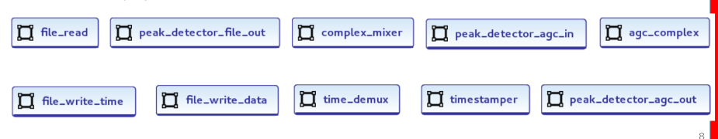

Add Component Properties and Values
The following table shows property values for some of the instances in this project. Using these values, follow the steps you took in Tutorial 1 to assign properties and values.
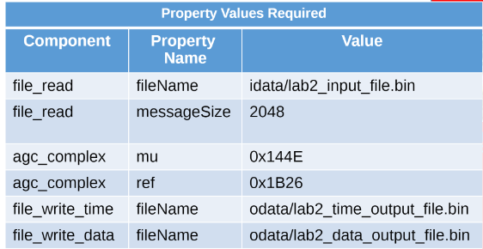
Your OAS diagram should look like the following image. We will now move on with the connections.
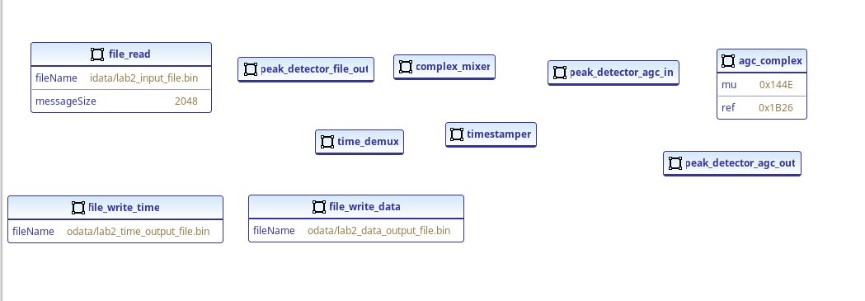

Make Connections and Modify Port Names
So far, we’ve made our connections all the way to timestamper. Why? Well, the instance we created - called time_demux - has its own names for its ports instead of the default out and in we see when we make an advanced connection as shown in Tutorial 1. We are going to have to change the port names.
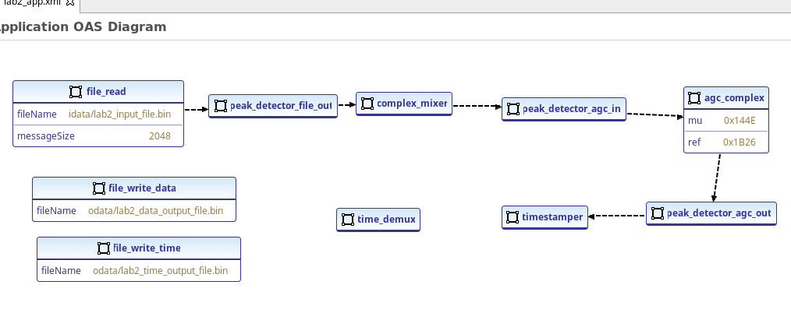
This is the window that pops up when we make a connection from timestamper to time_demux.
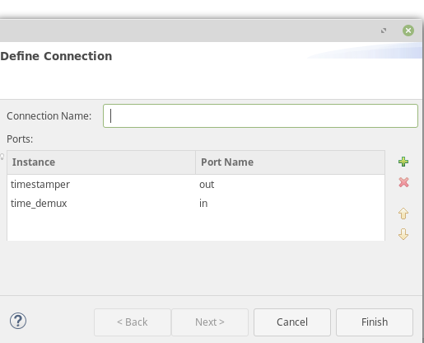
Double-click on the out under Port Name and change it to Mux_In.
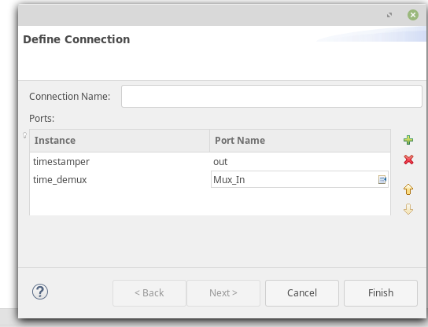
WAIT! I JUST CLICKED FINISH AND I DIDN’T CHANGE THE NAME!
No worries. If you didn’t change the name correctly, you can right-click on the instance time stamper and then select Show in Source.
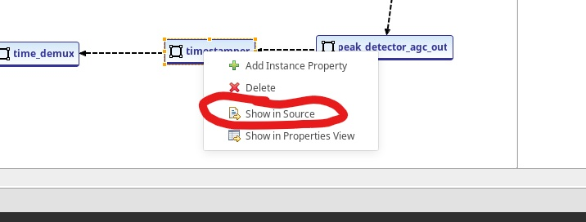
This is the XML file we are creating behind the GUI. If you scroll down until you see a connection with timestamper.
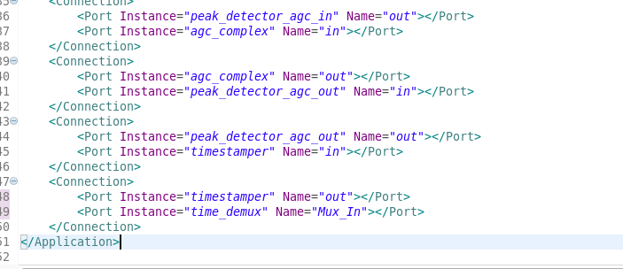
Notice the Name parameter for time_demux. If you went with the default values, it would just be out. If you double-click it, you can change its name to Mux_In and now you are worry-free.
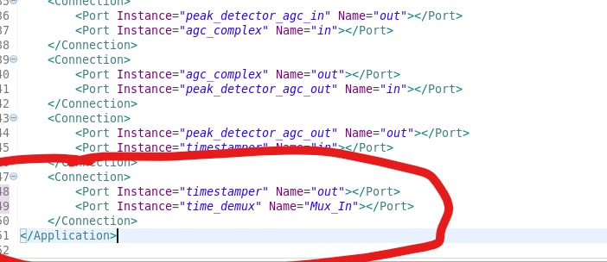
Now that you know how to change port names, make the other two connections. You are going to be changing the out ports on the other two. time_demux uses non-default port names:
- timestamper:out → time_demux: Mux_in
- time_demux: Data Out → file_write_data:in
- time_demux: Time_Out → file_write_time:in
All other components use default port names.
Now you should have finished all the connections with the modified port names to make time_demux work.
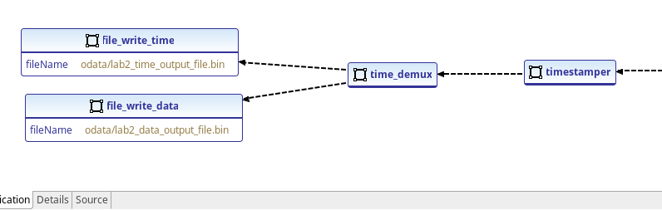

Create Assembly with RCC Workers
An HDL assembly specifies the HDL workers being used, the connections between HDL workers, and the connections external to the assembly.
Right-click on ocpi.tutorial and choose the asset wizard to create an HDL assembly called lab2_most_rcc_assy. As you can tell by the name, this assembly is going to be made using mostly RCC workers.
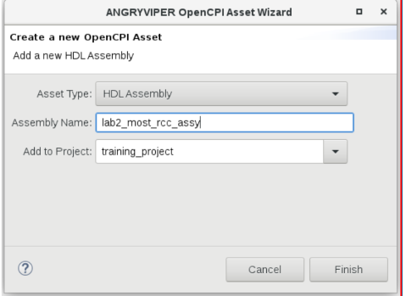
Notice the drop-down menu. We have a new option called assemblies.
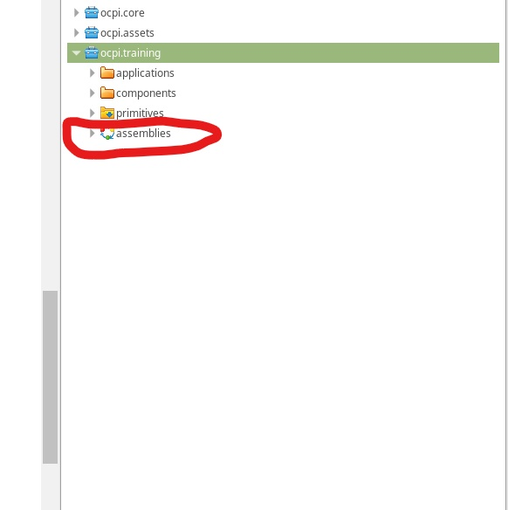
You can see the assembly you just created here:
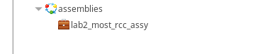
Go into the assembly you just created with the OAS editor and make it look like the following figure:
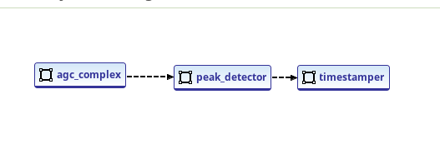
Click on agc_complex and go to the Properties view. Notice the External field.
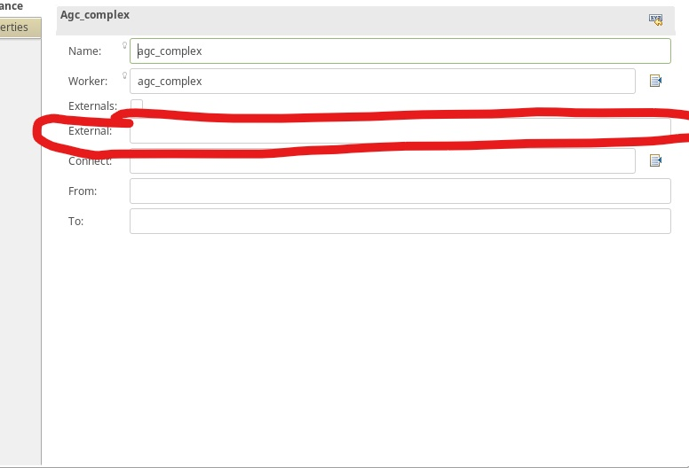
Enter in into the External field.
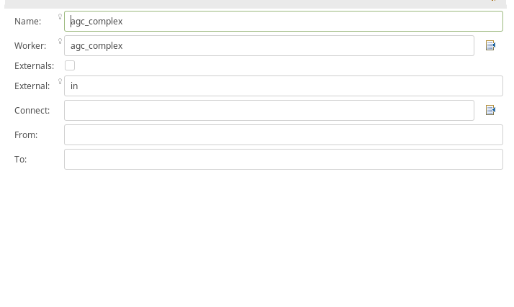
Go to timestamper and replace the blank External field with out.
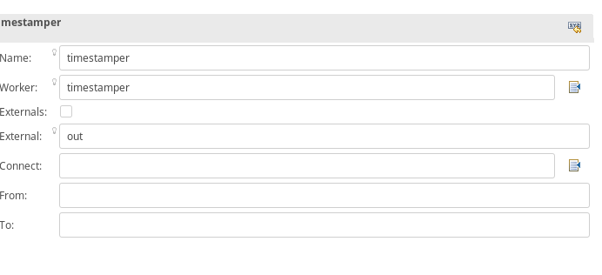

Build Project and Assemblies
Build ocpi.tutorial for centos7 and xsim and don’t forget to include assemblies.

Run Application with RCC Worker Assembly
Export your OCPI_LIBRARY_PATH to where ocpi.tutorial is located. For example:
‘export OCPI_LIBRARY_PATH=ocpi.core/exports:ocpi.tutorial/artifacts’
On your development host, cd into your applications directory under ocpi.tutorial and run the command:
cd ~/<opencpi-installation-dir>/projects/tutorial/applications
ocpirun -t l -d -v mcomplex_mixer=rcc Lab2 app.xml
Now run the following commands:
python ../scripts/plotAndFft.py idata/lab2_data_intput_file.bin complex 32768 100
python ../scripts/plotAndFft.py odata/lab2_data_output_file.bin complex 32768 100
You should get the results shown in the following figures.
Expected Result – Input Data
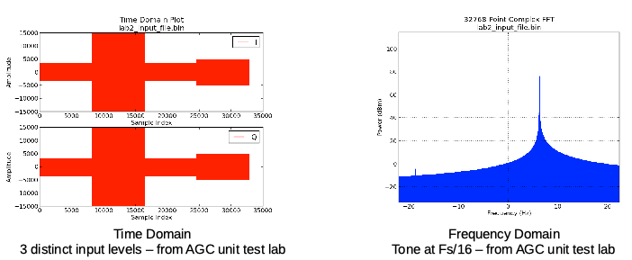
Expected Result – Output Data
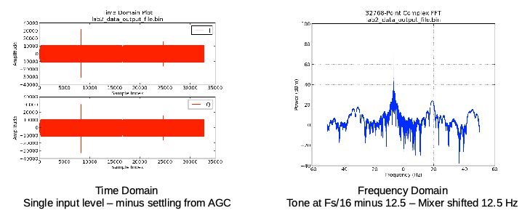

Build HDL Worker Assembly and Run Application
The image below shows a mostly HDL assembly.
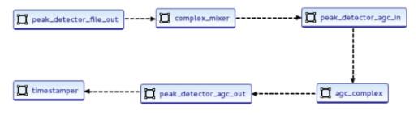
The sample assembly name is lab2_most_hdl_assy. Don’t forget to:
- Delete the “nothing” worker
- Uniquely name instances of peak_detector
- Specify external connections for input and output ports of the assembly. The input external connection should be peak_detector_file_out. The output external connector should be timestamper.
- Save your work before building
After you’ve built the assembly, execute the following ocpirun command:
ocpirun -t 1 -d -v -mcomplex_mixer=hdl lab2_app.xml
Now run the following command to plot the output file:
python ../scripts/plotAndFft.py odata/lab2_data_output_file.bin complex 32768 100
You should get the results shown in the following figure.
Expected Result – Output Data
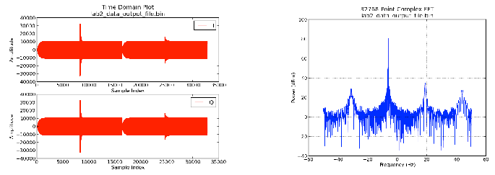
Expected Result Delta Explained
The differences you can see in the plots of the output data between the mostly RCC vs mostly HDL application is primarily a result of the precision of the math computations performed by the different authoring model implementations of the Complex Mixer. Specifically, the RCC worker uses the third-party LiquidDSP library, which performs floating-point computations (truncated to int16) while the HDL worker performs all fixed-point (16-bit) computations. While the difference is enough to be observed in the plots below, the system designer must determine whether the performance is sufficient for a given target application.
