Tutorial 0: Setting up an OpenCPI WorkSpace Environment
This tutorial is a reference for procedures that you will use in subsequent OpenCPI tutorials. The purpose of this tutorial is to remove any repetitive steps that may later seem redundant as you are completing the other tutorials. This tutorial demonstrates how to:
- Create local copies of OpenCPI projects
- Set up a new blank Eclipse workspace
- Import the OpenCPI projects for use in subsequent tutorials

Copying OpenCPI Projects to Your Workspace
The following projects are essential files for OpenCPI application development:
- core – basic components (read and write files)
- assets – various component libraries
- assets_ts – components for timestamping
- bsp_e310 – unique device workers, card definition and the E310 BSP
This tutorial leverages the core, assets and bsp_e310 projects that OpenCPI provides. You need to make local copies of them for use in the tutorials. To do this, you run the ocpi-copy-projects script and specify the location to which you want to copy the projects. In this example, we create a new folder called lab1_tut as a place to put the projects for this tutorial. You can use the default location if nothing else is there.

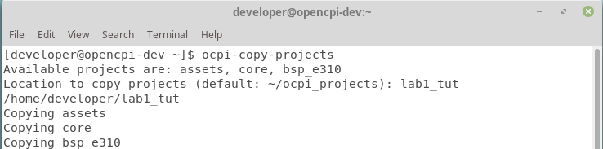
Unregister any previous projects before continuing.

Procedure 1: Set up a Workspace
Use this procedure to create a new, blank workspace each time you create a new project. This way, you don’t get confused with previous projects/ workspaces.

Step 1: Open Eclipse
Open Eclipse from your VM VirtualBox:
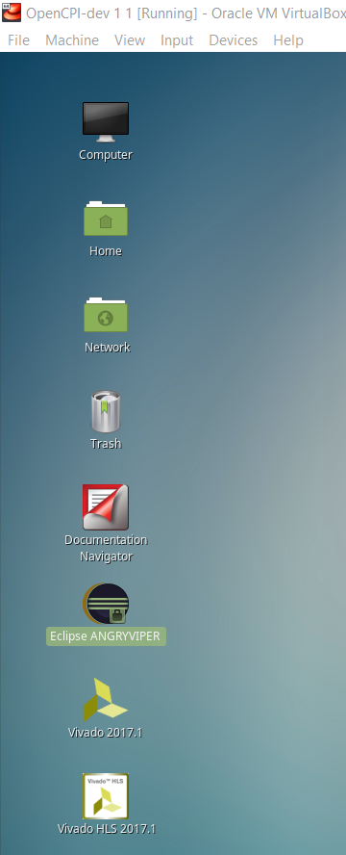
This window pops up:
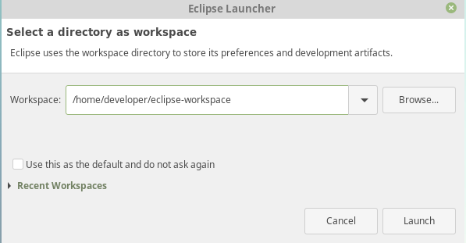

Step 2: Select Directory Workspace
Click Browse. The following dialog pops up:
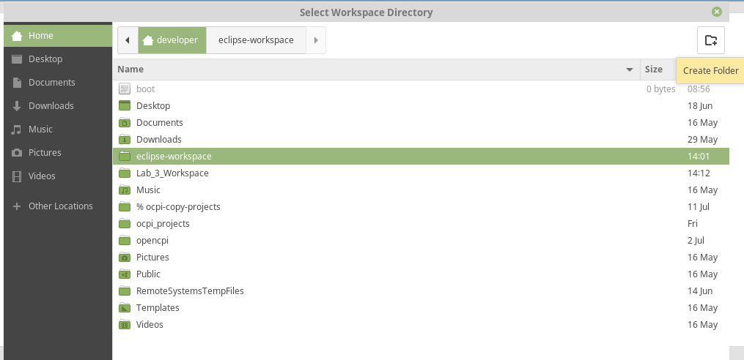
Select Developer, and then on the top right corner select the Create Folder tab. Name the workspace whatever you want, just keep the name in mind. Click OK to open it.
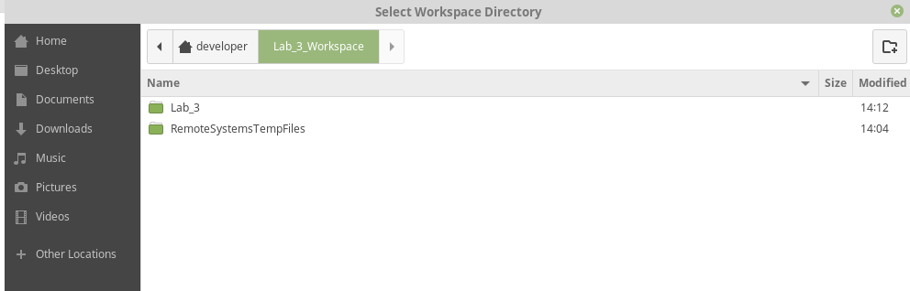

Step 3: Launch Workspace
Once you know you are in the new directory you created, click Launch.
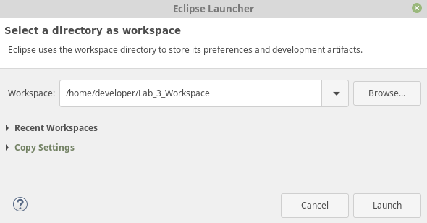

Step 4: Correct a Partial Window or Workspace (Optional)
You may get a partial window or the welcome page that is not the full Eclipse workspace. In this situation, select Window > Perspective > Open Perspective > Other:
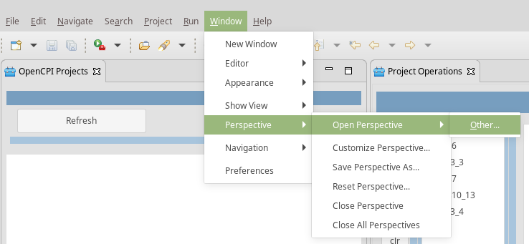

Highlight the ANGRYVIPER Perspective and then click Open:
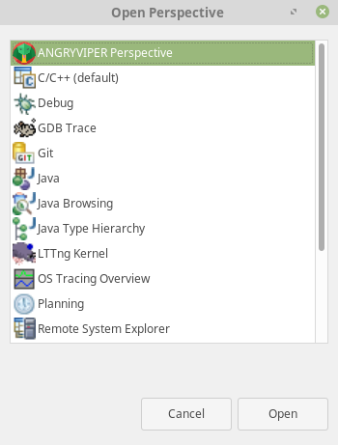
Your window should now look like this:
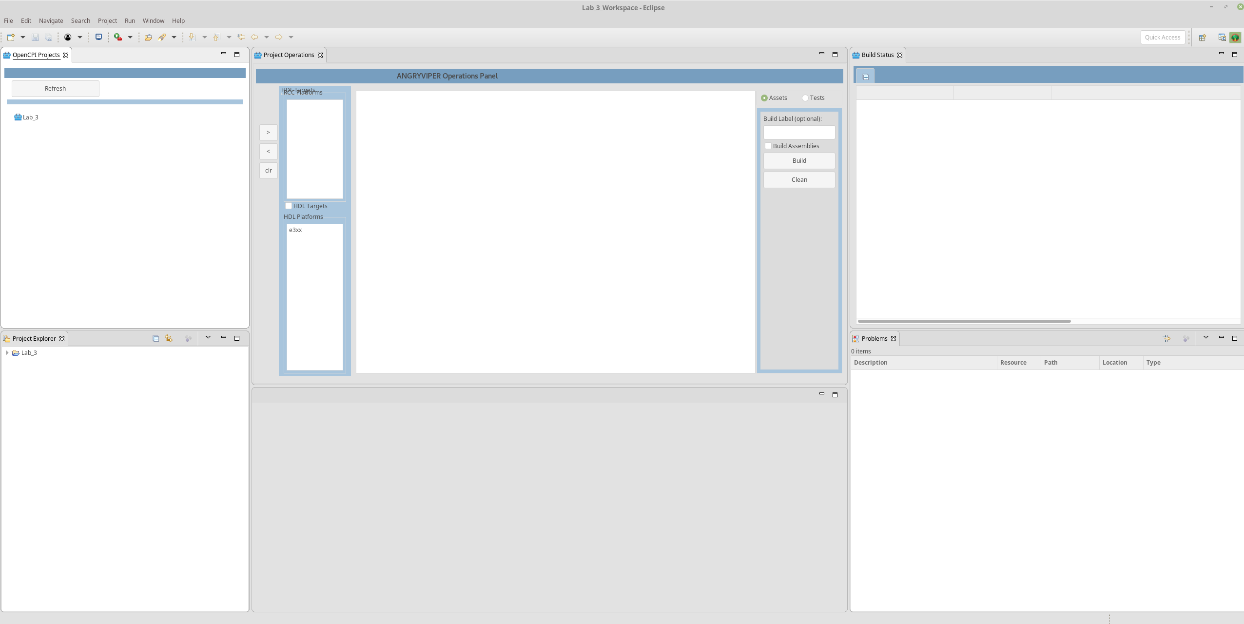
NOTE: This is what a blank workspace looks like. You will need to start with this for every tutorial.

Procedure 2: Import OpenCPI Projects
The following projects are essential files that allow you to build projects on different platforms with the build option in Eclipse:
- core – basic components (read and write files)
- assets – various component libraries
- assets_ts – components for timestamping
- bsp_e310 – unique device workers, card definition and the E310 BSP
In this procedure, we’ll import the core, assets and bsp_310 projects, which we’ll need for subsequent tutorials.
Note: Sometimes the target platforms aren’t displayed on the Operations panel. You can also use this procedure to fix this problem.

Step 1: Import the Project Files
Import the files from the ocpi_projects directory: go to the top left corner and select File > Import:
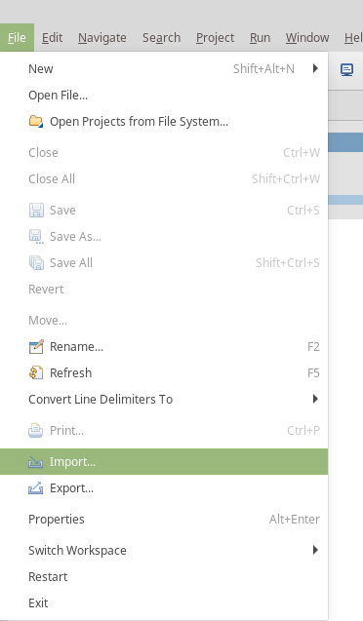

Step 2: Select Existing Projects into Workspace
In the window that pops up, select Existing Projects into Workspace:
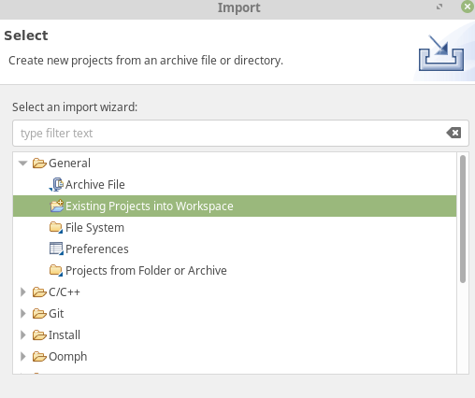

Step 3: Browse Root Directory
In the window that pops up, check select root directory and then click Browse.
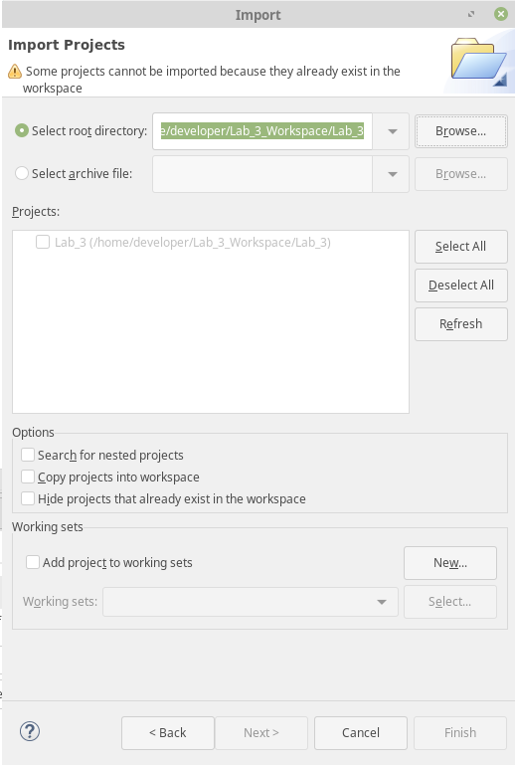
The following dialog pops up:
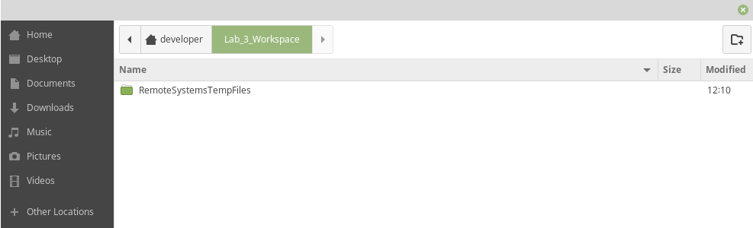

Step 4: Select ocpi_projects
Go to developer (or whatever your user space is) and highlight ocpi_projects:
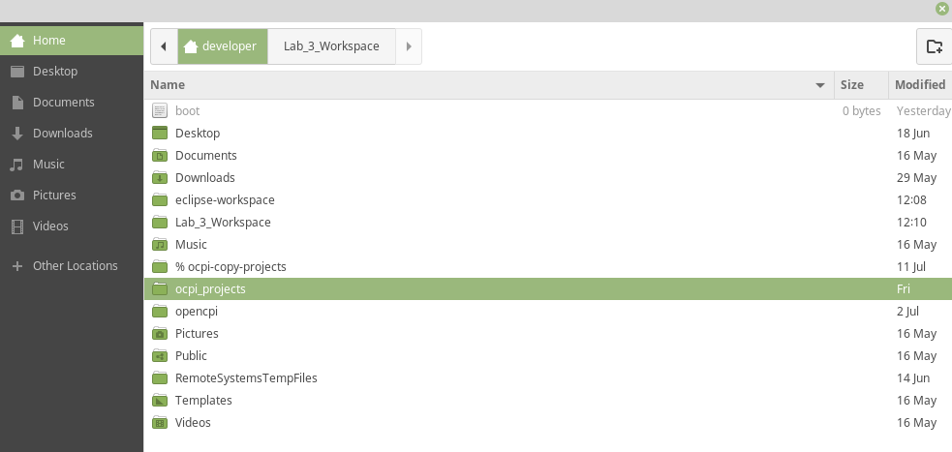
Select OK. The following window is displayed:
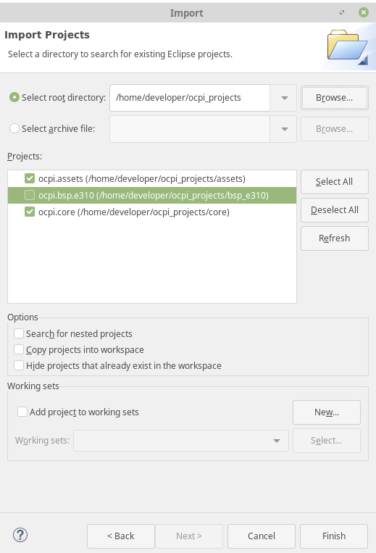

Step 5: Select Projects
Leave ocpi.core, ocpi.bsp_e310 and ocpi.assets and checked and then click Finish.
You should end up with these three projects in your Project Explorer and OpenCPI Projects window. Here is an example:
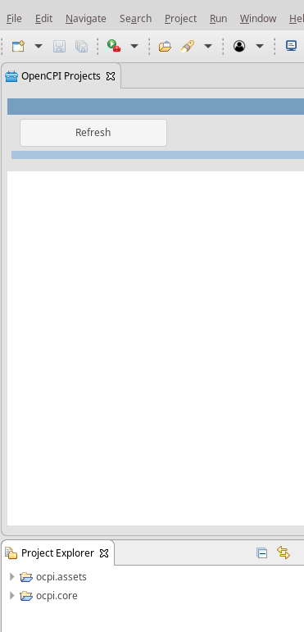
Click Refresh in the OpenCPI Projects window to display all of the projects:
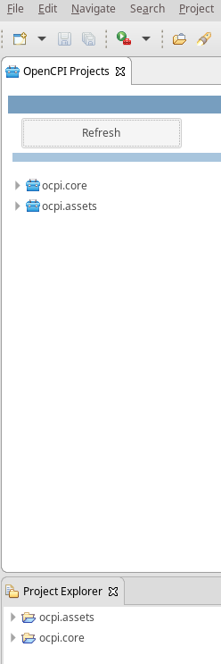
Done!
We recommend registering your imported projects before continuing with the tutorials. It also helps if you go ahead and build them for the target platform on which you plan to run them.

